305 Analogue Stochastic Signal Generators User Manual
06-2020 Rev. 1

1 Introduction
Beep boop

2 Installation & Power
This module requires 10hp of free space in a rack. When installing, always turn off the power supply before plugging anything in. When plugging in the 10-16 pin ribbon power cable, ensure that the red stripe lines up with the RED LINE mark (refer to fig. 2.1) on the module and the marking that indicates -12v on the bus board.
This module is not reverse polarity protected. This means that the module will get heavily damaged if the power cable is plugged in backwards. Additionally, a reversed power cable may also cause damage to the components in the module, as well as other modules connected to the same power supply.

3 Front Panel Overview

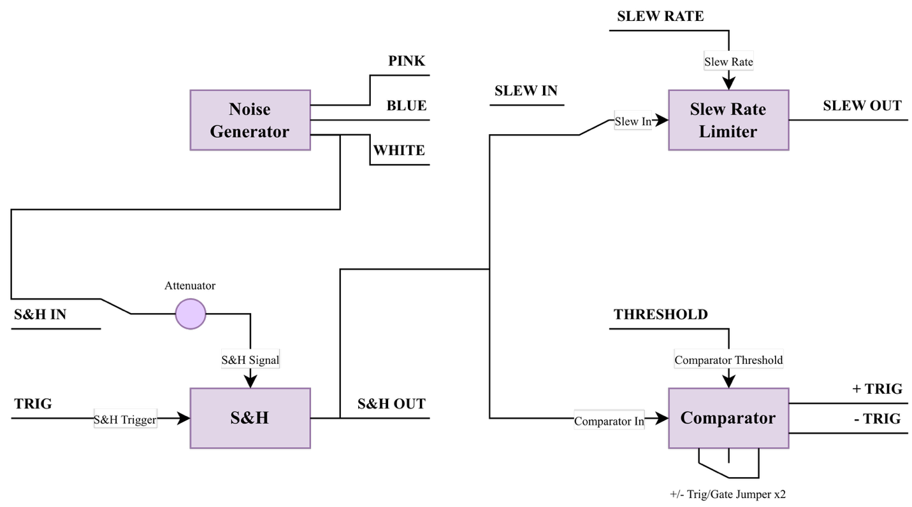
4 Additional Information (Optional)

5 Patch Ideas

6 Technical Specifications
6.1 Dimensions & Power
Width | Depth | +12v Current | -12v Current

6.2 Inputs & Outputs
Inputs |  | Outputs
Input name | Additional info | output name | Additional info

6.3 Other Specifications (Optional)

