202 Passive Signal Multipliers User Manual
05-2026 Rev. 1

1 Introduction
The 202 Passive Signal Multipliers are 2 simple utility passive multiples in Intellijel 1U format. Each multiple produces four copies of the input signal, and the input of the second multiple is normalled to the first input, so the module can be used as a single multiple that produces eight copies of the input signal.

2 Installation & Power
This module requires 14hp of free space in an Intellijel 1U row of the rack. This module is completely passive, meaning that it does not require power to work. Therefore, just mount the module to the rack and it will be in working state.

3 Front Panel Overview
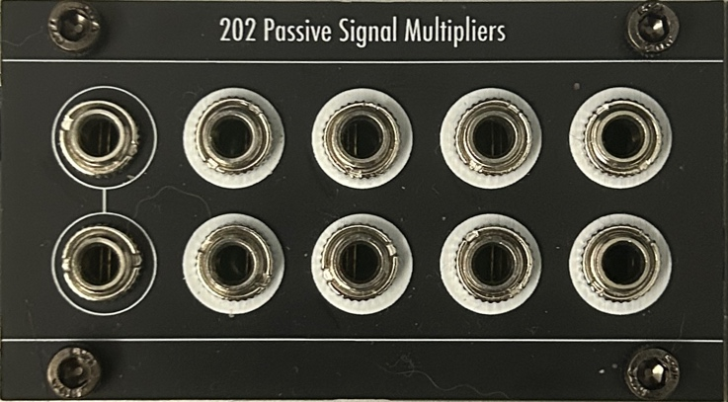
fig. 3.1 Panel Overview

4 Technical Specifications
4.1 Dimensions & Power
Width | Height | Depth | +12v Current | -12v Current
14hp | 1U Intellijel | ~15mm | 0 mA

4.2 Inputs & Outputs
Inputs |  | Outputs
IN 1, 2 | Any modular levels | OUT 1.1-4, 2.1-4 | Any modular levels

