304 Quad Channel Voltage Controlled Mixer User Manual
05-2026 Rev. 1

1 Introduction
The 304 Quad Channel Voltage Controlled Mixer is a flexible mixer module for audio. It comprises of four linear VCAs based on LM13700 dual OTA ICs. Each channel can be individually routed out through channel outputs, and are normalled to be mixed and output at the fourth output. This means that the modules can be used as anything between four individual VCAs and a quad channel mixer.

2 Installation & Power
This module requires 10hp of free space in a rack. When installing, always turn off the power supply before plugging anything in. When plugging in the 10-16 pin ribbon power cable, ensure that the red stripe lines up with the RED LINE mark (refer to fig. 2.1) on the module and the marking that indicates -12v on the bus board.
This module is not reverse polarity protected. This means that the module will get heavily damaged if the power cable is plugged in backwards. Additionally, a reversed power cable may also cause damage to other modules connected to the same power supply.
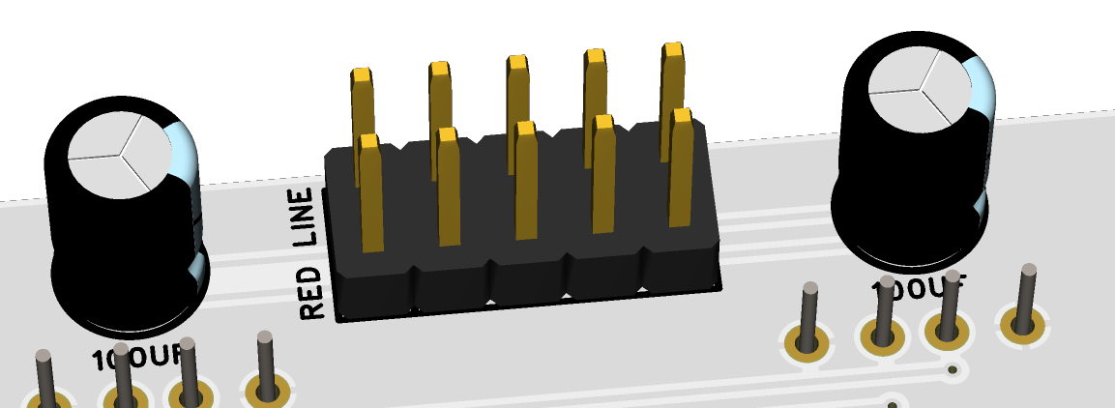
fig. 2.1 Power Connector
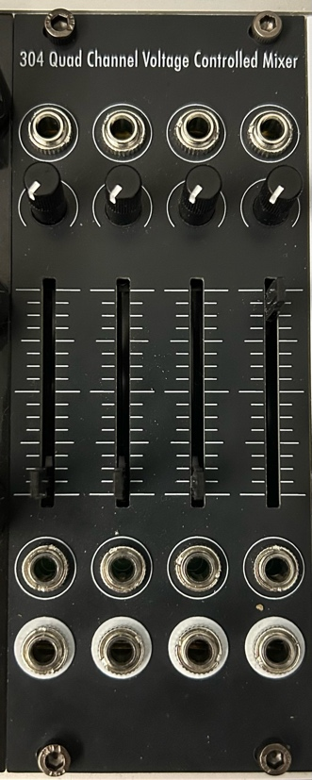
3 Front Panel Overview
The 304 panel lacks labels and text, but is still fairly straightforward to use. The elements in each channel is laid out vertically in strips, and four of those identical channels are laid out next to each other.
For each channel, there are 2 inputs and 1 output. The topmost input is the VCA CV in, with its respective attenuator right below it. The slider in the middle is the channel VOLUME slider.
Note: The VOLUME slider is a voltage offset, and will not be able to control the volume when CV is applied (see fig. 3.2).
Below the VOLUME slider are the audio IN and channel OUT jacks. If nothing is plugged into the OUT jack of a channel, the input will get normally mixed into the channel four MIX OUT (the rightmost output).
fig. 3.1 Panel Overview
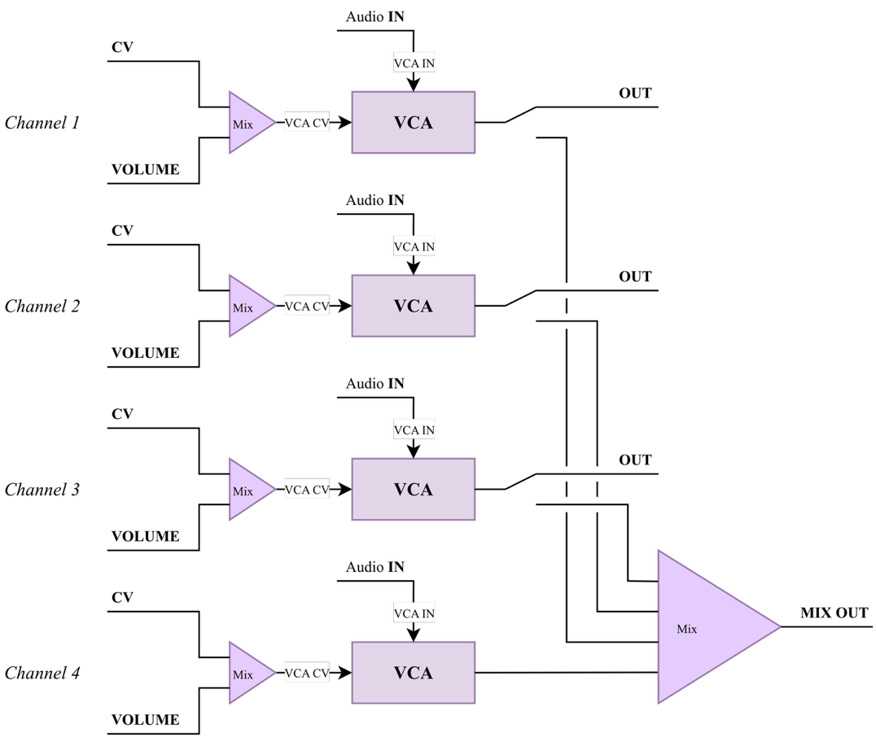
fig. 3.2 Block Diagram
4 Additional Information (Optional)
bleedthru

5 Technical Specifications
5.1 Dimensions & Power
Width | Depth | +12v Current | -12v Current
10hp | ~35mm max.

5.2 Inputs & Outputs
Inputs |  | Outputs
IN 1 - 4 | Any modular signal levels | OUT 1 - 4 | ~20 Vpp max.
CV 1 - 4 | Any modular signal levels

5.3 Other Specifications

