304 Quad Channel Voltage Controlled Mixer User Manual
20-05-2026 Rev. 1

1 Introduction
The 304 Quad Channel Voltage Controlled Mixer is four individual linear VCAs based on LM13700 dual OTA ICs. Each channel can be individually routed out through channel outputs, but are normalled to be mixed and output at the fourth output. This means that
2 Installation & Power
This module requires 10hp of free space in a rack. When installing, always turn off the power supply before plugging anything in. When plugging in the 10-16 pin ribbon power cable, ensure that the red stripe lines up with the RED LINE mark (refer to fig. 2.1) on the module and the marking that indicates -12v on the bus board.
This module is not reverse polarity protected. This means that the module will get heavily damaged if the power cable is plugged in backwards. Additionally, a reversed power cable may still cause damage to other modules connected to the same power supply.

3 Front Panel Overview
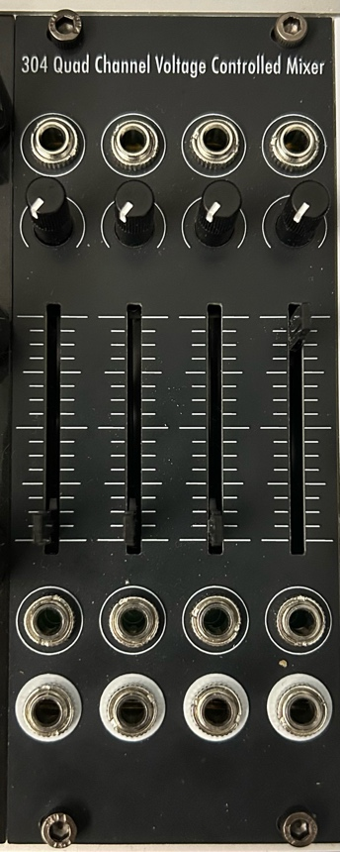
The 304

4 Additional Information (Optional)

5 Patch Ideas

6 Technical Specifications
6.1 Dimensions & Power
Width | Depth | +12v Current | -12v Current
10hp | ~35mm max.

6.2 Inputs & Outputs
Inputs |  | Outputs
Input name | Additional info | output name | Additional info

6.3 Other Specifications (Optional)

