310c Diode Voltage Controlled Filter User Manual
05-2026 Rev. 1

1 Introduction
The 310c Diode Voltage Controlled Filter is a basic VCF based on the diode ladder topology in a small 4hp format. It is a two-pole lowpass filter, meaning it has a $-12 dB/oct$ frequency response.
- talk about low frequencies at high resonance
- topology allows squelchy resonance
- potentially something else

2 Installation & Power
This module requires 4hp of free space in a rack. When installing, always turn off the power supply before plugging anything in. When plugging in the 10-16 pin ribbon power cable, ensure that the red stripe lines up with the RED LINE mark (see fig. 2.1) on the module and the marking that indicates -12v on the bus board.
This module is reverse polarity protected. This means that the module will not get heavily damaged if the power cable is plugged in backwards. However, a reversed power cable may still cause damage to the components in the module, as well as other modules connected to the same power supply.

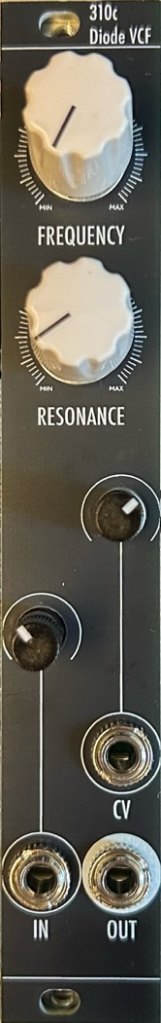
3 Front Panel Overview
The 310c has a common and straightforward interface similar to many VCF designs. The cutoff FREQUENCY knob allows for sweeping across the full frequency range ($20-20,000 Hz$), and the RESONANCE knob allows for control of resonance from completely zero up to self-oscillation (at about 2-3 o’clock) and overdriving self-oscillation. The resonance intensity can be adjusted, refer to Section 4.1.
The audio IN and CV inputs both accept standard Eurorack signal levels of up to $24Vpp$, and can be attenuated using their respective onboard attenuators, indicated by the panel. The IN attenuator can be used to overdrive the input signal when fully open, which will decrease the effect of resonance and result in a soft-clipped output signal. CV is capable of tracking $1 V/oct$ for around 2-3 octaves, depending on the attenuator position. To achieve this, the attenuator should be set at about 1-3 o’clock, the exact position also depends on the FREQUENCY knob position.
Finally, the jack below the CV input is OUT, which is the output of the filter.
fig. 3.1 Panel Overview

4 Additional Information
4.1 Resonance Intensity Adjustment
The intensity of the resonance can be adjusted via a trimmer potentiometer at the bottom PCB of the module. To adjust it, First turn the FREQUENCY knob to the central (12 o’clock) position and the RESONANCE knob to the maximum position, and plug a cable to OUT to monitor the output of the module. Next, remove the module from the rack and locate the resonance trimmer on the bottom PCB (see fig. 4.1). Using a small flathead screwdriver, adjust the frequency trimmer to your liking. The output of the resonance will be the resonance of the module with maximum resonance.
Warning:
- High resonance intensity can result in very high levels. Be careful to not damage hearing or speakers.
- Touching the PCB while adjusting the trimmer will cause instabilities in the module. While it won’t cause damage in the module, but will make adjustment more difficult. It is recommended to hold the panel or place the module upside-down on the rack (see fig 4.2) while adjusting.
- Do not allow contact from any metal with the PCB, as it may cause damage to the circuit.
4.2 Frequency Response

5 Patch Ideas
As this module is a very basic module without complicated functionality, creative uses for it are limited other than the standard VCF.
5.1 Filter Pinging
Filter pinging (percussions, kicks, etc)

5.2 Sine VCO
Using filter as a sine VCO

6 Technical Specifications
6.1 Dimensions & Power
Width | Depth | +12v Current | -12v Current
8hp | ~35mm max.

6.2 Inputs & Outputs
Inputs |  | Outputs
IN | ± 12 V max. | OUT | ~20 Vpp max.
CV | ± 12 V max.

6.3 Other Specifications (Optional)

Exact frequency range of the filter knob has yet to be measured
Voltage ranges are just recommended and/or maximums as module is analogue.

