308 Voltage Controlled Filter and Wavefolder User Manual
05-2026 Rev. 1

1 Introduction
The 308 Voltage Controlled Filter and Wavefolder is a complex sound shaping pair consisting of a VCF and an unusual VC-Wavefolder. The VCF is based on the classic late MS20 2-pole ($12 dB/oct$) OTA low/high pass filter, and the VC-Wavefolder is based on the harmonizer section of a rare Soviet synth (Alisa 1377), which has been adapted to Eurorack by Aubery Lis as the Lyssa Wavefolder. Above from the 2 main parts of the module, it also has a sawtooth to triangle converter for obtaining waves with lower harmonic content for better results at wavefolding.

2 Installation & Power
This module requires 16hp of free space in a rack. When installing, always turn off the power supply before plugging anything in. When plugging in the 10-16 pin ribbon power cable, ensure that the red stripe lines up with the RED LINE mark (refer to fig. 2.1) on the module and the marking that indicates -12v on the bus board.
This module is not reverse polarity protected. This means that the module will get heavily damaged if the power cable is plugged in backwards. Additionally, a reversed power cable may also cause damage to the components in the module, as well as other modules connected to the same power supply.
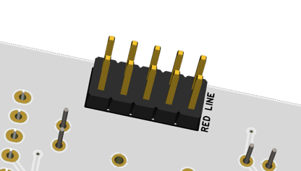
fig. 2.1 Power Connector
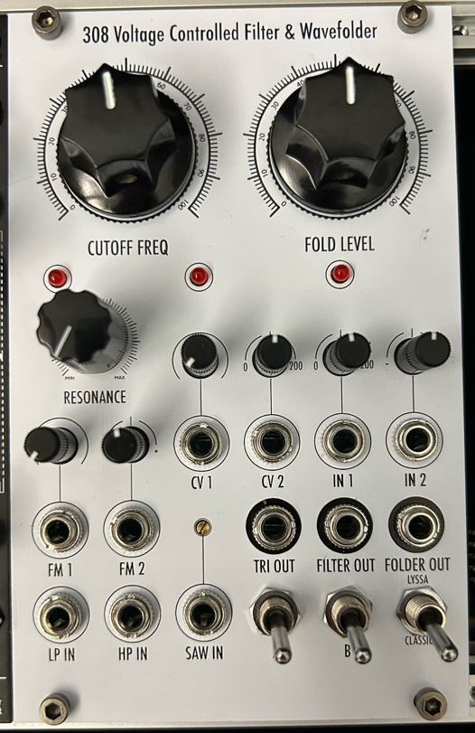
3 Front Panel Overview
The 308 has a feature packed panel that is separate into two main sections: on the left is the VCF section, and on the right is the wavefolder section. All the outputs are on the right side, and the two sections are independent of each other.
3.1 VCF Section
The VCF section is a standard OTA design, and is straightforward to understand. The large CUTOFF FREQ knob on the top allows a full range ($20-20,000 Hz$) sweep of the VCF, and the smaller RESONANCE knob below controls resonance. This module is not capable of self-oscillation, and resonance levels are relatively weak. The 2 LEDs are from the feedback gain stage, also offering indication for resonance levels. The two audio inputs, LP IN and HP IN offers lowpass and highpass filtering, respectively. The two CV inputs, FM 1 and FM 2 are above that, offering CV control to the cutoff frequency. The 2 small knobs above are an attenuator and an attenuverter r for FM 1 and FM 2 respectively, as indicated by the panel. The FILTER OUT is the middle output on the right of the module, which outputs the filtered signal.
fig 3.1 Panel Overview
3.2 Wavefolder Section
The wavefolder section takes up a larger area of the module. Starting from the large FOLD LEVEL knob, which controls an internal VCA to sweep from zero to maximum amplitude, essentially allowing zero to maximum wavefolding. Below that, the 4 inputs are (from left to right) the CV 1, CV 2, IN 1, and IN 2. CV 1 and CV 2 are the fold CV inputs, having their respective attenuator and amplitenuator as indicated by the panel. There is also an LED indicating the fold level, which takes all the CV ins and the knob into account. IN 1 and IN 2 are the inputs of the wavefolder, having their respective amplitenuator and attenuverter also indicated by the panel. Note that both inputs have normalised connections (see fig. 3.2), IN 1 is normalled to TRI OUT of the sawtooth to triangle converter, and IN 2 is normalised to a $+ 12 V$ offset voltage, which can be used to create asymmetric wavefolding. The wavefolder is output at the rightmost output, FOLDER OUT.
The 3 switches below the outputs are A, B, and LYSSA, respectively. The LYSSA switch switches between two modes, CLASSIC mode is closest to the original Alisa 1377 circuit, with two wavefolding stages, and LYSSA mode adds a third wavefolding section. In the original, the A and B switches are labelled as “More!”, as they increase the wavefolder depth of stage one and two of the wavefolder, respectively. They also lead to clipping and distortion. There are eight possible combinations of these three switches, and all of them drastically change the quality of the wavefolder.
The sawtooth to triangle converter is a minor part of the wavefolder section, it consists of a SAW IN, and is the converted waveform is output at the leftmost output, TRI OUT. This converter needs to be calibrated to achieve optimal conversion, and a calibration trimmer is available on the panel above the SAW IN jack. Refer to Section 4.1 for calibration instructions.

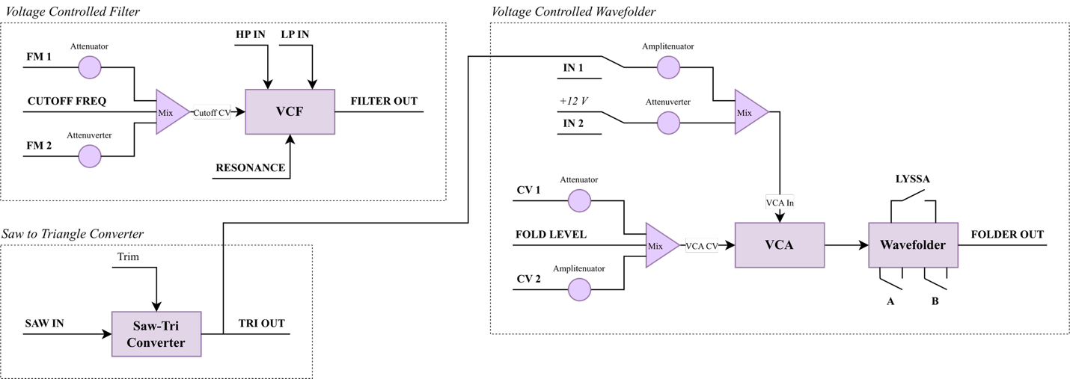
fig 3.2 Block Diagram

4 Additional Information
4.1 Sawtooth to Triangle Calibration

4.2 Frequency Response

4.3 Wavefolder Response

5 Patch Ideas
Patching cv into in2
Saturation of inputs using amplitenuators
Experimentation with switch combinations
Signal flow: filter -> wavefolder and wavefolder -> filter
Inputting other waves into saw-tri converter

6 Technical Specifications
6.1 Dimensions & Power
Width | Depth | +12v Current | -12v Current
16hp | ~ 35mm max.

6.2 Inputs & Outputs
Inputs |  | Outputs
LP IN, HP IN | Any modular levels | TRI OUT | Any modular levels
FM 1 | Any modular levels, attenuated | FILTER OUT | Any modular levels
FM 2 | Any modular levels, attenuverted | FOLDER OUT | Any modular levels
SAW IN | Any modular levels
IN 1 | Any modular levels, normalled to TRI OUT
IN 2 | Any modular levels, normalled to +12v
CV 1, 2 | Any modular levels

6.3 Other Specifications

http://www.ruskeys.net/base/alisa1377.php
https://sfcs.neocities.org/module/SFP50/
Exact frequency range has yet to be measured
Name from Xaoc Devices (https://xaocdevices.com/main/konin/), the amplitenuator mentioned here can attenuate and amplify for a full range of $0\%-200\%$ scaling of the input signal.

