THE RIVESIDE PRACTICE
PROCEDURE FOR THE ELECTRONIC
TRANSFER OF PATIENT DATA

Introduction
There is a statutory and contractual obligation on practices, under the GMS contract, to have in place a written procedure for the electronic transfer of patient data. The purpose of this protocol is to define circumstances in which this takes place within the practice and the administrative and security procedures that will apply.

It is vital that only records between health users be released in this manner and that the normal checks and authorities needed are still adhered too. For example, releasing patients’ notes for a legal report must be accompanied by the patient’s authorisation.

For the purposes of this document, electronic transmission is defined as:
- Email
- Pathology Test Results
- Out of Hours transmissions (OOH)
- Electronic Prescription Requesting (EPS)
- GP2GP
- The overriding standard is the Data Protection Act 2018 (see Resources)

Email
- Patient identifiable information will not generally be sent by email.
- It is acceptable for patient identifiable information to be sent by email providing it is wholly within the NHSmail system, NHS.NET TO NHS.NET
- In the interest of expedience, an email with or without attachments may be used to provide information in some instances. In this case, texts, images or other identifiable sections must be removed prior to dispatch. In these circumstances, the recipient will be contacted by phone to advise them the email will be sent, and will be informed verbally of the identity of the patient along with any relevant personal detail. The de-personalised items may then be emailed.
- All efforts will be taken to ensure that minor errors in the email address used do not result in an inappropriately or incorrectly addressed email.
See also: “E Mail – Guidelines for the Use of” [*]

Pathology/Test Results

- All (most) results are transmitted to the practice via the clinical system pathology link.
- The following results will NOT be received electronically BREAST SCREENING RESULTS
- Dr R Goel will be responsible for viewing the results on a daily basis. In his / her absence, Dr R Aggarwal will view the results. The reviewing clinician will identify any patient-related action required. If non urgent the result is assigned to the requesting doctor to review and action.
- The nominated clinicians will be responsible for the re-allocation of results to alternative GPs in the event of named GP absences.
- The nominated clinician(s) will check for any unmatched patients or unmatched doctors daily. If the result cannot be matched manually they will print off the result and return it to the pathology department, advising that the practice is unable to trace the patient.

- The pathology department will be contacted regarding any missing results or interchanges.
- The Practice Manager will check that the admin results action queue created by the GPs is actioned daily and that all appropriate actions have been taken. Results will not be removed from this queue until all actions are complete.
- All patient-related reports will be dealt with on the day of receipt.
- Individual clinicians will append comments to the results and file as a consultation into the clinical patient record.
- The nominated clinician will notify reception by means of an EMIS task, urgent or routine, of any additional action required.
- Receptionists will check their EMIS practice tasks inbox at regular intervals throughout the day and prior to leaving to ensure that action has been taken.
- Occasionally, GPs will need to use the “forward to” facility to forward a result to another GP (or nurse) in the practice that has specialist knowledge of the patient.

See also: Incoming Pathology Results (Handling) Procedure [*]

Out of Hours Transmissions (OOH)

- Information relating to OOH consultations is transmitted directly into the clinical system each morning by email or fax.
- The duty doctor is responsible for viewing the transmissions prior to 10 am. In the event of absence, the nominated person (practice manager or reception supervisor) will arrange for the role to be deputised.
- The transmissions will be printed and passed to the duty doctor for viewing prior to 10am if urgent.
- The GP will action the information and arrange any follow-up action.
- The nominated person will create a consultation record, and file the electronic transmission within the patient record on the clinical system. Where the details suggest a particularly urgent situation, the duty doctor may be interrupted in surgery to view the details.
- The nominated person will examine the home visit requests for the day on completion of the OOH procedure. Where a home visit is booked for a patient and an OOH call has been processed, the nominated person will ensure that the visiting GP is aware of the details of the OOH call or visit.

See also: “Out of Hours – Handling of Patient Information Protocol” [*]

Electronic Prescription Requesting (EPS)

The Electronic Prescription Service (EPS) is a service that offers patients the chance to change how their GP sends prescriptions to the place they choose to collect their medicines and appliances from. This means patients will not have to travel to their GP practice to pick up a paper prescription, but rather the GP will send it electronically to a place of the patient’s nomination.

A protocol for managing EPS within a practice could be as follows:

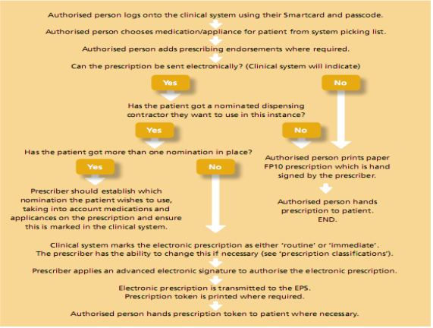

See also: Prescription Recording Procedure

GP2GP

GP2GP is a web-based service that makes it possible to send and receive medical records immediately through the clinical system. This will mean that upon registering a new patient, it is possible to electronically request their records and receive them quickly.

This protocol provides a brief record of the procedure which will apply within the practice for GP2GP transfers, however it is not a technical guide to the system, and technical queries should be addressed to the system supplier.

Process

- View the received patient record
- Verify patient identity
- Merge the received record into the record currently held (recently created at the new practice) for the patient
- Pass to a GP for a medication review
- Summarise the record using the normal summarising protocols ensuring that the existing entries on the merged clinical record meet the practice data quality standards, are correspondingly coded, and also check for duplicate codes and diagnoses, and accuracy of recording and coding, initiating corrections as necessary.

See also: GP2GP Transfer Protocol

Resources

Gov.uk – Data Protection Act
Department of Health – Electronic Transmission of Prescriptions

