ONLINE VIDEO CONSULTATION POLICY
Introduction
This document should be read in conjunction with the NHS England Digital Toolkit document “Using Online Consultations in Primary Care : Summary Implementation Toolkit for Practices” published in September 2019.

Practices using the information provided are expected to undertake due diligence and keep up to date with their information governance responsibilities.
https://www.england.nhs.uk/wp-content/uploads/2019/09/online-consultations-summary-tocolkit-for-practices-dec-2019.pdf

The NHS Long Term Plan commits that every patient will have the right to be offered digital-first primary care by 2023/24, an important step being the digitisation of primary care services and helping practices to achieve this. NHS England has already committed to a programme to support practices and commissioners to do that via a framework for digital suppliers to offer their products to primary care on NHS standard terms from 2021.

Recently there has been a growth in new GP digital providers offering patients to register with them directly and contact the practice via mobile apps. Under the current arrangement, the expansion of these models has taken place by registering patient across wide geographies from a single GP Practice.

However, if a large number of patients are registered with a practice distant from their home it is more challenging to deliver integrated care services and screening services. Because of the way NHS funding flows, following a patient’s registration with a GP, CCGs with high numbers of out of area registrations caused by having a digital provider in their area will become responsible for the healthcare costs of those patients.

Given the need for more GP capacity, it is also acknowledged that digital models offer further opportunities to improve access to services and bring additional capacity.
Online Consultations
Online consultation systems are app or web-based systems that enable communication and the transfer of information between the general practitioner (GP) and the patient. Some software platforms include algorithm-generated, tailored advice for patients (generally referred to as ‘artificial intelligence’ or AI). Some systems allow patients to book appointments, request repeat prescriptions and access their health records.

The Riverside Practice uses AccuRx to carry out its online consultations, both by text messaging, patient emails and video consultations. This is also used for patients to raise general enquiries. We also use the NHS App for patients to view their records and request repeat medication.

Security
To prevent any data breaches or cyberattacks, it is essential that the Practice maintains up-to-date operating systems, use antivirus software, and only download from approved sites. Devices and software must therefore be kept up-to-date, as users may still be vulnerable due to their operating systems and software being outdated.

It is also important to ensure suppliers are not using unsupported operating systems or internet browsers to access the online consultation systems. New vulnerabilities in software or devices can occur at any time and for this reason, updates or ‘patches’ are released regularly to address any potential security breaches. Updates should be applied regularly in order to ensure maximum protection under advisement from your local NHS IT Support.

Cyber safety should include firewalls to secure your connection, security settings for devices and software, controlled access to data and services based on job roles, ensuring a need-to-access basis.
Data Protection
Online consultation systems should be compliant with the NHS DSP Toolkit. As your chosen software will be processing data, it is important that suppliers are compliant to give assurance to clinicians and patients alike. Being compliant demonstrates that practices can maintain confidentiality and security of personal information, correctly handle data and, ensure protection from unauthorised access, loss, damage and destruction.

The Riverside Practice submit our completed DSP Toolkits which are evaluated by the NHS for compliance. Information Governance (IG) assurances are required as part of the Practice’s terms and conditions of providing health services and using national systems and services.
Patient Identification and Authentication
Practices have a legal obligation to provide a secure and confidential service for patients - identity verification and authentication protects both patients and practices from unauthorised disclosure of personal or confidential information and any fraudulent activity.

Practices must have processes in place to adequately authenticate and verify the identity of a patient, ensuring that the applicant for online access is the same person whose recorded identity the account is associated with. The verification process should allow patients to prove their identity in a simple process, but robust enough to prevent any identity fraud.

The responsibility of verification and authentication falls on the practice. Correctly verifying the applicant’s identity is necessary when prescribing, advising treatment plans or making referrals to

other services and/or healthcare professionals. Any information stored and processed is done in line with applicable privacy laws.
Skype and Information Governance
Skype is a popular video-chat method of communication that utilises software that is freely available in the general public. However, there are a number of risks that GPs, other healthcare professionals and patients should be aware of before making the decision to use Skype.

An independent security assessment in 2005 (Skype Security Evaluation, Tom Berson, 2005) concluded that Skype can verify user identity and content confidentiality between systems. NHS Digital recommend that each organisation should conduct their own risk assessments before implementing new systems.

The risks must be reviewed by individual practices as there may be differences in what services are available. Approval to use this method and the safety measures to implement will be required by the practice’s Caldicott Guardian. It is advised to consult your local NHS IT teams on viability of this or any other video consultation software being considered/used.

Using your own device for consultations

NHS Digital have stated that you can use your own devices for consultations where there is no practical alternative.

You are expected to take steps to ensure that this is safe and secure, including;
- Setting a strong password
- Using secure encrypted communications
- No personal or confidential information stored on the device unless there is no alternative
- Appropriate security is in place (check with local NHS IT Teams for specifics)

Considerations for the GP

The clinician must be in control of the call and always schedule, initiate and run the use of video consultations. Calls that have been initiated externally may be blocked as the N3 network may apply restrictions to network traffic which could affect the quality of connections during communications (i.e. reducing the call quality).

For online consultations, there should be a backup option in place (such as a mobile or desk phone) as internet connections and quality can fluctuate. Picture and sound quality cannot be guaranteed and must be considered by the clinician depending on the nature of the call.

Video consultation software must not to be used for emergency calls or as a replacement for other telecoms.
Data Protection Considerations
Requirements under The Health Service (Control of Patient Information) Regulations 2002 (COPI) state that confidential patient information can be processed for certain public health secondary purposes set out in Regulation 3(1) of COPI, such as to support tackling the NHS response to Covid-19.
Data Protection Act 2018 (incorporating GDPR) requirements
The General Data Protection Regulations allow the sharing of information for individual care, planning and research.
Where ‘special category data’ (health and care information) is shared for either individual care or to help tackle disease through research, then the following Articles apply;

- Article 6 : official authority, compliance with a legal obligation, public interest and on occasions vital interests
- Article 9 : substantial public interest, the delivery of health and care, vital interests or for public health purposes and scientific research

The principles relating to the processing of personal data should continue to be followed as they are the framework of good information management.

A Data Protection Impact Assessment should be carried out before video consultations are carried out to ensure there is an acceptable level of safety and protection for the practice and patient;
- Data Protection Risks
- If activity is necessary and proportionate
- What mitigating actions are in available and if they are in place

DPIAs are scalable, and in some instances this might not take more than a couple of pages. The ICO has produced guidance on carrying out DPIAs and a template that you can refer to. You should also update your privacy notice where data is being processed in new ways.

RESOURCES
NHS England Patient Identification & Authentication
https://www.england.nhs.uk/wp-content/uploads/2015/03/identity-verification.pdf
The Technology factsheet: Skype remote consultations; https://bit.ly/2UdtOwg
Skype security (Skype Security Policy; http://www.skype.com/en/security/#encryption
ICO Anonymisation : Managing Data Protection Risk Code of Practice
https://ico.org.uk/for-organisations/guide-to-data-protection/anonymisation/
ICO Guidance on Data Protection Impact Assessments
https://ico.org.uk/for-organisations/guide-to-the-general-data-protection-regulation-gdpr/data-protection-impact-assessments-dpias/

APPENDIX 1 : PRIVACY STATEMENT FOR ONLINE CONSULTATIONS
By law, all organisations that use personal information (personal data) must provide a clear description of how it is used and provide any related information to ensure the processing is carried out lawfully and fairly (this will be in addition to your Practice’s Privacy Notice, which should be available to patients, e.g. practice website or from reception when requested).

The additional information below only applies to the use of your information when you use our online consultation service.

***USING NHS APP FOR CONSULTATIONS***
Our Online Consultation Service

(THE RIVERSIDE PRACTICE) have engaged a specialised online consultation supplier which has been approved to NHS England technical standards and has gone through stringent scrutiny and achieved all necessary requirements to comply with the Online Consultations. The contracts with the supplier ensure that we remain the Data Controller of your personal information when you use such services and that your information is used Only for the purposes of the online consultation.

The name of the organisation we have engaged to provide this service is displayed in the NHS App. The NHS App is provided by NHS Digital and provides health services such as viewing your medical record and can be downloaded from the App Store and Google Play.

NHS Digital connects the NHS App to our online consultation service so that the service can operate within the NHS App. NHS Digital does this on our behalf. Both NHS Digital and our online consultation supplier are our processors.

***PRACTICE CARRYING OUT OWN CONSULTATIONS***
Our Online Consultation Service

During the course of this online consultation with a clinician from THE RIVERSIDE PRACTICE information will be shared between myself (the clinician) and you (the patient).

All information will be held in confidence and its use is covered by the Data Protection Act 2018 as well as the NHS Care Record Guarantee, which governs how the NHS can use your data.

Information will only be used by and shared with those who have a legitimate need to access the information to provide health care. The only information to be recorded and captured is the medical outcome of this discussion, which will be included on your patient record.

NHS Digital have said that it is fine to use video conferencing tools such as Skype, WhatsApp, Facetime as well as commercial products designed specifically for this purpose.
APPENDIX 2 : Sample Checklist (conducting online video consultation)
Technical
Security risks of local IT infrastructure understood and accepted.
Service meets required level of security and confidentiality.
If online consultation software has open access address book, pseudonymised username must be used
A local procedure to identify the patient that is consistent and robust must be in place.
Ensure that the patient’s contact details are up to date and on their record.

Preparation
Patients will contact the practice to book an appointment as usual and provide their username and contact number (this will be added to the patient contact details).
Patients will need a web/mobile phone cam, Skype link, privacy and good lighting to ensure call quality
Users must ensure they have adequate spyware and antivirus protection (do not rely on the video software to protect users against spyware or malware).
Informed patient consent must be obtained before the online consultation.
Online consultations conducted in a private enclosed area where conversation cannot be overheard, or screens can be viewed by others.

Privacy and IG requirements
Privacy Statement has been read out at the beginning of the call to inform the patient (see Appendix 1)
Patient made aware that some personal information stored locally on the computer that is being used, especially if using a public or shared computer
Once the privacy notice has been made available to the patient, all parties have the option to opt out.
The clinician will not make any audio-visual recording(s) of the meeting(s). Only the outcomes of the online consultation will form part of the patient record just as it would in a face to face consultation.
The clinician will record the outcomes of the consultation on the patient record, similar to that of a face to face consultation.

APPENDIX 3
Consent form for patient photography using a mobile device

Statement of healthcare professional taking photographs:
I have discussed with the patient the reasons for taking clinical photos using a mobile device, and how the images will be used, transmitted and stored and have explained to them the inherent risks and benefits. I understand the risks of data transfer from a mobile device and have taken appropriate steps to mitigate these risks.
Name
Date
Job Title
Signed

Areas Requiring Photography/Images

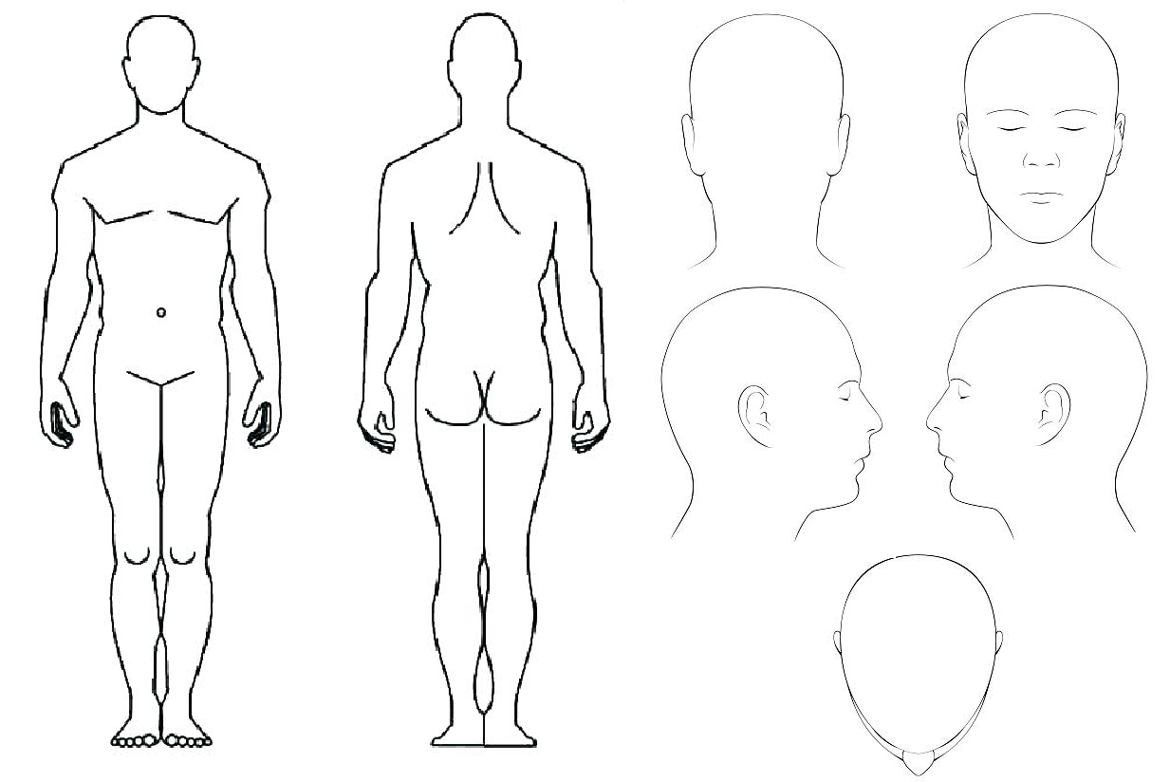

Patient Name
Date of Birth | dd/mm/yyyy | NHS Number
Your doctor has determined that it is necessary or helpful to obtain a photograph / recording of you or your condition to assist in your treatment. These will form part of your medical record and will be held and used strictly in accordance with your wishes which can be defined below.
These will only be taken and used with your consent, which can be refused or limited by you, and you can also withdraw this consent or change it in the future. Your doctor will explain this in more detail, including their use, storage, and security.
You will be able to view all images or recordings prior to signing this consent.

Patient Statement
I have had the process of clinical photography using a mobile device explained to me and I have had the opportunity to ask questions about the procedure. I agree to clinical photography as described on this form. I understand that:
- the photographs may be temporarily stored on the device until they are transferred to the Practice IT storage system (e.g. secure drive, clinical records or similar secure method of storage)
- I understand that there may be a difference between the accuracy of clinical care using photographs as compared to face-to-face clinical assessment.
- I have the right to withhold or withdraw my consent for photography at any time without this affecting my right to future care or treatment by the Practice. If at a later date I wish to withdraw my consent I will contact this Practice to do so.
- this consent limits the use of these photographs to the purposes specified by me below and any additional uses will require my further consent.
- Any extra images not suitable for or needed in the record will be deleted.

Please sign this consent once you are happy that the above have been explained fully to you.

 | Yes | No
I consent to photographs being taken for my health record within the practice
I consent to the photographs being made available to my consultant and other clinicians involved in my treatment in secondary care
I consent to my photographs being used for teaching purposes, providing these are anonymised
I consent to my photographs being used for another specific purpose (define):

I require the following restrictions to be applied to my images / recordings:

Signed |  | Print Name
GP Accepting Consent

Patient
Parent/Guardian/Carer
Date

