THE RIVERSIDE PRACTICE

PRESCRIPTION RECORDING PROCEDURE

Introduction

The purpose of this procedure is to set out the method of issuing both initial and repeat prescriptions, and to specify the method by which prescriptions are recorded within the practice.

Computerised Prescriptions

- It is practice policy that, so far as possible, all prescriptions are issued and printed electronically. This ensures that the medication history in the patient’s electronic record is always up to date and available to all clinicians in the practice involved in their care, and that those clinicians are alerted by the system to adverse reactions and contra-indications.

- All prescribing is using the EMIS electronic system which will store all the prescription details. This includes for home visits.

- Administration staff are responsible for producing printed patient summaries [or downloading patient details] for clinicians to take with them on home visits. These details must include adverse reactions to medication.

In general, the following procedure will take place:

- All prescription recording is entered in the patient record on the clinical system.
- When a prescription is issued in the surgery it is recorded on the clinical system in the medical record under medications.
- The record will state the prescription details and the date of issue.
- The issuer will enter each drug as current, acute or repeat and will provide an indicator for the drug within the clinical system. The opportunity will also generally be taken to ensure that an indicator exists for all repeat drugs on the patient record.
- When the prescription is no longer current, it will be filed under past drugs.

Nurse-Initiated Prescriptions

- When a prescription is initiated by a nurse eg for travel vaccines, it is entered in the patient record and sent to the doctor for signing electronically.
- The prescription is then checked and signed by the GP.

Nurse Practitioner (NP) Prescribing

- Where initiated by the Nurse Practitioner, enter into the clinical record as above with issue recorded.
- Non NP items as per nurses.

Manual Prescriptions

- The practice does not use hand written prescriptions and all prescribing is using the EMIS system and electronic. Nearly all prescriptions are prescribed electronically using EPS
- In the rare case that a prescription cannot be sent via EPS the duty doctor will access a blank electronic prescription from the store which has been logged to identify its serial number. This is then issued.
- A private prescription for malaria tablets is created using the blank right hand side of a prescription paper.

Electronic Prescription Service (EPS)

The Electronic Prescription Service (EPS) is a service that offers patients the chance to change how their GP sends prescriptions to the place they choose to collect their medicines and appliances from. This means patients will not have to travel to their GP practice to pick up a paper prescription, but rather the GP will send it electronically to a place of the patient’s nomination.

This can be a pharmacy or, depending on use and eligibility, a dispensing appliance contractor or a dispensing GP practice. The prescriptions will also be sent automatically to the Prescriptions Pricing Authority (PPA). Patients can change or cancel the nomination by notifying their GP, but should take care to do so before their next prescription is due.

The protocol for managing EPS within the practice is as follows:

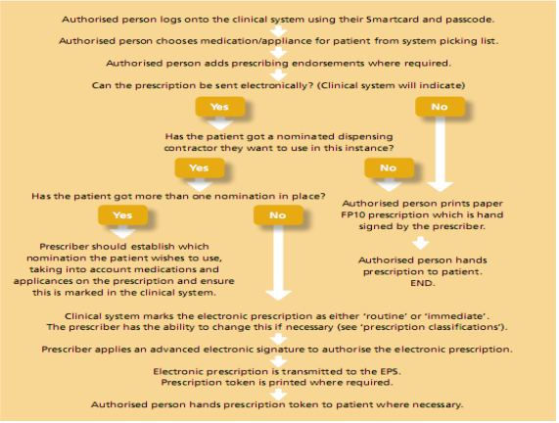

Repeat Prescribing Flowchart

This protocol is designed for EMIS practices and is suitable for both dispensing and non-dispensing practices. The flow of prescription authorisation will differ between practices and therefore this is presented as an example of a possible system only.

The flowchart is on the following two pages …

Request for repeat prescription made

Patient brings right hand side of previous prescription
Faxed request
Written note of patient request
Telephone requests
Emailed request

Requests sorted
into dispensing and non-dispensing

Dispensing patients requests to dispensary
Non-dispensing patient requests to reception staff

Open EPR on system

Check medication review date
Overdue
Review date OK
REFER TO DR

See page 2
Item in past drugs
Do not issue
Item in current drugs
No screen message authorising issue
Screen message authorises issue

Item in repeat drugs

Request is processed and prescription
has message attached for
GP to consider review date
Go to
Page 2 (a)

No computer
query at issue
Go to
Page 2 (b)

Computer system query at issue

Page 2
2 (b) - For the issue of a current medication that is authorised by screen message or a repeat medication which does not prompt a query by the computer system at issue
2 (a) - For the management of the request where a query is prompted by the computer system at issue

Prescription is issued
Prescriptions for dispensing patients sent to
'D' dispensing
Prescriptions for non-dispensing patients sent to
'H' Hold
Message warns that patient is overusing the medication
Message warns that the patient is underusing the medication
Do not issue
A message is attached to the request advising the doctor of the screen warning

Refer to Dr

Dispensed from stock from the queue on the computer
Dispensing checked and the prescription signed by GP
Printed in batches
Sorted by registered Dr and put in Dr’s boxes for signing
Bagged and shelved for collection
Returned signed to 'For collection' tray and filed alphabetically to await patient collection
GP reviews the request - amending review date, considering overusing, past drugs, current drugs etc and either issues the prescription or refers it back for more information
Dr asks administration staff to get further information from the patient or asks for an appointment to be made for review.
if GP approves request
if GP requires more info

