THE RIVERSIDE PRACTICE
REPEAT PRESCRIBING POLICY
Introduction
The purpose of this policy document is to set out the methods by which a repeat prescription will be issued and the roles and responsibilities within the practice.
There are Four Stages:
- Initiation/ Request
- Production/ Authorisation
- Clinician control/ Review
- Management control
The GP should retain an active involvement throughout the repeat prescribing process and should not delegate any entire part of the process to ancillary staff. Those stages in bold above are entirely the responsibility of a clinician.
1. Initiation/ Request
- The decision to transfer a drug from an acute prescription to a repeat prescription must always be made by the doctor after careful consideration of whether the drug has been effective, well-tolerated and is required long-term. (The patient should be seen, or at least spoken to, at this stage to ascertain the above and to check compliance). It is the duty of the doctor at this stage to ensure that the patient understands the repeat prescribing process and what is required of them.
- Care should be taken to ensure the repeat record is accurate, quantities for each drug are synchronised where possible and review dates are entered. See Appendix A for a synchronisation form which may be handed to the patient to complete.
- Computerisation of repeat prescribing is to be encouraged and is the ultimate aim for all practices
- Drugs should be linked to medical conditions within the clinical system as appropriate.
- Consideration should be given to alternative drugs and / or generic prescribing where appropriate.
Request

- This will largely be the responsibility of the patient.
- The patient should be given a list of drugs they are currently taking on repeat prescription, preferably as a computer-generated list (usually forming the right hand side of the prescription slip).
- Patients and their carers if digitally able to should be encouraged to make all requests using the practice website using AccuRx or the patient may also have access to the list of their repeat medication through the NHS App/ Patient Access or other online system. The manner in which they request a “repeat” does not alter the need for good practice in both ensuring the request is actioned and the medication correctly prescribed.
- The patient or his/her representative must have an active role in requesting a repeat prescription, even if they use a repeat request system operated on their behalf by a Care Home or Pharmacy etc. Any excessive requesting from the patient or other source must be recognised and acted upon directly
- The patient should be encouraged to indicate on the repeat request slip which drugs they require when a request is made. If they have left the form blank and it is not obvious from their computer record which medication is needed, then the patient should be contacted if possible, rather than all the medication given.
- Only urgent telephone requests or telephone requests from elderly, housebound patients and patients with communication needs can be taken. Patients should be advised to allow 48 hours for requests to be dealt with. This allows adequate time for a good quality repeat prescribing system to operate.
- For medication which requires monitoring by blood tests and or physical health checks patients should be advised to allow 7 days for requests to be dealt with. This allows their monitoring to take place and ensures safe prescribing.
- Patients should be encouraged to tell their GP’s if they are no longer taking a repeat medication. The appropriateness of this can then be assessed and the computer updated to reflect the change.
- It is becoming more common for chemists to request repeat medication on behalf of patients. Whilst this has advantages it is worth bearing in mind that not all chemists check with the patient their monthly needs which can result in everything being ordered when it is not necessarily required. Spot checks with patients and chemists are advisable to ensure the correct dosage and issue of medication is being made to those patients.
- The computerised clinical system will indicate any over-use or under-use of medication and the clinician undertaking prescribing must take note of this information and act appropriately.

Pharmacy nominations
When a patient nominates a preferred pharmacy or appliance contractor for a prescription collection service or EPS a record of the consent should be kept in the patient’s notes. Practice must take care when a patient has separate nominations for a community pharmacy and an appliance contractor to ensure prescriptions are directed to the appropriate organisation.

Audit Trail
It is best practice to keep all written requests for 1-2 weeks in case of any queries

Turnaround Times
The agreed turnaround time for non-urgent repeats, which patients are informed of, is a maximum of 2 working days. Urgent requests should be processed same day.

Requests for re-printing lost or stolen prescriptions.
Patients cannot obtain excessive quantities of medication via this route. All requests for re-prints should be referred to a GP or other suitably qualified person (reasons for reprinting should be noted in patient record).

Requests for reprints on more than one occasion should be added as alerts to records of patients. The Practice should be aware of requests for drugs that are prone to abuse or diversion.

Where there are safeguarding concerns, then the Practice should follow their local safeguarding policy and contact your CCG Safeguarding Team or local authority for further advice as needed.

Also see:

Monthly High Risk Drug Monitoring Protocol

Opiod Practice Prescribing Policy
Electronic Prescribing Service (EPS)
Using EPS means that prescriptions by GPs and other prescribers will be transferred electronically to the pharmacist nominated by the patient. The prescriptions will also be sent automatically to the Prescriptions Pricing Authority (PPA).
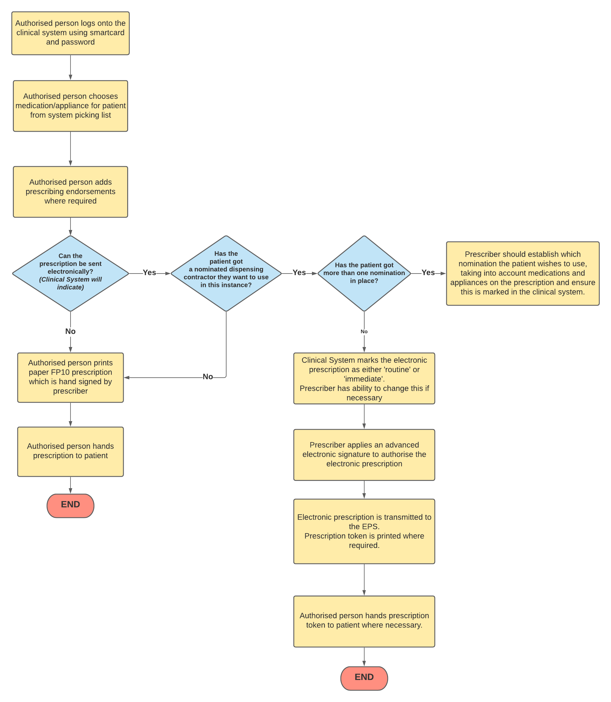
2. Production/ Authorisation
Production
- This will usually be the responsibility of the receptionist.
- Computer generated repeat prescriptions are good practice in that handwritten forms are prone to error.
- A compliance check is preferable at this stage and the computer should normally alert the user if medication appears to be over or under used. Particular attention should be paid to ‘as required’ drugs and if problems are suspected the doctor or clinical pharmacist should be alerted, preferably before the prescription is produced.
- Practices should not supply further repeat prescriptions at shorter time intervals than have been authorised without agreeing the reason for the early request, e.g. holiday.
- Provided there appears to be no problem, a prescription can be generated and left for the doctor to authorise and sign, with the notes to hand (computerised or manual) as far as practically possible, to cross check the validity and appropriateness of the request. Situations where notes should always be available include:

1. Where the request slip indicates that a review is necessary
2. Where any drug requested by the patient is not on their repeat record
3. Where any of the following drugs are requested:
- Temazepam
- Diazepam (Valium )
- Dihydrocodeine
- Paracetamol and codeine 500/30 preparations, e.g. Solpadol, Tylex
- PPI
- All controlled drugs
4. Where the item requested has been issued less than one month previously.
5. Any request about which the practice staff are concerned or uncertain.

- Where additions or corrections are made the doctor signing the prescription should initial or countersign against them. A record should be made of any subsequent handwritten alterations to computer-generated prescriptions.
- Blank prescriptions should never be signed by a doctor for later completion by him/herself or a delegate. To do so is in breach of terms of service.
- Unused space should be cancelled out under the last drug by a computerised mechanism or by the doctor deleting the space manually.
- All repeat prescriptions issued should be recorded on the computer.
- Practices should store prescriptions awaiting collection in a secure way and have a standard time limit for collection of repeat medication (e.g. 4 weeks) after which those not collected should be investigated, e.g. no longer required or medication underused etc.
- It may be that patients need their medication to be placed in blister packs of 7 days. This is usually appropriate for elderly patients and those that have serious difficulties managing their medication. A request should be put in to the surgery by either the chemist, district nurse or support worker and this should be passes to a GP or clinical pharmacist/ pharmacy technician for approval. It is then usual to produce these prescriptions in 7 day dosages and 4 can be issued at any one time. Care must be given if a medication is switched part way through a prescription that the dossette boxes are also changed.
3. Clinical Control/ Review
- This is solely the responsibility of the doctor, although the nurse can review certain patients on behalf of the doctor, e.g.: contraception and asthma although patients may not necessarily have to be seen by the doctor. The review date is set on the computer for every 6 months. For those patients who need annual review, e.g. chronic stable conditions, reviewing them in their birthday month may serve to remind patients of their obligation to attend for review.
- The practice clinical pharmacist can also carry out a medication review and make recommendations to be actioned by the doctor.
- A 28-day supply of 28 days will be given. A few patients being given three month’s supply, e.g. Oral contraceptives, HRT.
- When patients are on several regular long-term medications, quantities should be prescribed to synchronise repeat intervals. In the UK patient packs are in multiples of 28 days (rather than 30)
- When patients are discharged from hospital, their regular medication may have changed. This is a particularly vulnerable time for errors to occur and ideally the doctor should amend the repeat record personally. A check of prescriptions not yet collected should also be made to ensure that it contains the correct medication.
The following considerations should be kept in mind by the doctor when carrying out medication review consultations:
- Control of the condition - is this optimal?
- Unnecessary medication - can anything be stopped?
- Compliance - Is the patient taking the medication properly?
Could the regimen be simplified?
Is there a problem with unwanted adverse effects?
Check understanding of medication?
- Monitoring - is this required, e.g. phenytoin levels, INR, TFTs, LFTs, U&Es
- Cost considerations - change to generics if appropriate, or consider change to a more cost-effective treatment (consider CCG/NEL formulary)

- DMARDS – including azathioprine, Mycophenolate, Ciclosporin, Methotrexate. These should be prescribed after initiation by a consultant and can only be prescribed if the FBC, LFT, U+E creat and CRP have been checked and are normal as per the shared care protocol and no more than within the last 8 weeks.

- Warfarin- This can only be prescribed if the patient INR book is up to date and the copy must be shown to the prescribing GP showing the dose, INR value, last inr test and next due date. This must be after the date of the request.
4. Management control
This would largely be the responsibility of the practice manager.
Practice staff that write, or are involved in the preparation of, repeat prescriptions should be appropriately trained in the practice protocols for repeat prescribing, what their responsibilities are, and the need for accuracy. This should be on going, but is particularly important for new staff.
Liaison with local community pharmacists is essential if procedures are changed that may ultimately impact on them.
An adequate system for the secure storage and use of printed FP10s should be in place.
The practice computer system holding the prescribing records must be backed-up regularly.
Periodic audit of repeat prescribing will be carried out annually.
Setting up a repeat prescription including repeat dispensing.

- The medication to be included on a repeat prescription should be agreed between GP and patient.
- The importance of the need for regular review of repeat medication should be stressed to the patient.
- It is the responsibility of the patient’s GP to ensure that an accurate up-to-date record of a patient’s repeat medication is held in their computer records and that all prescriptions are indicated / linked to a condition.
- Repeat medication prescriptions should last for an agreed length of time, usually 6-12 months, before medication should be reviewed (although this period can be extended if felt appropriate at the discretion of the prescribing GP).
- Provide patients with details of the system operation at an appropriate time (on registration with the practice, on commencing a repeat prescription). Posters detailing the operation of the system should be displayed around the practice.

Operation of the system

The practice staff are responsible for the day to day running of the system. This should include:

- The reception staff have being given responsibility for the daily collection and processing of all repeat prescription requests.

- When preparing a repeat prescription, practice clinicians can make brand to generic name switches as appropriate (see attached list of those medications which should only be prescribed by brand name).

- Routine reauthorisation of repeat prescriptions is the responsibility of the Doctor. If items requested have expired and need reauthorisation the patient is required to attend a medication review, unless housebound. If housebound, the GP is then responsible for deciding whether to automatically re-authorise the repeat prescription or to provide a home visit.

When to refer the prescription back to the doctor or clinical pharmacist

- If anything is unclear with a repeat prescription request refer back to the prescribing GP or clinical pharmacist.
- If a patient requests an item which is not included or differs from the details recorded in their records, they should be referred to the GP or clinical pharmacist.
- If a patient under or over orders items on their repeat prescription indicating poor compliance, this should be highlighted with the GP or clinical pharmacist.

Monitoring of repeat prescribing

Ideally a GP or clinical pharmacist should carry out a medication review when:

- A block of repeat medication comes to an end.
- Patients attend for monitoring of the condition requiring repeat treatment.
- Opportunistically should a patient attend with another complaint.

The review should consist of an assessment of the patient’s condition and compliance with prescribed medication. If any repeat medications are no longer being requested, an attempt should be made to ascertain the reason why and appropriate action taken.

Resources:

Prescribing in General Practice - BMA

Good practice in prescribing and managing medicines and devices - GMC

eRD Practice Checklist and PDSA Cycle – Wessex AHSN

Repeat Prescribing Flowchart

Following agreement between patient and doctor to commence medication on a repeat prescription:
Set up appropriate details in patients medication records. Give patient details of the system’s operation

Patient puts request in at practice for repeat medication

Request collected by appropriate member of staff for processing

Does prescription request require clarification or reauthorisation before it can be processed any further?

Yes
Arrange medication review with GP or refer to GP for necessary home visit
No

Is it appropriate to make any brand name to generic name switches?

Yes

Make changes as necessary
No

Process prescription request
Pass to doctor for signing

Appendix A – Patient Synchronisation Form

Dear patient:

Synchronising your repeat medicines

We notice that on your last request for medication you asked for some and not all of your regular items. We would like to arrange that the renewal of all your medicines happens at the same time - this will have advantages for you, as you will be able to pick up all your medicines together, reducing the number of times you have to order / collect your medication.

To achieve this we will issue a single synchronising prescription. To help us with this synchronisation please complete the form below and hand it in the next time you order your repeat prescription. When you next collect your medicines you will receive different quantities of each to bring them in line. In the future you should be able to order all your regular items together – there will be a couple of exceptions, where the dose of medication varies i.e., painkillers, insulin.

If you have any questions or queries then please speak to one of the reception staff.

Please complete the first three columns of the table, following the first example:

Name of  medication | How do you  take the medication | How many  tablets do you have left | PRACTICE  1 MONTH  SUPPLY = | USE ONLY  Supply for synchronisation  prescription
EXAMPLE  Aspirin 75mg | One daily | 7

