|  |  |  |
| --- | --- | --- |
| **CHAPTER 1: INTRODUCTION** | | |
| 1.1 |  | Introduction about the company |
| 1.2 |  | Project Overview |
| 1.3 |  | Problem Statement |
| 1.4 |  | Proposed Solution |
| 1.5 |  | Deliverable |

**1.1 Introduction about the Company:**

**Aam Aadmi Party** (**AAP**) is an Indian political party, formally launched on 26 November 2012, and is currently the ruling party of the National Capital Territory of Delhi. The party made its electoral debut in the 2013 Delhi Legislative Assembly election, where it emerged as the second-largest party, winning 28 of the 70 seats.

The AAP changed the face of Indian politics giving hope to the common man of becoming a game changer. Leading the party, Arvind Kejriwal transformed into a quintessential ‘Aam Aadmi’ fighting for the common man’s cause. Sending shock-waves across political circuits, the AAP emerged as a force to reckon with, after winning 28 of the 70 seats in the 2013 Delhi Assembly Elections and formed its government with outside support from the Indian National Congress (INC). On 28 December 2013, party founder Arvind Kejriwal was sworn-in as the Chief Minister of New Delhi.

* **Vision**

We want to create a system where the political leaders we elect and place in the Parliament are directly responsible to the voters who elected them. Our party's vision is to realize the dream of SWARAJ that Gandhiji had envisaged for a free India - where the power of governance and rights of democracy will be in the hands of the people of India.

* **Mission**

The mission of the AAP is to attain optimal physical, mental, and social health and well-being for all infants, children, adolescents, and young adults. To accomplish this mission, the AAP shall support the professional needs of its members.

#### Voters’ Assessment: An Overview

Voters’ assessment overview explains how data can be used from a pdf file to extract and transform it in such a way that it becomes meaningful for the client to understand and form decisions based upon it.

* **Faster, better, advanced analytics**

Faster, better, secure and advanced analytics for AAP to help them identify the voter’s character and they can have visualized data for understanding the pattern and losses which helps them for making valuable policy decisions.

* **Machine Learning**

Advance feature of machine learning like supervised learning in which classification algorithm is used for classifying Hindu or non-Hindu. Algorithms can be used to find swingable voters.

* **Voters’ analysis**

Voters’ in the different age group has been identified using the frequentist approach, by which swingable voters have been identified in every age group which might help the client for their policy-making purposes.

* 1. **Problem Statement: -**

The work of the party is to make policies for those who don’t get certain facilities in the society. The facilities could be provided after knowing such voters. Party needs the help of the analysts to give them the analysis report so that the party can make policies and at the same time gain public support.

In this age, we can see that the voters have been changing on the basis of where the crowd is going and also based upon the religion. The party is majorly focusing on making policies so that voters could have a better life and live their life easier than before.

The voters are increasing and it has been seen that the population of voters is increasing with every election. So, every party is focusing on the votes as they play a major role in our society. Every party wants to gather as many votes as possible. So, they generally target certain age groups of voters.

Our problem here is that the party also wants to focus on the voters in the certain age group as well as religion based but didn’t know which age group to target so that maximum votes can be gathered from that age group and also to make policy.

Also, which religion to target is also a main concern for the party. So, the party needs to gather knowledge about all the problem mentioned above and take the action accordingly.

#### Proposed Solution: -

The main objective of building any machine learning model is to accumulate data in it so that the data can be used for training and testing of a model. It allows us to predict the number of swingable voters. Party can analyze the data as they occur and make policies accordingly.

Aam Aadmi Party can devise policies for the betterment of voters.

However, there are also subtle and hidden events in user behavior that may not be evident. Machine learning allows for creating algorithms that process large datasets with many variables and help find as much about a voter and about his/her family. Strength of machine learning systems compared to rule-based ones is faster data processing and less manual work. For example, smart algorithms fit well with behavior analytics for helping reduce the number of verification steps.

The Voter’s Assessment Model includes the following:

* Extraction of Data from ceo.delhi.gov.in.
* Cleaning and building a Matrix of data Extracted.
* Applying Algorithms to solve the problem.
* Visualization of data for better understanding.

This dissertation should act as an input to the technical designs required to support the functionality and to the test scenarios by which the accuracy and performance of the system will be judged.

This document will specify an analytics and detection process and how this data can be used to measure the accuracy of the model and visual representation of a data.

#### Deliverables: -

##### Table 1.1: System Deliverables

|  |  |  |
| --- | --- | --- |
| **S. No.** | **Phase** | **Deliverables** |
| **1.** | Requirement Analysis | Use Case |
| **2.** | Design | Data Flow Diagrams, Activity Diagram, Sequence Diagram |
| **3.** | Model Development | A Framework for Data Analysis |
| **4.** | Implementation | Graphs and Charts for Data Interpretation and Policy Planning |

|  |  |  |
| --- | --- | --- |
| **CHAPTER 2: PROJECT DESCRIPTION** | | |
| 2.1 |  | Tools and Techniques used |
|  | 2.1.1 | Hardware Specifications |
|  | 2.1.2 | Software Specifications |
| 2.2 |  | Proposed Model |
|  |  |  |

* 1. **Tools and Techniques used**

**ETL** stands for **Extract, Transform & Load**. Python provides various libraries like OpenCV, tesseract, etc. which helps in extraction as well as cleaning and loading the data much easier. Machine Learning allows us to make algorithms to the trained model which is further used to create a system for prediction. Machine learning allows for creating algorithms that process large datasets with many variables and help find these hidden correlations between user behavior and the likelihood of fraudulent actions. Strength of machine learning systems compared to other methodology is faster data processing and less manual work.

The main goal of **Extracting** is to off-load the data from the storage systems as fast as possible and as less cumbersome for these source systems, its development team and its end-users as possible. This implies that the type of source system and its characteristics are multiple instances, old Storage Data, archives, fixed & variable external data, and spreadsheets - should be taken into account as much as possible.

**Transform & Loading** the data is about to make changes or perform cleansing in data to better result because it might be possible there are some columns in which data is either missing or inconsistent which make a great effect on the analysis result. Sometimes we need to add new columns or rows for better sample data to increase the accuracy of the analysis. Even we need sometimes changes in metadata.

**Data profiling** is the process of examining the data available from an existing information source and collecting statistics or informative summaries about that data.

**Data analysis** is a process of inspecting, cleansing, transforming, and modeling data with the goal of discovering useful information, informing conclusions, and supporting decision-making.

**2.1.1 Hardware Specifications**

##### H/W Requirement-

* Microsoft Windows 7 or newer (32-bit and 64-bit).
* Intel Core i3 processor or newer.
* 4 GB memory.
* 50 GB minimum free disk space.
* 1366 x 768 screen resolution or higher.

**2.1.2 Software Specifications**

**S/W Requirement-**

* **Python 3.7**: Python is an interpreted, high-level, general-purpose programming language. Created by Guido van Rossum and first released in 1991, Python's design philosophy emphasizes code readability with its notable use of significant whitespace. Its language constructs and object-oriented approach aims to help programmers write clear, logical code for small and large-scale projects.
* **Libraries:**
* **Numpy 1.16.2:** NumPy is a library for the Python programming language, adding support for large, multi-dimensional arrays and matrices, along with a large collection of high-level mathematical functions to operate on these arrays.
* **Matplotlib 3.0.3:** Matplotlib is a plotting library for the Python programming language and its numerical mathematics extension NumPy.
* **Seaborn 0.9.0:** Seaborn is a Python data visualization library based on matplotlib. It provides a high-level interface for drawing attractive and informative statistical graphics.
* **Scikit-learn 0.20.3:** Scikit-learn (formerly scikits.learn) is a free software machine learning library for the Python programming language.
* **OpenCV 3.4.5:** OpenCV (Open source computer vision) is a library of programming functions mainly aimed at real-time computer vision.
* **Python-tesseract 3.05.02:** Python-tesseract is an optical character recognition (OCR) tool for python. That is, it will recognize and “read” the text embedded in images. Python-tesseract is a wrapper for Google's Tesseract-OCR Engine
* **Jupyter notebook:** The Jupyter Notebook is an open-source web application that allows you to create and share documents that contain live code, equations, visualizations, and narrative text.
* **Anaconda 2018.12:** Anaconda is a free and open-source[5] distribution of the Python and R programming languages for scientific computing (data science, machine learning applications, large-scale data processing, predictive analytics, etc.), that aims to simplify package management and deployment.
* **Microsoft Excel 2016:** Microsoft Excel is a spreadsheet program included in the Microsoft Office suite of applications. Spreadsheets present tables of values arranged in rows and columns that can be manipulated mathematically using both basic and complex arithmetic operations and functions.
  1. **Proposed Model:**

A framework is proposed for the analysis of voters’ data. In this framework, many steps are involved (Figure 2.1), starting from data collection to producing final results. Figure 2.1 presents a step by step procedure to perform analysis using the Frequentist approach. The whole framework presents a novel idea to perform analysis using Python Language. In this framework. This shows a more pictorial vision to the users. A brief description of the methodological steps is given below.

1. **Data Collection:** Data collection is the process of gathering and measuring information on variables of interest, in an established systematic fashion that enables one to answer stated research questions, test hypotheses, and evaluate outcomes.
2. **Data Cleaning:** Data cleansing or data cleaning is the process of detecting and correcting corrupt or inaccurate records from a record set, table, or database and refers to identifying incomplete, incorrect, inaccurate or irrelevant parts of the data and then replacing, modifying, or deleting the dirty or course data.
3. **Build Matrix:** For converting the unstructured data into structured data. Unstructured data is information that either does not have a pre-defined data model or is not organized in a pre-defined manner. Unstructured information is typically text-heavy but may contain data such as dates, numbers, and facts as well. Structured data has the advantage of being easily entered, stored, queried and analyzed. At one time, because of the high cost and performance limitations of storage, memory, and processing, relational database, and spreadsheets using structured data were the only way to effectively manage data. Anything that couldn't fit into a tightly organized structure would have to be stored on paper in a filing cabinet.

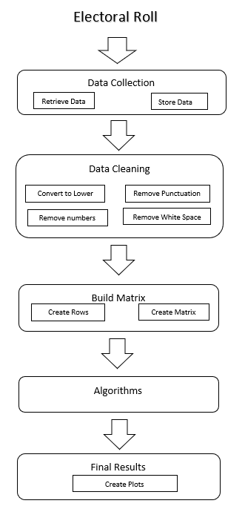

**Figure 2.1: Framework**

1. **Algorithms:** An algorithm is a step by step method of solving a problem. It is commonly used for data processing, calculation, and other related computer and mathematical operations. An algorithm is also used to manipulate data in various ways, such as inserting a new data item, searching for a particular item or sorting an item.
2. **Results:** Results include various plots. A plot is a graphical technique for representing a data set, usually as a graph showing the relationship between two or more variables. The plot can be drawn by hand or by a mechanical or electronic plotter. Graphs are a visual representation of the relationship between variables, which are very useful for humans who can then quickly derive an understanding which may not have come from lists of values. Graphs can also be used to read off the value of an unknown variable plotted as a function of a known one. Graphs of functions are used in mathematics, sciences, engineering, technology, finance, and other areas.

|  |  |  |
| --- | --- | --- |
| **CHAPTER 3: IMPLEMENTATION** | | |
| 3.1 |  | Model Implementation |
|  | 3.1.1 | Algorithm for Extraction |
|  | 3.1.2 | Algorithm for Frequentist Approach |
|  | 3.1.3 | Algorithm for Migrant Analysis |
|  |  |  |

The Model discussed in Chapter 2, is utilized for Voter’s Assessment in Delhi.

A step by step implementation discussed below.

1. **Data collection**

Data collection is the process of gathering and measuring information on variables of interest, in an established systematic fashion that enables one to answer stated research questions, test hypotheses, and evaluate outcomes.

Below are the steps involved during the collection of Data.

1. PDF to IMAGE

The first part of Data collection is to convert the image from pdf to use those images for extraction as OCR can’t directly work on pdf.

II. REGION HIGHLIGHTING

Region was highlighted based upon the algorithm used for extraction as shown in figure 2.3, Pixels were used from the left-top to right-down pixel of the box to mark the single box of every page in an electoral roll then used pixels to jump from one box to another and cover up all the boxes in a single page using loops.

III. PROPOSED SYSTEM

The proposed system consists of 4 steps:

* Localization of Electoral roll: An image captured by a camera has 3 channels (R, G, B) which corresponds to the Red, Green, and Blue intensity values, thus having 3 values per pixel. The image is converted to Grayscale image having one value per pixel followed by localization using Region highlighting which is used to highlight the Electoral roll.
* Image Processing: The obtained image is then threshold to obtain a black and white image. This image is then searched for all possible contours in it.
* Area Filtering: Area filtering is done to remove the random noises followed by Gaussian blurring to smoothen out the curves.
* PyTesseract: The image at this stage is then passed into an Optical Character Recognition tool (PyTesseract) which provides the text output of the printed characters.

The overview of the working algorithm has been shown below.

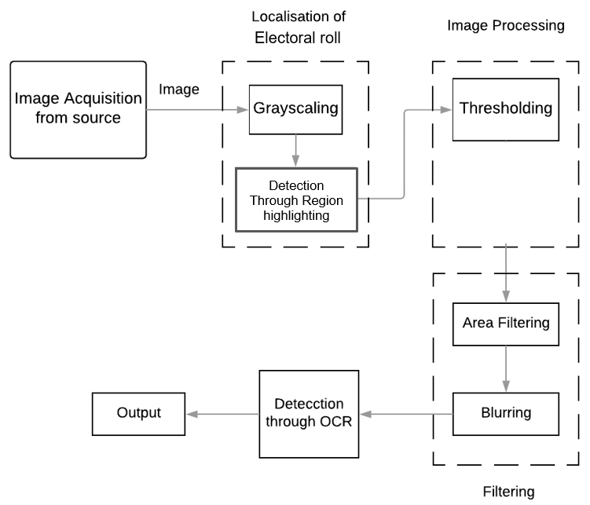

**Fig. 3.1 Algorithm for Extraction**

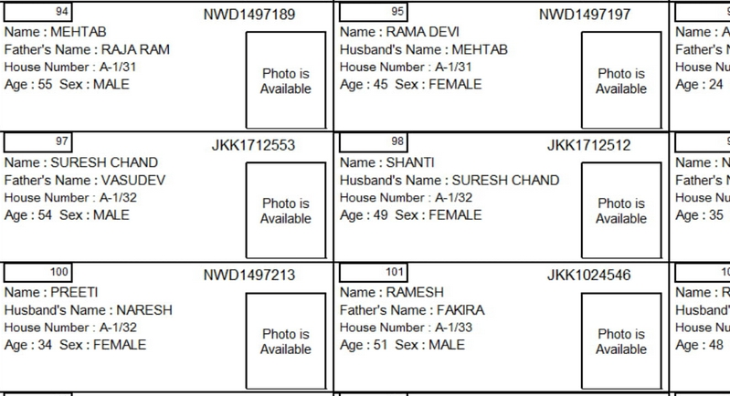

**Figure 3.2 Electoral roll**

1. **Localization of Electoral Roll**
2. **Gray-scaling**: The image obtained through the camera would be in RGB color space where each pixel has an array of three values. Operating on RGB color space is CPU extensive because of the need to take care of three values simultaneously. Gray-scaling the sample image at this point would produce a grayscale image in which each pixel has a single value. Further, the image has to be passed to the thresholding function which accepts only grayscale images.
3. **Region Highlighting**: Region highlighting includes highlighting only the region of interest which makes extraction much simpler. A sample image produced after this step has been shown.

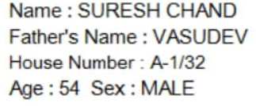

**Figure 3.3 Part of an image**

1. **Image processing**
2. **Thresholding**: This function accepts only grayscale images and provides an output where each pixel value has been mapped to either zero or 255, depending on two parameters – the current pixel value and the threshold limit. Any pixel having a value less than the decided limit would be mapped to zero (black) and any pixel having a value greater than the limit would be mapped to 255 (white). Although a lot of different and advanced thresholding techniques are available in OpenCV global thresholding yields satisfactory result.

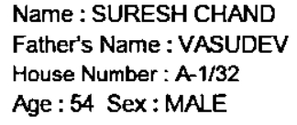

**Figure 3.4 After thresholding**

**C. Filtering**

1) **Area filtering:** If an Electoral roll is observed, there will be some random noises. To overcome this, the algorithm finds the sum total values of the area of all the contours and divides it by the number of contours, which will give the value of the average area. It is observed that such noises contain about 5% of the total area while the characters of interest contain up to 95% of the average area. Thus, we can easily filter out such random noises.

2) **Blurring**: Edges have a high-frequency content due to rapid changes of pixel values around them. This results in a coarse image which hinders the OCR process. So, using a low pass filter to smoothen out the coarse image proves to be easier to operate on the image for the next process. Blurring the image at this stage smoothens out the edges of characters. Although a lot of blurring techniques are available, Gaussian blurring produces the best results. The resultant image at this stage has been shown.

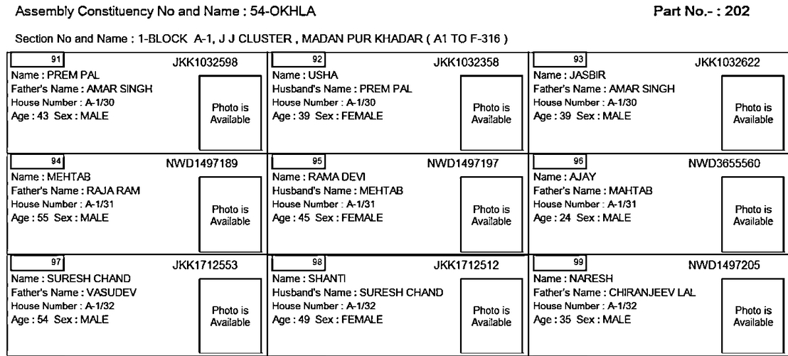**Figure 3.5 Before applying by tesseract**

**D. PyTesseract**

1) **OCR**: This is the final stage of this system where PyTesseract is used which is basically an OCR tool for python. PyTesseract segments the Electoral roll into individual characters by analyzing the change in pixel values while traversing horizontally.

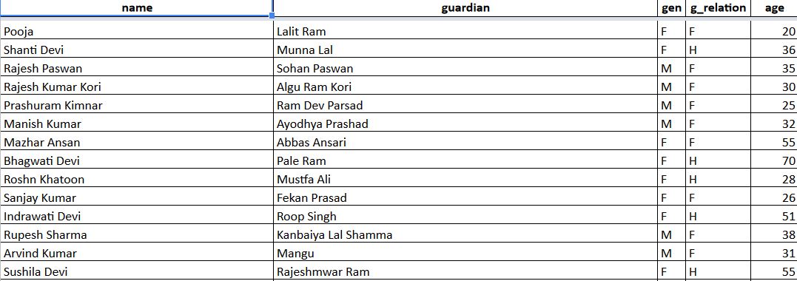

**Figure 3.6 After extraction and combining the data**

1. **Data cleaning**

This procedure is accomplished to produce the final and ready data for analysis. This procedure follows some steps: Convert to lower, Remove Punctuations, Remove Numbers and Remove whitespaces.

* Convert to lower: In this step, all the words are converted into upper to lower like “Great” to “great”
* Remove punctuations: various punctuations like: {(), [], :, _, “”, ?, |, \, <<, ;,&, %, #, @, &, ^}
* These are used in the details given. It is to be required to remove all these punctuations to achieve pure analysis.
* Remove numbers: The numbers that are available in the middle, before or after produce smut. So, it has to be removed.
* Remove whitespaces: Every sentence has whitespace after each word that should also require removed from the sentence.

1. **Build Matrix**

For converting the unstructured data into structured data, Pandas is used. The process of cleaning the data was performed and all the noise are removed. But before applying the technique of analysis, the data should be organized into Rows and Columns. Pandas is a library in the Python language that groups all the elements of data together and organizes them in a Two-Dimensional rectangular structure. Table II represents the organization of data in Two-Dimensional matrix. In this matrix, 0 and 1 show the frequency of words in a sentence.

**Table 3.1 Building the data matrix**

|  |  |  |  |  |  |  |  |  |
| --- | --- | --- | --- | --- | --- | --- | --- | --- |
| **Part Number** | **SrNo** | **EPIC ID** | **Name** | **Gender** | **Age** | **Guardian Name** | **Relationship** | **Address** |
| AC0230001 | 1 | RJN0429449 | Sandeep Gupta | Male | 44 | Jaibhagwan Gupta | Father’s | 3 |
| AC0230001 | 2 | RJN0429464 | Anju Gupta | Female | 43 | Sandeep Gupta | Husband’s | 3 |
| AC0230001 | 3 | RJN0429472 | Rajnish Gupta | Male | 42 | Jaibhagwan Gupta | Father’s | 3 |
| AC0230001 | 4 | RJN0429480 | Nisha Gupta | Female | 40 | Rajnish Gupta | Husband’s | 3 |
| AC0230001 | 5 | RJN1972669 | Parinita Gupta | Female | 20 | Sandeep Gupta | Father’s | 3 |
| AC0230001 | 6 | RJN1934909 | Tanushree Hazra | Female | 33 | Anand Kumar Hazra | Father’s | 5-A/11005 |

1. **Algorithms**

Mathematical formulas or models called algorithms may be applied to the data to identify relationships among the variables, such as correlation or causation. In general terms, models may be developed to evaluate a particular variable in the data based on other variables in the data, with some residual error depending on model accuracy (i.e., Data = Model + Error).

Inferential statistics includes techniques to measure relationships between particular variables. For example, regression analysis may be used to model whether a change in advertising (independent variable X) explains the variation in sales (dependent variable Y). In mathematical terms, Y (sales) is a function of X (advertising). It may be described as Y = aX + b + error, where the model is designed such that a and b minimize the error when the model predicts Y for a given range of values of X. Analysts may attempt to build models that are descriptive of the data to simplify analysis and communicate results.

* Algorithm during Extraction: Crop part of image rectangularly and extract the text of the image. Additionally, extract the same data 30 times. Knowing that they have equal distance, So, will hop one by one until reaching the end of the page. Do that for every feature being extracting. Notice that in below image that the size of the box was extended to the max on right, that is because the length of the name may vary.

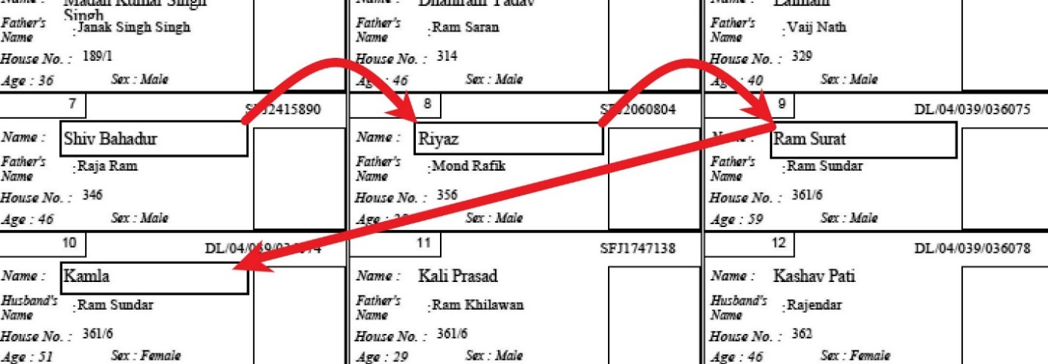

**Figure 3.7 Algorithm during extraction**

* Frequentist Approach: It uses an effective way to calculate Combined frequency using the Frequency of multiple tables or data.
  + - 1. **Algorithm for Frequentist Approach:**

Frequentist inference is a type of statistical inference that draws conclusions from sample data by emphasizing the frequency or proportion of the data. An alternative name is frequentist statistics. This is the inference framework in which the well-established methodologies of statistical hypothesis testing and confidence intervals are based. Other than frequentist inference, the main alternative approach to statistical inference is Bayesian inference, while another is fiducial inference.

Frequentist inference has been associated with the frequentist interpretation of probability, specifically that any given experiment can be considered as one of an infinite sequence of possible repetitions of the same experiment, each capable of producing statistically independent results. In this view, the frequentist inference approach to drawing conclusions from data is effectively to require that the correct conclusion should be drawn with a given (high) probability, among this notional set of repetitions. However, exactly the same procedures can be developed under a subtly different formulation. This is one where a pre-experiment point of view is taken. It can be argued that the design of an experiment should include, before undertaking the experiment, decisions about exactly what steps will be taken to reach a conclusion from the data yet to be obtained. These steps can be specified by the scientist so that there is a high probability of reaching a correct decision where, in this case, the probability relates to a yet to occur set of random events and hence does not rely on the frequency interpretation of probability. This formulation has been discussed by Neyman, among others.

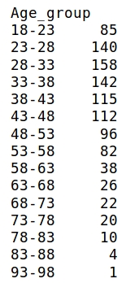 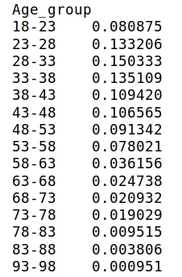

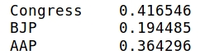

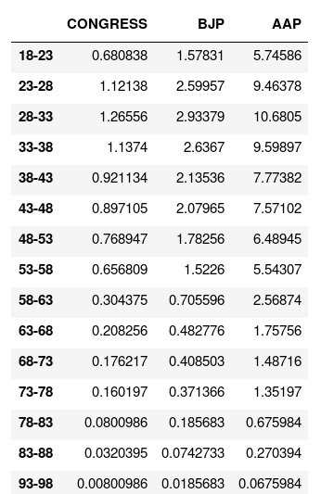

* + - 1. **Algorithm for Migrant analysis:**
* The migrants have been found using an algorithm on the basis of the median.
* The median Epic ID was found of every age group.
* The median of different age groups was compared in ascending order.
* If an exception occurs i.e. if there is an epic id which is bigger than previous it was assigned as a migrant

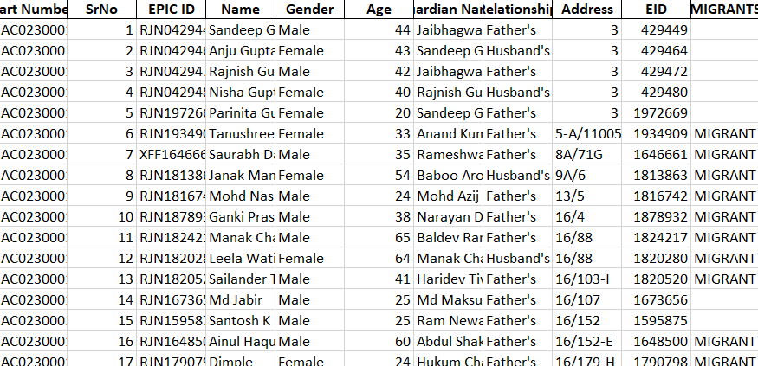

**Figure 3.8 Migrant Analysis**

|  |  |  |
| --- | --- | --- |
| **CHAPTER 4: RESULTS & INTERPRETATION** | | |
| 4.1 |  | Results |
|  | 4.1.1 | FrequeFreqentist Approach |
|  | 4.1.2 | Family Analysis |
|  |  |  |
|  |  |  |

**Results**

The utilization of developed Model in Voter’s Assessment generalized following results (demonstrated in figures given below)

**Frequentist Approach**

After the whole procedure of the proposed framework is done, we achieved the results on Voter’s Assessment that were collected from Electoral role as well as Form-20 data for legislative election.

Frequentist Approach:

* Firstly, find the age group wise population through electoral roll extracted data.

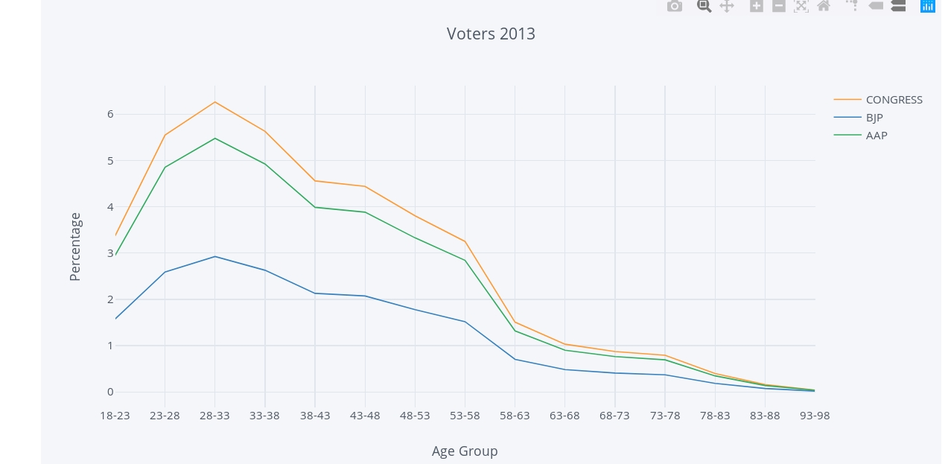

**Figure 4.1: Voters 2013**

Then, using form 20 data find the likelihood of major political parties to come up with the likelihood of different age group voting for different parties. Below, are the results: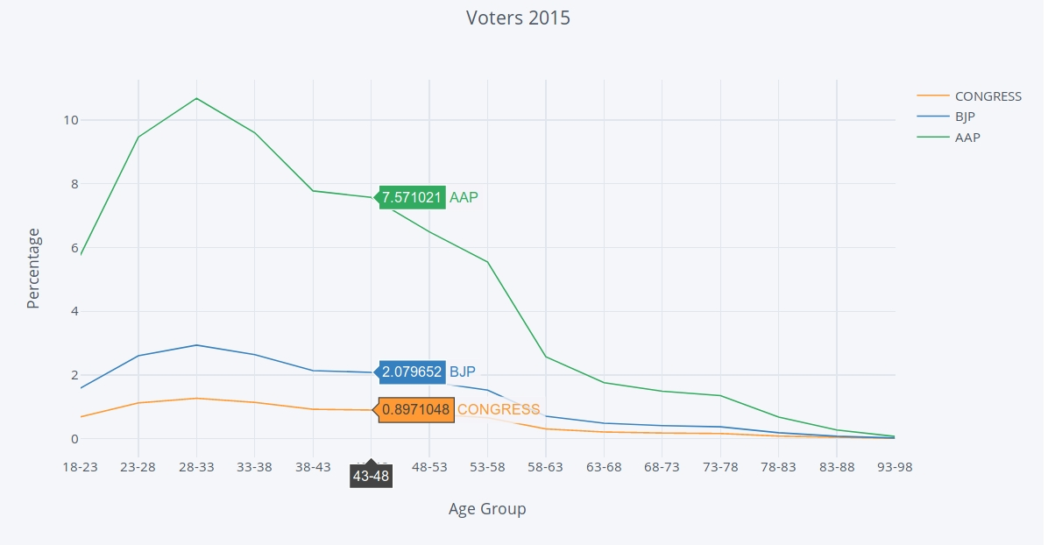

**Figure 4.2: Voters 2015**

* In the results above there is quite a range of swingable voters, in almost every age group which tends to shift towards AAP from The INC in 2015 compared to 2013.
* There is a majorly three age group in which the most swingable voters can be found e.g., 18-23, 23-28, 28-33, 33-38.
* From the above charts, we can see that the main age group which shifted from the INC to AAP is 28-33 and this group covers the youth so, further inference can be found youth can easily be manipulated.
  + 1. **Family Analysis:**

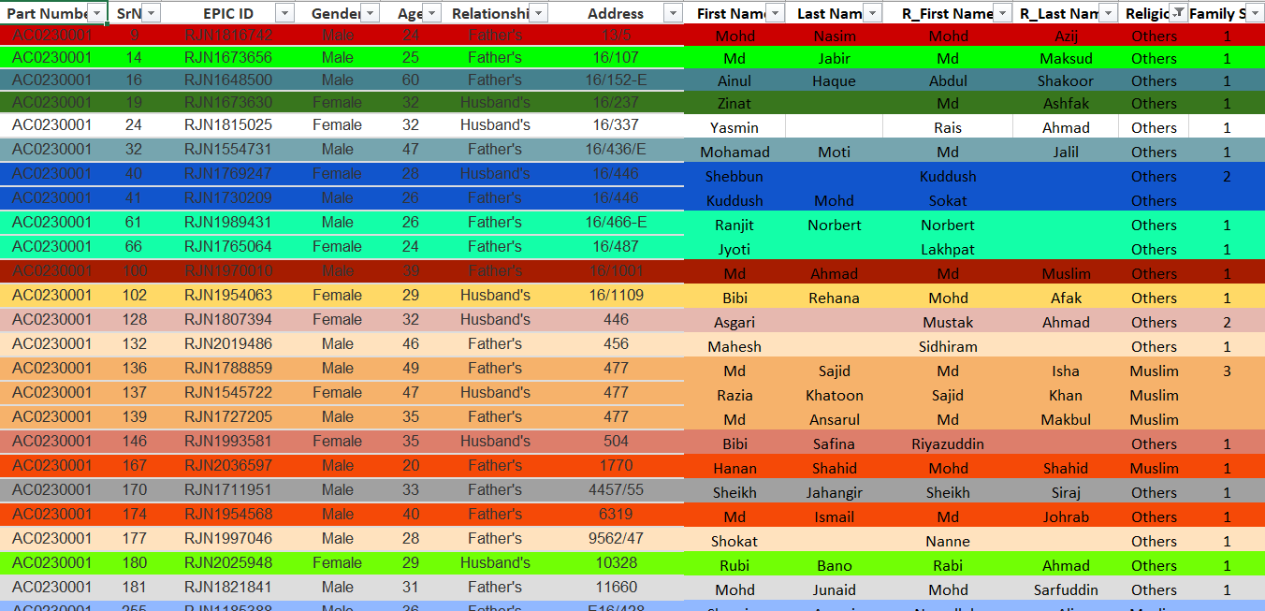

**Figure 4.3: Family distribution**

* Families have been distinguished on the basis of address.
* Each family is represented by a different color.
* After doing the analysis, the head of the family was found.

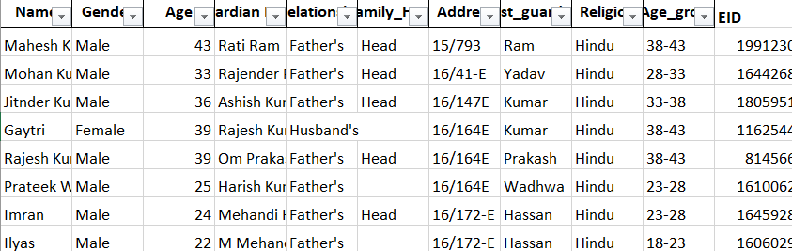

**Figure 4.4: Family head**

Family head and religion have been assigned using their age:

* A simple algorithm is used by finding the maximum age in the family and assigned that person as the head of the family.
* Religion can be identified using voters last name so the last name was separated from the full name and then used surname database created by the team to find the religion.

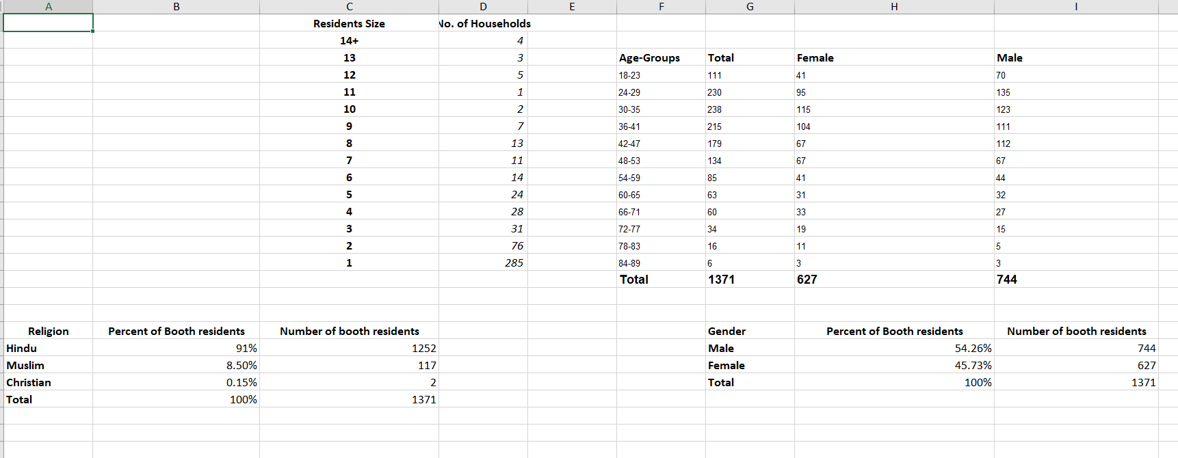

**Figure 4.5: Overview**

Above shown is the final results:

As it is shown there is more than 90% Hindu in this area.

* Also, the Resident size and number of households corresponding to the resident size were shown.
* Male and female voters can be identified and this is seen that in the age groups 28-33, 33-38 females are not so far off compared to males. So, from this point, only this can be identified that the swingable voters not only consist of male but female as well and for making policies female related policy should also be made.

|  |  |  |
| --- | --- | --- |
| **CHAPTER 5: CONCLUSION AND REFERENCES** | | |
| 5.1 |  | Conclusion |
| 5.2 |  | Limitations |
| 5.3 |  | Future scope |
| 5.4 |  | References/Bibliography |

* 1. **Conclusion:**

As the list of voters was increasing day by day which creates a large volume of data, manually finding the voters with limited features was becoming difficult. The population was increasing and each area was different from another. So, we need such a system which could act smartly and find the voters on time so that we could make policies accordingly.

This system helps you to put a particular population data in a system and with the help of advance feature like machine learning, we could analyze features of that area and find target voters.

This system put your voter data in a system and with the help of advance feature like machine learning to visualize data. Advanced analytics used for a political organization to help them identify the voter trends and they could have visualized data for understanding the pattern and losses which helps them for making valuable policy-making decisions.

We attain better model whose voters’ segregation accuracy was high and model speed was fast and also reliable for data. With the help of advanced machine learning, we could automate our system and give them intelligence so they could learn from historical data and find new patterns.

#### Limitations:

* The data transfer undergoes encryption methodology that is conventionally complex and costly.
* The requirement of high processing systems and upgraded browsers capable of handling trillions of records is another issue.
* It works in a particular time-space only.

#### Future Scope:

* In the future, this project provides the best way to detect voters and target them to make policies for them.
* We can further extend this project by conducting ***inter-cluster analysis*** (between two or more different constituencies, for eg: R.K. Puram and Rajinder Nagar).
* Currently, we have only conducted ***intra-cluster analysis*** (within one constituency).
* We can predict the features of other constituencies by determining the similarity of their regions based on the affluence of that region.
* It does not replace the traditional rules-based methods but it just adds up to your existing efforts to bring you more improved results.
* Regular report generation as per the need of the client.

#### References/Bibliography:

* https://www.tutorialspoint.com/python/
* https://www.scrapehero.com/web-scraping-tutorials/
* https://www.stackoverflow.com/
* https://www.youtube.com/watch?v=mKxFfjNyj3c
* Christopher M. Bishop, “Pattern Recognition and Machine Learning”, Springer, 2006
* Jiawei Han, Micheline Kamber and Jian Pei, “Data Mining Techniques and Concepts”, Morgan Kaufmann Publishers, 3rd Ed., 2012
* Allen B. Downey, “Think Stats: Probability and Statistics for Programmers”, Green Tea Press, 2011

|  |  |  |
| --- | --- | --- |
| **ANNEXURES** | | |
| A-1 |  | Work Flow Diagram |
| A-2 |  | Use Case Diagram |
| A-3 |  | Data Flow Diagrams-Level 0 and Level 1 |
| A-4 |  | Activity Diagram |
| A-5 |  | Sequence Diagram |

#### A-1. Work Flow Diagram: -

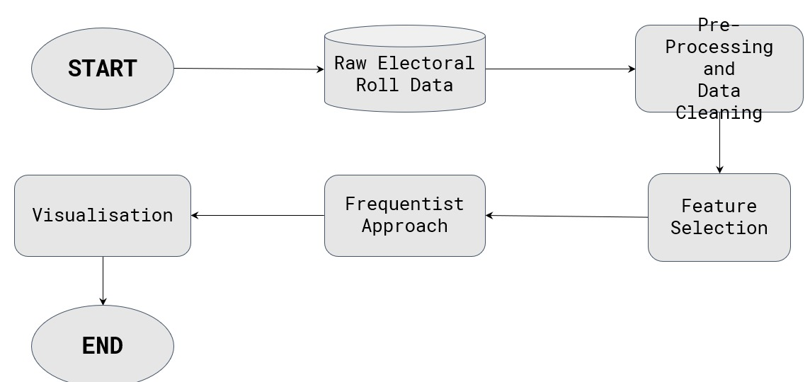

**Figure A1.1: Work Flow Diagram**

#### A-2. Use Case Diagram: -

#### 

#### Figure A1.2: Use Case Diagram for Voter’s Assessment

#### A-3. Data Flow Diagram: -

#### Data Flow Diagram Level-0:

#### Figure A1.3: DFD Level-0

#### Data Flow Diagram Level-1:

#### 

**Figure A1.4: DFD Level-1**

**A-4. Activity Diagram:-**

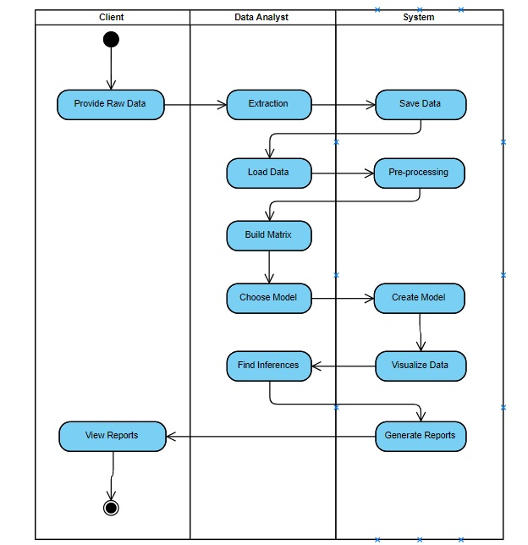

**Figure A1.5: Activity diagram**

**A-5. Sequence Diagram:-**

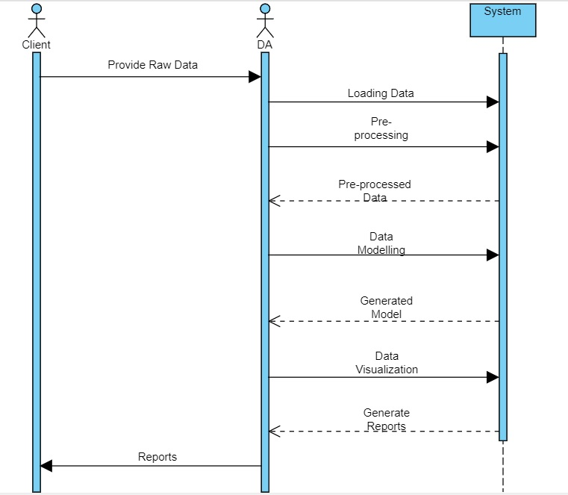

**Figure A1.6: Sequence diagram**