**Top-level middleware**

* Tool in Node
* “use\get ” keyword can be given a function:
* “app.use” an Express method which runs the passed in function on every request that comes to your server.

🡪 app.use(function(req, res, next) {

next();

})

* “next()” will invoke the next function in the chain.
* Post requests will usually hold a body sent to your server – post makes it more readable
* 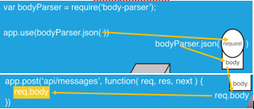Body-parser used with “app.use(bodyParser.json())”

🡪

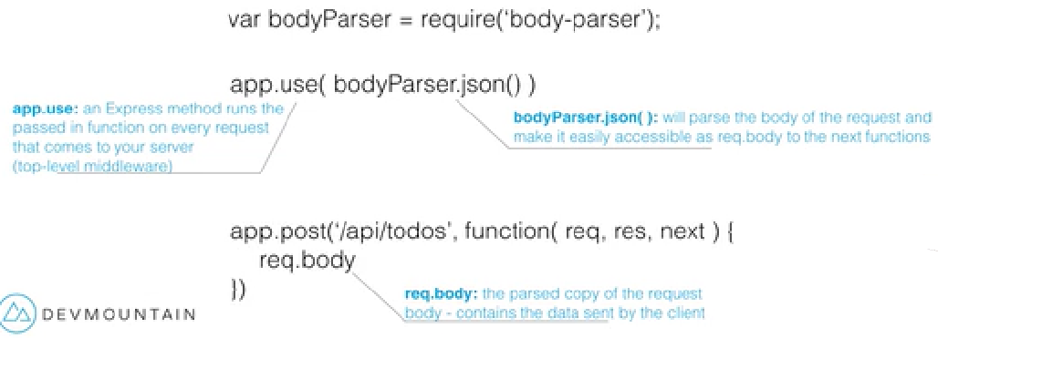

**Static Files**

* 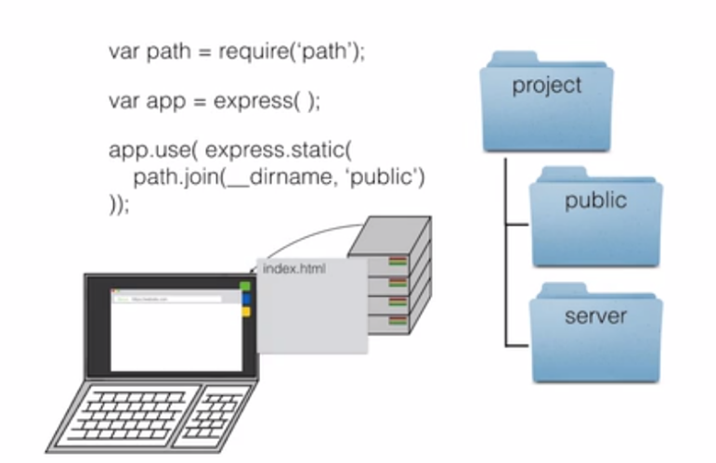Express can be used as a webserver with endpoints to send data back and forth, as well as helping to send HTML files and pictures back and forth.

