

**Milestone 2:** Analysis Deliverable

**Team Name**: The Four Great Analysts

**Table of Contents**

**Section 1: Project Description** 3

Executive Summary 3

Current Environment 3

Proposed System Objectives and Constraints 5

Expected Benefits 7

Stakeholders 8

Context Diagram 8

**Section 2: Analysis** 10

Executive Summary with Narrative and Conclusions 10

Use Case Diagram 11

Fully Detailed Use Case Specifications 12

Preliminary Non-Functional Requirements 29

# **Section 1: Project Description**

## **Executive Summary**

The Project Description contains information on the AITP current environment. It gives a brief description about AITP as well as the processes that the student organization goes through on a normal basis. Our group brainstormed and described what the proposed functional and non-functional requirements of the system will be. We then looked at all of the possible expected benefits that AITP will gain by using our proposed system.

## **Current Environment**

Association of Information Technology Professionals (AITP) is a student organization in the College of Business mainly made up of students majoring in Management Information Systems. AITP is growing as a student organization and has gone from 15 to 35 members in one semester. AITP has an executive board which currently consists of Co-President, Treasurer, Secretary, Membership Officer, Public Relations Chair, and Faculty Advisor positions. The students holding executive officer positions change on a semester basis due to students graduating, which often leads to new officers being appointed. Once new officers are appointed, they are assigned specific duties related to their position and will then gain access to the various websites where AITP stores documents.

The AITP executive board meets every Wednesday, with bi-weekly student chapter meetings consisting of guest speakers and panels, as well as bi-weekly executive board meetings which consist of planning for events and assigning tasks to various board members. The executive board typically plans the student chapter meetings two weeks in advance, and never has a set schedule for upcoming events.

If a member wants to join AITP, they manually fill out a membership form and turn it into the membership officer. The membership officer then enters all of the students data into an Excel spreadsheet with amounts that the student has paid or amount owed. The student then turns in their money to the treasurer and the treasurer then notifies the membership officer, by email or text message, that this student has paid. Membership forms are then handed to the co-president where they are kept in a binder with other important organization documents.

## **Problems observed with the current system**

**Organizational Management**

With officers constantly changing over the years documents have not been updated properly and files are stored in several different locations. Currently there are many versions of forms and outdated organization documents that still being shared with past AITP executives on all of the various websites. These websites include OrgSync, OneDrive, Dropbox, and social media pages. AITP does not have one centralized location to manage and store all up to date documents. With documents out there on various websites it is hard for the AITP executive board to stay organized and to determine which documents are most up to date.

**Membership Management**

Disorganization throughout AITP has become an issue with tracking active AITP members. Currently AITP uses a binder to store all of their membership documents. Students have to manually fill out a membership form and turn it into the membership officer, who manually enters their name onto an Excel spreadsheet. However, when students pay their membership dues, they give their money to the treasurer and the treasurer writes a note saying they paid on their membership form. There is no way for the membership officer to know that the treasurer received membership dues from a certain member unless it is marked on the membership form before it is given to the membership officer. The membership officer then has to go to the Excel spreadsheet and mark that the member has paid and then send out the Excel spreadsheet in an email to all of the Executive Board with the updated membership roster. All of the membership forms that the membership officer has entered in Excel are then given to one of the Co-Presidents and kept in a binder.

**Event Management**

AITP officers have an executive meeting every other Wednesday discussing plans for upcoming meetings and ideas for events during the semester. However, it has been difficult for AITP to plan agendas and dates for the general meetings ahead of time. Currently, AITP doesn’t have a set schedule for the semester with what each general meeting will entail as meetings are planned week to week. A major issue AITP has is reaching out to speakers about coming to speak at a meeting due to the fact that dates and rooms for meetings are never set till the last minute. This makes getting a speaker for a general meeting or coming up with ideas on what should happen at the general meeting very difficult. AITP has had to cancel general meetings in the past due to waiting till the last minute to find a speaker for the meeting.

## **Proposed System Objectives and Constraints**

**Functional:**

**Document Storage:**

The system shall store a centralized folder holding all organizational documents

The system shall organize documents by executive board position

The system shall allow updates to be made to documents

**Membership Management:**

The system shall store an updated membership roster

The system shall store an AITP alumni roster

**Report Generation:**

The system shall generate financial reports on a semester basis

The system shall generate a membership report with the following information:

* List of all club members
* Their current paymentstatus
* T-shirt purchases made by each member
* Membership expiration date

**Event Management:**

The system shall organize events and meetings within a calendar feature

The system shall allow for updates to events on the calendar to be made

The system shall store events for 12 months at a time

The system shall allow access to current month

**Assign Tasks:**

The system shall have the ability to assign tasks to users

The system shall only assign tasks to Executive Board members

System shall display a list of tasks including each task name, task description, supporting documents, and completion date

**Non-Functional**

**Availability**

The system shall be accessible 24/7 to Executive Board and Advisors

The system shall be available on multiple platforms

**Security**

The system shall allow login access to only the current Executive Board and Advisors

**Constraints**

**Time**

With the limited time given during the semester the question always stands of whether or not we will be able to finish the product in time.

**Money**

AITP has a very limited budget. A lot of the money AITP receives from the student’s membership dues go to organizing meetings to include pizza as well as planning for company tours in various cities.

## **Expected Benefits**

**Centralized Document Storage**

This system will store documents in one centralized location where users will be able to add and update documents. It will be a more effective way for the executive board to access and modify changes within documents from previous executive board terms.

**Structured Membership Management**

The system will allow all executive board members to access and modify the membership roster in order to keep up with current members more efficiently and effectively. Users will be able to keep up with all of the changes to the membership roster from year to year.

**Time-based Report Generation**

The system will allow the executive board to generate financial reports as well as membership reports for each semester. The generated reports will give the executive board the ability to view members who have paid membership dues, purchased t-shirts, and members with expiring memberships. This will help the executive keep up with all of the financials, membership data, and t-shirt allocation.

**Event Management**

The system is going to provide the executive board with a detailed schedule of meetings and events. This will help the executive board keep up with upcoming events and the scheduling of events planned for the future. They will have the ability to share information on the schedule about when speakers are scheduled to come throughout the semester and what rooms are booked for each meeting. This will allow for increased productivity when planning as well as less confusion throughout the executive board.

**Allocation of Tasks**

The system will give the Co-Presidents and Advisors the ability to distribute various tasks that need to be completed throughout the executive board officers. This will ensure that the various tasks that each officer is accountable for is being completed in a timely manner. Assigning tasks will decrease the number of emails and text messages the Co-Presidents and Advisors have to send out in order to remind each officer to complete their officer duties. Ultimately, allocating tasks will help the entire executive board stay on track with what needs to be accomplished.

## 

## **Stakeholders**

**Executive board:** Co-Presidents, Treasurer, Secretary, Membership Officer, PR Chair

**Advisors**

## /Users/ashleymoore/Desktop/Screen Shot 2017-09-26 at 9.23.18 PM.png

## **Context Diagram**

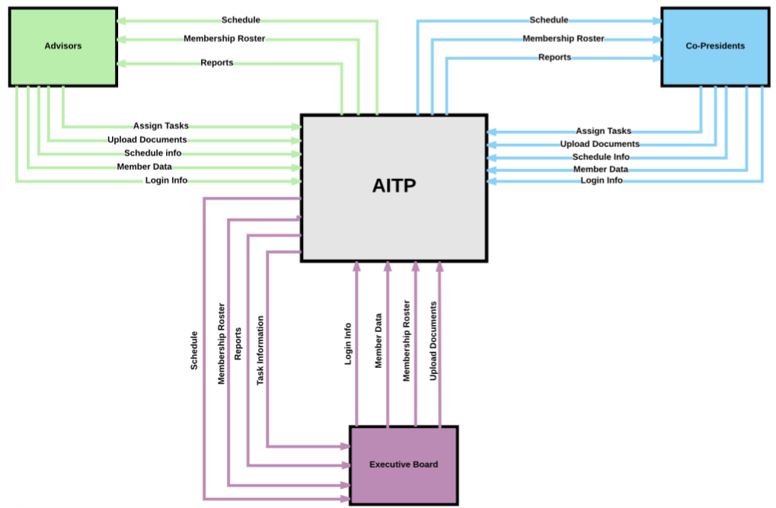

# 

# **Section 2: Analysis**

## **Executive Summary with Narrative and Conclusions**

After receiving feedback from our Milestone 1 presentation we decided as a group that it would be best to narrow the scope of our project and implement a system strictly for Executive Board and Advisor use. The system will not be used by students or members. By making this change we have removed our idea for a social engagement tool since that was a tool being developed for student use. However, we are adding a tool which will give the co-presidents and advisors the ability to assign tasks to various officers on the executive board. The Reports tool is going to be simplified by only having one membership report which will consist of member payment history, t-shirt purchases, and membership expiration dates. We believe by focusing mainly on a system for the executive board that we will be able to help increase productivity throughout the organization.

## 

## **Use Case Diagram**

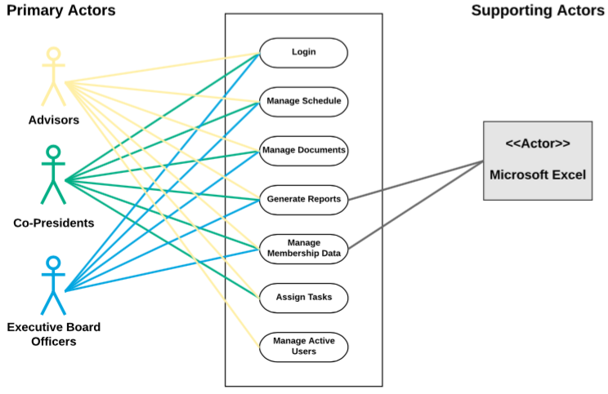

## **Fully Detailed Use Case Specifications**

**Use Case 1: Login**

|  |  |  |  |  |  |  |  |  |
| --- | --- | --- | --- | --- | --- | --- | --- | --- |
| **Use Case Name:** Login | | | **ID:** UC-1 | | | **Priority:** High | | |
| **Actor:** Advisors, Co-Presidents, Executive Board | | | | | | | | |
| **Description:** The purpose of this use case is to gain access to system once the user is verified by inputting a username and password | | | | | | | | |
| **Trigger:** User wants to gain access to the system  **Type:** External ☐ Temporal | | | | | | | | |
| **Preconditions:** User must have an account in the system, user account must have permission to access system | | | | | | | | |
| **Normal Course:**   |  | | --- | | 1. System displays login page, requesting username and password 2. User enters their username into “Username” box 3. User enters their passphrase in “Password” box 4. User selects “Login” button | |  | | | | **Information for Steps:**  ECU email address  ECU passphrase  User credentials verified | | | | | |
| **Alternative Courses:**   1. Username/passphrase not recognized    1. System displays error message notifying user that information is incorrect    2. System prompts user to re-enter username and passphrase | | | **Information for Alt. Course Steps:**  Error message | | | | | |
| **Postconditions:**  User gains access to the system | | | | | | | | |
| **Exceptions:**  Loss of network connection | | | | | | | | |
| **Summary Inputs:**  ECU email address  ECU passphrase | **Source:**  User | **Outputs:**  User authentication | | | **Destination:**  System home screen | | | |
|  |  |  |  |  | | |  |  | |

**Use Case 2: Manage Schedule**

|  |  |  |  |  |  |  |
| --- | --- | --- | --- | --- | --- | --- |
| **Use Case Name:** Manage Schedule | | | | **ID:** UC-2 | | **Priority:** High |
| **Actor:** Advisors, Co-Presidents, Executive Board | | | | | | |
| **Description:** The purpose of this use case is to allow users access to a scheduling tool that can be actively viewed and edited | | | | | | |
| **Trigger:** User wants to add, edit, or delete an event.  **Type:** External ☐ Temporal | | | | | | |
| **Preconditions:**  The user is logged into the system and has user permissions to access the schedule | | | | | | |
| **Normal Course:**   1. User selects the “Schedule” tab 2. The system displays a calendar of the current month with the option to move to upcoming months by clicking a forward arrow 3. The user selects a date on the calendar    1. System prompts user to add new event to date selected    2. User enters name of the event, start time, end time, short description of event, location    3. System prompts user to confirm event 4. The user selects a pre-existing event on the calendar    1. System displays option to edit selected event 5. User selects edit button 6. The user can edit event name, start time, end time, location or description 7. System prompts user to confirm all changes made    1. System displays option to delete selected event       1. The user selects delete button       2. System prompts user to confirm cancellation 8. System returns user to updated schedule page | | | **Information for Steps:**  Home screen displayed  Calendar  Event information  Confirm button  Calendar  Selected event  Edit button  Event Information  Confirm button  Delete button  Confirm button  Updated calendar | | | |
| **Alternative Courses:**   1. User leaves one or more of following fields blank: event name, start time, end time, location, description    1. System displays “error” message    2. System prompts user to enter information in required fields    3. User confirms information entered in required fields   2. The user tries to schedule a meeting during the same time as one already scheduled   1. System displays “error” message detailing time conflict 2. System prompts user to choose different time for new event 3. System prompts user to confirm new time for event | | | **Information for Alt. Course Steps:**  Error message  Required fields  Confirm button  Error message  Confirm button | | | |
| **Postconditions:**  The Executive board will have a detail oriented calendar keeping them updated with meetings in the future. | | | | | | |
| **Exceptions:**  Loss of network connection | | | | | | |
| **Summary Inputs:**  Event Information  Confirm Button  Edit Button  Delete Button  Selected Event | **Source:**  User | **Outputs:**  Home Screen Displayed  Calendar | | | **Destination:**  The schedule tab  Executive Board Schedule | |
|  |  |  |  |  |  |  |

**Use Case 3: Manage Documents**

|  |  |  |  |  |  |  |
| --- | --- | --- | --- | --- | --- | --- |
| **Use Case Name:** Manage Documents | | | | **ID:** UC-3 | | **Priority:** High |
| **Actor:** Advisors, Co-Presidents, Executive Board | | | | | | |
| **Description:** The purpose of this use case is to allow users the ability to manage important organizational documents | | | | | | |
| **Trigger:** User wants to upload, edit, or delete documents  **Type:** External ☐ Temporal | | | | | | |
| **Preconditions:**  The user must be logged into the system with permissions to access these documents. | | | | | | |
| **Normal Course:**   1. User selects “documents” tab 2. System displays all uploaded documents 3. User selects to add new document, edit, or delete existing document   3a. User selects “Add new document”   1. System prompts user to choose file from computer 2. User selects file from computer 3. User confirms file 4. System displays uploaded file   3b. User selects to edit existing document   1. User selects an existing file from list of uploaded documents 2. System displays document selected 3. User selects “Edit” button 4. System prompts user to confirm changes made 5. User confirms changes made to document   3c. User selects to delete existing document   1. User selects an existing file from list of uploaded documents 2. System displays document selected 3. User selects “Delete” button 4. System prompts user to confirm deletion of document 5. User confirms deletion   4. System displays updated list of documents | | | **Information for Steps:**  Home screen displayed  Add new document button  File Upload  Uploaded File  Document file  Edit button  Selected Document  Delete Button | | | |
| **Alternative Courses**   1. User closes document while making changes    1. System prompts user to save/not save changes made | | | **Information for Alt. Course Steps:**  Error Message | | | |
| **Postconditions:**  Users are able to view and continuously update documents | | | | | | |
| **Exceptions:**  Loss of network connection | | | | | | |
| **Summary Inputs:**  Document Button  Uploaded File  Updated information for existing documents  Document File  Edit Button  Delete Button  Selected Document | **Source:**  User  File search  User | **Outputs:**  Home Screen Displayed  Uploaded Files | | | **Destination:**  Documents tab  System | |

**Use Case 4: Generate Reports**

|  |  |  |  |  |  |
| --- | --- | --- | --- | --- | --- |
| **Use Case Name:** Generate Reports | | **ID:** UC-4 | | **Priority:** High | |
| **Actor:** Advisors, Co-Presidents, Executive Board | | | | | |
| **Description:** The purpose of this use case is to allow users to generate financial reports, membership lists, and payment records. | | | | | |
| **Trigger:** User wants to view or generate reports related to the organization  **Type:** External □ Temporal | | | | | |
| **Preconditions:** User must be logged in to the system and have permission to manage reports | | | | | |
| **Normal Course:**   1. User selects “Reports” tab 2. The system displays the current reports that are available 3. The user chooses which type of report they wish to generate    1. If the user selects “financial report” the system prompts the user to choose which semester they would like to view       1. A financial report will be generated based on the semester selected       2. User has the option to print, save, or export the report    2. If the user selects “Membership” the system prompts them to choose which semester they would like to view       1. A report will be generated showingall club members current paymentstatus, t-shirt purchases, and membership expiration date       2. User has the option to print, save, or export the report | | | | **Information for Steps**  Home screen display  Report type  Excel  Print, export, save  Type of report  Excel  print, export, save | |
| **Alternative Courses**   1. The user has selected the wrong report to generate 2. The user can select the back button at any time to change the report 3. The user does not have access to the report he or she may want 4. System displays an “error” message | | | | Back button  Error Message | |
| **Postconditions**  User has the ability to view financial or membership reports during specified time | | | | | |
| **Exceptions**  Network error during download | | | | | |
| **Summary Inputs**  Semester Selection  Membership Data | **Source**  User | | **Outputs**  Financial Report  Membership Report  Error Message | | **Destination**  Microsoft Excel  User |
|  |  |  |  |  |  |

**Use Case 5: Manage Membership Data**

|  |  |  |  |  |  |
| --- | --- | --- | --- | --- | --- |
| **Use Case Name:** Manage Membership data | | **ID:** UC-5 | | **Priority:** High | |
| **Actor:** Advisors, Co-Presidents, Executive Board | | | | | |
| **Description:** The purpose of this use case is to allow the users to access an updated list of all of the current organization members as well AITP Alumni | | | | | |
| **Trigger:** User wants to view, add, edit, or delete Member on Membership Roster  Type: External □ Temporal | | | | | |
| **Preconditions**  User must be logged in to the system and have permission to manage membership data | | | | | |
| **Normal Course**   1. User selects the “Membership Roster” tab 2. The system displays current Membership Roster    1. User selects “Add New Member”       1. System prompts user to fill out member name, email, phone number, grade, major, and membership term, and amount paid       2. User enters member information in required fields       3. User selects “confirm” button    2. User selects existing member in membership roster they wish to edit       1. System displays selected member information       2. System provides option to edit member information       3. User edits member information       4. User selects “confirm” button    3. User selects existing user in membership roster they wish to delete       1. System displays member information       2. System provides option to delete member from membership roster       3. User selects “delete” button | | | | **Information for Steps**  Home screen display  Member Information  Required fields  Completed member information  Updated member information  Delete button  Confirmation of deletion | |
| **Alternative Courses**   1. The user does not enter in one of the required fields for adding a new member 2. System will prompt user with a “missing required field” message | | | | Error Message | |
| **Postconditions**  Users will have the ability to view or manage the current membership roster | | | | | |
| **Exceptions**  Loss of network connection | | | | | |
| **Summary Inputs**  Updated list of current members  Updates list of current alumni | **Source**  User | | **Outputs**  Confirmation of Deletion  Updated member information | | **Destination** |
|  |  |  |  |  |  |

**Use Case 6: Assign User Tasks**

|  |  |  |  |  |  |  |
| --- | --- | --- | --- | --- | --- | --- |
| **Use Case Name:**  Assign User Tasks | | | | **ID:**  UC-6 | | **Priority:**  High |
| **Actor:** Advisors, Co-Presidents | | | | | | |
| **Description:** The purpose of this use case is allow Advisors and Co-Presidents the ability to assign tasks to other Executive Board members | | | | | | |
| **Trigger:** User wants to assign a task to another Executive Board member  **Type:** External ☐ Temporal | | | | | | |
| **Preconditions:**  User must be logged in with Advisor or Co-President permissions | | | | | | |
| **Normal Course:**   1. User selects “Tasks” tab 2. System displays a list of all tasks to be completed, with completion dates, and assignees 3. User selects options to add a new task, edit an existing task, or confirm completion of existing task    1. If user selects to add a new task       1. User enters Task Name, Task Description, supporting documents uploaded and attached, Completion Date       2. User selects a board member from a drop down box for assignee       3. User selects Confirm button to confirm new task assigned       4. System emails assignee with a notification about the task    2. If user selects to edit an existing task       1. User selects a task from the list of current tasks       2. System displays task information       3. User selects Edit button       4. System gives user the ability to update task description, assignee, or completion date       5. User selects Confirm button to confirm changes       6. System emails assignee with notification of changes    3. If user selects to confirm completion of task       1. User selects a task from the list of current tasks       2. System displays task information       3. User selects close task       4. System prompts user to confirm changes 4. System displays an updated list of all current tasks | | | **Information for Steps:**  Home screen display  Required fields  Co-Presidents, Treasurer, Secretary, Membership Officer, PR chair  Confirm Button  Email user  Edit button  Required fields  Confirm button  Email user  Task list  Select Close Task button  Notification message  Updated Task List | | | |
| **Alternative Courses:**   1. Required fields are left blank    1. system will prompt user to fill in necessary information 2. User does not confirm changes upon completion    1. system will display error message notifying user to save changes before continuing | | | **Information for Alt. Course Steps:**  Error Message  Error Message | | | |
| **Postconditions:**  Advisors and Co-Presidents are able to allocate tasks throughout the executive board in order to complete tasks efficiently | | | | | | |
| **Exceptions:**  Loss of network connection | | | | | | |
| **Summary Inputs:**  Task Name, Task Description, supporting documents uploaded and attached, Completion Date  Co-Presidents, Treasurer, Secretary, Membership Officer, PR chair  Confirm Button  Edit Button  Task Name, Task Description, Assignee, Completion Date  Confirm Button  Select User  Selects Close Task button | **Source:**  Advisors, Co-Presidents | **Outputs:**  Email user  Notification message  Updated Task List  Error Message  Error Message | | | **Destination:**  ECU Email  System message  System database  System message  System Message | |

**Use Case 7: Manage Active Users**

|  |  |  |  |  |  |
| --- | --- | --- | --- | --- | --- |
| **Use Case Name:**  Manage Active Users | | | **ID:**  UC-7 | | **Priority:**  High |
| **Actor:** Advisors | | | | | |
| **Description:** The purpose of this use case is to allow Advisors to update user permissions when the Executive Board changes positions each semester | | | | | |
| **Trigger:** User wants to update user permissions **Type:** ☐ External ☐ Temporal | | | | | |
| **Preconditions:**  User must be logged into the system with Advisor permissions | | | | | |
| **Normal Course:**   1. Advisor selects “Permissions” tab 2. System displays all active users with their positions and set permissions 3. Advisor selects to add a new user, edit an existing user’s profile, or delete an existing user    1. If the Advisor selects to add a new user       1. Advisor enters Name and ECU Email Address of new user       2. Advisor assigns position title to new user       3. Advisor specifies what permissions the new user will have       4. Advisor selects “Confirm”       5. System sends email invitation to new user    2. If the Advisor selects to edit an existing user       1. Advisor selects an existing user from the list       2. System displays user information       3. Advisor can update Name, Position Title, or change user permission levels       4. Advisor confirms changes    3. If the Advisor selects to delete a user       1. Advisor selects an existing user from the list       2. System displays user information       3. Advisor selects “Delete User” button       4. Advisor confirms changes 4. System displays an updated list of all active users | | | **Information for Steps:**  Home screen displays  Active user list  User’s Name, ECU Email Address  User Role (Advisor, Co-President, Secretary, Treasurer, Membership Officer, PR Chair)  Permissions (Can Edit, Can View)  Confirm Button  Email user  Selects User  User’s Name, Position Title, Permission Levels  Confirm Button  Selects User  Delete Button  Confirm Button  Updated User List | | |
| **Alternative Courses:**   1. Required fields are left blank    1. System will prompt Advisor to fill in necessary information 2. Advisor does not confirm changes when adding, editing, or deleting a user    1. System will display message a notifying Advisor that changes will not be saved if Advisor continues | | | **Information for Alt. Course Steps:**  Error Message  Error Message | | |
| **Postconditions:**  Advisors will be able to manage and modify the Executive Board member positions as necessary | | | | | |
| **Exceptions:**  Loss of network connection | | | | | |
| **Summary Inputs:**  User’s Name, ECU Email Address  Users Role Advisor, Co-President, Secretary, Treasurer, Membership Officer, PR Chair)  Permissions (Can Edit, Can View)  Confirm Button  Selects User  User’s Name, Position Title, Permission Levels  Confirm Button  Selects User  Delete User Button  Confirm Button | **Source:**  Advisor | **Outputs:**  Email User  Updated User List  Error Message  Error Message | | **Destination:**  ECU Email  System database | |