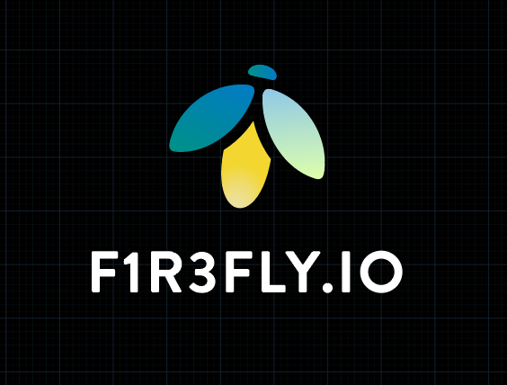
F1R3GAMES
Collective Intelligence Through Play

A White Paper by F1R3FLY.io
April 2026

Lucius Gregory Meredith
CEO, F1R3FLY.io | Chief Science Officer, F1R3FLY Industries

We Love When We Play

Abstract
F1R3Games is a suite of interactive, on-chain applications designed to cultivate collective intelligence through structured, playful collaboration. Built on the F1R3FLY shard infrastructure—a next-generation compute and storage platform grounded in the rho calculus and the rholang smart contract language—each game in the suite explores a distinct modality of group creativity: visual art (F1R3Pix), musical rhythm (F1R3Beat), collective sentiment (F1R3Ink), generative and evolutionary music (F1R3Skein), and collaborative storytelling (F1R3SideChat). By storing all participant actions and state on-chain via RSpace tuple-space storage and securing consensus through Casper CBC proof-of-stake, F1R3Games provides a fully decentralized, tamper-evident, and tokenized environment in which groups can co-create, negotiate, and evolve shared artifacts. This white paper describes the design principles, architecture, individual game mechanics, token economics, and broader implications of the F1R3Games platform for collective intelligence research and Web3 application development.

1. Introduction

1.1 The Problem of Collective Intelligence
Human progress depends on the capacity of groups to coordinate, deliberate, and create beyond what any individual can achieve alone. Yet the mechanisms by which collective intelligence emerges remain poorly understood, and existing digital platforms offer few structured environments for studying or exercising it. Social media optimizes for engagement and virality, not for convergent co-creation; collaborative software targets productivity, not the cultivation of shared imaginative faculties. There is a gap in the landscape: platforms that treat collective creative processes as first-class activities, and that record those processes with the fidelity required for scientific study and meaningful participation.

1.2 Games as Instruments of Collective Intelligence
Games provide an ideal substrate for collective intelligence. They impose constraints that channel creative energy, create shared attention, establish legible rules of interaction, and produce measurable outcomes. By designing games across multiple expressive modalities—visual, auditory, linguistic, and narrative—it becomes possible to exercise and observe the full spectrum of collective cognitive abilities. F1R3Games takes this insight seriously, offering a suite of games in which a group’s collective output is irreducible to any single participant’s contribution.

1.3 On-Chain as Ground Truth
A distinguishing feature of F1R3Games is that all game state—every pixel placed, every beat sequenced, every word written—is stored on a F1R3FLY shard. This means the complete history of every collective creation is immutable, auditable, and owned by the community of participants rather than by a centralized platform operator. On-chain state transforms ephemeral collaboration into a durable, verifiable record, enabling new forms of attribution, governance, and economic participation.

2. The F1R3FLY Platform Foundation

2.1 Rho Calculus and Rholang
The F1R3FLY platform is built on the rho calculus, a computational formalism that extends the π-calculus with a notion of reflection: processes can be quoted as names, and names can be dereferenced back into processes. This reflective structure provides the formal foundation for rholang, the platform’s smart contract language. Rholang is inherently concurrent and compositional, making it well-suited to modeling multi-party interactions such as those found in collaborative games. Every F1R3Games contract is written in rholang, and the semantics of the game are precisely the semantics of the rholang process.

2.2 F1R3Node Shards and RSpace
Each F1R3Games instance runs on a F1R3Node shard, which pairs a rholang execution engine with RSpace, a tuple-space-based storage layer. RSpace provides a key-value store whose entries are rholang channels, enabling fine-grained, concurrent reads and writes. Because RSpace stores data in a Merkle trie structure, every state transition produces a verifiable state hash, guaranteeing that the complete game history is tamper-evident and reproducible.

2.3 Casper CBC Consensus
Shard-level consensus is achieved through Casper CBC (Correct-by-Construction) proof-of-stake. Casper CBC provides safety guarantees under partial synchrony and allows validators to reach finality on state transitions without a global leader. For F1R3Games, this means that contributions from participants—placing a pixel, modifying a beat sequence, adding a line of text—are finalized with the same cryptographic guarantees as any financial transaction on the shard.

2.4 Shard-Native Architecture Pattern
All games in the F1R3Games suite follow a uniform shard-native architecture pattern consisting of four components:
- Identity: secp256k1 key pairs provide cryptographic identity for every participant. No centralized account system is required; players sign actions with their private key.
- Token mechanics: The revVault system manages phlogiston (phlo) and REV tokens, enabling both gas-metered computation and economic participation.
- State channels: Game state is maintained in rholang channels, where concurrent reads and writes are mediated by the rholang runtime. Each game defines a set of named channels corresponding to its state model.
- DeployService: Client applications communicate with the shard via gRPC through the DeployService interface, deploying rholang terms that represent player actions and reading back the resulting state.

3. Token Economics and Valuable Friction

3.1 Phlogiston and REV
Every on-chain action in F1R3Games consumes phlogiston (phlo), the computational fuel of the F1R3FLY platform. Phlo is denominated in REV, the native token of the shard. This creates what we term “valuable friction”: each action has a non-zero cost, which serves multiple purposes simultaneously.

3.2 The Valuable Friction Framework
Valuable friction is the principle that small, well-calibrated costs attached to actions produce outsized benefits in system quality. In the context of F1R3Games, phlo costs accomplish the following:
- Spam prevention: Because every pixel placement, beat adjustment, or text submission costs phlo, bad actors cannot flood the system with noise without incurring real economic cost.
- Deliberation incentive: When actions carry cost, participants think before they act. This transforms impulsive clicking into considered contribution, raising the quality of collective output.
- Attribution and provenance: Every phlo-consuming action is signed and recorded, creating an immutable chain of attribution that connects economic expenditure to creative contribution.
- Sustainable economics: Phlo costs fund the validators who maintain the shard, creating a self-sustaining economic loop in which the act of play supports the infrastructure of play.

3.3 Agentic AI as First-Class Participants
The F1R3Games token economics framework extends naturally to agentic AI participants. AI agents that hold REV and sign transactions with their own key pairs can participate in any F1R3Game alongside human players. This design choice is deliberate: it enables the study of human–AI collective intelligence in a controlled, economically grounded environment. Agents are subject to the same phlo costs as human players, ensuring that their participation is economically meaningful rather than trivially cheap.

4. The F1R3Games Suite
The F1R3Games suite currently comprises five games, each targeting a distinct modality of collective intelligence. All five share the shard-native architecture pattern described in Section 2.4, and all five store their complete state on-chain.
Game | Modality | Collective Activity | Key Mechanism
F1R3Pix | Visual | Collaborative pixel art | Shared canvas with phlo-gated placement
F1R3Beat | Auditory / Rhythmic | Collective groove creation | Step sequencer with layered contributions
F1R3Ink | Linguistic / Affective | Sentiment crystallization | Weighted token submission and aggregation
F1R3Skein | Generative / Auditory | Evolutionary music | Mathematical spigots + genetic algorithm
F1R3SideChat | Narrative | Collective storytelling | Turn-based narrative composition

4.1 F1R3Pix — Collective Pixel Art

4.1.1 Overview
F1R3Pix presents participants with a shared digital canvas on which they can place colored pixels. The canvas state is stored entirely on-chain: each pixel’s color, the identity of the player who placed it, and the timestamp of placement are recorded as entries in the shard’s tuple space. The result is a collectively authored image that emerges organically from the contributions of potentially thousands of participants.
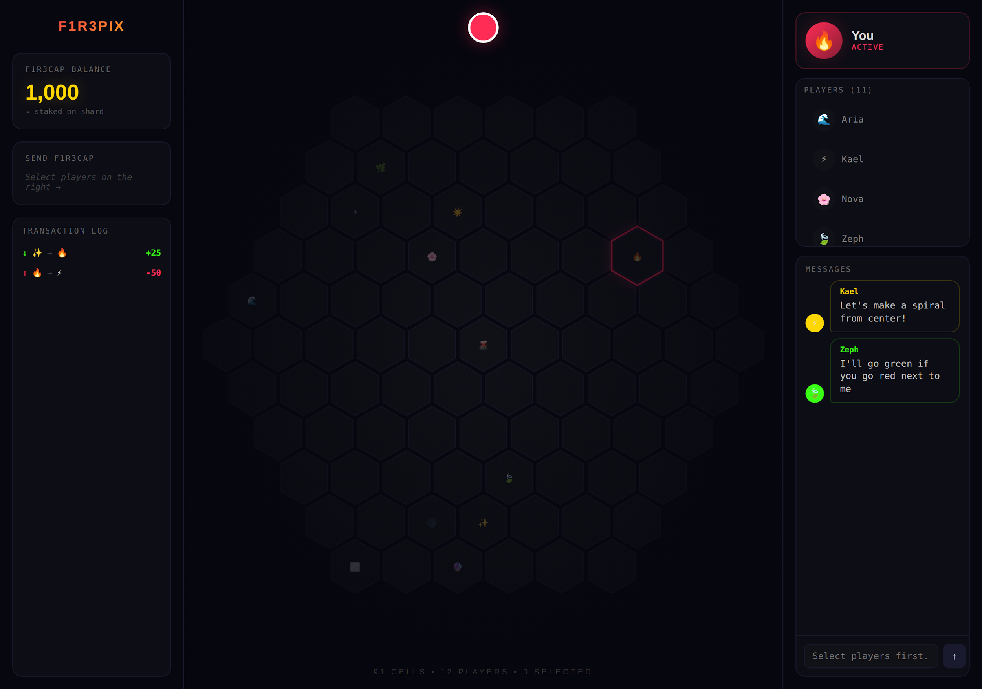
Figure 1: F1R3Pix — hexagonal collaborative canvas with player roster, transaction log, and real-time chat

4.1.2 Mechanics
Each pixel placement is a rholang deploy that consumes phlo, enforcing the valuable friction principle. Players select a color from a palette and a coordinate on the canvas, then sign and submit the transaction. The rholang contract validates the placement, deducts phlo from the player’s revVault, updates the canvas state channel, and emits an event that connected clients render in real time. Cooldown periods, palette rotations, and canvas expansions can be governed by community votes executed through companion governance contracts.

4.1.3 Collective Intelligence Properties
F1R3Pix exercises spatial reasoning, aesthetic negotiation, and emergent coordination. Without centralized direction, groups must implicitly negotiate shared visual intentions—defending or extending motifs, establishing color zones, and resolving territorial conflicts. The on-chain record enables post-hoc analysis of coordination patterns, faction dynamics, and the emergence of visual coherence from decentralized action.

4.2 F1R3Beat — Collective Groove Creation

4.2.1 Overview
F1R3Beat allows a group to collectively build a musical groove by collaboratively editing a shared step sequencer. Each participant can add, remove, or modify beat patterns across multiple instrument channels, with the composite rhythm emerging from the layered contributions of the group.
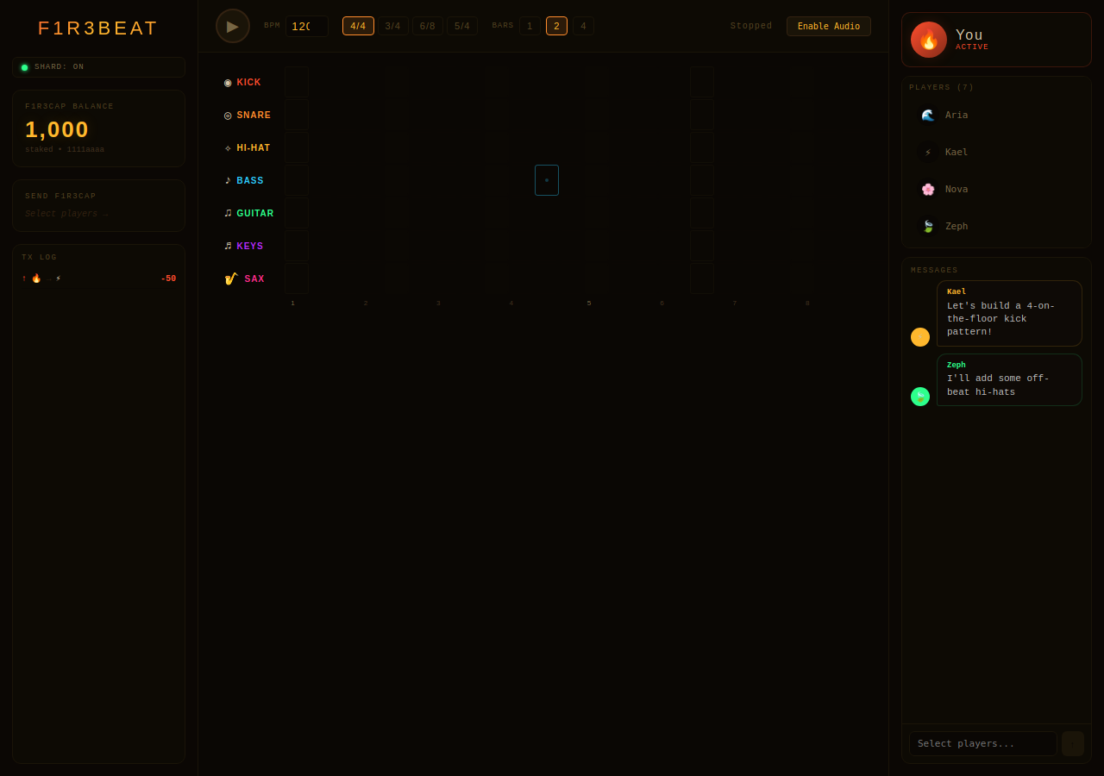
Figure 2: F1R3Beat — multi-track step sequencer with BPM, time signature controls, and collaborative messaging

4.2.2 Mechanics
The game state is a multi-track step sequencer stored in rholang channels: each channel represents an instrument lane (kick, snare, hi-hat, bass, guitar, keys, sax), and each step within a lane is a boolean or velocity value. Players deploy rholang terms that toggle steps or adjust velocities, with each modification consuming phlo. The composite pattern is synthesized client-side using Web Audio API, giving participants immediate auditory feedback on the collective output. Temporal rules—such as round-robin editing, democratic voting on pattern locks, or escalating phlo costs for contested steps—can be layered on top of the base mechanics.

4.2.3 Collective Intelligence Properties
F1R3Beat exercises rhythmic perception, temporal coordination, and aesthetic compromise. Creating a satisfying groove requires participants to listen to the current state, identify gaps or dissonances, and contribute elements that complement rather than conflict with existing patterns. The on-chain history reveals how rhythmic coherence emerges, how conflicts between competing rhythmic visions are resolved, and whether groups converge on stable grooves or exhibit chaotic oscillation.

4.3 F1R3Ink — Collective Sentiment

4.3.1 Overview
F1R3Ink is a game of collective sentiment crystallization. Participants submit words, phrases, or short tokens that capture their sentiment about a given topic or prompt. The system aggregates these contributions to produce a collective expression—a word cloud, a ranked list, a distilled statement—that represents the group’s shared emotional or evaluative state.
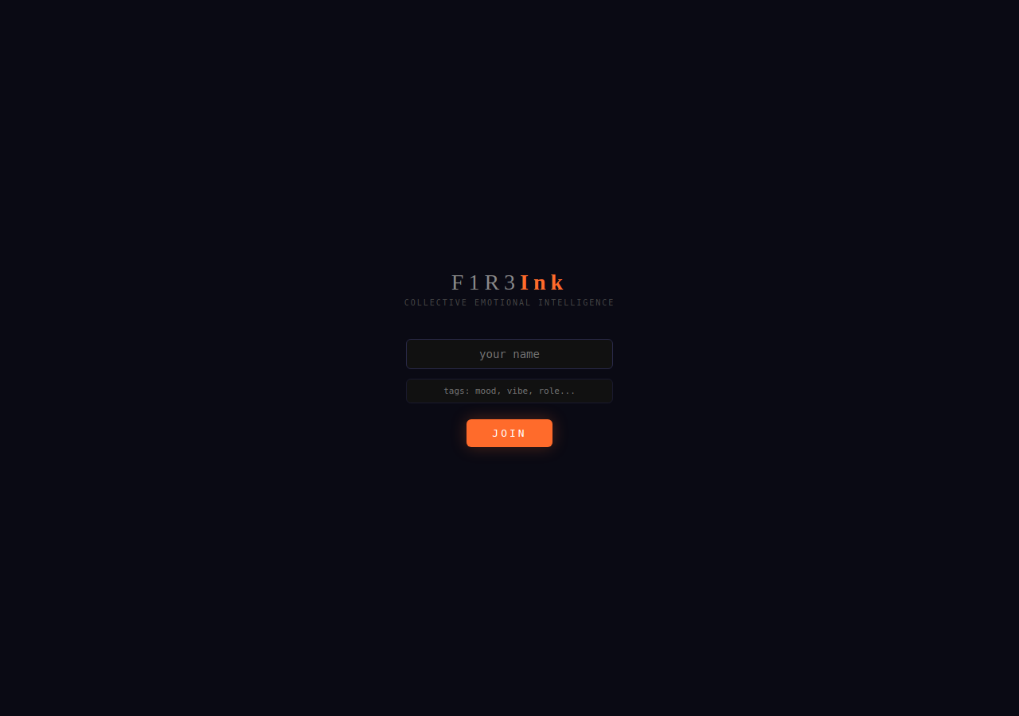
Figure 3: F1R3Ink — lobby screen for Collective Emotional Intelligence with tag-based identity

4.3.2 Mechanics
Participants deploy rholang terms containing their textual contributions, weighted by the amount of phlo they are willing to stake. Higher-phlo contributions carry more weight in the aggregation, creating a market-like mechanism for signal strength. The aggregation algorithm—which may be a simple frequency count, a weighted rank, or a more sophisticated NLP-based clustering—runs on-chain or in a verifiable off-chain computation anchored to the shard. The resulting collective sentiment artifact is stored on-chain and can be referenced by other contracts, governance processes, or downstream games.

4.3.3 Collective Intelligence Properties
F1R3Ink exercises the group’s capacity for affective convergence: finding shared language for shared feelings. The phlo-weighting mechanism introduces a strategic dimension, as participants must decide how strongly to signal their sentiment. Over time, repeated rounds of F1R3Ink on evolving topics produce a longitudinal record of collective affect—a kind of emotional EEG for a community.

4.4 F1R3Skein — Generative and Evolutionary Music

4.4.1 Overview
F1R3Skein provides a novel approach to music generation by deriving melodies from mathematical constants via dual spigot algorithms, then employing genetic algorithms to breed and evolve the resulting compositions. The system’s name evokes a skein of yarn: multiple threads of melody intertwined and shaped by collective selection pressure.
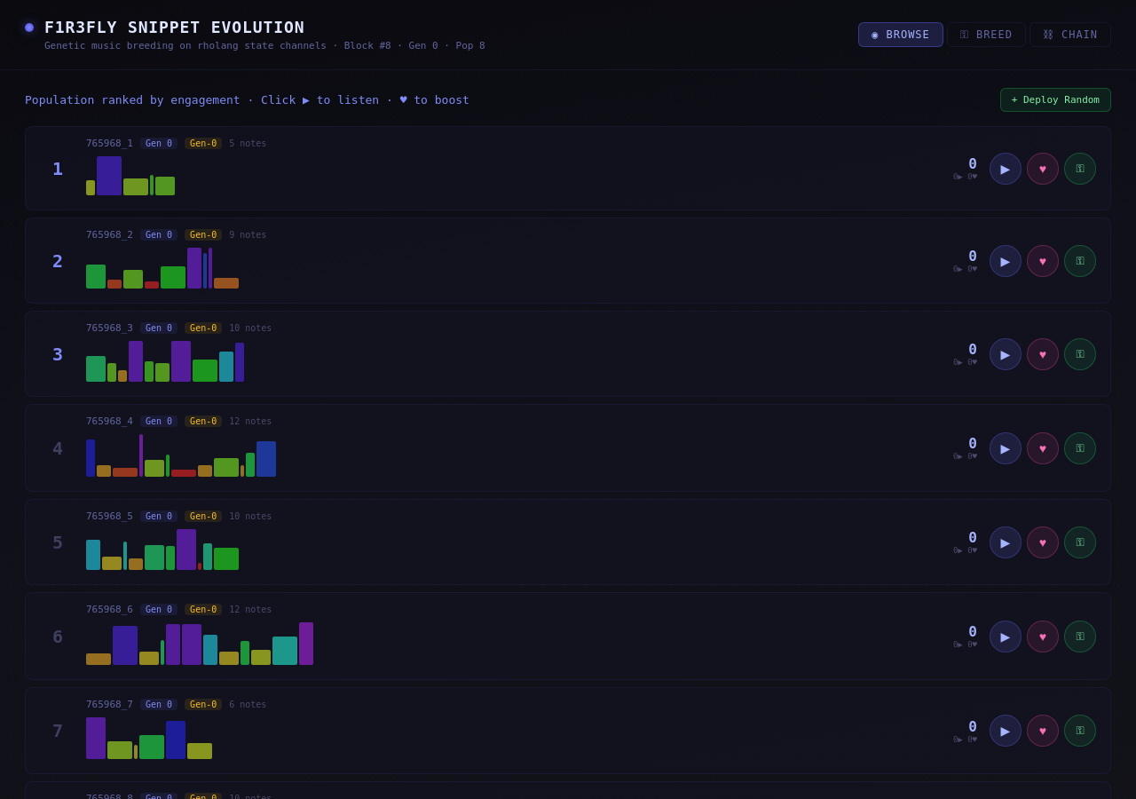
Figure 4: F1R3Skein — evolutionary snippet breeding with generation tracking, note visualizations, and phlo-weighted voting

4.4.2 The Spigot Architecture
At the heart of F1R3Skein is the Leap Spigot system, which maps the digit streams of mathematical constants (pi, e, the golden ratio, and others) to MIDI note sequences. Two spigots run in parallel—one governing pitch, the other governing rhythm—and their streams are interleaved to produce melodic phrases. Because the digit sequences are deterministic and infinite, every melody has a precise mathematical address: a starting position and a mapping function that together determine the musical output. These addresses are compact and reproducible, enabling melodies to be stored on-chain as parameters rather than as full audio data.

4.4.3 Evolutionary Breeding
F1R3Skein layers a genetic algorithm over the spigot-generated melodies. Participants listen to candidate melodies and express preferences through phlo-weighted votes. The highest-ranked melodies survive to the next generation, where crossover and mutation operators produce new offspring by recombining and perturbing spigot parameters: starting positions, mapping functions, octave ranges, and rhythmic quantization. Over successive generations, the population of melodies evolves under collective aesthetic selection, producing compositions that no individual designed but that reflect the group’s emergent musical taste.

4.4.4 Collective Intelligence Properties
F1R3Skein exercises musical aesthetic judgment at a collective level. By decoupling generation (mathematical and deterministic) from selection (collective and subjective), it isolates the group’s capacity for aesthetic convergence. The on-chain evolutionary record provides a detailed genealogy of musical taste: which features are preserved across generations, how quickly the population converges, and whether distinct aesthetic lineages emerge within the group.

4.5 F1R3SideChat — Collective Storytelling

4.5.1 Overview
F1R3SideChat is a game of collective narrative construction. Participants collaboratively build a story by contributing text passages in turns, with each contribution extending, branching, or redirecting the narrative arc established by previous contributors.
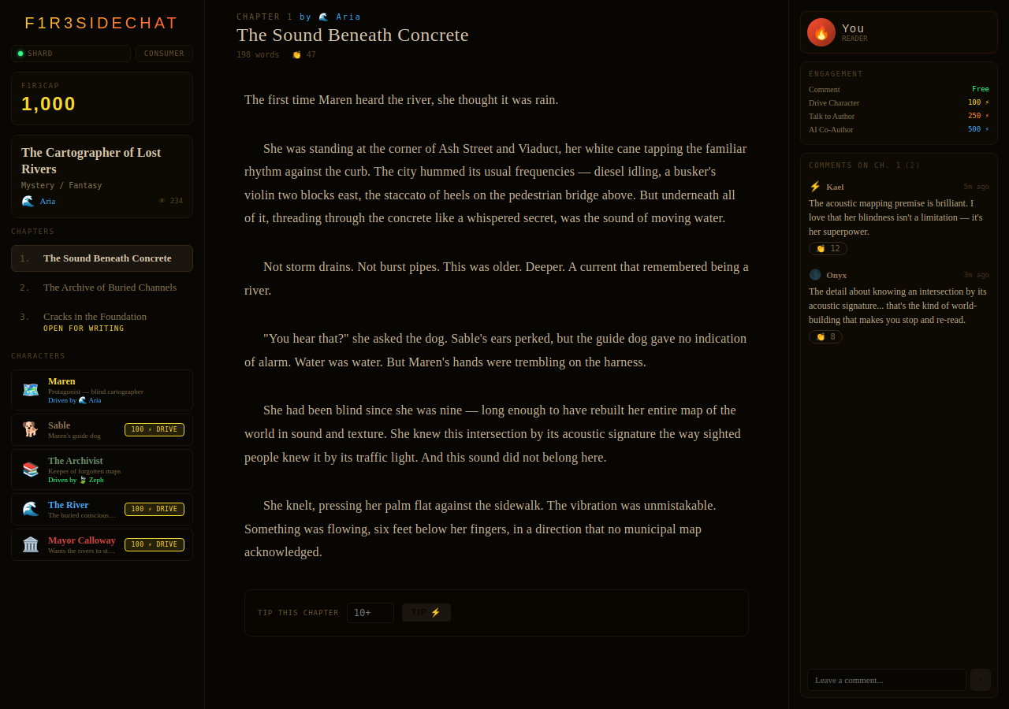
Figure 5: F1R3SideChat — collaborative storytelling with chapters, character roster, tipping, and community commentary

4.5.2 Mechanics
The story state is a directed graph of text nodes stored in rholang channels, where each node contains a passage and metadata (author identity, phlo cost, timestamp, parent node references). Players deploy rholang terms that append new nodes to the graph, either continuing a linear narrative or forking it into alternative branches. Branching creates a tree structure that the community can navigate and prune. Governance mechanisms—voting to canonize a branch, merging parallel threads, or retiring dead ends—are implemented as rholang contracts operating over the story graph. The complete narrative graph, with its full branching history, is permanently stored on-chain.

4.5.3 Collective Intelligence Properties
F1R3SideChat exercises narrative intelligence: the capacity to construct coherent, compelling, and surprising stories through distributed authorship. The branching structure reveals how groups manage narrative tension, whether dominant storylines emerge through consensus or competition, and how creative diversity is maintained in the face of convergence pressure. The on-chain graph provides a rich dataset for studying collaborative creativity and discourse dynamics.

5. The F1R3Games Portal
All five games are accessible through a unified F1R3Games portal that provides a single entry point for identity management, token operations, and game selection. The portal is built as a React-based single-page application that communicates with the underlying F1R3Node shard via gRPC-Web.
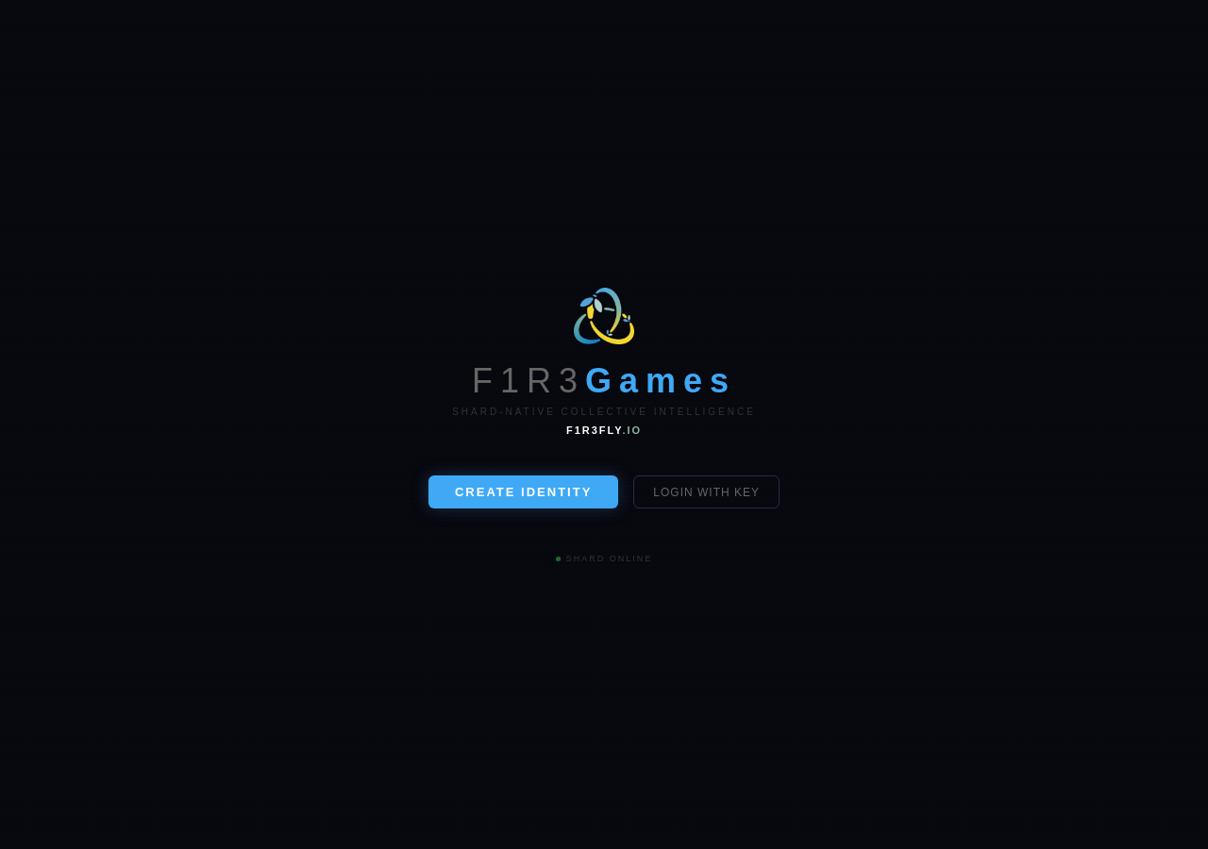
Figure 6: F1R3Games Portal — shard-native identity creation and login with live shard status
Key features of the portal include:
- Unified identity: A single secp256k1 key pair serves as the player’s identity across all games. The portal manages key generation, storage, and transaction signing through a browser-based wallet interface.
- Token dashboard: Players can view their REV balance, phlo expenditure history, and per-game spending through a unified dashboard. Token transfers between players and top-ups from external sources are handled through the portal’s revVault integration.
- Game launcher: Each game is launched from the portal as a distinct view, with the portal maintaining session state and providing shared UI components (identity badges, balance displays, notification feeds).
- Cross-game analytics: Because all game actions flow through the same shard, the portal can provide cross-game analytics: total contributions, participation patterns, and collective achievement metrics.

6. Collective Intelligence Framework

6.1 Modality Coverage
The five games in the F1R3Games suite are not arbitrary; they are chosen to span the major modalities of human collective cognition:
Modality | Game | Cognitive Faculty Exercised
Visual–Spatial | F1R3Pix | Spatial coordination, aesthetic negotiation
Auditory–Rhythmic | F1R3Beat | Temporal coordination, rhythmic perception
Affective–Linguistic | F1R3Ink | Sentiment convergence, signal calibration
Generative–Evaluative | F1R3Skein | Aesthetic selection, evolutionary dynamics
Narrative–Discursive | F1R3SideChat | Story coherence, collaborative creativity

6.2 Measurability
Because all game state is on-chain, F1R3Games provides an unprecedented level of measurability for collective intelligence research. Every action is timestamped, attributed, and economically weighted. Researchers can compute metrics such as convergence rate (how quickly a group reaches a stable collective artifact), entropy (the diversity of contributions over time), coordination efficiency (the ratio of constructive to destructive edits), and economic intensity (total phlo expenditure as a function of output quality). These metrics can be compared across games, groups, and time periods, enabling rigorous, longitudinal studies of collective intelligence.

6.3 Composability
The shard-native architecture makes the games composable. A collective image from F1R3Pix can serve as the visual prompt for a F1R3Ink sentiment round. A groove from F1R3Beat can provide the rhythmic scaffold for a F1R3Skein evolutionary run. A story from F1R3SideChat can reference on-chain artifacts from any other game. This composability is not a feature bolted on after the fact; it is a natural consequence of all game state residing in the same tuple space and being addressable by the same rholang programs.

7. Security and Governance

7.1 Security Model
The security of F1R3Games inherits from the security of the underlying F1R3FLY platform. Rholang’s object capability (OCap) model ensures that contracts can only access resources for which they hold explicit capabilities. The shard’s Casper CBC consensus guarantees finality and resistance to Byzantine faults. A comprehensive security audit program—engaging firms such as Runtime Verification, Trail of Bits, and academic groups specializing in process calculi—has been developed to verify the platform’s formal semantics and identify residual attack surfaces.

7.2 Community Governance
Governance of the F1R3Games suite is managed through CatchingF1R3, a shard-native voting and governance application built within the F1R3FLY ecosystem. CatchingF1R3 enables token-weighted voting on game parameters (canvas sizes, round durations, phlo cost schedules), meta-governance decisions (adding new games, modifying the portal), and community treasury allocations. All votes are on-chain, and the execution of approved proposals is automated through rholang governance contracts.

8. Tournaments and Community Adjudication

8.1 Tournament Structure
F1R3Games introduces a formal tournament system that transforms casual collective play into structured competitive events. Tournaments are time-bounded, rule-defined competitions in which teams or individuals compete to produce the highest-quality collective artifact—the most compelling pixel mosaic, the tightest groove, the most resonant sentiment crystallization, the most evolved melody, or the most gripping narrative. Each tournament is instantiated as a rholang contract that encodes its rules, timeline, entry requirements, prize structure, and adjudication mechanism.

8.2 Staking to Enter
Participation in a tournament requires an entry stake denominated in REV. This stake serves several functions simultaneously. It signals genuine commitment, filtering out casual or disruptive entrants. It funds the prize pool, creating a self-financing competitive structure. And it raises the economic stakes of participation, sharpening the incentive to contribute thoughtfully. The entry stake is locked in a tournament-specific rholang escrow contract for the duration of the event, and the total staked amount forms the basis of the prize distribution.

8.3 Community as Judge
Tournament outcomes are determined by community adjudication rather than by algorithmic scoring. Any token-holder on the shard can register as a judge for a given tournament by staking a smaller judging deposit. Judges review the competing artifacts—viewing the collaborative canvas, listening to the groove, reading the story—and cast ranked votes. To prevent collusion and strategic voting, several mechanisms are employed:
- Commit–reveal voting: Judges submit a cryptographic hash of their vote during the commitment phase, then reveal the actual vote in a subsequent phase. This prevents judges from anchoring on early votes.
- Stake-weighted influence: A judge’s vote weight is proportional to their judging stake, but with diminishing returns to prevent plutocratic capture.
- Coherence rewards: Judges whose votes align with the final consensus ranking receive a small payout drawn from the tournament’s fee pool. Judges whose votes diverge sharply from consensus forfeit a portion of their judging deposit. This incentivizes honest, thoughtful evaluation.
The community-as-judge model turns adjudication itself into a collective intelligence exercise: the quality of the tournament outcome depends on the collective aesthetic and critical judgment of the judging pool.

8.4 Prize Structure
Prizes are distributed from the pooled entry stakes according to a gold–silver–bronze tier structure. The precise percentages are configurable per tournament, but a representative allocation is as follows:
Tier | Share of Prize Pool | Recipients | Typical Payout
Gold | 50% | 1st place | Largest single payout
Silver | 25% | 2nd place | Half of gold
Bronze | 10% | 3rd place | Quarter of gold
Judges’ Pool | 10% | All coherent judges | Distributed pro rata
Platform Fee | 5% | Shard validators | Infrastructure support

This structure ensures that the majority of staked value flows to the highest-performing participants, while also compensating the community judges who made fair adjudication possible and the validators who sustain the infrastructure. Because the entire prize distribution is executed by a rholang contract, payouts are automatic, transparent, and tamper-proof.

8.5 Tournament as Collective Intelligence Amplifier
Tournaments amplify the collective intelligence dynamics already present in each game. The competitive context raises the quality ceiling, as teams coordinate more intensely under time pressure and economic incentive. The judging process adds a meta-layer of collective cognition: evaluating the outputs of collective creativity is itself a collective intelligence task. And the on-chain record of tournament history—entries, votes, rankings, payouts—provides a rich dataset for studying how competition and adjudication interact with collaborative creativity.

9. AI and Machine Learning for Trend Analysis

9.1 The Data Opportunity
Because every action across every game and tournament is recorded on-chain with cryptographic attribution and precise timestamps, F1R3Games generates a uniquely rich longitudinal dataset of collective creative behavior. As the platform scales to thousands of games, hundreds of tournaments, and millions of individual contributions, this dataset becomes a substrate for machine learning models that can detect patterns, anomalies, and trends invisible to human observers.

9.2 Trend Detection Across Games
Machine learning models trained on cross-game data can identify macro-level trends in collective intelligence. Examples include:
- Coordination signatures: Clustering algorithms applied to contribution timestamps and spatial/temporal patterns can identify characteristic coordination styles—whether a group tends toward centralized leadership, distributed parallel work, or emergent self-organization—and track how these styles evolve over successive games.
- Aesthetic drift: In F1R3Pix and F1R3Skein, convolutional and sequence models can track how collective aesthetic preferences shift over time: which color palettes, rhythmic patterns, or melodic features gain or lose favor across generations of play.
- Sentiment trajectories: NLP models applied to F1R3Ink contributions and F1R3SideChat narratives can chart the emotional arc of a community: how collective mood shifts in response to external events, internal conflicts, or the introduction of new participants.
- Skill progression: Tracking individual and group performance metrics across tournaments reveals learning curves, plateau effects, and the emergence of expertise within the community.

9.3 Predictive Models
Beyond descriptive analytics, the dataset enables predictive modeling. Regression and transformer-based models can be trained to forecast outcomes such as: whether a given group composition is likely to converge on a coherent artifact or fragment into competing factions; which tournament entries are likely to rank highest based on early contribution patterns; and how changes in phlo cost schedules or canvas sizes will affect participation rates and output quality. These predictions can inform platform governance, helping the community set parameters that maximize collective intelligence outcomes.

9.4 Anomaly Detection and Fair Play
Machine learning also serves a governance function. Anomaly detection models can flag suspicious patterns—bot-like contribution cadences, coordinated voting rings in tournaments, or Sybil attacks using multiple identities—enabling the community to investigate and respond before the integrity of a game or tournament is compromised. Because the training data is entirely on-chain and publicly auditable, the anomaly detection pipeline itself can be subjected to community review.

9.5 Dashboards and Community Insight
The insights generated by AI and ML models are surfaced through the F1R3Games portal as interactive trend dashboards. Community members can explore visualizations of coordination patterns across hundreds of games, compare their group’s performance to platform-wide baselines, and drill into the evolutionary genealogy of F1R3Skein melodies or the branching topology of F1R3SideChat narratives. By making collective intelligence visible and navigable, these dashboards close the feedback loop: communities can see how they create, learn from their patterns, and consciously evolve their collaborative practice.

10. Future Directions
The F1R3Games platform is designed for extensibility. Several directions for future development include:
- New game modalities: Additional games targeting kinesthetic, logical–mathematical, and interpersonal intelligence modalities will expand the suite’s coverage of collective cognitive faculties.
- Cross-shard play: As the F1R3FLY platform scales to multiple shards, cross-shard game interactions will enable larger participant pools and inter-community collaboration.
- AI co-players: Integrating agentic AI participants as first-class players will enable controlled studies of human–AI collective intelligence, with AI agents contributing to and learning from collective creative processes.
- Formal verification of game contracts: Lean 4 proofs of game contract properties (fairness, liveness, economic soundness) will provide mathematical guarantees about game behavior.
- VisionOS and spatial computing: Porting F1R3Games to spatial computing platforms will add embodied, three-dimensional interaction to the collective intelligence toolkit, with particular promise for F1R3Pix (volumetric canvas) and F1R3Skein (spatial audio).

11. Conclusion
F1R3Games represents a new paradigm at the intersection of gaming, collective intelligence, and decentralized infrastructure. By grounding every game in the formal semantics of the rho calculus, storing every action on a F1R3FLY shard, and attaching economic weight to every contribution through the phlogiston token model, the platform creates an environment in which collective creativity is structured, measurable, and economically self-sustaining. The tournament system and community adjudication add a competitive dimension that sharpens collective effort, while AI-driven trend analysis closes the feedback loop by making the patterns of collective intelligence visible and actionable.
The five games of the current suite—F1R3Pix, F1R3Beat, F1R3Ink, F1R3Skein, and F1R3SideChat—span the visual, auditory, affective, generative, and narrative modalities of collective intelligence, providing both a playground for communities and a laboratory for researchers. As the platform evolves to include new games, AI co-players, cross-shard interactions, and ever-deeper analytical insight into how groups create together, F1R3Games will continue to demonstrate a central thesis: that play, properly designed and transparently recorded, is among the most powerful instruments for the cultivation of collective intelligence.

We Love When We Play

