Can a Quantum Kernel Pick Better Demonstrations? A Controlled Study of Few-Qubit Kernel Retrieval for Few-Shot LLM Classification
Author One, Author Two, Author Three (Department of Computer Science and Engineering, University Name, City, Country)
Abstract—Large language models (LLMs) classify text well from a few labelled demonstrations, and those demonstrations are usually the query’s nearest neighbours under a classical similarity. We ask a narrow question: if nothing else in the pipeline changes, does a quantum kernel retrieve demonstrations that help a frozen LLM more? Sixteen selectors share one pool, prompt and LLM and differ only in how they choose examples. Sentence embeddings are compressed to $d=2$–$12$ features, one per qubit, and scored by classical kernels, by fixed fidelity and projected kernels of an entangling IQP circuit, or by IQP and RBF kernels whose input scales are trained on the pool labels; BM25, maximal marginal relevance, a trained metric retriever, rank fusion and a label oracle complete the field. We show that top-$k$ retrieval depends only on how a kernel orders the pool, so the RBF bandwidth and global depolarizing noise cannot change the picks. On TREC, Emotion, DBpedia-14 and the 77-intent Banking77, with a commercial LLM, an open 1.5B model and a 7B spot check, the IQP kernel changed TREC accuracy by XYZ points against an RBF kernel on the same features (95% CI XYZ), a preregistered verdict of XYZ; equivalence tests and detectable-effect sizes state how small any effect must be. [FILL: written by the code from your results] [FILL: written by the code from your results]
Index Terms—in-context learning, demonstration selection, quantum kernels, quantum machine learning, few-shot classification, large language models, equivalence testing

1 Introduction
Few-shot prompting turned large language models into general-purpose text classifiers [1]. A user writes a short instruction, adds $k$ labelled examples, and appends the text to be labelled. The choice of those $k$ examples has a large effect on accuracy. Liu et al. [2] showed that picking the nearest neighbours of the query in a sentence-embedding space beats random picks by a wide margin, and later work has refined how demonstrations are retrieved, ranked and diversified [3–5]. Every one of these methods rests on a similarity function, and almost all of them use cosine similarity or a learned dot product.
Quantum machine learning offers a different kind of similarity. A quantum feature map loads a vector into the state of a register of qubits, and the overlap between two such states defines a kernel [6, 7]. For some feature maps this kernel is believed to be hard to compute classically [6, 8], and that property is often presented as a reason to expect better models. The theory is more cautious: a quantum kernel helps only if it ranks data differently from the classical kernels one could use instead [9], and many quantum kernels concentrate, so that their values become nearly identical for all pairs of inputs as the number of qubits grows [10, 11]. Systematic benchmarks found out-of-the-box classical models ahead of popular quantum classifiers [12] and the performance of quantum kernels to depend strongly on their hyperparameters [13].
Natural language processing has seen a growing number of hybrid quantum models [14–16]. Most of them place a trained variational circuit at the end of a classical pipeline and report one accuracy figure [17–19]. Systems that combine quantum components with LLMs often change several parts at once; Quantum-RAG, for instance, introduces a new generator, tokenizer and retrieval stack together [20]. In such designs it is hard to say what the quantum part contributed.
Demonstration retrieval avoids this problem. The quantum kernel sits upstream as a similarity function: it never sees the test labels, and the LLM downstream stays frozen. Apart from decoding noise, an accuracy change can only come from the selector.
Why so few qubits? At two to twelve qubits every kernel we test is easy to simulate, so no computational advantage is at stake, and we do not claim one. What is at stake is the inductive bias of the quantum kernel, its notion of which examples are alike [21]. This is the question that matters in practice: the hybrid NLP models cited above compress sentence embeddings to a handful of features precisely so that they fit on present hardware, and they credit the quantum similarity for their results. If the quantum notion of similarity is useful, a small, clean testbed is where it should first become visible; if it is not, the testbed should say why. Because a supervised compression to five features may leave every kernel little to disagree about, we also run the LLM with six to twelve qubits, train the input scales of both a quantum and a classical kernel, and add a harder task with 77 intents. We ask:
- RQ1. Does a quantum kernel retrieve demonstrations that make a frozen LLM more accurate than a classical kernel on the same features, and if not, can we show that any effect is small?
- RQ2. Can we tell, before paying for any LLM calls, whether a quantum kernel is able to change the retrieved set at all?
- RQ3. Does the answer change with more qubits, with trained rather than fixed kernels, on a harder task, under gate and shot noise, with another tuning rule, larger LLMs or another encoder?
We make four contributions. (1) A controlled testbed with sixteen selectors that share pool, prompt, LLM and decoding: random selection, three classical similarities and three fixed quantum kernels on the same compressed features, a quantum and a classical kernel with trained input scales (same parameter count, same objective), cosine on the full embedding, five strong or diversity-aware retrievers (BM25, maximal marginal relevance on the classical and on the quantum kernel, a trained metric, rank fusion of classical and quantum rankings) and a label oracle that bounds what any selector could gain. (2) A rank-invariance result for retrieval: top-$k$ selection is blind to any per-query monotone transform of a kernel, so the RBF bandwidth and global depolarizing noise cannot change the picks; it motivates a rank-agreement diagnostic. (3) An evaluation past accuracy on four datasets, with the LLM from two to twelve qubits, three LLMs and two encoders, preregistered decision rules, equivalence tests, minimum detectable effects and difficulty strata. (4) Mechanism studies without the LLM, covering qubit scaling, local depolarizing noise with finite shots and a twelve-variant ablation, and a bandwidth study with the LLM in the loop.

2 Related Work

2.1 Demonstration selection for in-context learning
Nearest-neighbour retrieval of demonstrations with sentence embeddings [2] remains the default baseline. Rubin et al. [3] trained a retriever with LLM feedback, Ye et al. [5] selected sets jointly with a determinantal point process, and Levy et al. [4] showed that diverse demonstrations help compositional generalization. Luo et al. [22] confirmed that simple dense and sparse retrievers beat random picks across many tasks. Demonstration order [23] and the surprisingly small role of label correctness [24] complicate the picture further. Classical information retrieval supplies the sparse baseline BM25 [25], the relevance-diversity trade-off of maximal marginal relevance (MMR) [26] and reciprocal rank fusion [27], all of which we include. We hold order, format and labels fixed and vary only the selector, a factor these works take as given.

2.2 Quantum kernels and their limits
A quantum feature map $|ψ\left(x\right)⟩$ induces the fidelity kernel $\left|⟨ψ\left(x\right)\right|ψ\left(x′\right)⟩|^{2}$ [6, 7], and many variational models can be read as kernel machines [28]. Provable advantages exist for specially constructed problems [8, 29], but on generic data the picture is mixed. Huang et al. [9] introduced the geometric difference, which bounds how much better a quantum kernel can be than a classical one on a given data set, and proposed projected kernels that compare single-qubit reduced states. Fidelity kernels concentrate exponentially in the number of qubits for expressive maps [10]; scaling the inputs by a bandwidth restores useful variation [11, 30], and the inductive bias of a quantum kernel decides whether it can generalize at all [21]. Noise adds a further limit: gate errors and finite sampling shrink the useful range of kernel values on hardware [31, 32]. Kernels can also be trained, for example by maximizing their alignment with the labels [33–35].
Benchmarks. Bowles et al. [12] compared popular quantum models with classical baselines on small classification tasks and found that out-of-the-box classical models outperformed the quantum classifiers, and that removing entanglement often gave as good or better performance. Schnabel and Roth [13] trained more than 20,000 fidelity and projected quantum kernel models on 64 data sets and examined how strongly their performance depends on hyperparameters. Sakka et al. [36] reported that even an automatically designed quantum feature map stayed slightly behind a classical RBF kernel. Against this background, Cajas Ordóñez et al. [37] reported an advantage of quantum kernels on compressed foundation-model embeddings for image classification. Our study differs from all of them in what is measured: not a kernel machine’s accuracy but which demonstrations a kernel retrieves and how a frozen LLM uses them, with the classical kernel on the same features, trained kernels on both sides, and equivalence tests that can show the absence of an effect. RBF on the same features is therefore our main opponent.

2.3 Quantum methods in NLP and around LLMs
Compositional quantum NLP maps grammatical structure to circuits [14, 15]. A more recent strand compresses pretrained sentence embeddings and feeds them to small variational classifiers [17, 18]. Hassan et al. [19] showed on TREC that supervised compression (LDA) to five dimensions keeps baseline accuracy while PCA does not, and that fitting the reducer on all data inflates accuracy by several points; we adopt both lessons. Work that touches LLMs has used adaptive quantum-classical fusion [38], cosine similarity estimated on quantum hardware [39] and quantum-assisted retrieval for a low-resource language model [20]. We found no prior study that tests a quantum kernel as the demonstration selector for a frozen LLM with everything else held constant.

3 Method
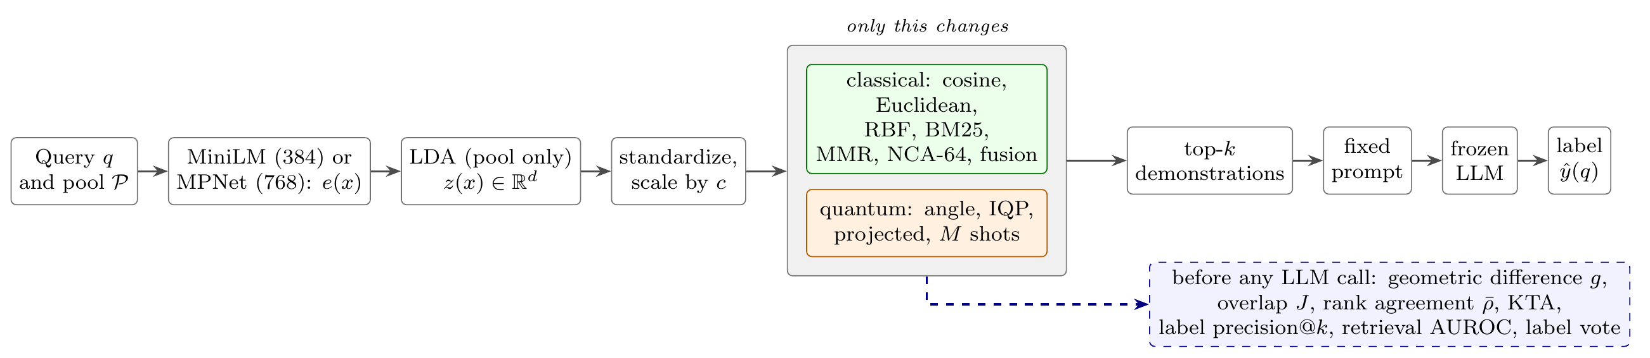
Fig. 1. Pipeline. Only the selector (gray box) changes; the pool, features, prompt template, LLM and decoding are shared. The diagnostics (dashed box) need no LLM calls and are computed before the paid runs.

3.1 Problem setup
Let $P=\{\left(x_{i},y_{i}\right)\}_{i=1}^{N}$ be a labelled pool with $N=500$ and labels from a set $Y$. For a test input $q$, a selector assigns a score $s\left(q,x_{i}\right)$ to every pool item and keeps the $k$ highest, $A_{k}\left(q\right)$. A fixed template turns $A_{k}\left(q\right)$ and $q$ into a prompt, and a frozen LLM returns a label $\hat{y}\left(q\right)$. Selectors differ only in how they build $A_{k}\left(q\right)$ (Fig. 1).

3.2 Representation
Each text is embedded with the sentence encoder all-MiniLM-L6-v2 [40, 41] and normalized to unit length, $e\left(x\right)∈R^{384}$; a robustness run uses all-mpnet-base-v2 [42] ($e\left(x\right)∈R^{768}$). Because every feature later becomes one qubit, we compress $e\left(x\right)$ with linear discriminant analysis (LDA) [43] fitted on the pool only, $z\left(x\right)=W^{⊤}e\left(x\right)∈R^{d}$. LDA yields at most $\left|Y\right|−1$ directions, five for the six-class tasks, so we use $d∈\{2,3,4,5\}$ on all datasets. Neighbourhood components analysis (NCA) [44], also fitted on the pool only, has no such cap and supplies $d∈\{6,8,10,12\}$ for the LLM runs with more qubits and the scaling study. Unlike LDA, NCA does not reduce the classes to their means, so it leaves the kernels more room to disagree. For the RBF and quantum kernels each feature is standardized with the pool mean and standard deviation, giving $\tilde{z}\left(x\right)$; the quantum circuits receive $c \tilde{z}\left(x\right)$ for a bandwidth $c$.

3.3 Selectors
Table I lists the selectors. S2 is standard practice [2]. S3 to S9 see the same $d$ LDA features (S5 to S9 in standardized form), so differences among them come from the similarity function alone. The second group tests whether the quantum kernel competes with retrievers a practitioner would actually use. S10 is BM25 on the raw text ($k_{1}=1.5$, $b=0.75$) [25]. S11 and S12 apply MMR [26], which adds the next example $x$ maximizing $λs\left(q,x\right)−\left(1−λ\right)\max_{x′∈A}s\left(x,x′\right)$, with $λ=0.5$ fixed in advance, to the cosine and IQP kernels respectively. S13 is a trained metric retriever: NCA fitted on the pool labels of the full embedding to 64 dimensions, ranked by Euclidean distance. S15 fuses the cosine and IQP rankings by reciprocal rank fusion, s=r​1/60+rankr [27], and asks whether the quantum ranking can add to the standard one. S14 is not a selector but an upper bound: it takes the $k$ most similar (cosine) pool items that carry the query’s gold label. The gap between S14 and the best real selector is the headroom left for any similarity function.
S16 and S17 answer the objection that a fixed quantum kernel is a straw man. Both learn one scale per input feature, $w∈R_{>0}^{d}$: S16 is the IQP kernel on $w⊙\tilde{z}$, and S17 is the RBF kernel exp−j​wj2zj−z′j2 with automatic relevance determination. Both maximize the centred kernel-target alignment [34] on 250 pool items with L-BFGS (at most 60 iterations, scales in $\left[{10}^{−3},10\right]$), starting from the tuned $c$ (S16) and the median-rule $γ$ (S17). They use the same data, objective, optimizer and parameter count, so S16 against S17 compares the two families at their best on equal terms, in the spirit of trained quantum embedding kernels [35].
TABLE I. Selectors. All use the same pool, prompt and LLM. S14 uses the gold label and only bounds what selection can gain.
ID | Selector | Score or rule
S1 | Random | uniform random (fixed seed)
S2 | Cosine, full embedding | $cos\left(e\left(q\right),e\left(x\right)\right)$
S3 | Cosine, LDA | $cos\left(z\left(q\right),z\left(x\right)\right)$
S4 | Euclidean, LDA | $−∥z\left(q\right)−z\left(x\right)∥$
S5 | RBF, LDA | $exp\left(−γ∥\tilde{z}\left(q\right)−\tilde{z}\left(x\right)∥^{2}\right)$
S6 | Quantum angle | $K_{A}$, Eq. (2) (control)
S7 | Quantum IQP | $K_{B}$, Eqs. (1), (3)
S8 | Quantum projected | $K_{P}$, Eq. (4)
S9 | Quantum IQP, $M$ shots | ${\hat{K}}_{B}$, Eq. (5) (robustness)
S10 | BM25 | lexical score on raw text
S11 | MMR, cosine | S2 relevance, $λ=0.5$
S12 | MMR, quantum IQP | S7 relevance, $λ=0.5$
S13 | NCA-64 | trained metric on $e\left(x\right)$
S14 | Label oracle | gold-label neighbours (bound)
S15 | Fusion | RRF of S2 and S7
S16 | Quantum IQP, trained | $K_{B}$ on $w⊙\tilde{z}$, $w$ trained
S17 | RBF, trained | ARD-RBF, $w$ trained

3.4 Quantum kernels
In this subsection $x∈R^{d}$ denotes the encoded vector $c \tilde{z}\left(⋅\right)$ of a text. A feature map $U\left(x\right)$ on $d$ qubits prepares $|ψ\left(x\right)⟩=U\left(x\right)|0⟩^{⊗d}$. The fidelity kernel is
$$K\left(x,x′\right)={\left|⟨ψ\left(x\right)|ψ\left(x′\right)⟩\right|}^{2}. \left(1\right)$$
Map A (angle encoding). $U_{A}\left(x\right)=⨂_{j=1}^{d}R_{Y}\left(x_{j}\right)$ rotates each qubit independently and creates no entanglement. It is widely used in hybrid NLP models [16].
Proposition 1. For Map A, the fidelity kernel equals $$K_{A}\left(x,x′\right)=\prod_{j=1}^{d}{\cos^{2}}​\left(\frac{x_{j}−x′_{j}}{2}\right), \left(2\right)$$ a product of shifted cosine kernels that a classical computer evaluates in $O\left(d\right)$ time. Proof. The state is a product, $|ψ_{A}\left(x\right)⟩=⨂_{j}\left(cos\frac{x_{j}}{2}|0⟩+sin\frac{x_{j}}{2}|1⟩\right)$, so the overlap factorizes into j​cosxj2cosx′j2+sinxj2sinx′j2=j​cosxj−x′j2. Squaring gives (2). $▫$
The observation is known and elementary; we state it for completeness because it matters for interpretation: anything obtained with Map A is a classical result. Our unit tests check (2) against the simulated circuit to ${10}^{−9}$.
Map B (IQP encoding). In the spirit of Havlı́ček et al. [6] and the instantaneous quantum polynomial circuits of [45], we use the IQPEmbedding of PennyLane, whose pair terms use $x_{j}x_{l}$ instead of the $\left(π−x_{j}\right)\left(π−x_{l}\right)$ of [6]:
UBx=UZx H⊗d2,UZx=j​RZxjj<l​RZZxjxl, 3
with $R_{Z}\left(θ\right)=e^{−iθZ/2}$ and $R_{ZZ}\left(θ\right)=e^{−iθZ_{j}Z_{l}/2}$ on every pair of qubits (Fig. 2). The pairwise terms entangle the register, and the resulting kernel $K_{B}$ has no known product form.
Projected kernel. To reduce concentration, Huang et al. [9] compare the one-qubit reduced states $ρ_{j}\left(x\right)$ instead of the full state. We use their Bloch vectors $b_{j}\left(x\right)=\left(⟨X_{j}⟩,⟨Y_{j}⟩,⟨Z_{j}⟩\right)$ from Map B and define
$$K_{P}\left(x,x′\right)=exp\left(−γ_{P}\sum_{j=1}^{d}{∥}b_{j}\left(x\right)−b_{j}\left(x′\right)∥^{2}\right). \left(4\right)$$
Since $∥ρ_{j}−ρ′_{j}∥_{F}^{2}=1/2∥b_{j}−b′_{j}∥^{2}$, this matches their definition up to a constant absorbed in $γ_{P}$.
Finite shots. On hardware, $K_{B}\left(x,x′\right)$ is the probability of reading all zeros after $U_{B}{\left(x′\right)}^{†}U_{B}\left(x\right)$ (Fig. 2c). With $M$ shots the estimate is binomial,
$${\hat{K}}_{B}\left(x,x′\right)=B/M, B∼Binomial\left(M,K_{B}\left(x,x′\right)\right), \left(5\right)$$
and S9 uses $M=1,024$. It models shot noise only; gate noise is treated in Section 3.9.
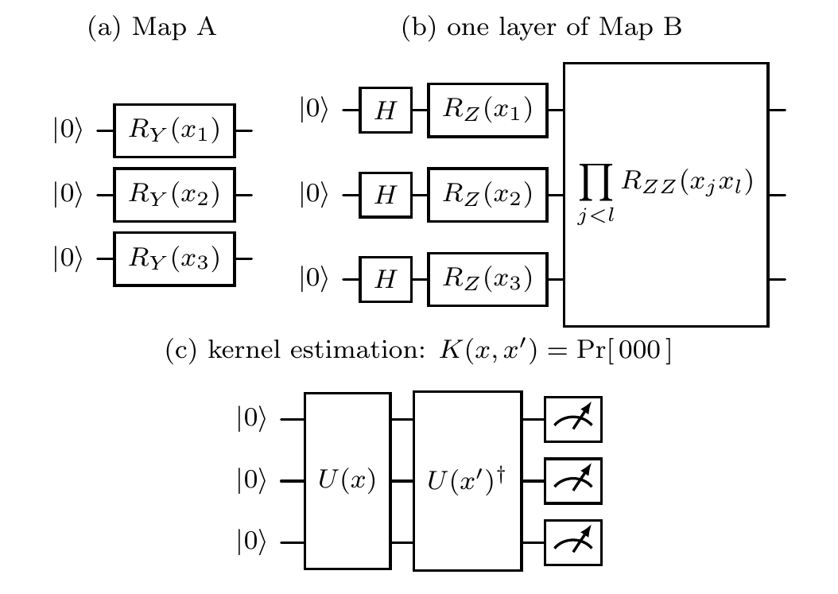
Fig. 2. Circuits for $d=3$. (a) Map A, no entangling gates. (b) One layer of Map B; the layer is applied twice. (c) Kernel estimation on hardware: the probability of the all-zero outcome equals $K\left(x,x′\right)$.

3.5 What retrieval can see of a kernel
A selector keeps the $k$ highest scores of each query and discards the values. This simple fact shapes the whole study.
Proposition 2. Let $f_{q}:R→R$ be strictly increasing for every query $q$. The scores $s\left(q,x\right)$ and $f_{q}\left(s\left(q,x\right)\right)$ retrieve the same set $A_{k}\left(q\right)$ for every $q$ (with the same tie-breaking). In particular: (a) the RBF kernel retrieves the same items for every $γ>0$; (b) for fixed $c$, the projected kernel retrieves the same items for every $γ_{P}>0$; (c) global depolarizing noise of any strength $p<1$ applied to the encoded states, $ρ↦\left(1−p\right)ρ+p I/2^{d}$, does not change the items retrieved by the fidelity kernel. Proof. A strictly increasing map preserves the order of each row of scores, and $A_{k}\left(q\right)$ depends on that order only. (a) $e^{−γu}$ is decreasing in the squared distance $u$ for any $γ>0$, so every $γ$ induces the same order. (b) is the same argument on Bloch-vector distances. (c) For noisy states the swap test measures $Tr\left(\tilde{ρ}\tilde{ρ}′\right)={\left(1−p\right)}^{2}K+\left(1−{\left(1−p\right)}^{2}\right)/2^{d}$, and the compute-uncompute circuit with a final global channel gives $\left(1−p\right)K+p/2^{d}$; both are affine in $K$ with positive slope. $▫$
The proposition covers selectors that rank one score per item. MMR (S11, S12) mixes kernel values, so it is invariant only under positive affine maps, which still include case (c). Three consequences follow. The RBF and projected bandwidths need no tuning for retrieval; they affect only diagnostics computed from kernel values. Hardware noise can only harm a quantum selector through noise that is not a global affine map of the kernel: local gate errors, which act differently on different inputs, and finite sampling. And the geometric difference $g$ [9], designed for kernel regression, is not invariant under such transforms, so it can report a difference that retrieval never sees. We therefore add a diagnostic that is: the rank agreement ρK,K′=1Qq​SpearmanKq,⋅,K′q,⋅, the mean per-query rank correlation of two kernels over the pool. Two selectors with $\overset{‾}{ρ}$ close to one build nearly the same prompts whatever their values look like.

3.6 Tuning
Quantum kernels are sensitive to input scaling [11, 30], so we tune the bandwidth $c∈\{0.1,0.25,0.5,1\}$ once per seed and dimension. The criterion is the accuracy of a $k$-nearest-neighbour vote with the IQP kernel on a validation set of 100 training items disjoint from the pool; ties go to the smaller value, and S6 to S9 and S12 share the chosen $c$. Neither the LLM nor any test item is involved. By Proposition 2 the classical kernels need no counterpart. The RBF parameter matters only for $g$, where we give the classical side the benefit of the doubt and report the smallest $g$ over $γ=mγ_{0}$, $m∈\{0.25,0.5,1,2\}$, with $γ_{0}$ the inverse median squared pairwise distance on the pool ($γ_{P}$ uses the same median rule on Bloch vectors). If anything, this protocol favours the quantum side, which gets four validated candidates for its only parameter that changes retrieval. Because the vote is only a proxy for what the LLM needs, a separate study (Section 3.9) re-tunes $c$ with the LLM itself.

3.7 Prompting and inference
Every selector uses one template per dataset: a one-line instruction listing the label words, the $k$ demonstrations as “Question:/Answer:” pairs (“Text:” for Emotion and DBpedia-14, “Query:” for Banking77), and the query. Demonstrations are printed from least to most similar, so the nearest one sits directly above the query (MMR keeps its selection order, most relevant last). We decode greedily with at most 24 new tokens, keep the first line of the reply, lowercase it and strip surrounding punctuation; spaces and hyphens may also be read as underscores (Banking77 intent names). A reply counts as a label if it equals it, if it starts with it followed by a non-letter (the longest such label wins), or, when at least ten characters long, if it is a prefix of exactly one label (a name cut off by the token limit); anything else counts as wrong. Answers are cached by the exact prompt, so two selectors that pick the same demonstrations in the same order receive the same answer.
We use three LLMs. The main model is Claude Haiku 4.5 (claude-haiku-4-5-20251001, Anthropic API, accessed [FILL: dates are read from the LLM cache]), queried through its API at temperature 0. The second is Qwen2.5-1.5B-Instruct [46], an open-weight model run locally, and the third is Qwen2.5-7B-Instruct, run locally with 4-bit NF4 quantization [47]. For the 1.5B model we also compute a probability for every label (seed 0, datasets with at most 20 labels), py∣prompt∝v∈Vy​explogpv∣prompt, where $V\left(y\right)$ holds the lower-case and capitalized spellings of the label word and $logp\left(v∣⋅\right)$ sums the token log-probabilities. These probabilities give LLM-level AUROC and calibration.

3.8 Diagnostics before the LLM
Overlap. The mean Jaccard index between the sets retrieved by two selectors, JA,B=1Qq​Akq∩Bkq/Akq∪Bkq. With $J≈1$ two selectors build nearly identical prompts.
Geometric difference. Following Huang et al. [9], with both pool Gram matrices scaled to trace $N$,
$$g\left(K_{C} ∥ K_{Q}\right)=\sqrt{λ_{max}​\left(K_{Q}^{1/2}{\left(K_{C}+λI\right)}^{−1}K_{Q}^{1/2}\right)}, \left(6\right)$$
with $λ={10}^{−3}$. Values near one mean that the classical kernel $K_{C}$ can already express what the quantum kernel $K_{Q}$ expresses on this pool. Besides RBF we use the cosine kernel $\cos^{2}$ on LDA features (positive semidefinite) as $K_{C}$.
Rank agreement $\overset{‾}{ρ}$, defined in Section 3.5, and kernel-target alignment [33], $KTA\left(K\right)=⟨K,Y⟩_{F}/\left(∥K∥_{F}∥Y∥_{F}\right)$ with $Y_{ij}=1\left[y_{i}=y_{j}\right]$, computed on the pool Gram matrix as in the original definition. KTA measures how well a kernel’s geometry matches the labels without any learner; like $g$, it depends on kernel values and is not invariant under the transforms of Proposition 2. For RBF it uses the $γ$ that gives the smallest $g$ (Section 3.6); in the scaling study, the median rule $γ_{0}$. On the LDA settings, rank agreement is computed on the 100 validation queries; in the scaling study, on the test queries. The table of geometric differences reports $g$ both at the minimizing $γ$ and at the median rule $γ_{0}$, since the minimum favours the conclusion that the kernels do not differ.
Label precision. Prec@kq=1kxi∈Akq​1yi=yq, the share of retrieved demonstrations that carry the query’s true label.
Retrieval AUROC. For each query, the probability that a random same-label pool item is scored above a random different-label item (ties count one half),
$${AUROC}_{ret}\left(q\right)=Pr\left[s\left(q,x^{+}\right)>s\left(q,x^{−}\right)\right], \left(7\right)$$
averaged over queries [48]. Unlike precision at $k$, it reflects the full ranking. Rule-based selectors (S11, S12, S14) produce no single score per item and have no AUROC$​_{ret}$.

3.9 Mechanism studies
Qubit scaling. LDA caps $d$ at $\left|Y\right|−1$, so the scaling study uses NCA fitted on the pool for $d∈\{2,3,4,5,6,8,10,12\}$. For each $d$ we tune $c$ on the validation set exactly as in the main runs and record, on the test queries, $\overset{‾}{ρ}$ and $J$ between IQP and RBF, the smallest $g$, the spread (standard deviation) of off-diagonal IQP values on the pool at the tuned $c$ and at $c=1$, KTA, retrieval AUROC and label precision. No LLM is involved.
Gate noise.
For $d=5$ we simulate density matrices of Map B with local depolarizing channels [49]: after each Hadamard layer every qubit receives one-qubit noise $p_{1}$, and after each phase layer every qubit receives $p_{1}+\left(d−1\right)p_{2}$, a first-order account of its one $R_{Z}$ and $d−1$ two-qubit gates, with $p_{1}=p_{2}/10$ and $p_{2}∈\{0,{10}^{−3},3⋅{10}^{−3},{10}^{−2},3⋅{10}^{−2}\}$. The kernel is $Tr\left(ρρ′\right)$, as a swap test measures it; we use exact probabilities and $1,024$ swap-test shots, where the all-zero ancilla probability is $\left(1+Trρρ′\right)/2$. As a check of Proposition 2(c) we also apply global depolarizing noise, which must leave every pick unchanged.
Bandwidth with the LLM.
For seed 0 and every $d$, the open 1.5B model answers the 100 validation queries and the test queries with S7 and S8 at every candidate $c$; we choose $c$ by the validation accuracy of S7 and report the test accuracy at every $c$, so the reader can see the IQP-minus-RBF gap under any choice. RBF needs no counterpart (Proposition 2).

4 Experimental Setup

4.1 Datasets and runs
TREC [50] (6 question types, 5,452 training and 500 test questions) is our main dataset. Emotion [51] contains short, noisy tweets with six emotions. DBpedia-14 [52] has fourteen topics, more classes than qubits, which tests whether a few qubits can separate many labels. Banking77 [53] has 77 fine-grained customer intents (10,003 training and 3,080 test queries); it is the harder task, where five supervised features are unlikely to separate the classes and a similarity function may have more room to matter. For the three larger datasets we draw stratified samples of at most 6,000 training and 500 test items; DBpedia texts are the title plus the first 300 characters of the abstract. For every dataset and seed we draw one label-stratified sample of 600 training items and split it at random into the pool (500) and the validation set (100); no test item is ever used for fitting or tuning.
The main setting uses $k=4$ and $d∈\{2,3,4,5\}$ (LDA). The main LLM runs three pool seeds on TREC and one on Emotion and DBpedia-14; the 1.5B model runs three seeds on these three datasets and seed 0 on Banking77; the 7B model runs seed 0 at $d=5$. With seed 0 and the 1.5B model we further run NCA features with $d∈\{6,8,10,12\}$ on all four datasets, vary $k∈\{2,4,8,16\}$, replace MiniLM by MPNet on TREC, reorder the demonstrations, run the bandwidth study, and repeat the main setting on 2,000 test items for Emotion, DBpedia-14 and Banking77 (TREC’s official test set has 500 items). The main LLM additionally runs S9 against S7 and NCA features with $d∈\{6,8\}$ on TREC.

4.2 Metrics and statistics
We report accuracy and macro-F1, retrieval AUROC (Eq. 7), label precision, and the accuracy of a majority vote over the retrieved labels (ties go to the nearest), which shows how much the LLM adds beyond the labels themselves. For the 1.5B model we add one-vs-rest macro AUROC [48] and expected calibration error (ECE, ten bins) [54].
Per setting. For each seed and dimension we compute the accuracy gap with a 95% paired bootstrap interval over queries (1,000 resamples) and an exact McNemar test [55]. Comparisons fall into three preregistered families, each corrected separately with Holm’s method [56] over all its tests and settings [57]: primary, S7 against S5 and against S3; secondary, S7 against the strongest classical retrievers, S2 and S13; and exploratory, S8 against S5, S12 against S11, S15 against S2, S16 against S17 and S16 against S7. Every other analysis (more qubits, Banking77, the larger test sets, the $k$ sweep, order, bandwidth, robustness and difficulty strata) is exploratory, reported without correction and marked as such.
Pooled. Each query’s gap is first averaged over all its seeds and sizes, and the interval comes from a cluster bootstrap over queries, so the same query never counts as independent evidence twice. A non-significant difference is not evidence of no difference, so we add a two one-sided tests (TOST) equivalence test [58, 59] with the preregistered margin of $±2$ points: the gap is equivalent to zero when the 90% bootstrap interval lies inside the margin ($α=0.05$). We chose the margin before any LLM run as the smallest gain a practitioner would trade a quantum circuit for: prompt format, example order and the random draw of examples move few-shot accuracy by several points and often far more [23, 60], so a smaller effect could not be acted on. [FILL: written by the code from your results] We also report the minimum detectable effect (MDE) at 80% power, $\left(z_{0.975}+z_{0.8}\right) \hat{σ}/\sqrt{n}$ over the per-query gaps, so the reader can judge what the study could have found [61]; the 2,000-item test sets exist to bring the MDE below the margin. Finally, we split the test queries into terciles of difficulty and report the IQP-minus-RBF gap per tercile. Difficulty is the retrieval AUROC of cosine on the full embedding, a selector outside the comparison; defining it by RBF itself would favour IQP on the hard tercile through regression to the mean.

4.3 Decision rules
Before the main run we froze the following rules in a dated file. We conclude that the quantum kernel did better only if (i) the interval for S7 minus S5 lies above zero and the Holm-corrected $p<0.05$; (ii) the gap is at least 2 points; (iii) (i) and (ii) hold in at least two of three seeds (one of one for single-seed runs) and in at least three of four dimensions; (iv) S7 beats random selection and the LLM beats the label vote with S7; and (v) $J\left(S5,S7\right)<0.9$ and $g>1$. Conditions (iv) use accuracies averaged over settings, and (v) must hold in every setting. Using the same count as in (iii), we call the result no practical difference when the whole interval lies within $±2$ points, quantum worse when it lies below zero with a gap of at least 2 points and Holm-corrected $p<0.05$, and mixed otherwise. A general claim requires the same verdict on at least two of the three main datasets. The pooled TOST result is reported next to the verdict; it does not replace it.

4.4 Implementation
Circuits are simulated as exact state vectors with PennyLane [62] and cross-checked against an independent NumPy implementation, which also runs the density-matrix noise model, the scaling study and the training of S16. Each state is computed once, so a $500×500$ kernel needs 1,000 circuit evaluations. The open LLMs ran on one NVIDIA T4 GPU. [FILL: written by the code from your results]

5 Results

5.1 Main comparison (RQ1)
TABLE II. LLM accuracy and macro-F1 (%) with the main LLM, $k=4$, averaged over $d∈\{2,…,5\}$. TREC shows mean$±$std over three seeds; the other datasets use seed 0. AUROC$​_{ret}$ is the retrieval AUROC of Eq. (7) ($×100$). Best value per column in bold.
 | TREC (3 seeds) |  |  | Emotion |  | DBpedia-14
Selector | Acc | Macro-F1 | AUROC$​_{ret}$ | Acc | Macro-F1 | Acc | Macro-F1
Zero-shot ($k=0$) | XYZ | XYZ | – | – | – | – | –
Random | XYZ | XYZ | XYZ | XYZ | XYZ | XYZ | XYZ
Cosine, 384-d | XYZ | XYZ | XYZ | XYZ | XYZ | XYZ | XYZ
Cosine, LDA | XYZ | XYZ | XYZ | XYZ | XYZ | XYZ | XYZ
Euclidean, LDA | XYZ | XYZ | XYZ | XYZ | XYZ | XYZ | XYZ
RBF, LDA | XYZ | XYZ | XYZ | XYZ | XYZ | XYZ | XYZ
Quantum angle | XYZ | XYZ | XYZ | XYZ | XYZ | XYZ | XYZ
Quantum IQP | XYZ | XYZ | XYZ | XYZ | XYZ | XYZ | XYZ
Quantum projected | XYZ | XYZ | XYZ | XYZ | XYZ | XYZ | XYZ
Table II lists the accuracy of the selectors that share the LDA features, with random and full-embedding cosine for reference. On TREC, random demonstrations reached XYZ% against XYZ% for cosine on the full embedding, and zero-shot prompting reached XYZ%. The quantum IQP selector reached XYZ%, compared with XYZ% for the RBF kernel and XYZ% for cosine on the same LDA features. [FILL: written by the code from your results]
TABLE III. Accuracy gaps in points, pooled over seeds, dimensions and queries, with 95% cluster bootstrap intervals. B/E/W/U counts the settings (seed $×$ $d$) that the per-setting rule judged better, equivalent (95% interval within $±2$ points), worse or unclear for IQP vs. RBF. Verdicts follow the preregistered rules.
Data | LLM | IQP$−$RBF | IQP$−$Cos(LDA) | Proj.$−$RBF | B/E/W/U | Verdict
TREC | main LLM | XYZ XYZ | XYZ XYZ | XYZ XYZ | XYZ | XYZ
Emotion |  | XYZ XYZ | XYZ XYZ | XYZ XYZ | XYZ | XYZ
DBpedia-14 |  | XYZ XYZ | XYZ XYZ | XYZ XYZ | XYZ | XYZ
TREC | Qwen2.5-1.5B | XYZ XYZ | XYZ XYZ | XYZ XYZ | XYZ | XYZ
Emotion |  | XYZ XYZ | XYZ XYZ | XYZ XYZ | XYZ | XYZ
DBpedia-14 |  | XYZ XYZ | XYZ XYZ | XYZ XYZ | XYZ | XYZ
Table III gives the paired comparisons. With the main LLM, the IQP-minus-RBF gap was XYZ points on TREC (XYZ), XYZ on Emotion (XYZ) and XYZ on DBpedia-14 (XYZ). The verdicts were XYZ, XYZ and XYZ, respectively. With the open LLM the gaps were XYZ, XYZ and XYZ points. [FILL: written by the code from your results]
TABLE IV. Pooled gaps (points, main LLM) for every preregistered contrast, with the TOST equivalence $p$-value for a margin of $±2$ points ($​^{*}$: equivalent at $α=0.05$) and the minimum detectable effect at 80% power. Families are Holm-corrected separately in the per-setting tests.
 |  | TREC |  |  | Emotion |  |  | DBpedia-14
Family | Contrast | Gap [95% CI] | $p_{TOST}$ | MDE | Gap [95% CI] | $p_{TOST}$ | MDE | Gap [95% CI] | $p_{TOST}$ | MDE
Primary | IQP $−$ RBF | XYZ | XYZ | XYZ | XYZ | XYZ | XYZ | XYZ | XYZ | XYZ
Primary | IQP $−$ Cos (LDA) | XYZ | XYZ | XYZ | XYZ | XYZ | XYZ | XYZ | XYZ | XYZ
Secondary | IQP $−$ Cos (384-d) | XYZ | XYZ | XYZ | XYZ | XYZ | XYZ | XYZ | XYZ | XYZ
Secondary | IQP $−$ NCA-64 | XYZ | XYZ | XYZ | XYZ | XYZ | XYZ | XYZ | XYZ | XYZ
Exploratory | Proj. $−$ RBF | XYZ | XYZ | XYZ | XYZ | XYZ | XYZ | XYZ | XYZ | XYZ
Exploratory | MMR-IQP $−$ MMR-Cos | XYZ | XYZ | XYZ | XYZ | XYZ | XYZ | XYZ | XYZ | XYZ
Exploratory | Fusion $−$ Cos (384-d) | XYZ | XYZ | XYZ | XYZ | XYZ | XYZ | XYZ | XYZ | XYZ
Exploratory | Trained IQP $−$ trained RBF | XYZ | XYZ | XYZ | XYZ | XYZ | XYZ | XYZ | XYZ | XYZ
Exploratory | Trained IQP $−$ IQP | XYZ | XYZ | XYZ | XYZ | XYZ | XYZ | XYZ | XYZ | XYZ
How small is the effect? [FILL: written by the code from your results] Table IV gives the same quantities for every contrast. [FILL: written by the code from your results]

5.2 Against stronger, diversity-aware and trained retrievers
TABLE V. Accuracy (%) of the classical retrievers, the quantum variants, the trained kernels and the label oracle, averaged over $d$ and seeds, for the main LLM and the open 1.5B LLM. Best real selector per column in bold; the last row is the oracle minus the best real selector.
 | TREC |  | Emotion |  | DBpedia-14
Selector | Main | Open | Main | Open | Main | Open
Random | XYZ | XYZ | XYZ | XYZ | XYZ | XYZ
BM25 (lexical) | XYZ | XYZ | XYZ | XYZ | XYZ | XYZ
Cosine, 384-d | XYZ | XYZ | XYZ | XYZ | XYZ | XYZ
MMR, cosine 384-d | XYZ | XYZ | XYZ | XYZ | XYZ | XYZ
NCA-64 (trained metric) | XYZ | XYZ | XYZ | XYZ | XYZ | XYZ
RBF, LDA | XYZ | XYZ | XYZ | XYZ | XYZ | XYZ
Quantum IQP | XYZ | XYZ | XYZ | XYZ | XYZ | XYZ
MMR, quantum IQP | XYZ | XYZ | XYZ | XYZ | XYZ | XYZ
Fusion: cosine + IQP | XYZ | XYZ | XYZ | XYZ | XYZ | XYZ
RBF, trained scales | XYZ | XYZ | XYZ | XYZ | XYZ | XYZ
Quantum IQP, trained scales | XYZ | XYZ | XYZ | XYZ | XYZ | XYZ
Label oracle (bound) | XYZ | XYZ | XYZ | XYZ | XYZ | XYZ
Headroom (oracle $−$ best) | XYZ | XYZ | XYZ | XYZ | XYZ | XYZ
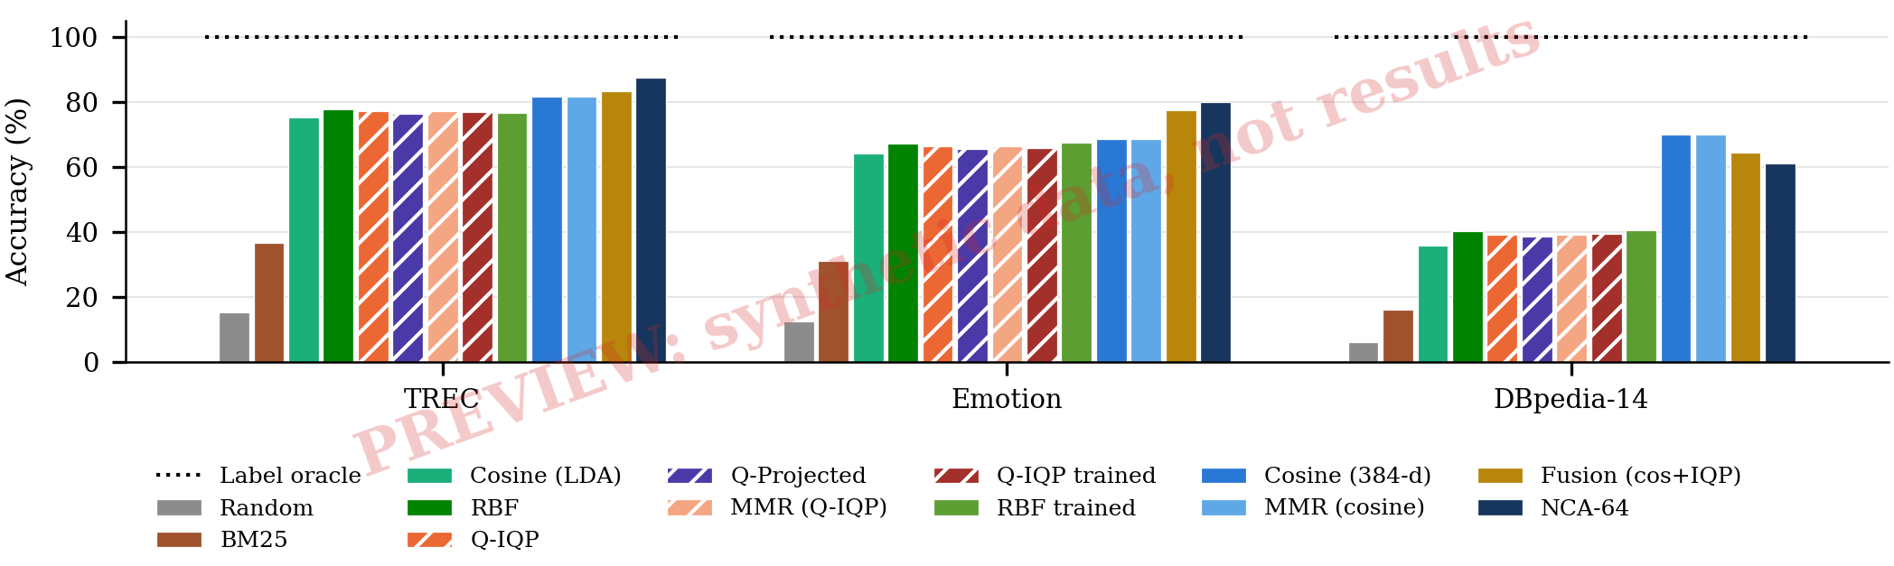
Fig. 3. Main-LLM accuracy of every selector per dataset. Hatched bars use a quantum kernel; the dotted line is the label oracle.
A quantum kernel that only ties an RBF kernel on five features could still matter if both beat the retrievers people use. Table V and Fig. 3 test this. [FILL: written by the code from your results] [FILL: written by the code from your results] [FILL: written by the code from your results] The oracle row shows how much any similarity function could still gain: with the main LLM, XYZ points on TREC, XYZ on Emotion and XYZ on DBpedia-14 above the best real selector.
Trained kernels. A fixed circuit may simply be the wrong quantum kernel. When both sides learn one input scale per feature with the same objective (S16, S17): [FILL: written by the code from your results]

5.3 Why the selectors agree or differ (RQ2)
TABLE VI. Diagnostics computed without the LLM, averaged over settings. $g$: geometric difference (Eq. 6); $J$: Jaccard overlap of retrieved sets; Prec@4: label precision; AUROC$​_{ret}$ ($×100$).
Diagnostic (no LLM) | TREC | Emotion | DBpedia-14
$g\left(K_{RBF} ∥ K_{IQP}\right)$, smallest over $γ$ | XYZ | XYZ | XYZ
$g\left(K_{RBF} ∥ K_{IQP}\right)$, median $γ_{0}$ | XYZ | XYZ | XYZ
$g\left(K_{cos} ∥ K_{IQP}\right)$ | XYZ | XYZ | XYZ
$g\left(K_{RBF} ∥ K_{proj}\right)$ | XYZ | XYZ | XYZ
$J$(RBF, angle) | XYZ | XYZ | XYZ
$J$(RBF, IQP) | XYZ | XYZ | XYZ
$J$(RBF, projected) | XYZ | XYZ | XYZ
$J$(IQP, IQP 1024 shots) | XYZ | XYZ | XYZ
Precision@4, RBF | XYZ | XYZ | XYZ
Precision@4, IQP | XYZ | XYZ | XYZ
Precision@4, projected | XYZ | XYZ | XYZ
AUROC$​_{ret}$, RBF | XYZ | XYZ | XYZ
AUROC$​_{ret}$, IQP | XYZ | XYZ | XYZ
AUROC$​_{ret}$, cosine 384-d | XYZ | XYZ | XYZ
Table VI helps to read Table III. The overlap between RBF and the angle kernel S6 was between XYZ and XYZ across datasets. A high value is expected from Eq. (2): for small differences $\cos^{2}\left(u/2\right)=1−u^{2}/4+O\left(u^{4}\right)$, which matches $e^{−u^{2}/4}$ to second order, so Map A ranks nearby points almost as a Gaussian kernel does. The overlap between RBF and IQP ranged from XYZ to XYZ, and the geometric difference of IQP against RBF from XYZ to XYZ at the minimizing $γ$ (XYZ to XYZ at the median rule). [FILL: written by the code from your results]
The geometric difference compares kernel values; retrieval sees only their order. The rank agreement measures the order directly (geometry table in the supplementary material). [FILL: written by the code from your results] Kernel-target alignment (XYZ–XYZ for IQP against XYZ–XYZ for RBF) shows whether the quantum geometry fits the labels better than the classical one.
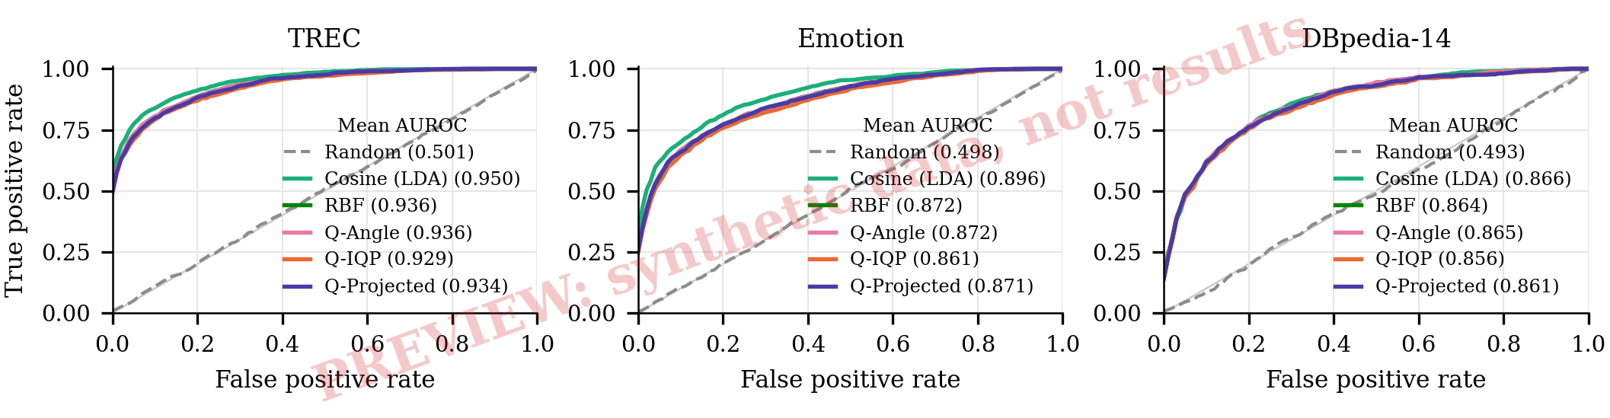
Fig. 4. Retrieval ROC curves (vertically averaged over the 500 test queries) at $d=5$, seed 0. A pool item counts as positive when it shares the query’s label. Legends give the mean retrieval AUROC.
Fig. 4 shows retrieval ROC curves for one setting. Averaged over all TREC settings (Table VI), the retrieval AUROC was XYZ for IQP and XYZ for RBF, against XYZ for cosine on the full embedding. [FILL: written by the code from your results]
Predicting the gap before paying. Across the XYZ TREC settings, the Spearman correlation between the absolute IQP-minus-RBF accuracy gap and $1−J$ was XYZ, and with $g$ it was XYZ. Over all selectors, datasets and both LLMs, label precision and LLM accuracy correlated with $ρ=$ XYZ (supplement). [FILL: written by the code from your results]

5.4 More qubits, with and without the LLM (RQ3)
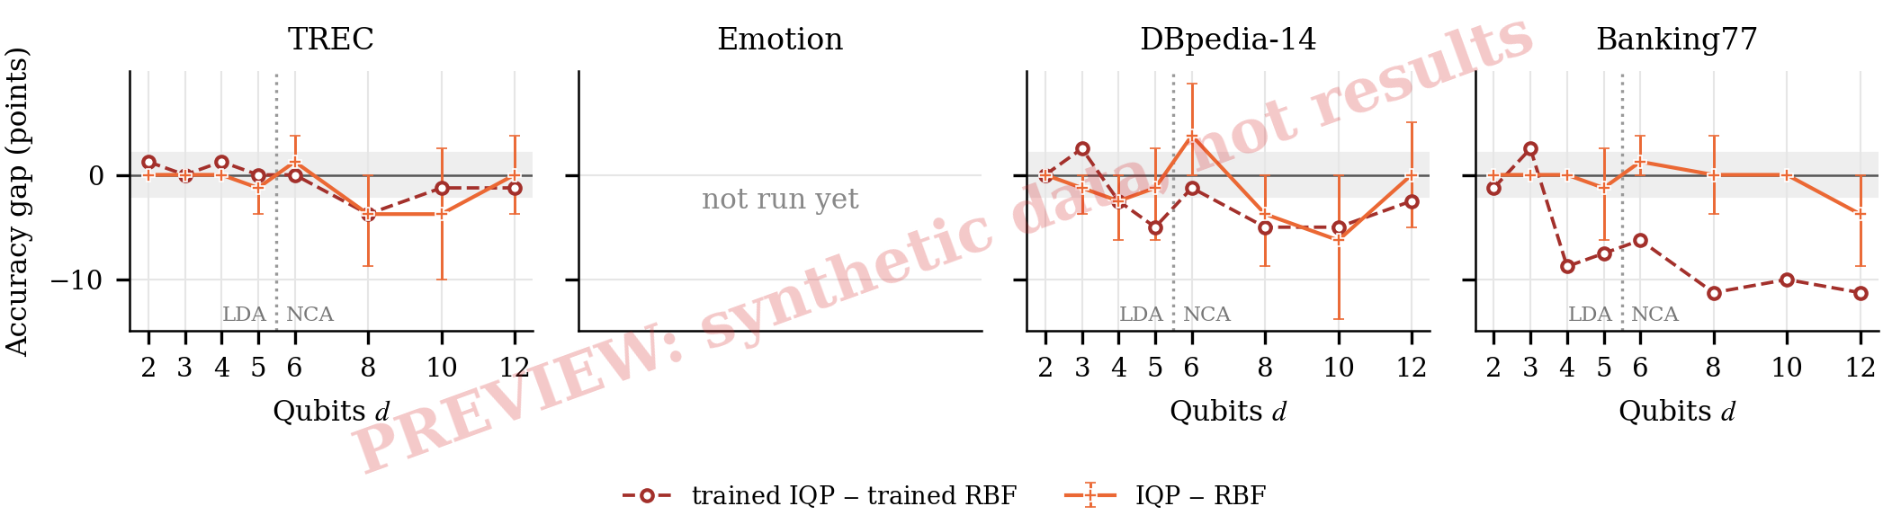
Fig. 5. Exploratory. IQP-minus-RBF accuracy gap with the open 1.5B LLM from two to twelve qubits (seed 0; LDA features up to five, NCA beyond), with 95% bootstrap intervals; the gray band is the $±2$-point margin. Dashed: the same gap for the two trained kernels.
The main runs use at most five LDA features, a regime in which every distance-based kernel may find the same neighbours. Fig. 5 lifts this limit with the LLM in the loop. [FILL: written by the code from your results]
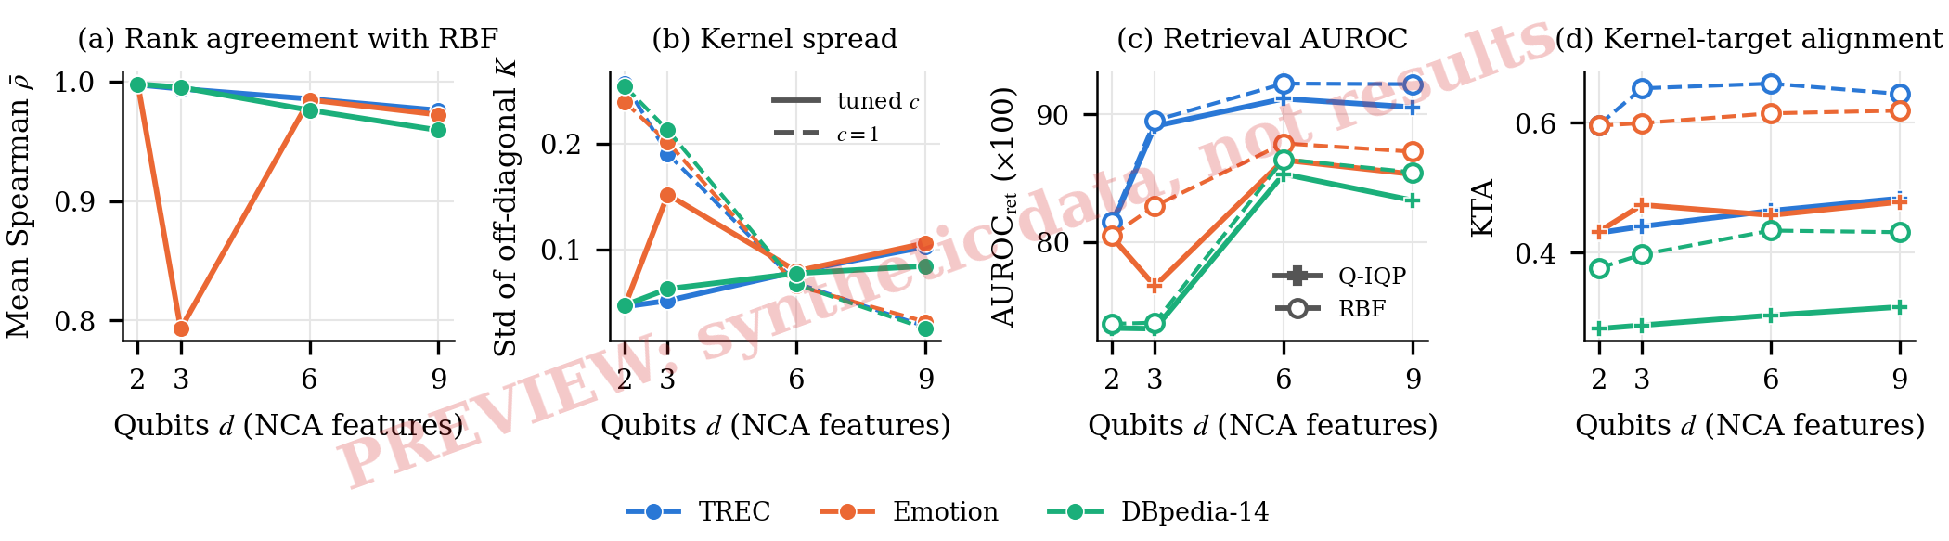
Fig. 6. Qubit scaling without the LLM (NCA features, seed 0). (a) Mean per-query rank correlation of IQP and RBF over the pool. (b) Spread of off-diagonal IQP kernel values at the tuned bandwidth (solid) and at $c=1$ (dashed). (c) Retrieval AUROC of IQP (solid) and RBF (dashed). (d) Kernel-target alignment of IQP (solid) and RBF (dashed).
Fig. 6 follows the kernels themselves from two to twelve qubits. [FILL: written by the code from your results]

5.5 A harder task: Banking77
TABLE VII. Exploratory. Banking77 (77 intents), seed 0, averaged over $d∈\{2,…,5\}$: accuracy (%) with the open 1.5B LLM and, where run, the main LLM, and retrieval AUROC ($×100$, open-LLM run). Best real selector per column in bold.
Selector | Acc (open) | Acc (main) | AUROC$​_{ret}$
Random | XYZ | XYZ | XYZ
BM25 (lexical) | XYZ | XYZ | XYZ
Cosine, 384-d | XYZ | XYZ | XYZ
MMR, cosine 384-d | XYZ | XYZ | –
NCA-64 (trained metric) | XYZ | XYZ | XYZ
Cosine, LDA | XYZ | XYZ | XYZ
RBF, LDA | XYZ | XYZ | XYZ
Quantum angle | XYZ | XYZ | XYZ
Quantum IQP | XYZ | XYZ | XYZ
Quantum projected | XYZ | XYZ | XYZ
RBF, trained scales | XYZ | XYZ | XYZ
Quantum IQP, trained scales | XYZ | XYZ | XYZ
Label oracle (bound) | XYZ | XYZ | –
With 77 intents, a compression to five LDA features is a hard test for any similarity function, and the label oracle shows how much room a better notion of similarity would have. [FILL: written by the code from your results] Fig. 5 has a Banking77 panel with up to twelve qubits.

5.6 Gate noise and shot noise
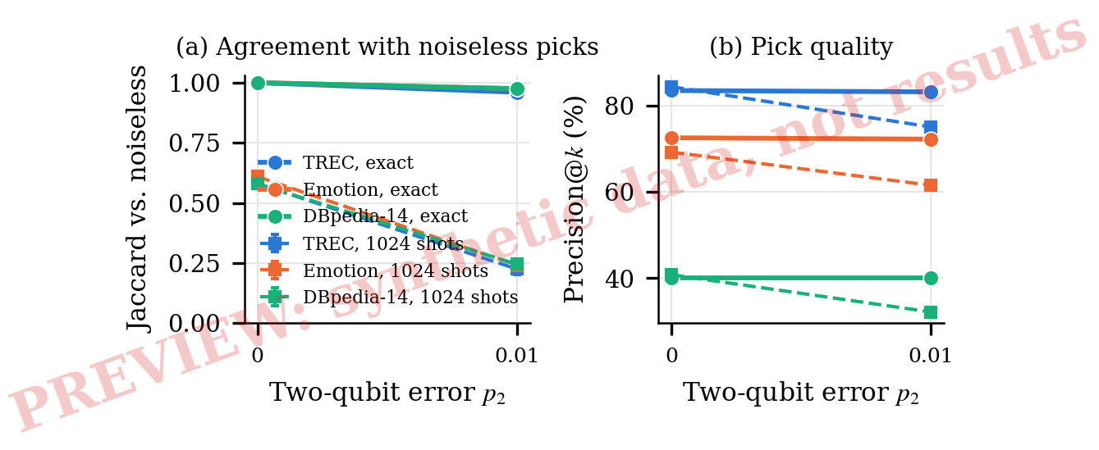
Fig. 7. Local depolarizing noise on TREC ($d=5$, seed 0). (a) Overlap of the noisy top-$k$ with the noiseless picks, with exact probabilities (solid) and 1,024 swap-test shots (dashed, five draws). (b) Label precision of the picks.
With 1,024 shots (TREC, seed 0, $d=5$), the IQP picks overlapped the exact picks with $J=$ XYZ, and LLM accuracy changed by XYZ points (XYZ). Kernel concentration and the effect of the number of shots are plotted in the supplementary material. [FILL: written by the code from your results] Fig. 7 adds gate noise. [FILL: written by the code from your results] The swap test, needed for mixed states, estimates $\left(1+K\right)/2$ and so has a larger variance for $K$ than the compute-uncompute estimate of Eq. (5); shot-only overlaps here are therefore not directly comparable with S9. [FILL: written by the code from your results]

5.7 Tuning the bandwidth with the LLM
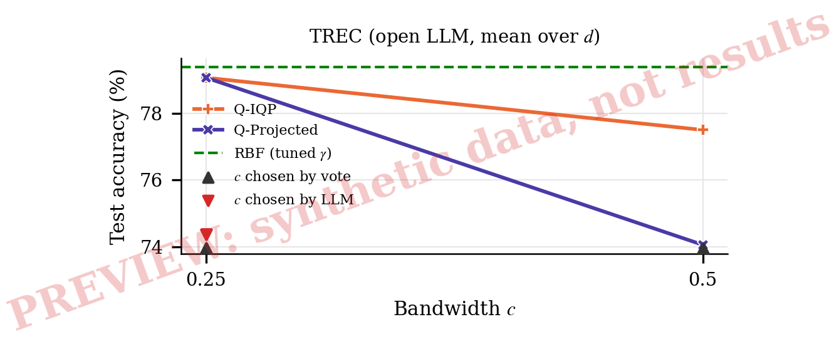
Fig. 8. Exploratory. Test accuracy of the quantum selectors at every bandwidth $c$ (open 1.5B LLM, seed 0, mean over $d$), against RBF, which does not depend on $c$. Markers at the bottom show the $c$ chosen by the neighbour vote and by the LLM on the validation set, one per $d$.
Our main runs tune $c$ with a neighbour vote so that the LLM never touches tuning. A reviewer may ask whether this choice hides an advantage. Fig. 8 answers it. [FILL: written by the code from your results]

5.8 Larger LLM, another encoder, more test items and more demonstrations
TABLE VIII. Exploratory. Robustness of the IQP-minus-RBF gap (points, pooled with 95% cluster bootstrap intervals). Eq.: equivalent to zero within $±2$ points by TOST; the number of seeds is in brackets. The last row uses 2,000 test items (not possible for TREC).
 |  | TREC |  | Emotion |  | DBpedia-14
LLM | Encoder | IQP$−$RBF [95% CI] | Eq. (seeds) | IQP$−$RBF [95% CI] | Eq. (seeds) | IQP$−$RBF [95% CI] | Eq. (seeds)
Main LLM | MiniLM | XYZ | XYZ | XYZ | XYZ | XYZ | XYZ
Qwen2.5-1.5B | MiniLM | XYZ | XYZ | XYZ | XYZ | XYZ | XYZ
Qwen2.5-7B (4-bit) | MiniLM | XYZ | XYZ | XYZ | XYZ | XYZ | XYZ
Qwen2.5-1.5B | MPNet | XYZ | XYZ | XYZ | XYZ | XYZ | XYZ
Qwen2.5-1.5B, 2,000 test | MiniLM | – | – | XYZ | XYZ | XYZ | XYZ
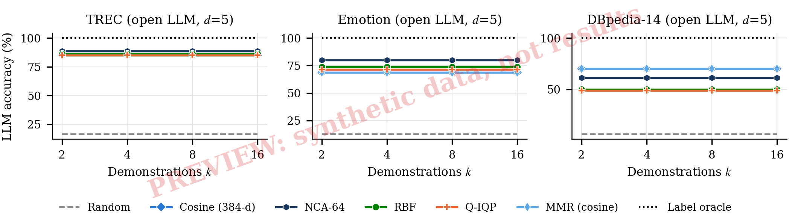
Fig. 9. Exploratory. Accuracy against the number of demonstrations $k$ (open 1.5B LLM, seed 0, largest $d$). The dotted line is the label oracle.
Table VIII repeats the primary contrast with a five times larger open model (a single-seed spot check), with a stronger encoder (TREC only), with three seeds everywhere and with four times as many test items. [FILL: written by the code from your results] With 2,000 test items the minimum detectable effect was XYZ points on Emotion and XYZ on DBpedia-14 (TOST $p=$ XYZ and XYZ); the Banking77 result is in Section 5.5. Fig. 9 varies the number of demonstrations. [FILL: written by the code from your results]

5.9 Difficulty, calibration, ablation and order
These analyses are exploratory; their tables and figures are in the supplementary material. Difficulty. An average gap near zero could hide a kernel that helps on hard queries and hurts on easy ones. [FILL: written by the code from your results] Calibration. On TREC the IQP selector gave the open LLM a macro AUROC of XYZ and an ECE of XYZ, against XYZ and XYZ for RBF; the paired bootstrap difference in AUROC was XYZ points (XYZ). [FILL: written by the code from your results] Ablation. We changed one component of the IQP selector at a time, without the LLM. [FILL: written by the code from your results] Order. Prompt order is a known source of variance [23]. Keeping the retrieved sets fixed and changing only their order moved the open model’s TREC accuracy by at most XYZ points for cosine, RBF and IQP. [FILL: written by the code from your results] [FILL: written by the code from your results]

6 Discussion
Quantum retrieval. A quantum kernel can only change what an LLM sees if it changes the ranking of the pool. Our diagnostics measure this directly: [FILL: written by the code from your results] [FILL: written by the code from your results] Proposition 2 says where any difference has to live. Whatever distinguishes the two kernels in their values rather than in the order they give each query’s pool, or far from the query rather than among its nearest items, is thrown away by the top-$k$ rule. Near the query, the IQP fidelity falls with a distance measured in the metric the circuit induces (its quantum Fisher information), which is a weighted quadratic form that can vary from point to point, whereas RBF uses one isotropic distance; whether the two orders agree is therefore an empirical question, and the rank agreement answers it. The scaling study asks whether this changes with more qubits, and the noise study whether hardware would add a difference of its own. [FILL: written by the code from your results]
What practitioners can take from this. Three lessons do not depend on the quantum question. [FILL: written by the code from your results] The overlap of retrieved sets, which needs no LLM call, [FILL: written by the code from your results] predict the LLM gap well enough to serve as a screen before paid runs. And a comparison that finds no significant difference is only informative with its power: an equivalence test and the detectable effect say how large a difference the data still allow. We suggest that work proposing quantum similarity for NLP report at least the rank agreement and overlap with an RBF kernel on the same features, the headroom to a label oracle, a classical kernel trained on equal terms, and an equivalence test.
Limitations. The LLM experiments use simulated circuits; gate noise enters only through a first-order local depolarizing model, without crosstalk, readout error or error mitigation. With the LLM, the runs beyond five qubits use NCA features, a single seed and the open model, and the scaling study reaches twelve qubits without an LLM. The main LLM is a single commercial model whose behaviour at temperature 0 may not be fully deterministic, which our caching hides but does not remove; the open models are small and medium sized, and the 7B model is a single-seed spot check. All four datasets are public and may have been seen during pretraining; contamination would raise absolute accuracy and could compress differences between selectors, which the oracle headroom partly measures. The secondary datasets use subsampled training data and one seed with the main LLM. Our trained kernels learn only input scales; kernels built for a known symmetry [29] or with trainable circuits [35] might behave differently.

7 Conclusion
We asked whether a quantum kernel retrieves better demonstrations for a frozen LLM when nothing else changes. In a testbed with sixteen selectors, four datasets and three LLMs, the preregistered verdict for the entangling IQP kernel against an RBF kernel on the same features was XYZ on TREC. [FILL: written by the code from your results] The angle-encoding kernel is classical, retrieval is blind to any monotone transform of a kernel, and the ablation [FILL: written by the code from your results]. The overlap of retrieved sets can be computed in seconds and [FILL: written by the code from your results] the size of the LLM gap. [FILL: written by the code from your results] Next steps are kernels designed for linguistic structure, hardware runs with error mitigation, and selectors that use a quantum kernel where the classical ranking is least certain.

Acknowledgment
The authors used an AI assistant (Claude, Anthropic) to help draft and edit parts of the text and the analysis code. The authors designed the study, ran all experiments, checked every result and reference, and take full responsibility for the content. Code, cached LLM answers and the preregistration are available at https://github.com/USERNAME/qkernel-icl.

References
[1] T. B. Brown et al., “Language models are few-shot learners,” in Advances in neural information processing systems, vol. 33, pp. 1877–1901, 2020.
[2] J. Liu, D. Shen, Y. Zhang, B. Dolan, L. Carin, and W. Chen, “What makes good in-context examples for GPT-3?” in Proc. Deep learning inside out (DeeLIO): The 3rd workshop on knowledge extraction and integration for deep learning architectures, pp. 100–114, 2022.
[3] O. Rubin, J. Herzig, and J. Berant, “Learning to retrieve prompts for in-context learning,” in Proc. NAACL-HLT, pp. 2655–2671, 2022.
[4] I. Levy, B. Bogin, and J. Berant, “Diverse demonstrations improve in-context compositional generalization,” in Proc. ACL, pp. 1401–1422, 2023.
[5] J. Ye, Z. Wu, J. Feng, T. Yu, and L. Kong, “Compositional exemplars for in-context learning,” in Proc. Int. Conf. Machine learning (ICML), pp. 39818–39833, 2023.
[6] V. Havlíček et al., “Supervised learning with quantum-enhanced feature spaces,” Nature, vol. 567, 209–212, 2019.
[7] M. Schuld, and N. Killoran, “Quantum machine learning in feature Hilbert spaces,” Physical Review Letters, vol. 122, no. 4, 040504, 2019.
[8] Y. Liu, S. Arunachalam, and K. Temme, “A rigorous and robust quantum speed-up in supervised machine learning,” Nature Physics, vol. 17, 1013–1017, 2021.
[9] H.-Y. Huang et al., “Power of data in quantum machine learning,” Nature Communications, vol. 12, 2631, 2021.
[10] S. Thanasilp, S. Wang, M. Cerezo, and Z. Holmes, “Exponential concentration in quantum kernel methods,” Nature Communications, vol. 15, 5200, 2024.
[11] R. Shaydulin, and S. M. Wild, “Importance of kernel bandwidth in quantum machine learning,” Physical Review A, vol. 106, no. 4, 042407, 2022.
[12] J. Bowles, S. Ahmed, and M. Schuld, “Better than classical? The subtle art of benchmarking quantum machine learning models,” arXiv preprint arXiv:2403.07059, 2024.
[13] J. Schnabel, and M. Roth, “Quantum kernel methods under scrutiny: A benchmarking study,” Quantum Machine Intelligence, 2025.
[14] R. Lorenz, A. Pearson, K. Meichanetzidis, D. Kartsaklis, and B. Coecke, “QNLP in practice: Running compositional models of meaning on a quantum computer,” Journal of Artificial Intelligence Research, vol. 76, 1305–1342, 2023.
[15] K. Meichanetzidis, A. Toumi, G. de Felice, and B. Coecke, “Grammar-aware sentence classification on quantum computers,” Quantum Machine Intelligence, vol. 5, 10, 2023.
[16] A. Vats, R. Raja, A. Kattamuri, and A. Bohra, “A systematic survey of quantum natural language processing: Models, encoding paradigms, and evaluation methods,” in Proc. QuantumNLP: Integrating quantum computing with natural language processing, pp. 53–64, 2025.
[17] P. Pal, D. Das, A. K. Kolya, and S. Bhattacharyya, “Hybrid classical-quantum framework for sentiment classification and claim check-worthiness identification in Bengali,” in Proc. QuantumNLP: Integrating quantum computing with natural language processing, pp. 10–19, 2025.
[18] D. K, F. S. Mohamad, D. V. Mohan, and R. Sheik, “A hybrid quantum-classical fusion for deep semantic paraphrase detection,” in Proc. QuantumNLP: Integrating quantum computing with natural language processing, pp. 20–25, 2025.
[19] A. Hassan, Z. Zhao, and M. A. Metawei, “Hybrid quantum-classical NLP classification with compact semantic representations: An experimental analysis of representation compression,” arXiv preprint arXiv:2609.10089, 2026.
[20] J. Singh, and R. Thakur, “Quantum-RAG and PunGPT2: Advancing low-resource language generation and retrieval for the Punjabi language,” arXiv preprint arXiv:2508.01918, 2025.
[21] J. M. Kübler, S. Buchholz, and B. Schölkopf, “The inductive bias of quantum kernels,” in Advances in neural information processing systems, vol. 34, pp. 12661–12673, 2021.
[22] M. Luo et al., “Dr.ICL: Demonstration-retrieved in-context learning,” arXiv preprint arXiv:2305.14128, 2023.
[23] Y. Lu, M. Bartolo, A. Moore, S. Riedel, and P. Stenetorp, “Fantastically ordered prompts and where to find them: Overcoming few-shot prompt order sensitivity,” in Proc. ACL, pp. 8086–8098, 2022.
[24] S. Min et al., “Rethinking the role of demonstrations: What makes in-context learning work?” in Proc. EMNLP, pp. 11048–11064, 2022.
[25] S. Robertson, and H. Zaragoza, “The probabilistic relevance framework: BM25 and beyond,” Foundations and Trends in Information Retrieval, vol. 3, no. 4, 333–389, 2009.
[26] J. Carbonell, and J. Goldstein, “The use of MMR, diversity-based reranking for reordering documents and producing summaries,” in Proc. ACM SIGIR conf. Research and development in information retrieval, pp. 335–336, 1998.
[27] G. V. Cormack, C. L. A. Clarke, and S. Büttcher, “Reciprocal rank fusion outperforms Condorcet and individual rank learning methods,” in Proc. ACM SIGIR conf. Research and development in information retrieval, pp. 758–759, 2009.
[28] M. Schuld, “Supervised quantum machine learning models are kernel methods,” arXiv preprint arXiv:2101.11020, 2021.
[29] J. R. Glick et al., “Covariant quantum kernels for data with group structure,” Nature Physics, vol. 20, 479–483, 2024.
[30] A. Canatar, E. Peters, C. Pehlevan, S. M. Wild, and R. Shaydulin, “Bandwidth enables generalization in quantum kernel models,” Transactions on Machine Learning Research, 2023.
[31] X. Wang, Y. Du, Y. Luo, and D. Tao, “Towards understanding the power of quantum kernels in the NISQ era,” Quantum, vol. 5, 531, 2021.
[32] V. Heyraud, Z. Li, Z. Denis, A. Le Boité, and C. Ciuti, “Noisy quantum kernel machines,” Physical Review A, vol. 106, no. 5, 052421, 2022.
[33] N. Cristianini, J. Shawe-Taylor, A. Elisseeff, and J. Kandola, “On kernel-target alignment,” in Advances in neural information processing systems (NIPS), vol. 14, pp. 367–373, 2002.
[34] C. Cortes, M. Mohri, and A. Rostamizadeh, “Algorithms for learning kernels based on centered alignment,” Journal of Machine Learning Research, vol. 13, 795–828, 2012.
[35] T. Hubregtsen, D. Wierichs, E. Gil-Fuster, P.-J. H. S. Derks, P. K. Faehrmann, and J. J. Meyer, “Training quantum embedding kernels on near-term quantum computers,” Physical Review A, vol. 106, no. 4, 042431, 2022.
[36] K. Sakka, K. Mitarai, and K. Fujii, “Automating quantum feature map design via large language models,” arXiv preprint arXiv:2504.07396, 2025.
[37] S. Cajas Ordóñez et al., “Quantum kernel advantage over classical collapse in medical foundation model embeddings,” arXiv preprint arXiv:2604.24597, 2026.
[38] Y. Pan et al., “Bridging classical and quantum computing for next-generation language models,” in Proceedings of the AAAI symposium series, vol. 7, pp. 381–389, 2025.
[39] T. A. Laine, “Quantum LLMs using quantum computing to analyze and process semantic information,” arXiv preprint arXiv:2512.02619, 2025.
[40] N. Reimers, and I. Gurevych, “Sentence-BERT: Sentence embeddings using Siamese BERT-networks,” in Proc. EMNLP-IJCNLP, pp. 3982–3992, 2019.
[41] W. Wang, F. Wei, L. Dong, H. Bao, N. Yang, and M. Zhou, “MiniLM: Deep self-attention distillation for task-agnostic compression of pre-trained transformers,” in Advances in neural information processing systems, vol. 33, pp. 5776–5788, 2020.
[42] K. Song, X. Tan, T. Qin, J. Lu, and T.-Y. Liu, “MPNet: Masked and permuted pre-training for language understanding,” in Advances in neural information processing systems (NeurIPS), vol. 33, pp. 16857–16867, 2020.
[43] R. A. Fisher, “The use of multiple measurements in taxonomic problems,” Annals of Eugenics, vol. 7, no. 2, 179–188, 1936.
[44] J. Goldberger, S. Roweis, G. Hinton, and R. Salakhutdinov, “Neighbourhood components analysis,” in Advances in neural information processing systems, vol. 17, 2004.
[45] D. Shepherd, and M. J. Bremner, “Temporally unstructured quantum computation,” Proceedings of the Royal Society A, vol. 465, no. 2105, 1413–1439, 2009.
[46] Qwen Team, “Qwen2.5 technical report,” arXiv preprint arXiv:2412.15115, 2024.
[47] T. Dettmers, A. Pagnoni, A. Holtzman, and L. Zettlemoyer, “QLoRA: Efficient finetuning of quantized LLMs,” in Advances in neural information processing systems (NeurIPS), vol. 36, 2023.
[48] T. Fawcett, “An introduction to ROC analysis,” Pattern Recognition Letters, vol. 27, no. 8, 861–874, 2006.
[49] M. A. Nielsen, and I. L. Chuang, Quantum computation and quantum information. Cambridge University Press, 2010.
[50] X. Li, and D. Roth, “Learning question classifiers,” in Proc. COLING, 2002.
[51] E. Saravia, H.-C. T. Liu, Y.-H. Huang, J. Wu, and Y.-S. Chen, “CARER: Contextualized affect representations for emotion recognition,” in Proc. EMNLP, pp. 3687–3697, 2018.
[52] X. Zhang, J. Zhao, and Y. LeCun, “Character-level convolutional networks for text classification,” in Advances in neural information processing systems, vol. 28, 2015.
[53] I. Casanueva, T. Temčinas, D. Gerz, M. Henderson, and I. Vulić, “Efficient intent detection with dual sentence encoders,” in Proc. 2nd workshop on natural language processing for conversational AI, pp. 38–45, 2020.
[54] C. Guo, G. Pleiss, Y. Sun, and K. Q. Weinberger, “On calibration of modern neural networks,” in Proc. Int. Conf. Machine learning (ICML), pp. 1321–1330, 2017.
[55] Q. McNemar, “Note on the sampling error of the difference between correlated proportions or percentages,” Psychometrika, vol. 12, no. 2, 153–157, 1947.
[56] S. Holm, “A simple sequentially rejective multiple test procedure,” Scandinavian Journal of Statistics, vol. 6, no. 2, 65–70, 1979.
[57] R. Dror, G. Baumer, S. Shlomov, and R. Reichart, “The hitchhiker’s guide to testing statistical significance in natural language processing,” in Proc. ACL, pp. 1383–1392, 2018.
[58] D. J. Schuirmann, “A comparison of the two one-sided tests procedure and the power approach for assessing the equivalence of average bioavailability,” Journal of Pharmacokinetics and Biopharmaceutics, vol. 15, no. 6, 657–680, 1987.
[59] D. Lakens, “Equivalence tests: A practical primer for $t$ tests, correlations, and meta-analyses,” Social Psychological and Personality Science, vol. 8, no. 4, 355–362, 2017.
[60] Z. Zhao, E. Wallace, S. Feng, D. Klein, and S. Singh, “Calibrate before use: Improving few-shot performance of language models,” in Proc. Int. Conf. Machine learning (ICML), pp. 12697–12706, 2021.
[61] D. Card, P. Henderson, U. Khandelwal, R. Jia, K. Mahowald, and D. Jurafsky, “With little power comes great responsibility,” in Proc. Conf. Empirical methods in natural language processing (EMNLP), pp. 9263–9274, 2020.
[62] V. Bergholm, J. Izaac, M. Schuld, C. Gogolin, et al., “PennyLane: Automatic differentiation of hybrid quantum-classical computations,” arXiv preprint arXiv:1811.04968, 2018.

