Getweather.py V1.0 readme

This document serves as guide to deploy and use getweather script.

Download “getweather.py” & “city.list.json” and store it to /home/user directory.  
Note – both files must be stored to same location

**Info:**  
GETWEATHER_API_KEY : 813c581f9ee77f230ed5bc4aa616452b  
USER: Default  
Script gather data from <https://openweathermap.org/api> .

**Workflow:**Parameters are not used when running script.

**1.**Script first check environment variables if API Key is set, otherwise will prompt user to enter the API KEY. Value is then stored to variable and env for the current process. Is no key is provided, script is terminated. ( Before executing script, you can run “export OPENWEATHER_API_KEY=813c581f9ee77f230ed5bc4aa616452b” to avoid typing the key in running process.)

**2.**User is prompted to enter the CITY name. If no CITY is entered, user is prompted again to enter the CITY name. If not provided, script is terminated.

**3.**City name that user entered is then compared to data in “city.list.json” “database” file, downloaded from “openweathermap.org” and check if the city exists. If city doesn’t exists, script is terminated.

**4.**Http request is processed to retrieve data from API. Based on response status code, script is terminated with error message or continues.

**5.**Data retrieved from request are formatted and final output is displayed to user. Also the environment variables for CITY_NAME & OPENWEATHER_API_KEYare displayed to user. See output screenshots bellow.

When API_KEY is not set in env:  
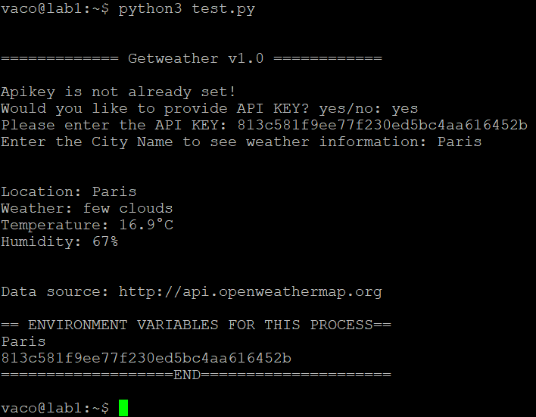

When API KEY is set in env:  
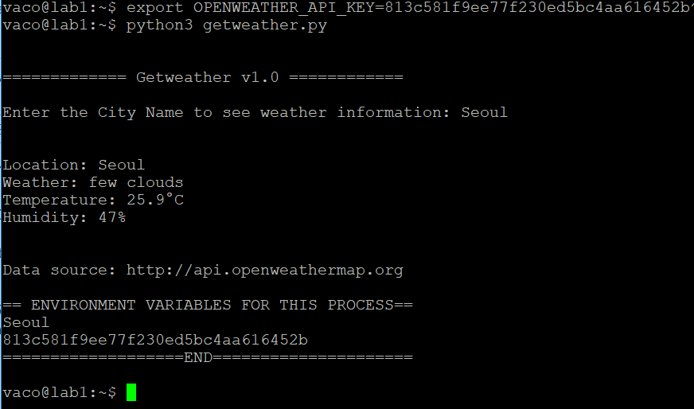

**Usage:**  
Run “getweather.py” script using python3. (python3 getweather.py)