Database Technical Documentation

ER Diagram
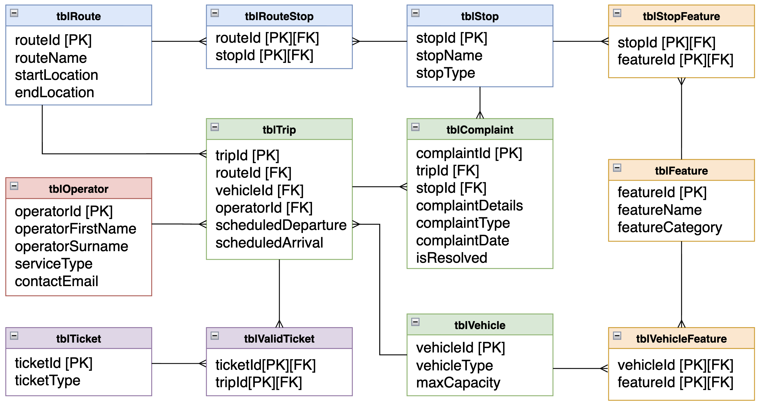

Data Dictionary
Key:
R = Required | Y | Yes | N | No
I = Indexed | Y | Yes | N | No | U | Unique

Database Name | CSC1034_2526_044

Table Name | tblRoute | Key Field(s) | routeId

Foreign Key Table Name | Foreign Key Field
N/A | N/A

General Table Description:
This table describes the routes that passengers can take, either on the bus or train. It describes a general route that users can identify by it’s unique name and the start and end location.

Field Name | R | I | Data Type | Len | Validation Rule | Default Value | Description | Typical Data
routeId | Y | U | Int | n/a | Primary key, AUTO INCREMENT, must be unique, not null | n/a | Uniquely identifies a route. | 100
routeName | Y | N | VARCHAR | 100 | Not null | n/a | The name of the route that can be identified by customers. | 8b
startLocation | Y | N | VARCHAR | 50 | Not null | n/a | The start location of the bus/train route. | Derry
endLocation | Y | N | VARCHAR | 50 | Not null | n/a | The end location of the bus/train route. | Belfast

Table-wide Constraints:
Combination of routeName, endLocation, and startLocation should be unique.

Table Name | tblRouteStop | Key Field(s) | routeId, stopId

Foreign Key Relationships
Foreign Key Table Name | Foreign Key Field
tblRoute | routeId
tblStop | stopId

General Table Description:
Resolves the many-to-many relationship between routes and stops by recording which stops the vehicle can stop at on a route

Field Name | R | I | Data Type | Len | Validation Rule | Default Value | Description | Typical Data
routeId | Y | Y | INT | N/A | Not NULL, Numeric, Exists in tblRoute | N/A | Identifies a route that the stop is associated with. Part of a composite key | 14
stopId | Y | Y | INT | N/A | Not NULL, Numeric, Exists in tblStop | N/A | Identifies a stop assigned to the route. Part of a composite key | 309

Table Name | tblStop | Key Field(s) | stopId

Foreign Key Table Name | Foreign Key Field
N/A | N/A

General Table Description:
Stores details of stops that vehicles can stop at, including the name of the stop, and the type of stop it is

Field Name | R | I | Data Type | Len | Validation Rule | Default Value | Description | Typical Data
stopId | Y | U | INT | N/A | Primary Key, Auto Increment, Unique, Not NULL, numeric | N/A | Unique identifier for the stop within the database | 52
stopName | Y | U | VARCHAR | 225 | Not NULL, Unique | N/A | The name of the stop allowing it to be identified by customers | Grand Central Station
stopType | Y | Y | ENUM (‘Bus Stop’ ‘Train Station’ ‘Bus & Train Station’ ‘Buscentre’) | N/A | Not NULL | N/A | The type of stop, describing if it is a building (station vs stop) and which vehicles pass through it | Bus & Train Station

Table Name | tblStopFeature | Key Field(s) | stopId, featureId

Foreign Key Relationships
Foreign Key Table Name | Foreign Key Field
tblStop | stopId
tblFeature | featureId

General Table Description:
Resolves the many-to-many relationship between stops and features by recording what features are a part of each stop

Field Name | R | I | Data Type | Len | Validation Rule | Default Value | Description | Typical Data
stopId | Y | Y | INT | N/A | Not NULL, Numeric, Exists in tblStop | N/A | Unique identifier for the stop a feature applies to | 87
featureId | Y | Y | INT | N/A | Not NULL, Numeric, exists in tblFeature | N/A | Unique identifier for the feature that applied to a stop | 3

Table Name | tblFeature | Key Field(s) | featureId

Foreign Key Table Name | Foreign Key Field
N/A | N/A

General Table Description:
Stores details of features that a stop or vehicle can have, including the name of the feature and the category of the feature i.e. whether it’s associated with a vehicle or stop.

Field Name | R | I | Data Type | Len | Validation Rule | Default Value | Description | Typical Data
featureId | Y | U | INT | N/A | Primary Key, unique, auto increment, NOT NULL | N/A | Primary Key, unique identifier for each feature | 3
featureName | Y | U | VARCHAR | 50 | NOT NULL | N/A | Name of feature | Ramp
featureCategory | Y | Y | ENUM | N/A | NOT NULL, must be ‘Vehicle’ or ‘Stop’ | N/A | Name of category | Bus

Table Name | tblVehicleFeature | Key Field(s) | vehicleId, featureId

Foreign Key Relationships
Foreign Key Table Name | Foreign Key Field
tblVehicle | vehicleId
tblFeature | featureId

General Table Description:
Resolves the many-to-many relationship between stops and features by recording what features are a part of each vehicle.

Field Name | R | I | Data Type | Len | Validation Rule | Default Value | Description | Typical Data
vehicleId | Y | Y | Int | n/a | Part of Primary Key, Foreign key referencing Vehicle(VehicleId), NOT NULL) | n/a | Foreign Key uniquely identifying a vehicle. | 6
featureId | Y | Y | Int | n/a | Part of Primary Key, Foreign key referencing Feature(FeatureId), NOT NULL) | n/a | Foreign key uniquely identifying a feature. | 7

Table Name | tblVehicle | Key Field(s) | vehicleId

Foreign Key Table Name | Foreign Key Field
N/A | N/A

General Table Description:
Stores details of vehicles owned by the organisation, including the type of vehicle and the vehicle capacity

Field Name | R | I | Data Type | Len | Validation Rule | Default Value | Description | Typical Data
vehicleId | Y | U | INT | N/A | Primary Key, unique, auto increment, NOT NULL | N/A | Primary Key, unique identifier for each complaint | 43
vehicleType | Y | Y | ENUM | N/A | NOT NULL, must be ‘Metro’, ‘Glider’, ‘Foyle Metro’, ‘Goldliner’, ‘Ulsterbus’, ‘NI Railways’ or ‘Airport Express 300’ | N/A | Different types of vehicles | Metro
maxCapacity | Y | N | INT | N/A | Not NULL, Numeric | N/A | The number of passengers that can fit on a vehicle at once | 30

Table Name | tblComplaint | Key Field(s) | complaintId

Foreign Key Relationships
Foreign Key Table Name | Foreign Key Field
tblTrip | tripId
tblStop | stopId

General Table Description:
Stores details of complaints made by customers, including the trip or stop the complaint is about, the date the complaint was submitted, and whether it has been resolved by Translink

Field Name | R | I | Data Type | Len | Validation Rule | Default Value | Description | Typical Data
complaintId | Y | U | INT | N/A | Primary Key, unique, auto increment, NOT NULL | N/A | Primary Key, unique identifier for each complaint | 7
tripId | Y | U | INT | N/A | Exists in TRIP  If tripId IS NULL, stopId IS NOT NULL and if stopId IS NULL, tripId IS NOT NULL | N/a | Foreign Key referencing  trip(trip id) | 32
stopId | Y | U | INT | N/A | Exists in STOP  If tripId IS NULL, stopId IS NOT NULL and if stopId IS NULL, tripId IS NOT NULL | N/A | Foreign Key referencing  stop(stop id) | 4
complaintDetails | Y | N | VARCHAR | 300 | NOT NULL | N/A | Description of complaint | The train departed late
complaintType | Y | Y | ENUM | N/A | NOT NULL  Must be one of the following:  ‘Accessibility’, ‘Service’, ‘Reliability’, ‘Staff behaviour’, ‘Vehicle Condition’, ‘Stop condition’, ‘Safety’ or ‘Other’ | N/A | The type of complaint | Accessibility
complaintDate | Y | N | DATETIME | N/A | Valid Date, NOT NULL | CURRENT_TIMESTAMP | Date complaint was created | 2026-03-20 19:00
isResolved | Y | Y | TINYINT | 1 | NOT NULL, must be 0 or 1, defaults to 0 | 0 | Whether complaint is resolved or not | 0
Table-wide Constraints:
If tripId is null, then stopId should not be null, and if stopId is null, tripId should not be null. This constraint is to be named chk_trip_or_stop_new
Table Name | tblTrip | Key Field(s) | tripId

Foreign Key Relationships
Foreign Key Table Name | Foreign Key Field
tblRoute | routeId
tblVehicle | vehicleId
tblOperator | operatorId

General Table Description:
This Table stores the trip information for trips within the system.

Field Name | R | I | Data Type | Len | Validation Rule | Default Value | Description | Typical Data
tripId | Y | Y | INT | N/A | Unique, Numeric, auto-increment, NOT NULL | N/A | Primary key; unique  identifier for each trip | 1, 2, 3
routeId | Y | Y | INT | N/A | Numeric, Exists within tblRoute, NOT NULL | N/A | Foreign Key referencing tblRoute for this trip | 1, 2, 3
vehicleId | Y | Y | INT | N/A | Numeric, Exists within tblVehicle, NOT NULL | N/A | Foreign Key referencing tblVehicle for this trip | 1, 2, 3
operatorId | Y | Y | INT | N/A | Numeric, Exists within tblOperator, NOT NULL | N/A | Foreign Key referencing tblOperator for this trip | 1, 2, 3
scheduledDeparture | Y | Y | DATETIME | N/A | Valid Time, NOT NULL | N/A | Planned Date and Time of Departure for the trip | 24-03-2026  09:30
scheduledArrival | Y | N | DATETIME | N/A | Valid Time, NOT NULL | N/A | Planned Date and Time of Arrival for the Trip | 24-03-2026  14:34

Table-wide Constraints:
The combination of vehicleId and scheduledDeparture should be unique and the combination of operatorId and scheduledDeparture should be unique.
scheduledArrival should be after scheduledDeparture, and this constraint is so be named chk_arrival_after_departure
Table Name | tblOperator | Key Field(s) | operatorId

Foreign Key Table Name | Foreign Key Field
N/A | N/A

General Table Description:
This Table stores the operator information for the company operators.

Field Name | R | I | Data Type | Len | Validation Rule | Default Value | Description | Typical Data
operatorId | Y | Y | INT | N/A | Unique, Numeric, auto-increment, NOT NULL | N/A | Primary key; unique  identifier for each operator | 1, 2, 3
operatorFirstName | Y | N | VARCHAR | 50 | NOT NULL | N/A | Operators First Name | ‘Jeff’, ‘Harold’, ‘Susan’
operatorSurname | Y | Y | VARCHAR | 50 | NOT NULL | N/A | Operators Surname | ‘O’Connell’, ‘Taylor’, ‘Smith’
serviceType | Y | Y | ENUM | N/A | NOT NULL  (Bus, Train, etc) | N/A (must be specified) | What service does the operator run | ‘Train’
contactEmail | Y | N | VARCHAR | 100 | NOT NULL,  UNIQUE | N/A | Contact email for the operator | ‘john.Taylor@translink.co.uk’

Table Name | tblValidTicket | Key Field(s) | ticketId, tripId

Foreign Key Relationships
Foreign Key Table Name | Foreign Key Field
tblTicket | ticketId
tblTrip | tripId

General Table Description:
This Table links the tickets to the trips on which they were used in the form of a valid ticket table.

Field Name | R | I | Data Type | Len | Validation Rule | Default Value | Description | Typical Data
ticketId | Y | Y | INT | N/A | Numeric, Foreign Key, NOT NULL | N/A | Part of composite Primary key; creates part of a unique valid ticket. - foreign key from tblTicket | 1, 2, 3
tripId | Y | Y | INT | N/A | Numeric, Foreign Key, NOT NULL | N/A | Part of composite Primary key; creates part of a unique valid ticket. - foreign key from tblTrip | 1, 2, 3

Table Name | tblTicket | Key Field(s) | ticketId

Foreign Key Table Name | Foreign Key Field
N/A | N/A

General Table Description:
Stores details of tickets or travel passes that have been issued to customers, including the type of ticket, or travel pass

Field Name | R | I | Data Type | Len | Validation Rule | Default Value | Description | Typical Data
ticketId | Y | U | INT | N/A | Primary Key, AUTO INCREMENT,  must be unique, NOT NULL | None | Unique identifier for each ticket | 1, 2, 3
ticketType | Y | Y | ENUM | N/A | NOT NULL,  Must be one of the following: ‘Single’, ‘Return’, ‘Half Fare’, ‘SmartPass’, ‘Senior SmartPass’, ‘Registered Blind SmartPass’, ‘War Disablement SmartPass’) | None | The type of ticket, or travel pass | Single

CRUD Requirements

Create Operations
There will be functionality for adding new records to the following tables:
tblRoute | Enter route name, start location and end location
tblStop | Enter stop name and select stop type
tblFeature | Enter feature name and select feature category
tblVehicle | Enter vehicle type and maximum capacity
tblOperator | Enter operator first name, surname and email, and select the service type they operate on
tblTrip | Select the route, vehicle and operator and enter the scheduled departure and arrival date and time
tblRouteStop | Select route and new stop
tblStopFeature | Select stop and new feature
tblVehicleFeature | Select vehicle and new feature

We won’t include CREATE functionality for tblTicket, tblValidTicket, or tblComplaint, because the data for these tables will be coming from an external source and allowing their manual creation could reduce data integrity.

Read Operations
There will be functionality for reading details of records from the following tables:
tblTrip | Reads the vehicle, operator, scheduledDeparture and scheduledArrival
tblRoute | Reads the route name, start location and end location
tblStop | Reads the stop name and stop type
tblComplaint | Reads the route name or stop name, scheduled departure date and time, complaint details, complaint type, complaint date and whether it has been resolved
tblOperator | Reads the operator’s first name, surname, email and service type

Update Operations
There will be functionality for updating records from the following tables:
tblTrip | Update the vehicle, operator, scheduledDeparture and scheduledArrival
tblRoute | Update the route name, start location and end location
tblStop | Update the stop name and stop type
tblComplaint | Update if the complaint has been resolved
tblOperator | Update the operator’s first name, surname, email and service type

We won’t include UPDATE or READ functionality for tblRouteStop, tblStopFeature, tblVehicleFeature as these are link tables, nor tblTicket or tblValidTicket as altering these could cause data integrity issues.

Delete Operations
There will be functionality for deleting records from the following tables:
tblRouteStop | Select a route, and then a stop you want to delete from the route
tblStopFeature | Select a stop, and then a feature you want to delete from the stop
tblVehicleFeature | Select a vehicle, and then a feature you want to delete from the vehicle
tblFeature | Select a feature you want to delete
tblComplaint | Select a complaint you want to delete (This functionality will be added in case a complaint received is not a valid complaint for example if a complaint description is “abcdefghijk”)

We won’t include DELETE functionality for tblRoute, tblStop, tblOperator, tblTrip, tblTicket, tblValidTicket, or tblVehicle, as all of these include historical data that if deleted, would cause data integrity and reporting issues.

Business Questions for Reporting
What vehicles are related to accessibility complaints?
What percentage of stops provide accessibility for people with visual impairments?
Which stops should be prioritised for accessibility improvements?
When do vulnerable passengers travel most?
Which Stops are the Least Accessible?
Which routes have the highest accessibility complaints?
What percentage of vehicles provide wheelchair accessibility?
What accessibility‑related features are available at each stop across the network?
How many transport routes include at least one stop serving a hospital?
What percentage of stops have accessibility features?
How many stops on each route have accessibility features?
What accessibility features are available on each vehicle?
Which routes have the highest demand from passengers requiring accessibility support?
Which stops have the highest number of accessibility related complaints?
How effectively are accessibility complaints being resolved over time?

