[SCHOOL NAME]
[College / Department]

WAREHOUSE MANAGEMENT SYSTEM
for I.O.T Warehouse
A Java Desktop Information System for Warehouses, Products, Receiving, Releasing and Stock Transfers
Developed with Java Swing, Java AWT, JDBC and Apache Derby
A Project Presented to
[Instructor Name]
In Partial Fulfillment of the Requirements for
[Course Code - Course Title]
Submitted by:
[Member 1 - Full Name]
[Member 2 - Full Name]
[Member 3 - Full Name]
[Member 4 - Full Name]

[Month Year]
TABLE OF CONTENTS
CHAPTER 1 - INTRODUCTION 1
1.1 Background of the Study 1
1.2 System Overview 1
1.3 Problem Statement 1
1.4 Objectives 2
General Objective 2
Specific Objectives 2
1.5 Scope and Limitations 2
Scope (included features) 2
Limitations (outside the scope) 3
1.6 Significance of the Project 3
1.7 Definition of Terms 3
CHAPTER 2 - SYSTEM ANALYSIS AND DESIGN 5
2.1 Existing System 5
2.2 Proposed System 5
2.3 Functional Requirements 6
2.4 Non-Functional Requirements 6
2.5 System Users 7
2.6 Use Case Diagram 8
2.7 System Flowchart 9
2.8 Data Flow Diagram 10
2.9 Entity Relationship Diagram 12
Relationship Explanation 14
2.10 Database Design 14
2.10.1 Table Relationship Diagram 14
2.10.2 Normalization 16
2.10.3 Constraints 16
2.10.4 Data Dictionary 16
CHAPTER 3 - SYSTEM DEVELOPMENT 21
3.1 Development Tools 21
3.2 Java Swing 21
3.3 Java AWT 22
3.4 JDBC 22
3.5 Apache Derby 22
3.6 System Architecture 24
3.7 Program Structure 24
3.8 Database Connection 28
3.9 CRUD Implementation 28
CREATE - INSERT 28
READ - SELECT with INNER JOIN, WHERE and ORDER BY 29
UPDATE and DELETE 30
Saving a document in one transaction 30
Stock update that can never go below zero 31
SQL operations demonstrated 31
3.10 GUI Implementation 32
3.10.1 GUI Navigation 32
3.10.2 Start-up, Login and Dashboard 34
3.10.3 Transactions 37
3.10.4 Master Data and User Management 41
3.10.5 Reports 46
3.10.6 Other Screens and Role-Based Access 49
CHAPTER 4 - TESTING 51
4.1 Test Plan 51
4.2 Test Cases 51
4.3 Login and Security Testing 52
4.4 Input Validation Testing 53
4.5 CRUD Testing 53
4.6 Database Testing 54
4.7 Search and Report Testing 54
4.8 Error Handling Testing 55
4.9 User Acceptance Testing 55
CHAPTER 5 - CONCLUSION 57
5.1 Summary 57
5.2 Conclusions 57
5.3 Recommendations 57
5.4 Possible Future Improvements 57
APPENDIX A - SQL STATEMENTS 59
A.1 Database Schema (schema.sql) 59
A.2 Sample CRUD Statements 62
A.3 Stock Updates (inside a transaction) 63
A.4 Report Queries 63
APPENDIX B - USER GUIDE 64
B.1 Running the Program 64
B.2 Common Tasks 64
APPENDIX C - COMPLIANCE WITH THE PROJECT REQUIREMENTS 65

LIST OF FIGURES
Figure 1 . Use case diagram 8
Figure 2 . System flowchart 9
Figure 3 . Data flow diagram, Level 0 (context diagram) 10
Figure 4 . Data flow diagram, Level 1 11
Figure 5 . Entity relationship diagram (crow's foot notation) 13
Figure 6 . Table relationship diagram (keys only) 15
Figure 7 . System architecture 24
Figure 8 . Class diagram - model package 26
Figure 9 . Class diagram - ui, dao, database and util packages 27
Figure 10 . GUI navigation diagram 33
Figure 11 . Splash screen - starting the Derby database server 34
Figure 12 . Login screen 34
Figure 13 . Login screen after an invalid password 35
Figure 14 . Error message for incorrect credentials 35
Figure 15 . Dashboard (Administrator) 36
Figure 16 . Inventory - stock on hand per warehouse with LOW / OUT status 36
Figure 17 . Receiving - new document with two product lines 37
Figure 18 . Receiving history with keyword, date range and status filters 38
Figure 19 . Transaction details dialog (a voided receiving) 38
Figure 20 . Releasing - the available stock is shown while adding items 39
Figure 21 . Validation: releasing more than the available stock 39
Figure 22 . Stock transfer - new document 40
Figure 23 . Stock transfer history 40
Figure 24 . Product management (a record loaded for updating) 41
Figure 25 . Validation message for a required field 41
Figure 26 . Confirmation before deleting a record 42
Figure 27 . A record in use cannot be deleted (foreign key) 42
Figure 28 . Category management 43
Figure 29 . Warehouse management 43
Figure 30 . Supplier management 44
Figure 31 . Customer management 44
Figure 32 . User management (Administrator only) 45
Figure 33 . Report - Inventory Status 46
Figure 34 . Report - Low Stock / Reorder List 47
Figure 35 . Report - Stock Movement History 47
Figure 36 . Report - Warehouse Summary 48
Figure 37 . Report - Monthly In/Out Summary 48
Figure 38 . Change password dialog 49
Figure 39 . About dialog with the I.O.T Warehouse logo 49
Figure 40 . Logout confirmation 50
Figure 41 . Warehouse Staff view: master data is view-only; no Reports or Users 50

LIST OF TABLES
Table 1 . Significance of the project 3
Table 2 . Definition of terms 3
Table 3 . Problems of the existing manual system 5
Table 4 . How the proposed system works 5
Table 5 . Functional requirements 6
Table 6 . Non-functional requirements 6
Table 7 . System users 7
Table 8 . Access rights by role 7
Table 9 . Processes of the Level 1 data flow diagram 12
Table 10 . Relationships between the tables 14
Table 11 . Normalization 16
Table 12 . Database constraints 16
Table 13 . Data dictionary: USERS 16
Table 14 . Data dictionary: CATEGORIES 17
Table 15 . Data dictionary: PRODUCTS 17
Table 16 . Data dictionary: WAREHOUSES 17
Table 17 . Data dictionary: SUPPLIERS 17
Table 18 . Data dictionary: CUSTOMERS 18
Table 19 . Data dictionary: WAREHOUSE_STOCK 18
Table 20 . Data dictionary: RECEIVINGS 18
Table 21 . Data dictionary: RECEIVING_ITEMS 18
Table 22 . Data dictionary: RELEASES 19
Table 23 . Data dictionary: RELEASE_ITEMS 19
Table 24 . Data dictionary: STOCK_TRANSFERS 19
Table 25 . Data dictionary: TRANSFER_ITEMS 19
Table 26 . Development tools 21
Table 27 . Swing components used 21
Table 28 . AWT features used 22
Table 29 . JDBC classes used 22
Table 30 . Database settings 23
Table 31 . Packages 25
Table 32 . SQL features used 31
Table 33 . Test plan 51
Table 34 . Test cases and results (automated) 51
Table 35 . Login and security testing 52
Table 36 . Input validation testing 53
Table 37 . CRUD testing 53
Table 38 . Database testing 54
Table 39 . Search and report testing 54
Table 40 . Error handling testing 55
Table 41 . User acceptance testing form 55
Table 42 . UAT testers 56
Table 43 . Demo accounts 64
Table 44 . Common tasks 64
Table 45 . Compliance with the project requirements 65

CHAPTER 1 - INTRODUCTION

1.1 Background of the Study
A warehouse is where a business keeps its goods between the time they arrive from suppliers and the time they are delivered to customers or to its branches. Knowing exactly how much of each product is stored in each location is essential: it prevents running out of stock, avoids over-ordering, and lets the business answer customers quickly.
Many small and medium-sized businesses still record warehouse activity manually, in logbooks, stock cards and spreadsheets that are passed from person to person. Every delivery that arrives, every order that leaves and every movement between storage locations has to be written down by hand, and the balance has to be computed again. As the number of products and warehouses grows, these records become slow to update, hard to search and easy to get wrong.
This project develops the Warehouse Management System (WMS) of I.O.T Warehouse, a Java desktop application that computerizes these records. It was built for the Java System Project using Java Swing and AWT for the graphical user interface, JDBC for database connectivity and Apache Derby as the relational database management system.

1.2 System Overview
The Warehouse Management System is a Java-based desktop information system that records warehouses, products and every stock movement. It keeps a live stock balance for every product in every warehouse, and three kinds of transactions change that balance automatically:
- Receiving - stock delivered by a supplier is added to a warehouse.
- Releasing - stock released to a customer is deducted from a warehouse.
- Stock transfer - stock is moved from one warehouse to another.
The system also maintains the master data (warehouses, products, categories, suppliers and customers), shows a dashboard and an inventory view, produces 12 reports, and controls access with three user roles: Administrator, Warehouse Manager and Warehouse Staff. All information is stored in an Apache Derby database made of 13 related tables.

1.3 Problem Statement
The manual way of recording warehouse activity causes the following problems:
1. The stock of each product in each warehouse is not known at any moment; staff must count it or recompute the balance by hand.
2. Computation errors and missing entries make the recorded balance differ from the actual stock.
3. Finding a past delivery or release by date, supplier, customer or product takes a long time.
4. Reports such as inventory status, low-stock items and monthly movements take days to prepare.
5. There is no reliable record of who recorded each transaction.
6. Duplicate product, supplier and customer records appear because nothing checks for them.
7. Paper records can be lost or damaged, and the information is not centralized.
General problem: How can a Java desktop information system help a business record and monitor its warehouse stock accurately and efficiently?

1.4 Objectives

General Objective
To develop a functional Java desktop information system that uses Swing/AWT for its graphical user interface and JDBC with Apache Derby for database operations, to manage warehouses, products, receiving, releasing and stock transfers.

Specific Objectives
The system should allow the user to:
1. log in with a username and password, with role-based access for Administrators, Warehouse Managers and Warehouse Staff;
2. add, view, search, update and delete warehouses, products, categories, suppliers, customers and user accounts;
3. record receiving, releasing and stock-transfer documents, each with several product lines;
4. update the stock of each warehouse automatically and prevent negative stock, over-releasing and exceeding the warehouse capacity;
5. search records by ID, name, code, reference number, date range and status;
6. generate, print and export useful reports such as inventory status, low stock, stock movements and monthly summaries;
7. validate required fields, numbers, e-mail addresses, phone numbers and dates, and prevent duplicate entries;
8. maintain data consistency through primary keys, foreign keys and other database constraints; and
9. handle database and input errors with clear messages instead of crashing.

1.5 Scope and Limitations

Scope (included features)
- User login, logout, password change and user management (Administrator only).
- Master data management: warehouses (with capacity and person in charge), product categories, products, suppliers and customers.
- Transaction management: receiving, releasing and stock transfers with automatic reference numbers, history search, detail view and void.
- Inventory (stock on hand) per warehouse with LOW and OUT indicators.
- Dashboard with summary cards, a stock-versus-capacity chart, recent transactions and low-stock alerts.
- Twelve reports with printing and CSV (Excel) export.
- Input validation, error handling, password hashing and role-based access control.

Limitations (outside the scope)
- The system is a desktop application for one computer; it has no web, mobile or online customer access.
- It does not handle purchase orders, sales orders, invoicing, payments or accounting.
- It does not use barcode or RFID scanners.
- It does not track shelf or bin locations, batch or lot numbers, or expiry dates.
- Physical stock-count adjustments are not included; a wrong document is voided and recorded again.
- There are no e-mail or SMS notifications and no cloud synchronization between branches.
- Stock value uses each product's standard unit cost (no FIFO or weighted-average costing), and warehouse capacity is measured in units.

1.6 Significance of the Project
Table 1. Significance of the project
Beneficiary | Benefit
Warehouse Staff | Record deliveries, releases and transfers faster, see the available stock while entering items, and avoid computation errors.
Warehouse Managers | Monitor stock levels, warehouse capacity and low-stock alerts at a glance, and produce reports in seconds instead of days.
Administrators / owners | Control who can access what, know who recorded every document, and protect the data with constraints and hashed passwords.
Customers and suppliers | Benefit indirectly from accurate stock information and faster processing.
Students and developers | The project shows how a layered Java application (GUI, validation, DAO, JDBC, database) is designed and can serve as a reference for similar systems.

1.7 Definition of Terms
Table 2. Definition of terms
Term | Definition
Apache Derby | An open-source relational database management system written in Java. This project uses its Network Server on localhost, port 1527.
AWT | Abstract Window Toolkit, Java's original GUI library. Used here for layouts, colors, fonts, events and custom drawing with Graphics2D.
CRUD | Create, Read, Update and Delete, the four basic database operations.
DAO | Data Access Object: a class that contains the SQL code for one table or feature, separating database work from the screens.
Foreign Key (FK) | A column that refers to the primary key of another table, creating a relationship.
JDBC | Java Database Connectivity, the Java API used to connect to a database and run SQL statements.
JTable | The Swing component used to display records in rows and columns.
Primary Key (PK) | A column (or group of columns) that uniquely identifies each row of a table.
PreparedStatement | A pre-compiled SQL statement with ? placeholders for values; it prevents SQL injection.
Receiving | Recording stock that arrives at a warehouse from a supplier.
Reference Number | The unique number of a document, e.g. RCV-20260928-001 (type, date and sequence).
Releasing | Recording stock that leaves a warehouse for a customer.
Reorder Level | The minimum quantity of a product. At or below it, the product is reported as low stock.
SKU | Stock Keeping Unit, the unique code of a product, e.g. ELE-1001.
Stock on Hand | The quantity of a product currently stored in a warehouse.
Stock Transfer | Moving stock from one warehouse to another.
Swing | Java's GUI toolkit used to build the windows, forms, tables and dialogs.
Void | Cancelling a posted document. Its stock effect is reversed and its status becomes VOIDED.
Warehouse Capacity | The maximum number of units a warehouse can hold.

CHAPTER 2 - SYSTEM ANALYSIS AND DESIGN

2.1 Existing System
Before the system, warehouse activity is recorded on paper:
1. When goods arrive, the storekeeper writes the supplier, date and quantities in a delivery logbook and updates each product's stock card by hand.
2. When goods are released, a release slip is written and the stock cards are updated again.
3. A transfer between warehouses needs two entries (out of one warehouse and into another), which are often forgotten or written twice.
4. To know the stock of a product, someone has to find its stock card or count it physically.
5. Monthly reports are compiled by reading through the logbooks.
Table 3. Problems of the existing manual system
Problem | Effect
Manual record keeping and paper documents | Slow processing; records can be lost or damaged.
Hand-computed balances | Human errors; recorded stock differs from actual stock.
No central record | Each warehouse keeps its own cards; the total stock is unknown.
No search | Finding a past document takes a long time.
No duplicate checking | The same product or supplier is recorded twice.
No access control | Anyone can change the records; nobody knows who recorded what.
Manual reports | Inventory and movement reports take days to prepare.

2.2 Proposed System
The proposed Warehouse Management System replaces the logbooks and stock cards with a Java desktop application connected to an Apache Derby database. The table below explains how it works.
Table 4. How the proposed system works
Question | How the proposed system works
Who enters the information? | Warehouse Staff record receiving, releasing and stock transfers. Warehouse Managers maintain the master data and void wrong documents. Administrators manage the user accounts (and can do everything else).
What information is entered? | Warehouses (code, name, location, capacity, contact number, person in charge, status); categories; products (SKU, name, category, unit, unit cost, reorder level, status); suppliers and customers (name, contact person, contact number, e-mail, address, status); transactions (date, warehouse, supplier, customer or destination warehouse, remarks and product lines with quantities and costs); user accounts (username, full name, role, status, password).
Where is it stored? | In the Apache Derby database WarehouseDB (13 related tables), accessed through JDBC. The database files are kept in the project's data folder.
How do users search? | Every list has a keyword search (ID, name, code, SKU, reference number, e-mail, product) and filters such as category, status, role, warehouse and date range. Results appear in a JTable that can also be sorted by clicking a column heading.
How are records updated? | The user clicks a row, the record is loaded into the form, the fields are changed and Update is clicked. The input is validated before the UPDATE statement runs.
How are records deleted? | Only Administrators can delete, after a confirmation dialog. Records that are used by other records are protected by foreign keys; the user is advised to set them INACTIVE instead. Saved transactions are never deleted: they are voided and their stock effect is reversed, which keeps a complete audit trail.
What reports can be generated? | Inventory Status, Low Stock / Reorder List, Stock Movement History, Receiving Report, Releasing Report, Stock Transfer Report, Warehouse Summary, Monthly In/Out Summary, and lists of products, suppliers, customers and users. All can be printed or exported to CSV.
What can users access? | It depends on the role; see Section 2.5.

2.3 Functional Requirements
Table 5. Functional requirements
ID | Requirement
FR-01 | Login. Username and password fields, Login, Clear and Exit buttons. Credentials are verified against the USERS table (hashed passwords); invalid credentials and inactive accounts show an error message.
FR-02 | Logout. Ends the session and shows the login screen again.
FR-03 | Change password. Any user can change their own password after entering the current one.
FR-04 | Dashboard. Summary cards, stock-versus-capacity chart, recent transactions and low-stock alerts.
FR-05 | Warehouse management. Add, view, search, update and delete warehouses; capacity and person in charge (a manager can be in charge of only one warehouse).
FR-06 | Category management. Add, view, search, update and delete product categories.
FR-07 | Product management. Add, view, search, update and delete products; total stock is shown.
FR-08 | Supplier management. Add, view, search, update and delete suppliers.
FR-09 | Customer management. Add, view, search, update and delete customers.
FR-10 | User management. Administrators add, update, deactivate and delete user accounts and assign roles.
FR-11 | Receiving. Record stock delivered by a supplier; the quantities are added to the warehouse stock.
FR-12 | Releasing. Record stock released to a customer; the available stock is checked and deducted.
FR-13 | Stock transfer. Move stock between two different warehouses; source stock and destination capacity are checked.
FR-14 | Transaction history. Search documents by keyword, date range and status; view and print details.
FR-15 | Void. Managers and Administrators void a posted document; the stock effect is reversed.
FR-16 | Inventory. Stock on hand per warehouse and product with filters and LOW / OUT status.
FR-17 | Reports. Twelve reports with print and CSV export (Managers and Administrators).
FR-18 | Validation. Required fields, numbers, amounts, e-mail, phone numbers, dates and duplicates.
FR-19 | Error handling. Friendly messages for database, validation and unexpected errors.

2.4 Non-Functional Requirements
Table 6. Non-functional requirements
Category | Requirement | How the system meets it
Usability | The system should be easy to understand. | One consistent theme in the I.O.T Warehouse brand colors (black, amber and white) with a large, readable 15-point font, defined once in UITheme; aligned forms, clear button names, a date picker, Enter-key shortcuts, confirmation dialogs and clear success and error messages.
Performance | Searches and common operations should be quick. | Short queries with indexes on keys and dates; with the sample data every search and save finishes in well under a second.
Reliability | The system should handle errors without closing. | Every document is saved in one database transaction (commit or rollback); a global error handler shows a message instead of crashing.
Maintainability | The code should be organized into logical classes and packages. | Packages model, dao, database, ui and util; base classes CrudPanel and TransactionPanel; one DAO per table; the SQL schema is kept in a script file.
Security | Protected functions require authentication. | Login, PBKDF2 password hashes, role-based access, PreparedStatement for all user input, JPasswordField and logout.
Data integrity | The database should prevent invalid relationships and duplicates. | Primary keys, 19 foreign keys, UNIQUE, NOT NULL, DEFAULT and CHECK constraints; stock can never become negative.
Portability | The system should run on the school computers. | Runs on Windows with JDK 17 or newer; the Derby libraries are included; opens directly in NetBeans or with run.bat.

2.5 System Users
Table 7. System users
User Type | Description
Administrator | Has full access: system configuration, user management and deleting records, plus everything a Warehouse Manager can do.
Warehouse Manager | Supervises the warehouses: maintains the master data, views all records and reports, and voids wrong transactions. Cannot manage users or delete records.
Warehouse Staff | Records receiving, releasing and stock transfers, and views products, warehouses and stock. Master data is view-only.

Table 8. Access rights by role
Module / action | Administrator | Manager | Staff
Dashboard, Inventory, change own password | Yes | Yes | Yes
Warehouses, Categories, Products, Suppliers, Customers | Add, edit, delete | Add, edit | View and search only
Receiving, Releasing, Stock Transfers | Create, view, void | Create, view, void | Create, view
Reports (print and CSV export) | Yes | Yes | No
User Management | Yes | No | No

2.6 Use Case Diagram
The use case diagram shows what each type of user can do. A Warehouse Manager inherits all the use cases of a Warehouse Staff user, and an Administrator inherits all the use cases of a Manager. Recording a receiving, release or transfer, and voiding a document, always include updating the warehouse stock balance.
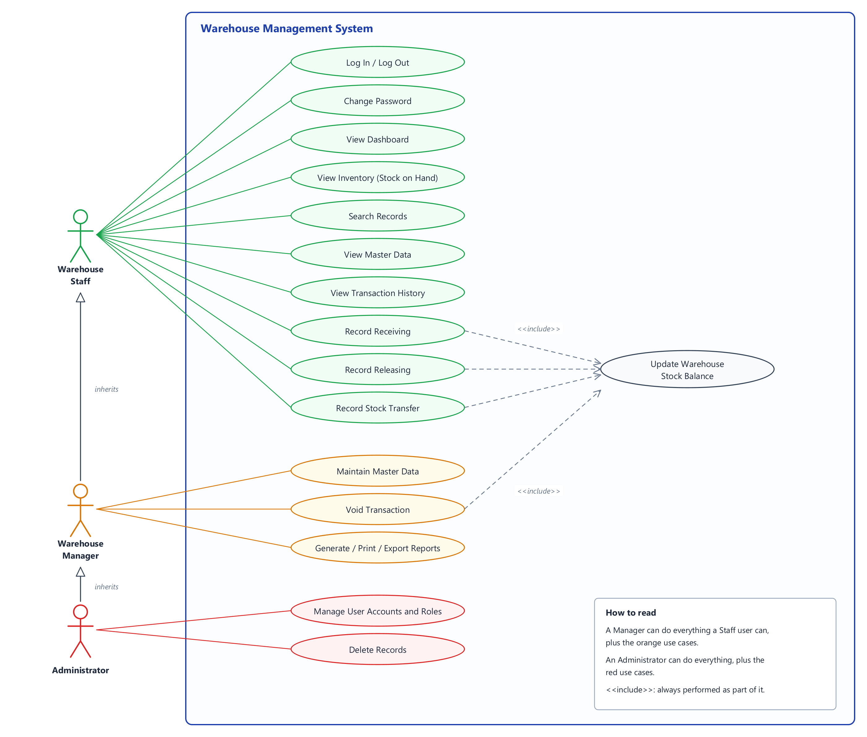
Figure 1. Use case diagram

2.7 System Flowchart
The flowchart shows the main flow of the program: starting the database, logging in, choosing a module, validating and saving data, and logging out or exiting.
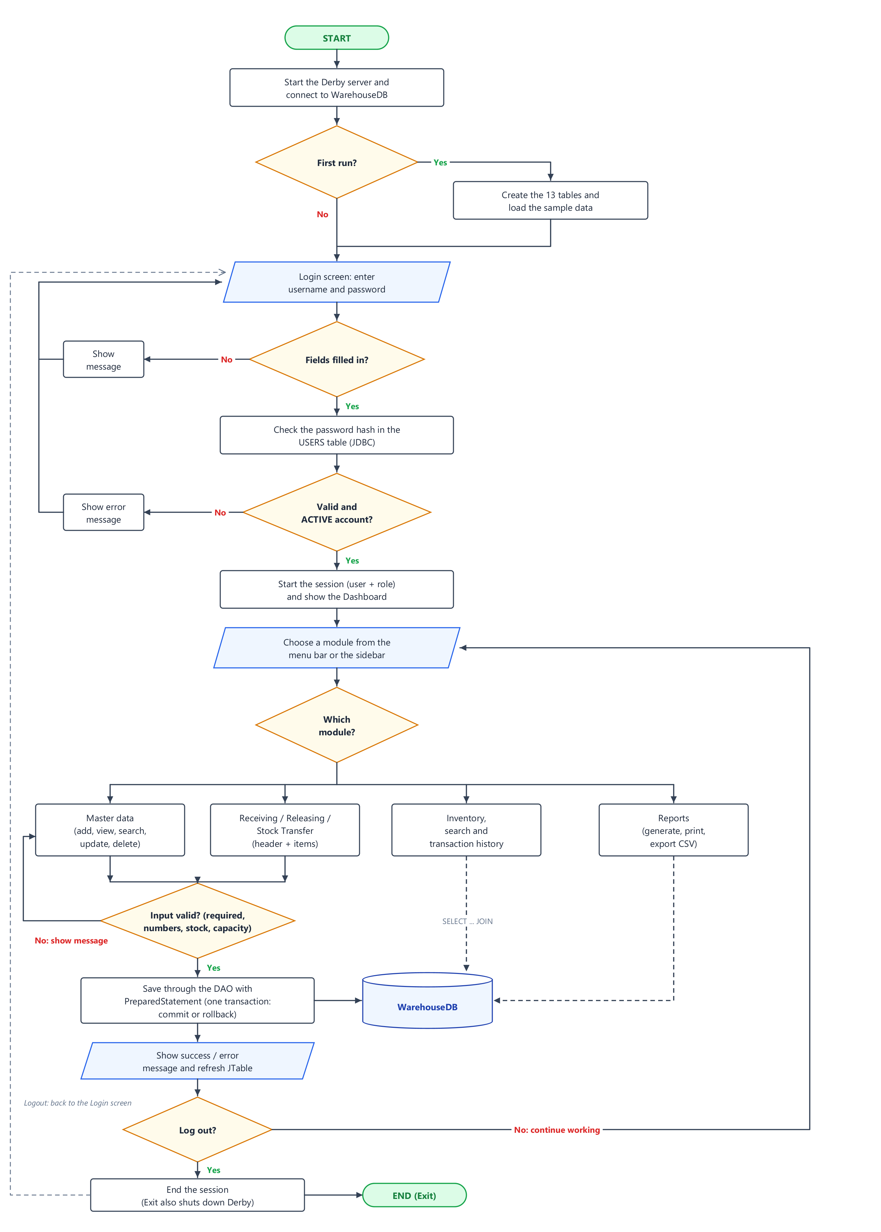
Figure 2. System flowchart

2.8 Data Flow Diagram
The context diagram (Level 0) shows the system as a single process and the external entities that exchange data with it. The Level 1 diagram breaks the system into seven processes and shows the data stores they use.
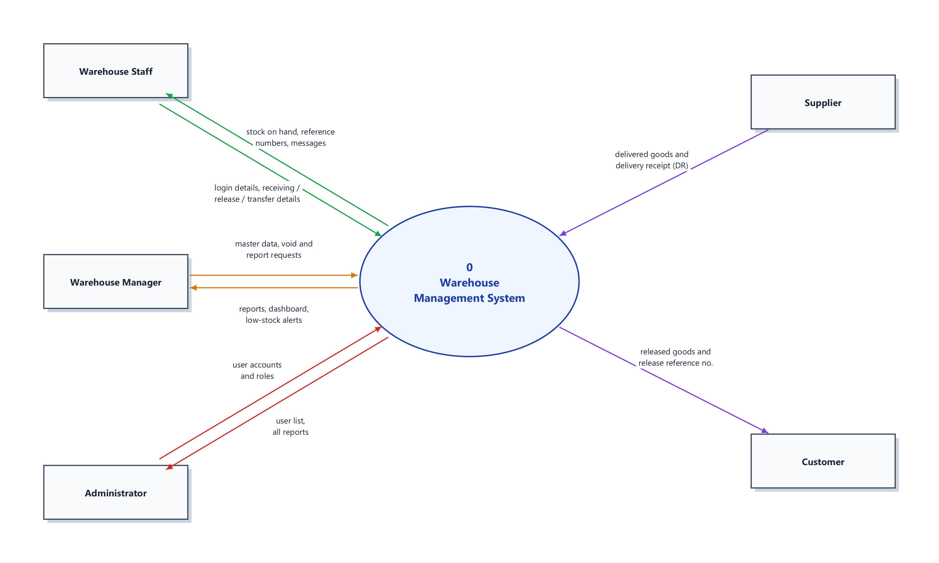
Figure 3. Data flow diagram, Level 0 (context diagram)

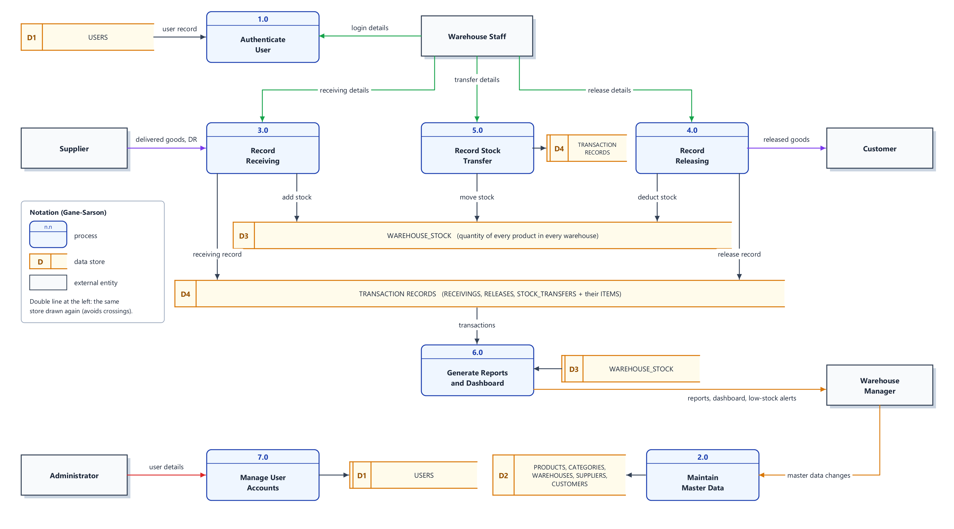
Figure 4. Data flow diagram, Level 1

Table 9. Processes of the Level 1 data flow diagram
Process | Description | Data stores
1.0 Authenticate User | Checks the username and password against the stored hash. | D1 Users
2.0 Maintain Master Data | Adds, updates and deletes warehouses, categories, products, suppliers, customers. | D2 Products, categories, warehouses, suppliers, customers
3.0 Record Receiving | Saves a receiving document and adds its quantities to the warehouse stock. | D3 Stock, D4 Transactions
4.0 Record Releasing | Checks the available stock, saves a release and deducts the quantities. | D3 Stock, D4 Transactions
5.0 Record Stock Transfer | Moves quantities from the source warehouse to the destination warehouse. | D3 Stock, D4 Transactions
6.0 Generate Reports and Dashboard | Reads the stock and the transactions to build reports and alerts. | D3 Stock, D4 Transactions
7.0 Manage User Accounts | Creates and changes user accounts; passwords are hashed. | D1 Users

2.9 Entity Relationship Diagram
The ERD shows the 13 entities, their attributes, primary keys (PK), foreign keys (FK), unique values (UQ) and the relationships in crow's foot notation. It contains one-to-one, one-to-many, and many-to-many relationships resolved through associative tables.

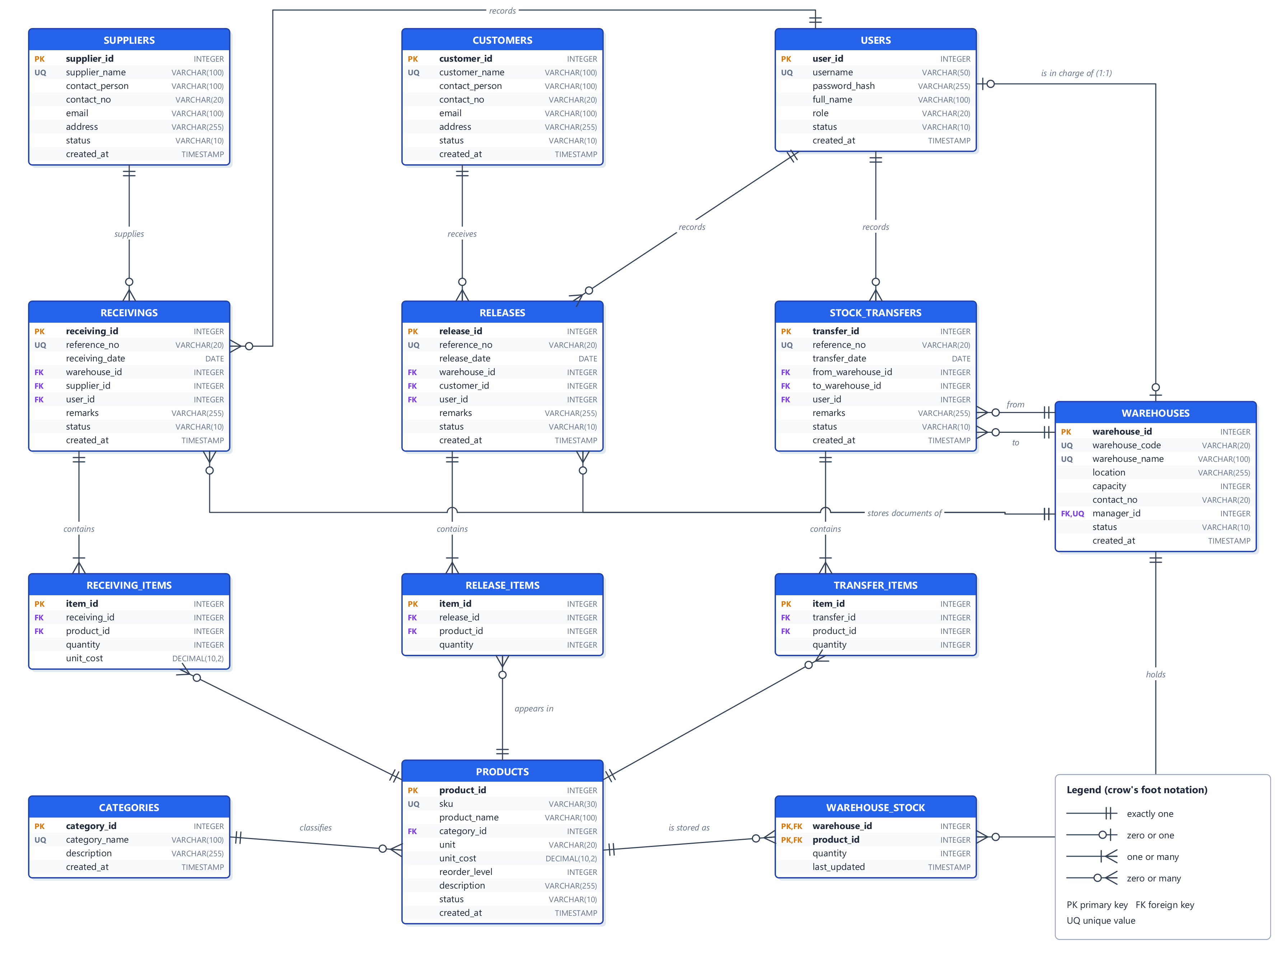
Figure 5. Entity relationship diagram (crow's foot notation)

Relationship Explanation
Table 10. Relationships between the tables
Relationship | Type | Meaning
CATEGORIES - PRODUCTS | 1 : M | One category contains many products; each product belongs to one category.
USERS - WAREHOUSES (manager_id) | 1 : 1 (optional) | A warehouse has at most one person in charge, and a manager can be in charge of at most one warehouse (foreign key with a UNIQUE constraint).
WAREHOUSES - PRODUCTS | M : N | A warehouse stores many products and a product is stored in many warehouses. Resolved by the associative table WAREHOUSE_STOCK (composite key).
SUPPLIERS - RECEIVINGS | 1 : M | One supplier delivers many receivings.
CUSTOMERS - RELEASES | 1 : M | One customer receives many releases.
WAREHOUSES - RECEIVINGS / RELEASES | 1 : M | Each document belongs to one warehouse.
WAREHOUSES - STOCK_TRANSFERS | 1 : M (twice) | Each transfer has a source (from_warehouse_id) and a destination (to_warehouse_id) warehouse.
USERS - RECEIVINGS / RELEASES / STOCK_TRANSFERS | 1 : M | One user records many documents.
RECEIVINGS - RECEIVING_ITEMS | 1 : M | One receiving contains many item lines.
RELEASES - RELEASE_ITEMS | 1 : M | One release contains many item lines.
STOCK_TRANSFERS - TRANSFER_ITEMS | 1 : M | One transfer contains many item lines.
PRODUCTS - ..._ITEMS | 1 : M | A product appears in many item lines. RECEIVING_ITEMS, RELEASE_ITEMS and TRANSFER_ITEMS are associative tables between the documents and the products.

2.10 Database Design

2.10.1 Table Relationship Diagram
The table relationship diagram shows only the key columns of each table and marks each relationship with 1 (one) and M (many).

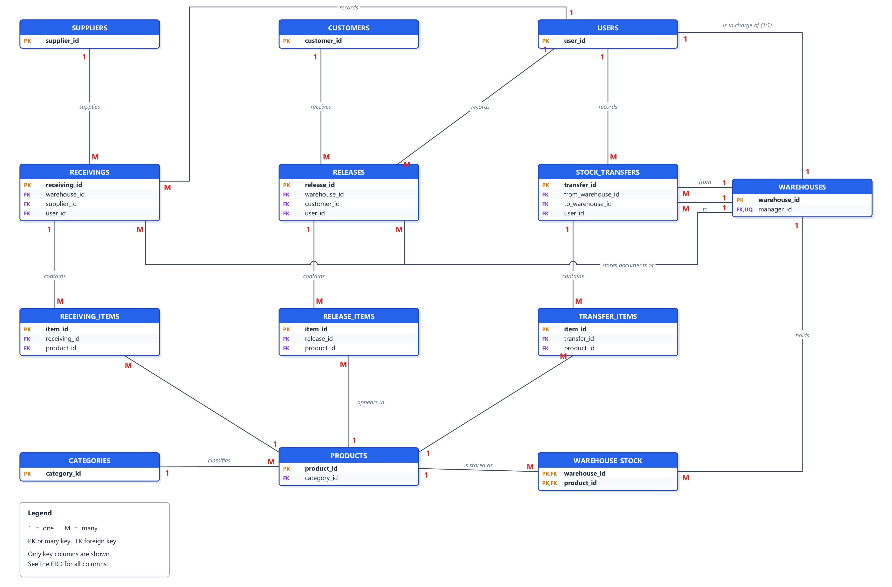
Figure 6. Table relationship diagram (keys only)

2.10.2 Normalization
Table 11. Normalization
Normal form | Rule | How the design follows it
First (1NF) | Each field holds a single value; no repeating groups. | Every product of a document is a separate row in RECEIVING_ITEMS, RELEASE_ITEMS or TRANSFER_ITEMS, never a list such as "Laptop, Mouse, Keyboard" in one field.
Second (2NF) | Non-key attributes depend on the whole primary key. | In WAREHOUSE_STOCK the key is (warehouse_id, product_id) and quantity depends on both: the quantity of one product in one warehouse.
Third (3NF) | Non-key attributes depend only on the key, not on other non-key attributes. | Names are stored once and referenced by ID (a product stores category_id, not the category name). Totals, subtotals and total stock are calculated with SUM() and JOIN instead of being stored.

2.10.3 Constraints
Table 12. Database constraints
Constraint | Where it is used
PRIMARY KEY | Every table (identity columns); composite key in WAREHOUSE_STOCK.
FOREIGN KEY | 19 relationships. Deleting a record that is still referenced is refused. manager_id uses ON DELETE SET NULL; item lines use ON DELETE CASCADE with their document.
UNIQUE | username, category_name, sku, warehouse_code, warehouse_name, manager_id, supplier_name, customer_name, reference numbers, and (document, product) in each item table.
NOT NULL | All required columns, e.g. names, codes, dates, quantities.
DEFAULT | status ('ACTIVE' or 'POSTED'), created_at (CURRENT_TIMESTAMP), unit ('pcs'), reorder_level (10), quantity (0).
CHECK | role and status values; unit_cost >= 0; reorder_level >= 0; capacity > 0; stock quantity >= 0; item quantity > 0; a transfer's source and destination must be different.

2.10.4 Data Dictionary
For every table: field name, data type, size, primary key, foreign key, whether NULL is allowed, default value and description.
USERS - Stores the user accounts that can log in, with their role and status.
Table 13. Data dictionary: USERS
Field | Type | Size | PK | FK | Null | Default | Description
user_id | INTEGER | - | Yes | No | No | Identity | Unique user ID
username | VARCHAR | 50 | No | No | No | - | Login name (UNIQUE)
password_hash | VARCHAR | 255 | No | No | No | - | PBKDF2 salted hash of the password
full_name | VARCHAR | 100 | No | No | No | - | User's full name
role | VARCHAR | 20 | No | No | No | - | ADMIN, MANAGER or STAFF (CHECK)
status | VARCHAR | 10 | No | No | No | 'ACTIVE' | ACTIVE or INACTIVE (CHECK)
created_at | TIMESTAMP | - | No | No | No | CURRENT_TIMESTAMP | When the account was created

CATEGORIES - Groups products into categories.
Table 14. Data dictionary: CATEGORIES
Field | Type | Size | PK | FK | Null | Default | Description
category_id | INTEGER | - | Yes | No | No | Identity | Unique category ID
category_name | VARCHAR | 100 | No | No | No | - | Category name (UNIQUE)
description | VARCHAR | 255 | No | No | Yes | NULL | Category description
created_at | TIMESTAMP | - | No | No | No | CURRENT_TIMESTAMP | When the record was created

PRODUCTS - Items kept in the warehouses. The stock itself is stored per warehouse in WAREHOUSE_STOCK.
Table 15. Data dictionary: PRODUCTS
Field | Type | Size | PK | FK | Null | Default | Description
product_id | INTEGER | - | Yes | No | No | Identity | Unique product ID
sku | VARCHAR | 30 | No | No | No | - | Product code (UNIQUE)
product_name | VARCHAR | 100 | No | No | No | - | Product name
category_id | INTEGER | - | No | Yes | No | - | References CATEGORIES
unit | VARCHAR | 20 | No | No | No | 'pcs' | Unit of measure (pcs, box, ream...)
unit_cost | DECIMAL | 10,2 | No | No | No | 0 | Standard cost per unit (>= 0)
reorder_level | INTEGER | - | No | No | No | 10 | Low-stock threshold (>= 0)
description | VARCHAR | 255 | No | No | Yes | NULL | Product description
status | VARCHAR | 10 | No | No | No | 'ACTIVE' | ACTIVE or INACTIVE
created_at | TIMESTAMP | - | No | No | No | CURRENT_TIMESTAMP | When the record was created

WAREHOUSES - Storage locations, their capacity and the person in charge.
Table 16. Data dictionary: WAREHOUSES
Field | Type | Size | PK | FK | Null | Default | Description
warehouse_id | INTEGER | - | Yes | No | No | Identity | Unique warehouse ID
warehouse_code | VARCHAR | 20 | No | No | No | - | Warehouse code (UNIQUE)
warehouse_name | VARCHAR | 100 | No | No | No | - | Warehouse name (UNIQUE)
location | VARCHAR | 255 | No | No | No | - | Address / location
capacity | INTEGER | - | No | No | No | - | Maximum units it can hold (> 0)
contact_no | VARCHAR | 20 | No | No | Yes | NULL | Contact number
manager_id | INTEGER | - | No | Yes | Yes | NULL | Person in charge (USERS, UNIQUE, 1:1)
status | VARCHAR | 10 | No | No | No | 'ACTIVE' | ACTIVE or INACTIVE
created_at | TIMESTAMP | - | No | No | No | CURRENT_TIMESTAMP | When the record was created

SUPPLIERS - Companies that deliver stock to the warehouses.
Table 17. Data dictionary: SUPPLIERS
Field | Type | Size | PK | FK | Null | Default | Description
supplier_id | INTEGER | - | Yes | No | No | Identity | Unique supplier ID
supplier_name | VARCHAR | 100 | No | No | No | - | Supplier name (UNIQUE)
contact_person | VARCHAR | 100 | No | No | Yes | NULL | Contact person
contact_no | VARCHAR | 20 | No | No | No | - | Contact number
email | VARCHAR | 100 | No | No | Yes | NULL | E-mail address
address | VARCHAR | 255 | No | No | Yes | NULL | Address
status | VARCHAR | 10 | No | No | No | 'ACTIVE' | ACTIVE or INACTIVE
created_at | TIMESTAMP | - | No | No | No | CURRENT_TIMESTAMP | When the record was created

CUSTOMERS - Customers and branches that receive released stock.
Table 18. Data dictionary: CUSTOMERS
Field | Type | Size | PK | FK | Null | Default | Description
customer_id | INTEGER | - | Yes | No | No | Identity | Unique customer ID
customer_name | VARCHAR | 100 | No | No | No | - | Customer name (UNIQUE)
contact_person | VARCHAR | 100 | No | No | Yes | NULL | Contact person
contact_no | VARCHAR | 20 | No | No | No | - | Contact number
email | VARCHAR | 100 | No | No | Yes | NULL | E-mail address
address | VARCHAR | 255 | No | No | Yes | NULL | Address
status | VARCHAR | 10 | No | No | No | 'ACTIVE' | ACTIVE or INACTIVE
created_at | TIMESTAMP | - | No | No | No | CURRENT_TIMESTAMP | When the record was created

WAREHOUSE_STOCK - Quantity of each product in each warehouse (associative table, composite primary key).
Table 19. Data dictionary: WAREHOUSE_STOCK
Field | Type | Size | PK | FK | Null | Default | Description
warehouse_id | INTEGER | - | Yes | Yes | No | - | References WAREHOUSES
product_id | INTEGER | - | Yes | Yes | No | - | References PRODUCTS
quantity | INTEGER | - | No | No | No | 0 | Units on hand (>= 0)
last_updated | TIMESTAMP | - | No | No | No | CURRENT_TIMESTAMP | Time of the last change

RECEIVINGS - Header of each receiving document (stock IN from a supplier).
Table 20. Data dictionary: RECEIVINGS
Field | Type | Size | PK | FK | Null | Default | Description
receiving_id | INTEGER | - | Yes | No | No | Identity | Unique receiving ID
reference_no | VARCHAR | 20 | No | No | No | - | e.g. RCV-20260928-001 (UNIQUE)
receiving_date | DATE | - | No | No | No | - | Date of the delivery
warehouse_id | INTEGER | - | No | Yes | No | - | Receiving warehouse
supplier_id | INTEGER | - | No | Yes | No | - | Supplier
user_id | INTEGER | - | No | Yes | No | - | User who recorded it
remarks | VARCHAR | 255 | No | No | Yes | NULL | Notes, e.g. delivery receipt number
status | VARCHAR | 10 | No | No | No | 'POSTED' | POSTED or VOIDED
created_at | TIMESTAMP | - | No | No | No | CURRENT_TIMESTAMP | When it was recorded

RECEIVING_ITEMS - Product lines of a receiving.
Table 21. Data dictionary: RECEIVING_ITEMS
Field | Type | Size | PK | FK | Null | Default | Description
item_id | INTEGER | - | Yes | No | No | Identity | Unique line ID
receiving_id | INTEGER | - | No | Yes | No | - | Receiving document (ON DELETE CASCADE)
product_id | INTEGER | - | No | Yes | No | - | Product received
quantity | INTEGER | - | No | No | No | - | Quantity received (> 0)
unit_cost | DECIMAL | 10,2 | No | No | No | - | Cost per unit (>= 0)

RELEASES - Header of each release document (stock OUT to a customer).
Table 22. Data dictionary: RELEASES
Field | Type | Size | PK | FK | Null | Default | Description
release_id | INTEGER | - | Yes | No | No | Identity | Unique release ID
reference_no | VARCHAR | 20 | No | No | No | - | e.g. REL-20260928-001 (UNIQUE)
release_date | DATE | - | No | No | No | - | Date of the release
warehouse_id | INTEGER | - | No | Yes | No | - | Warehouse the stock leaves
customer_id | INTEGER | - | No | Yes | No | - | Customer
user_id | INTEGER | - | No | Yes | No | - | User who recorded it
remarks | VARCHAR | 255 | No | No | Yes | NULL | Notes
status | VARCHAR | 10 | No | No | No | 'POSTED' | POSTED or VOIDED
created_at | TIMESTAMP | - | No | No | No | CURRENT_TIMESTAMP | When it was recorded

RELEASE_ITEMS - Product lines of a release.
Table 23. Data dictionary: RELEASE_ITEMS
Field | Type | Size | PK | FK | Null | Default | Description
item_id | INTEGER | - | Yes | No | No | Identity | Unique line ID
release_id | INTEGER | - | No | Yes | No | - | Release document (ON DELETE CASCADE)
product_id | INTEGER | - | No | Yes | No | - | Product released
quantity | INTEGER | - | No | No | No | - | Quantity released (> 0)

STOCK_TRANSFERS - Header of each transfer between two different warehouses.
Table 24. Data dictionary: STOCK_TRANSFERS
Field | Type | Size | PK | FK | Null | Default | Description
transfer_id | INTEGER | - | Yes | No | No | Identity | Unique transfer ID
reference_no | VARCHAR | 20 | No | No | No | - | e.g. TRF-20260928-001 (UNIQUE)
transfer_date | DATE | - | No | No | No | - | Date of the transfer
from_warehouse_id | INTEGER | - | No | Yes | No | - | Source warehouse
to_warehouse_id | INTEGER | - | No | Yes | No | - | Destination warehouse (CHECK: different)
user_id | INTEGER | - | No | Yes | No | - | User who recorded it
remarks | VARCHAR | 255 | No | No | Yes | NULL | Notes
status | VARCHAR | 10 | No | No | No | 'POSTED' | POSTED or VOIDED
created_at | TIMESTAMP | - | No | No | No | CURRENT_TIMESTAMP | When it was recorded

TRANSFER_ITEMS - Product lines of a transfer.
Table 25. Data dictionary: TRANSFER_ITEMS
Field | Type | Size | PK | FK | Null | Default | Description
item_id | INTEGER | - | Yes | No | No | Identity | Unique line ID
transfer_id | INTEGER | - | No | Yes | No | - | Transfer document (ON DELETE CASCADE)
product_id | INTEGER | - | No | Yes | No | - | Product moved
quantity | INTEGER | - | No | No | No | - | Quantity moved (> 0)

CHAPTER 3 - SYSTEM DEVELOPMENT

3.1 Development Tools
Table 26. Development tools
Tool | Version | Purpose
Java Development Kit (JDK) | 21 (compiled for Java 17) | Programming language and runtime
Apache NetBeans IDE | 31 | Editing, building and running the project (Java with Ant)
Apache Derby | 10.16.1.1 | Relational database (engine, Network Server and client driver)
Java Swing and AWT | Part of the JDK | Graphical user interface
JDBC | Part of the JDK (java.sql) | Database connectivity
Operating system | Windows 11 | Development and testing

3.2 Java Swing
All the windows, forms, tables and dialogs are built with Swing. The table lists the Swing components required by the project and where they are used.
Table 27. Swing components used
Component | Where it is used
JFrame | LoginFrame and DashboardFrame (the main window).
JPanel | Every screen and card (CrudPanel, TransactionPanel, DashboardPanel, InventoryPanel, ReportsPanel...).
JLabel | Titles, field labels, status bar, totals and messages.
JTextField | Codes, names, quantities, amounts, search boxes and dates.
JPasswordField | Login screen, User Management and Change Password (passwords are never shown).
JButton | Save, Update, Delete, Clear, Search, Add Item, Void, Print, Export (FlatButton extends JButton).
JComboBox | Category, unit, warehouse, supplier, customer, product, role, status and report pickers.
JRadioButton | Active / Inactive status in the product, warehouse, supplier, customer and user forms.
JCheckBox | Show password (login) and Show low / out of stock only (inventory).
JTable | Every list of records, the item lines of documents and all reports.
JScrollPane | Around every JTable, the text areas and the forms.
JTextArea | Descriptions, addresses and remarks.
JMenuBar / JMenu / JMenuItem | Main menu: File, Transactions, Inventory, Master Data, Reports, Admin, Help.
JOptionPane | Success, validation, warning and error messages, and all confirmations.
Others | JTabbedPane, JDialog, JWindow (splash), JProgressBar, JPopupMenu (date picker), JFileChooser (CSV export), javax.swing.Timer (clock) and SwingWorker (background database work).

3.3 Java AWT
Table 28. AWT features used
AWT feature | Where it is used
BorderLayout | Main window (header, sidebar, content, status bar) and most panels.
GridBagLayout | All forms (FormGrid), document headers and the login form.
FlowLayout / GridLayout | Button bars, dashboard cards (2 x 4), calendar of the date picker.
CardLayout | Switching between the module screens inside the main window.
Color, Font, Dimension, Insets | Defined once in UITheme so that every screen looks the same: the I.O.T brand colors (black, amber #FBAB06, white) and a 15-point font.
ActionListener | Every button, menu item, combo box and Enter key in text fields.
MouseListener (MouseAdapter) | Hover effect of the sidebar, double-click on a history row, calendar days.
KeyListener (KeyAdapter) | Enter moves from username to password; Delete removes an item line.
WindowListener (WindowAdapter) | The main window asks for confirmation before closing, then shuts the database server down cleanly.
ItemListener | Show-password check box and low-stock filter.
Graphics2D | Custom drawing: the stock-vs-capacity bar chart, flat buttons, cards, sidebar icons and the app icon (the amber "O" of the I.O.T logo).
Image / ImageIO | Loads and scales the I.O.T Warehouse logo shown on the splash screen, login screen, header and About dialog.
java.awt.print | Printing of reports and documents (JTable.print).

3.4 JDBC
The program uses JDBC to communicate with Apache Derby: Java application -> JDBC -> Apache Derby -> database tables. The main classes are:
Table 29. JDBC classes used
JDBC class / method | Use in the project
DriverManager, Connection | DatabaseConnection.getConnection() opens every connection.
PreparedStatement | Every INSERT, SELECT, UPDATE and DELETE that contains user input (? placeholders).
Statement | Only to run the fixed schema.sql script when the database is created.
ResultSet | Reading query results into model objects and JTables.
SQLException | Caught in every screen; ErrorHandler turns its SQLState into a clear message.
getGeneratedKeys() | Returns the new ID after an INSERT.
addBatch() / executeBatch() | Inserts all item lines of a document at once.
setAutoCommit(false), commit(), rollback() | Saves a document, its items and the stock as one transaction.
DatabaseMetaData | Checks whether the tables already exist on start-up.

3.5 Apache Derby
The system uses the Apache Derby 10.16.1.1 Network Server (the same set-up as NetBeans' Java DB). When the program starts, DatabaseConnection checks whether a Derby server is running on localhost:1527. If not, it starts one inside the program (NetworkServerControl) and stores the database in the project's data folder. On the first run, DatabaseInitializer creates the 13 tables from schema.sql and loads the sample data. While the program is running, the same database can be opened from NetBeans (Services > Databases) to show the tables during the defense.
Table 30. Database settings
Setting | Value
JDBC URL | jdbc:derby://localhost:1527/WarehouseDB
User / password | app / app (default APP schema)
Driver | Derby Network Client (lib/derbyclient-10.16.1.1.jar)
Libraries | derby, derbynet, derbyclient, derbyshared, derbytools (version 10.16.1.1)
Database files | data/WarehouseDB (delete the data folder to start over with fresh sample data)

3.6 System Architecture
The system follows the layered architecture required by the project: the Swing/AWT GUI calls the validation and application logic, which calls the DAO classes, which use JDBC to talk to the Apache Derby server and its tables. Results come back as ResultSets that are turned into model objects and shown in JTables.
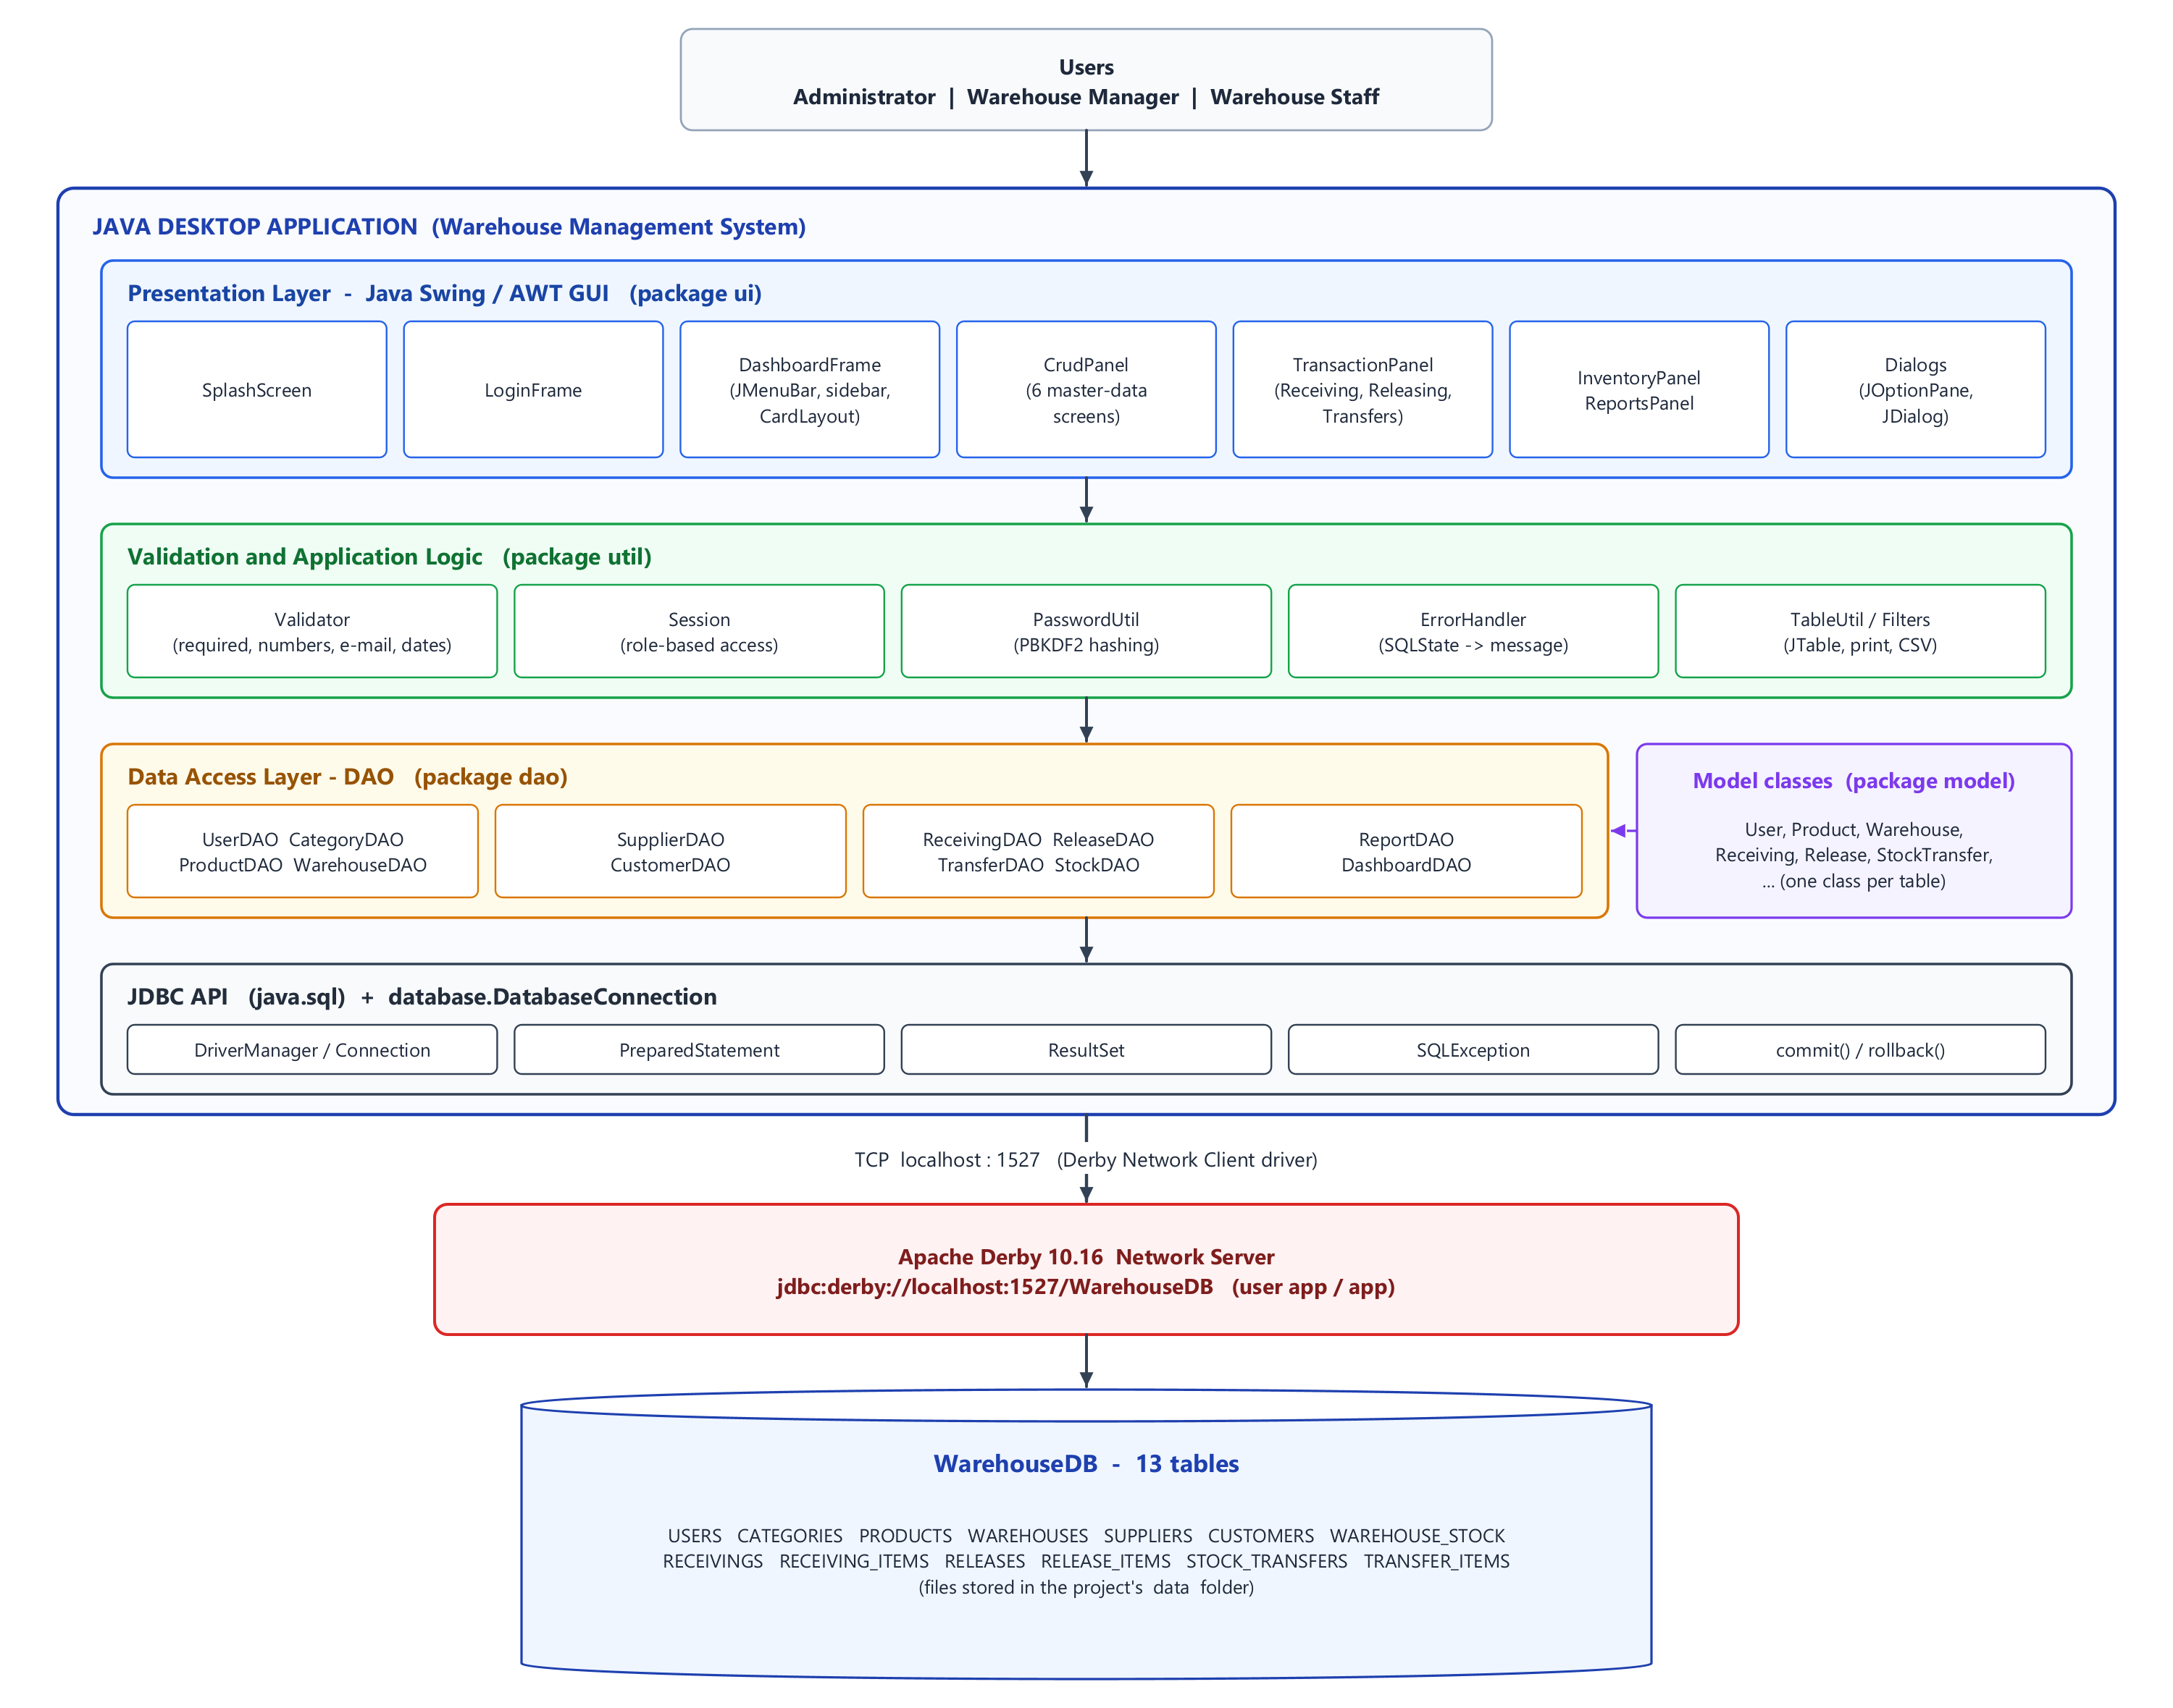
Figure 7. System architecture

3.7 Program Structure
The source code is organized into packages, following the recommended project structure:
WarehouseManagementSystem/
|-- build.xml, nbproject/ NetBeans project files
|-- lib/ Apache Derby 10.16.1.1 jars
|-- data/ database files (created on the first run)
|-- docs/ documentation, diagrams and screenshots
|-- run.bat, run-tests.bat run the program / the tests without NetBeans
|-- test/WmsTestRunner.java 26 automated tests
`-- src/
|-- Main.java entry point
|-- database/ DatabaseConnection, DatabaseInitializer, SampleDataSeeder,
| schema.sql, sample_data.sql
|-- model/ User, Role, Category, Product, Warehouse, Supplier, Customer,
| WarehouseStock, StockDocument, Receiving, Release, StockTransfer,
| DocumentItem, ReceivingItem, ReleaseItem, TransferItem,
| ReportData, ReportType, DashboardStats, Status
|-- dao/ UserDAO, CategoryDAO, ProductDAO, WarehouseDAO, SupplierDAO,
| CustomerDAO, StockDAO, ReceivingDAO, ReleaseDAO, TransferDAO,
| ReportDAO, DashboardDAO, ReferenceNumber, DaoUtil
|-- ui/ LoginFrame, DashboardFrame, SplashScreen, CrudPanel + 6 panels,
| | TransactionPanel + 3 panels, DashboardPanel, InventoryPanel,
| | ReportsPanel, dialogs, UITheme
| `-- components/ FlatButton, RoundedPanel, FormGrid, DateField, StatCard,
| BarChartPanel, SidebarButton, ModuleIcon, WrapLayout
`-- util/ Validator, Session, PasswordUtil, ErrorHandler, TableUtil,
NumericFilter, LengthFilter, Formats, BusinessRuleException,
InsufficientStockException
Table 31. Packages
Package | Responsibility
model | One class per table (encapsulated fields, constructors, getters and setters). Receiving, Release and StockTransfer extend the abstract class StockDocument; the item classes extend DocumentItem.
dao | All SQL. Each DAO has add, get/search, update and delete methods; transaction DAOs save a document, its items and the stock in one database transaction.
database | The single connection class, the automatic creation of the tables and the sample data.
ui | Screens. CrudPanel is the base of the six management forms; TransactionPanel is the base of the three transaction screens (template method pattern).
util | Validation, role permissions (Session), password hashing, error messages and JTable helpers.

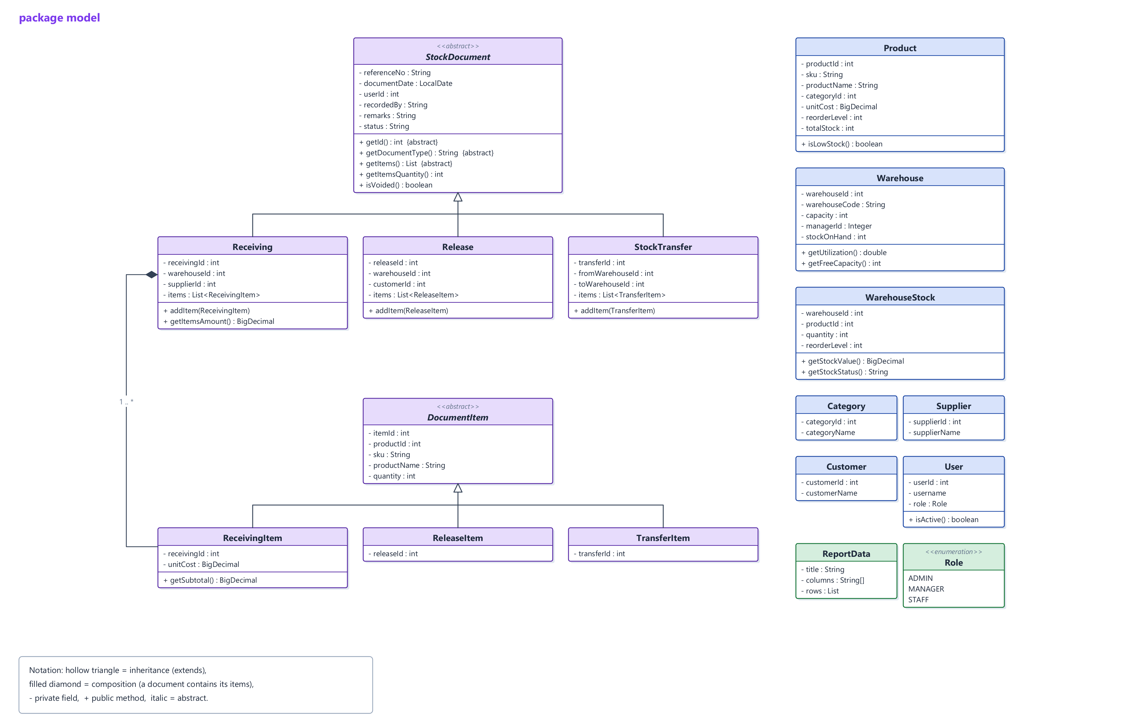
Figure 8. Class diagram - model package
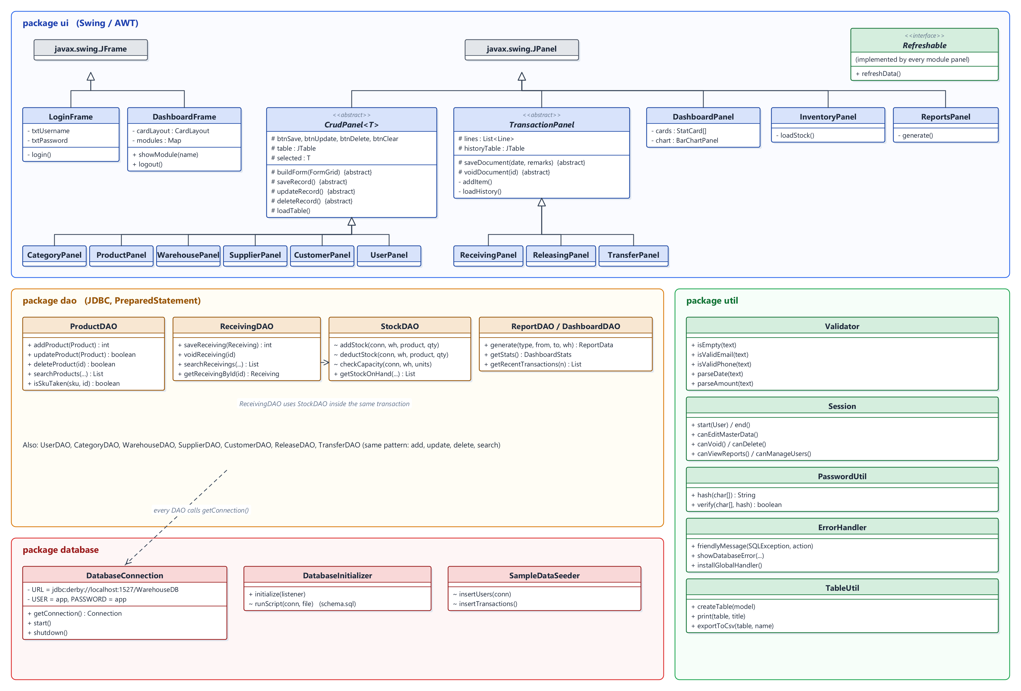
Figure 9. Class diagram - ui, dao, database and util packages

3.8 Database Connection
A separate class, DatabaseConnection, is used for every connection instead of repeating the connection code:
public class DatabaseConnection {
private static final String HOST = "localhost";
private static final int PORT = Integer.getInteger("wms.db.port", 1527);
private static final String DATABASE_NAME = System.getProperty("wms.db.name", "WarehouseDB");
private static final String URL = "jdbc:derby://" + HOST + ":" + PORT + "/" + DATABASE_NAME;
private static final String USER = "app";
private static final String PASSWORD = "app";
// ...
/**
* Returns a new connection to the database. Always close it
* (try-with-resources) after use.
*/
public static Connection getConnection() throws SQLException {
return DriverManager.getConnection(URL, USER, PASSWORD);
}
/**
* Makes sure a Derby Network Server is running on localhost:1527 and that
* the database exists. Called once when the program starts.
*/
public static synchronized void start() throws Exception {
if (!isServerRunning()) {
startServer();
}
// ";create=true" creates the database on the first run; afterwards it simply connects.
try (Connection conn = DriverManager.getConnection(URL + ";create=true", USER, PASSWORD)) {
conn.getMetaData(); // connection test
}
}
// ... startServer(), shutdown() and getters
}
Every DAO method opens its connection with try-with-resources, so the connection, the PreparedStatement and the ResultSet are always closed, even when an error occurs:
try (Connection conn = DatabaseConnection.getConnection();
PreparedStatement ps = conn.prepareStatement(sql)) {
ps.setInt(1, productId);
return ps.executeUpdate() > 0;
}

3.9 CRUD Implementation
Every data operation is done in a DAO class with PreparedStatement. The examples below come from ProductDAO.

CREATE - INSERT
public int addProduct(Product product) throws SQLException {
String sql = "INSERT INTO PRODUCTS (sku, product_name, category_id, unit, unit_cost, "
+ "reorder_level, description, status) VALUES (?, ?, ?, ?, ?, ?, ?, ?)";
try (Connection conn = DatabaseConnection.getConnection();
PreparedStatement ps = DaoUtil.prepareInsert(conn, sql)) {
fillStatement(ps, product);
int id = DaoUtil.insertAndGetId(ps);
product.setProductId(id);
return id;
}
}
private void fillStatement(PreparedStatement ps, Product product) throws SQLException {
ps.setString(1, product.getSku().trim().toUpperCase());
ps.setString(2, product.getProductName().trim());
ps.setInt(3, product.getCategoryId());
ps.setString(4, product.getUnit());
ps.setBigDecimal(5, product.getUnitCost());
ps.setInt(6, product.getReorderLevel());
DaoUtil.setText(ps, 7, product.getDescription());
ps.setString(8, product.getStatus());
}

READ - SELECT with INNER JOIN, WHERE and ORDER BY
private static final String SELECT_PRODUCTS =
"SELECT p.product_id, p.sku, p.product_name, p.category_id, c.category_name, p.unit, "
+ "p.unit_cost, p.reorder_level, p.description, p.status, "
+ "(SELECT COALESCE(SUM(s.quantity), 0) FROM WAREHOUSE_STOCK s "
+ " WHERE s.product_id = p.product_id) AS total_stock "
+ "FROM PRODUCTS p INNER JOIN CATEGORIES c ON p.category_id = c.category_id ";
/**
* Searches by ID, SKU, product name or category name.
*
* @param keyword text to look for (empty = everything)
* @param categoryId 0 = all categories
* @param status null = all statuses
*/
public List<Product> searchProducts(String keyword, int categoryId, String status) throws SQLException {
List<Object> params = new ArrayList<>();
StringBuilder sql = new StringBuilder(SELECT_PRODUCTS);
String pattern = DaoUtil.likePattern(keyword);
sql.append("WHERE (UPPER(p.sku)").append(DaoUtil.LIKE)
.append(" OR UPPER(p.product_name)").append(DaoUtil.LIKE)
.append(" OR UPPER(c.category_name)").append(DaoUtil.LIKE);
params.add(pattern);
params.add(pattern);
params.add(pattern);
Integer id = DaoUtil.parseId(keyword);
if (id != null) {
sql.append(" OR p.product_id = ?");
params.add(id);
}
sql.append(")");
if (categoryId > 0) {
sql.append(" AND p.category_id = ?");
params.add(categoryId);
}
if (status != null) {
sql.append(" AND p.status = ?");
params.add(status);
}
sql.append(" ORDER BY p.product_name");
List<Product> list = new ArrayList<>();
try (Connection conn = DatabaseConnection.getConnection();
PreparedStatement ps = conn.prepareStatement(sql.toString())) {
DaoUtil.bind(ps, params);
try (ResultSet rs = ps.executeQuery()) {
while (rs.next()) {
list.add(mapRow(rs));
}
}
}
return list;
}

UPDATE and DELETE
public boolean updateProduct(Product product) throws SQLException {
String sql = "UPDATE PRODUCTS SET sku = ?, product_name = ?, category_id = ?, unit = ?, "
+ "unit_cost = ?, reorder_level = ?, description = ?, status = ? WHERE product_id = ?";
try (Connection conn = DatabaseConnection.getConnection();
PreparedStatement ps = conn.prepareStatement(sql)) {
fillStatement(ps, product);
ps.setInt(9, product.getProductId());
return ps.executeUpdate() > 0;
}
}
public boolean deleteProduct(int productId) throws SQLException {
String sql = "DELETE FROM PRODUCTS WHERE product_id = ?";
try (Connection conn = DatabaseConnection.getConnection();
PreparedStatement ps = conn.prepareStatement(sql)) {
ps.setInt(1, productId);
return ps.executeUpdate() > 0;
}
}

Saving a document in one transaction
A receiving is saved together with its items and the stock update. If anything fails (for example the warehouse has no space), rollback() undoes everything, so the stock is always consistent.
/**
* Saves a receiving and ADDS its quantities to the warehouse stock.
* Header, items and stock are saved in ONE database transaction:
* if anything fails, everything is rolled back.
*
* @return the new receiving_id (the reference number is set on the object)
*/
public int saveReceiving(Receiving receiving) throws SQLException, BusinessRuleException {
if (receiving.getItems().isEmpty()) {
throw new BusinessRuleException("Add at least one product before saving the receiving.");
}
try (Connection conn = DatabaseConnection.getConnection()) {
conn.setAutoCommit(false); // start of the transaction
try {
stockDAO.requireActiveWarehouse(conn, receiving.getWarehouseId());
stockDAO.checkCapacity(conn, receiving.getWarehouseId(), receiving.getItemsQuantity());
String referenceNo = ReferenceNumber.next(conn, "RCV", "RECEIVINGS", receiving.getDocumentDate());
int receivingId;
try (PreparedStatement ps = DaoUtil.prepareInsert(conn, INSERT_HEADER)) {
ps.setString(1, referenceNo);
ps.setDate(2, Date.valueOf(receiving.getDocumentDate()));
ps.setInt(3, receiving.getWarehouseId());
ps.setInt(4, receiving.getSupplierId());
ps.setInt(5, receiving.getUserId());
DaoUtil.setText(ps, 6, receiving.getRemarks());
receivingId = DaoUtil.insertAndGetId(ps);
}
try (PreparedStatement ps = conn.prepareStatement(INSERT_ITEM)) {
for (ReceivingItem item : receiving.getItems()) {
ps.setInt(1, receivingId);
ps.setInt(2, item.getProductId());
ps.setInt(3, item.getQuantity());
ps.setBigDecimal(4, item.getUnitCost());
ps.addBatch();
}
ps.executeBatch();
}
for (ReceivingItem item : receiving.getItems()) {
stockDAO.addStock(conn, receiving.getWarehouseId(), item.getProductId(), item.getQuantity());
}
conn.commit(); // everything succeeded
receiving.setReceivingId(receivingId);
receiving.setReferenceNo(referenceNo);
receiving.setStatus(Status.POSTED);
return receivingId;
} catch (SQLException | BusinessRuleException | RuntimeException e) {
DaoUtil.rollback(conn, e); // nothing is saved
throw e;
}
}
}

Stock update that can never go below zero
/**
* Deducts stock. The condition "quantity >= ?" makes the check and the
* update one atomic step, so the stock can never become negative.
*/
void deductStock(Connection conn, int warehouseId, int productId, int quantity)
throws SQLException, InsufficientStockException {
String sql = "UPDATE WAREHOUSE_STOCK SET quantity = quantity - ?, last_updated = CURRENT_TIMESTAMP "
+ "WHERE warehouse_id = ? AND product_id = ? AND quantity >= ?";
try (PreparedStatement ps = conn.prepareStatement(sql)) {
ps.setInt(1, quantity);
ps.setInt(2, warehouseId);
ps.setInt(3, productId);
ps.setInt(4, quantity);
if (ps.executeUpdate() == 0) {
throw new InsufficientStockException(productName(conn, productId),
warehouseName(conn, warehouseId), getQuantity(conn, warehouseId, productId), quantity);
}
}
}

SQL operations demonstrated
Table 32. SQL features used
SQL feature | Example in the system
INSERT / SELECT / UPDATE / DELETE | All master-data DAOs (e.g. ProductDAO).
WHERE, LIKE, BETWEEN | Keyword searches, filters and date ranges.
ORDER BY | Every list (by name, code or date).
INNER JOIN / LEFT JOIN | Products with categories, documents with warehouses, suppliers, customers and users.
GROUP BY, HAVING, SUM, COUNT | Low-stock report, warehouse summary, dashboard totals.
UNION ALL | Stock Movement History and Recent Transactions combine the three document types.
Sub-queries / EXISTS | Total stock per product; searching documents by the products they contain.
COMMIT / ROLLBACK | Saving and voiding receiving, release and transfer documents.

3.10 GUI Implementation

3.10.1 GUI Navigation
The GUI navigation diagram shows how the user moves between the screens: the splash screen starts the database, the login form opens the main window, and the sidebar and the menu bar switch between the modules. The modules a user sees depend on their role.

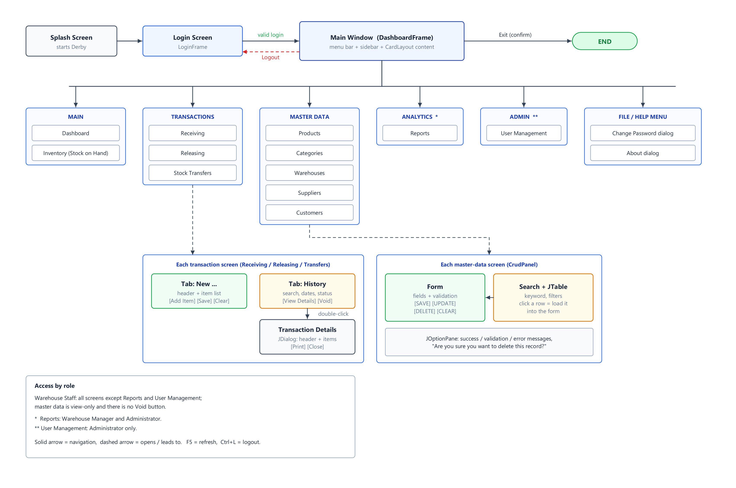
Figure 10. GUI navigation diagram

3.10.2 Start-up, Login and Dashboard
The program starts with a splash screen while the database server starts. After a successful login the Dashboard shows the summary cards, the stock-versus-capacity chart, the recent transactions and the low-stock alerts.
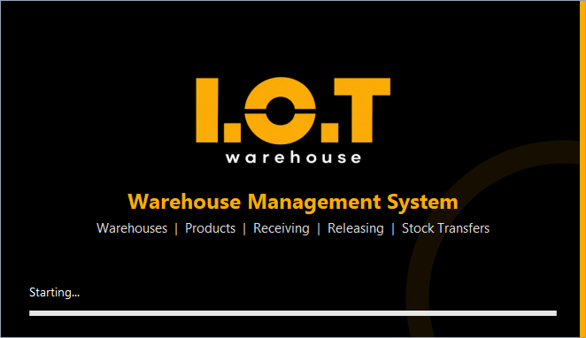
Figure 11. Splash screen - starting the Derby database server
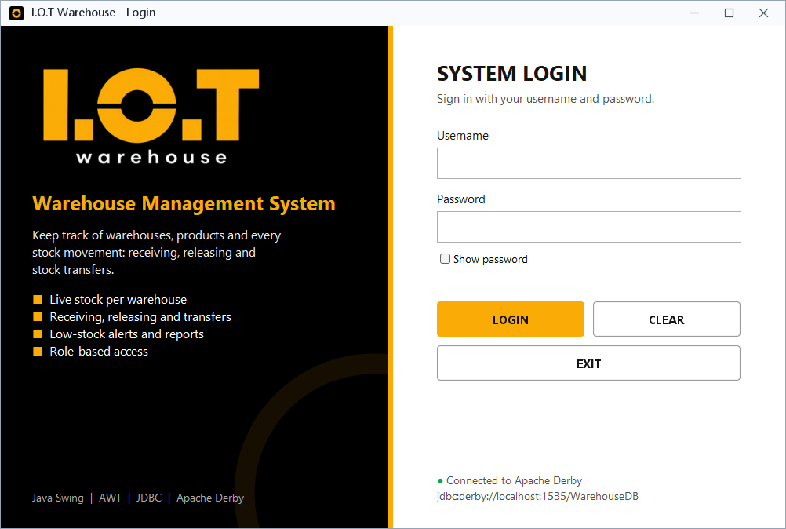
Figure 12. Login screen
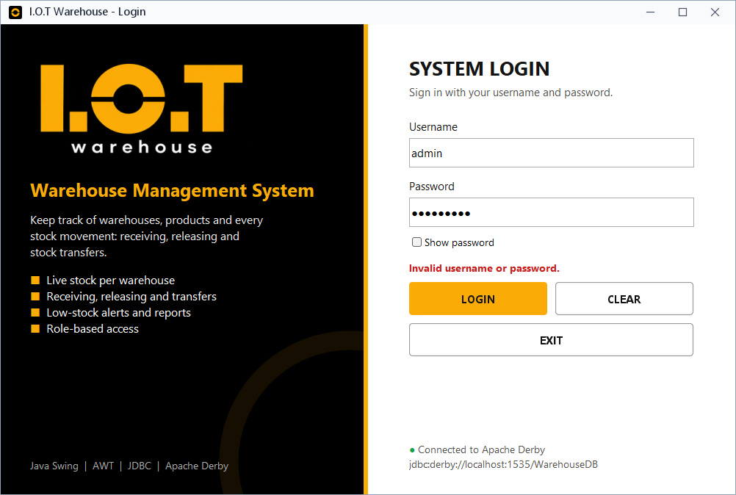
Figure 13. Login screen after an invalid password
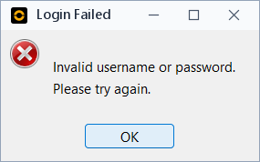
Figure 14. Error message for incorrect credentials
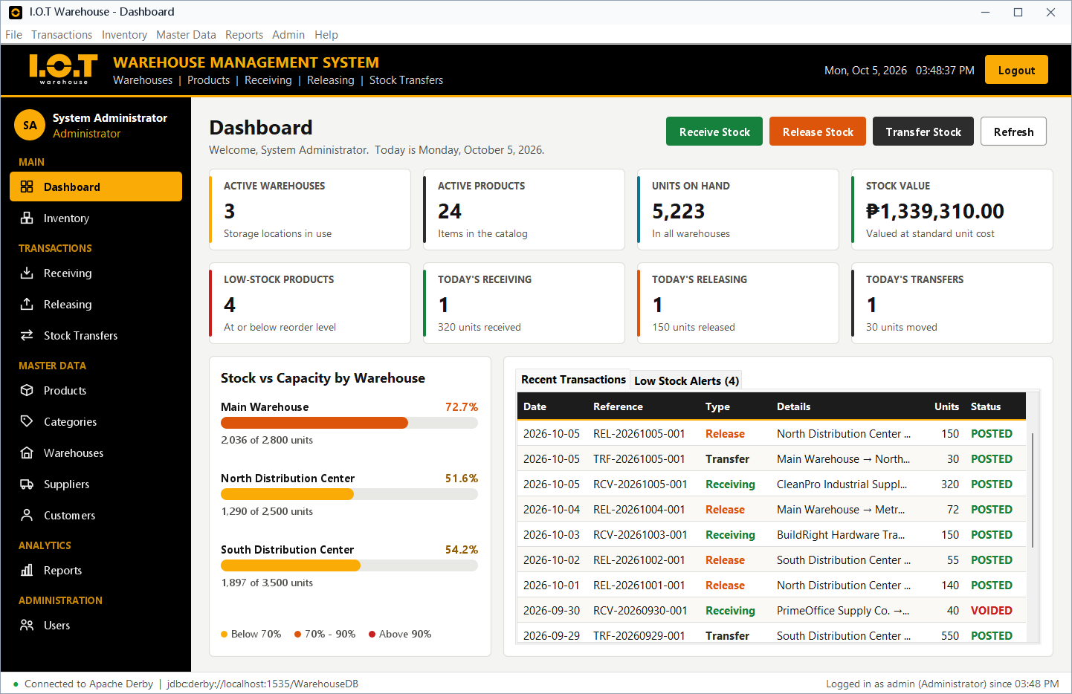
Figure 15. Dashboard (Administrator)
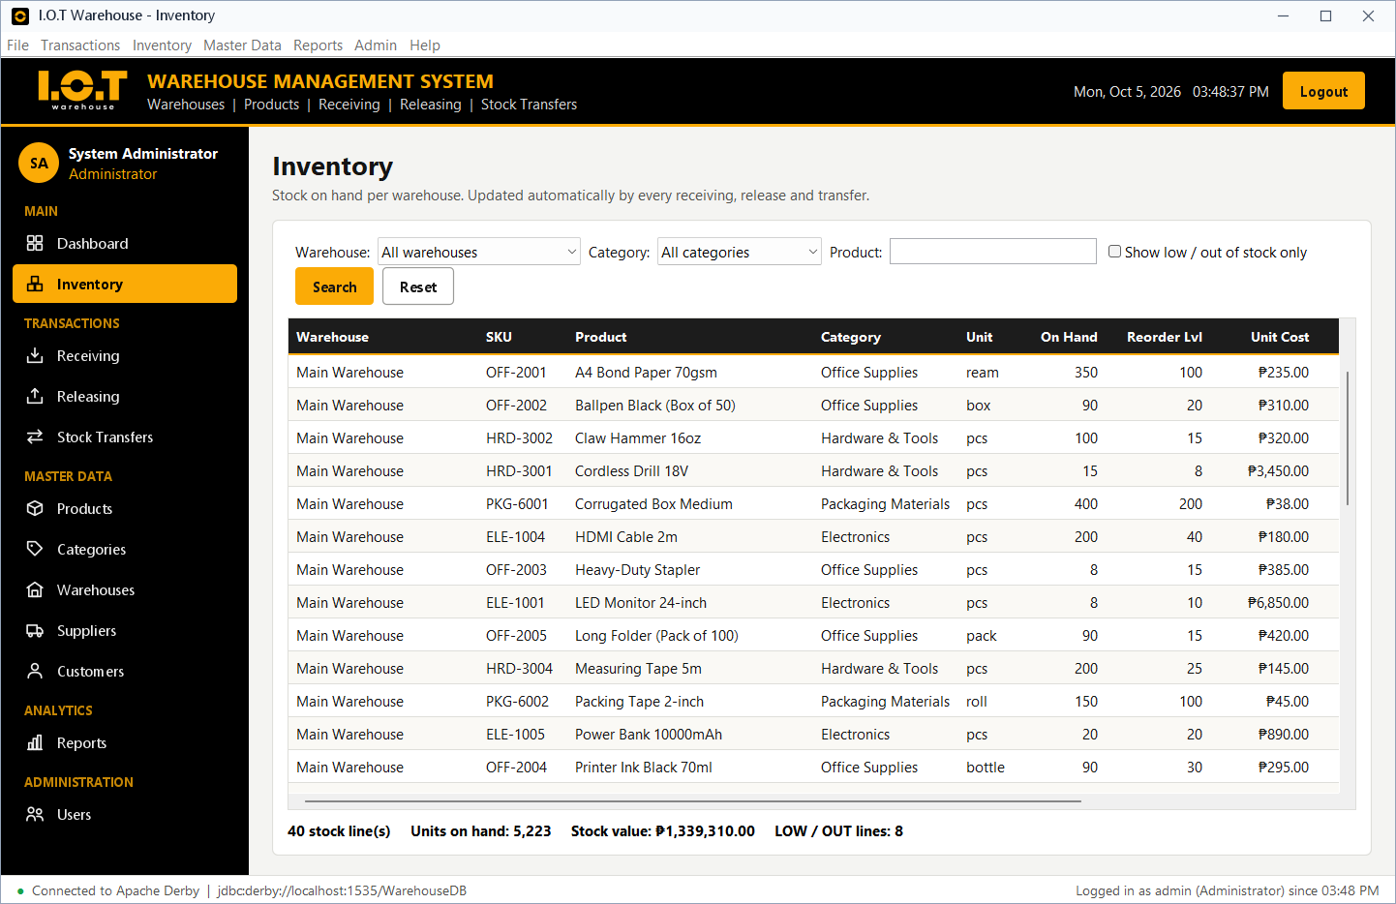
Figure 16. Inventory - stock on hand per warehouse with LOW / OUT status

3.10.3 Transactions
Each transaction screen has two tabs: a form for a new document (header and product lines) and a history tab with search, date range and status filters, View Details, Void and Print.
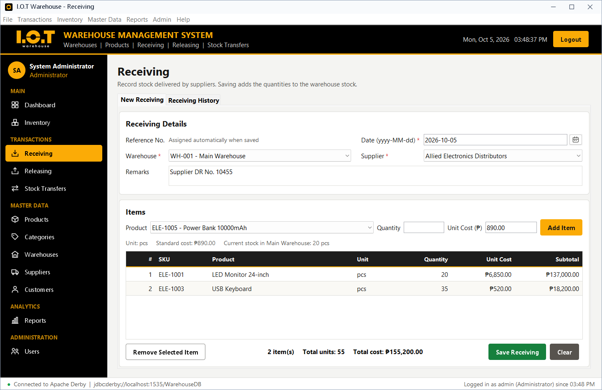
Figure 17. Receiving - new document with two product lines
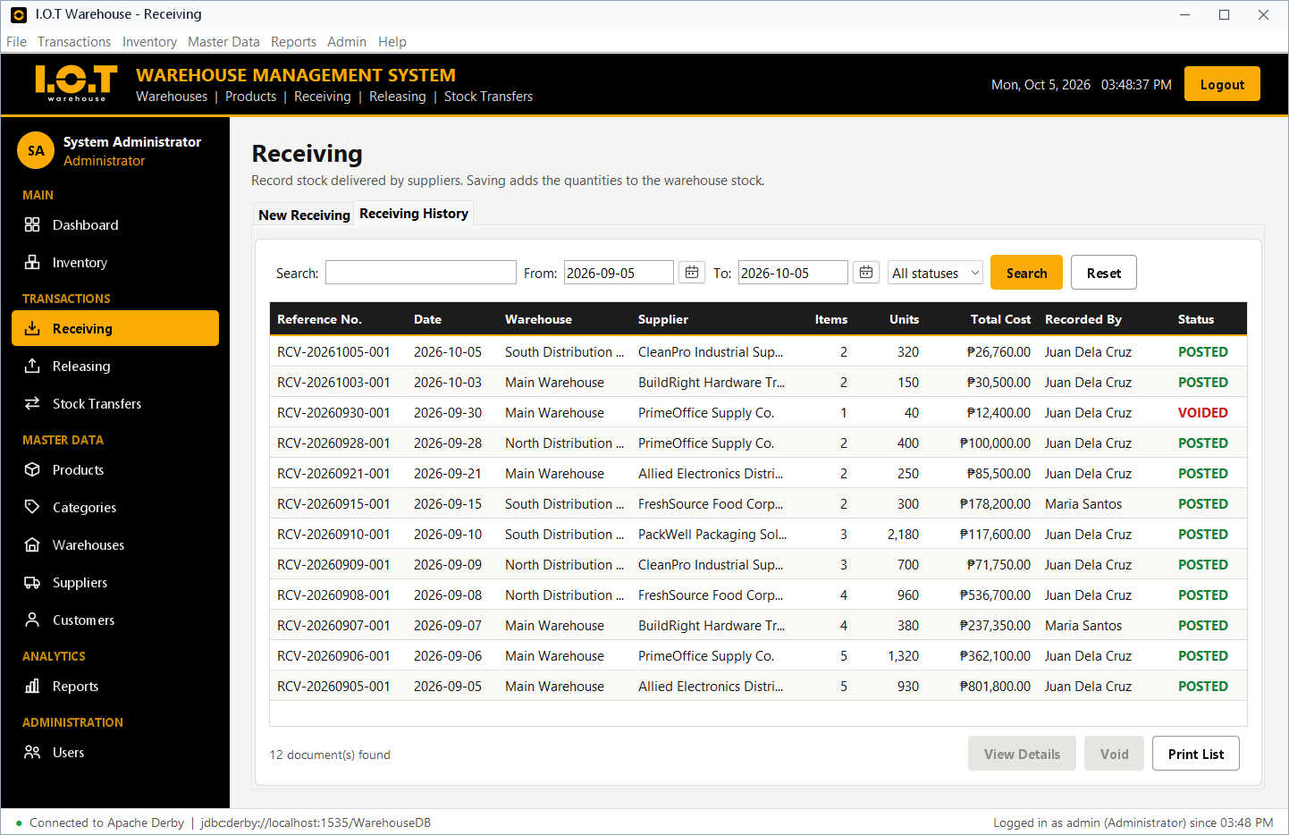
Figure 18. Receiving history with keyword, date range and status filters
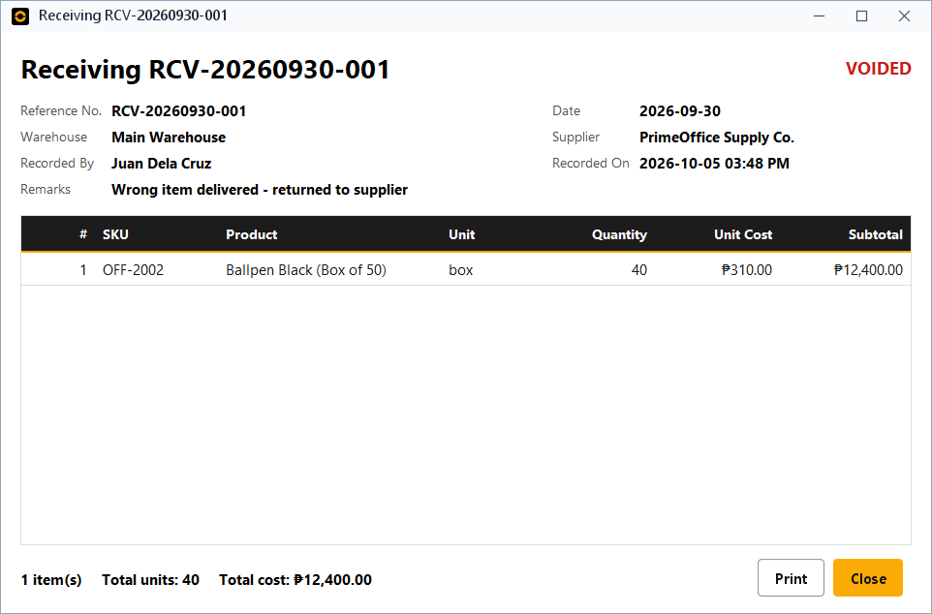
Figure 19. Transaction details dialog (a voided receiving)
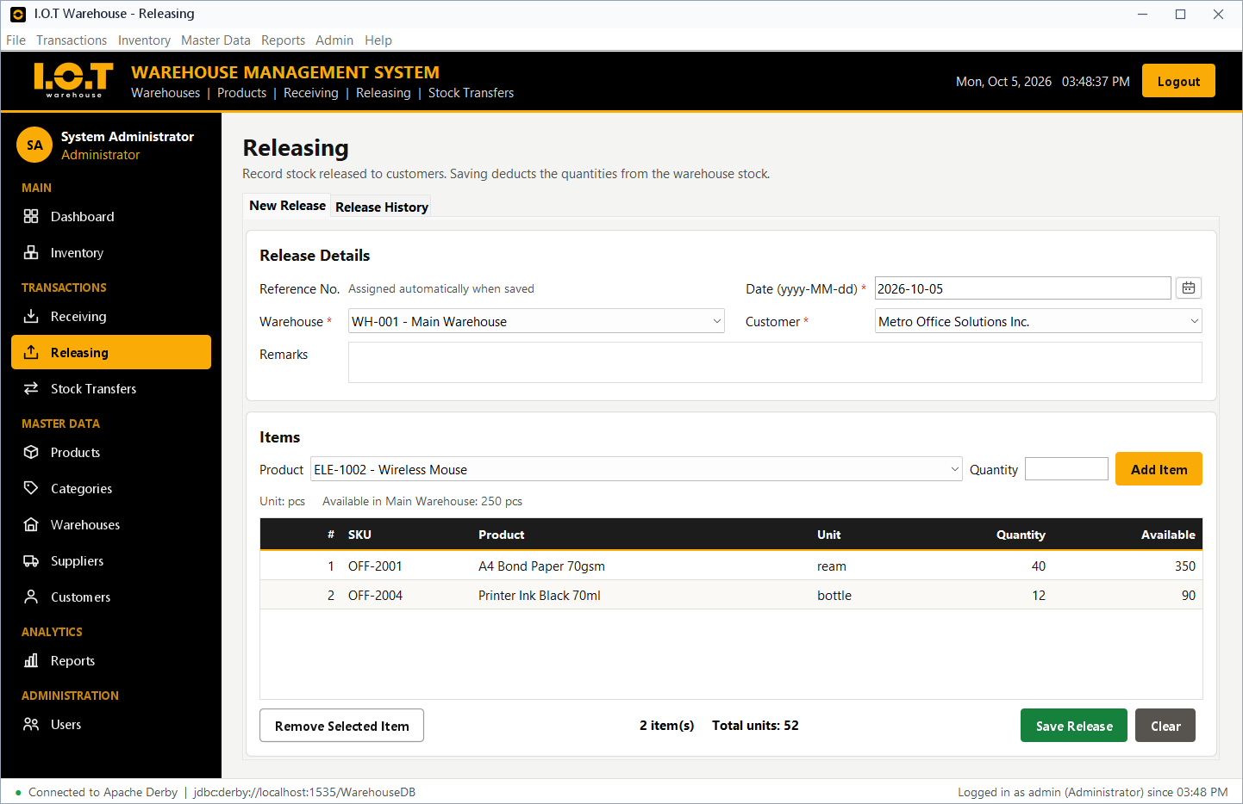
Figure 20. Releasing - the available stock is shown while adding items
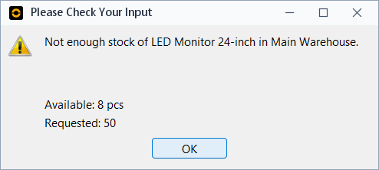
Figure 21. Validation: releasing more than the available stock
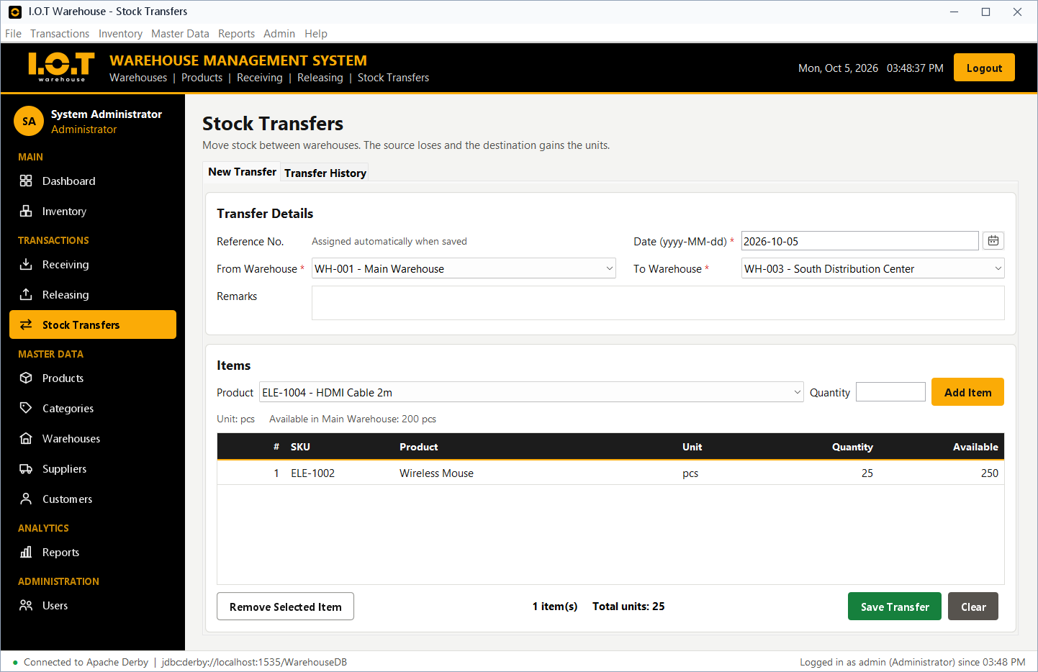
Figure 22. Stock transfer - new document
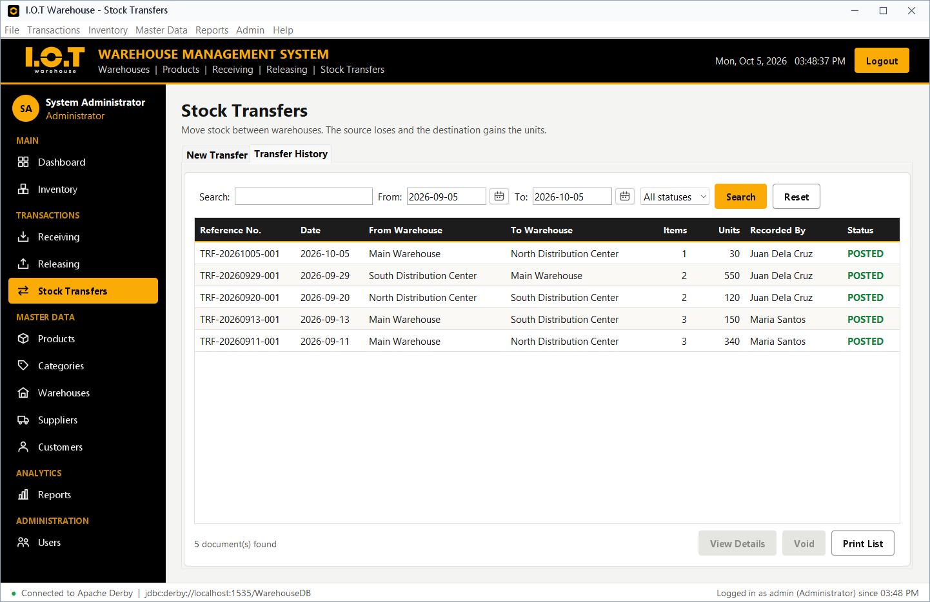
Figure 23. Stock transfer history

3.10.4 Master Data and User Management
All management screens share the same layout: the form with [SAVE] [UPDATE] [DELETE] [CLEAR] on the left, and the search bar and the JTable of records on the right. Clicking a row loads the record into the form.
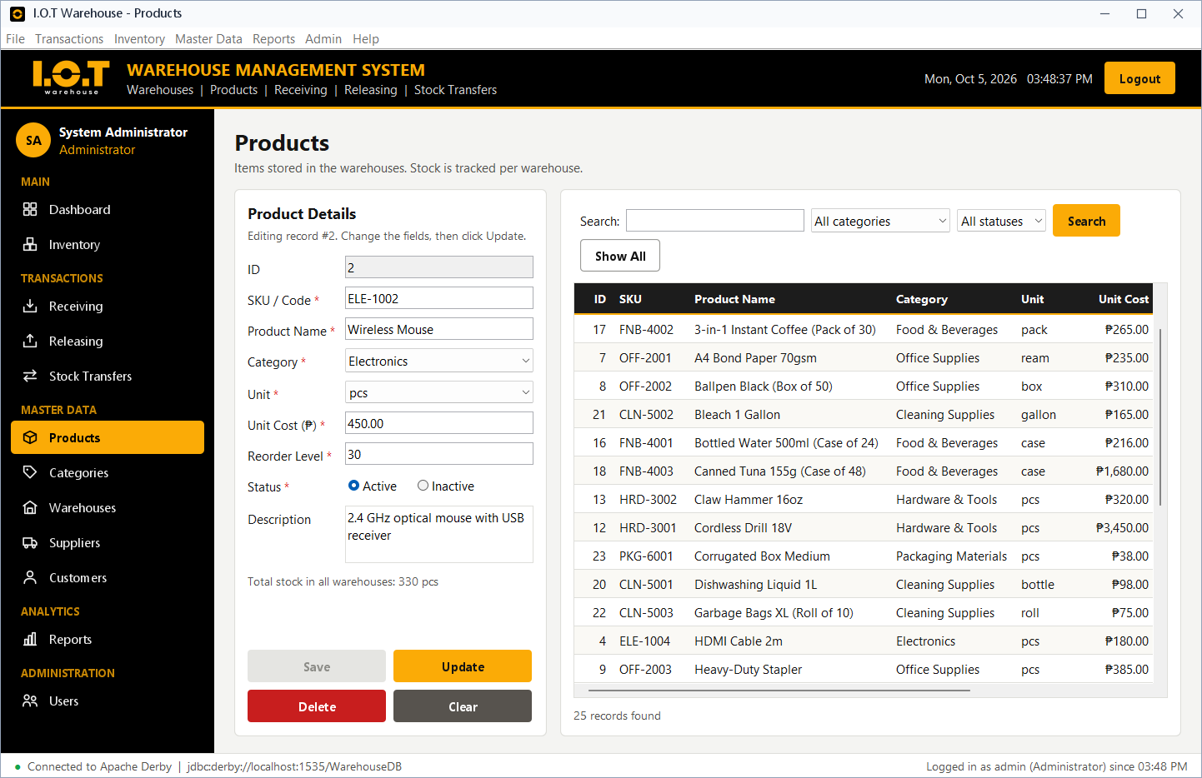
Figure 24. Product management (a record loaded for updating)
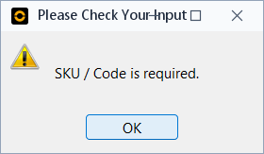
Figure 25. Validation message for a required field
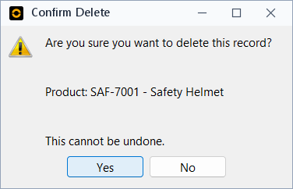
Figure 26. Confirmation before deleting a record
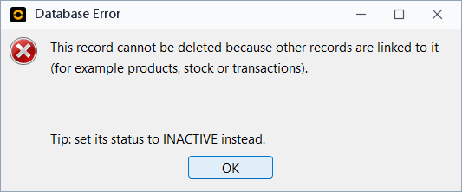
Figure 27. A record in use cannot be deleted (foreign key)
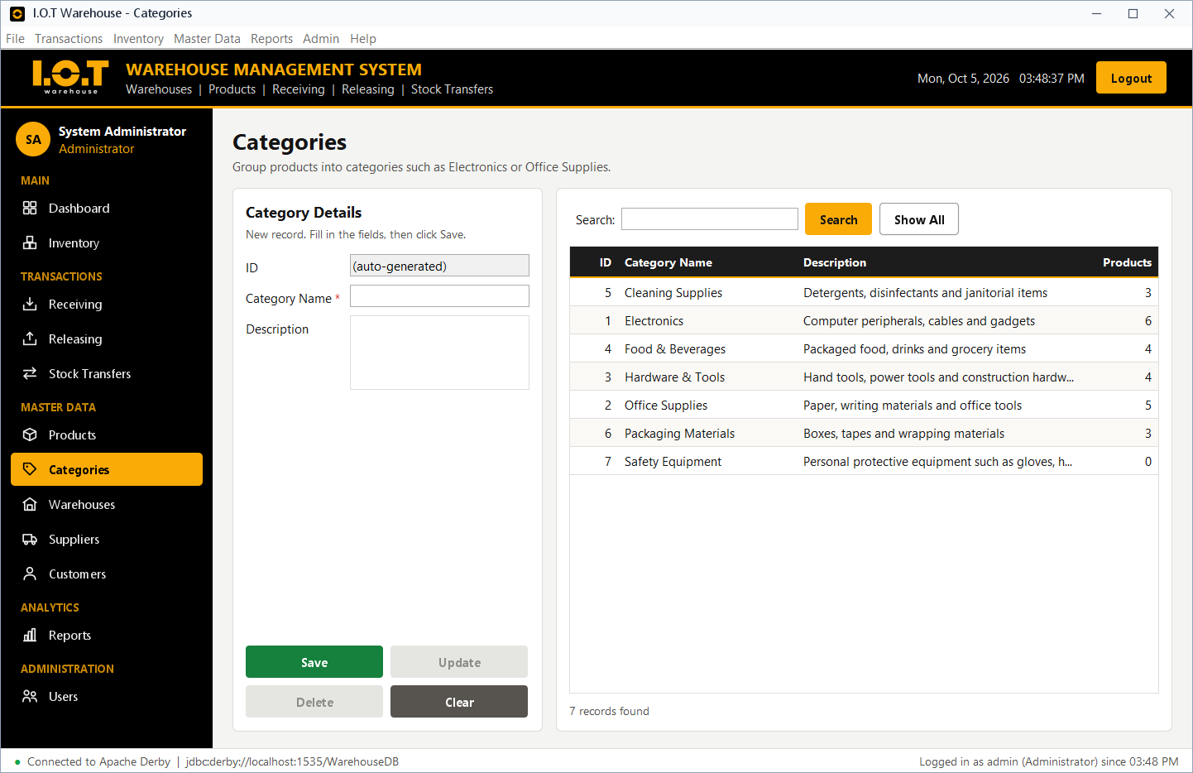
Figure 28. Category management
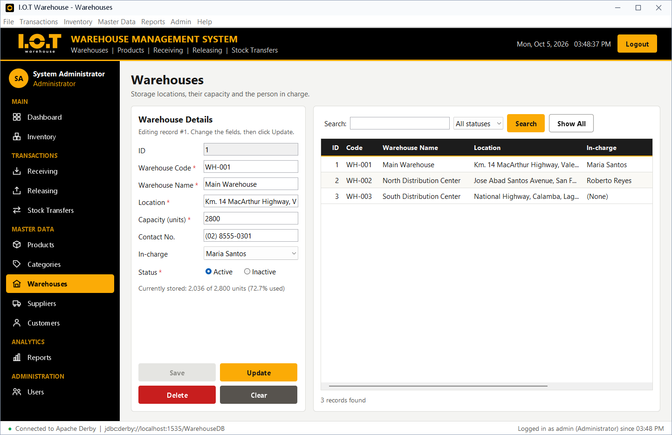
Figure 29. Warehouse management
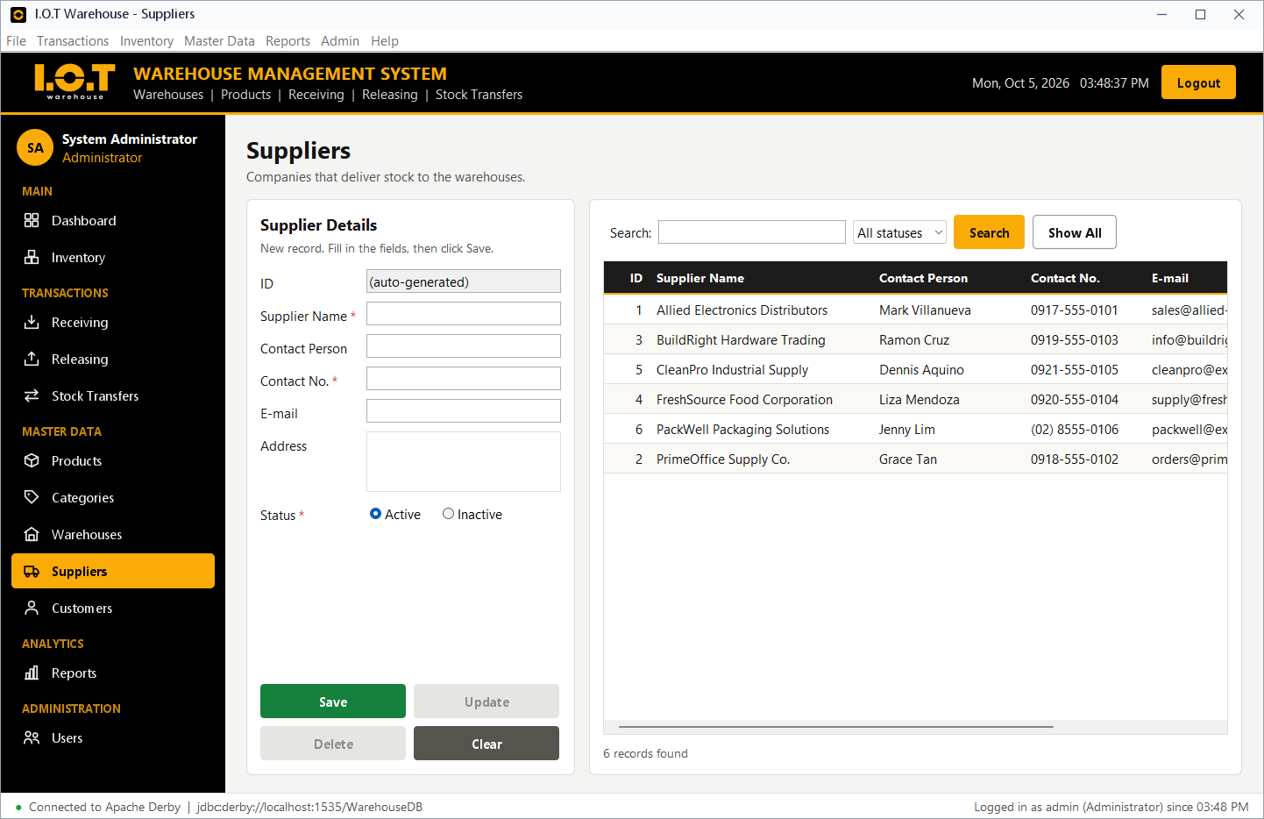
Figure 30. Supplier management
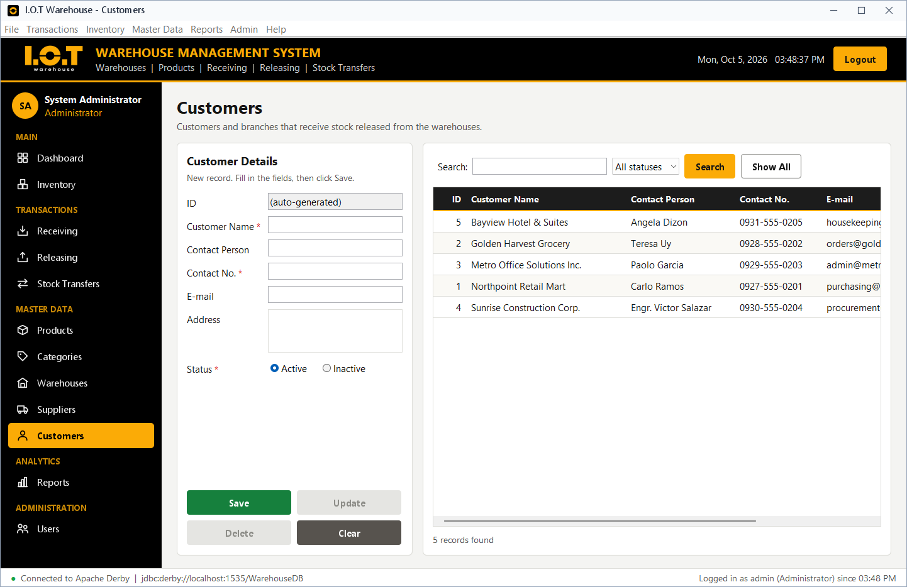
Figure 31. Customer management
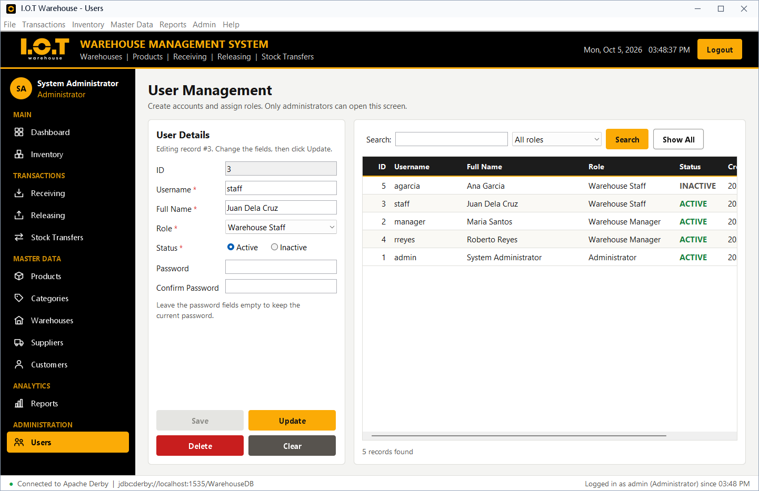
Figure 32. User management (Administrator only)

3.10.5 Reports
The Reports screen lists the twelve reports. The date range and warehouse filters are enabled only for the reports that use them. Every report can be printed or exported to a CSV file that opens in Excel.
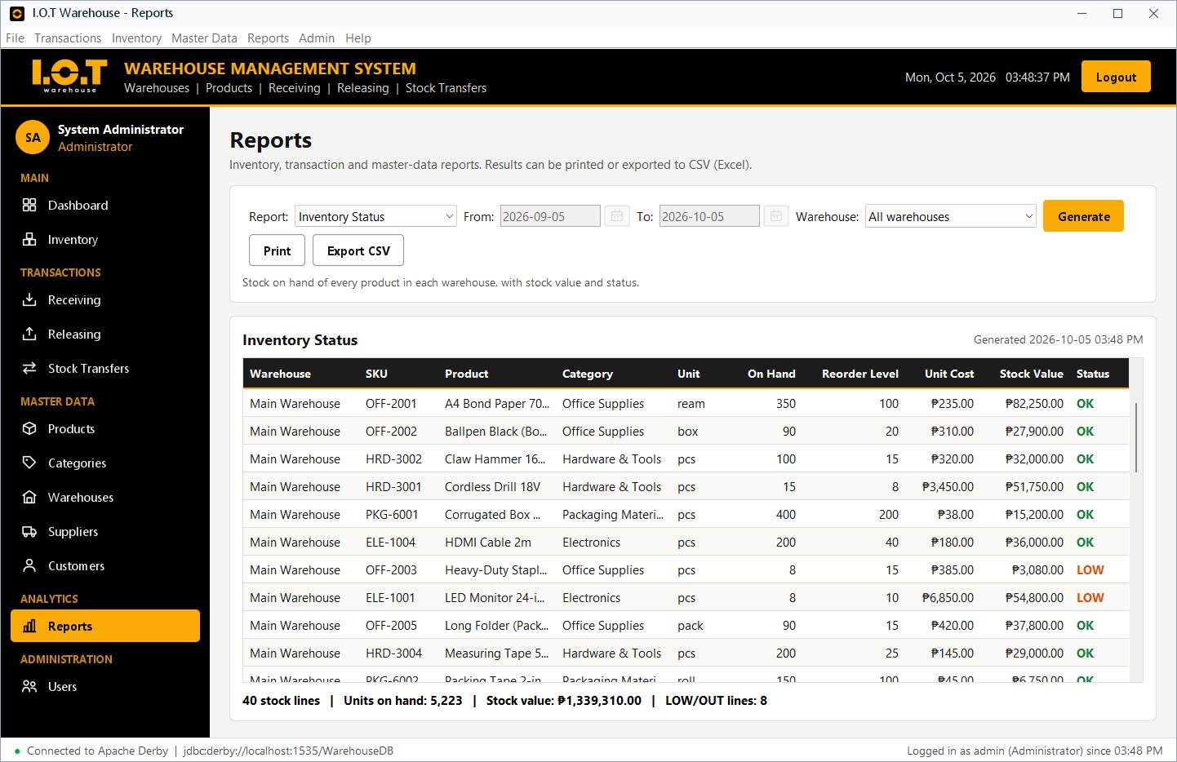
Figure 33. Report - Inventory Status
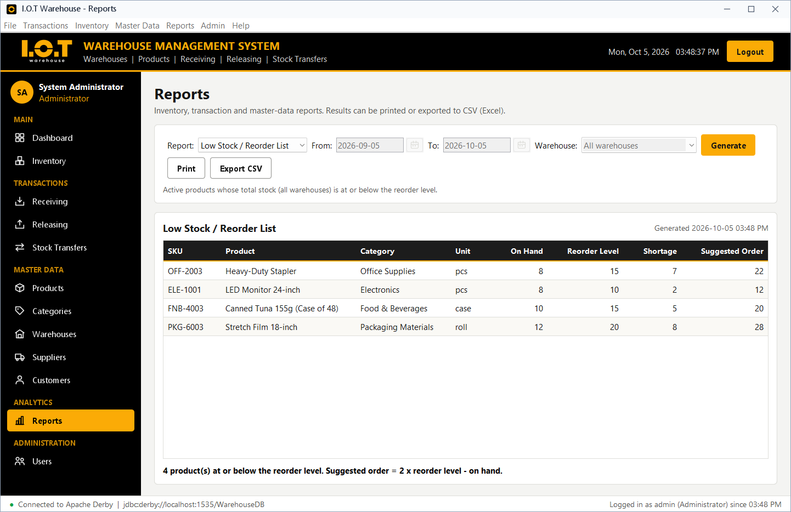
Figure 34. Report - Low Stock / Reorder List
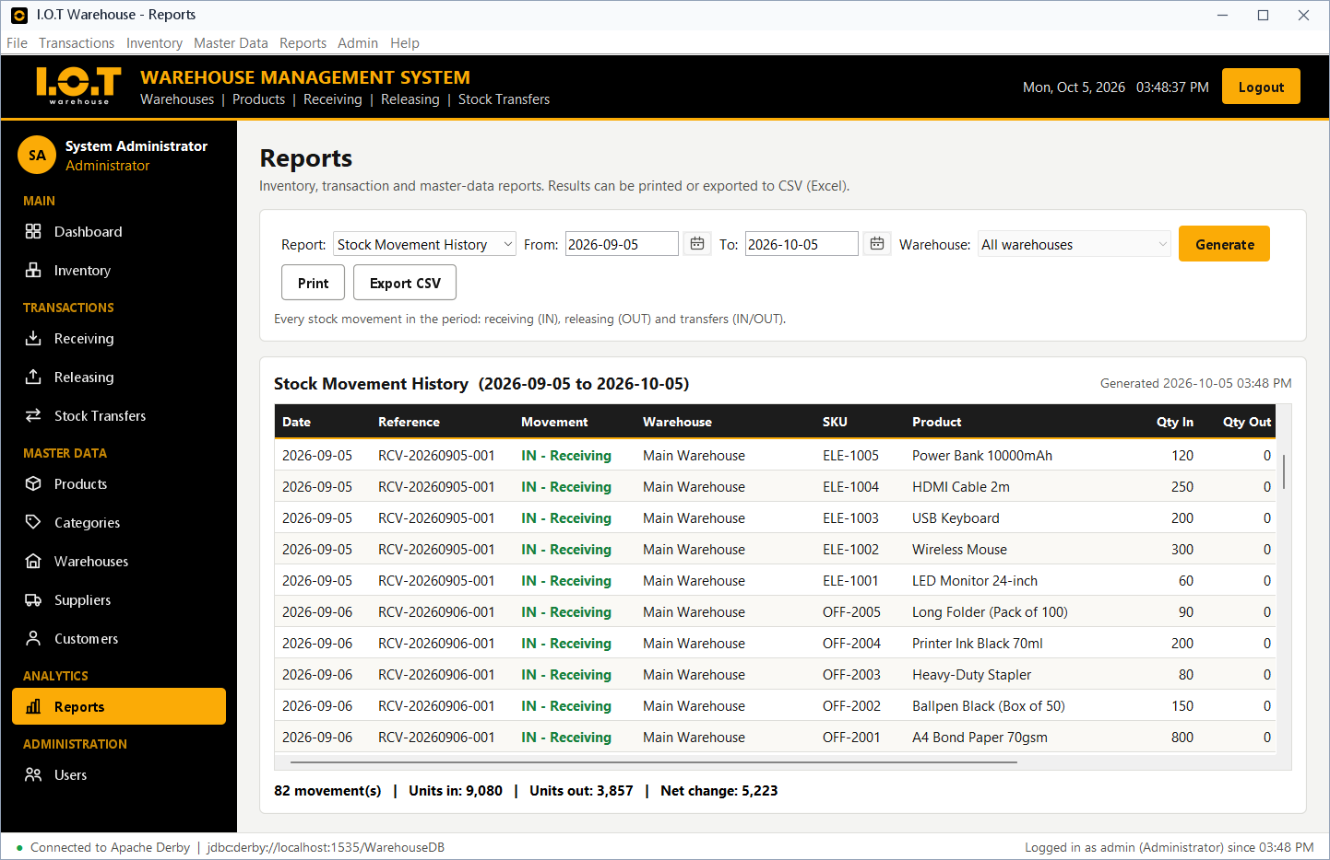
Figure 35. Report - Stock Movement History
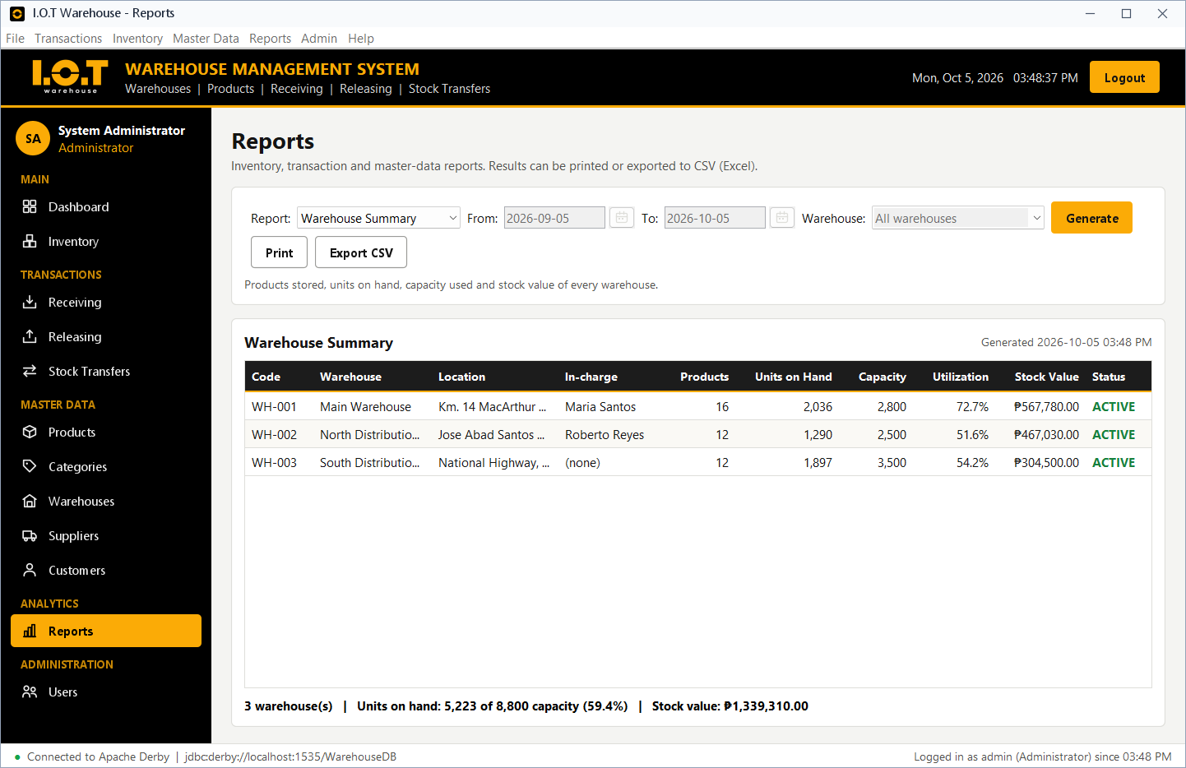
Figure 36. Report - Warehouse Summary
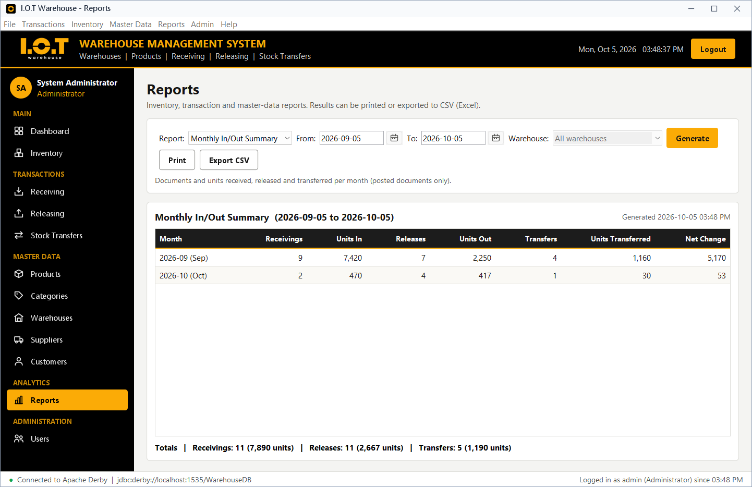
Figure 37. Report - Monthly In/Out Summary

3.10.6 Other Screens and Role-Based Access
Any user can change their own password. The last screenshot shows what a Warehouse Staff user sees: the master data is view-only and the Reports and User Management modules are hidden.
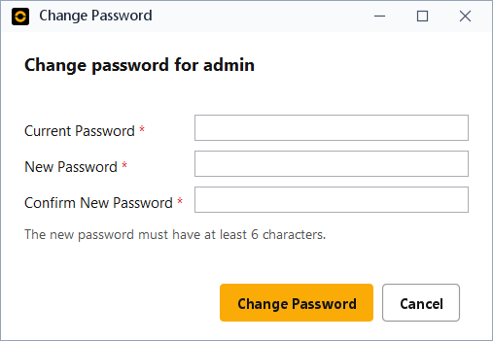
Figure 38. Change password dialog
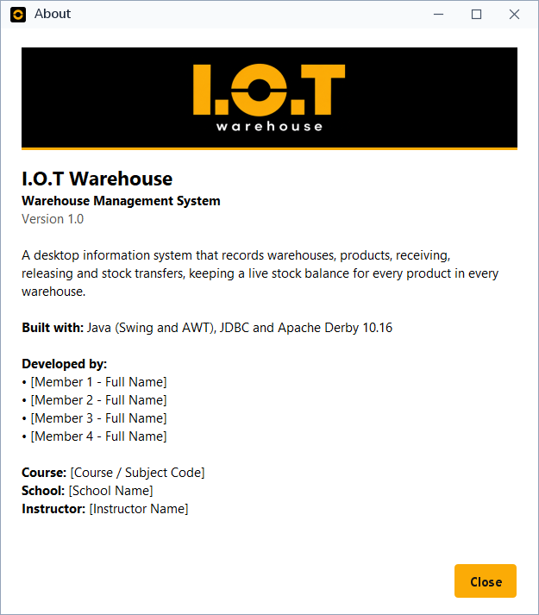
Figure 39. About dialog with the I.O.T Warehouse logo
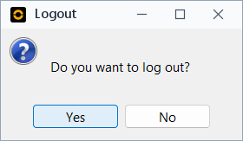
Figure 40. Logout confirmation
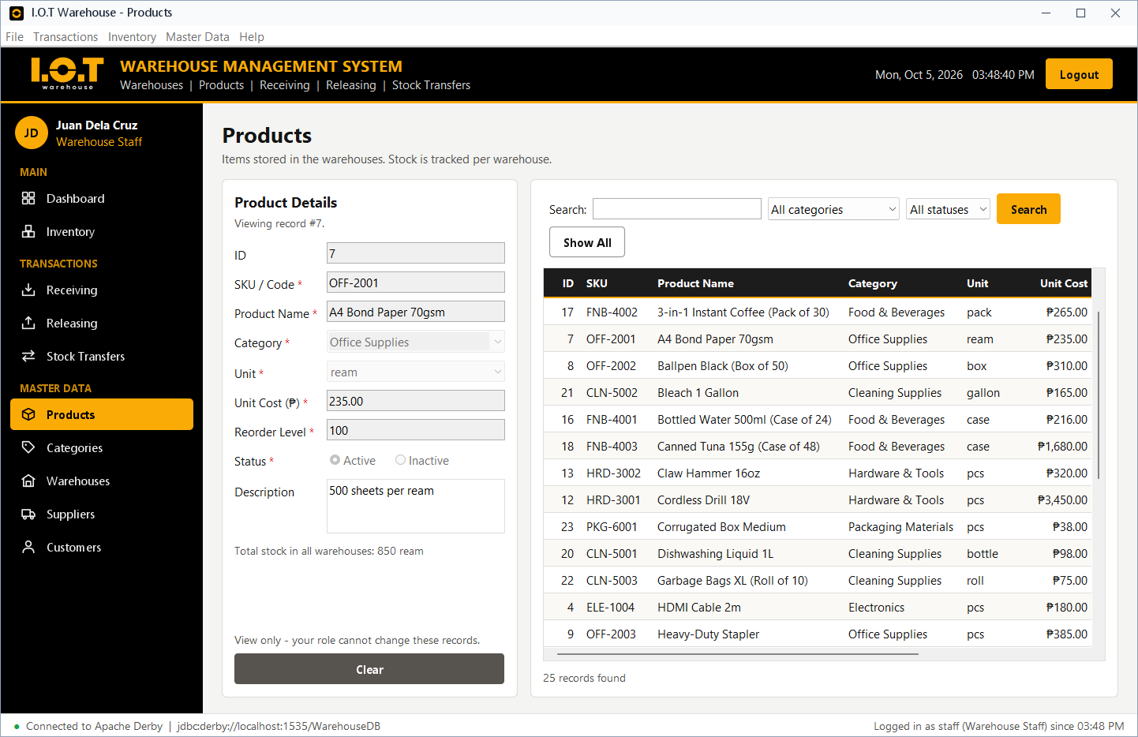
Figure 41. Warehouse Staff view: master data is view-only; no Reports or Users

CHAPTER 4 - TESTING

4.1 Test Plan
Table 33. Test plan
Item | Plan
Objective | Verify that every function works, that invalid input is refused, that the stock stays correct and that errors are handled without crashing.
Automated database tests | test/WmsTestRunner.java runs 26 test cases directly against the DAO classes on a separate test database (run-tests.bat).
Automated GUI flow test | A test program drives the real Swing screens (fills fields, clicks buttons, answers dialogs) and checks 30 results in the database and on screen.
Manual testing | Walk-through of every screen with the three demo accounts (Administrator, Manager, Staff).
Environment | Windows 11, JDK 21, Apache Derby 10.16.1.1 Network Server, sample data.
Pass criteria | The actual result equals the expected result for every test case.

4.2 Test Cases
The table below lists the automated test cases. Actual results and status were recorded by the test runner.
Table 34. Test cases and results (automated)
Test ID | Function | Test Input | Expected Result | Actual Result | Status
T001 | Login | Correct credentials (admin / correct password) | User is accepted with the ADMIN role | Accepted: System Administrator (Administrator) | PASS
T002 | Login | Wrong password | Login is rejected (error message) | Rejected for wrong password and unknown user | PASS
T003 | Add | Valid category record | Record is saved with a new ID | Saved with ID 8 | PASS
T004 | Add | Empty required field | Validation message; database also refuses NULL | Validator detects blank input; Derby NOT NULL -> SQLState 23502 | PASS
T005 | Update | Modify the category description | Record is updated | Description changed to "Updated description" | PASS
T006 | Delete | Existing unused record | Confirmation, then the record is deleted | Record 8 deleted | PASS
T007 | Search | Existing keyword "mouse" | Matching records are shown | 1 match: ELE-1002 - Wireless Mouse | PASS
T008 | Search | Keyword that does not exist | No matching records | 0 records | PASS
T009 | Releasing | Release more than the available stock | Blocked; stock unchanged | Blocked: available 8, requested 13 | PASS
T010 | Transfer | Source and destination are the same warehouse | Blocked by the program and the database | Program rule + CHECK constraint (SQLState 23513) | PASS
T011 | Receiving | Receive more than the free warehouse capacity | Blocked; stock unchanged | Blocked: free space 764, requested 765 | PASS
T012 | Add | Duplicate SKU | Duplicate is detected and refused | Program check + UNIQUE constraint (SQLState 23505) | PASS
T013 | Delete | Product used in transactions | Refused with a friendly message | FOREIGN KEY (SQLState 23503): "This record cannot be deleted..." | PASS
T014 | Transactions | Receive 10, release 4, transfer 3 units | Stock changes exactly by those amounts | Main: 15 -> 18, North: 0 -> 3 | PASS
T015 | Void | Void a posted receiving | Stock is reversed and status becomes VOIDED | RCV-20260928-003 voided, stock back to 450; second void refused | PASS
T016 | Void | Void a receiving whose units were already released | Void is refused | Refused: only 5 of 20 units remain in the warehouse | PASS
T017 | Security | Role permissions of Staff, Manager and Admin | Each role gets only its allowed actions | Staff: transactions only; Manager: + master data, void, reports; Admin: everything | PASS
T018 | Login | Inactive account (agarcia) | Login is refused | Password correct but status INACTIVE -> access refused | PASS
T019 | Validation | Invalid e-mail, phone, date, amount, username | All invalid values are rejected | All invalid samples rejected, valid samples accepted | PASS
T020 | Security | Password storage | Passwords are stored as salted hashes | PBKDF2 hashes, random salt, plain text never stored | PASS
T021 | Error handling | Database server not reachable | Friendly connection message, no crash | SQLState 08001 -> "Cannot connect to the database..." | PASS
T022 | Transactions | Release with 2 lines where line 2 exceeds the stock | Nothing is saved (rollback) | Rolled back: line 1 stock still 350, no document created | PASS
T023 | Reports | Generate all 12 reports | Every report runs; totals match the dashboard | 12 reports OK; inventory units = dashboard units = 5234 | PASS
T024 | Transactions | Reference numbers of two documents on the same day | Unique, in sequence | 4 receivings today, e.g. RCV-20260928-004 | PASS
T025 | Relationships | Same manager in charge of two warehouses | Refused (one-to-one rule) | UNIQUE manager_id (SQLState 23505); assigned managers are not offered | PASS
T026 | Dashboard | Low-stock detection on the sample data | Products at/below reorder level are listed | 4 low-stock product(s), e.g. OFF-2003 (8 left) | PASS

Result: 26 of 26 automated test cases passed, and 30 of 30 GUI flow checks passed.
In Sections 4.3 to 4.8, the test cases are grouped by area. T-numbers are the automated test cases above; GUI rows are checks made by the automated GUI flow test on the real screens (it types into the fields, clicks the buttons and answers the dialogs like a user).

4.3 Login and Security Testing
Login was tested with correct credentials, a wrong password, an unknown user and an inactive account. The role permissions, the password storage and logging out were also checked.
Table 35. Login and security testing
Test | Test input / check | Expected result | Actual result | Status
T001 | Correct credentials (admin / correct password) | User is accepted with the ADMIN role | Accepted: System Administrator (Administrator) | PASS
T002 | Wrong password | Login is rejected (error message) | Rejected for wrong password and unknown user | PASS
T018 | Inactive account (agarcia) | Login is refused | Password correct but status INACTIVE -> access refused | PASS
T017 | Role permissions of Staff, Manager and Admin | Each role gets only its allowed actions | Staff: transactions only; Manager: + master data, void, reports; Admin: everything | PASS
T020 | Password storage | Passwords are stored as salted hashes | PBKDF2 hashes, random salt, plain text never stored | PASS
GUI | admin with a wrong password | Error message; stays on login | "Invalid username or password. Please try again." | PASS
GUI | admin with the correct password | Main window opens | Main window opened for the Administrator | PASS
GUI | Admin changes own role to Staff | Refused with a warning | "You cannot remove your own administrator role..." | PASS
GUI | Logout and answer Yes | Session ends; login screen shown | Logout confirmation, then the login screen | PASS

4.4 Input Validation Testing
Empty required fields, duplicate values, invalid e-mail addresses, phone numbers, dates, amounts and passwords were entered. Number fields also refuse letters while typing.
Table 36. Input validation testing
Test | Test input / check | Expected result | Actual result | Status
T004 | Empty required field | Validation message; database also refuses NULL | Validator detects blank input; Derby NOT NULL -> SQLState 23502 | PASS
T012 | Duplicate SKU | Duplicate is detected and refused | Program check + UNIQUE constraint (SQLState 23505) | PASS
T019 | Invalid e-mail, phone, date, amount, username | All invalid values are rejected | All invalid samples rejected, valid samples accepted | PASS
GUI | Save a product with an empty SKU | Required-field message | "SKU / Code is required." | PASS
GUI | Save SKU SAF-7001 a second time | Duplicate message; nothing saved | "The SKU SAF-7001 is already used by another product." | PASS
GUI | Supplier contact number "12" | Validation message | "Contact number must have 7 to 15 digits..." | PASS
GUI | Supplier e-mail "bad@mail" | Validation message | "Please enter a valid e-mail address..." | PASS
GUI | Release date 2099-01-01 | Validation message | "The date cannot be in the future." | PASS
GUI | Release date 2026-02-30 | Validation message | "Date must be a real date in the yyyy-MM-dd format..." | PASS
GUI | WH-001 capacity changed to 100 | Validation message | "Capacity cannot be lower than the units currently stored (2,028)." | PASS
GUI | New user; password and confirmation differ | Validation message | "The two passwords do not match." | PASS

4.5 CRUD Testing
Records were added, viewed, updated and deleted, and every change was checked in the database.
Table 37. CRUD testing
Test | Test input / check | Expected result | Actual result | Status
T003 | Valid category record | Record is saved with a new ID | Saved with ID 8 | PASS
T005 | Modify the category description | Record is updated | Description changed to "Updated description" | PASS
T006 | Existing unused record | Confirmation, then the record is deleted | Record 8 deleted | PASS
GUI | New product SAF-7001 Safety Helmet | Success message; record saved | "Product SAF-7001 - Safety Helmet was saved (ID 26)." | PASS
GUI | SKU typed in lowercase, unit cost 350.50 | Stored in uppercase with the exact cost | Row found in PRODUCTS: SAF-7001, unit cost 350.50 | PASS
GUI | Change the name, click Update | Success message | "Product SAF-7001 was updated." | PASS
GUI | Search the product by its new name | The new name is stored | The new name was found in the PRODUCTS table | PASS
GUI | Delete SAF-7001 and answer Yes | Confirmation, then deleted | Confirm Delete dialog, then "The product was deleted." | PASS
GUI | New user newclerk with matching passwords | Success message; account saved | "User account "newclerk" was created (ID 6)." | PASS

4.6 Database Testing
These tests check the stock calculations, the business rules, the transactions (commit and rollback), the reference numbers and the constraints and relationships of the database.
Table 38. Database testing
Test | Test input / check | Expected result | Actual result | Status
T009 | Release more than the available stock | Blocked; stock unchanged | Blocked: available 8, requested 13 | PASS
T010 | Source and destination are the same warehouse | Blocked by the program and the database | Program rule + CHECK constraint (SQLState 23513) | PASS
T011 | Receive more than the free warehouse capacity | Blocked; stock unchanged | Blocked: free space 764, requested 765 | PASS
T014 | Receive 10, release 4, transfer 3 units | Stock changes exactly by those amounts | Main: 15 -> 18, North: 0 -> 3 | PASS
T015 | Void a posted receiving | Stock is reversed and status becomes VOIDED | RCV-20260928-003 voided, stock back to 450; second void refused | PASS
T016 | Void a receiving whose units were already released | Void is refused | Refused: only 5 of 20 units remain in the warehouse | PASS
T022 | Release with 2 lines where line 2 exceeds the stock | Nothing is saved (rollback) | Rolled back: line 1 stock still 350, no document created | PASS
T024 | Reference numbers of two documents on the same day | Unique, in sequence | 4 receivings today, e.g. RCV-20260928-004 | PASS
T025 | Same manager in charge of two warehouses | Refused (one-to-one rule) | UNIQUE manager_id (SQLState 23505); assigned managers are not offered | PASS
GUI | Add ELE-1002 twice (12 + 8 units) | One line of 20 units | The quantities were merged into one line | PASS
GUI | Save the receiving | Saved with a new reference number | "Receiving RCV-20260928-002 was saved." | PASS
GUI | Read the warehouse stock | 20 units more than before | WAREHOUSE_STOCK quantity increased by 20 | PASS
GUI | Release 999 units of ELE-1001 | Not-enough-stock message | "Not enough stock of LED Monitor 24-inch... Available: 8 pcs" | PASS
GUI | Release 3 units with a valid date | Saved; stock deducted | "Release REL-20260928-002 was saved." | PASS
GUI | From WH-001 to WH-001 | Validation message | "The source and destination warehouses must be different." | PASS
GUI | 5 units from WH-001 to WH-002 | Saved; both warehouses updated | "Transfer TRF-20260928-002 was saved." | PASS
GUI | Void the new receiving and answer Yes | Confirmation; stock reversed | Confirm Void dialog; stock reversed, status VOIDED | PASS

4.7 Search and Report Testing
Searches were tested with an existing keyword and with a keyword that does not exist. All reports and the dashboard were generated and their totals compared.
Table 39. Search and report testing
Test | Test input / check | Expected result | Actual result | Status
T007 | Existing keyword "mouse" | Matching records are shown | 1 match: ELE-1002 - Wireless Mouse | PASS
T008 | Keyword that does not exist | No matching records | 0 records | PASS
T023 | Generate all 12 reports | Every report runs; totals match the dashboard | 12 reports OK; inventory units = dashboard units = 5234 | PASS
T026 | Low-stock detection on the sample data | Products at/below reorder level are listed | 4 low-stock product(s), e.g. OFF-2003 (8 left) | PASS
GUI | Open every module from the sidebar | Every screen loads its data | All 12 modules opened, no error message | PASS
GUI | Generate each of the 12 reports | Every report is shown | All 12 reports generated, no error message | PASS

4.8 Error Handling Testing
Error handling was tested by deleting records that are in use (foreign keys) and by connecting to a database server that is not running. In every case a clear message is shown and the program keeps running.
Table 40. Error handling testing
Test | Test input / check | Expected result | Actual result | Status
T013 | Product used in transactions | Refused with a friendly message | FOREIGN KEY (SQLState 23503): "This record cannot be deleted..." | PASS
T021 | Database server not reachable | Friendly connection message, no crash | SQLState 08001 -> "Cannot connect to the database..." | PASS
GUI | Delete ELE-1002 (used in documents) | Refused with an explanation | "ELE-1002 cannot be deleted because it already appears in 4 transaction line(s)." | PASS
GUI | Delete a supplier that has receivings | Friendly foreign-key message | "This record cannot be deleted because other records are linked to it..." | PASS

4.9 User Acceptance Testing
User acceptance testing is done with people acting as the real users (for example classmates acting as warehouse staff and managers). Each tester completes the tasks below with the demo accounts and rates each item from 1 (poor) to 5 (excellent). The ratings are filled in during the actual UAT session.
Table 41. User acceptance testing form
# | Criterion / task | Rating (1-5) | Remarks
1 | Logging in and out is easy and error messages are clear.
2 | Adding, updating and deleting a product is easy.
3 | Recording a receiving with several products is easy.
4 | The system prevents releasing more than the available stock.
5 | Transferring stock between warehouses updates both warehouses correctly.
6 | Searching for a record by keyword, date or status gives the expected results.
7 | The dashboard and reports give useful information.
8 | Printing and exporting reports works.
9 | The screens are consistent, readable and well organized.
10 | Each role sees only the functions it is allowed to use.

Table 42. UAT testers
Tester name | Role tested | Date | Overall rating | Signature

CHAPTER 5 - CONCLUSION

5.1 Summary
The project developed a Warehouse Management System for I.O.T Warehouse, a Java desktop information system for warehouses, products, receiving, releasing and stock transfers. The graphical user interface was built with Java Swing and AWT, the data is stored in an Apache Derby database of 13 related tables, and the program communicates with the database through JDBC using PreparedStatement.
The system keeps a live stock balance for every product in every warehouse, records who created every document, prevents invalid operations (negative stock, over-releasing, exceeding capacity, transfers to the same warehouse, duplicates), and produces a dashboard and twelve reports that can be printed or exported. Three user roles control access to the functions. All 26 automated test cases and 30 GUI flow checks passed.

5.2 Conclusions
- A Java desktop application with Swing/AWT, JDBC and Apache Derby can fully replace manual logbooks and stock cards for a small or medium-sized warehouse operation.
- Separating the program into layers (GUI, validation, DAO, JDBC, database) made the code easier to build, test and maintain.
- Database constraints (primary keys, foreign keys, UNIQUE, CHECK) together with program validation keep the data consistent even when a user makes a mistake.
- Saving each document in one database transaction guarantees that the stock is never partly updated.
- Role-based access and hashed passwords give basic but effective security for the system.

5.3 Recommendations
- Train the users with the sample data before entering real data, then start with a clean database by deleting the data folder.
- Back up the data folder regularly (while the program is closed).
- Change the demo passwords and create an account for every real user.
- Complete the user acceptance testing form with the actual users and use their feedback to improve the screens.

5.4 Possible Future Improvements
- Barcode or QR-code scanning of products when receiving and releasing.
- Stock-count adjustments and damaged-goods tracking.
- Bin/shelf locations, batch numbers and expiry dates.
- Purchase orders and sales orders linked to receiving and releasing.
- E-mail alerts for low stock and a scheduled daily report.
- Multi-user network access to a central database server and a web or mobile version.
- An activity log that records every change and login attempt, and locking an account after several failed logins.
- Charts in reports and export to PDF and Excel formats.

APPENDIX A - SQL STATEMENTS

A.1 Database Schema (schema.sql)
-- =====================================================================
-- WAREHOUSE MANAGEMENT SYSTEM - Apache Derby database schema
-- 13 tables with primary keys, foreign keys, UNIQUE, NOT NULL,
-- DEFAULT and CHECK constraints.
-- This script is executed automatically on the first run of the program
-- (see DatabaseInitializer.java). Tables are created in dependency order.
-- =====================================================================
-- ---------------------------------------------------------------------
-- 1. USERS : system accounts (passwords are stored as PBKDF2 hashes)
-- ---------------------------------------------------------------------
CREATE TABLE USERS (
user_id INTEGER NOT NULL GENERATED ALWAYS AS IDENTITY (START WITH 1, INCREMENT BY 1),
username VARCHAR(50) NOT NULL,
password_hash VARCHAR(255) NOT NULL,
full_name VARCHAR(100) NOT NULL,
role VARCHAR(20) NOT NULL,
status VARCHAR(10) DEFAULT 'ACTIVE' NOT NULL,
created_at TIMESTAMP DEFAULT CURRENT_TIMESTAMP NOT NULL,
CONSTRAINT pk_users PRIMARY KEY (user_id),
CONSTRAINT uq_users_username UNIQUE (username),
CONSTRAINT ck_users_role CHECK (role IN ('ADMIN', 'MANAGER', 'STAFF')),
CONSTRAINT ck_users_status CHECK (status IN ('ACTIVE', 'INACTIVE'))
);
-- ---------------------------------------------------------------------
-- 2. CATEGORIES : product classification
-- ---------------------------------------------------------------------
CREATE TABLE CATEGORIES (
category_id INTEGER NOT NULL GENERATED ALWAYS AS IDENTITY (START WITH 1, INCREMENT BY 1),
category_name VARCHAR(100) NOT NULL,
description VARCHAR(255),
created_at TIMESTAMP DEFAULT CURRENT_TIMESTAMP NOT NULL,
CONSTRAINT pk_categories PRIMARY KEY (category_id),
CONSTRAINT uq_categories_name UNIQUE (category_name)
);
-- ---------------------------------------------------------------------
-- 3. PRODUCTS : items stored in the warehouses (CATEGORIES 1 : M PRODUCTS)
-- ---------------------------------------------------------------------
CREATE TABLE PRODUCTS (
product_id INTEGER NOT NULL GENERATED ALWAYS AS IDENTITY (START WITH 1, INCREMENT BY 1),
sku VARCHAR(30) NOT NULL,
product_name VARCHAR(100) NOT NULL,
category_id INTEGER NOT NULL,
unit VARCHAR(20) DEFAULT 'pcs' NOT NULL,
unit_cost DECIMAL(10,2) DEFAULT 0 NOT NULL,
reorder_level INTEGER DEFAULT 10 NOT NULL,
description VARCHAR(255),
status VARCHAR(10) DEFAULT 'ACTIVE' NOT NULL,
created_at TIMESTAMP DEFAULT CURRENT_TIMESTAMP NOT NULL,
CONSTRAINT pk_products PRIMARY KEY (product_id),
CONSTRAINT uq_products_sku UNIQUE (sku),
CONSTRAINT fk_products_category FOREIGN KEY (category_id) REFERENCES CATEGORIES (category_id),
CONSTRAINT ck_products_cost CHECK (unit_cost >= 0),
CONSTRAINT ck_products_reorder CHECK (reorder_level >= 0),
CONSTRAINT ck_products_status CHECK (status IN ('ACTIVE', 'INACTIVE'))
);
-- ---------------------------------------------------------------------
-- 4. WAREHOUSES : storage locations
-- manager_id is UNIQUE and optional -> one-to-one with USERS
-- (a user can be in charge of at most one warehouse)
-- ---------------------------------------------------------------------
CREATE TABLE WAREHOUSES (
warehouse_id INTEGER NOT NULL GENERATED ALWAYS AS IDENTITY (START WITH 1, INCREMENT BY 1),
warehouse_code VARCHAR(20) NOT NULL,
warehouse_name VARCHAR(100) NOT NULL,
location VARCHAR(255) NOT NULL,
capacity INTEGER NOT NULL,
contact_no VARCHAR(20),
manager_id INTEGER,
status VARCHAR(10) DEFAULT 'ACTIVE' NOT NULL,
created_at TIMESTAMP DEFAULT CURRENT_TIMESTAMP NOT NULL,
CONSTRAINT pk_warehouses PRIMARY KEY (warehouse_id),
CONSTRAINT uq_warehouses_code UNIQUE (warehouse_code),
CONSTRAINT uq_warehouses_name UNIQUE (warehouse_name),
CONSTRAINT uq_warehouses_manager UNIQUE (manager_id),
CONSTRAINT fk_warehouses_manager FOREIGN KEY (manager_id) REFERENCES USERS (user_id) ON DELETE SET NULL,
CONSTRAINT ck_warehouses_capacity CHECK (capacity > 0),
CONSTRAINT ck_warehouses_status CHECK (status IN ('ACTIVE', 'INACTIVE'))
);
-- ---------------------------------------------------------------------
-- 5. SUPPLIERS : where received stock comes from
-- ---------------------------------------------------------------------
CREATE TABLE SUPPLIERS (
supplier_id INTEGER NOT NULL GENERATED ALWAYS AS IDENTITY (START WITH 1, INCREMENT BY 1),
supplier_name VARCHAR(100) NOT NULL,
contact_person VARCHAR(100),
contact_no VARCHAR(20) NOT NULL,
email VARCHAR(100),
address VARCHAR(255),
status VARCHAR(10) DEFAULT 'ACTIVE' NOT NULL,
created_at TIMESTAMP DEFAULT CURRENT_TIMESTAMP NOT NULL,
CONSTRAINT pk_suppliers PRIMARY KEY (supplier_id),
CONSTRAINT uq_suppliers_name UNIQUE (supplier_name),
CONSTRAINT ck_suppliers_status CHECK (status IN ('ACTIVE', 'INACTIVE'))
);
-- ---------------------------------------------------------------------
-- 6. CUSTOMERS : where released stock goes to
-- ---------------------------------------------------------------------
CREATE TABLE CUSTOMERS (
customer_id INTEGER NOT NULL GENERATED ALWAYS AS IDENTITY (START WITH 1, INCREMENT BY 1),
customer_name VARCHAR(100) NOT NULL,
contact_person VARCHAR(100),
contact_no VARCHAR(20) NOT NULL,
email VARCHAR(100),
address VARCHAR(255),
status VARCHAR(10) DEFAULT 'ACTIVE' NOT NULL,
created_at TIMESTAMP DEFAULT CURRENT_TIMESTAMP NOT NULL,
CONSTRAINT pk_customers PRIMARY KEY (customer_id),
CONSTRAINT uq_customers_name UNIQUE (customer_name),
CONSTRAINT ck_customers_status CHECK (status IN ('ACTIVE', 'INACTIVE'))
);
-- ---------------------------------------------------------------------
-- 7. WAREHOUSE_STOCK : quantity of each product in each warehouse.
-- Associative table: WAREHOUSES M : N PRODUCTS.
-- Composite primary key (warehouse_id, product_id).
-- ---------------------------------------------------------------------
CREATE TABLE WAREHOUSE_STOCK (
warehouse_id INTEGER NOT NULL,
product_id INTEGER NOT NULL,
quantity INTEGER DEFAULT 0 NOT NULL,
last_updated TIMESTAMP DEFAULT CURRENT_TIMESTAMP NOT NULL,
CONSTRAINT pk_warehouse_stock PRIMARY KEY (warehouse_id, product_id),
CONSTRAINT fk_stock_warehouse FOREIGN KEY (warehouse_id) REFERENCES WAREHOUSES (warehouse_id),
CONSTRAINT fk_stock_product FOREIGN KEY (product_id) REFERENCES PRODUCTS (product_id),
CONSTRAINT ck_stock_quantity CHECK (quantity >= 0)
);
-- ---------------------------------------------------------------------
-- 8. RECEIVINGS : stock IN from a supplier (document header)
-- ---------------------------------------------------------------------
CREATE TABLE RECEIVINGS (
receiving_id INTEGER NOT NULL GENERATED ALWAYS AS IDENTITY (START WITH 1, INCREMENT BY 1),
reference_no VARCHAR(20) NOT NULL,
receiving_date DATE NOT NULL,
warehouse_id INTEGER NOT NULL,
supplier_id INTEGER NOT NULL,
user_id INTEGER NOT NULL,
remarks VARCHAR(255),
status VARCHAR(10) DEFAULT 'POSTED' NOT NULL,
created_at TIMESTAMP DEFAULT CURRENT_TIMESTAMP NOT NULL,
CONSTRAINT pk_receivings PRIMARY KEY (receiving_id),
CONSTRAINT uq_receivings_ref UNIQUE (reference_no),
CONSTRAINT fk_receivings_warehouse FOREIGN KEY (warehouse_id) REFERENCES WAREHOUSES (warehouse_id),
CONSTRAINT fk_receivings_supplier FOREIGN KEY (supplier_id) REFERENCES SUPPLIERS (supplier_id),
CONSTRAINT fk_receivings_user FOREIGN KEY (user_id) REFERENCES USERS (user_id),
CONSTRAINT ck_receivings_status CHECK (status IN ('POSTED', 'VOIDED'))
);
-- ---------------------------------------------------------------------
-- 9. RECEIVING_ITEMS : products of a receiving (RECEIVINGS M : N PRODUCTS)
-- ---------------------------------------------------------------------
CREATE TABLE RECEIVING_ITEMS (
item_id INTEGER NOT NULL GENERATED ALWAYS AS IDENTITY (START WITH 1, INCREMENT BY 1),
receiving_id INTEGER NOT NULL,
product_id INTEGER NOT NULL,
quantity INTEGER NOT NULL,
unit_cost DECIMAL(10,2) NOT NULL,
CONSTRAINT pk_receiving_items PRIMARY KEY (item_id),
CONSTRAINT uq_receiving_items UNIQUE (receiving_id, product_id),
CONSTRAINT fk_ritems_receiving FOREIGN KEY (receiving_id) REFERENCES RECEIVINGS (receiving_id) ON DELETE CASCADE,
CONSTRAINT fk_ritems_product FOREIGN KEY (product_id) REFERENCES PRODUCTS (product_id),
CONSTRAINT ck_ritems_quantity CHECK (quantity > 0),
CONSTRAINT ck_ritems_cost CHECK (unit_cost >= 0)
);
-- ---------------------------------------------------------------------
-- 10. RELEASES : stock OUT to a customer (document header)
-- ---------------------------------------------------------------------
CREATE TABLE RELEASES (
release_id INTEGER NOT NULL GENERATED ALWAYS AS IDENTITY (START WITH 1, INCREMENT BY 1),
reference_no VARCHAR(20) NOT NULL,
release_date DATE NOT NULL,
warehouse_id INTEGER NOT NULL,
customer_id INTEGER NOT NULL,
user_id INTEGER NOT NULL,
remarks VARCHAR(255),
status VARCHAR(10) DEFAULT 'POSTED' NOT NULL,
created_at TIMESTAMP DEFAULT CURRENT_TIMESTAMP NOT NULL,
CONSTRAINT pk_releases PRIMARY KEY (release_id),
CONSTRAINT uq_releases_ref UNIQUE (reference_no),
CONSTRAINT fk_releases_warehouse FOREIGN KEY (warehouse_id) REFERENCES WAREHOUSES (warehouse_id),
CONSTRAINT fk_releases_customer FOREIGN KEY (customer_id) REFERENCES CUSTOMERS (customer_id),
CONSTRAINT fk_releases_user FOREIGN KEY (user_id) REFERENCES USERS (user_id),
CONSTRAINT ck_releases_status CHECK (status IN ('POSTED', 'VOIDED'))
);
-- ---------------------------------------------------------------------
-- 11. RELEASE_ITEMS : products of a release (RELEASES M : N PRODUCTS)
-- ---------------------------------------------------------------------
CREATE TABLE RELEASE_ITEMS (
item_id INTEGER NOT NULL GENERATED ALWAYS AS IDENTITY (START WITH 1, INCREMENT BY 1),
release_id INTEGER NOT NULL,
product_id INTEGER NOT NULL,
quantity INTEGER NOT NULL,
CONSTRAINT pk_release_items PRIMARY KEY (item_id),
CONSTRAINT uq_release_items UNIQUE (release_id, product_id),
CONSTRAINT fk_litems_release FOREIGN KEY (release_id) REFERENCES RELEASES (release_id) ON DELETE CASCADE,
CONSTRAINT fk_litems_product FOREIGN KEY (product_id) REFERENCES PRODUCTS (product_id),
CONSTRAINT ck_litems_quantity CHECK (quantity > 0)
);
-- ---------------------------------------------------------------------
-- 12. STOCK_TRANSFERS : stock moved between two different warehouses
-- (two foreign keys to the same WAREHOUSES table)
-- ---------------------------------------------------------------------
CREATE TABLE STOCK_TRANSFERS (
transfer_id INTEGER NOT NULL GENERATED ALWAYS AS IDENTITY (START WITH 1, INCREMENT BY 1),
reference_no VARCHAR(20) NOT NULL,
transfer_date DATE NOT NULL,
from_warehouse_id INTEGER NOT NULL,
to_warehouse_id INTEGER NOT NULL,
user_id INTEGER NOT NULL,
remarks VARCHAR(255),
status VARCHAR(10) DEFAULT 'POSTED' NOT NULL,
created_at TIMESTAMP DEFAULT CURRENT_TIMESTAMP NOT NULL,
CONSTRAINT pk_stock_transfers PRIMARY KEY (transfer_id),
CONSTRAINT uq_transfers_ref UNIQUE (reference_no),
CONSTRAINT fk_transfers_from FOREIGN KEY (from_warehouse_id) REFERENCES WAREHOUSES (warehouse_id),
CONSTRAINT fk_transfers_to FOREIGN KEY (to_warehouse_id) REFERENCES WAREHOUSES (warehouse_id),
CONSTRAINT fk_transfers_user FOREIGN KEY (user_id) REFERENCES USERS (user_id),
CONSTRAINT ck_transfers_warehouses CHECK (from_warehouse_id <> to_warehouse_id),
CONSTRAINT ck_transfers_status CHECK (status IN ('POSTED', 'VOIDED'))
);
-- ---------------------------------------------------------------------
-- 13. TRANSFER_ITEMS : products of a transfer (STOCK_TRANSFERS M : N PRODUCTS)
-- ---------------------------------------------------------------------
CREATE TABLE TRANSFER_ITEMS (
item_id INTEGER NOT NULL GENERATED ALWAYS AS IDENTITY (START WITH 1, INCREMENT BY 1),
transfer_id INTEGER NOT NULL,
product_id INTEGER NOT NULL,
quantity INTEGER NOT NULL,
CONSTRAINT pk_transfer_items PRIMARY KEY (item_id),
CONSTRAINT uq_transfer_items UNIQUE (transfer_id, product_id),
CONSTRAINT fk_titems_transfer FOREIGN KEY (transfer_id) REFERENCES STOCK_TRANSFERS (transfer_id) ON DELETE CASCADE,
CONSTRAINT fk_titems_product FOREIGN KEY (product_id) REFERENCES PRODUCTS (product_id),
CONSTRAINT ck_titems_quantity CHECK (quantity > 0)
);
-- ---------------------------------------------------------------------
-- Extra indexes for date searches (Derby indexes PK/UNIQUE/FK columns automatically)
-- ---------------------------------------------------------------------
CREATE INDEX idx_receivings_date ON RECEIVINGS (receiving_date);
CREATE INDEX idx_releases_date ON RELEASES (release_date);
CREATE INDEX idx_transfers_date ON STOCK_TRANSFERS (transfer_date);

A.2 Sample CRUD Statements
-- INSERT
INSERT INTO CATEGORIES (category_name, description) VALUES (?, ?);
INSERT INTO PRODUCTS (sku, product_name, category_id, unit, unit_cost, reorder_level, description, status)
VALUES (?, ?, ?, ?, ?, ?, ?, ?);
-- SELECT with INNER JOIN, a sub-query, WHERE, LIKE and ORDER BY (ProductDAO.searchProducts)
SELECT p.product_id, p.sku, p.product_name, p.category_id, c.category_name, p.unit,
p.unit_cost, p.reorder_level, p.description, p.status,
(SELECT COALESCE(SUM(s.quantity), 0) FROM WAREHOUSE_STOCK s
WHERE s.product_id = p.product_id) AS total_stock
FROM PRODUCTS p INNER JOIN CATEGORIES c ON p.category_id = c.category_id
WHERE (UPPER(p.sku) LIKE ? ESCAPE '\' OR UPPER(p.product_name) LIKE ? ESCAPE '\'
OR UPPER(c.category_name) LIKE ? ESCAPE '\' OR p.product_id = ?)
AND p.category_id = ? AND p.status = ? -- only when these filters are chosen
ORDER BY p.product_name;
-- UPDATE
UPDATE PRODUCTS SET sku = ?, product_name = ?, category_id = ?, unit = ?, unit_cost = ?,
reorder_level = ?, description = ?, status = ? WHERE product_id = ?;
-- DELETE
DELETE FROM PRODUCTS WHERE product_id = ?;

A.3 Stock Updates (inside a transaction)
-- add stock (the row is inserted the first time a product enters a warehouse)
UPDATE WAREHOUSE_STOCK SET quantity = quantity + ?, last_updated = CURRENT_TIMESTAMP
WHERE warehouse_id = ? AND product_id = ?;
INSERT INTO WAREHOUSE_STOCK (warehouse_id, product_id, quantity) VALUES (?, ?, ?);
-- deduct stock only when enough is available (0 rows updated = not enough stock)
UPDATE WAREHOUSE_STOCK SET quantity = quantity - ?, last_updated = CURRENT_TIMESTAMP
WHERE warehouse_id = ? AND product_id = ? AND quantity >= ?;
-- next reference number of the day, e.g. RCV-20260928-004
SELECT MAX(CAST(SUBSTR(reference_no, 14) AS INTEGER)) FROM RECEIVINGS WHERE reference_no LIKE ?;

A.4 Report Queries
-- Low Stock / Reorder List: total stock at or below the reorder level (GROUP BY + HAVING)
SELECT p.sku, p.product_name, c.category_name, p.unit,
COALESCE(SUM(s.quantity), 0) AS on_hand, p.reorder_level
FROM PRODUCTS p INNER JOIN CATEGORIES c ON p.category_id = c.category_id
LEFT JOIN WAREHOUSE_STOCK s ON s.product_id = p.product_id
WHERE p.status = ? -- 'ACTIVE'
GROUP BY p.product_id, p.sku, p.product_name, c.category_name, p.unit, p.reorder_level
HAVING COALESCE(SUM(s.quantity), 0) <= p.reorder_level
ORDER BY 5, 2;
-- Stock Movement History: four SELECTs combined with UNION ALL
-- (IN - Receiving, OUT - Release, OUT - Transfer, IN - Transfer). The first one:
SELECT r.receiving_date AS move_date, r.reference_no,
CAST('IN - Receiving' AS VARCHAR(20)) AS movement,
w.warehouse_name, p.sku, p.product_name, i.quantity AS qty_in, 0 AS qty_out,
s.supplier_name AS party, u.full_name
FROM RECEIVING_ITEMS i INNER JOIN RECEIVINGS r ON i.receiving_id = r.receiving_id
INNER JOIN WAREHOUSES w ON r.warehouse_id = w.warehouse_id
INNER JOIN PRODUCTS p ON i.product_id = p.product_id
INNER JOIN SUPPLIERS s ON r.supplier_id = s.supplier_id
INNER JOIN USERS u ON r.user_id = u.user_id
WHERE r.status = 'POSTED' AND r.receiving_date BETWEEN ? AND ?
UNION ALL
SELECT ... FROM RELEASE_ITEMS ... -- same columns for releases (OUT - Release)
UNION ALL
SELECT ... FROM TRANSFER_ITEMS ... -- source warehouse of each transfer (OUT - Transfer)
UNION ALL
SELECT ... FROM TRANSFER_ITEMS ... -- destination warehouse (IN - Transfer)
ORDER BY 1, 2, 3;
-- Warehouse Summary (LEFT JOIN + GROUP BY + CASE)
SELECT w.warehouse_code, w.warehouse_name, w.location, u.full_name,
COUNT(CASE WHEN s.quantity > 0 THEN 1 END) AS products,
COALESCE(SUM(s.quantity), 0) AS units, w.capacity,
COALESCE(SUM(s.quantity * p.unit_cost), 0) AS stock_value, w.status
FROM WAREHOUSES w
LEFT JOIN USERS u ON w.manager_id = u.user_id
LEFT JOIN WAREHOUSE_STOCK s ON s.warehouse_id = w.warehouse_id
LEFT JOIN PRODUCTS p ON s.product_id = p.product_id
GROUP BY w.warehouse_id, w.warehouse_code, w.warehouse_name, w.location, u.full_name,
w.capacity, w.status
ORDER BY w.warehouse_code;

APPENDIX B - USER GUIDE

B.1 Running the Program
1. Install JDK 17 or newer.
2. In NetBeans: File > Open Project, select the WarehouseManagementSystem folder, then Run (F6). Without NetBeans: double-click run.bat.
3. The splash screen starts the database. On the first run the tables and the sample data are created automatically.
4. Log in with one of the demo accounts below.
Table 43. Demo accounts
Username | Password | Role | Notes
admin | admin123 | Administrator | Full access
manager | manager123 | Warehouse Manager | In charge of WH-001
rreyes | manager123 | Warehouse Manager | In charge of WH-002
staff | staff123 | Warehouse Staff | Transactions; master data view-only
agarcia | staff123 | Warehouse Staff | INACTIVE - cannot log in (for testing)

B.2 Common Tasks
Table 44. Common tasks
Task | Steps
Receive stock | Receiving > New Receiving: choose the warehouse and supplier, pick a product, enter the quantity (and unit cost), click Add Item for each product, then Save Receiving.
Release stock | Releasing > New Release: choose the warehouse and customer, add the items (the available stock is shown), then Save Release.
Transfer stock | Stock Transfers > New Transfer: choose the From and To warehouses, add the items, then Save Transfer.
Void a document | Open the History tab, select the document, click Void and confirm (Manager or Administrator).
Add a product | Products: fill in the form and click Save. To change it, click the row, edit and click Update.
Check the stock | Inventory: filter by warehouse, category or product; tick Show low / out of stock only.
Print a report | Reports: choose the report and the filters, then Print or Export CSV.
Change password | File > Change Password.
Start over | Close the program and delete the data folder; the next run creates fresh sample data.

APPENDIX C - COMPLIANCE WITH THE PROJECT REQUIREMENTS
Table 45. Compliance with the project requirements
Requirement (section) | How the project meets it
Technologies (1) | Java, Swing, AWT, JDBC and Apache Derby.
Login, add, view, search, update, delete, clear, logout (7) | Every management form: [SAVE] [UPDATE] [DELETE] [CLEAR], search box, JTable; login and logout.
GUI components (8) | All recommended Swing components and AWT layouts, colors, fonts, dimensions and listeners (Section 3.2 and 3.3).
Required screens (9) | Login form, main dashboard with navigation, management forms (Section 3.10).
Input validation (10) | Required fields, numbers, e-mail, dates (yyyy-MM-dd), duplicates, JPasswordField.
Database (11-16, 29-30) | 13 related tables, PK, 19 FK, UNIQUE, NOT NULL, DEFAULT, CHECK; normalized to 3NF; ERD and table relationship diagram.
JDBC, connection class, PreparedStatement (17-19) | DatabaseConnection class; PreparedStatement for every statement with user input.
CRUD, WHERE, ORDER BY, JOIN (20-22, 38) | All present, plus GROUP BY/HAVING, UNION ALL and transactions.
Structure, models, DAOs (23-25) | Packages model, dao, database, ui, util and Main.java.
Error handling (31) | ErrorHandler with friendly messages for every SQLState; global exception handler.
User-friendly and security (32-33) | Consistent theme, confirmations, messages; hashed passwords, roles, logout.
Reports (34) | Twelve reports with print and CSV export, plus the dashboard.
Documentation and diagrams (35, 41, 42) | Chapters 1-5; architecture, use case, flowchart, DFD, ERD, table relationship, class and GUI navigation diagrams; data dictionary.
Testing table (37) | Section 4.2 (26 automated test cases) and Sections 4.3-4.8.
Presentation (43) | README.md contains a step-by-step defense walkthrough for items A to J.

