Veloura
Admin Feature Reviewer: what the admin sees, and the code behind it
Online fragrance store · PHP + MySQL (XAMPP) · October 2026
How to use this reviewer
- Each feature starts with what it does and which requirement it covers.
- The screenshots are from the real site, taken with the admin account and a demo customer.
- Then comes the code behind the feature, with the file name and its real line numbers. Green lines are the block comments in the code.
- Under each piece of code, "What this code does" explains it in plain words.

Contents

Contents 2
Admin features 3
1. Pages that need a login or an admin 3
2. Product list 5
3. Add product with photos 7
4. Edit product and remove photos 10
5. Delete product 12
6. User list, activate and deactivate 13
7. Add and edit users, change the role 16
8. Delete user 18
9. All orders and order details 19
10. Update order status, email and PDF receipt 21

Right-click the contents and choose Update Field if the page numbers are empty.

Admin features

1. Pages that need a login or an admin
Requirement: MP3 restrict users, redirect with a message
Pages for logged-in users include loginCheck.php; admin pages and scripts include adminCheck.php. Typing the address of a protected page sends the visitor away with a message.
What it looks like
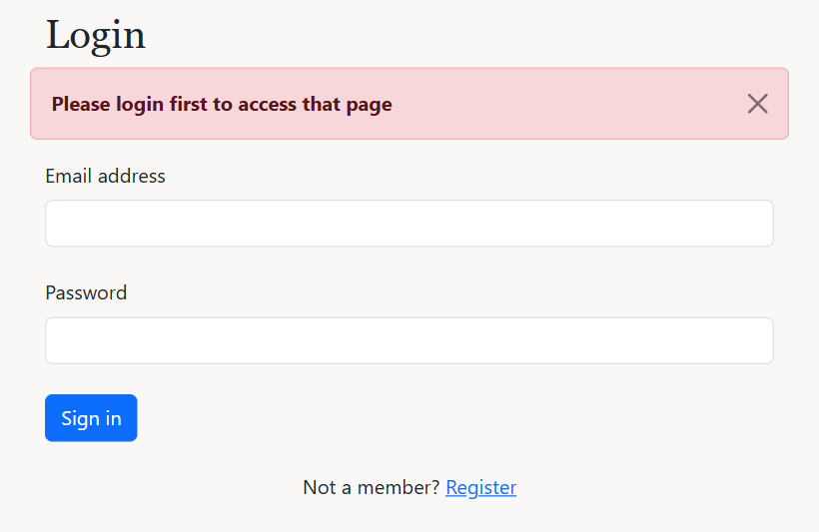
A guest opening /admin/orders.php is sent to the login page
The code behind it
includes/loginCheck.php lines 2–7
2 // IF block (access control): not logged in, go to the login page with a message
3 if (!isset($_SESSION['user_id'])) {
4 $_SESSION['message'] = 'Please login first to access that page';
5 header("Location: " . BASE_URL . "/user/login.php");
6 exit();
7 }
What this code does
- If $_SESSION['user_id'] is not set, nobody is logged in: the message is saved and the visitor goes to the login page.
- exit() stops the rest of the page from running.
includes/adminCheck.php lines 2–14
2 // IF block (access control): not logged in, go to the login page with a message
3 if (!isset($_SESSION['user_id'])) {
4 $_SESSION['message'] = 'Please login first to access that page';
5 header("Location: " . BASE_URL . "/user/login.php");
6 exit();
7 }
8
9 // IF block (access control): logged in but not an admin, go back to the home page
10 if ($_SESSION['role'] !== 'admin') {
11 $_SESSION['message'] = 'Only administrators can access that page';
12 header("Location: " . BASE_URL . "/index.php");
13 exit();
14 }
What this code does
- First check: not logged in, go to the login page.
- Second check: logged in but role is not admin, go back to the home page with "Only administrators can access that page".
- It is included in the admin scripts too (store, update, delete), not only the pages.

2. Product list
Requirement: MP1 Read
The admin's product list shows every product with its photo, prices, category and stock, with edit and delete icons.
What it looks like
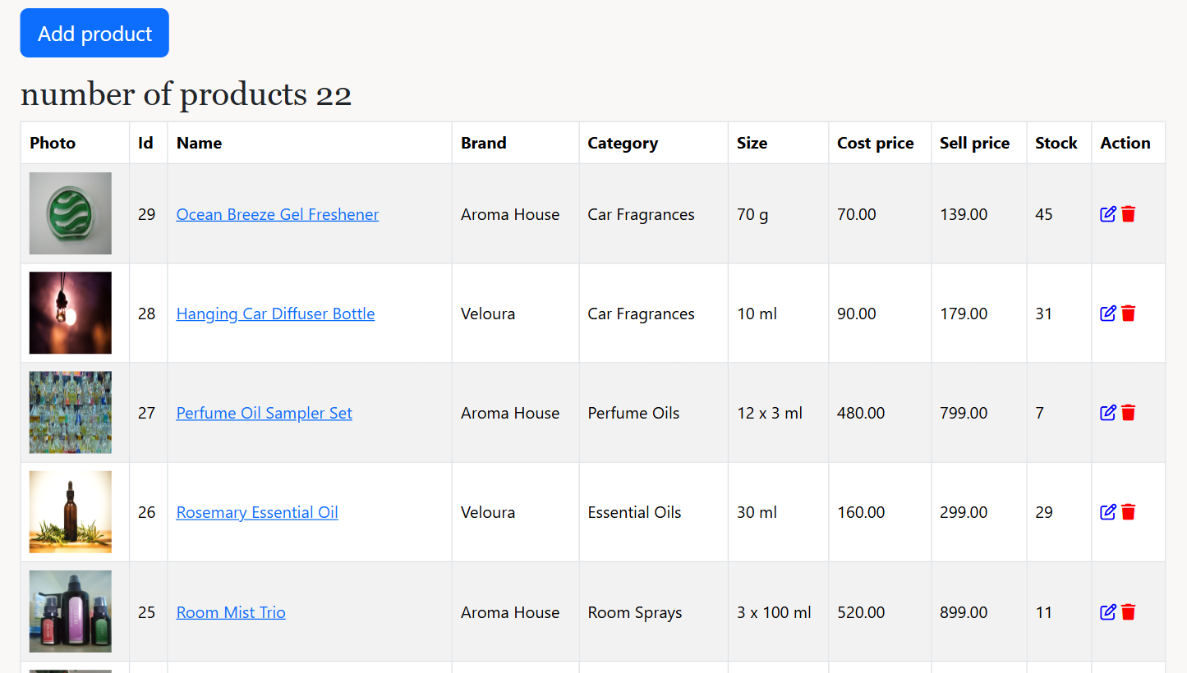
Products page (admin)
The code behind it
product/index.php lines 8–13
8 // SELECT query (JOIN): all products with their category and stock
9 $sql = "SELECT p.product_id, p.name, p.brand, p.size, p.img_path, p.cost_price, p.sell_price, c.name AS category, s.quantity
10 FROM product p INNER JOIN category c USING (category_id) INNER JOIN stock s USING (product_id)
11 ORDER BY p.product_id DESC";
12 $result = mysqli_query($conn, $sql);
13 $itemCount = mysqli_num_rows($result);
What this code does
- One SELECT joins product, category and stock. mysqli_num_rows() counts the products for the heading.
product/index.php lines 37–52
37 // WHILE loop: one table row per product
38 while ($row = mysqli_fetch_assoc($result)) {
39 echo "<tr>";
40 echo "<td><img src='{$row['img_path']}' width='80' height='80' /></td>";
41 echo "<td>{$row['product_id']}</td>";
42 echo "<td><a href='view.php?id={$row['product_id']}'>{$row['name']}</a></td>";
43 echo "<td>{$row['brand']}</td>";
44 echo "<td>{$row['category']}</td>";
45 echo "<td>{$row['size']}</td>";
46 echo "<td>{$row['cost_price']}</td>";
47 echo "<td>{$row['sell_price']}</td>";
48 echo "<td>{$row['quantity']}</td>";
49 echo "<td><a href='edit.php?id={$row['product_id']}'><i class='fa-regular fa-pen-to-square' style='color: blue'></i></a>
50 <a href='delete.php?id={$row['product_id']}'><i class='fa-solid fa-trash' style='color: red'></i></a></td>";
51 echo "</tr>";
52 }
What this code does
- One table row per product. The pencil icon opens edit.php?id=... and the trash icon opens delete.php?id=...

3. Add product with photos
Requirement: MP1 Create, upload one and many photos, MP5 validation
create.php shows the form; store.php checks every field in PHP. A main photo is required and more photos are optional. The product, its stock and its extra photos are saved in one transaction.
What it looks like
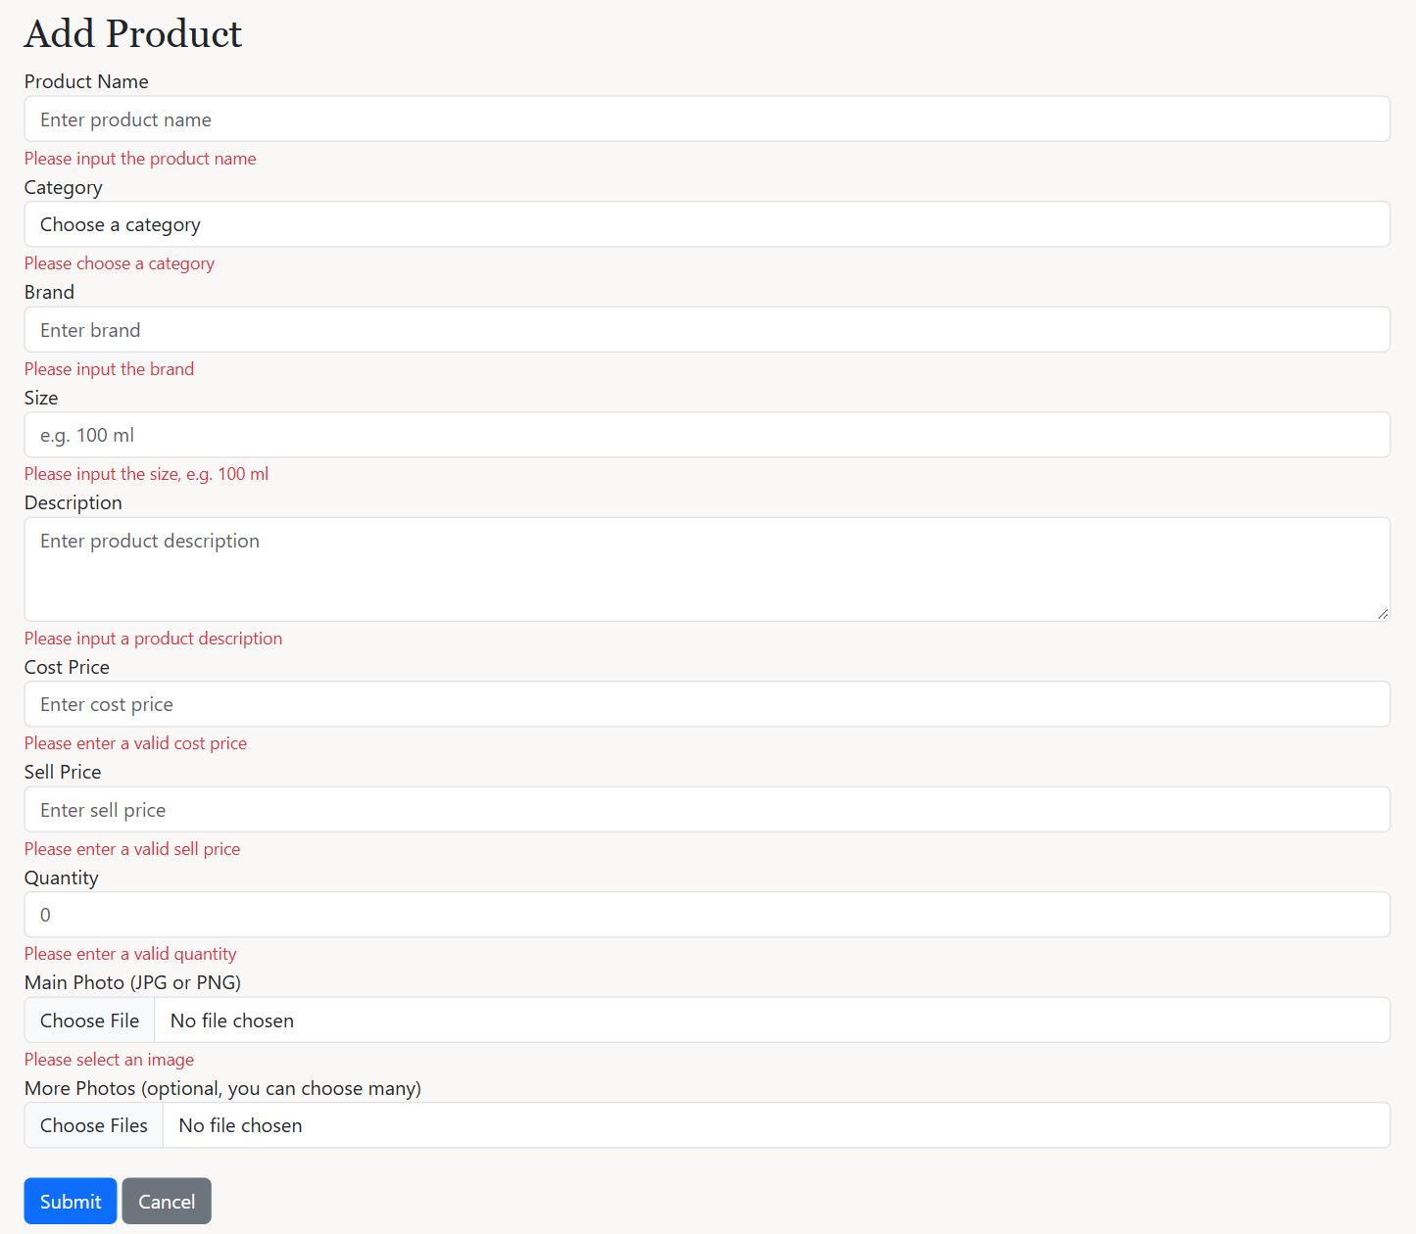
Submitting the empty Add Product form: an error under each field
The code behind it
product/create.php lines 21–25
21 // IF block: show the field's error message once (same for every field below)
22 if (isset($_SESSION['nameError'])) {
23 echo $_SESSION['nameError'];
24 unset($_SESSION['nameError']);
25 }
What this code does
- Each field has a small block like this: it shows that field's error from store.php once, then removes it.
product/store.php lines 20–80
20 // IF-ELSE blocks (validation): check every field in PHP
21 if ($name === '') {
22 $_SESSION['nameError'] = 'Please input the product name';
23 $hasErrors = true;
24 } else if (strlen($name) > 100) {
25 $_SESSION['nameError'] = 'The product name should be 100 characters or less';
26 $hasErrors = true;
27 }
28 if ($category_id === '' || !is_numeric($category_id)) {
29 $_SESSION['categoryError'] = 'Please choose a category';
30 $hasErrors = true;
31 }
32 if ($brand === '') {
33 $_SESSION['brandError'] = 'Please input the brand';
34 $hasErrors = true;
35 }
36 if ($size === '') {
37 $_SESSION['sizeError'] = 'Please input the size, e.g. 100 ml';
38 $hasErrors = true;
39 }
40 if ($desc === '') {
41 $_SESSION['descError'] = 'Please input a product description';
42 $hasErrors = true;
43 } else if (strlen($desc) > 255) {
44 $_SESSION['descError'] = 'The description should be 255 characters or less';
45 $hasErrors = true;
46 }
47 if ($costInput === '' || !is_numeric($costInput) || $costInput <= 0) {
48 $_SESSION['costError'] = 'Please enter a valid cost price';
49 $hasErrors = true;
50 }
51 if ($sellInput === '' || !is_numeric($sellInput) || $sellInput <= 0) {
52 $_SESSION['sellError'] = 'Please enter a valid sell price';
53 $hasErrors = true;
54 } else if (is_numeric($costInput) && $sellInput < $costInput) {
55 $_SESSION['sellError'] = 'The sell price should not be lower than the cost price';
56 $hasErrors = true;
57 }
58 if ($qtyInput === '' || filter_var($qtyInput, FILTER_VALIDATE_INT) === false || (int)$qtyInput < 0) {
59 $_SESSION['qtyError'] = 'Please enter a valid quantity';
60 $hasErrors = true;
61 }
62
63 // IF-ELSE block: the main photo is required and must be JPG or PNG
64 if (!isset($_FILES['img_path']) || $_FILES['img_path']['error'] === UPLOAD_ERR_NO_FILE) {
65 $_SESSION['imageError'] = 'Please select an image';
66 $hasErrors = true;
67 } else if (!isImage($_FILES['img_path']['type'])) {
68 $_SESSION['imageError'] = 'wrong file type, please use JPG or PNG';
69 $hasErrors = true;
70 }
71
72 // IF block + FOREACH loop: extra photos are optional but must be JPG or PNG
73 if (isset($_FILES['photos']) && $_FILES['photos']['name'][0] !== '') {
74 foreach ($_FILES['photos']['type'] as $key => $type) {
75 if (!isImage($type)) {
76 $_SESSION['photosError'] = "wrong file type: {$_FILES['photos']['name'][$key]}, please use JPG or PNG";
77 $hasErrors = true;
78 }
79 }
80 }
What this code does
- Every field is checked: name and description length, a chosen category, numbers for the prices, sell price not lower than cost price, a whole-number quantity.
- The main photo must be chosen and be JPG or PNG. Each extra photo in photos[] must also be JPG or PNG (FOREACH loop).
product/store.php lines 105–141
105 // TRY-CATCH block (TRANSACTION): save the product, its stock and extra photos together
106 mysqli_begin_transaction($conn);
107 try {
108 // PREPARED STATEMENT (INSERT): the product
109 $sql = "INSERT INTO product (category_id, name, brand, size, description, cost_price, sell_price, img_path) VALUES (?, ?, ?, ?, ?, ?, ?, ?)";
110 $stmt1 = mysqli_prepare($conn, $sql);
111 mysqli_stmt_bind_param($stmt1, 'issssdds', $category_id, $name, $brand, $size, $desc, $cost, $sell, $target);
112 mysqli_stmt_execute($stmt1);
113 $product_id = mysqli_insert_id($conn);
114
115 // PREPARED STATEMENT (INSERT): its stock
116 $sql = "INSERT INTO stock (product_id, quantity) VALUES (?, ?)";
117 $stmt2 = mysqli_prepare($conn, $sql);
118 mysqli_stmt_bind_param($stmt2, 'ii', $product_id, $qty);
119 mysqli_stmt_execute($stmt2);
120
121 // IF block + FOREACH loop: save each extra photo in product_images
122 if (isset($_FILES['photos']) && $_FILES['photos']['name'][0] !== '') {
123 $sql = "INSERT INTO product_images (product_id, img_path) VALUES (?, ?)";
124 $stmt3 = mysqli_prepare($conn, $sql);
125 foreach ($_FILES['photos']['name'] as $key => $photoName) {
126 $photo = savePhoto($_FILES['photos']['tmp_name'][$key], $photoName);
127 mysqli_stmt_bind_param($stmt3, 'is', $product_id, $photo);
128 mysqli_stmt_execute($stmt3);
129 }
130 }
131
132 mysqli_commit($conn);
133 $_SESSION['success'] = 'product saved';
134 header("Location: index.php");
135 exit();
136 } catch (mysqli_sql_exception $e) {
137 mysqli_rollback($conn);
138 $_SESSION['message'] = 'could not save the product';
139 header("Location: create.php");
140 exit();
141 }
What this code does
- Three prepared INSERTs in one transaction: the product, its stock, and one product_images row for each extra photo.
- 'issssdds' tells bind_param the type of each value: i = integer, s = string, d = decimal number.

4. Edit product and remove photos
Requirement: MP1 Update, multiple photos
edit.php fills the form with the product. Each extra photo has a remove checkbox. update.php validates like store.php, then updates everything in one transaction.
What it looks like
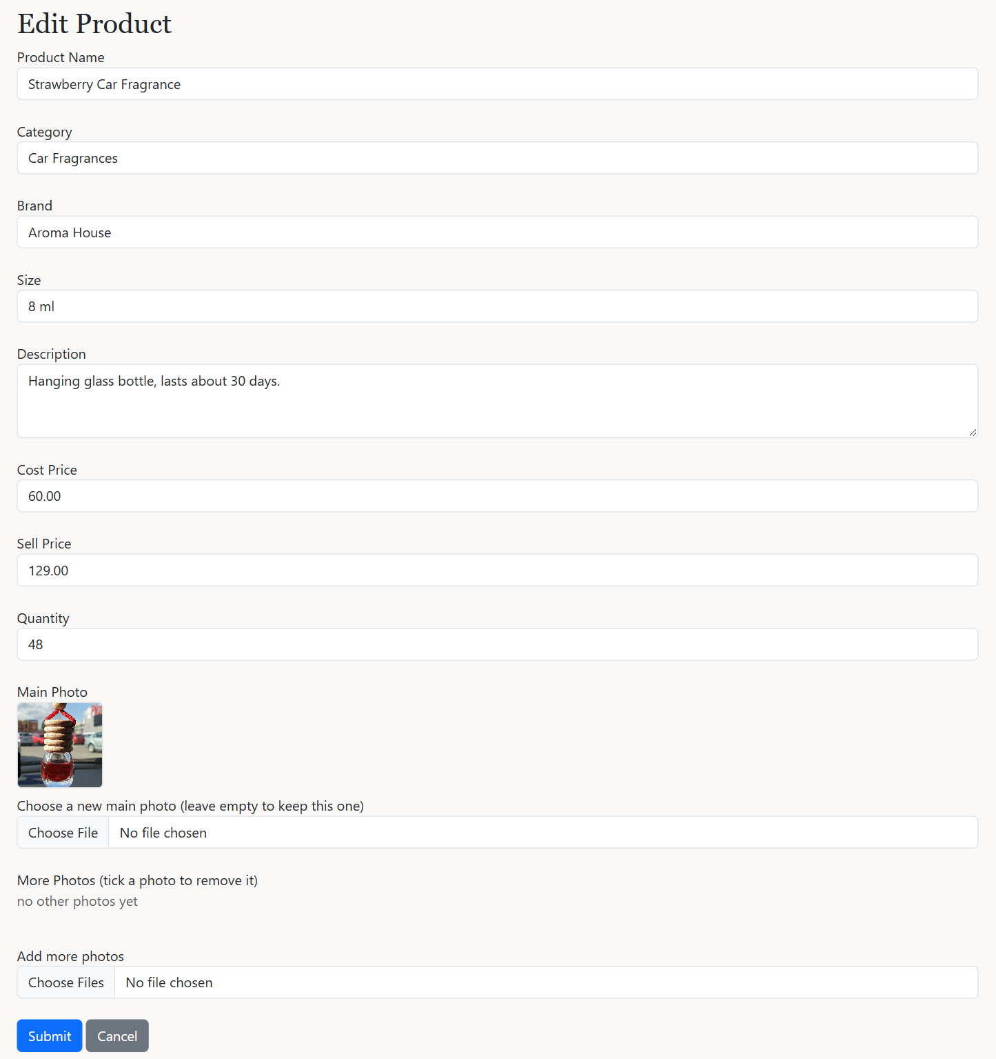
Edit Product form
The code behind it
product/edit.php lines 140–148
140 // IF block + WHILE loop: the extra photos, each with a remove checkbox
141 if (mysqli_num_rows($photo_result) === 0) {
142 echo "<p class='text-muted'>no other photos yet</p>";
143 }
144 while ($photo = mysqli_fetch_assoc($photo_result)) {
145 echo "<label class='me-3 mb-2'><img src='{$photo['img_path']}' class='extra-photo'><br>
146 <input type='checkbox' name='delete_photos[]' value='{$photo['image_id']}' /> remove</label>";
147 }
148 ?>
What this code does
- Shows each extra photo with a checkbox named delete_photos[] whose value is the photo's image_id.
product/update.php lines 104–129
104 // IF-ELSE block: prepared UPDATE with the new main photo, or keep the old one
105 if ($newPhoto) {
106 $target = savePhoto($_FILES['img_path']['tmp_name'], $_FILES['img_path']['name']);
107
108 $sql = "UPDATE product SET category_id = ?, name = ?, brand = ?, size = ?, description = ?, cost_price = ?, sell_price = ?, img_path = ? WHERE product_id = ?";
109 $stmt1 = mysqli_prepare($conn, $sql);
110 mysqli_stmt_bind_param($stmt1, 'issssddsi', $category_id, $name, $brand, $size, $desc, $cost, $sell, $target, $product_id);
111 } else {
112 $sql = "UPDATE product SET category_id = ?, name = ?, brand = ?, size = ?, description = ?, cost_price = ?, sell_price = ? WHERE product_id = ?";
113 $stmt1 = mysqli_prepare($conn, $sql);
114 mysqli_stmt_bind_param($stmt1, 'issssddi', $category_id, $name, $brand, $size, $desc, $cost, $sell, $product_id);
115 }
116 mysqli_stmt_execute($stmt1);
117
118 // PREPARED STATEMENT (UPDATE): the stock quantity
119 $sql = "UPDATE stock SET quantity = ? WHERE product_id = ?";
120 $stmt2 = mysqli_prepare($conn, $sql);
121 mysqli_stmt_bind_param($stmt2, 'ii', $qty, $product_id);
122 mysqli_stmt_execute($stmt2);
123
124 // IF block + FOREACH loop: delete the ticked extra photos
125 if (isset($_POST['delete_photos']) && is_array($_POST['delete_photos'])) {
126 foreach ($_POST['delete_photos'] as $image_id) {
127 mysqli_execute_query($conn, "DELETE FROM product_images WHERE image_id = ? AND product_id = ?", [$image_id, $product_id]);
128 }
129 }
What this code does
- If a new main photo was chosen, the UPDATE includes img_path; otherwise the old photo is kept.
- The stock quantity is updated, and each ticked photo is deleted from product_images.

5. Delete product
Requirement: MP1 Delete
The trash icon opens delete.php. A product that is already in a customer's order cannot be deleted, because the order still needs it.
What it looks like
Trying to delete a product that is in an order
The code behind it
product/delete.php lines 15–35
15 // TRY-CATCH block (TRANSACTION): delete the stock row, then the product; blocked if it is in an order
16 mysqli_begin_transaction($conn);
17
18 try {
19 $stockStmt = mysqli_prepare($conn, 'DELETE FROM stock WHERE product_id = ?');
20 mysqli_stmt_bind_param($stockStmt, 'i', $product_id);
21 mysqli_stmt_execute($stockStmt);
22
23 $productStmt = mysqli_prepare($conn, 'DELETE FROM product WHERE product_id = ?');
24 mysqli_stmt_bind_param($productStmt, 'i', $product_id);
25 mysqli_stmt_execute($productStmt);
26
27 mysqli_commit($conn);
28 $_SESSION['success'] = 'product deleted';
29 } catch (mysqli_sql_exception $e) {
30 mysqli_rollback($conn);
31 $_SESSION['message'] = 'This product cannot be deleted because it is already in a customer order';
32 }
33
34 header('Location: index.php');
35 exit;
What this code does
- The stock row is deleted first, then the product. Extra photos and reviews are deleted automatically (ON DELETE CASCADE).
- If the product is in order_items, the foreign key stops the DELETE. The catch block rolls back and shows a message instead of an error page.

6. User list, activate and deactivate
Requirement: MP2 Read, admin deactivates a user
The Users page lists every account. The Deactivate and Activate buttons open status.php. A deactivated user cannot log in.
What it looks like
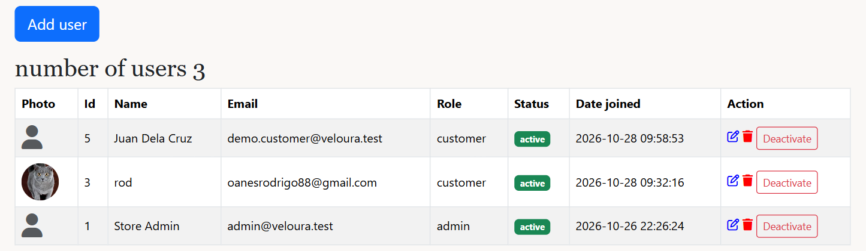
Users page (admin)
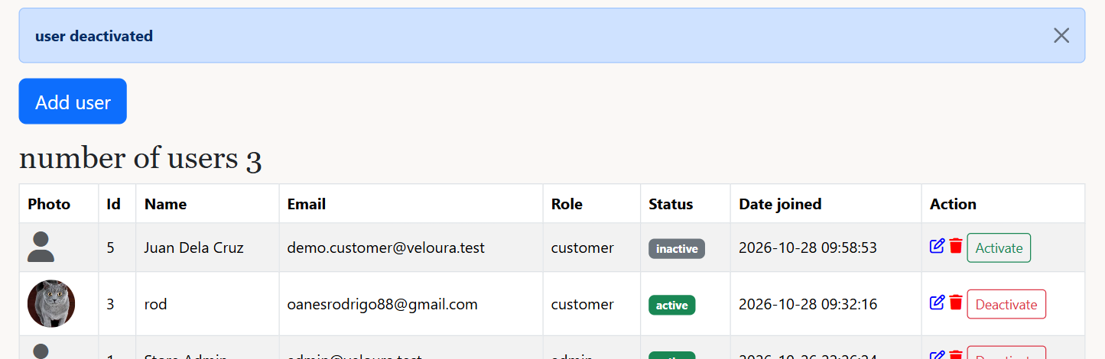
After clicking Deactivate
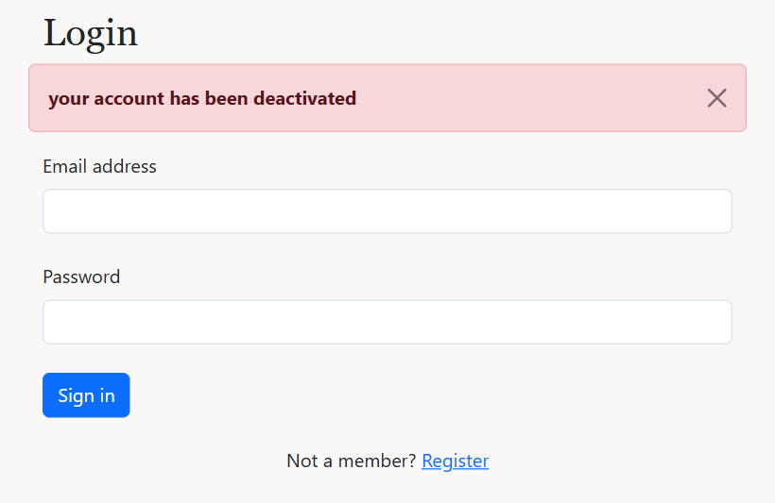
The deactivated customer trying to log in
The code behind it
admin/users/index.php lines 41–48
41 // IF-ELSE block: status badge and Activate/Deactivate button
42 if ($row['status'] === 'active') {
43 $status = "<span class='badge bg-success'>active</span>";
44 $statusLink = "<a href='status.php?id={$row['user_id']}&status=inactive' class='btn btn-sm btn-outline-danger'>Deactivate</a>";
45 } else {
46 $status = "<span class='badge bg-secondary'>inactive</span>";
47 $statusLink = "<a href='status.php?id={$row['user_id']}&status=active' class='btn btn-sm btn-outline-success'>Activate</a>";
48 }
What this code does
- An active user gets a green badge and a Deactivate button; an inactive one a grey badge and an Activate button.
admin/users/status.php lines 11–27
11 // IF-ELSE IF-ELSE block: check the request, then activate or deactivate (a deactivated user cannot log in)
12 if (!$user_id || ($status !== 'active' && $status !== 'inactive')) {
13 $_SESSION['message'] = 'invalid request';
14 } else if ($user_id == $_SESSION['user_id']) {
15 $_SESSION['message'] = 'you cannot deactivate your own account';
16 } else {
17 $sql = "UPDATE users SET status = ? WHERE user_id = ?";
18 $stmt = mysqli_prepare($conn, $sql);
19 mysqli_stmt_bind_param($stmt, 'si', $status, $user_id);
20 mysqli_stmt_execute($stmt);
21 if ($status === 'inactive') {
22 $_SESSION['success'] = 'user deactivated';
23 } else {
24 $_SESSION['success'] = 'user activated';
25 }
26 }
27 header("Location: index.php");
What this code does
- Checks the id and that the new status is active or inactive. An admin cannot deactivate their own account.
- A prepared UPDATE saves the new status.
user/login.php lines 36–37
36 } else if ($row['status'] !== 'active') {
37 $_SESSION['message'] = 'your account has been deactivated';
What this code does
- login.php refuses an inactive account even when the password is right.

7. Add and edit users, change the role
Requirement: MP2 Create and Update, admin updates an active user's role
The admin can add a user with a role and photo, and edit a user's name, email, role and photo. The role list is disabled for a deactivated user.
What it looks like
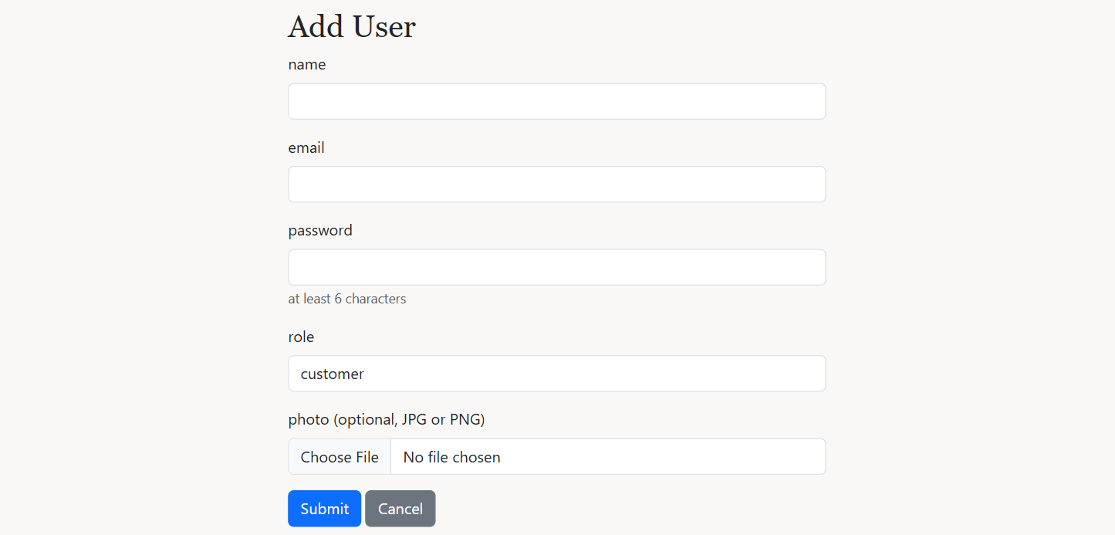
Add User form
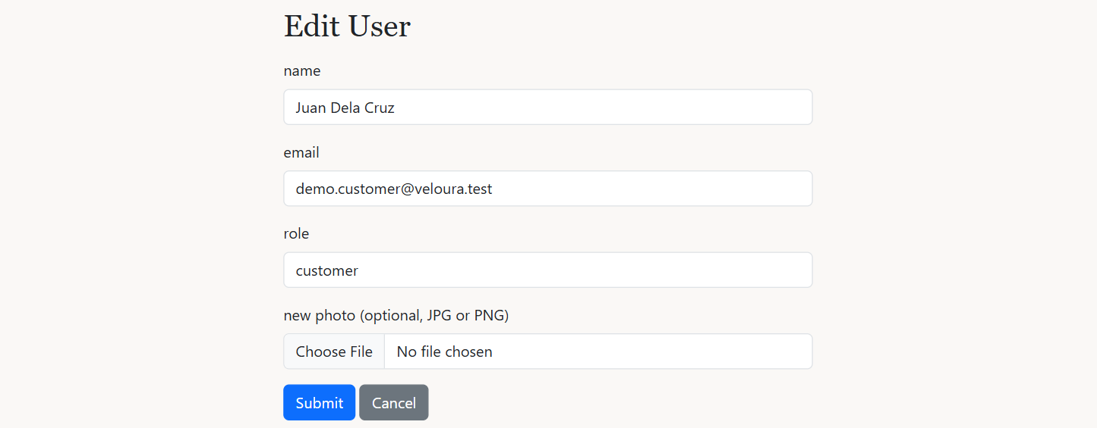
Edit User form
The code behind it
admin/users/update.php lines 23–50
23 // IF block: keep the current role when the role list was disabled
24 $role = $user['role'];
25 if (isset($_POST['role'])) {
26 $role = $_POST['role'];
27 }
28
29 // IF-ELSE IF blocks (validation): name, email, role, only active users, not your own role
30 if ($name === '') {
31 $_SESSION['message'] = 'please enter the name';
32 header("Location: {$back}");
33 exit();
34 } else if (!isValidEmail($email)) {
35 $_SESSION['message'] = 'email invalid format';
36 header("Location: {$back}");
37 exit();
38 } else if ($role !== 'customer' && $role !== 'admin') {
39 $_SESSION['message'] = 'please choose a role';
40 header("Location: {$back}");
41 exit();
42 } else if ($role !== $user['role'] && $user['status'] !== 'active') {
43 $_SESSION['message'] = 'only an active user\'s role can be changed';
44 header("Location: {$back}");
45 exit();
46 } else if ($role !== $user['role'] && $user_id == $_SESSION['user_id']) {
47 $_SESSION['message'] = 'you cannot change your own role';
48 header("Location: {$back}");
49 exit();
50 }
What this code does
- A disabled select is not sent by the browser, so the current role is kept in that case.
- Validation: name, email format, role is customer or admin. Only an active user's role can change, and an admin cannot change their own role.
admin/users/store.php lines 55–66
55 // TRY-CATCH block + prepared INSERT: hash the password and save the user
56 try {
57 $password = password_hash($password, PASSWORD_BCRYPT);
58
59 $sql = "INSERT INTO users (name, email, password, img_path, role, status, created_at) VALUES (?, ?, ?, ?, ?, 'active', NOW())";
60 $stmt1 = mysqli_prepare($conn, $sql);
61 mysqli_stmt_bind_param($stmt1, 'sssss', $name, $email, $password, $target, $role);
62 mysqli_stmt_execute($stmt1);
63
64 unset($_SESSION['regName'], $_SESSION['regEmail']);
65 $_SESSION['success'] = 'user added';
66 header("Location: index.php");
What this code does
- The password is hashed with password_hash() and the new user is inserted with the chosen role and status active.

8. Delete user
Requirement: MP2 Delete
The trash icon on the Users page opens delete.php. A user with orders or reviews cannot be deleted; the admin should deactivate them instead.
What it looks like
Trying to delete a customer who has orders
The code behind it
admin/users/delete.php lines 7–30
7 // IF blocks: stop if the id is invalid or it is your own account
8 $user_id = filter_input(INPUT_GET, 'id', FILTER_VALIDATE_INT);
9
10 if (!$user_id) {
11 header('Location: index.php');
12 exit;
13 }
14 if ($user_id == $_SESSION['user_id']) {
15 $_SESSION['message'] = 'you cannot delete your own account';
16 header('Location: index.php');
17 exit;
18 }
19
20 // TRY-CATCH block + prepared DELETE: blocked when the user has orders or reviews
21 try {
22 $stmt = mysqli_prepare($conn, 'DELETE FROM users WHERE user_id = ?');
23 mysqli_stmt_bind_param($stmt, 'i', $user_id);
24 mysqli_stmt_execute($stmt);
25 $_SESSION['success'] = 'user deleted';
26 } catch (mysqli_sql_exception $e) {
27 $_SESSION['message'] = 'This user has orders or reviews, so the account cannot be deleted. Deactivate it instead.';
28 }
29
30 header('Location: index.php');
What this code does
- An admin cannot delete their own account.
- The prepared DELETE fails when the user has orders or reviews (foreign keys), and the catch block shows a message. Their delivery details are deleted automatically (ON DELETE CASCADE).

9. All orders and order details
Requirement: Term Test: admin views all orders
The Orders page lists every order with its customer, item count, total, payment and status. The eye icon opens the order details: customer, address, payment, items, grand total and the status form.
What it looks like
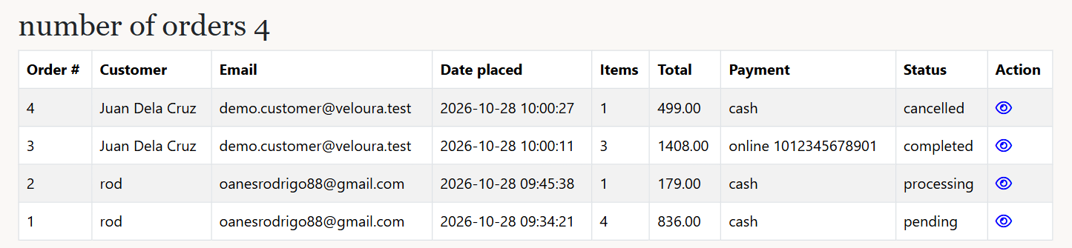
Orders page (admin)
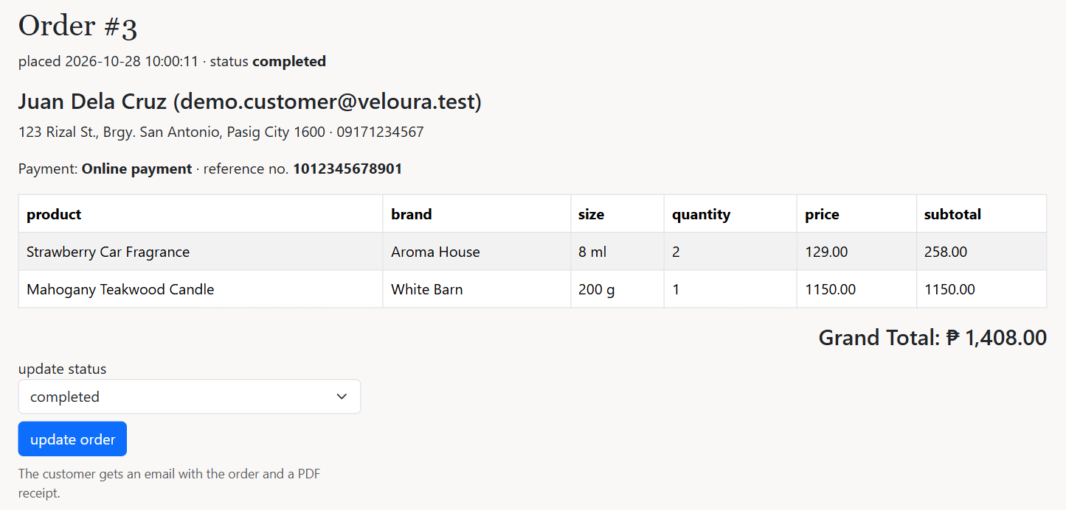
Order details with the update status form
The code behind it
database.sql lines 122–140
122 -- CREATE VIEW: one row per product in an order, with the customer and subtotal
123 CREATE VIEW order_details_view AS
124 SELECT o.order_id, o.user_id, u.name, u.email, c.addressline, c.town, c.zipcode, c.phone,
125 o.status, o.payment_method, o.reference_no, o.date_placed, p.product_id, p.name AS product_name, p.brand, p.size,
126 oi.quantity, oi.price, oi.quantity * oi.price AS subtotal
127 FROM orders o
128 INNER JOIN users u ON u.user_id = o.user_id
129 LEFT JOIN customer c ON c.user_id = o.user_id
130 INNER JOIN order_items oi ON oi.order_id = o.order_id
131 INNER JOIN product p ON p.product_id = oi.product_id;
132
133 -- CREATE VIEW: one row per order with its grand total
134 CREATE VIEW order_totals_view AS
135 SELECT o.order_id, o.user_id, u.name, u.email, o.status, o.payment_method, o.reference_no, o.date_placed,
136 SUM(oi.quantity) AS items, SUM(oi.quantity * oi.price) AS total
137 FROM orders o
138 INNER JOIN users u ON u.user_id = o.user_id
139 INNER JOIN order_items oi ON oi.order_id = o.order_id
140 GROUP BY o.order_id, o.user_id, u.name, u.email, o.status, o.payment_method, o.reference_no, o.date_placed;
What this code does
- order_details_view joins orders, users, customer, order_items and product, and works out each subtotal (quantity x price).
- order_totals_view groups the items by order and adds them up with SUM() to get the grand total.
- The order pages, the email and the review check read these views instead of writing the long JOIN every time.
admin/orderDetails.php lines 32–38
32 // IF-ELSE block: the payment method, with the reference number for online payments
33 if ($customer['payment_method'] === 'online') {
34 echo "<p>Payment: <strong>Online payment</strong> &middot; reference no. <strong>{$customer['reference_no']}</strong></p>";
35 } else {
36 echo "<p>Payment: <strong>Cash on delivery</strong></p>";
37 }
38 ?>
What this code does
- Shows the payment method, and the reference number for online payments, so the admin can check the payment before processing.

10. Update order status, email and PDF receipt
Requirement: Term Test: update status, email with PDF, Mailtrap
The admin picks a new status and clicks update order. updateOrder.php saves it (returning the stock if cancelled), makes a PDF receipt with FPDF and emails it to the customer with PHPMailer through Mailtrap. A cancelled order can no longer change.
What it looks like
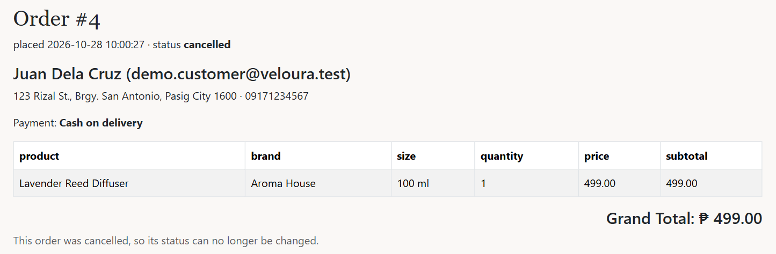
A cancelled order: the status can no longer be changed
The code behind it
admin/updateOrder.php lines 42–59
42 // TRY-CATCH block (TRANSACTION): update the status, return the stock if cancelled
43 try {
44 mysqli_begin_transaction($conn);
45
46 $q = 'UPDATE orders SET status = ? WHERE order_id = ?';
47 $stmt1 = mysqli_prepare($conn, $q);
48 mysqli_stmt_bind_param($stmt1, 'si', $status, $order_id);
49 mysqli_stmt_execute($stmt1);
50
51 // IF block + prepared UPDATE: put the items back into stock
52 if ($status === 'cancelled') {
53 $q2 = 'UPDATE stock s INNER JOIN order_items oi ON oi.product_id = s.product_id SET s.quantity = s.quantity + oi.quantity WHERE oi.order_id = ?';
54 $stmt2 = mysqli_prepare($conn, $q2);
55 mysqli_stmt_bind_param($stmt2, 'i', $order_id);
56 mysqli_stmt_execute($stmt2);
57 }
58
59 mysqli_commit($conn);
What this code does
- A prepared UPDATE saves the new status. If it is cancelled, a second UPDATE adds the quantities back to stock, in the same transaction.
admin/updateOrder.php lines 80–129
80 // FPDF: build the PDF receipt
81 $pdf = new FPDF();
82 $pdf->AddPage();
83 $pdf->SetFont('Helvetica', 'B', 18);
84 $pdf->Cell(0, 10, 'Veloura', 0, 1);
85 $pdf->SetFont('Helvetica', '', 11);
86 $pdf->Cell(0, 7, 'Official Receipt', 0, 1);
87 $pdf->Ln(4);
88 $pdf->Cell(0, 6, "Order #: {$order_id}", 0, 1);
89 $pdf->Cell(0, 6, "Date placed: {$customer['date_placed']}", 0, 1);
90 $pdf->Cell(0, 6, "Status: {$status}", 0, 1);
91 $pdf->Cell(0, 6, "Customer: {$customer['name']} ({$customer['email']})", 0, 1);
92 $pdf->Cell(0, 6, "Deliver to: {$customer['addressline']}, {$customer['town']} {$customer['zipcode']}", 0, 1);
93 $pdf->Cell(0, 6, "Phone: {$customer['phone']}", 0, 1);
94 $pdf->Cell(0, 6, "Payment: {$paymentText}", 0, 1);
95 $pdf->Ln(4);
96
97 $pdf->SetFont('Helvetica', 'B', 11);
98 $pdf->Cell(85, 8, 'Product', 1);
99 $pdf->Cell(20, 8, 'Qty', 1, 0, 'C');
100 $pdf->Cell(40, 8, 'Price', 1, 0, 'R');
101 $pdf->Cell(45, 8, 'Subtotal', 1, 1, 'R');
102 $pdf->SetFont('Helvetica', '', 11);
103
104 // FOREACH loop: one PDF row and one email row per product, adds up the grand total
105 $grandTotal = 0;
106 $rows = '';
107 foreach ($items as $item) {
108 $grandTotal += $item['subtotal'];
109 $pdf->Cell(85, 8, "{$item['product_name']} ({$item['size']})", 1);
110 $pdf->Cell(20, 8, $item['quantity'], 1, 0, 'C');
111 $pdf->Cell(40, 8, 'PHP ' . number_format($item['price'], 2), 1, 0, 'R');
112 $pdf->Cell(45, 8, 'PHP ' . number_format($item['subtotal'], 2), 1, 1, 'R');
113
114 $rows .= "<tr>
115 <td>{$item['product_name']} ({$item['size']})</td>
116 <td align='center'>{$item['quantity']}</td>
117 <td align='right'>" . peso($item['price']) . "</td>
118 <td align='right'>" . peso($item['subtotal']) . "</td>
119 </tr>";
120 }
121
122 $pdf->SetFont('Helvetica', 'B', 11);
123 $pdf->Cell(145, 8, 'Grand Total', 1, 0, 'R');
124 $pdf->Cell(45, 8, 'PHP ' . number_format($grandTotal, 2), 1, 1, 'R');
125 $pdf->Ln(6);
126 $pdf->SetFont('Helvetica', '', 10);
127 $pdf->Cell(0, 6, 'Thank you for shopping at Veloura!', 0, 1);
128 // OUTPUT 'S': return the PDF as a string so it can be attached to the email
129 $pdfFile = $pdf->Output('S');
What this code does
- FPDF builds the receipt line by line: Cell() writes a box of text, Ln() adds space, SetFont() changes the font.
- The FOREACH loop adds one PDF row and one email table row per product and adds up the grand total.
- Output('S') returns the PDF as text in $pdfFile instead of showing it, so it can be attached to the email.
admin/updateOrder.php lines 140–176
140 // PHPMAILER: SMTP server settings from mail_config.php
141 $mail = new PHPMailer();
142 $mail->isSMTP();
143 $mail->Host = SMTP_HOST;
144 $mail->SMTPAuth = true;
145 $mail->Port = SMTP_PORT;
146 $mail->Username = SMTP_USERNAME;
147 $mail->Password = SMTP_PASSWORD;
148
149 // PHPMAILER: sender and recipient
150 $mail->setFrom(MAIL_FROM, 'Veloura');
151 $mail->addAddress($customer['email'], $customer['name']);
152
153 // PHPMAILER: subject, HTML body with the order table, and the PDF attachment
154 $mail->isHTML(true);
155 $mail->Subject = "Your order #{$order_id} is now {$status}";
156 $mail->Body = "<p>Hi {$customer['name']},</p>
157 <p>The status of your order <strong>#{$order_id}</strong> is now <strong>{$status}</strong>.</p>
158 <p>Payment: {$paymentText}</p>
159 <table border='1' cellpadding='6' cellspacing='0'>
160 <tr><th>Product</th><th>Quantity</th><th>Price</th><th>Subtotal</th></tr>
161 {$rows}
162 <tr><td colspan='3' align='right'><strong>Grand Total</strong></td><td align='right'><strong>" . peso($grandTotal) . "</strong></td></tr>
163 </table>
164 <p>Your receipt is attached as a PDF.</p>
165 <p>Thank you for shopping at Veloura!</p>";
166 $mail->AltBody = "The status of your order #{$order_id} is now {$status}. Grand total: PHP " . number_format($grandTotal, 2);
167 $mail->addStringAttachment($pdfFile, "receipt-order-{$order_id}.pdf");
168
169 // IF-ELSE block: send the email and show the result
170 if ($mail->send()) {
171 $_SESSION['success'] = "order #{$order_id} is now {$status}. an email with the PDF receipt was sent to {$customer['email']}";
172 } else {
173 $_SESSION['success'] = "order #{$order_id} is now {$status}";
174 $_SESSION['message'] = "the email could not be sent. Mailer Error: {$mail->ErrorInfo}";
175 }
176 header("Location: {$back}");
What this code does
- The SMTP settings (host, port, username, password) come from includes/mail_config.php (Mailtrap).
- The HTML email lists the products, subtotals, grand total and payment. addStringAttachment() attaches the PDF.
- send() returns true or false, and the admin sees whether the email was sent.

