Veloura
Feature Reviewer: what you see, and the code behind it
Online fragrance store · PHP + MySQL (XAMPP) · October 2026
How to use this reviewer
- Each feature starts with what it does and which requirement it covers.
- The screenshots are from the real site, taken with the admin account and a demo customer.
- Then comes the code behind the feature, with the file name and its real line numbers. Green lines are the block comments in the code.
- Under each piece of code, "What this code does" explains it in plain words.

Contents

Contents 2
Setup and shared parts 3
1. Database setup on a new computer 3
2. Navigation bar that changes by role 5
3. Messages after an action (flash messages) 7
4. User-defined functions 8
Visitor and customer features 10
5. Home page and product cards 10
6. Search 12
7. Register with a profile photo 14
8. Login and validation 17
9. Logout 20
10. Pages that need a login or an admin 21
11. Profile and delivery details 23
12. Product details page 25
13. Add to Cart 27
14. View, update and remove cart items 28
15. Checkout with cash or online payment 30
16. My Orders and cancelling an order 34
17. Writing and updating a review 36
Admin features 39
18. Product list 39
19. Add product with photos 41
20. Edit product and remove photos 44
21. Delete product 46
22. User list, activate and deactivate 47
23. Add and edit users, change the role 50
24. Delete user 52
25. All orders and order details 53
26. Update order status, email and PDF receipt 55

Right-click the contents and choose Update Field if the page numbers are empty.

Setup and shared parts

1. Database setup on a new computer
Requirement: Runs on every page
Every page includes config.php, which connects to MySQL and checks that the database matches database.sql. If the database is missing or old, the visitor is sent to setup.php, where one click imports database.sql.
What it looks like
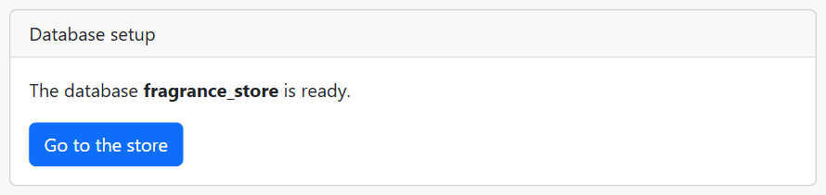
setup.php when the database is already set up
The code behind it
includes/config.php lines 35–47
35 // TRY-CATCH block: connect to MySQL, show a message if MySQL is not started
36 try {
37 $conn = mysqli_connect($db_host, $db_username, $db_passwd, '', $db_port);
38 } catch (mysqli_sql_exception $e) {
39 die("Could not connect to MySQL. Open the XAMPP Control Panel and start MySQL, then reload this page.");
40 }
41
42 // INCLUDE + IF block: check the database and select it (skipped on setup.php)
43 include_once(__DIR__ . '/dbSetup.php');
44 if (!isset($setupPage)) {
45 checkDatabase($conn, $db_name);
46 mysqli_select_db($conn, $db_name);
47 }
What this code does
- mysqli_connect() opens the connection to MySQL. If MySQL is not started, the catch block shows a friendly message instead of a PHP error.
- checkDatabase() runs on every page except setup.php ($setupPage is set there), then mysqli_select_db() picks the fragrance_store database.
includes/dbSetup.php lines 2–16
2 // FUNCTION: sends the visitor to setup.php when the database is missing or old (checked once per session)
3 function checkDatabase($conn, $db_name)
4 {
5 $version = filemtime(__DIR__ . '/../database.sql');
6 if (isset($_SESSION['dbChecked']) && $_SESSION['dbChecked'] === $version) {
7 return;
8 }
9 if (databaseProblem($conn, $db_name) !== '') {
10 header("Location: " . BASE_URL . "/setup.php");
11 exit();
12 }
13 if (session_status() === PHP_SESSION_ACTIVE) {
14 $_SESSION['dbChecked'] = $version;
15 }
16 }
What this code does
- filemtime() gives the time database.sql was last changed, so the check runs again whenever the file changes.
- If databaseProblem() returns a message, header("Location: ...setup.php") sends the visitor to the setup page.
setup.php lines 10–23
10 // IF block + TRY-CATCH: import database.sql when the button is clicked
11 if (isset($_POST['install']) && $problem !== '') {
12 try {
13 importDatabase($conn);
14 } catch (mysqli_sql_exception $e) {
15 $_SESSION['message'] = 'could not import database.sql: ' . $e->getMessage();
16 header("Location: setup.php");
17 exit();
18 }
19 $_SESSION = array();
20 $_SESSION['success'] = 'the database is ready. you can login with admin@veloura.test / admin123 or customer@veloura.test / customer123';
21 header("Location: user/login.php");
22 exit();
23 }
What this code does
- The import only runs when the button is clicked AND the database has a problem, so a working store cannot be reset by accident.
- After importing, $_SESSION = array() clears the old login, and the visitor goes to the login page with a success message.

2. Navigation bar that changes by role
Requirement: MP3 access control
header.php is included at the top of every page. It reads $_SESSION to decide which links to show: guests see Login and Register, customers see Cart, My Orders and My Profile, and admins also see Products, Orders and Users.
What it looks like
Guest (not logged in)
Logged in as a customer
Logged in as the admin
The code behind it
includes/header.php lines 36–48
36 // IF block: menu links for admins only
37 if (isset($_SESSION['role']) && $_SESSION['role'] === 'admin') {
38 echo '<li class="nav-item"><a class="nav-link" href="' . BASE_URL . '/product/index.php">Products</a></li>';
39 echo '<li class="nav-item"><a class="nav-link" href="' . BASE_URL . '/admin/orders.php">Orders</a></li>';
40 echo '<li class="nav-item"><a class="nav-link" href="' . BASE_URL . '/admin/users/index.php">Users</a></li>';
41 }
42
43 // IF block: menu links for logged-in users
44 if (isset($_SESSION['user_id'])) {
45 echo '<li class="nav-item"><a class="nav-link" href="' . BASE_URL . '/cart/view_cart.php"><i class="fa-solid fa-cart-shopping"></i> Cart</a></li>';
46 echo '<li class="nav-item"><a class="nav-link" href="' . BASE_URL . '/user/myorders.php">My Orders</a></li>';
47 echo '<li class="nav-item"><a class="nav-link" href="' . BASE_URL . '/user/profile.php">My Profile</a></li>';
48 }
What this code does
- The first IF block only runs when $_SESSION['role'] is admin, so only admins see the Products, Orders and Users links.
- The second IF block runs for anyone logged in ($_SESSION['user_id'] is set) and adds Cart, My Orders and My Profile.
includes/header.php lines 58–71
58 // IF-ELSE block: Login/Register links, or the user's photo, email and Logout
59 if (!isset($_SESSION['user_id'])) {
60 echo "<div class='navbar-nav ms-auto'>
61 <a href='" . BASE_URL . "/user/login.php' class='nav-item nav-link'>Login</a>
62 <a href='" . BASE_URL . "/user/register.php' class='nav-item nav-link'>Register</a></div>";
63 } else {
64 $photo = "<i class='fa-solid fa-user'></i>";
65 if (!empty($_SESSION['photo'])) {
66 $photo = "<img src='" . BASE_URL . "/user/{$_SESSION['photo']}' class='nav-photo'>";
67 }
68 echo "<div class='navbar-nav ms-auto align-items-lg-center'>
69 <span class='nav-item nav-link'>{$photo} {$_SESSION['email']}</span>
70 <a href='" . BASE_URL . "/user/logout.php' class='nav-item nav-link'>Logout</a></div>";
71 }
What this code does
- If nobody is logged in, the right side shows Login and Register.
- Otherwise it shows the user's profile photo (or a user icon), their email, and Logout.

3. Messages after an action (flash messages)
Requirement: Used by every form
Scripts put a message in the session, then redirect. The next page includes alert.php, which shows the message once in a red or blue box and removes it.
What it looks like
A success message (blue)
An error message (red)
The code behind it
includes/alert.php lines 3–19
3 // IF block: show the error message (red) once, then remove it
4 if (isset($_SESSION['message'])) {
5
6 echo "<div class='alert alert-danger alert-dismissible fade show' role='alert'>
7 <strong>{$_SESSION['message']}</strong>
8 <button type='button' class='btn-close' data-bs-dismiss='alert' aria-label='Close'></button></div>";
9 unset($_SESSION['message']);
10 }
11
12 // IF block: show the success message (blue) once, then remove it
13 if (isset($_SESSION['success'])) {
14
15 echo "<div class='alert alert-primary alert-dismissible fade show' role='alert'>
16 <strong>{$_SESSION['success']}</strong>
17 <button type='button' class='btn-close' data-bs-dismiss='alert' aria-label='Close'></button></div>";
18 unset($_SESSION['success']);
19 }
What this code does
- $_SESSION['message'] is shown as a red Bootstrap alert; $_SESSION['success'] as a blue one.
- unset() removes the message after showing it, so it appears only once.

4. User-defined functions
Requirement: User-defined functions
functions.php holds 5 functions that several pages need, so the same check is written once. For example peso() formats every price on the site, like the prices on the product cards.
What it looks like
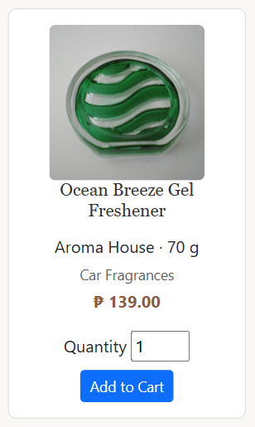
peso() formats the price on each product card
The code behind it
includes/functions.php lines 2–36
2 // FUNCTION: checks the email format with a regular expression, e.g. juan@gmail.com
3 function isValidEmail($email)
4 {
5 return preg_match("/^[\w.+-]+@\w+(\.\w+)+$/", $email);
6 }
7
8 // FUNCTION: returns true only if the uploaded file is a JPG or PNG
9 function isImage($type)
10 {
11 return $type == "image/jpeg" || $type == "image/jpg" || $type == "image/png";
12 }
13
14 // FUNCTION: saves an uploaded photo in the images folder and returns its path
15 function savePhoto($source, $fileName, $folder = '')
16 {
17 $target = 'images/' . time() . '_' . $fileName;
18 move_uploaded_file($source, $folder . $target) or die("Couldn't copy");
19 return $target;
20 }
21
22 // FUNCTION: replaces bad words with **** using a regular expression
23 function censor($text)
24 {
25 $badWords = array('fuck', 'shit', 'bitch', 'asshole', 'bastard', 'damn', 'putangina', 'tangina', 'gago', 'tanga', 'bobo', 'ulol', 'tarantado', 'punyeta');
26 foreach ($badWords as $word) {
27 $text = preg_replace("/\b{$word}\w*\b/i", "****", $text);
28 }
29 return $text;
30 }
31
32 // FUNCTION: formats an amount in pesos, e.g. peso(1500) gives ₱ 1,500.00
33 function peso($amount)
34 {
35 return "&#8369; " . number_format($amount, 2);
36 }
What this code does
- isValidEmail() returns true when preg_match() finds the pattern name@domain.ext in the text.
- isImage() checks the file type sent with the upload: only image/jpeg, image/jpg or image/png are allowed.
- savePhoto() moves the uploaded file into the images folder with time() in front of the name, so two uploads never overwrite each other, and returns the saved path.
- censor() replaces each bad word with ****: \b means whole words only and i ignores capital letters.
- peso() adds the peso sign (&#8369;) and formats the number with commas and 2 decimals.

Visitor and customer features

5. Home page and product cards
Requirement: Product listing
index.php reads every product with its category and stock, then builds one card per product. A product in stock shows an Add to Cart form; one with no stock shows "Out of stock".
What it looks like

Home page with the video banner and product cards
The code behind it
index.php lines 50–81
50 // WHILE loop: build one product card per product
51 $products_item = '<ul class="products">';
52 while ($row = mysqli_fetch_assoc($results)) {
53 // IF-ELSE block: Add to Cart form when in stock, otherwise "Out of stock"
54 if ($row['qty'] > 0) {
55 $cartForm = <<<EOT
56 <form method="POST" action="cart/cart_update.php">
57 <label>Quantity <input type="text" size="2" name="product_qty" value="1" /></label>
58 <input type="hidden" name="product_id" value="{$row['product_id']}" />
59 <input type="hidden" name="type" value="add" />
60 <button type="submit" class="btn btn-sm btn-primary mt-2">Add to Cart</button>
61 </form>
62 EOT;
63 } else {
64 $cartForm = "<p class='text-danger'>Out of stock</p>";
65 }
66
67 // HEREDOC string: the HTML of one product card
68 $price = peso($row['sell_price']);
69 $products_item .= <<<EOT
70 <li class="product">
71 <div class="product-thumb"><a href="product/view.php?id={$row['product_id']}"><img src="./product/{$row['img_path']}"></a></div>
72 <h3><a href="product/view.php?id={$row['product_id']}">{$row['name']}</a></h3>
73 <p class="mb-1">{$row['brand']} &middot; {$row['size']}</p>
74 <p class="mb-1 small text-muted">{$row['category']}</p>
75 <p class="price">{$price}</p>
76 {$cartForm}
77 </li>
78 EOT;
79 }
80 $products_item .= '</ul>';
81 echo $products_item;
What this code does
- The WHILE loop runs once for every product row returned by the query.
- The IF-ELSE block decides between the Add to Cart form (stock above 0) and the "Out of stock" text.
- The HEREDOC string (<<<EOT ... EOT;) holds the HTML of one card, with the product values written inside {...}.
- The Add to Cart form sends product_id, product_qty and type=add to cart/cart_update.php.

6. Search
Requirement: Quiz 3 search on the homepage
The search box sends ?search=keyword to index.php. The page then looks for the keyword in the product name, brand, category and description, and shows how many products were found.
What it looks like
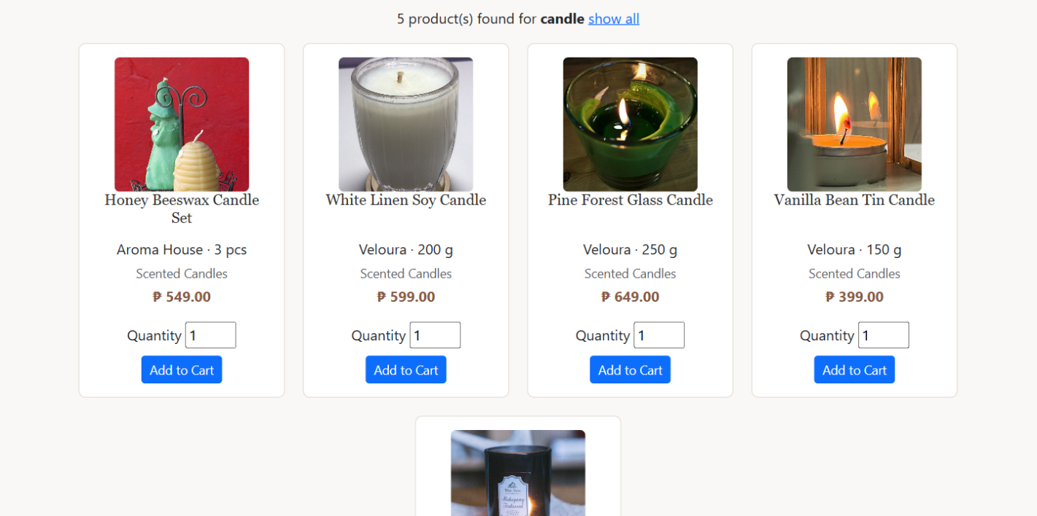
Searching for "candle"
The code behind it
index.php lines 8–24
8 // IF-ELSE block (search): find products by name, brand, category or description, or show all
9 if (isset($_GET['search']) && trim($_GET['search']) !== '') {
10 $keyword = strtolower(trim($_GET['search']));
11 $sql = "SELECT p.product_id, p.name, p.brand, p.size, p.img_path, p.sell_price, c.name AS category, s.quantity AS qty
12 FROM product p INNER JOIN category c USING (category_id) INNER JOIN stock s USING (product_id)
13 WHERE p.name LIKE ? OR p.brand LIKE ? OR c.name LIKE ? OR p.description LIKE ?
14 ORDER BY p.product_id DESC";
15 $like = "%{$keyword}%";
16 $results = mysqli_execute_query($conn, $sql, [$like, $like, $like, $like]);
17 } else {
18 $keyword = '';
19 $sql = "SELECT p.product_id, p.name, p.brand, p.size, p.img_path, p.sell_price, c.name AS category, s.quantity AS qty
20 FROM product p INNER JOIN category c USING (category_id) INNER JOIN stock s USING (product_id)
21 ORDER BY p.product_id DESC";
22 $results = mysqli_query($conn, $sql);
23 }
24 $productCount = mysqli_num_rows($results);
What this code does
- If a keyword was typed, the SQL uses LIKE ? on four columns. The value "%keyword%" means "contains the keyword anywhere".
- mysqli_execute_query() is a prepared statement: the keyword is sent separately from the SQL, so it cannot break the query (no SQL injection).
- Without a keyword, the ELSE part shows all products, newest first.
index.php lines 45–48
45 // IF block: show how many products were found
46 if ($keyword !== '') {
47 echo "<p align='center'>{$productCount} product(s) found for <strong>" . strip_tags($keyword) . "</strong> <a href='index.php'>show all</a></p>";
48 }
What this code does
- Shows "X product(s) found for keyword" with a "show all" link. strip_tags() removes any HTML from the keyword before showing it.

7. Register with a profile photo
Requirement: MP2 registration with photo, MP5 PHP validation
register.php shows the form and sends it to user/store.php. store.php checks every field in PHP, refuses an email that is already registered, saves the optional photo, hashes the password and inserts the new customer.
What it looks like
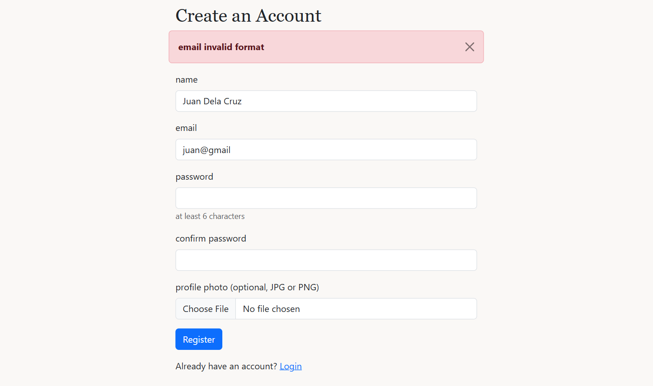
Validation error: the email has no domain ending
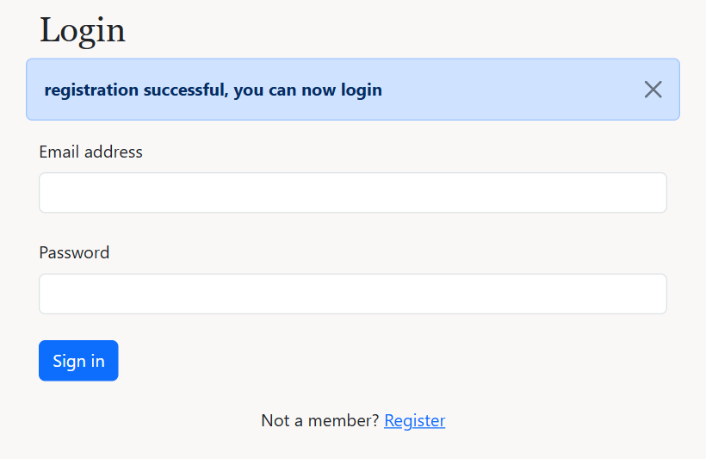
After registering, the login page shows a success message
The code behind it
user/store.php lines 15–40
15 // IF-ELSE IF blocks (validation): name, email format, password length, matching passwords
16 if ($name === '') {
17 $_SESSION['message'] = 'please enter your name';
18 header("Location: register.php");
19 exit();
20 } else if (!isValidEmail($email)) {
21 $_SESSION['message'] = 'email invalid format';
22 header("Location: register.php");
23 exit();
24 } else if (!(strlen($password) >= 6)) {
25 $_SESSION['message'] = 'password should be at least 6 characters';
26 header("Location: register.php");
27 exit();
28 } else if ($password !== $confirmPass) {
29 $_SESSION['message'] = 'passwords do not match';
30 header("Location: register.php");
31 exit();
32 }
33
34 // IF block + SELECT query: stop if the email is already registered
35 $result = mysqli_execute_query($conn, "SELECT user_id FROM users WHERE email = ? LIMIT 1", [$email]);
36 if (mysqli_num_rows($result) > 0) {
37 $_SESSION['message'] = 'this email is already registered';
38 header("Location: register.php");
39 exit();
40 }
What this code does
- The IF-ELSE IF chain stops at the first problem: empty name, bad email format (isValidEmail), password under 6 characters, or passwords that do not match.
- Each error sets $_SESSION['message'] and redirects back to register.php, where alert.php shows it.
- The SELECT query checks that no other account already uses this email.
user/store.php lines 42–69
42 // IF block: save the optional profile photo if it is a JPG or PNG
43 $target = null;
44 if (isset($_FILES['photo']) && $_FILES['photo']['error'] !== UPLOAD_ERR_NO_FILE) {
45 if (isImage($_FILES['photo']['type'])) {
46 $target = savePhoto($_FILES['photo']['tmp_name'], $_FILES['photo']['name']);
47 } else {
48 $_SESSION['message'] = 'wrong file type, please use JPG or PNG';
49 header("Location: register.php");
50 exit();
51 }
52 }
53
54 // TRY-CATCH block + prepared INSERT: hash the password and save the new user
55 try {
56 $password = password_hash($password, PASSWORD_BCRYPT);
57
58 $sql = "INSERT INTO users (name, email, password, img_path, role, status, created_at) VALUES (?, ?, ?, ?, 'customer', 'active', NOW())";
59 $stmt1 = mysqli_prepare($conn, $sql);
60 mysqli_stmt_bind_param($stmt1, 'ssss', $name, $email, $password, $target);
61 mysqli_stmt_execute($stmt1);
62
63 unset($_SESSION['regName'], $_SESSION['regEmail']);
64 $_SESSION['success'] = 'registration successful, you can now login';
65 header("Location: login.php");
66 } catch (mysqli_sql_exception $e) {
67 $_SESSION['message'] = 'registration failed, please try again';
68 header("Location: register.php");
69 }
What this code does
- The photo is optional: it is only saved when a file was chosen and isImage() says it is a JPG or PNG.
- password_hash(..., PASSWORD_BCRYPT) turns the password into a hash, so the real password is never stored.
- The INSERT is a prepared statement (mysqli_prepare + mysqli_stmt_bind_param with 'ssss' = four strings).

8. Login and validation
Requirement: MP3 login, MP5 PHP validation
login.php checks the form in PHP (the form has novalidate, so the browser does not). It then finds the user by email, checks the password and the account status, and saves the user in the session.
What it looks like
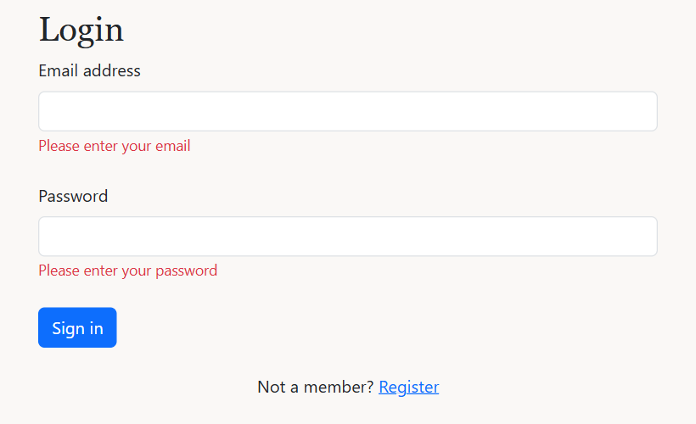
Submitting the empty form: an error under each field
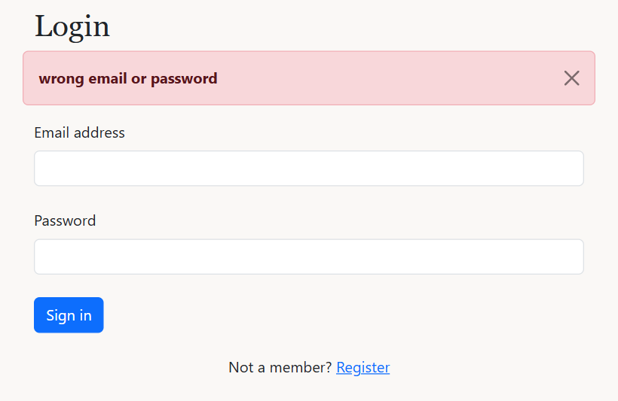
Wrong password
The code behind it
user/login.php lines 7–54
7 // IF block (form submitted): read the email and password
8 if (isset($_POST['submit'])) {
9 $email = trim($_POST['email']);
10 $password = trim($_POST['password']);
11 $hasErrors = false;
12
13 // IF-ELSE blocks (validation): check the fields in PHP
14 if ($email === '') {
15 $_SESSION['emailError'] = 'Please enter your email';
16 $hasErrors = true;
17 } else if (!isValidEmail($email)) {
18 $_SESSION['emailError'] = 'Please enter a valid email, e.g. juan@gmail.com';
19 $hasErrors = true;
20 }
21 if ($password === '') {
22 $_SESSION['passwordError'] = 'Please enter your password';
23 $hasErrors = true;
24 }
25
26 // IF block + prepared SELECT: find the user by email
27 if (!$hasErrors) {
28 $sql = "SELECT user_id, email, password, img_path, role, status FROM users WHERE email = ? LIMIT 1";
29 $result = mysqli_execute_query($conn, $sql, [$email]);
30
31 if ($result->num_rows === 1) {
32 $row = mysqli_fetch_assoc($result);
33 // IF-ELSE block: wrong password, deactivated account, or log in and save the user in the session
34 if (!password_verify($password, $row['password'])) {
35 $_SESSION['message'] = 'wrong email or password';
36 } else if ($row['status'] !== 'active') {
37 $_SESSION['message'] = 'your account has been deactivated';
38 } else {
39 $_SESSION['email'] = $row['email'];
40 $_SESSION['user_id'] = $row['user_id'];
41 $_SESSION['role'] = $row['role'];
42 $_SESSION['photo'] = $row['img_path'];
43 if ($row['role'] === 'admin') {
44 header("Location: ../product/index.php");
45 } else {
46 header("Location: ../index.php");
47 }
48 exit();
49 }
50 } else {
51 $_SESSION['message'] = 'wrong email or password';
52 }
53 }
54 }
What this code does
- Validation: each empty or wrong field gets its own error (emailError, passwordError), shown under that field.
- The prepared SELECT finds the user by email. password_verify() compares the typed password with the saved hash.
- An inactive (deactivated) account is refused even with the right password.
- On success the user_id, email, role and photo are saved in $_SESSION. Admins go to the product list, customers to the home page.
user/login.php lines 61–87
61 <!-- HTML FORM: login form, novalidate so only PHP checks it -->
62 <form action="<?php echo $_SERVER['PHP_SELF']; ?>" method="POST" novalidate>
63 <div class="form-outline mb-4">
64 <label class="form-label" for="email">Email address</label>
65 <input type="text" id="email" class="form-control" name="email" />
66 <small class="text-danger"><?php
67 // IF block: show the email error under the field
68 if (isset($_SESSION['emailError'])) {
69 echo $_SESSION['emailError'];
70 unset($_SESSION['emailError']);
71 }
72 ?></small>
73 </div>
74
75 <div class="form-outline mb-4">
76 <label class="form-label" for="password">Password</label>
77 <input type="password" id="password" class="form-control" name="password" />
78 <small class="text-danger"><?php
79 // IF block: show the password error under the field
80 if (isset($_SESSION['passwordError'])) {
81 echo $_SESSION['passwordError'];
82 unset($_SESSION['passwordError']);
83 }
84 ?></small>
85 </div>
86
87 <button type="submit" class="btn btn-primary btn-block mb-4" name="submit">Sign in</button>
What this code does
- novalidate turns off the browser's own checks, so all validation is done in PHP (MP5).
- The small IF blocks print the error for each field once, then unset() removes it.

9. Logout
Requirement: MP3 logout
The Logout link in the navbar opens logout.php, which ends the session.
What it looks like
The Logout link in the navbar
The code behind it
user/logout.php lines 2–5
2 // LOGOUT: end the session and go back to the home page
3 session_start();
4 session_destroy();
5 header("Location: ../index.php");
What this code does
- session_destroy() deletes everything saved in the session (the login and the cart), then the visitor goes back to the home page.

10. Pages that need a login or an admin
Requirement: MP3 restrict users, redirect with a message
Pages for logged-in users include loginCheck.php; admin pages and scripts include adminCheck.php. Typing the address of a protected page sends the visitor away with a message.
What it looks like
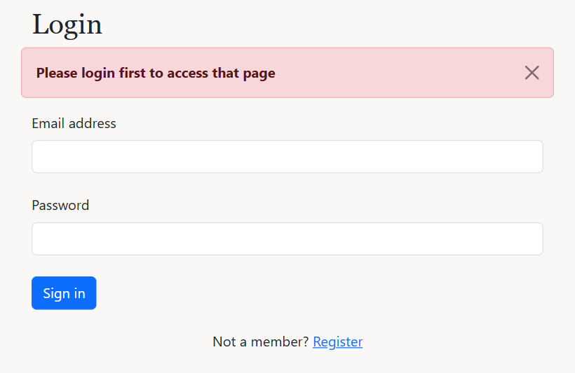
A guest opening /admin/orders.php is sent to the login page
The code behind it
includes/loginCheck.php lines 2–7
2 // IF block (access control): not logged in, go to the login page with a message
3 if (!isset($_SESSION['user_id'])) {
4 $_SESSION['message'] = 'Please login first to access that page';
5 header("Location: " . BASE_URL . "/user/login.php");
6 exit();
7 }
What this code does
- If $_SESSION['user_id'] is not set, nobody is logged in: the message is saved and the visitor goes to the login page.
- exit() stops the rest of the page from running.
includes/adminCheck.php lines 2–14
2 // IF block (access control): not logged in, go to the login page with a message
3 if (!isset($_SESSION['user_id'])) {
4 $_SESSION['message'] = 'Please login first to access that page';
5 header("Location: " . BASE_URL . "/user/login.php");
6 exit();
7 }
8
9 // IF block (access control): logged in but not an admin, go back to the home page
10 if ($_SESSION['role'] !== 'admin') {
11 $_SESSION['message'] = 'Only administrators can access that page';
12 header("Location: " . BASE_URL . "/index.php");
13 exit();
14 }
What this code does
- First check: not logged in, go to the login page.
- Second check: logged in but role is not admin, go back to the home page with "Only administrators can access that page".
- It is included in the admin scripts too (store, update, delete), not only the pages.

11. Profile and delivery details
Requirement: MP2 user updates profile with a photo
profile.php has two forms: one uploads a new profile photo, the other saves the name and delivery details. Checkout needs these delivery details first.
What it looks like
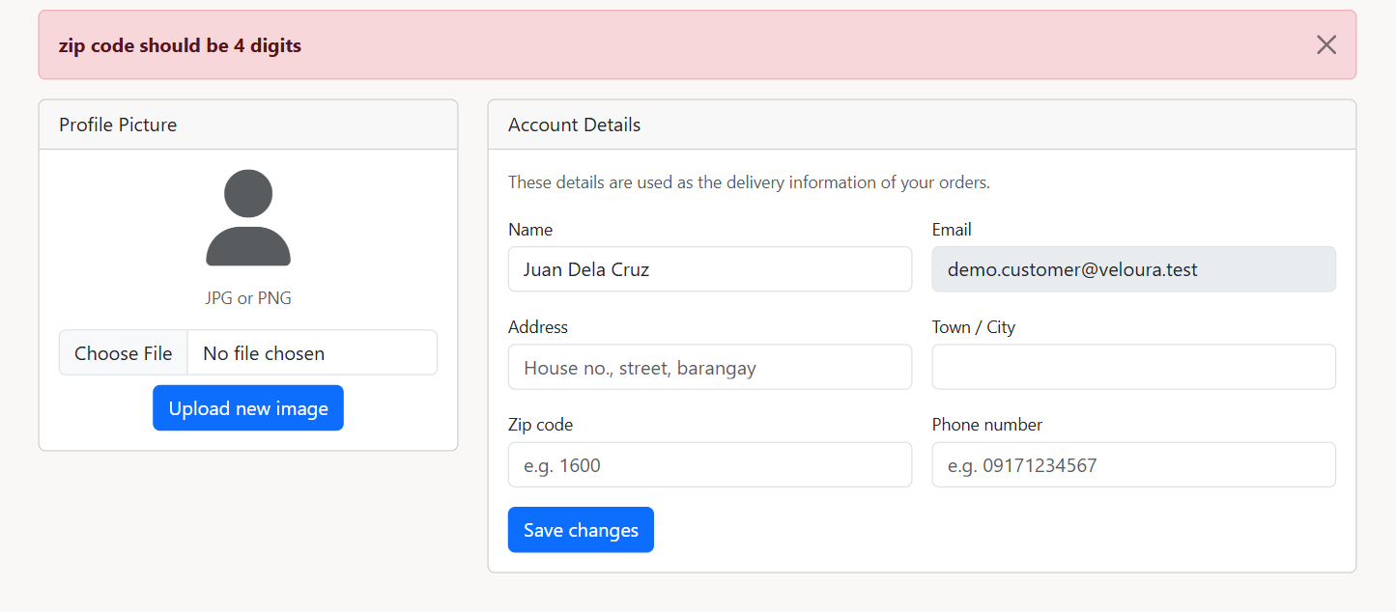
Validation: the zip code must be 4 digits
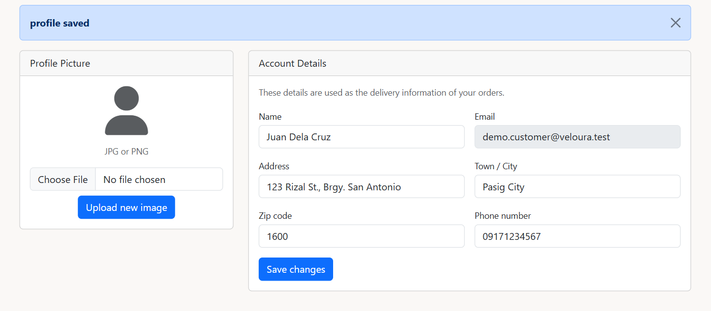
Saved profile
The code behind it
user/profile.php lines 10–26
10 // IF block (photo form): upload a new profile photo
11 if (isset($_POST['upload_photo'])) {
12 if (!isset($_FILES['photo']) || $_FILES['photo']['error'] === UPLOAD_ERR_NO_FILE) {
13 $_SESSION['message'] = 'Please select an image';
14 } else if (isImage($_FILES['photo']['type'])) {
15 $target = savePhoto($_FILES['photo']['tmp_name'], $_FILES['photo']['name']);
16
17 $sql = "UPDATE users SET img_path = ? WHERE user_id = ?";
18 mysqli_execute_query($conn, $sql, [$target, $user_id]);
19 $_SESSION['photo'] = $target;
20 $_SESSION['success'] = 'profile photo updated';
21 } else {
22 $_SESSION['message'] = 'wrong file type, please use JPG or PNG';
23 }
24 header("Location: profile.php");
25 exit();
26 }
What this code does
- Runs when the Upload new image button is clicked. isImage() checks the type and savePhoto() saves the file.
- The UPDATE saves the new photo path, and $_SESSION['photo'] is updated so the navbar shows it straight away.
user/profile.php lines 28–59
28 // IF block (details form): save the name and delivery details
29 if (isset($_POST['submit'])) {
30 $name = trim(strip_tags($_POST['name']));
31 $address = trim(strip_tags($_POST['address']));
32 $town = trim(strip_tags($_POST['town']));
33 $zipcode = trim($_POST['zipcode']);
34 $phone = trim($_POST['phone']);
35
36 // IF-ELSE IF blocks (validation): all fields, 4-digit zip code, 11-digit phone starting with 09
37 if ($name === '' || $address === '' || $town === '' || $zipcode === '' || $phone === '') {
38 $_SESSION['message'] = 'please fill in all fields';
39 } else if (!preg_match("/^[0-9]{4}$/", $zipcode)) {
40 $_SESSION['message'] = 'zip code should be 4 digits';
41 } else if (!preg_match("/^09[0-9]{9}$/", $phone)) {
42 $_SESSION['message'] = 'phone number should be 11 digits and start with 09';
43 } else {
44 $sql = "UPDATE users SET name = ? WHERE user_id = ?";
45 mysqli_execute_query($conn, $sql, [$name, $user_id]);
46
47 // IF-ELSE block: INSERT the delivery details the first time, UPDATE after that
48 $result = mysqli_execute_query($conn, "SELECT customer_id FROM customer WHERE user_id = ? LIMIT 1", [$user_id]);
49 if (mysqli_num_rows($result) === 1) {
50 $sql = "UPDATE customer SET addressline = ?, town = ?, zipcode = ?, phone = ? WHERE user_id = ?";
51 } else {
52 $sql = "INSERT INTO customer (addressline, town, zipcode, phone, user_id) VALUES (?, ?, ?, ?, ?)";
53 }
54 mysqli_execute_query($conn, $sql, [$address, $town, $zipcode, $phone, $user_id]);
55 $_SESSION['success'] = 'profile saved';
56 }
57 header("Location: profile.php");
58 exit();
59 }
What this code does
- Validation with regular expressions: the zip code must be exactly 4 digits (/^[0-9]{4}$/) and the phone 11 digits starting with 09 (/^09[0-9]{9}$/).
- The name is saved in users. The delivery details go in the customer table: INSERT the first time, UPDATE after that.

12. Product details page
Requirement: MP1 view product photos, MP4 reviews
Anyone can open a product. The page shows the main photo, the extra photos, the price, the stock, the average rating and the reviews.
What it looks like
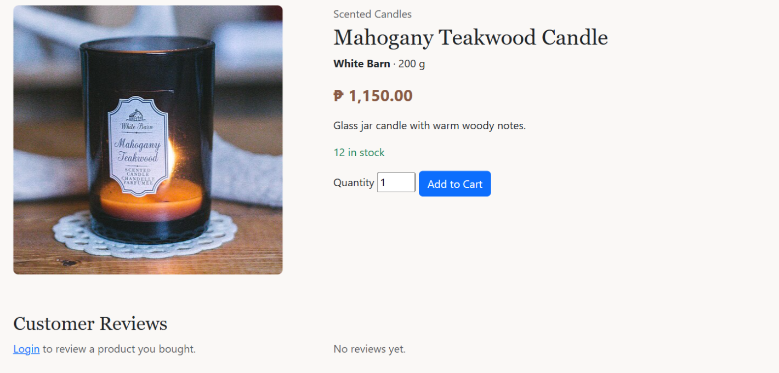
Product details page
The code behind it
product/view.php lines 7–36
7 // SELECT query (JOIN): load the product, go home if it does not exist
8 $product_id = filter_input(INPUT_GET, 'id', FILTER_VALIDATE_INT);
9 $sql = "SELECT p.*, c.name AS category, s.quantity AS qty
10 FROM product p INNER JOIN category c USING (category_id) INNER JOIN stock s USING (product_id)
11 WHERE p.product_id = ? LIMIT 1";
12 $result = mysqli_execute_query($conn, $sql, [$product_id]);
13 $product = mysqli_fetch_assoc($result);
14 if (!$product) {
15 $_SESSION['message'] = 'product not found';
16 header("Location: ../index.php");
17 exit();
18 }
19
20 // SELECT query: the extra photos
21 $photo_result = mysqli_execute_query($conn, "SELECT img_path FROM product_images WHERE product_id = ?", [$product_id]);
22
23 // SELECT query (JOIN): the reviews with the reviewer's name and photo
24 $sql = "SELECT r.user_id, r.rating, r.comment, r.created_at, r.updated_at, u.name, u.img_path
25 FROM review r INNER JOIN users u USING (user_id)
26 WHERE r.product_id = ? ORDER BY r.created_at DESC";
27 $review_result = mysqli_execute_query($conn, $sql, [$product_id]);
28 $reviewCount = mysqli_num_rows($review_result);
29
30 // IF block + AVG query: the average rating
31 $average = 0;
32 if ($reviewCount > 0) {
33 $sql = "SELECT AVG(rating) AS average FROM review WHERE product_id = ?";
34 $row = mysqli_fetch_assoc(mysqli_execute_query($conn, $sql, [$product_id]));
35 $average = round($row['average'], 1);
36 }
What this code does
- filter_input(..., FILTER_VALIDATE_INT) makes sure the id in the address is a number.
- The JOIN reads the product with its category name and stock in one query. If it does not exist, the visitor goes home with a message.
- Two more queries read the extra photos (product_images) and the reviews with the reviewer's name.
- AVG(rating) gives the average rating, rounded to 1 decimal.

13. Add to Cart
Requirement: Shopping cart
The Add to Cart form sends the product and quantity to cart_update.php. The cart is kept in the session, not in the database, until checkout.
What it looks like
Asking for more than the stock shows an error
The code behind it
cart/cart_update.php lines 7–49
7 // IF block (Add to Cart): add a product to the session cart
8 if (isset($_POST["type"]) && $_POST["type"] == 'add') {
9 $product_id = (int)$_POST['product_id'];
10 $qty = trim($_POST['product_qty']);
11
12 // SELECT query: get the product and its stock
13 $sql = "SELECT p.product_id, p.name, p.sell_price, s.quantity FROM product p INNER JOIN stock s USING (product_id) WHERE p.product_id = ?";
14 $row = mysqli_fetch_assoc(mysqli_execute_query($conn, $sql, [$product_id]));
15
16 // IF blocks (validation): the product exists and the quantity is a whole number of 1 or more
17 if (!$row) {
18 $_SESSION['message'] = 'product not found';
19 header('Location: ../index.php');
20 exit();
21 }
22 if (filter_var($qty, FILTER_VALIDATE_INT) === false || $qty < 1) {
23 $_SESSION['message'] = 'please enter a valid quantity';
24 header('Location: ../index.php');
25 exit();
26 }
27
28 // IF blocks: add to the quantity already in the cart, then check the stock
29 if (isset($_SESSION["cart_products"][$product_id])) {
30 $qty = $qty + $_SESSION["cart_products"][$product_id]["product_qty"];
31 }
32 if ($qty > $row['quantity']) {
33 $_SESSION['message'] = "only {$row['quantity']} {$row['name']} left in stock";
34 header('Location: ../index.php');
35 exit();
36 }
37
38 // ARRAY: save the product in the session cart
39 $new_product = array();
40 $new_product["product_id"] = $row['product_id'];
41 $new_product["product_name"] = $row['name'];
42 $new_product["product_price"] = $row['sell_price'];
43 $new_product["product_qty"] = (int)$qty;
44 $_SESSION["cart_products"][$product_id] = $new_product;
45
46 $_SESSION['success'] = "{$row['name']} added to your cart";
47 header('Location: view_cart.php');
48 exit();
49 }
What this code does
- The SELECT reads the product price and its stock.
- Validation: the product must exist and the quantity must be a whole number of 1 or more (filter_var with FILTER_VALIDATE_INT).
- If the product is already in the cart, the new quantity is added to the old one, then checked against the stock.
- The product is saved in the array $_SESSION["cart_products"], with the product id as the key.

14. View, update and remove cart items
Requirement: Shopping cart
view_cart.php lists the items in the session cart with a quantity box and a Remove checkbox each. Update sends the changes to cart_update.php.
What it looks like
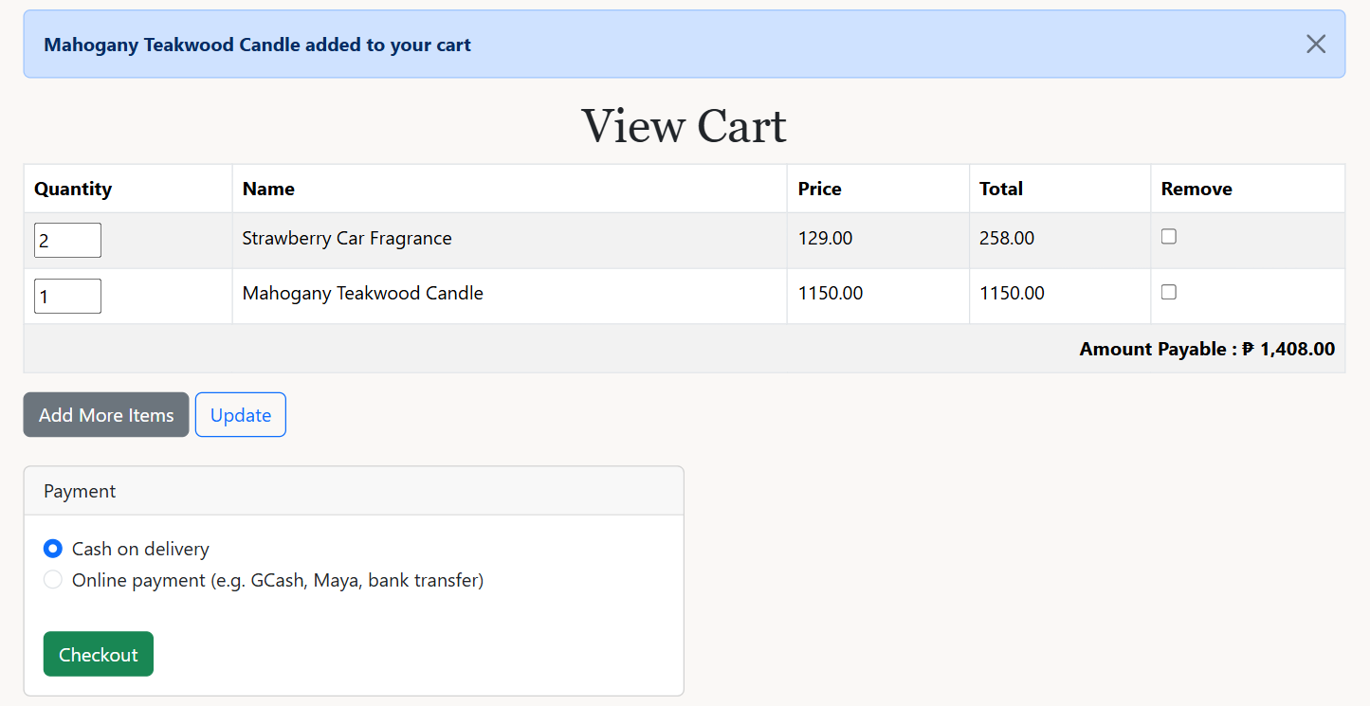
The cart with two products and the Payment box
The code behind it
cart/view_cart.php lines 32–49
32 // FOREACH loop: one row per cart item, adds up the total
33 $total = 0;
34 foreach ($_SESSION["cart_products"] as $cart_itm) {
35 $product_name = $cart_itm["product_name"];
36 $product_qty = $cart_itm["product_qty"];
37 $product_price = $cart_itm["product_price"];
38 $product_code = $cart_itm["product_id"];
39 $subtotal = ($product_price * $product_qty);
40
41 echo '<tr>';
42 echo '<td><input type="text" size="2" name="product_qty[' . $product_code . ']" value="' . $product_qty . '" /></td>';
43 echo '<td>' . $product_name . '</td>';
44 echo '<td>' . $product_price . '</td>';
45 echo '<td>' . sprintf("%01.2f", $subtotal) . '</td>';
46 echo '<td><input type="checkbox" name="remove_code[]" value="' . $product_code . '" /></td>';
47 echo '</tr>';
48 $total = ($total + $subtotal);
49 }
What this code does
- The FOREACH loop goes through every item in $_SESSION["cart_products"] and prints one table row.
- Each quantity box is named product_qty[id] and each checkbox remove_code[], so PHP receives them as arrays.
- The subtotal (price x quantity) is added to $total, shown as Amount Payable with peso().
cart/cart_update.php lines 51–75
51 // IF block (Update button): change quantities or remove products
52 if (isset($_POST["product_qty"]) || isset($_POST["remove_code"])) {
53 if (isset($_POST["product_qty"]) && is_array($_POST["product_qty"])) {
54 // FOREACH loop: set each new quantity
55 foreach ($_POST["product_qty"] as $key => $value) {
56 if (!isset($_SESSION["cart_products"][$key])) {
57 continue;
58 }
59 if (filter_var($value, FILTER_VALIDATE_INT) !== false && $value > 0) {
60 $_SESSION["cart_products"][$key]["product_qty"] = (int)$value;
61 } else {
62 $_SESSION['message'] = 'please enter a valid quantity';
63 }
64 }
65 }
66
67 if (isset($_POST["remove_code"]) && is_array($_POST["remove_code"])) {
68 // FOREACH loop: remove the ticked products
69 foreach ($_POST["remove_code"] as $key) {
70 unset($_SESSION["cart_products"][$key]);
71 }
72 }
73 }
74
75 header('Location: view_cart.php');
What this code does
- The first FOREACH sets each new quantity, if it is a whole number above 0.
- The second FOREACH removes the ticked products from the session cart with unset().

15. Checkout with cash or online payment
Requirement: Term Test: transaction with prepared statements
Below the cart, the Payment box lets the customer pick Cash on delivery or Online payment. Online payment needs the reference number from the receipt. checkout.php checks the choice, then saves the order, its items and the new stock in one transaction.
What it looks like
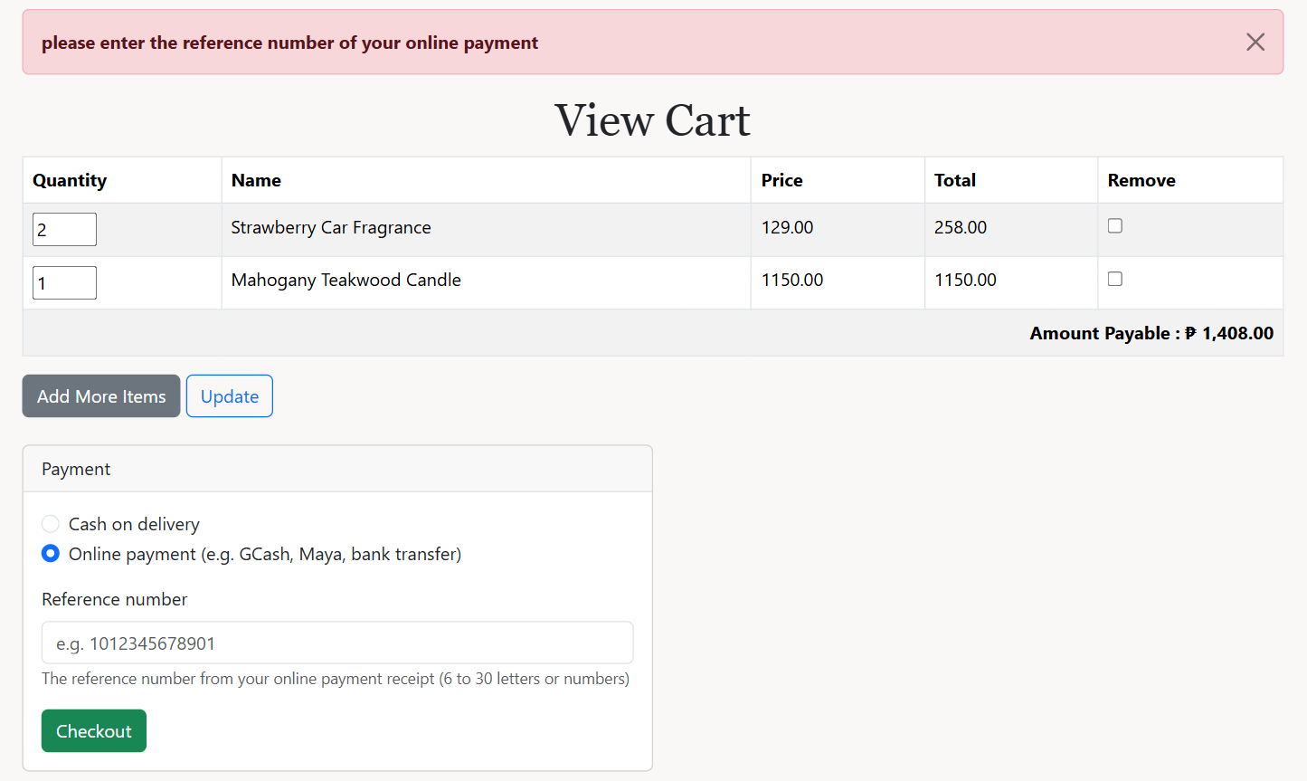
Online payment chosen without a reference number
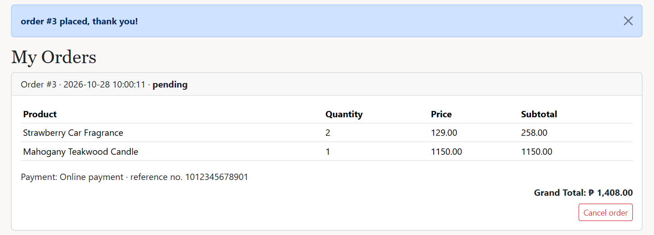
After checkout: the order with its payment and reference number
The code behind it
cart/view_cart.php lines 61–94
61 // VARIABLES: the payment choice typed before, if checkout failed
62 $payment = $_SESSION['payMethod'] ?? 'cash';
63 $reference = $_SESSION['payReference'] ?? '';
64 unset($_SESSION['payMethod'], $_SESSION['payReference']);
65 ?>
66 <!-- HTML FORM: payment method (cash or online with a reference number), sent to checkout.php -->
67 <form method="POST" action="checkout.php" class="card mt-4 col-md-6" novalidate>
68 <div class="card-header">Payment</div>
69 <div class="card-body">
70 <div class="form-check">
71 <input class="form-check-input" type="radio" name="payment_method" id="payCash" value="cash" <?php if ($payment === 'cash') echo 'checked'; ?>>
72 <label class="form-check-label" for="payCash">Cash on delivery</label>
73 </div>
74 <div class="form-check mb-3">
75 <input class="form-check-input" type="radio" name="payment_method" id="payOnline" value="online" <?php if ($payment === 'online') echo 'checked'; ?>>
76 <label class="form-check-label" for="payOnline">Online payment (e.g. GCash, Maya, bank transfer)</label>
77 </div>
78 <div id="referenceBox">
79 <label for="reference" class="form-label">Reference number</label>
80 <input type="text" class="form-control" id="reference" name="reference_no" placeholder="e.g. 1012345678901" value="<?php echo $reference; ?>">
81 <small class="text-muted">The reference number from your online payment receipt (6 to 30 letters or numbers)</small>
82 </div>
83 <button type="submit" class="btn btn-success mt-3" name="checkout">Checkout</button>
84 </div>
85 </form>
86 <script>
87 // JAVASCRIPT: show the reference number box only when "Online payment" is chosen
88 function toggleReference() {
89 document.getElementById('referenceBox').style.display = document.getElementById('payOnline').checked ? 'block' : 'none';
90 }
91 document.getElementById('payCash').addEventListener('change', toggleReference);
92 document.getElementById('payOnline').addEventListener('change', toggleReference);
93 toggleReference();
94 </script>
What this code does
- Two radio buttons named payment_method (cash or online) and a text box named reference_no.
- If checkout failed, $_SESSION['payMethod'] and ['payReference'] bring back what the customer chose and typed.
- The small JavaScript function shows the reference number box only when Online payment is selected. PHP still checks it.
cart/checkout.php lines 14–44
14 // IF block: checkout only works from the Payment form on the cart page
15 if (!isset($_POST['checkout'])) {
16 header('Location: view_cart.php');
17 exit();
18 }
19
20 // VARIABLES: read the payment method and the reference number
21 $payment_method = $_POST['payment_method'] ?? '';
22 $reference_no = trim(strip_tags($_POST['reference_no'] ?? ''));
23
24 // IF-ELSE IF blocks (validation): cash or online, and online needs a valid reference number
25 $payError = '';
26 if ($payment_method !== 'cash' && $payment_method !== 'online') {
27 $payError = 'please choose a payment method';
28 } else if ($payment_method === 'online' && $reference_no === '') {
29 $payError = 'please enter the reference number of your online payment';
30 } else if ($payment_method === 'online' && !preg_match('/^[A-Za-z0-9-]{6,30}$/', $reference_no)) {
31 $payError = 'the reference number should be 6 to 30 letters or numbers';
32 }
33 // IF block: go back to the cart with the error and the typed values
34 if ($payError !== '') {
35 $_SESSION['message'] = $payError;
36 $_SESSION['payMethod'] = $payment_method;
37 $_SESSION['payReference'] = $reference_no;
38 header('Location: view_cart.php');
39 exit();
40 }
41 // IF block: cash orders have no reference number
42 if ($payment_method === 'cash') {
43 $reference_no = null;
44 }
What this code does
- Checkout only runs from the Payment form (the Checkout button is named checkout).
- Validation: the method must be cash or online. Online needs a reference number of 6 to 30 letters, numbers or dashes (regex /^[A-Za-z0-9-]{6,30}$/).
- On an error, the customer goes back to the cart with the message and their typed values. Cash orders save no reference number (NULL).
cart/checkout.php lines 55–106
55 // TRY-CATCH block (TRANSACTION): save the whole order, or nothing if a step fails
56 try {
57 mysqli_begin_transaction($conn);
58
59 // PREPARED STATEMENT (INSERT): the order row with its payment method and reference number
60 $q = 'INSERT INTO orders (user_id, status, payment_method, reference_no, date_placed) VALUES (?, \'pending\', ?, ?, NOW())';
61 $stmt1 = mysqli_prepare($conn, $q);
62 mysqli_stmt_bind_param($stmt1, 'iss', $_SESSION['user_id'], $payment_method, $reference_no);
63 mysqli_stmt_execute($stmt1);
64 $order_id = mysqli_insert_id($conn);
65
66 // PREPARED STATEMENT (INSERT): one row per product in the order
67 $q2 = 'INSERT INTO order_items (order_id, product_id, quantity, price) VALUES (?, ?, ?, ?)';
68 $stmt2 = mysqli_prepare($conn, $q2);
69 mysqli_stmt_bind_param($stmt2, 'iiid', $order_id, $product_code, $product_qty, $product_price);
70
71 // PREPARED STATEMENT (UPDATE): lower the stock
72 $q3 = 'UPDATE stock SET quantity = quantity - ? WHERE product_id = ?';
73 $stmt3 = mysqli_prepare($conn, $q3);
74 mysqli_stmt_bind_param($stmt3, 'ii', $product_qty, $product_code);
75
76 // SELECT ... FOR UPDATE: lock the stock row while checking it
77 $q4 = 'SELECT p.name, p.sell_price, s.quantity FROM product p INNER JOIN stock s USING (product_id) WHERE p.product_id = ? FOR UPDATE';
78
79 // FOREACH loop: check the stock, use today's price, save the item, lower the stock
80 foreach ($_SESSION["cart_products"] as $cart_itm) {
81 $product_qty = $cart_itm["product_qty"];
82 $product_code = $cart_itm["product_id"];
83
84 $row = mysqli_fetch_assoc(mysqli_execute_query($conn, $q4, [$product_code]));
85 if (!$row || $row['quantity'] < $product_qty) {
86 mysqli_rollback($conn);
87 $_SESSION['message'] = "not enough stock for {$cart_itm['product_name']}, please change the quantity";
88 header('Location: view_cart.php');
89 exit();
90 }
91 $product_price = $row['sell_price'];
92
93 mysqli_stmt_execute($stmt2);
94 mysqli_stmt_execute($stmt3);
95 }
96
97 // COMMIT: save everything, empty the cart, go to My Orders
98 mysqli_commit($conn);
99 unset($_SESSION['cart_products']);
100 $_SESSION['success'] = "order #{$order_id} placed, thank you!";
101 header('Location: ../user/myorders.php');
102 } catch (mysqli_sql_exception $e) {
103 mysqli_rollback($conn);
104 $_SESSION['message'] = 'checkout failed, please try again';
105 header('Location: view_cart.php');
106 }
What this code does
- mysqli_begin_transaction() starts the transaction: either every query is saved (mysqli_commit) or none are (mysqli_rollback).
- The order row is inserted with the payment method and reference number. mysqli_insert_id() gives the new order number.
- For each cart item, SELECT ... FOR UPDATE locks the stock row and checks there is enough, so two customers cannot buy the last item at once.
- Each item is saved in order_items with today's price, and the stock is lowered. Then the cart is emptied.

16. My Orders and cancelling an order
Requirement: Customer order history and cancel
My Orders lists the customer's orders with their products, payment and total. A pending order has a Cancel order button; cancelOrder.php cancels it and puts the items back into stock.
What it looks like
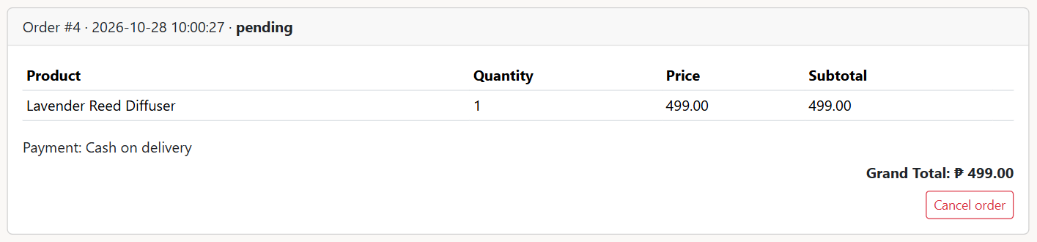
A pending cash order with the Cancel order button
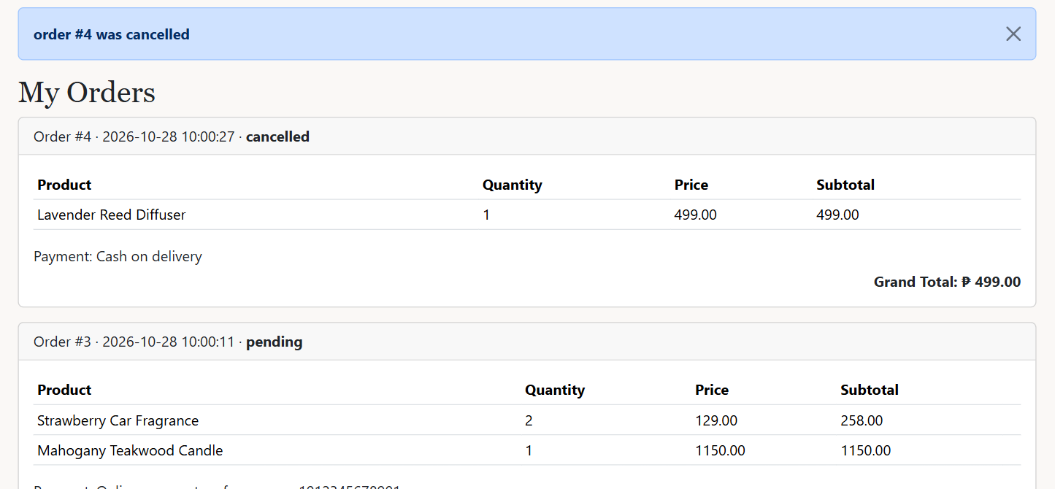
After cancelling: status cancelled, no Cancel button
The code behind it
user/myorders.php lines 46–62
46 // IF-ELSE block: the payment method, with the reference number for online payments
47 if ($order['payment_method'] === 'online') {
48 $payment = "Online payment &middot; reference no. {$order['reference_no']}";
49 } else {
50 $payment = "Cash on delivery";
51 }
52 echo "<p class='mb-1'>Payment: {$payment}</p>";
53 echo "<p class='text-end mb-0'><strong>Grand Total: " . peso($order['total']) . "</strong></p>";
54
55 // IF block (HTML FORM): Cancel order button only while the order is still pending
56 if ($order['status'] === 'pending') {
57 echo "<form method='POST' action='cancelOrder.php' class='text-end mt-2' onsubmit=\"return confirm('Cancel order #{$order['order_id']}?');\">
58 <input type='hidden' name='order_id' value='{$order['order_id']}' />
59 <button type='submit' class='btn btn-sm btn-outline-danger'>Cancel order</button>
60 </form>";
61 }
62 echo "</div></div>";
What this code does
- Shows "Online payment · reference no. ..." or "Cash on delivery".
- The Cancel order form is only printed when the status is pending. onsubmit="return confirm(...)" asks "Cancel order #X?" before sending.
user/cancelOrder.php lines 7–44
7 // IF block: only the Cancel order button on My Orders can open this script
8 if (!isset($_POST['order_id'])) {
9 header('Location: myorders.php');
10 exit();
11 }
12 $order_id = (int)$_POST['order_id'];
13
14 // TRY-CATCH block (TRANSACTION): cancel the order and put the items back into stock
15 try {
16 mysqli_begin_transaction($conn);
17
18 // SELECT ... FOR UPDATE + IF block: the order must be this customer's and still pending
19 $sql = "SELECT status FROM orders WHERE order_id = ? AND user_id = ? FOR UPDATE";
20 $order = mysqli_fetch_assoc(mysqli_execute_query($conn, $sql, [$order_id, $_SESSION['user_id']]));
21 if (!$order || $order['status'] !== 'pending') {
22 mysqli_rollback($conn);
23 $_SESSION['message'] = 'only your pending orders can be cancelled';
24 header('Location: myorders.php');
25 exit();
26 }
27
28 // PREPARED STATEMENT (UPDATE): mark the order as cancelled
29 $stmt1 = mysqli_prepare($conn, "UPDATE orders SET status = 'cancelled' WHERE order_id = ?");
30 mysqli_stmt_bind_param($stmt1, 'i', $order_id);
31 mysqli_stmt_execute($stmt1);
32
33 // PREPARED STATEMENT (UPDATE): return the quantities to stock
34 $stmt2 = mysqli_prepare($conn, 'UPDATE stock s INNER JOIN order_items oi ON oi.product_id = s.product_id SET s.quantity = s.quantity + oi.quantity WHERE oi.order_id = ?');
35 mysqli_stmt_bind_param($stmt2, 'i', $order_id);
36 mysqli_stmt_execute($stmt2);
37
38 mysqli_commit($conn);
39 $_SESSION['success'] = "order #{$order_id} was cancelled";
40 } catch (mysqli_sql_exception $e) {
41 mysqli_rollback($conn);
42 $_SESSION['message'] = 'could not cancel the order, please try again';
43 }
44 header('Location: myorders.php');
What this code does
- SELECT ... FOR UPDATE reads the order with user_id = the logged-in customer, so nobody can cancel someone else's order.
- Only a pending order can be cancelled; once the admin starts processing it, the customer gets "only your pending orders can be cancelled".
- In one transaction the status becomes cancelled and each item's quantity is added back to the stock.

17. Writing and updating a review
Requirement: MP4 review CRUD and regex bad-word filter
Only a customer whose order with that product is completed can review it. The form is on the product page; review/store.php validates it, hides bad words, and saves or updates the review.
What it looks like
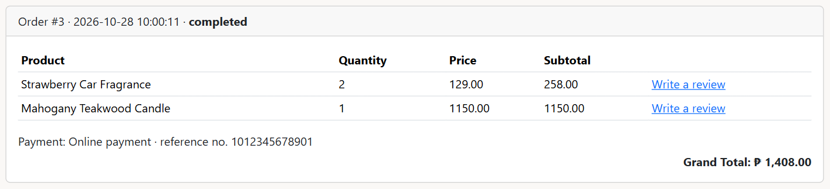
A completed order shows "Write a review" links
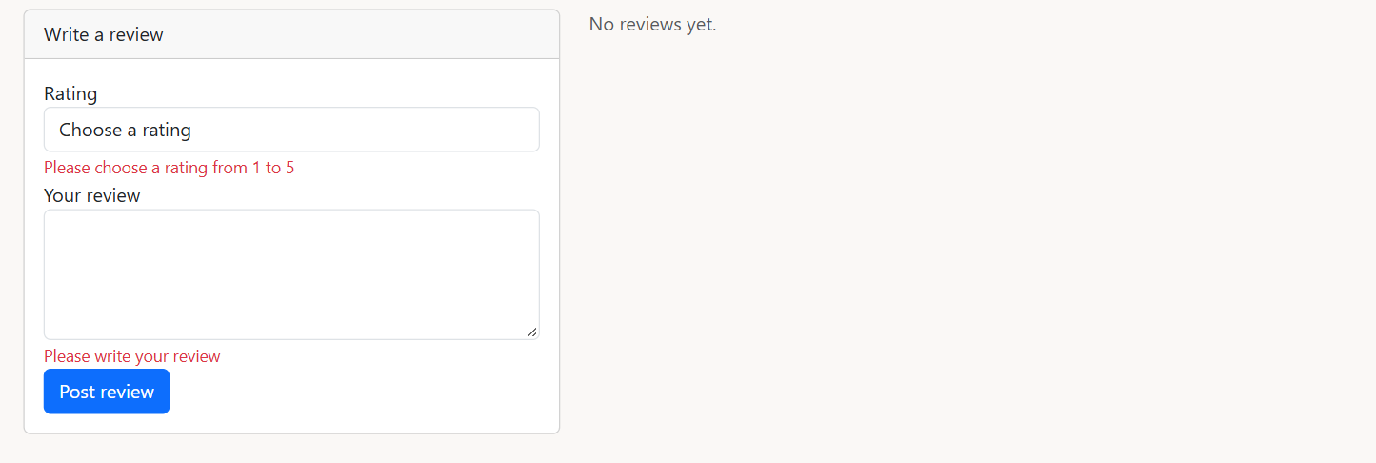
Validation errors on the review form
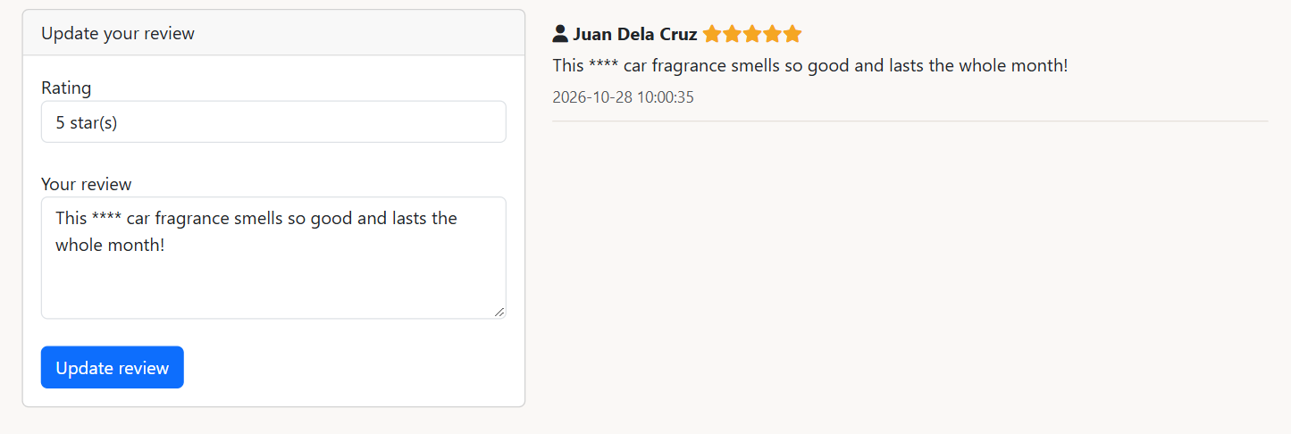
The saved review: the bad word became ****
The code behind it
product/view.php lines 38–48
38 // IF block + SELECT queries: can this user review, and do they already have a review
39 $canReview = false;
40 $myReview = null;
41 if (isset($_SESSION['user_id'])) {
42 $sql = "SELECT order_id FROM order_details_view WHERE user_id = ? AND product_id = ? AND status = 'completed' LIMIT 1";
43 $result = mysqli_execute_query($conn, $sql, [$_SESSION['user_id'], $product_id]);
44 $canReview = mysqli_num_rows($result) > 0;
45
46 $sql = "SELECT rating, comment FROM review WHERE user_id = ? AND product_id = ? LIMIT 1";
47 $myReview = mysqli_fetch_assoc(mysqli_execute_query($conn, $sql, [$_SESSION['user_id'], $product_id]));
48 }
What this code does
- $canReview is true only if order_details_view has a completed order of this product for this user.
- $myReview holds the customer's existing review, so the form shows "Update review" with the old rating and comment.
review/store.php lines 16–60
16 // IF block + SELECT query (view): only customers with a completed order of this product can review
17 $sql = "SELECT order_id FROM order_details_view WHERE user_id = ? AND product_id = ? AND status = 'completed' LIMIT 1";
18 $result = mysqli_execute_query($conn, $sql, [$user_id, $product_id]);
19 if (mysqli_num_rows($result) === 0) {
20 $_SESSION['message'] = 'Only customers who bought this product can review it';
21 header("Location: {$back}");
22 exit();
23 }
24
25 // IF blocks (validation): rating 1 to 5, comment not empty and 1000 characters or less
26 $hasErrors = false;
27 if (filter_var($rating, FILTER_VALIDATE_INT) === false || $rating < 1 || $rating > 5) {
28 $_SESSION['ratingError'] = 'Please choose a rating from 1 to 5';
29 $hasErrors = true;
30 }
31 if ($comment === '') {
32 $_SESSION['commentError'] = 'Please write your review';
33 $hasErrors = true;
34 } else if (strlen($comment) > 1000) {
35 $_SESSION['commentError'] = 'Your review should be 1000 characters or less';
36 $hasErrors = true;
37 }
38 if ($hasErrors) {
39 $_SESSION['reviewRating'] = $rating;
40 $_SESSION['reviewComment'] = $comment;
41 header("Location: {$back}");
42 exit();
43 }
44
45 // FUNCTION CALL: replace bad words with ****
46 $comment = censor($comment);
47
48 // IF-ELSE block: UPDATE the review if it exists, otherwise INSERT a new one
49 $sql = "SELECT review_id FROM review WHERE user_id = ? AND product_id = ? LIMIT 1";
50 $result = mysqli_execute_query($conn, $sql, [$user_id, $product_id]);
51
52 if (mysqli_num_rows($result) === 1) {
53 $sql = "UPDATE review SET rating = ?, comment = ?, updated_at = NOW() WHERE user_id = ? AND product_id = ?";
54 mysqli_execute_query($conn, $sql, [$rating, $comment, $user_id, $product_id]);
55 $_SESSION['success'] = 'your review was updated';
56 } else {
57 $sql = "INSERT INTO review (product_id, user_id, rating, comment, created_at) VALUES (?, ?, ?, ?, NOW())";
58 mysqli_execute_query($conn, $sql, [$product_id, $user_id, $rating, $comment]);
59 $_SESSION['success'] = 'thank you for your review';
60 }
What this code does
- The same completed-order check runs again in the script, so the review cannot be sent without buying the product.
- Validation: rating 1 to 5, comment not empty and 1000 characters or less. Errors show under the fields.
- censor() replaces bad words with **** before saving.
- If the customer already reviewed the product, it is an UPDATE (with updated_at); otherwise an INSERT. One review per customer per product.

Admin features

18. Product list
Requirement: MP1 Read
The admin's product list shows every product with its photo, prices, category and stock, with edit and delete icons.
What it looks like
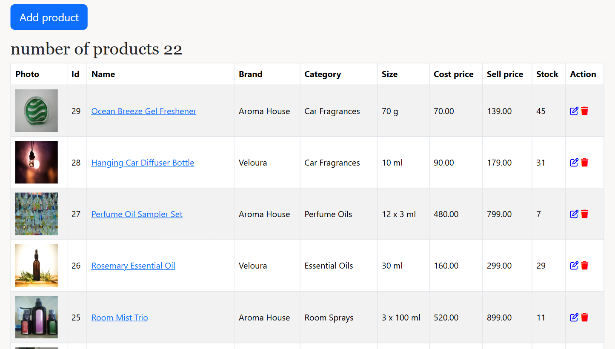
Products page (admin)
The code behind it
product/index.php lines 8–13
8 // SELECT query (JOIN): all products with their category and stock
9 $sql = "SELECT p.product_id, p.name, p.brand, p.size, p.img_path, p.cost_price, p.sell_price, c.name AS category, s.quantity
10 FROM product p INNER JOIN category c USING (category_id) INNER JOIN stock s USING (product_id)
11 ORDER BY p.product_id DESC";
12 $result = mysqli_query($conn, $sql);
13 $itemCount = mysqli_num_rows($result);
What this code does
- One SELECT joins product, category and stock. mysqli_num_rows() counts the products for the heading.
product/index.php lines 37–52
37 // WHILE loop: one table row per product
38 while ($row = mysqli_fetch_assoc($result)) {
39 echo "<tr>";
40 echo "<td><img src='{$row['img_path']}' width='80' height='80' /></td>";
41 echo "<td>{$row['product_id']}</td>";
42 echo "<td><a href='view.php?id={$row['product_id']}'>{$row['name']}</a></td>";
43 echo "<td>{$row['brand']}</td>";
44 echo "<td>{$row['category']}</td>";
45 echo "<td>{$row['size']}</td>";
46 echo "<td>{$row['cost_price']}</td>";
47 echo "<td>{$row['sell_price']}</td>";
48 echo "<td>{$row['quantity']}</td>";
49 echo "<td><a href='edit.php?id={$row['product_id']}'><i class='fa-regular fa-pen-to-square' style='color: blue'></i></a>
50 <a href='delete.php?id={$row['product_id']}'><i class='fa-solid fa-trash' style='color: red'></i></a></td>";
51 echo "</tr>";
52 }
What this code does
- One table row per product. The pencil icon opens edit.php?id=... and the trash icon opens delete.php?id=...

19. Add product with photos
Requirement: MP1 Create, upload one and many photos, MP5 validation
create.php shows the form; store.php checks every field in PHP. A main photo is required and more photos are optional. The product, its stock and its extra photos are saved in one transaction.
What it looks like
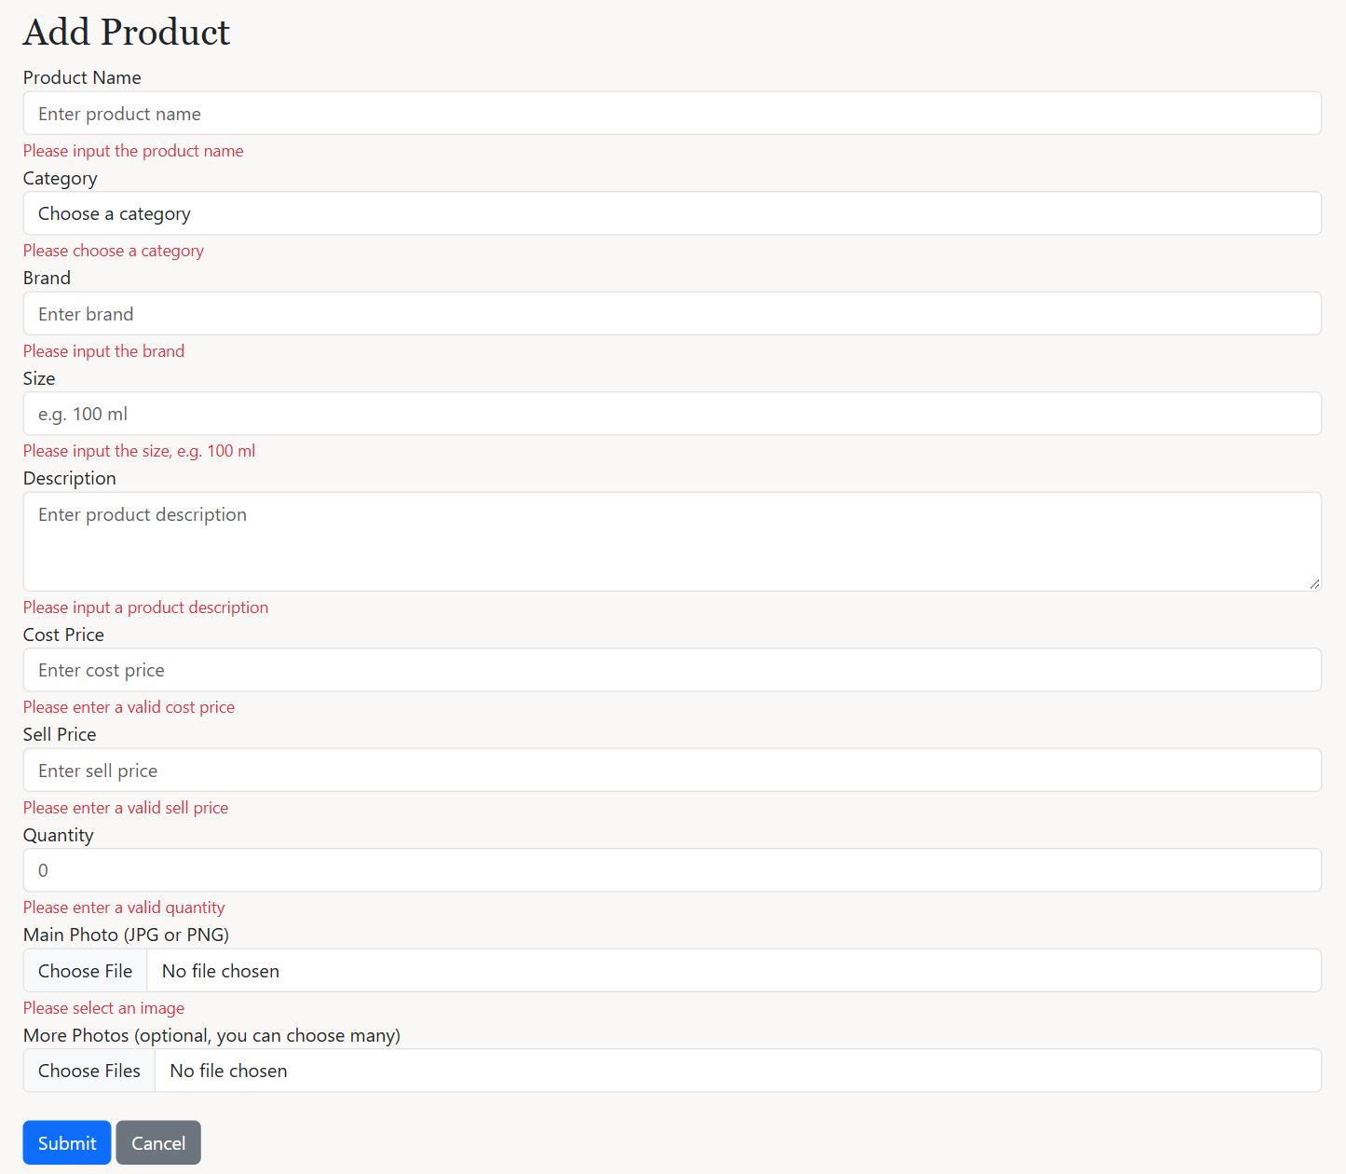
Submitting the empty Add Product form: an error under each field
The code behind it
product/create.php lines 21–25
21 // IF block: show the field's error message once (same for every field below)
22 if (isset($_SESSION['nameError'])) {
23 echo $_SESSION['nameError'];
24 unset($_SESSION['nameError']);
25 }
What this code does
- Each field has a small block like this: it shows that field's error from store.php once, then removes it.
product/store.php lines 20–80
20 // IF-ELSE blocks (validation): check every field in PHP
21 if ($name === '') {
22 $_SESSION['nameError'] = 'Please input the product name';
23 $hasErrors = true;
24 } else if (strlen($name) > 100) {
25 $_SESSION['nameError'] = 'The product name should be 100 characters or less';
26 $hasErrors = true;
27 }
28 if ($category_id === '' || !is_numeric($category_id)) {
29 $_SESSION['categoryError'] = 'Please choose a category';
30 $hasErrors = true;
31 }
32 if ($brand === '') {
33 $_SESSION['brandError'] = 'Please input the brand';
34 $hasErrors = true;
35 }
36 if ($size === '') {
37 $_SESSION['sizeError'] = 'Please input the size, e.g. 100 ml';
38 $hasErrors = true;
39 }
40 if ($desc === '') {
41 $_SESSION['descError'] = 'Please input a product description';
42 $hasErrors = true;
43 } else if (strlen($desc) > 255) {
44 $_SESSION['descError'] = 'The description should be 255 characters or less';
45 $hasErrors = true;
46 }
47 if ($costInput === '' || !is_numeric($costInput) || $costInput <= 0) {
48 $_SESSION['costError'] = 'Please enter a valid cost price';
49 $hasErrors = true;
50 }
51 if ($sellInput === '' || !is_numeric($sellInput) || $sellInput <= 0) {
52 $_SESSION['sellError'] = 'Please enter a valid sell price';
53 $hasErrors = true;
54 } else if (is_numeric($costInput) && $sellInput < $costInput) {
55 $_SESSION['sellError'] = 'The sell price should not be lower than the cost price';
56 $hasErrors = true;
57 }
58 if ($qtyInput === '' || filter_var($qtyInput, FILTER_VALIDATE_INT) === false || (int)$qtyInput < 0) {
59 $_SESSION['qtyError'] = 'Please enter a valid quantity';
60 $hasErrors = true;
61 }
62
63 // IF-ELSE block: the main photo is required and must be JPG or PNG
64 if (!isset($_FILES['img_path']) || $_FILES['img_path']['error'] === UPLOAD_ERR_NO_FILE) {
65 $_SESSION['imageError'] = 'Please select an image';
66 $hasErrors = true;
67 } else if (!isImage($_FILES['img_path']['type'])) {
68 $_SESSION['imageError'] = 'wrong file type, please use JPG or PNG';
69 $hasErrors = true;
70 }
71
72 // IF block + FOREACH loop: extra photos are optional but must be JPG or PNG
73 if (isset($_FILES['photos']) && $_FILES['photos']['name'][0] !== '') {
74 foreach ($_FILES['photos']['type'] as $key => $type) {
75 if (!isImage($type)) {
76 $_SESSION['photosError'] = "wrong file type: {$_FILES['photos']['name'][$key]}, please use JPG or PNG";
77 $hasErrors = true;
78 }
79 }
80 }
What this code does
- Every field is checked: name and description length, a chosen category, numbers for the prices, sell price not lower than cost price, a whole-number quantity.
- The main photo must be chosen and be JPG or PNG. Each extra photo in photos[] must also be JPG or PNG (FOREACH loop).
product/store.php lines 105–141
105 // TRY-CATCH block (TRANSACTION): save the product, its stock and extra photos together
106 mysqli_begin_transaction($conn);
107 try {
108 // PREPARED STATEMENT (INSERT): the product
109 $sql = "INSERT INTO product (category_id, name, brand, size, description, cost_price, sell_price, img_path) VALUES (?, ?, ?, ?, ?, ?, ?, ?)";
110 $stmt1 = mysqli_prepare($conn, $sql);
111 mysqli_stmt_bind_param($stmt1, 'issssdds', $category_id, $name, $brand, $size, $desc, $cost, $sell, $target);
112 mysqli_stmt_execute($stmt1);
113 $product_id = mysqli_insert_id($conn);
114
115 // PREPARED STATEMENT (INSERT): its stock
116 $sql = "INSERT INTO stock (product_id, quantity) VALUES (?, ?)";
117 $stmt2 = mysqli_prepare($conn, $sql);
118 mysqli_stmt_bind_param($stmt2, 'ii', $product_id, $qty);
119 mysqli_stmt_execute($stmt2);
120
121 // IF block + FOREACH loop: save each extra photo in product_images
122 if (isset($_FILES['photos']) && $_FILES['photos']['name'][0] !== '') {
123 $sql = "INSERT INTO product_images (product_id, img_path) VALUES (?, ?)";
124 $stmt3 = mysqli_prepare($conn, $sql);
125 foreach ($_FILES['photos']['name'] as $key => $photoName) {
126 $photo = savePhoto($_FILES['photos']['tmp_name'][$key], $photoName);
127 mysqli_stmt_bind_param($stmt3, 'is', $product_id, $photo);
128 mysqli_stmt_execute($stmt3);
129 }
130 }
131
132 mysqli_commit($conn);
133 $_SESSION['success'] = 'product saved';
134 header("Location: index.php");
135 exit();
136 } catch (mysqli_sql_exception $e) {
137 mysqli_rollback($conn);
138 $_SESSION['message'] = 'could not save the product';
139 header("Location: create.php");
140 exit();
141 }
What this code does
- Three prepared INSERTs in one transaction: the product, its stock, and one product_images row for each extra photo.
- 'issssdds' tells bind_param the type of each value: i = integer, s = string, d = decimal number.

20. Edit product and remove photos
Requirement: MP1 Update, multiple photos
edit.php fills the form with the product. Each extra photo has a remove checkbox. update.php validates like store.php, then updates everything in one transaction.
What it looks like
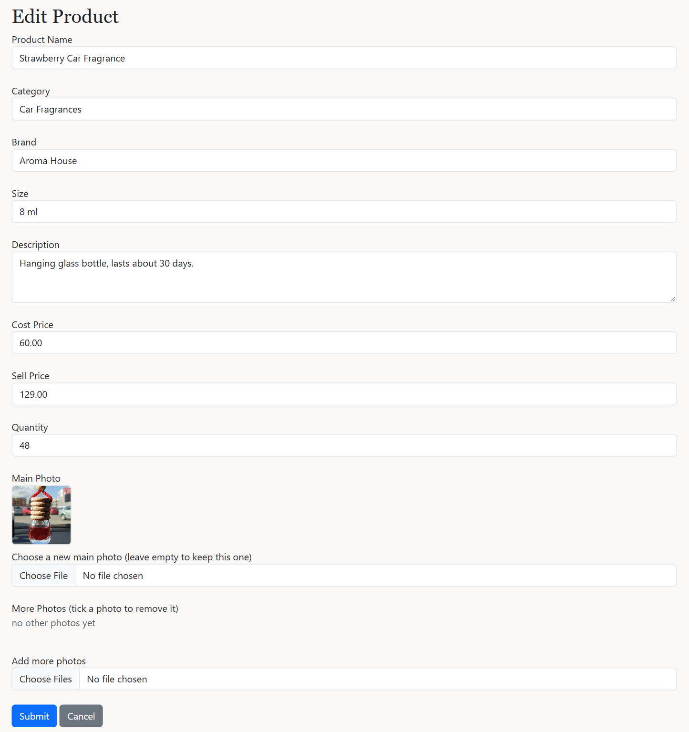
Edit Product form
The code behind it
product/edit.php lines 140–148
140 // IF block + WHILE loop: the extra photos, each with a remove checkbox
141 if (mysqli_num_rows($photo_result) === 0) {
142 echo "<p class='text-muted'>no other photos yet</p>";
143 }
144 while ($photo = mysqli_fetch_assoc($photo_result)) {
145 echo "<label class='me-3 mb-2'><img src='{$photo['img_path']}' class='extra-photo'><br>
146 <input type='checkbox' name='delete_photos[]' value='{$photo['image_id']}' /> remove</label>";
147 }
148 ?>
What this code does
- Shows each extra photo with a checkbox named delete_photos[] whose value is the photo's image_id.
product/update.php lines 104–129
104 // IF-ELSE block: prepared UPDATE with the new main photo, or keep the old one
105 if ($newPhoto) {
106 $target = savePhoto($_FILES['img_path']['tmp_name'], $_FILES['img_path']['name']);
107
108 $sql = "UPDATE product SET category_id = ?, name = ?, brand = ?, size = ?, description = ?, cost_price = ?, sell_price = ?, img_path = ? WHERE product_id = ?";
109 $stmt1 = mysqli_prepare($conn, $sql);
110 mysqli_stmt_bind_param($stmt1, 'issssddsi', $category_id, $name, $brand, $size, $desc, $cost, $sell, $target, $product_id);
111 } else {
112 $sql = "UPDATE product SET category_id = ?, name = ?, brand = ?, size = ?, description = ?, cost_price = ?, sell_price = ? WHERE product_id = ?";
113 $stmt1 = mysqli_prepare($conn, $sql);
114 mysqli_stmt_bind_param($stmt1, 'issssddi', $category_id, $name, $brand, $size, $desc, $cost, $sell, $product_id);
115 }
116 mysqli_stmt_execute($stmt1);
117
118 // PREPARED STATEMENT (UPDATE): the stock quantity
119 $sql = "UPDATE stock SET quantity = ? WHERE product_id = ?";
120 $stmt2 = mysqli_prepare($conn, $sql);
121 mysqli_stmt_bind_param($stmt2, 'ii', $qty, $product_id);
122 mysqli_stmt_execute($stmt2);
123
124 // IF block + FOREACH loop: delete the ticked extra photos
125 if (isset($_POST['delete_photos']) && is_array($_POST['delete_photos'])) {
126 foreach ($_POST['delete_photos'] as $image_id) {
127 mysqli_execute_query($conn, "DELETE FROM product_images WHERE image_id = ? AND product_id = ?", [$image_id, $product_id]);
128 }
129 }
What this code does
- If a new main photo was chosen, the UPDATE includes img_path; otherwise the old photo is kept.
- The stock quantity is updated, and each ticked photo is deleted from product_images.

21. Delete product
Requirement: MP1 Delete
The trash icon opens delete.php. A product that is already in a customer's order cannot be deleted, because the order still needs it.
What it looks like
Trying to delete a product that is in an order
The code behind it
product/delete.php lines 15–35
15 // TRY-CATCH block (TRANSACTION): delete the stock row, then the product; blocked if it is in an order
16 mysqli_begin_transaction($conn);
17
18 try {
19 $stockStmt = mysqli_prepare($conn, 'DELETE FROM stock WHERE product_id = ?');
20 mysqli_stmt_bind_param($stockStmt, 'i', $product_id);
21 mysqli_stmt_execute($stockStmt);
22
23 $productStmt = mysqli_prepare($conn, 'DELETE FROM product WHERE product_id = ?');
24 mysqli_stmt_bind_param($productStmt, 'i', $product_id);
25 mysqli_stmt_execute($productStmt);
26
27 mysqli_commit($conn);
28 $_SESSION['success'] = 'product deleted';
29 } catch (mysqli_sql_exception $e) {
30 mysqli_rollback($conn);
31 $_SESSION['message'] = 'This product cannot be deleted because it is already in a customer order';
32 }
33
34 header('Location: index.php');
35 exit;
What this code does
- The stock row is deleted first, then the product. Extra photos and reviews are deleted automatically (ON DELETE CASCADE).
- If the product is in order_items, the foreign key stops the DELETE. The catch block rolls back and shows a message instead of an error page.

22. User list, activate and deactivate
Requirement: MP2 Read, admin deactivates a user
The Users page lists every account. The Deactivate and Activate buttons open status.php. A deactivated user cannot log in.
What it looks like
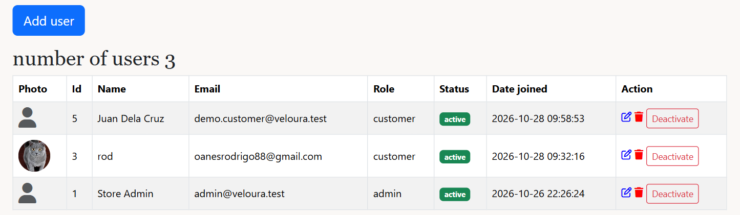
Users page (admin)
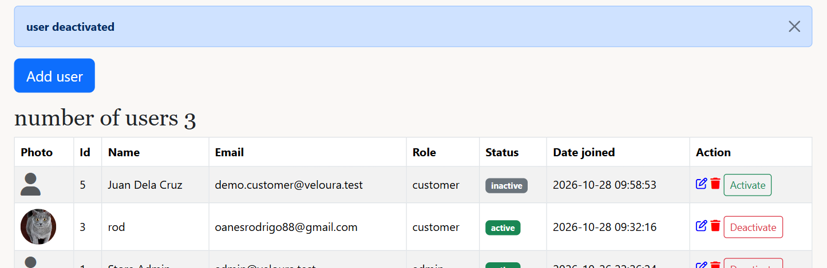
After clicking Deactivate
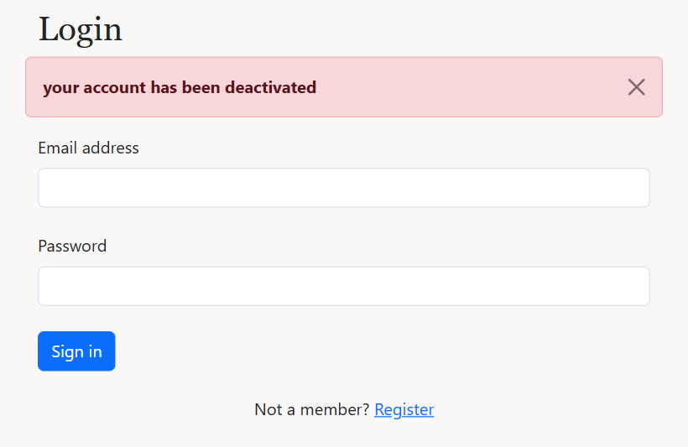
The deactivated customer trying to log in
The code behind it
admin/users/index.php lines 41–48
41 // IF-ELSE block: status badge and Activate/Deactivate button
42 if ($row['status'] === 'active') {
43 $status = "<span class='badge bg-success'>active</span>";
44 $statusLink = "<a href='status.php?id={$row['user_id']}&status=inactive' class='btn btn-sm btn-outline-danger'>Deactivate</a>";
45 } else {
46 $status = "<span class='badge bg-secondary'>inactive</span>";
47 $statusLink = "<a href='status.php?id={$row['user_id']}&status=active' class='btn btn-sm btn-outline-success'>Activate</a>";
48 }
What this code does
- An active user gets a green badge and a Deactivate button; an inactive one a grey badge and an Activate button.
admin/users/status.php lines 11–27
11 // IF-ELSE IF-ELSE block: check the request, then activate or deactivate (a deactivated user cannot log in)
12 if (!$user_id || ($status !== 'active' && $status !== 'inactive')) {
13 $_SESSION['message'] = 'invalid request';
14 } else if ($user_id == $_SESSION['user_id']) {
15 $_SESSION['message'] = 'you cannot deactivate your own account';
16 } else {
17 $sql = "UPDATE users SET status = ? WHERE user_id = ?";
18 $stmt = mysqli_prepare($conn, $sql);
19 mysqli_stmt_bind_param($stmt, 'si', $status, $user_id);
20 mysqli_stmt_execute($stmt);
21 if ($status === 'inactive') {
22 $_SESSION['success'] = 'user deactivated';
23 } else {
24 $_SESSION['success'] = 'user activated';
25 }
26 }
27 header("Location: index.php");
What this code does
- Checks the id and that the new status is active or inactive. An admin cannot deactivate their own account.
- A prepared UPDATE saves the new status.
user/login.php lines 36–37
36 } else if ($row['status'] !== 'active') {
37 $_SESSION['message'] = 'your account has been deactivated';
What this code does
- login.php refuses an inactive account even when the password is right.

23. Add and edit users, change the role
Requirement: MP2 Create and Update, admin updates an active user's role
The admin can add a user with a role and photo, and edit a user's name, email, role and photo. The role list is disabled for a deactivated user.
What it looks like
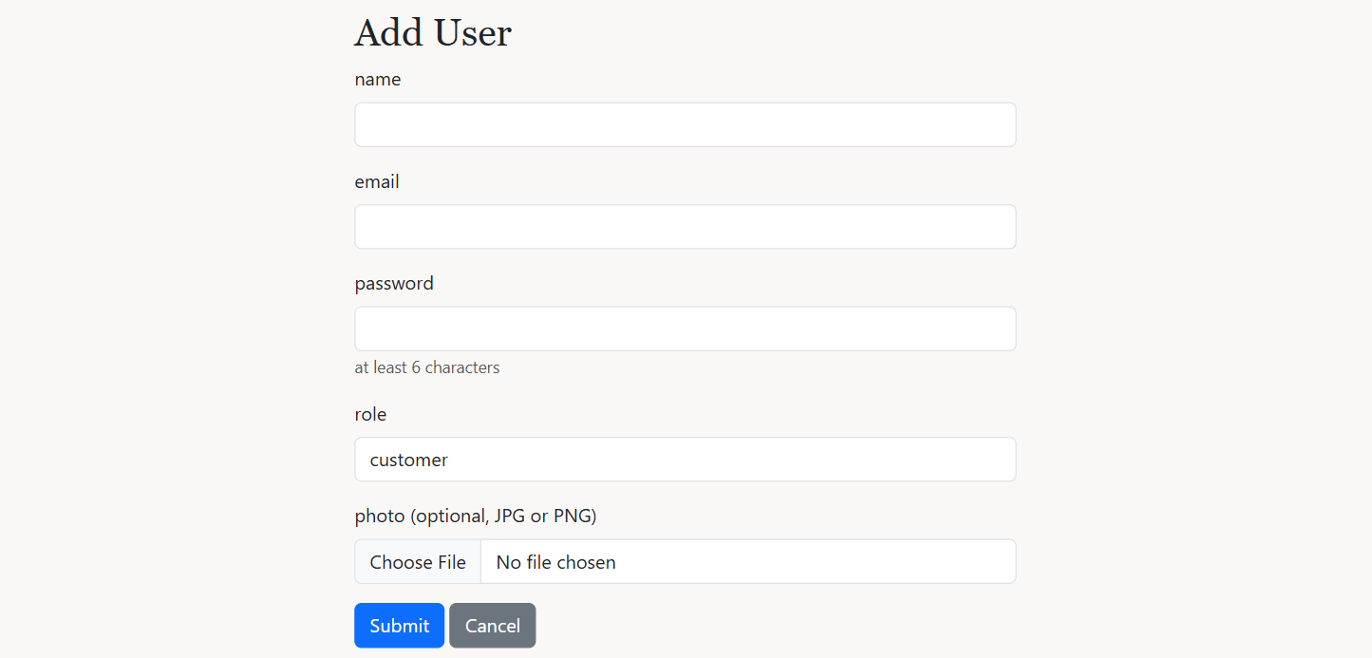
Add User form
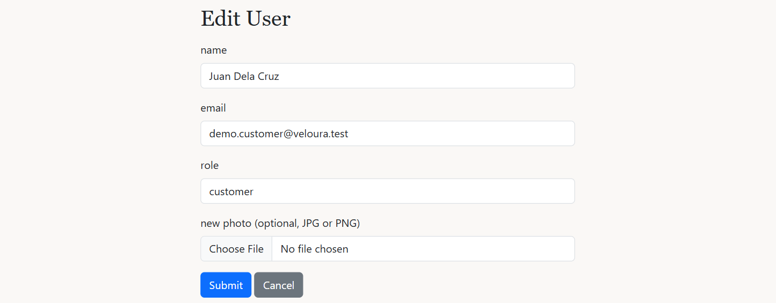
Edit User form
The code behind it
admin/users/update.php lines 23–50
23 // IF block: keep the current role when the role list was disabled
24 $role = $user['role'];
25 if (isset($_POST['role'])) {
26 $role = $_POST['role'];
27 }
28
29 // IF-ELSE IF blocks (validation): name, email, role, only active users, not your own role
30 if ($name === '') {
31 $_SESSION['message'] = 'please enter the name';
32 header("Location: {$back}");
33 exit();
34 } else if (!isValidEmail($email)) {
35 $_SESSION['message'] = 'email invalid format';
36 header("Location: {$back}");
37 exit();
38 } else if ($role !== 'customer' && $role !== 'admin') {
39 $_SESSION['message'] = 'please choose a role';
40 header("Location: {$back}");
41 exit();
42 } else if ($role !== $user['role'] && $user['status'] !== 'active') {
43 $_SESSION['message'] = 'only an active user\'s role can be changed';
44 header("Location: {$back}");
45 exit();
46 } else if ($role !== $user['role'] && $user_id == $_SESSION['user_id']) {
47 $_SESSION['message'] = 'you cannot change your own role';
48 header("Location: {$back}");
49 exit();
50 }
What this code does
- A disabled select is not sent by the browser, so the current role is kept in that case.
- Validation: name, email format, role is customer or admin. Only an active user's role can change, and an admin cannot change their own role.
admin/users/store.php lines 55–66
55 // TRY-CATCH block + prepared INSERT: hash the password and save the user
56 try {
57 $password = password_hash($password, PASSWORD_BCRYPT);
58
59 $sql = "INSERT INTO users (name, email, password, img_path, role, status, created_at) VALUES (?, ?, ?, ?, ?, 'active', NOW())";
60 $stmt1 = mysqli_prepare($conn, $sql);
61 mysqli_stmt_bind_param($stmt1, 'sssss', $name, $email, $password, $target, $role);
62 mysqli_stmt_execute($stmt1);
63
64 unset($_SESSION['regName'], $_SESSION['regEmail']);
65 $_SESSION['success'] = 'user added';
66 header("Location: index.php");
What this code does
- The password is hashed with password_hash() and the new user is inserted with the chosen role and status active.

24. Delete user
Requirement: MP2 Delete
The trash icon on the Users page opens delete.php. A user with orders or reviews cannot be deleted; the admin should deactivate them instead.
What it looks like
Trying to delete a customer who has orders
The code behind it
admin/users/delete.php lines 7–30
7 // IF blocks: stop if the id is invalid or it is your own account
8 $user_id = filter_input(INPUT_GET, 'id', FILTER_VALIDATE_INT);
9
10 if (!$user_id) {
11 header('Location: index.php');
12 exit;
13 }
14 if ($user_id == $_SESSION['user_id']) {
15 $_SESSION['message'] = 'you cannot delete your own account';
16 header('Location: index.php');
17 exit;
18 }
19
20 // TRY-CATCH block + prepared DELETE: blocked when the user has orders or reviews
21 try {
22 $stmt = mysqli_prepare($conn, 'DELETE FROM users WHERE user_id = ?');
23 mysqli_stmt_bind_param($stmt, 'i', $user_id);
24 mysqli_stmt_execute($stmt);
25 $_SESSION['success'] = 'user deleted';
26 } catch (mysqli_sql_exception $e) {
27 $_SESSION['message'] = 'This user has orders or reviews, so the account cannot be deleted. Deactivate it instead.';
28 }
29
30 header('Location: index.php');
What this code does
- An admin cannot delete their own account.
- The prepared DELETE fails when the user has orders or reviews (foreign keys), and the catch block shows a message. Their delivery details are deleted automatically (ON DELETE CASCADE).

25. All orders and order details
Requirement: Term Test: admin views all orders
The Orders page lists every order with its customer, item count, total, payment and status. The eye icon opens the order details: customer, address, payment, items, grand total and the status form.
What it looks like
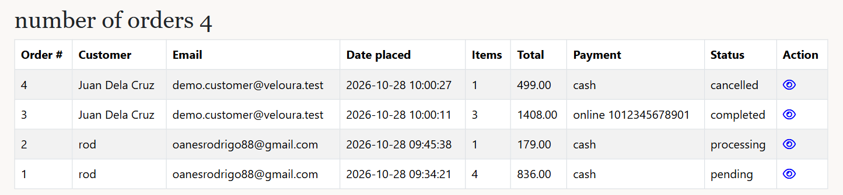
Orders page (admin)
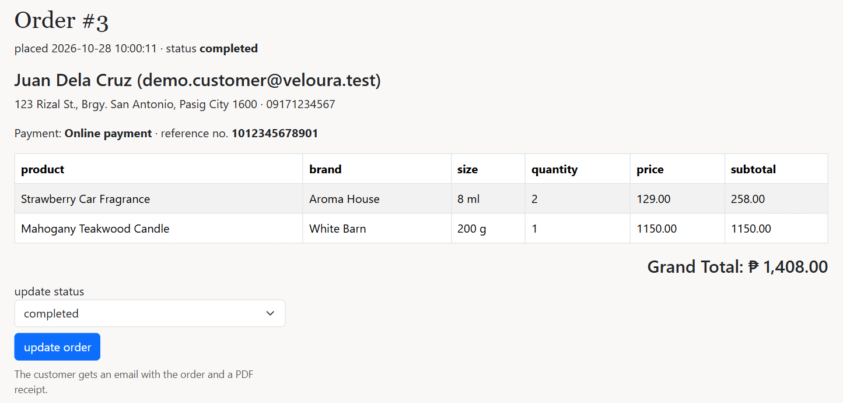
Order details with the update status form
The code behind it
database.sql lines 122–140
122 -- CREATE VIEW: one row per product in an order, with the customer and subtotal
123 CREATE VIEW order_details_view AS
124 SELECT o.order_id, o.user_id, u.name, u.email, c.addressline, c.town, c.zipcode, c.phone,
125 o.status, o.payment_method, o.reference_no, o.date_placed, p.product_id, p.name AS product_name, p.brand, p.size,
126 oi.quantity, oi.price, oi.quantity * oi.price AS subtotal
127 FROM orders o
128 INNER JOIN users u ON u.user_id = o.user_id
129 LEFT JOIN customer c ON c.user_id = o.user_id
130 INNER JOIN order_items oi ON oi.order_id = o.order_id
131 INNER JOIN product p ON p.product_id = oi.product_id;
132
133 -- CREATE VIEW: one row per order with its grand total
134 CREATE VIEW order_totals_view AS
135 SELECT o.order_id, o.user_id, u.name, u.email, o.status, o.payment_method, o.reference_no, o.date_placed,
136 SUM(oi.quantity) AS items, SUM(oi.quantity * oi.price) AS total
137 FROM orders o
138 INNER JOIN users u ON u.user_id = o.user_id
139 INNER JOIN order_items oi ON oi.order_id = o.order_id
140 GROUP BY o.order_id, o.user_id, u.name, u.email, o.status, o.payment_method, o.reference_no, o.date_placed;
What this code does
- order_details_view joins orders, users, customer, order_items and product, and works out each subtotal (quantity x price).
- order_totals_view groups the items by order and adds them up with SUM() to get the grand total.
- The order pages, the email and the review check read these views instead of writing the long JOIN every time.
admin/orderDetails.php lines 32–38
32 // IF-ELSE block: the payment method, with the reference number for online payments
33 if ($customer['payment_method'] === 'online') {
34 echo "<p>Payment: <strong>Online payment</strong> &middot; reference no. <strong>{$customer['reference_no']}</strong></p>";
35 } else {
36 echo "<p>Payment: <strong>Cash on delivery</strong></p>";
37 }
38 ?>
What this code does
- Shows the payment method, and the reference number for online payments, so the admin can check the payment before processing.

26. Update order status, email and PDF receipt
Requirement: Term Test: update status, email with PDF, Mailtrap
The admin picks a new status and clicks update order. updateOrder.php saves it (returning the stock if cancelled), makes a PDF receipt with FPDF and emails it to the customer with PHPMailer through Mailtrap. A cancelled order can no longer change.
What it looks like
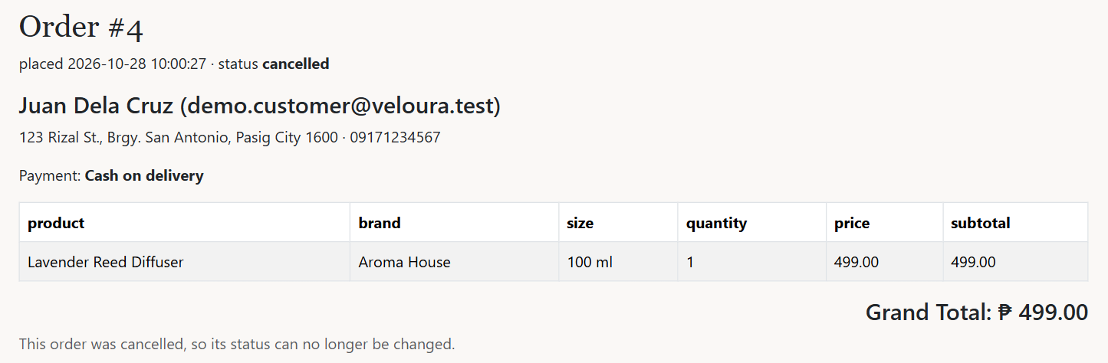
A cancelled order: the status can no longer be changed
The code behind it
admin/updateOrder.php lines 42–59
42 // TRY-CATCH block (TRANSACTION): update the status, return the stock if cancelled
43 try {
44 mysqli_begin_transaction($conn);
45
46 $q = 'UPDATE orders SET status = ? WHERE order_id = ?';
47 $stmt1 = mysqli_prepare($conn, $q);
48 mysqli_stmt_bind_param($stmt1, 'si', $status, $order_id);
49 mysqli_stmt_execute($stmt1);
50
51 // IF block + prepared UPDATE: put the items back into stock
52 if ($status === 'cancelled') {
53 $q2 = 'UPDATE stock s INNER JOIN order_items oi ON oi.product_id = s.product_id SET s.quantity = s.quantity + oi.quantity WHERE oi.order_id = ?';
54 $stmt2 = mysqli_prepare($conn, $q2);
55 mysqli_stmt_bind_param($stmt2, 'i', $order_id);
56 mysqli_stmt_execute($stmt2);
57 }
58
59 mysqli_commit($conn);
What this code does
- A prepared UPDATE saves the new status. If it is cancelled, a second UPDATE adds the quantities back to stock, in the same transaction.
admin/updateOrder.php lines 80–129
80 // FPDF: build the PDF receipt
81 $pdf = new FPDF();
82 $pdf->AddPage();
83 $pdf->SetFont('Helvetica', 'B', 18);
84 $pdf->Cell(0, 10, 'Veloura', 0, 1);
85 $pdf->SetFont('Helvetica', '', 11);
86 $pdf->Cell(0, 7, 'Official Receipt', 0, 1);
87 $pdf->Ln(4);
88 $pdf->Cell(0, 6, "Order #: {$order_id}", 0, 1);
89 $pdf->Cell(0, 6, "Date placed: {$customer['date_placed']}", 0, 1);
90 $pdf->Cell(0, 6, "Status: {$status}", 0, 1);
91 $pdf->Cell(0, 6, "Customer: {$customer['name']} ({$customer['email']})", 0, 1);
92 $pdf->Cell(0, 6, "Deliver to: {$customer['addressline']}, {$customer['town']} {$customer['zipcode']}", 0, 1);
93 $pdf->Cell(0, 6, "Phone: {$customer['phone']}", 0, 1);
94 $pdf->Cell(0, 6, "Payment: {$paymentText}", 0, 1);
95 $pdf->Ln(4);
96
97 $pdf->SetFont('Helvetica', 'B', 11);
98 $pdf->Cell(85, 8, 'Product', 1);
99 $pdf->Cell(20, 8, 'Qty', 1, 0, 'C');
100 $pdf->Cell(40, 8, 'Price', 1, 0, 'R');
101 $pdf->Cell(45, 8, 'Subtotal', 1, 1, 'R');
102 $pdf->SetFont('Helvetica', '', 11);
103
104 // FOREACH loop: one PDF row and one email row per product, adds up the grand total
105 $grandTotal = 0;
106 $rows = '';
107 foreach ($items as $item) {
108 $grandTotal += $item['subtotal'];
109 $pdf->Cell(85, 8, "{$item['product_name']} ({$item['size']})", 1);
110 $pdf->Cell(20, 8, $item['quantity'], 1, 0, 'C');
111 $pdf->Cell(40, 8, 'PHP ' . number_format($item['price'], 2), 1, 0, 'R');
112 $pdf->Cell(45, 8, 'PHP ' . number_format($item['subtotal'], 2), 1, 1, 'R');
113
114 $rows .= "<tr>
115 <td>{$item['product_name']} ({$item['size']})</td>
116 <td align='center'>{$item['quantity']}</td>
117 <td align='right'>" . peso($item['price']) . "</td>
118 <td align='right'>" . peso($item['subtotal']) . "</td>
119 </tr>";
120 }
121
122 $pdf->SetFont('Helvetica', 'B', 11);
123 $pdf->Cell(145, 8, 'Grand Total', 1, 0, 'R');
124 $pdf->Cell(45, 8, 'PHP ' . number_format($grandTotal, 2), 1, 1, 'R');
125 $pdf->Ln(6);
126 $pdf->SetFont('Helvetica', '', 10);
127 $pdf->Cell(0, 6, 'Thank you for shopping at Veloura!', 0, 1);
128 // OUTPUT 'S': return the PDF as a string so it can be attached to the email
129 $pdfFile = $pdf->Output('S');
What this code does
- FPDF builds the receipt line by line: Cell() writes a box of text, Ln() adds space, SetFont() changes the font.
- The FOREACH loop adds one PDF row and one email table row per product and adds up the grand total.
- Output('S') returns the PDF as text in $pdfFile instead of showing it, so it can be attached to the email.
admin/updateOrder.php lines 140–176
140 // PHPMAILER: SMTP server settings from mail_config.php
141 $mail = new PHPMailer();
142 $mail->isSMTP();
143 $mail->Host = SMTP_HOST;
144 $mail->SMTPAuth = true;
145 $mail->Port = SMTP_PORT;
146 $mail->Username = SMTP_USERNAME;
147 $mail->Password = SMTP_PASSWORD;
148
149 // PHPMAILER: sender and recipient
150 $mail->setFrom(MAIL_FROM, 'Veloura');
151 $mail->addAddress($customer['email'], $customer['name']);
152
153 // PHPMAILER: subject, HTML body with the order table, and the PDF attachment
154 $mail->isHTML(true);
155 $mail->Subject = "Your order #{$order_id} is now {$status}";
156 $mail->Body = "<p>Hi {$customer['name']},</p>
157 <p>The status of your order <strong>#{$order_id}</strong> is now <strong>{$status}</strong>.</p>
158 <p>Payment: {$paymentText}</p>
159 <table border='1' cellpadding='6' cellspacing='0'>
160 <tr><th>Product</th><th>Quantity</th><th>Price</th><th>Subtotal</th></tr>
161 {$rows}
162 <tr><td colspan='3' align='right'><strong>Grand Total</strong></td><td align='right'><strong>" . peso($grandTotal) . "</strong></td></tr>
163 </table>
164 <p>Your receipt is attached as a PDF.</p>
165 <p>Thank you for shopping at Veloura!</p>";
166 $mail->AltBody = "The status of your order #{$order_id} is now {$status}. Grand total: PHP " . number_format($grandTotal, 2);
167 $mail->addStringAttachment($pdfFile, "receipt-order-{$order_id}.pdf");
168
169 // IF-ELSE block: send the email and show the result
170 if ($mail->send()) {
171 $_SESSION['success'] = "order #{$order_id} is now {$status}. an email with the PDF receipt was sent to {$customer['email']}";
172 } else {
173 $_SESSION['success'] = "order #{$order_id} is now {$status}";
174 $_SESSION['message'] = "the email could not be sent. Mailer Error: {$mail->ErrorInfo}";
175 }
176 header("Location: {$back}");
What this code does
- The SMTP settings (host, port, username, password) come from includes/mail_config.php (Mailtrap).
- The HTML email lists the products, subtotals, grand total and payment. addStringAttachment() attaches the PDF.
- send() returns true or false, and the admin sees whether the email was sent.

