1. Iteration 1 Contribution Summary
In Iteration 1, my responsibility focused on project structuring, integration coordination, UML preparation, and agile reporting support rather than on implementing one isolated algorithmic component. According to the group’s internal task allocation, my role was to establish the package structure, prepare the initial UML class diagram for the console-based multithreaded prototype, merge teammates’ code into a common branch, carry out a full compilation check, identify interface mismatches, chair the Day 3 stand-up meeting, and prepare the agile-development notes for the report. This role was aligned with the Stage 2 coursework emphasis on threads, design patterns, packages, and agile development processes.
My work in this iteration therefore had two linked purposes. The first was architectural: to ensure that the project had a coherent package layout and a documented class structure rather than a collection of unrelated source files. The second was integrative: to verify whether the independently developed classes could actually be compiled and run together as the minimum console-based simulation required by Iteration 1. This was particularly important because the coursework explicitly requires appropriate use of packages, UML documentation, and a clear explanation of how the software was developed using agile techniques.
2. Package Structure and Architectural Organisation
A key part of my Iteration 1 work was to organise the project into explicit packages and ensure that no class remained in the default package. This decision was motivated both by software engineering quality and by the Stage 2 coursework requirement to “use packages appropriately.” The resulting structure separated the codebase into distinct responsibilities: api for public-facing service abstractions and data transfer objects, model for domain entities, simulation for the producer-consumer logic, logging for the Singleton logger, loader for CSV input handling, service for application services, report for report generation, gui for Swing user-interface classes, and util for general validation logic. This separation reduced coupling, improved readability, and made it easier to identify ownership boundaries during collaborative development.
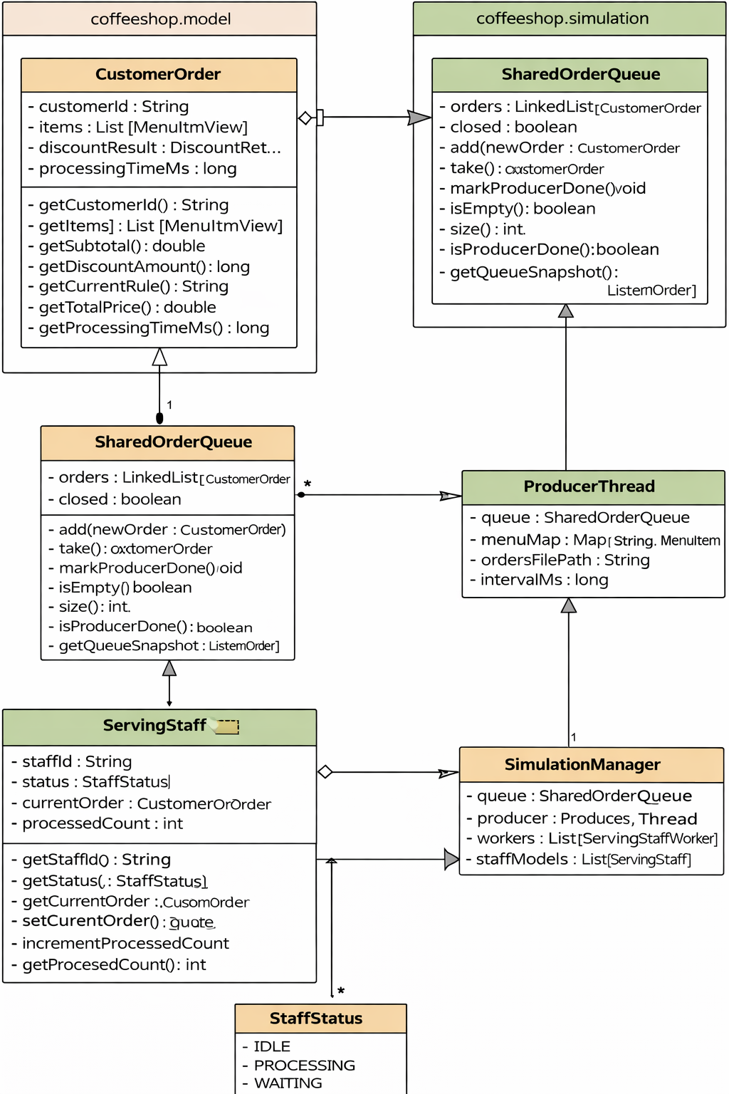
Figure 2.1. Initial UML class diagram for Iteration 1.
The diagram shows the initial console-based producer–consumer simulation architecture developed in Iteration 1, focusing on the core classes CustomerOrder, SharedOrderQueue, ProducerThread, ServingStaffWorker, SimulationManager, and EventLogger, together with their main associations. This early UML intentionally excludes GUI, Observer, and MVC components because the first iteration was scoped only around the minimum multithreaded console prototype.
For Iteration 1 specifically, the active implementation focus was the console-based multithreaded simulation rather than the GUI. Although GUI-related classes already existed in the repository, such as App and MainFrame, the internal iteration plan explicitly stated that the first iteration should extend the Stage 1 codebase into a minimal threaded console version only, without GUI, Observer, or extra extensions. For that reason, the package structure was designed to support the full Stage 2 application, but the UML and integration work for this round concentrated only on the classes needed for the minimum producer-consumer simulation.
3. Initial UML Scope for Iteration 1
I produced the initial UML class diagram for the classes that form the core of the Iteration 1 simulation. In line with the task allocation, the diagram focused on CustomerOrder, SharedOrderQueue, ProducerThread, ServingStaffWorker, SimulationManager, and EventLogger, together with the principal associations between them. This scope was intentionally restricted. The goal of the first UML version was not to document every existing class in the repository, but rather to provide a clear design view of the minimum threaded architecture required for the first iteration.
The class relationships reflected the intended producer-consumer workflow. SimulationManager coordinates the simulation and owns the shared queue, the producer, and the worker set. ProducerThread loads order data and submits grouped customer orders into SharedOrderQueue. ServingStaffWorker retrieves orders from the queue, updates the linked ServingStaff model, simulates processing time, and records events through EventLogger. SimulationSnapshot and ServingStaff were not the visual centre of the UML, but they support later iteration work by representing queue/staff state and potential observer-friendly snapshots. This staged UML approach was also consistent with the coursework guidance that UML diagrams should clearly show both associations and class contents, possibly across more than one diagram.
4. Integration Check and Compile-Time Findings
A major part of my Iteration 1 contribution was to perform the first real integration pass across all submitted code. This work showed that the project structure itself was largely correct, but the codebase had not yet reached a fully integrated runnable state by the end of the first iteration. The main problems were interface mismatches and compile-time inconsistencies rather than fundamental architectural flaws.
The first concrete issue was in SimulationApp.java, where the package declaration was written as package coffeeshop without a terminating semicolon. This prevents the control-entry class from compiling at all. A second issue appeared in the interaction between SimulationManager and ServingStaffWorker. The constructor of ServingStaffWorker takes parameters in the order (ServingStaff staff, SharedOrderQueue queue), but SimulationManager instantiates the worker using (queue, staffModel), which is a direct parameter-order mismatch.
A third and more important inconsistency concerned thread ownership. ServingStaffWorker is implemented as Runnable, but SimulationManager invokes start() and join() on worker objects as if they were Thread instances. This is not a stylistic difference; it means the code cannot compile in its current form unless the worker design is unified. Either the worker class must extend Thread, or SimulationManager must create and manage separate Thread wrappers. A fourth issue was found in ProducerThread, which was intended in the task allocation to reuse an order-loading method, but the current implementation assumes a static OrderLoader.load(...) style, whereas the uploaded OrderLoader defines load(String filename) as an instance method. This also blocks clean integration.
These findings were important for the iteration outcome. They showed that the project had already assembled the main simulation elements, but it was still more accurate to describe the result as a functionally assembled skeleton with known integration issues than as a fully runnable finished console prototype. This distinction matters in the report because the coursework explicitly asks groups to state what works, what remains incomplete, and whether any known bugs are still outstanding.
5. Day 3 Stand-up and Coordination Role
As part of my allocated responsibilities, I chaired the Day 3 stand-up meeting and recorded each member’s progress, blockers, and immediate next actions. This meeting had a practical coordination purpose: by the third day, the team needed to verify whether the separate pieces of work could actually function together within the agreed Iteration 1 scope. The meeting also helped to protect the iteration boundary by confirming that the team should remain focused on the console-based threaded skeleton and should not start introducing GUI, Observer, or further extensions prematurely.
The stand-up also surfaced the central technical blockers quickly. Member A and Member B had focused on the queue and model layer, Member C had implemented the producer and manager logic, and Member D had provided the worker and Singleton logging components. My role at that point was not to rewrite all of those classes, but to consolidate the outputs, check their compatibility, and turn the problems into actionable integration issues. In agile terms, this meeting was useful because it converted vague uncertainty into a short, concrete defect list that could be resolved before Iteration 2 work began.
6. Agile Development Notes for Iteration 1
Iteration 1 was planned as a narrow and controlled extension of the Stage 1 codebase rather than as a full Stage 2 delivery. The internal task plan defined a very clear target: extend the existing project in place, implement a minimum multithreaded simulation using a producer-consumer structure, and verify the console output sequence from order enqueueing to worker completion and clean shutdown. GUI, Observer, MVC, and extensions were deliberately excluded from this round. This was a sensible agile choice because it reduced scope and allowed the group to validate the threading architecture before building the more complex graphical and pattern-heavy functionality required later.
In terms of what was actually built, the iteration produced the main structural parts of the simulation: a shared queue based on explicit synchronisation rather than java.util.concurrent collections, a producer thread, worker logic, a manager component, domain models for order and staff state, processing-time logic, and a Singleton logger. This meant that the core architecture of the simulation existed by the end of the time-box, and the team had already begun aligning its implementation with the Stage 2 requirement to demonstrate threads and patterns in a meaningful way.
What changed during the iteration was mainly the team’s understanding of the integration risk. Initially, the objective was to complete a minimal runnable threaded prototype. However, once the first full integration pass was attempted, several issues appeared: a syntax error in the console main class, incompatible assumptions about whether workers were Runnable or Thread, mismatched constructor usage, and inconsistent expectations around the order-loading interface. As a result, the iteration outcome had to be reframed slightly. Rather than claiming that the console simulation was completely integrated, the more accurate conclusion was that the team had completed the architectural skeleton and identified the fixes required for final alignment. This is still a valid agile outcome because exposing defects early is preferable to hiding them until later iterations.
A key lesson from this iteration was that parallel implementation only works efficiently when interface contracts are agreed early and checked continuously. The team’s division of labour was effective in terms of speed, but constructor signatures, thread ownership decisions, and entry-point expectations were not frozen precisely enough before coding progressed. For Iteration 2, when the codebase would also need GUI updates, Observer integration, and MVC-style interactions, earlier interface agreement would be even more important.
7. Formal Iteration 1 Status Statement
At the end of Iteration 1, the project had substantially completed the console-based multithreaded simulation skeleton. The codebase already contained the shared queue, producer logic, worker logic, simulation manager, processing-time service, and initial logging mechanism required to support a producer-consumer style coffee-shop simulation. The package structure had also been organised appropriately, and an initial UML description of the threaded subsystem had been prepared.
However, the iteration should not yet be described as fully integrated and completely runnable. The first compile-and-integration pass revealed several outstanding issues, including syntax, constructor mismatch, thread-model inconsistency, and loader-interface inconsistency. Therefore, the most accurate report wording is that Iteration 1 successfully delivered the structural foundation of the Stage 2 threaded simulation, but final interface alignment was still required before the console prototype could be treated as fully operational.
8. Process Reflection
From my perspective, Iteration 1 confirmed that integration work is not merely administrative; it is part of the technical design process itself. Even when each team member produces a sensible local solution, the system as a whole may still fail if packages, class contracts, and thread responsibilities are not aligned. My main contribution in this iteration was to make that alignment visible: by structuring the package layout, documenting the initial architecture in UML, coordinating the stand-up discussion, and carrying out the first whole-project compilation review, I helped convert a set of separate coding tasks into an increasingly coherent software system.
The most important lesson I would carry into the next iteration is that integration checking should begin earlier and occur more than once. This is especially important because the later Stage 2 tasks introduce GUI updates, Observer support, and stronger pattern-driven structure, which increase the number of dependencies between classes. For the next iteration, interface decisions should be agreed before implementation continues in parallel, and integration should be treated as an ongoing activity rather than something done only at the end of the time-box.

