Iteration 2 Contribution Report
1. Iteration 2 Role and Purpose
In Iteration 2, my main responsibility was not to implement one isolated class, but to act as the integration and reporting coordinator for this stage of development. According to the group’s task allocation, my role in this iteration was to check whether the implementation satisfied Functional Requirements 1 to 6, update the UML class diagrams to reflect the new Stage 2 architecture, and prepare the agile-development material for the report, especially the draft of Section 3. This role was a continuation of my work in Iteration 1, where I had already focused on package organisation, UML preparation, integration checking, and development-process reporting.
The purpose of my work in Iteration 2 was therefore twofold. First, I needed to confirm that the project had progressed from the console-based threading skeleton of Iteration 1 to a GUI-based simulation that met the core Stage 2 requirements. Second, I needed to document that progress clearly, so that the group report would not only describe the final code but also explain how the system evolved through iterative agile development. This was especially important because the Stage 2 coursework places clear emphasis not only on functionality, but also on threads, design patterns, agile methods, UML, and technical explanation.
2. FR1–FR6 Acceptance Work
A major part of my Iteration 2 work was to validate whether the implementation matched the six core functional requirements for Stage 2. My checking focused on whether the system had moved beyond the minimal console architecture and now supported a full simulation interface with real-time visual feedback, correct thread-based behaviour, and end-of-run outputs. The acceptance work therefore acted as a bridge between development and documentation: it provided evidence for what could be claimed in the report and also helped identify which parts still needed refinement before the next iteration.
From the code structure, the project clearly supported the main single-queue, multiple-staff simulation model required by Stage 2. The application entry point creates a shared queue, a staff list, a simulation service, and a simulation manager, then launches the GUI through MainFrame. This shows that the design had already moved to the intended Stage 2 simulation structure rather than remaining a Stage 1 ordering interface.
The GUI side also provided strong evidence that the core display requirements had been addressed. MainFrame combines QueuePanel, StaffPanel, and ControlPanel into one simulation window, with the queue shown separately from the staff display. QueuePanel receives queue snapshots and updates the visible waiting list, while StaffPanel displays one column per staff member and shows real-time status changes. This meant I could reasonably validate that the system was intended to support visible queue changes and staff activity throughout the simulation, which is one of the most important practical requirements in the coursework.
Another important part of the acceptance work was checking whether the simulation state could flow correctly from the worker logic into the interface. The Observer-based structure was already visible in the code: QueueObserver and ServerObserver define the update contracts, while SimulationService stores the observer lists, constructs SimulationSnapshot objects, and notifies the GUI when queue or server state changes occur. On the simulation side, SharedOrderQueue publishes queue changes after add, take, and producer-completion events, and ServingStaffWorker updates server state while processing orders. This was an important checkpoint because it showed that the GUI was not disconnected decoration, but was linked to the core simulation state through a structured update mechanism.
I also checked the output side of the system, since Stage 2 requires both logging and reporting. The existing codebase already included a reporting component with staff-processing summaries, and the simulation lifecycle wrote a log file at shutdown through the central logger path. This was useful for acceptance because it meant the application was not only displaying live behaviour, but also producing persistent records of what happened during the run.
Overall, my acceptance work in Iteration 2 was not just a checklist exercise. It helped confirm that the project had reached the main architectural target of this iteration: a functioning GUI-based, observer-connected, multithreaded simulation that was visibly closer to the full Stage 2 coursework requirements than the Iteration 1 prototype.
3. UML Update for Iteration 2
Another core responsibility in this iteration was to update the UML diagrams so that they matched the expanded architecture. In Iteration 1, the UML had focused mainly on the console-based producer-consumer skeleton, covering classes such as the shared queue, worker logic, producer logic, manager, and logger. By Iteration 2, this was no longer enough, because the most important development change was the addition of GUI classes and the Observer/MVC-based links between simulation logic and the interface. My UML update therefore had to make these new relationships visible rather than continuing to present the system as if it were only a threaded backend.
The most important additions to the Iteration 2 UML were QueueObserver, ServerObserver, SimulationService, SimulationController, MainFrame, QueuePanel, StaffPanel, and ControlPanel. These classes and interfaces are what distinguish the Iteration 2 design from the earlier console prototype. In particular, SimulationService became the bridge between the simulation and the GUI, while SimulationController made the MVC structure clearer by linking user actions to the simulation lifecycle. QueuePanel and StaffPanel also needed to appear explicitly in the diagram because they are not passive interface containers; they participate directly in the Observer flow by receiving simulation snapshots and updating the visual state.
Updating the UML in this way served two purposes. First, it improved the technical accuracy of the report, since the Stage 2 design is no longer understandable if the GUI and Observer layers are omitted. Second, it made the iteration boundary clearer: Iteration 1 had established the thread skeleton, while Iteration 2 added the architectural layers needed for a visible, interactive Stage 2 system.
To reflect the architectural changes introduced in Iteration 2, the UML documentation was updated from the earlier console-based threading skeleton to a more complete representation of the GUI-based simulation system. In Iteration 1, the UML mainly focused on the producer-consumer structure and the minimum multithreaded simulation core. By Iteration 2, this was no longer sufficient, because the system had expanded to include GUI classes, observer interfaces, a snapshot-based update service, and a controller layer connecting user actions to the simulation lifecycle. The updated UML therefore shows not only the simulation core, but also the links between the model, the observer/service layer, the GUI, and the reporting component.
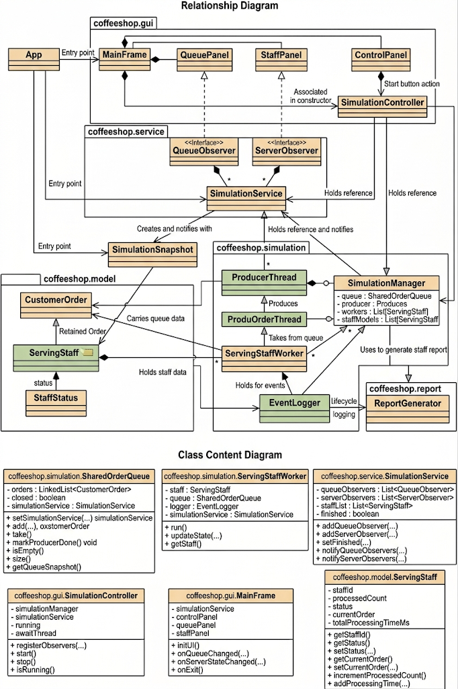
The relationship diagram shows how the Iteration 2 system is organised across packages and architectural layers. At the core of the simulation are the producer-consumer classes in the coffeeshop.simulation package, including SharedOrderQueue, ProducerThread, ServingStaffWorker, and SimulationManager. These classes are responsible for queue management, order production, concurrent order processing, and lifecycle coordination. The coffeeshop.model package contains the domain state of the simulation, including CustomerOrder, ServingStaff, StaffStatus, and SimulationSnapshot. On top of this, the coffeeshop.service package introduces the observer bridge through QueueObserver, ServerObserver, and SimulationService, which allows simulation updates to be propagated to the interface. Finally, the coffeeshop.gui package contains the main Stage 2 interface classes, with MainFrame composing QueuePanel, StaffPanel, and ControlPanel, while SimulationController acts as the controller linking GUI actions to the simulation logic. This structure makes clear that Iteration 2 is no longer just a threaded backend prototype, but a layered and interactive simulation system.
The class content diagram complements the relationship view by showing the main fields and methods of the key Iteration 2 classes. SharedOrderQueue contains the linked-list-based queue state together with the synchronized methods used for adding, taking, and closing the queue. ServingStaffWorker holds references to a ServingStaff model, the shared queue, the logger, and the simulation service, and its behaviour is centred on the run() method and state-update logic. SimulationService maintains observer lists and provides the notification methods used to distribute snapshots to the GUI. On the GUI side, SimulationController contains the control logic for starting and stopping the simulation, while MainFrame owns the major interface panels and delegates user actions through the controller. ServingStaff is also included because it is the central model object representing each worker’s current state, processed count, active order, and total processing time. Together, these class contents make the design more concrete and show how the architectural responsibilities are implemented in code.
This updated UML was important for two reasons. First, it improved the technical accuracy of the documentation by making visible the classes and interfaces that distinguish Iteration 2 from the earlier console-based prototype. Second, it helped clarify the boundary between iterations: Iteration 1 established the minimum producer-consumer simulation, whereas Iteration 2 introduced the GUI, observer flow, and controller structure needed for a visible and interactive Stage 2 application.
4. Agile Reporting and Development Notes
I was also responsible for turning the work of Iteration 2 into material for the report section on agile development. This involved collecting information about what had been planned at the start of the iteration, what had actually been built by the end, and what had changed during implementation. This was important because the Stage 2 report requires an explanation of how the program was developed using agile processes, including what happened in each iteration and which agile practices were actually used.
For Iteration 2, the overall goal was much clearer than in Iteration 1: by the end of this round, the system was expected to support the full GUI-based version of the core simulation, together with the required Observer and MVC structure. In practice, this meant that the iteration was less about creating basic classes and more about integration. The queue, worker threads, snapshots, interface panels, controller logic, and lifecycle behaviour all had to work together correctly. This made Iteration 2 the most integration-heavy phase of the project so far.
One useful observation for the report was that agile methods were genuinely helpful at this stage. Short coordination meetings and progress checks helped the group keep the iteration focused on the required core functionality rather than jumping too early into more ambitious extensions. This was particularly useful because once GUI code, thread code, and observer logic are introduced together, the risk of interface mismatches and hidden integration bugs increases significantly. The iteration therefore reinforced one of the main practical lessons of agile development: in a system with concurrency and interface updates, progress is not just about writing more classes, but about repeatedly checking whether independently written parts actually work together.
5. Problems Identified During Integration
A realistic part of my role in Iteration 2 was to identify integration issues rather than simply record that everything had been added. One of the main challenges in this round was that the architecture had become more layered than in Iteration 1. Once the GUI, controller, observer interfaces, and snapshot service were added, correctness depended not only on whether individual classes compiled, but also on whether updates flowed through the system in the right order and on the right thread.
A particularly important issue was GUI thread safety. The worker threads and queue logic run in the background, but Swing components must be updated on the Event Dispatch Thread. The code addressed this by using SwingUtilities.invokeLater() in the GUI panels when applying updates. From an integration perspective, this was one of the most important design decisions in the whole iteration, because without it the simulation might still run, but the interface would become unreliable or unsafe.
Another integration challenge was making sure that observer notifications did not interfere with queue synchronisation. SharedOrderQueue captures a snapshot inside the synchronized region but performs observer publication outside it, which is a sensible design because it reduces the risk of holding locks while GUI-related notifications are dispatched. This was exactly the kind of detail that became visible only at the integration stage, and it is one reason why Iteration 2 needed careful acceptance checking rather than just code collection.
These issues were valuable from a reporting perspective as well. They showed that the technical work of Iteration 2 was not simply “adding a GUI,” but rather making the threading model, the observer model, and the interface model operate together in a safe and understandable way.
6. Iteration 2 Outcome
By the end of Iteration 2, the project had clearly progressed beyond the thread-only skeleton of the previous round. The system architecture now included a dedicated simulation window, queue and staff panels, observer interfaces, a snapshot-based update service, and controller-based GUI integration. This meant that the project had reached the key goal of this iteration: transforming the Stage 2 design from a backend simulation structure into a system that could visibly demonstrate the simulation as it ran.
From my perspective as Member E, the most important contribution I made in this iteration was to make that progress visible and reportable. By checking the functional requirements, updating the UML to reflect the real architecture, and organising the agile-development material for the report, I helped connect the implementation work to the documentation that the coursework requires. In other words, my work in Iteration 2 was about ensuring not only that the project developed, but also that the group could explain that development clearly and credibly.
7. Reflection
Looking back, Iteration 2 confirmed that integration and reporting are technical tasks in their own right, not just supporting activities. In a project that involves multiple threads, GUI state updates, and design patterns, it is not enough for each member to finish their own class independently. Someone also has to check whether the parts align, whether the architecture still makes sense, and whether the report reflects the software that was actually built. That was the main value of my role in this iteration.
The biggest lesson I would take forward is that once a project reaches the stage where multiple architectural layers interact, UML and acceptance checking become much more important. In Iteration 1, a simplified design view was enough. In Iteration 2, it was necessary to document not only the classes themselves, but also how the simulation, observer, and GUI layers related to one another. The same is true for functional checking: once the system becomes interactive and concurrent, verifying the connections between components becomes just as important as verifying the components individually. This made Iteration 2 a very important stage in moving the project from a partial prototype to a much more complete Stage 2 application.

