AI – Assignment 2
23F-0736
Aleeza Ahmad
3/1/26

Dynamic Pathfinding Agent

1. Project Overview
This project implements a Dynamic Pathfinding Agent that navigates a grid-based environment using Informed Search Algorithms.
Key points:
- Handles dynamic obstacles that appear randomly during navigation.
- Performs real-time path detection and re-planning to reach the goal successfully.
- Built in Python using the Tkinter library for GUI.
- Supports:
  - Search Algorithms: A* and Greedy Best-First Search (GBFS)
  - Heuristics: Manhattan Distance and Euclidean Distance
  - Dynamic Obstacle Mode to simulate unpredictable environments

2. Environment & Features
- Dynamic Grid Sizing:
Users can define any grid dimension using Rows and Columns spinboxes. Clicking Apply Grid resets and redraws the environment.
- Fixed Start and Goal:
  - Start node (green, top-left by default)
  - Goal node (red, bottom-right by default)
  - Nodes remain fixed unless manually relocated using Set Start or Set Goal edit modes
- Random Map Generation:
  - User sets an obstacle density percentage (e.g., 30%)
  - Clicking Generate Random Map randomly marks that percentage of cells as walls
  - Start and Goal cells remain clear
- Interactive Map Editor:
  - Edit Modes: Place Wall, Set Start, Set Goal, Erase
  - Click or drag to build custom maps

- Visualization Colors:
Color | Meaning
Green | Start Node
Red | Goal Node
Cyan/Teal | Final Path
Yellow | Frontier Nodes (in priority queue)
Blue | Visited/Explored Nodes
Gray | Wall/Obstacle
White Circle | Agent's Current Position
- Real-Time Metrics Dashboard:
Shows:
  - Nodes Visited (total expanded)
  - Path Cost (steps in final path)
  - Execution Time (milliseconds)
  - Re-plans count
  - Status

3. Implementation Logic

3.1 Shared Search Architecture
- Both A* and GBFS use a single _search() function.
- Uses:
  - Min-heap priority queue (heapq)
  - g_score dictionary
  - came_from dictionary for path reconstruction
- Priority formula differs only between the two algorithms.
- Counter is used as a tiebreaker in heap to avoid comparison errors.
- Frontier snapshots saved at every expansion for GUI animation.

3.2 A Search Algorithm*
- Core Concept: Combines actual cost (g(n)) and heuristic cost (h(n)) for completeness and optimality.

Evaluation Function:
f(n) = g(n) + h(n)
Step-by-Step Implementation:
- Initialize priority queue: push start node with (f = g(start) + h(start, goal))
- Pop node with lowest f value
- If node = goal → reconstruct path via came_from
- For each neighbor: compute tentative_g = g(current) + 1
- If tentative_g < g(neighbor): update g_score & came_from, push neighbor to heap
- Save frontier snapshot for animation
- Repeat until goal found or queue empty

3.3 Greedy Best-First Search (GBFS)
- Core Concept: Expands nodes based only on heuristic h(n), ignoring cost so far.
Evaluation Function:
f(n) = h(n)
Step-by-Step Implementation:
- Initialize priority queue: push start node with f = h(start, goal)
- Pop node with smallest heuristic
- If node = goal → reconstruct path
- For each unvisited neighbor: update came_from & push to heap
- No g_score updates
- Save frontier snapshot for animation

3.4 Heuristic Functions
- Manhattan Distance:
h = |r_1 - r_2| + |c_1 - c_2|
  - Ideal for 4-directional movement
  - Admissible → guarantees optimality for A*
- Euclidean Distance:
h = sqrt(r_1-r_2)^2 + (c_1-c_2)^2
  - Straight-line distance
  - More aggressive, may expand fewer nodes, slightly underestimates cost in 4-directional grids

3.5 Dynamic Obstacle & Re-Planning Logic
- Spawning Logic:
  - On each agent step, a random number is compared against spawn probability (e.g., 8%)
  - If triggered, a random empty cell is converted to a wall
  - Avoids cells on agent’s remaining path
- Re-Planning Mechanism:
  - If new wall is on remaining path → call _search() from current agent position
  - Else → continue uninterrupted

4. Pros and Cons

4.1 A Search*
Advantages:
- Optimal path guaranteed
- Complete (always finds a path)
- Balanced exploration
- Reliable in dynamic re-planning
- Works well in complex mazes
Disadvantages:
- Higher memory usage
- Slower than GBFS
- Overkill on simple open maps

4.2 Greedy Best-First Search (GBFS)
Advantages:
- Very fast
- Low memory usage
- Excellent for open/semi-open maps
- Simple and intuitive
Disadvantages:
- Not optimal
- Can get trapped in maze environments
- Heuristic dependent and fragile
- Inconsistent re-planning quality

4.3 Summary Comparison
Feature | A* Search | Greedy BFS
Formula | f(n) = g(n) + h(n) | f(n) = h(n) only
Optimal | Yes | No
Complete | Yes | Yes
Speed | Slower | Faster
Memory | Higher | Lower
Path Quality | Always shortest | May be longer
Best For | Complex mazes, re-planning | Open grids, speed priority
Worst Case | Dense obstacle grids | Trap/maze environments

5. Test Cases

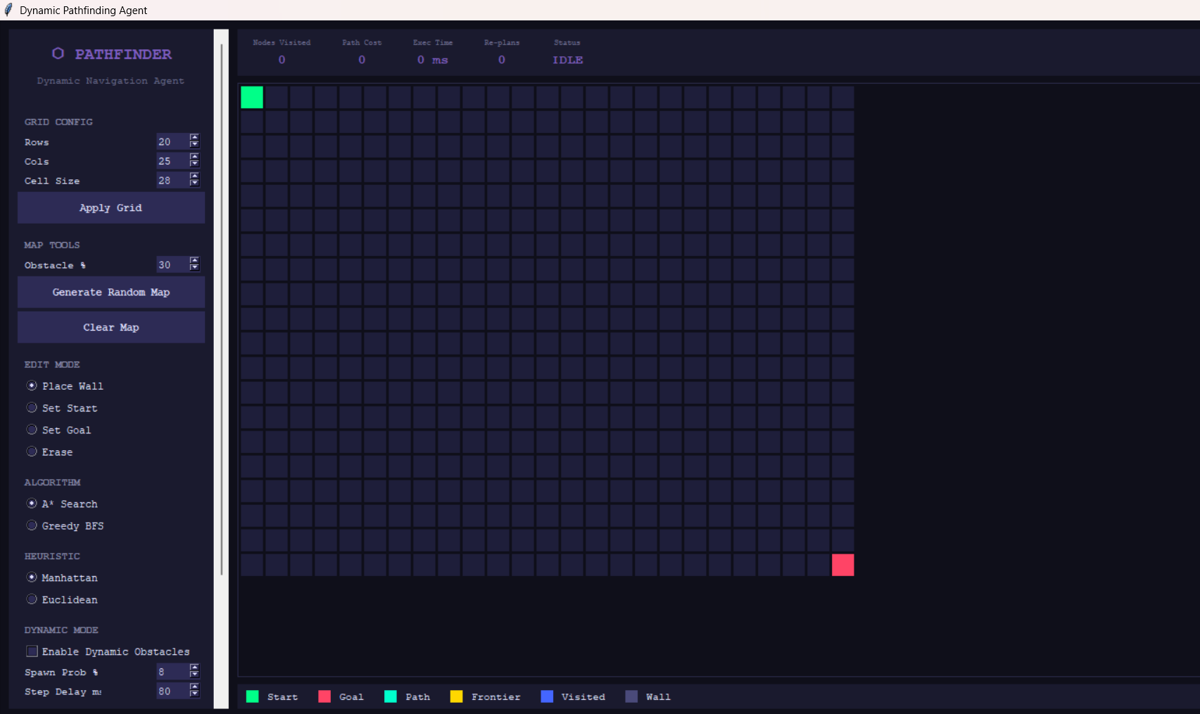
TEST CASE 1 — A* Manhattan, Best Case

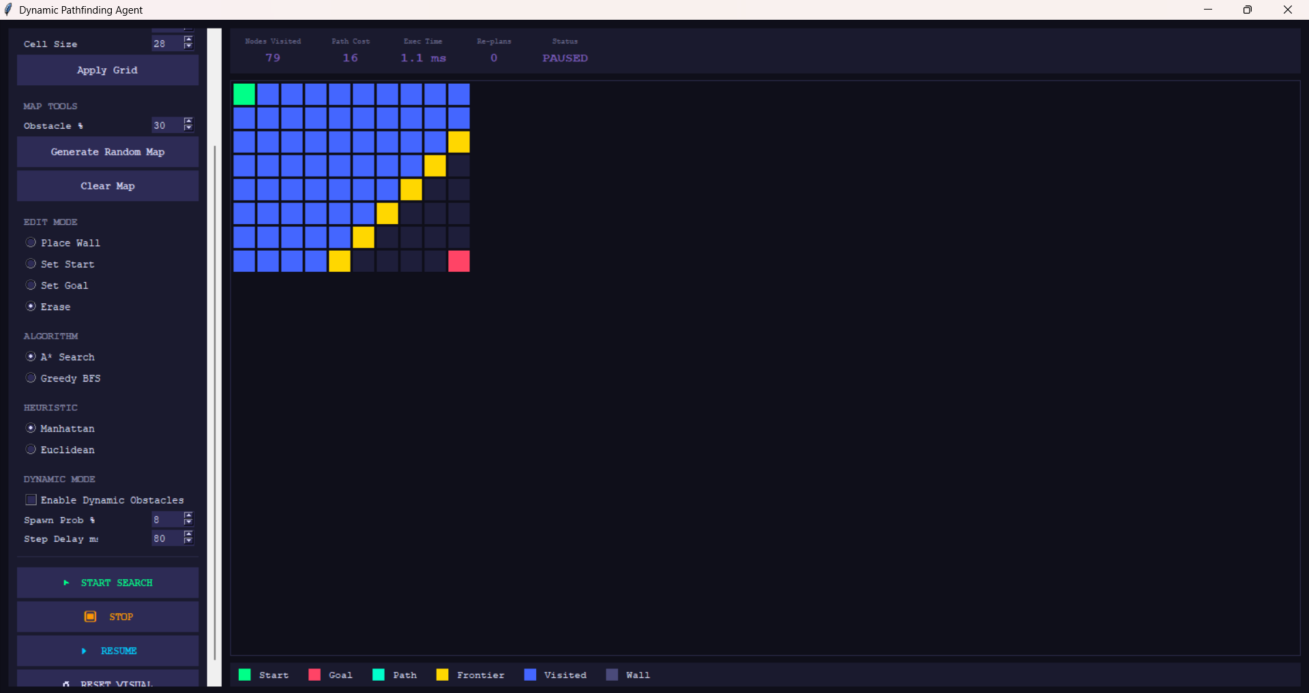
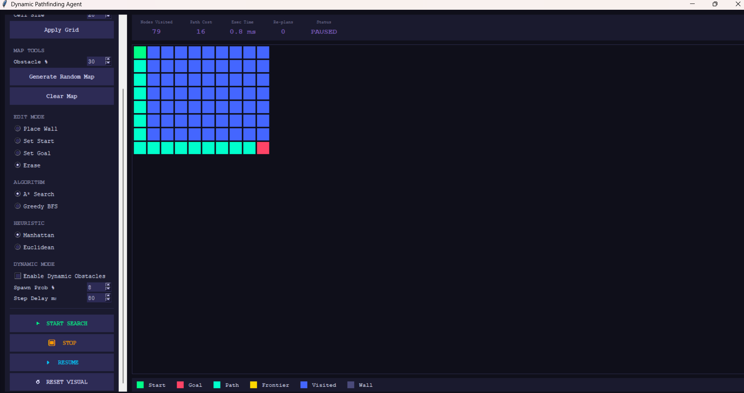
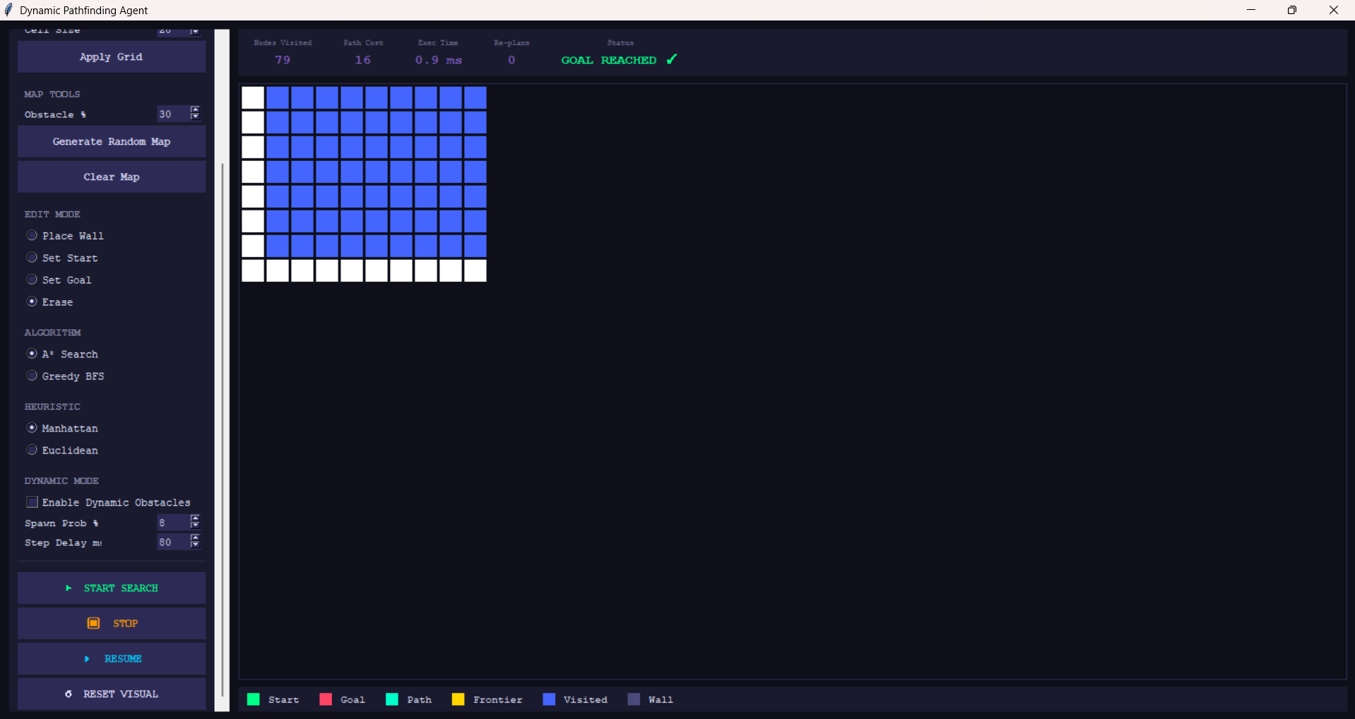

TEST CASE 2 — A* Manhattan, Worst Case
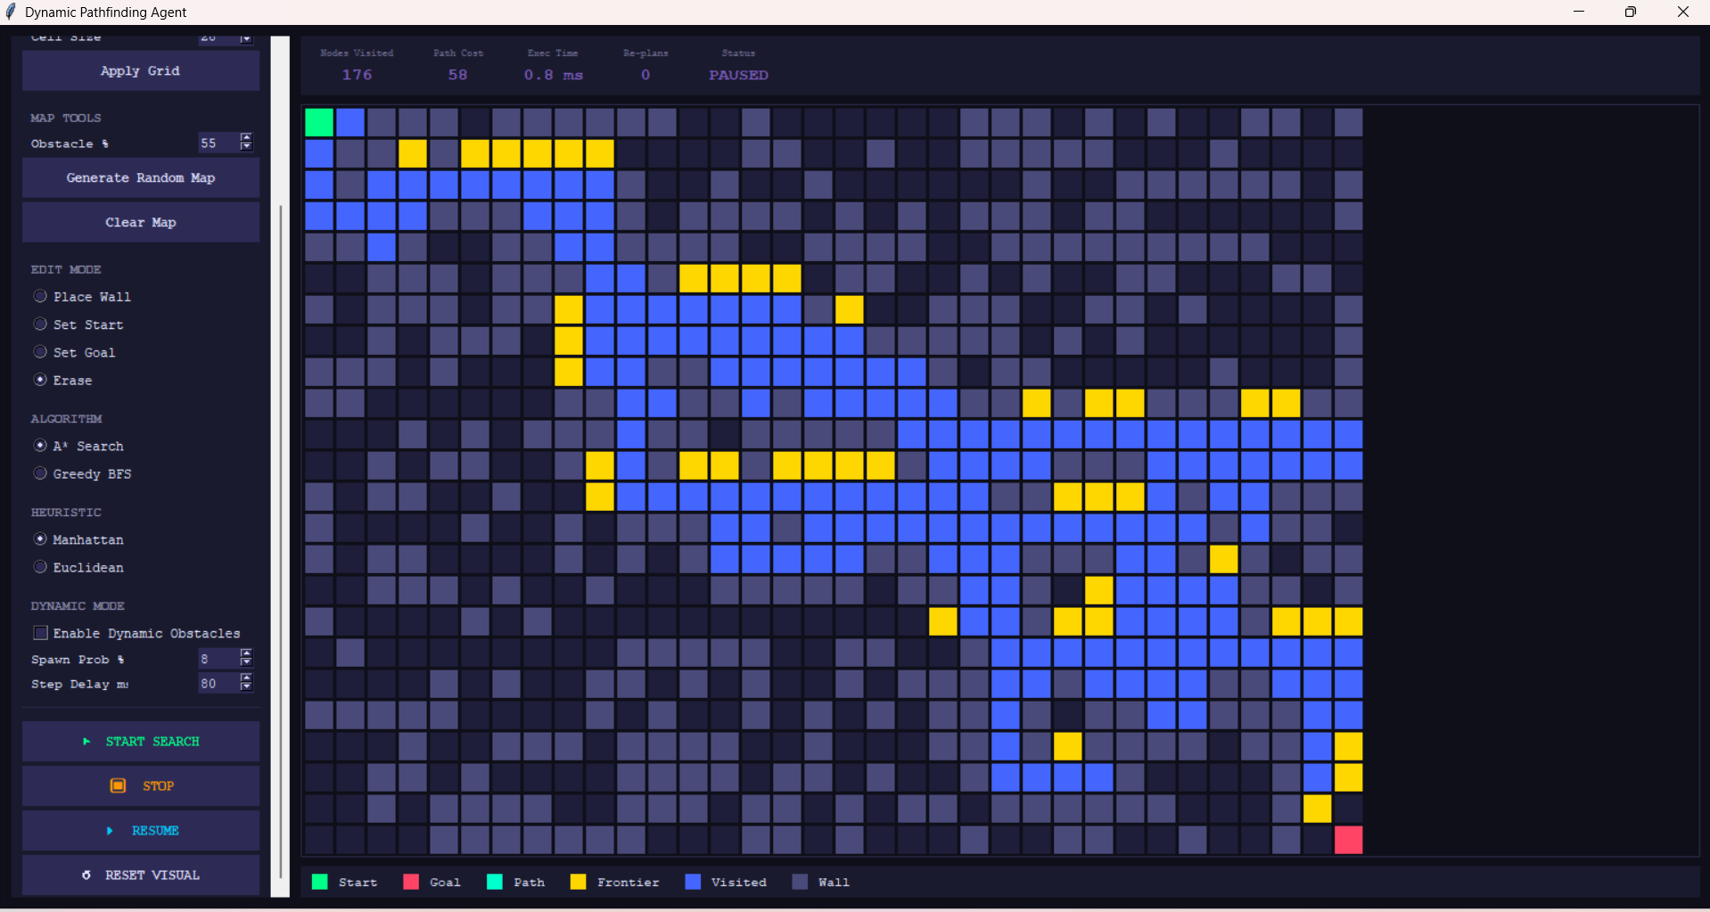
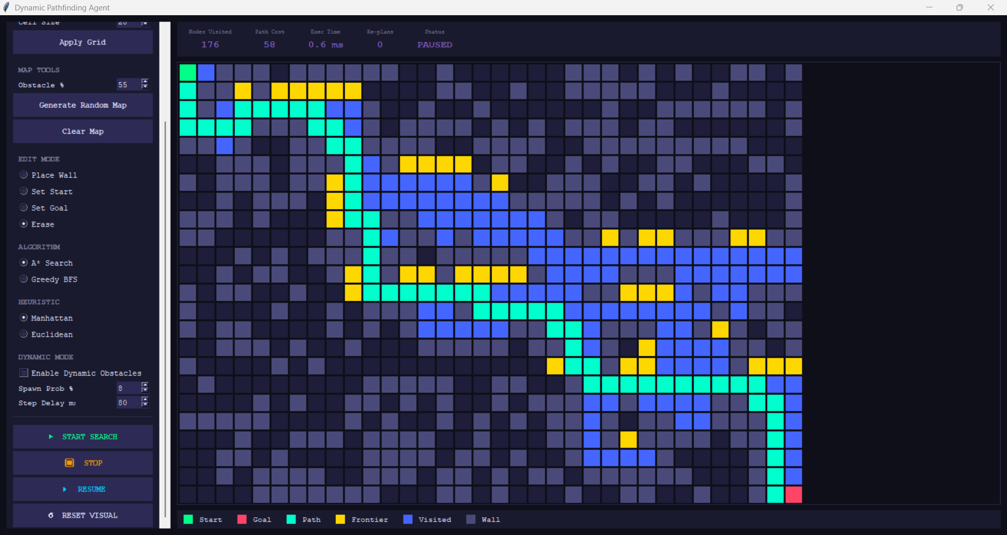
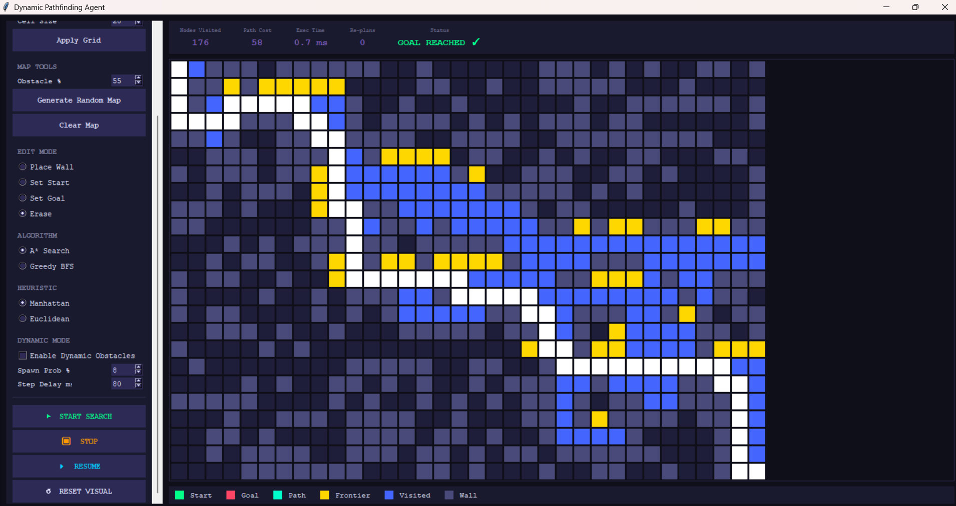

TEST CASE 3 — GBFS Euclidean, Best Case
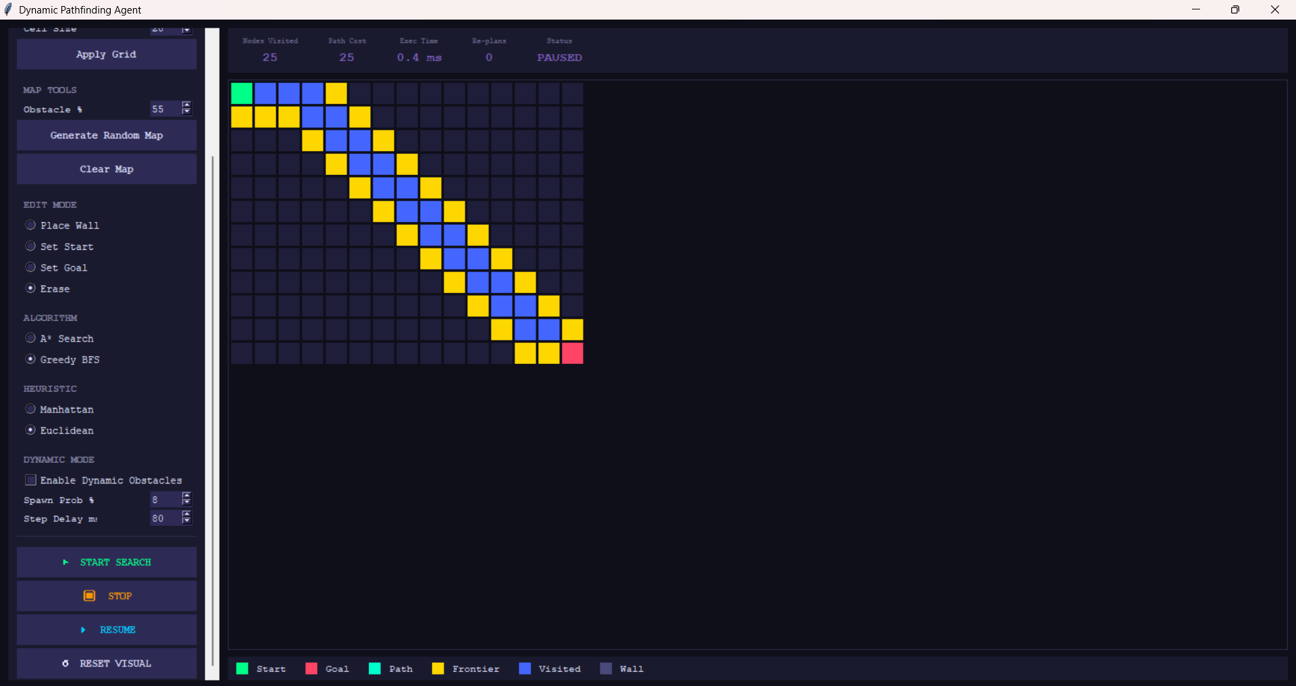
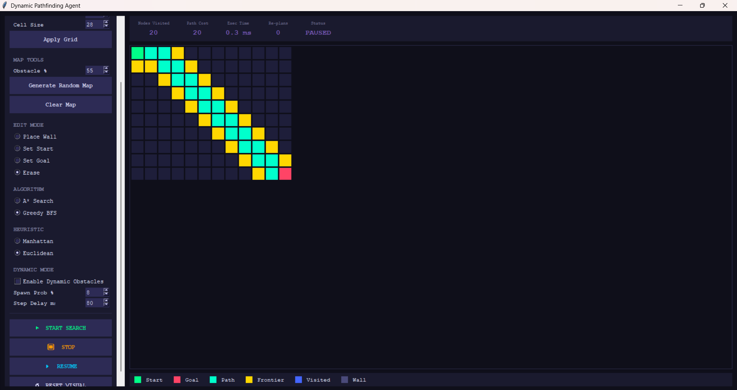
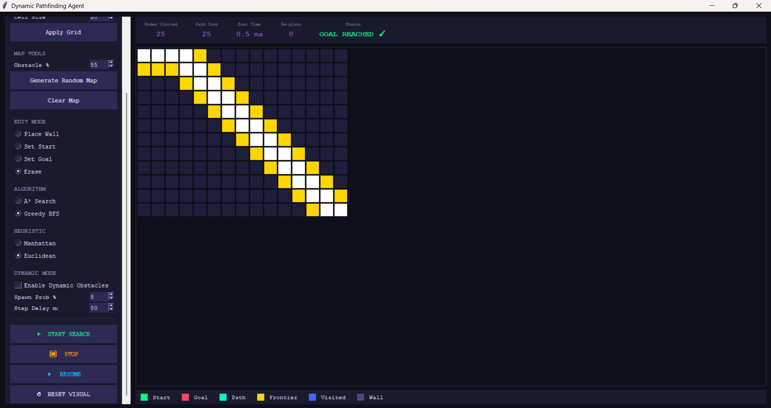

TEST CASE 4 — GBFS Worst Case (Maze)
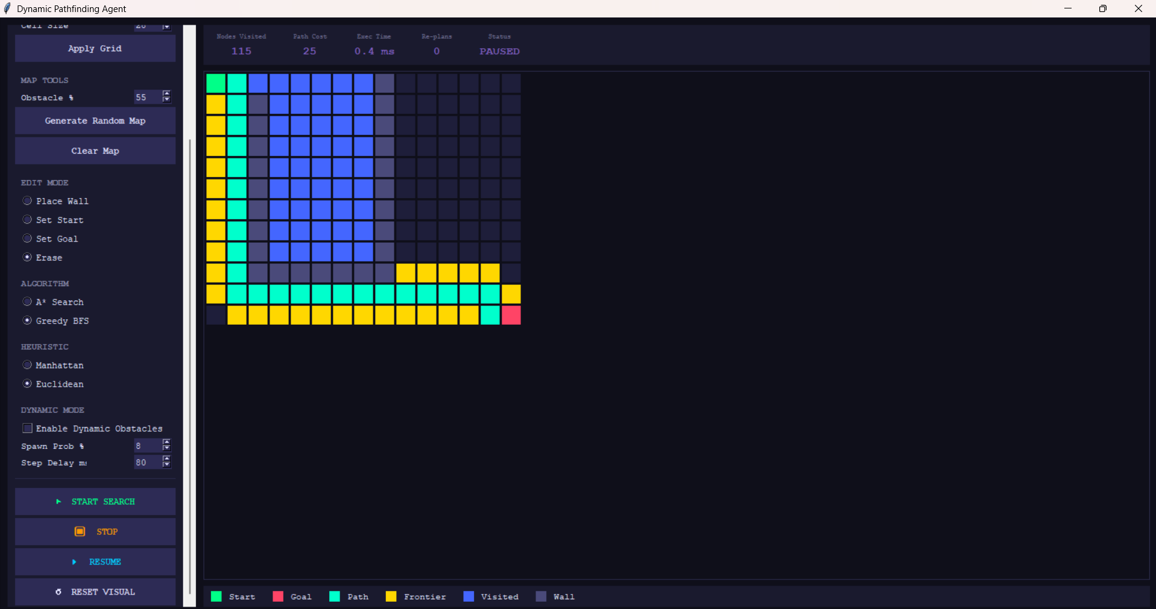
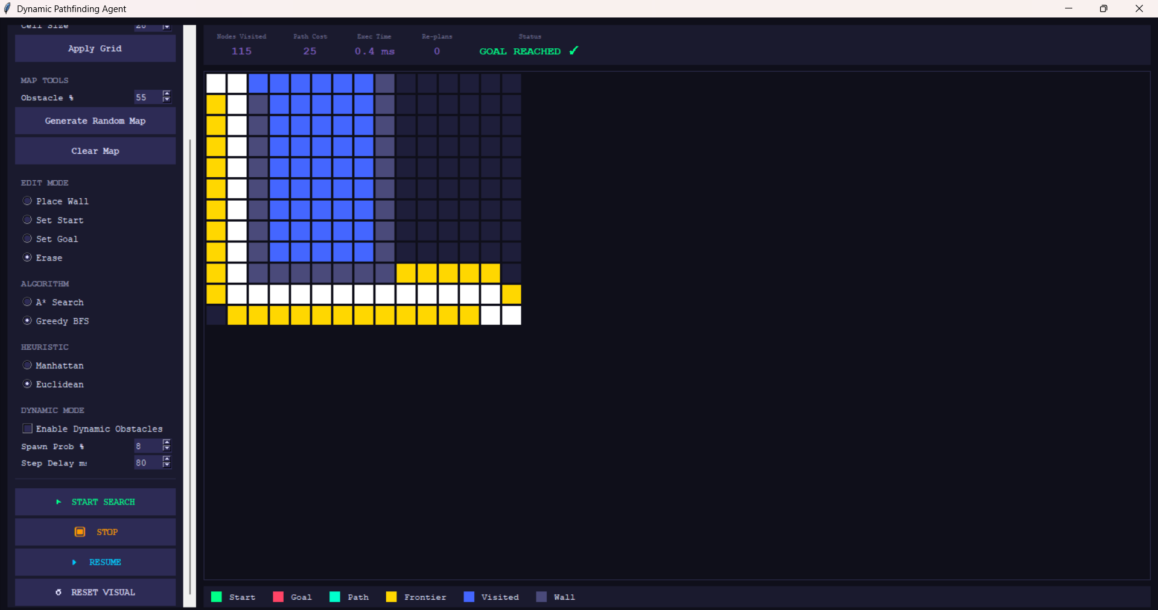

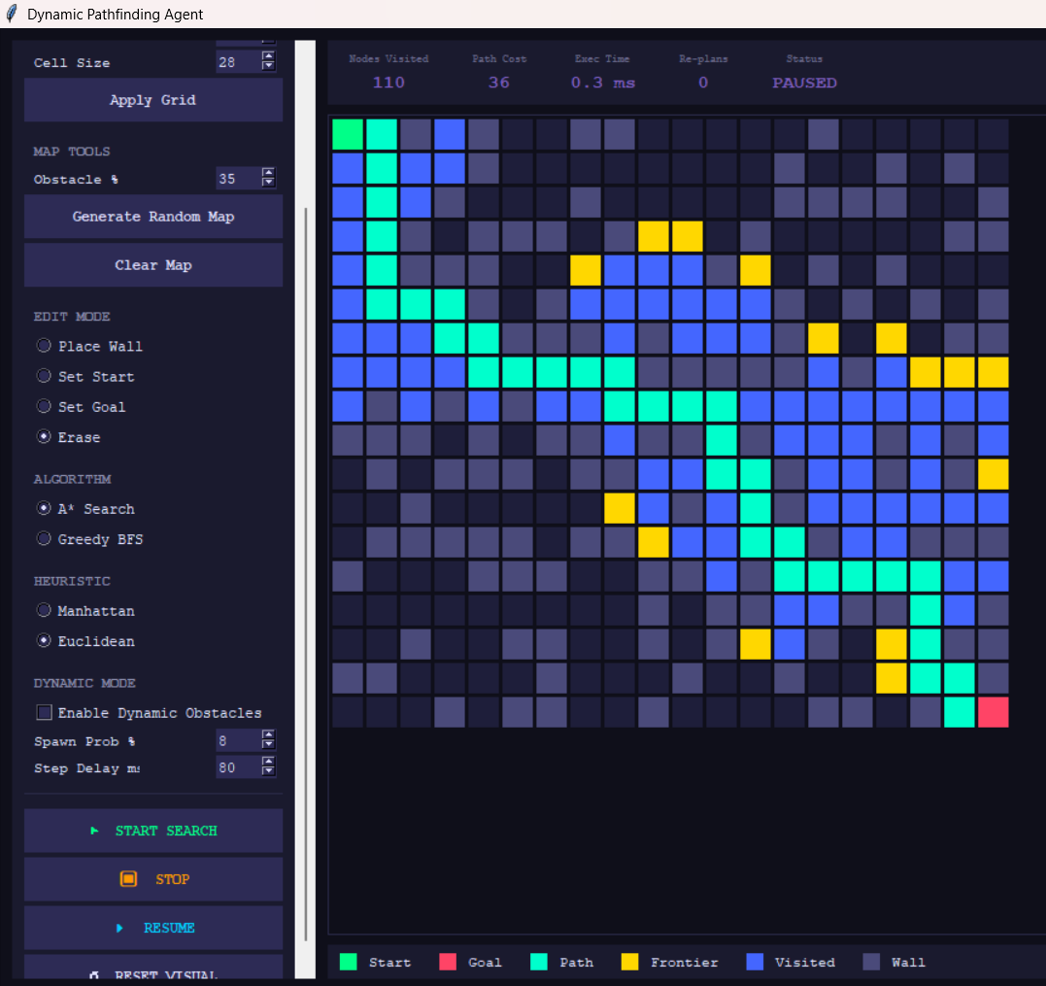
TEST CASE 5 — A* vs GBFS Comparison (SameMap)

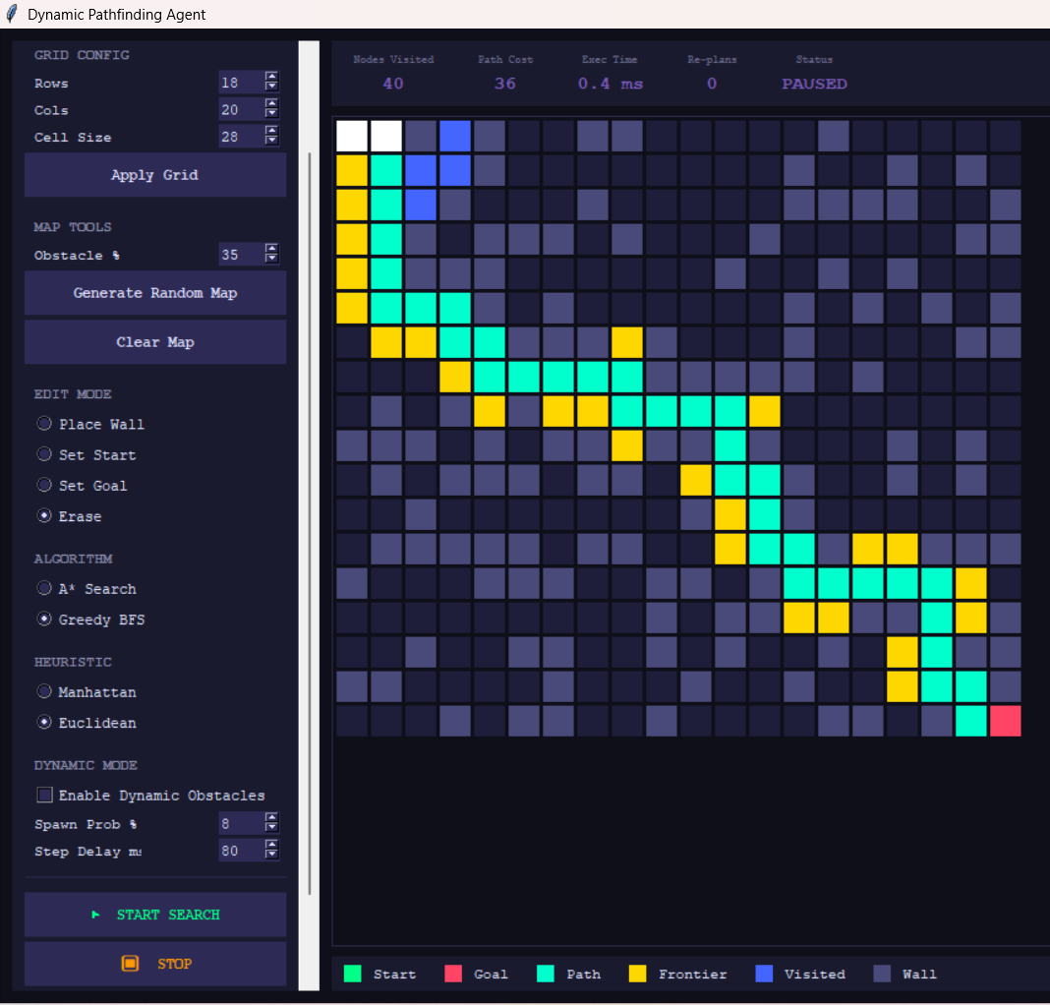

TEST CASE 6 — Dynamic Mode

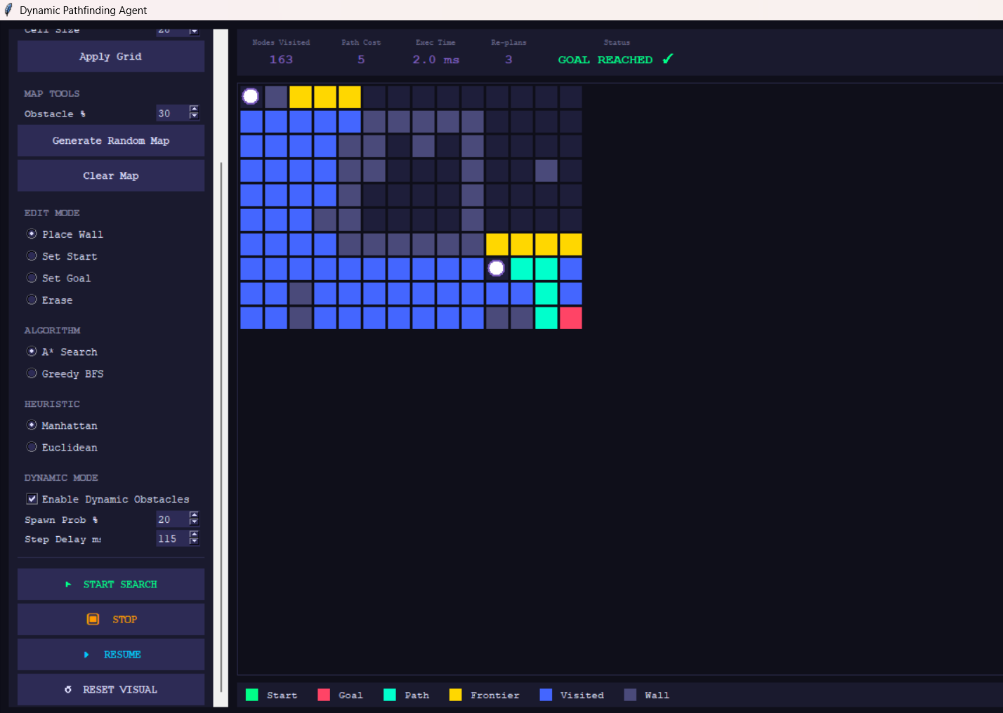
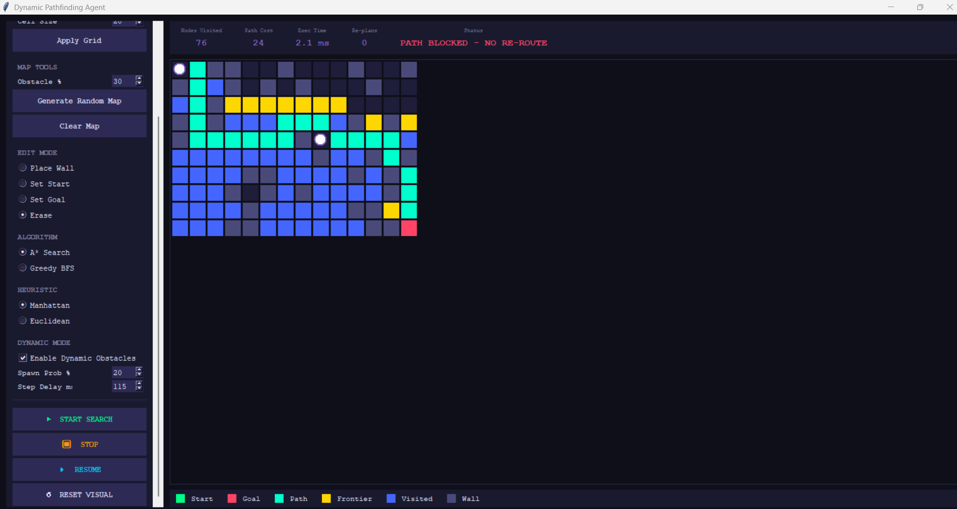TEST CASE 7 — Interactive Map Editor
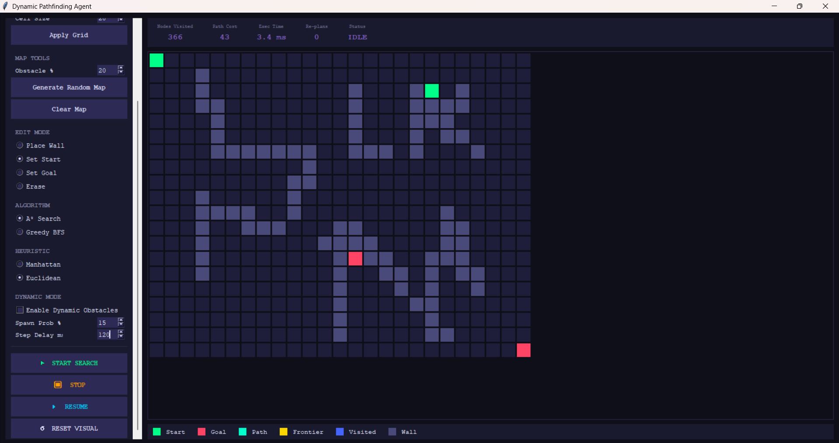
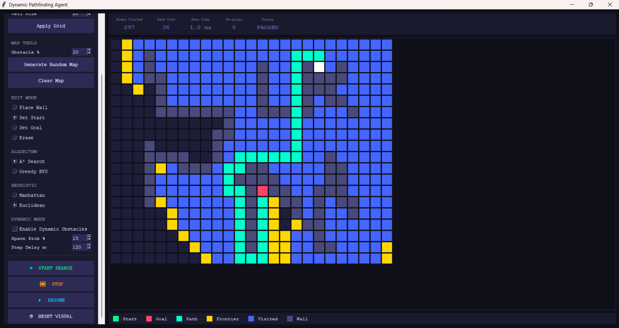

TEST CASE 8 — No Path Scenario
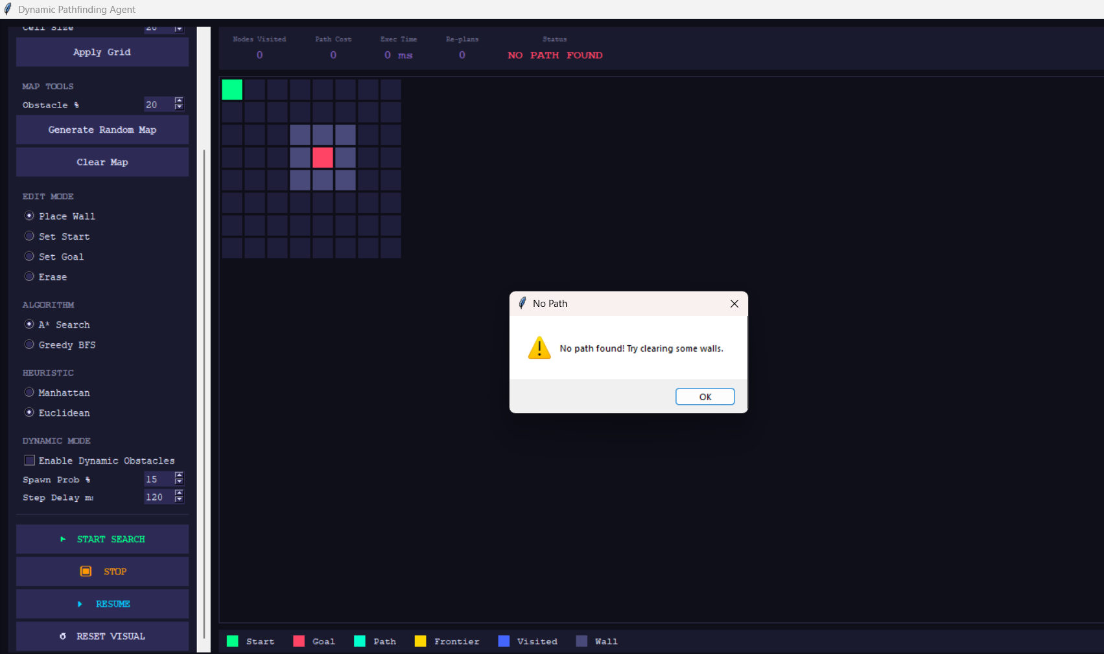

6-Test Cases Result
# | Test Case | Result
1 | A* Manhattan – Best Case (small open grid) | Few blue nodes, direct green path, low exec time ~0.9ms
2 | A* Manhattan – Worst Case (large dense maze) | Almost entire grid turns blue, high node count, path barely found
3 | GBFS Euclidean – Best Case (open grid) | Fewer nodes than A*, rushes straight to goal, very fast
4 | GBFS Euclidean – Worst Case (U-shape maze) | Gets trapped, explores wrong direction, suboptimal or longer path
5 | A* vs GBFS same map comparison | A* visits more nodes but finds shorter path; GBFS faster but suboptimal
6 | Dynamic Mode – obstacle spawning | New walls appear mid-run, "RE-PLANNING..." status shows, Re-plans count > 0
7 | Interactive Map Editor | Start/Goal move correctly, walls place/erase on click/drag
8 | No Path (goal surrounded by walls) | Popup appears: "No path found!", status shows "NO PATH FOUND"

