Министерство образования и науки РФ

Федеральное государственное бюджетное образовательное учреждение

высшего образования «Московский политехнический университет»

**факультет информационных технологий**

**Кафедра СМАРТ-технологий**

Дисциплина: Технологии визуализации данных систем управления

Отчёт по лабораторной работе №1

«Использование графических возможностей C# для визуализации данных стохастических процессов»

Работу выполнена:

<ФИО>

Научный руководитель

_______________________

<ФИО>

**Цель работы**

Разработать приложение по генерации стохастических данных с заданным профилем распределения и визуализации распределения случайных величин.**Задачи**

* Подготовить приложение на языке C# для статистической обработки и визуализации собранных наборов данных
* Реализовать функции анализа данных

**Ход работы**

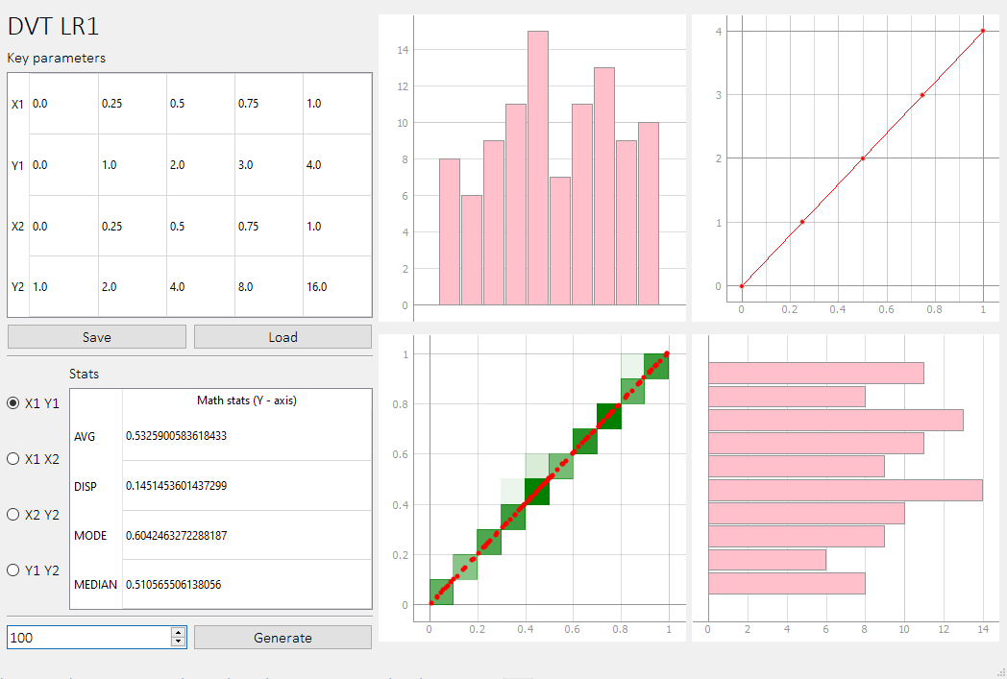

Параметры профиля преобразования (Key parameters) задаются пользователем с помощью таблицы и сохраняются в .json файл по нажатию кнопки Save. Имеется и возможность загрузки их из .json файла (по нажатию кнопки Load)  


Для начала работы необходимо загрузить профиль преобразования, выбрать количество элементов и нажать Generate. Будут сгенерированы случайные числа (массивы X1 и X2) в диапазоне от 0 до 1 в указанном количестве. Из этих массивов с помощью профиля преобразования генерируются массивы Y1 и Y2 соответственно.

После генерации происходит отрисовка всех данных, включая отображение облака точек, «блоков» точек, гистограмм плотности по двум осям, а также, диаграммы профиля преобразования.

Между осями можно переключатся.

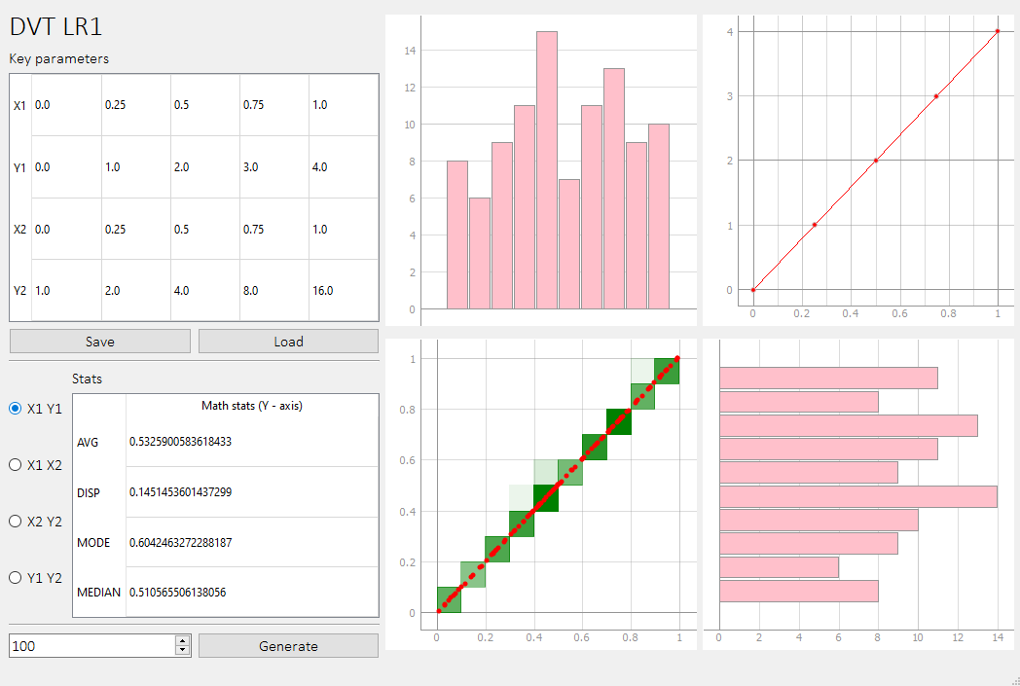 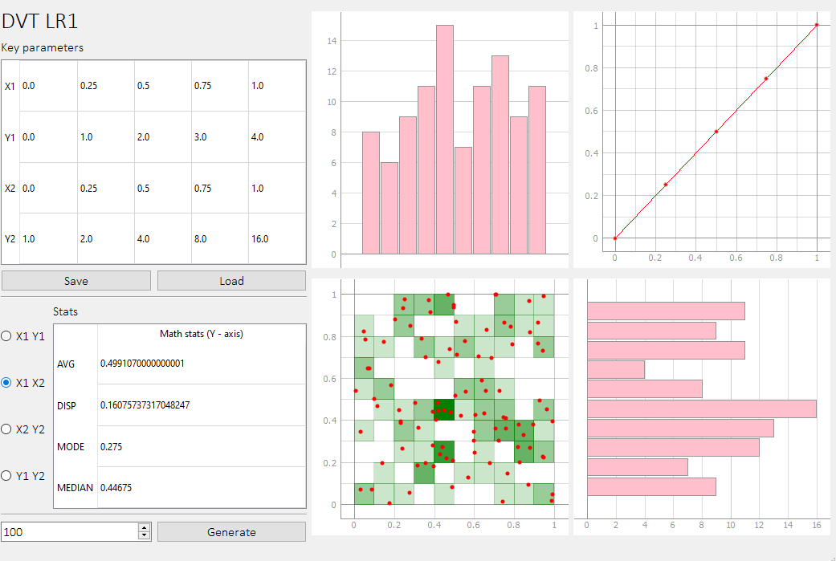 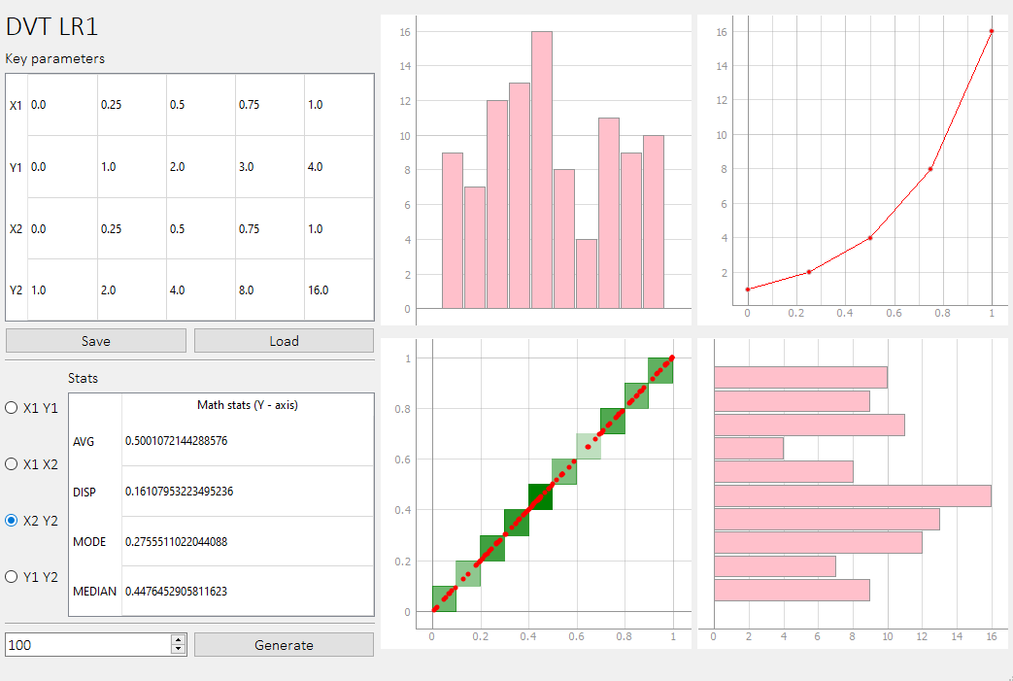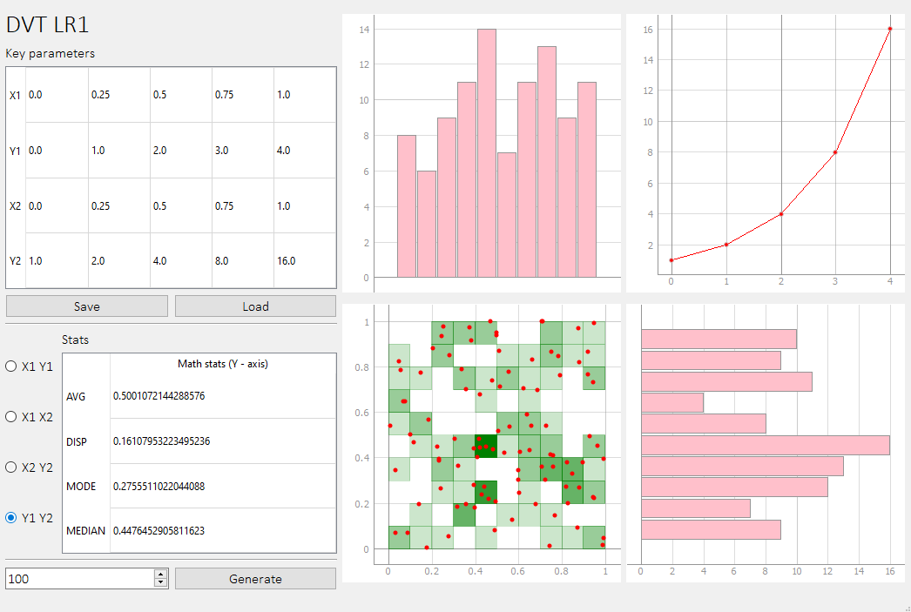

**Вывод**

В ходе данной работы было создано приложение по генерации стохастических данных с заданным профилем распределения и визуализации распределения случайных величин

**Исходный код**

*"""  
 Licensed under the Unlicense License;  
 you may not use this file except in compliance with the License.  
 You may obtain a copy of the License at  
  
 https://unlicense.org  
  
 Unless required by applicable law or agreed to in writing, software  
 distributed under the License is distributed on an "AS IS" BASIS,  
 WITHOUT WARRANTIES OR CONDITIONS OF ANY KIND, either express or implied.  
 See the License for the specific language governing permissions and  
 limitations under the License.  
"""*

import json  
import statistics  
import sys  
  
import numpy as np  
import pyqtgraph as pg  
from PyQt5 import uic, QtGui, QtWidgets, QtCore  
from PyQt5.QtCore import Qt  
from PyQt5.QtWidgets import QApplication, QMainWindow, QTableWidgetItem  
  
PROJECT_FOLDER = **'LR1_data'**def valmap(value, istart, istop, ostart, ostop):  
 return ostart + (ostop - ostart) * ((value - istart) / (istop - istart))  
  
  
class Window(QMainWindow):  
 def __init__(self):  
 super(Window, self).__init__()  
  
 *# Variables* self.keys = []  
 self.data_x = []  
 self.data_y = []  
 self.blocks = []  
 self.max_block_value = 0  
 self.bars_x = []  
 self.bars_y = []  
  
 *# Load GUI file* self.gui = uic.loadUi(**'LR1.ui'**)  
 self.gui.show()  
  
 *# Connect GUI controls* self.gui.pushButton.clicked.connect(self.save_keys)  
 self.gui.pushButton_2.clicked.connect(self.load_keys)  
 self.gui.pushButton_3.clicked.connect(self.generate)  
 self.gui.radioButton.clicked.connect(self.update_view)  
 self.gui.radioButton_2.clicked.connect(self.update_view)  
 self.gui.radioButton_3.clicked.connect(self.update_view)  
 self.gui.radioButton_4.clicked.connect(self.update_view)  
  
 *# Initialize charts and tables* self.init_charts()  
 self.init_tables()  
  
 **"""  
 Initializes charts  
 """** def init_charts(self):  
 self.gui.graphWidget.setBackground(QtGui.QColor(**'white'**))  
 self.gui.graphWidget_2.setBackground(QtGui.QColor(**'white'**))  
 self.gui.graphWidget_3.setBackground(QtGui.QColor(**'white'**))  
 self.gui.graphWidget_4.setBackground(QtGui.QColor(**'white'**))  
 *# self.gui.graphWidget.getAxis('left').setPen(QtGui.QColor('black'))  
 # self.gui.graphWidget.getAxis('left').setTextPen(QtGui.QColor('black'))  
 # self.gui.graphWidget.getAxis('bottom').setPen(QtGui.QColor('black'))  
 # self.gui.graphWidget.getAxis('bottom').setTextPen(QtGui.QColor('black'))* self.gui.graphWidget_2.getPlotItem().hideAxis(**'left'**)  
 self.gui.graphWidget_3.getPlotItem().hideAxis(**'bottom'**)  
 self.gui.graphWidget.showGrid(x=True, y=True, alpha=1.0)  
 self.gui.graphWidget_2.showGrid(x=True, y=True, alpha=1.0)  
 self.gui.graphWidget_3.showGrid(x=True, y=True, alpha=1.0)  
 self.gui.graphWidget_4.showGrid(x=True, y=True, alpha=1.0)  
  
 **"""  
 Initializes tables  
 """** def init_tables(self):  
 *# Key parameters table* self.gui.tableWidget.setColumnCount(5)  
 self.gui.tableWidget.setRowCount(4)  
 self.gui.tableWidget.horizontalHeader().setVisible(False)  
 self.gui.tableWidget.setCornerButtonEnabled(False)  
 self.gui.tableWidget.setSelectionMode(QtWidgets.QAbstractItemView.NoSelection)  
 self.gui.tableWidget.setFocusPolicy(Qt.NoFocus)  
  
 header = self.gui.tableWidget.horizontalHeader()  
 header.setSectionResizeMode(0, QtWidgets.QHeaderView.Stretch)  
 for i in range(self.gui.tableWidget.columnCount()):  
 header.setSectionResizeMode(i, QtWidgets.QHeaderView.Stretch)  
  
 header = self.gui.tableWidget.verticalHeader()  
 header.setSectionResizeMode(0, QtWidgets.QHeaderView.Stretch)  
 for i in range(self.gui.tableWidget.rowCount()):  
 header.setSectionResizeMode(i, QtWidgets.QHeaderView.Stretch)  
  
 self.gui.tableWidget.setVerticalHeaderLabels([**'X1'**, **'Y1'**, **'X2'**, **'Y2'**])  
  
 *# Stats table* self.gui.tableWidget_2.setColumnCount(1)  
 self.gui.tableWidget_2.setRowCount(4)  
 self.gui.tableWidget_2.setCornerButtonEnabled(False)  
 self.gui.tableWidget_2.setSelectionMode(QtWidgets.QAbstractItemView.NoSelection)  
 self.gui.tableWidget_2.setFocusPolicy(Qt.NoFocus)  
 self.gui.tableWidget_2.setEditTriggers(QtWidgets.QAbstractItemView.NoEditTriggers)  
  
 header = self.gui.tableWidget_2.horizontalHeader()  
 header.setSectionResizeMode(0, QtWidgets.QHeaderView.Stretch)  
 for i in range(self.gui.tableWidget_2.columnCount()):  
 header.setSectionResizeMode(i, QtWidgets.QHeaderView.Stretch)  
  
 header = self.gui.tableWidget_2.verticalHeader()  
 header.setSectionResizeMode(0, QtWidgets.QHeaderView.Stretch)  
 for i in range(self.gui.tableWidget_2.rowCount()):  
 header.setSectionResizeMode(i, QtWidgets.QHeaderView.Stretch)  
  
 self.gui.tableWidget_2.setVerticalHeaderLabels([**'AVG'**, **'DISP'**, **'MODE'**, **'MEDIAN'**])  
 self.gui.tableWidget_2.setHorizontalHeaderLabels([**'Math stats (Y - axis)'**])  
  
 **"""  
 Generates random X numbers and calcultaes Y values  
 """** def generate(self):  
 *# Check if keys are loaded* assert len(self.keys) > 0  
  
 self.data_x = [[round(num, 4) for num in np.random.sample(self.gui.spinBox.value())],  
 [round(num, 4) for num in np.random.sample(self.gui.spinBox.value())]]  
 self.data_y = []  
  
 for i in range(2):  
 array_y = []  
 for data_x in self.data_x[i]:  
 *# Calculate Y* if self.keys[0][0] <= data_x <= self.keys[0][1]:  
 *# if X >= keys_X1[0] && X <= keys_X1[1]  
 # Y = keys_Y1[1] / keys_X1[1] * X* array_y.append(self.keys[1][1] / self.keys[0][1] * data_x)  
 if self.keys[0][1] < data_x <= self.keys[0][2]:  
 *# if X > keys_X1[1] && X <= keys_X1[2]  
 # Y = keys_Y1[2] / keys_X1[2] * X* array_y.append(self.keys[1][2] / self.keys[0][2] * data_x)  
 if self.keys[0][2] < data_x <= self.keys[0][3]:  
 *# if X > keys_X1[2] && X <= keys_X1[3]  
 # Y = keys_Y1[3] / keys_X1[3] * X* array_y.append(self.keys[1][3] / self.keys[0][3] * data_x)  
 if self.keys[0][3] < data_x <= self.keys[0][4]:  
 *# if X > keys_X1[3] && X <= keys_X1[4]  
 # Y = keys_Y1[4] / keys_X1[4] * X* array_y.append(self.keys[1][4] / self.keys[0][4] * data_x)  
  
 *# Normalize data* array_y /= max(array_y)  
  
 self.data_y.append(array_y)  
  
 self.update_view()  
  
 **"""  
 Draws keys chart, main chart and bar charts  
 """** def update_view(self):  
 *# Keys chart* if self.gui.radioButton.isChecked():  
 *# X1 Y1* keys_x = self.keys[0]  
 keys_y = self.keys[1]  
 data_x = self.data_x[0]  
 data_y = self.data_y[0]  
 elif self.gui.radioButton_2.isChecked():  
 *# X1 X2* keys_x = self.keys[0]  
 keys_y = self.keys[2]  
 data_x = self.data_x[0]  
 data_y = self.data_x[1]  
 elif self.gui.radioButton_3.isChecked():  
 *# X2 Y2* keys_x = self.keys[2]  
 keys_y = self.keys[3]  
 data_x = self.data_x[1]  
 data_y = self.data_y[1]  
 else:  
 *# X1 Y2* keys_x = self.keys[1]  
 keys_y = self.keys[3]  
 data_x = self.data_x[0]  
 data_y = self.data_y[1]  
  
 self.gui.graphWidget_4.clear()  
 self.gui.graphWidget_4.plot(keys_x, keys_y, pen=pg.mkPen(QtGui.QColor(**'red'**)),  
 symbolBrush=(255, 0, 0),  
 symbolSize=5)  
  
 *# Count how many points in each block* self.count_blocks(data_x, data_y)  
  
 *# Draw blocks (background)* self.gui.graphWidget.clear()  
 for x in range(10):  
 for y in range(10):  
 self.gui.graphWidget.addItem(  
 RectItem(QtCore.QRectF(x / 10, y / 10, 0.1, 0.1),  
 alpha=valmap(self.blocks[x][y], 0, self.max_block_value, 0, 1)))  
  
 *# Draw main chart* self.gui.graphWidget.plot(data_x, data_y, pen=None,  
 symbolBrush=(255, 0, 0), symbolSize=5, symbolPen=None)  
  
 *# Bar charts* bar_x = list(range(10))  
 self.gui.graphWidget_2.clear()  
 self.gui.graphWidget_3.clear()  
 bar_top = pg.BarGraphItem(x=bar_x, height=self.bars_x, width=0.9, brush=QtGui.QColor(**'pink'**))  
 bar_right = pg.BarGraphItem(x=bar_x, height=self.bars_y, width=0.9, brush=QtGui.QColor(**'pink'**))  
 bar_right.rotate(-90)  
 self.gui.graphWidget_3.addItem(bar_top)  
 self.gui.graphWidget_2.addItem(bar_right)  
  
 *# Math stats* self.count_stats(data_y)  
  
 **"""  
 Counts how many points in each block  
 """** def count_blocks(self, data_x, data_y):  
 self.max_block_value = 0  
 self.blocks = []  
 self.bars_x = [0] * 10  
 self.bars_y = [0] * 10  
 for x in range(10):  
 blocks_column = []  
 for y in range(10):  
 points_in_block = 0  
 for i in range(len(data_x)):  
 if x / 10 <= data_x[i] < (x / 10 + 0.1) \  
 and y / 10 <= data_y[i] < (y / 10 + 0.1):  
 points_in_block += 1  
 if points_in_block > self.max_block_value:  
 self.max_block_value = points_in_block  
  
 self.bars_x[x] += points_in_block  
 self.bars_y[y] += points_in_block  
  
 blocks_column.append(points_in_block)  
  
 self.blocks.append(blocks_column)  
 self.bars_y.reverse()  
  
 **"""  
 Calculates math stats (average, dispertion, mode, median)  
 """** *# noinspection PyBroadException* def count_stats(self, data_y):  
 *# Average* average = sum(data_y) / len(data_y)  
  
 *# Dispertion* disp_sum = 0  
 for point in data_y:  
 disp_sum += (point - average) * (point - average)  
 dispertion = disp_sum / sum(data_y)  
  
 *# Median* try:  
 mode = statistics.mode(data_y)  
 except:  
 mode = None  
  
 *# Median* median = statistics.median(data_y)  
  
 *# Fill table* self.gui.tableWidget_2.setItem(0, 0, QTableWidgetItem(str(average)))  
 self.gui.tableWidget_2.setItem(0, 1, QTableWidgetItem(str(dispertion)))  
 if mode is not None:  
 self.gui.tableWidget_2.setItem(0, 2, QTableWidgetItem(str(mode)))  
 else:  
 self.gui.tableWidget_2.setItem(0, 2, QTableWidgetItem(**'No Mode'**))  
 self.gui.tableWidget_2.setItem(0, 3, QTableWidgetItem(str(median)))  
  
 **"""  
 Saves keys to JSON file  
 """** def save_keys(self):  
 self.keys = []  
 for i in range(self.gui.tableWidget.rowCount()):  
 keys_row = []  
 for k in range(self.gui.tableWidget.columnCount()):  
 keys_row.append(float(self.gui.tableWidget.item(i, k).text()))  
 self.keys.append(keys_row)  
  
 with open(PROJECT_FOLDER + **'/keys.json'**, **'w'**) as f:  
 json.dump(self.keys, f)  
  
 **"""  
 Loads keys from JSON file  
 """** def load_keys(self):  
 self.keys = np.array(json.load(open(PROJECT_FOLDER + **'/keys.json'**)))  
  
 for i in range(self.gui.tableWidget.rowCount()):  
 for k in range(self.gui.tableWidget.columnCount()):  
 self.gui.tableWidget.setItem(i, k, QTableWidgetItem(str(self.keys[i][k])))  
  
  
**"""  
This class draws rectangles on the chart  
"""**class RectItem(pg.GraphicsObject):  
 def __init__(self, rect, alpha=1.0, parent=None):  
 super().__init__(parent)  
 self._rect = rect  
 self._alpha = alpha  
 self.picture = QtGui.QPicture()  
 self._generate_picture()  
  
 @property  
 def rect(self):  
 return self._rect  
  
 @property  
 def alpha(self):  
 return self._alpha  
  
 def _generate_picture(self):  
 painter = QtGui.QPainter(self.picture)  
 color = QtGui.QColor(**'green'**)  
 color.setAlphaF(self.alpha)  
 painter.setPen(pg.mkPen(color))  
 painter.setBrush(pg.mkBrush(color))  
 painter.drawRect(self.rect)  
 painter.end()  
  
 def paint(self, painter, option, widget=None):  
 painter.drawPicture(0, 0, self.picture)  
  
 def boundingRect(self):  
 return QtCore.QRectF(self.picture.boundingRect())  
  
  
if __name__ == **'__main__'**:  
 app = QApplication(sys.argv)  
 win = Window()  
 sys.exit(app.exec_())

<!--

Licensed under the Unlicense License;

you may not use this file except in compliance with the License.

You may obtain a copy of the License at

https://unlicense.org

Unless required by applicable law or agreed to in writing, software

distributed under the License is distributed on an "AS IS" BASIS,

WITHOUT WARRANTIES OR CONDITIONS OF ANY KIND, either express or implied.

See the License for the specific language governing permissions and

limitations under the License.

-->

<?xml version="1.0" encoding="UTF-8"?>

<ui version="4.0">

<class>MainWindow</class>

<widget class="QMainWindow" name="MainWindow">

<property name="geometry">

<rect>

<x>0</x>

<y>0</y>

<width>1051</width>

<height>707</height>

</rect>

</property>

<property name="font">

<font>

<family>Calibri Light</family>

<pointsize>12</pointsize>

</font>

</property>

<property name="windowTitle">

<string>DVT LR1</string>

</property>

<widget class="QWidget" name="centralwidget">

<layout class="QGridLayout" name="gridLayout_2">

<item row="1" column="0">

<layout class="QVBoxLayout" name="verticalLayout_3">

<item>

<widget class="QLabel" name="label">

<property name="font">

<font>

<pointsize>22</pointsize>

</font>

</property>

<property name="text">

<string>DVT LR1</string>

</property>

</widget>

</item>

<item>

<widget class="QLabel" name="label_2">

<property name="text">

<string>Key parameters</string>

</property>

</widget>

</item>

<item>

<widget class="QTableWidget" name="tableWidget"/>

</item>

<item>

<layout class="QHBoxLayout" name="horizontalLayout_2">

<item>

<widget class="QPushButton" name="pushButton">

<property name="text">

<string>Save</string>

</property>

</widget>

</item>

<item>

<widget class="QPushButton" name="pushButton_2">

<property name="text">

<string>Load</string>

</property>

</widget>

</item>

</layout>

</item>

<item>

<widget class="Line" name="line">

<property name="orientation">

<enum>Qt::Horizontal</enum>

</property>

</widget>

</item>

<item>

<layout class="QHBoxLayout" name="horizontalLayout_3">

<item>

<layout class="QVBoxLayout" name="verticalLayout_2">

<item>

<widget class="QRadioButton" name="radioButton">

<property name="text">

<string>X1 Y1</string>

</property>

<property name="checked">

<bool>true</bool>

</property>

</widget>

</item>

<item>

<widget class="QRadioButton" name="radioButton_2">

<property name="text">

<string>X1 X2</string>

</property>

</widget>

</item>

<item>

<widget class="QRadioButton" name="radioButton_3">

<property name="text">

<string>X2 Y2</string>

</property>

</widget>

</item>

<item>

<widget class="QRadioButton" name="radioButton_4">

<property name="text">

<string>Y1 Y2</string>

</property>

</widget>

</item>

</layout>

</item>

<item>

<layout class="QVBoxLayout" name="verticalLayout">

<item>

<widget class="QLabel" name="label_3">

<property name="text">

<string>Stats</string>

</property>

</widget>

</item>

<item>

<widget class="QTableWidget" name="tableWidget_2"/>

</item>

</layout>

</item>

</layout>

</item>

<item>

<widget class="Line" name="line_2">

<property name="orientation">

<enum>Qt::Horizontal</enum>

</property>

</widget>

</item>

<item>

<layout class="QHBoxLayout" name="horizontalLayout">

<item>

<widget class="QSpinBox" name="spinBox">

<property name="minimum">

<number>1</number>

</property>

<property name="maximum">

<number>99999</number>

</property>

<property name="value">

<number>20</number>

</property>

</widget>

</item>

<item>

<widget class="QPushButton" name="pushButton_3">

<property name="text">

<string>Generate</string>

</property>

</widget>

</item>

</layout>

</item>

</layout>

</item>

<item row="1" column="1">

<layout class="QGridLayout" name="gridLayout" rowstretch="0,0" rowminimumheight="0,0" columnminimumwidth="0,0">

<property name="sizeConstraint">

<enum>QLayout::SetDefaultConstraint</enum>

</property>

<item row="0" column="1">

<widget class="PlotWidget" name="graphWidget_4" native="true">

<property name="enabled">

<bool>true</bool>

</property>

<property name="minimumSize">

<size>

<width>320</width>

<height>320</height>

</size>

</property>

<property name="maximumSize">

<size>

<width>320</width>

<height>320</height>

</size>

</property>

</widget>

</item>

<item row="1" column="0">

<widget class="PlotWidget" name="graphWidget" native="true">

<property name="minimumSize">

<size>

<width>320</width>

<height>320</height>

</size>

</property>

<property name="maximumSize">

<size>

<width>320</width>

<height>320</height>

</size>

</property>

</widget>

</item>

<item row="1" column="1">

<widget class="PlotWidget" name="graphWidget_2" native="true">

<property name="minimumSize">

<size>

<width>320</width>

<height>320</height>

</size>

</property>

<property name="maximumSize">

<size>

<width>320</width>

<height>320</height>

</size>

</property>

</widget>

</item>

<item row="0" column="0">

<widget class="PlotWidget" name="graphWidget_3" native="true">

<property name="minimumSize">

<size>

<width>320</width>

<height>320</height>

</size>

</property>

<property name="maximumSize">

<size>

<width>320</width>

<height>320</height>

</size>

</property>

<property name="sizeIncrement">

<size>

<width>0</width>

<height>0</height>

</size>

</property>

</widget>

</item>

</layout>

</item>

</layout>

</widget>

<widget class="QMenuBar" name="menubar">

<property name="geometry">

<rect>

<x>0</x>

<y>0</y>

<width>1051</width>

<height>21</height>

</rect>

</property>

</widget>

<widget class="QStatusBar" name="statusbar"/>

</widget>

<customwidgets>

<customwidget>

<class>PlotWidget</class>

<extends>QWidget</extends>

<header>pyqtgraph</header>

<container>1</container>

</customwidget>

</customwidgets>

<resources/>

<connections/>

</ui>