Министерство образования и науки РФ

Федеральное государственное бюджетное образовательное учреждение

высшего образования «Московский политехнический университет»

**факультет информационных технологий**

**Кафедра СМАРТ-технологий**

Дисциплина: Нейронные сети в задачах технического зрения и управления

Отчёт по лабораторной работе №3

«Применение свёрточных нейронных сетей»

Работу выполнил_и

студент_ка 3 курса

очного отделения

<ФИО>

Научный руководитель

_______________________

<ФИО>

**Цель работы**

Разработать алгоритм классификации стандартизованных изображений с помощью свёрточной нейронной сети.

**Задачи**

* Подготовить приложение для генерации обучающей выборки из исходного набора изображений;
* Разработать функцию расчета свёрточной карты для выбранного ядра;
* Разработать класс, реализующий функциональность свёрточной сети для классификации изображений;
* Разработать функцию обучения с учителем для нейтронной сети по подготовленной ранее обучающей выборке.

**Ход работы**

В начале было разработано приложение, генерирующее набор изображений, размером 20x20 пикселей для обучения и проверки работы нейросети из любого цветного или ч/б изображения.

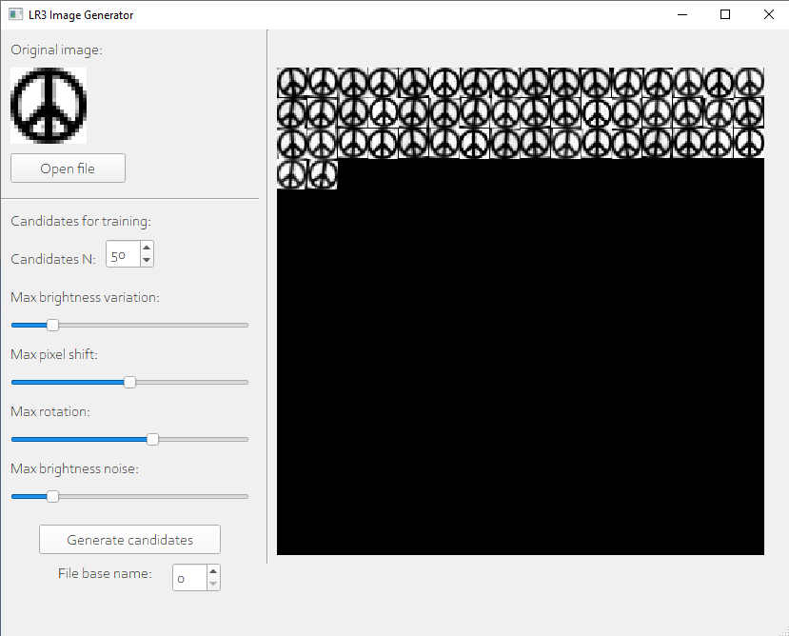

В изображения подмешивается яркостный шум, поворот, сдвиг пикселей, изменение яркости. Имеется возможность настройки каждого параметра. Полученные изображения сохраняются в отдельные файлы.

Основное приложение использует данные изображения для обучения и проверки работы нейросети.

Полученные изображения преобразуются в одномерный массив 0-1 и сопоставляясь с «метками»:

-------------------- INPUT DATA --------------------

Shape of loaded_imagess: (4, 50, 20, 20)

Shape of loaded_labels: (4, 50, 1)

Arrays:

[[[[0.37254902 0.22745098 0.1372549 ... 0.07058824 0.2627451

...

[1. 1. 1. ... 1. 1.

1. ]]

...

[[0.03921569 0.07058824 0.04313725 ... 0.55686275 0.61176471

1. ]

...

[0.61568627 0.55686275 0.49411765 ... 0.03921569 0.60784314

1. ]]]]

[[[0]

[0]

...

[3]

[3]]]

----------------------------------------------------

Далее выполняется генерация ядер свёртки (5x5) и (2x2) случайным образом. Диапазон значений {0; 1}. Также имеется возможность сохранить или загрузить ядра из файла.

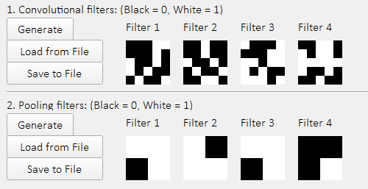

Первые фильтры применяются со страйдом 1, вторые – со страйдом 2. В итоге, на выходе получается изображение 8x8 пикселей. После операции свёртки производится нормализация полученных изображений. Имеется возможность предпросмотра операций свёртки и пуллинга. А также, загрузка и сохранение результатов в файл.

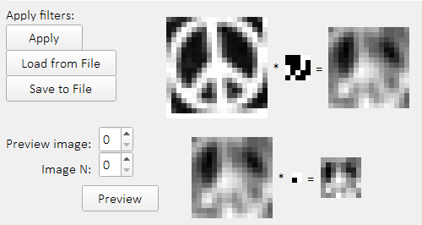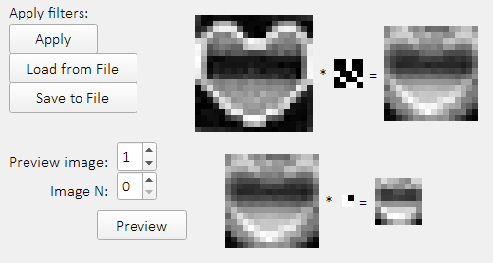

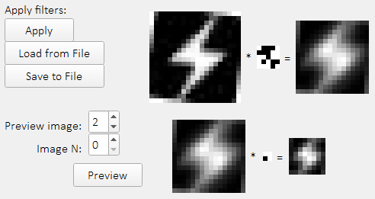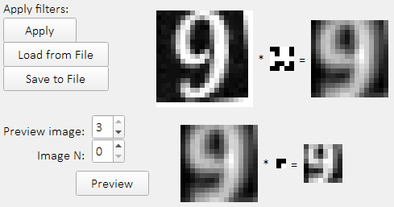

После свёртки, изображение преобразуется в одномерный массив с диапазоном [0; 1] и подаётся на вход MLP-сети, структура которой выглядит следующим образом:

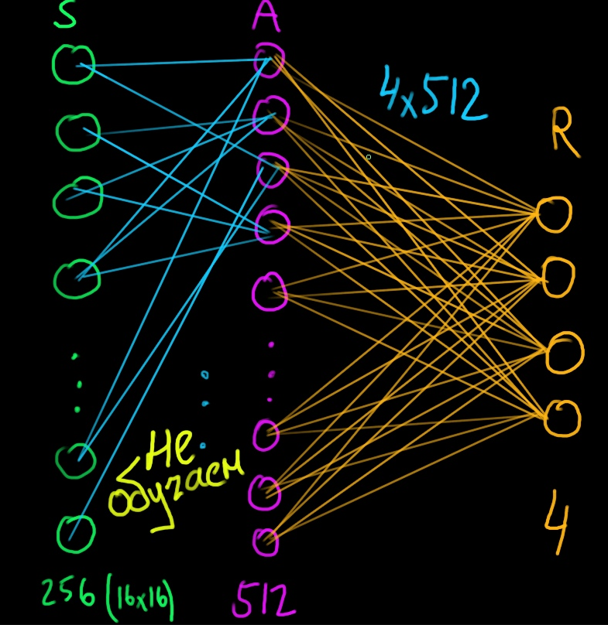

Обучение производиться только оранжевых весов и выглядит следующим образом:

* За первый слой принимается массив входных данных (изображения)
* Далее, вычисляется скалярное произведение первого слоя на первые веса (значения которых {-1; 0; 1}). Результат проходит через функцию активации:

def layer_0_activator(weights_sum):result = [[0] * weights_sum[0]] * weights_sum  
 for i in range(len(weights_sum)):  
 sample_result = [0] * weights_sum[0]  
 for k in range(len(weights_sum[i])):  
  
 threshold = 1.8 if weights_sum[i][k] >= threshold:  
 sample_result[k] = weights_sum[i][k] - 2.2else:  
 sample_result[k] = 0  
  
 result[i] = sample_result  
 result = np.array(result)return np.array(result)

* Результат считается вторым слоем. Далее производится скалярное произведение этого [второго] слоя на вторые веса (значения которых [0; 1]). Результат пропускается через сигмоидную функцию активации:

def sigmoid(x):  
 return 1 / (1 + np.exp(-x))

* В итоге, последний (третий) слой содержит 4 элемента.
* Вычисляется ошибка (тот выход, который должен соответствовать метке принимается за 1, остальные три – за 0.).
* На основе ошибки вычисляются корректирующие значения для весов

adjustments_l2 = output_l1.T.dot(error_l2 * (output_l2 * (1 - output_l2)))

* Эти корректировки прибавляются к весам второго слоя.

В среднем, необходимо 2 итерации чтобы достичь точности в 80-90% и 30-40 итераций, чтобы достичь точности в 95-100%

-------------------- I: 0 --------------------

accuracy: 0.145

-------------------- I: 1 --------------------

accuracy: 0.85

-------------------- I: 2 --------------------

accuracy: 0.925

-------------------- I: 3 --------------------

accuracy: 0.935

...

-------------------- I: 29 --------------------

accuracy: 0.98

-------------------- I: 30 --------------------

accuracy: 0.98

Обученные веса можно сохранить в файл для дальнейшего использования.

Результат предсказания отображается в виде выходов последнего слоя. А также имеется графический предпросмотр работы MLP в виде слоёв и весов.

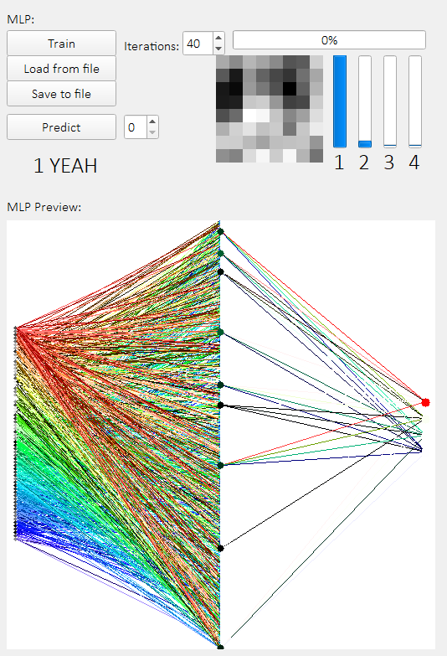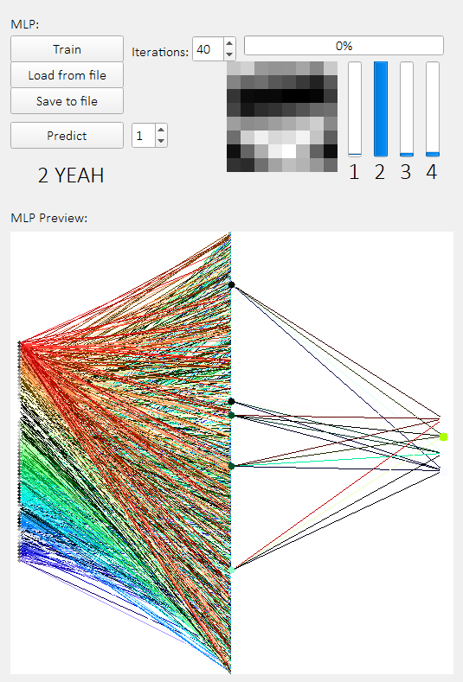

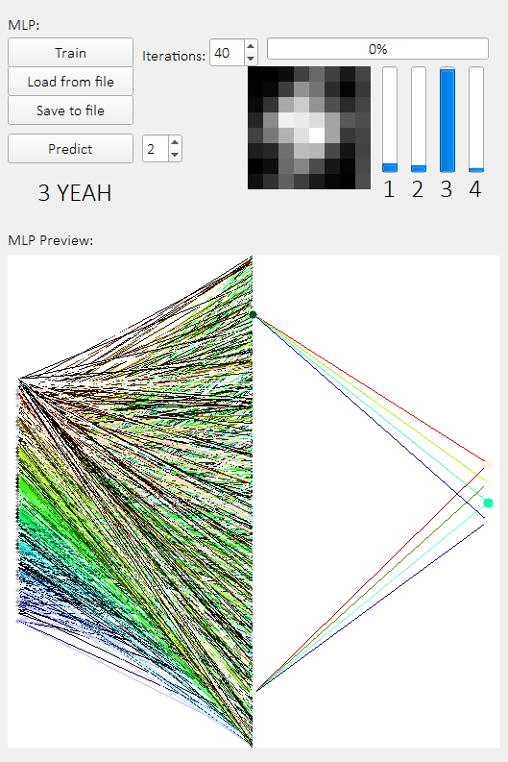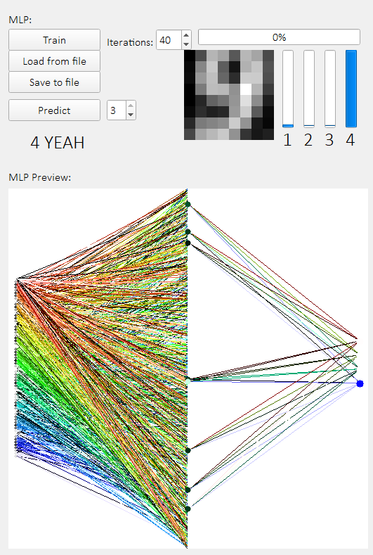

**Вывод**

В ходе данной работы была создана свёрточная нейросеть, в начале выполняющая операции свёртка и пуллинга, а также, дальнейшую классификацию с высокой точностью.

**Исходный код генератора изображений**

import os  
import numpy as np  
import cv2  
import sys  
from PyQt5 import QtWidgets  
from PyQt5.QtGui import QPixmap  
import qimage2ndarray  
import random  
from tkinter import filedialog  
import tkinter  
  
root = tkinter.Tk()  
root.withdraw()  
  
import gui_3_Collector  
  
  
def valmap(value, istart, istop, ostart, ostop):  
 return ostart + (ostop - ostart) * ((value - istart) / (istop - istart))  
  
  
class CollectorApp(QtWidgets.QMainWindow, gui_3_Collector.Ui_MainWindow):  
 def __init__(self):  
 super().__init__()  
 self.setupUi(self)  
 self.btn_open_file.clicked.connect(self.open_file)  
 self.btn_candidates_generate.clicked.connect(self.generate_candidates)  
  
 *# self.cvl_original.setStyleSheet("background-color: lightgreen")  
 # self.cvl_candidates.setStyleSheet("background-color: lightgreen")* self.original_image = None  
 self.candidates_image = None  
  
 def open_file(self):  
 file_path = filedialog.askopenfilename()  
 temp_image = cv2.cvtColor(cv2.imread(file_path), cv2.COLOR_BGR2GRAY)  
 self.original_image = cv2.resize(temp_image, (20, 20), interpolation=cv2.INTER_NEAREST)  
 self.cvl_original.setPixmap(QPixmap.fromImage(qimage2ndarray.array2qimage(  
 cv2.cvtColor(cv2.resize(self.original_image, (80, 80), interpolation=cv2.INTER_NEAREST),  
 cv2.COLOR_GRAY2RGB))))  
  
 print(file_path)  
  
 def generate_candidates(self):  
 self.candidates_image = np.zeros(shape=[320, 320], dtype=np.uint8) *# [16 X 16] images or [16*20 X 16*20] pixels* generated_images = []  
  
 *# Generation of modified images* for n in range(self.spin_cindidates_n.value()):  
 temp_image = self.original_image.copy().astype(**'float32'**)  
  
 *# Brightness noise* if self.slider_brightness.value():  
 temp_image += random.randrange(-self.slider_brightness.value(), self.slider_brightness.value())  
  
 temp_image = np.clip(temp_image, 0, 255)  
 temp_image = temp_image.astype(**'uint8'**)  
  
 *# Pixel noise* if self.slider_noise.value():  
 for i in range(20):  
 for j in range(20):  
 if random.randrange(0, 2) and temp_image[i][j] > 0:  
 brightness_pixel = temp_image[i][j] + random.randrange(-self.slider_noise.value(),  
 self.slider_noise.value())  
 if brightness_pixel > 255: brightness_pixel = 255  
 if brightness_pixel < 0: brightness_pixel = 0  
 temp_image[i][j] = brightness_pixel  
  
 *# Rotation* if self.slider_rotation.value() > 0:  
 num_rows, num_cols = temp_image.shape[:2]  
 rotation_matrix = cv2.getRotationMatrix2D(  
 (num_cols / 2, num_rows / 2),  
 random.randrange(-self.slider_rotation.value(), self.slider_rotation.value()), 1)  
 temp_image = cv2.warpAffine(temp_image, rotation_matrix, (num_cols, num_rows))  
  
 *# Pixel shift* if self.slider_shift.value() > 0:  
 shift_size_x = random.randrange(-self.slider_shift.value(), self.slider_shift.value())  
 shift_size_y = random.randrange(-self.slider_shift.value(), self.slider_shift.value())  
 rows, cols = temp_image.shape  
 M = np.float32([[1, 0, shift_size_x], [0, 1, shift_size_y]])  
 temp_image = cv2.warpAffine(temp_image, M, (cols, rows))  
  
 generated_images.append(temp_image)  
  
 if not os.path.exists(**'LR3_data'**):  
 os.makedirs(**'LR3_data'**)  
  
 image_counter = 0  
 for y in range(16):  
 for x in range(16):  
 temp_image = generated_images[image_counter]  
  
 *# Save to file* cv2.imwrite(**'LR3_data/'** + str(self.spin_cindidates_file.value())  
 + **'_'** + str(image_counter) + **'.bmp'**, temp_image)  
  
 self.candidates_image[y * 20: y * 20 + 20, x * 20: x * 20 + 20] = temp_image *# y:y + h, x:x + w* image_counter += 1  
 if image_counter == len(generated_images):  
 break  
 if image_counter == len(generated_images):  
 break  
  
 self.cvl_candidates.setPixmap(QPixmap.fromImage(qimage2ndarray.array2qimage(  
 cv2.cvtColor(cv2.resize(self.candidates_image, (512, 512),  
 interpolation=cv2.INTER_NEAREST), cv2.COLOR_GRAY2RGB))))  
  
  
if __name__ == **'__main__'**:  
 app = QtWidgets.QApplication(sys.argv)  
 app.setStyle(**"fusion"**)  
 window = CollectorApp()  
 window.show()  
 app.exec_()

**Исходный код основной программы**

import threading  
  
import numpy as np  
import cv2  
import sys  
from PyQt5 import QtWidgets  
import random  
from PyQt5.QtGui import QPixmap  
import qimage2ndarray  
import pickle  
  
import gui_3_CNN  
  
  
def sigmoid(x):  
 return 1 / (1 + np.exp(-x))  
  
  
def dot_0_layer(input_layer, synaptic_weights):  
 return layer_0_activator(np.dot(input_layer, synaptic_weights.T))  
  
  
def valmap(value, istart, istop, ostart, ostop):  
 return ostart + (ostop - ostart) * ((value - istart) / (istop - istart))  
  
  
def layer_0_activator(weights_sum):  
 *# return max(0, weights_sum)* result = [[0] * weights_sum[0]] * weights_sum  
 for i in range(len(weights_sum)):  
 sample_result = [0] * weights_sum[0]  
 for k in range(len(weights_sum[i])):  
  
 threshold = 1.8 *# 1.79* if weights_sum[i][k] >= threshold:  
 sample_result[k] = weights_sum[i][k] - 2.2 *# 0.79* else:  
 sample_result[k] = 0  
  
 result[i] = sample_result  
 result = np.array(result)  
 *# exit(0)* return np.array(result)  
  
  
class CNNApp(QtWidgets.QMainWindow, gui_3_CNN.Ui_MainWindow):  
 def __init__(self):  
 self.DEBUG = True  
  
 super().__init__()  
 self.setupUi(self)  
 self.btn_load_images.clicked.connect(self.load_images)  
 self.btn_filter_1_generate.clicked.connect(self.filter_1_generate)  
 self.btn_filter_1_load.clicked.connect(self.filter_1_load)  
 self.btn_filter_1_save.clicked.connect(self.filter_1_save)  
 self.btn_filter_2_generate.clicked.connect(self.filter_2_generate)  
 self.btn_filter_2_load.clicked.connect(self.filter_2_load)  
 self.btn_filter_2_save.clicked.connect(self.filter_2_save)  
 self.btn_filters_load.clicked.connect(self.filters_load)  
 self.btn_filters_save.clicked.connect(self.filters_save)  
  
 self.btn_apply_filters.clicked.connect(self.apply_filters)  
 self.btn_preview_filters.clicked.connect(self.preview_filters)  
  
 self.btn_start_training.clicked.connect(self.start_training)  
 self.btn_predict.clicked.connect(self.predict_test_image)  
 self.btn_save_to_file.clicked.connect(self.save_model_to_file)  
 self.btn_load_from_file.clicked.connect(self.load_model_from_file)  
 self.test_values = False  
  
 self.synaptic_weights_0 = np.array([])  
 self.synaptic_weights_1 = np.array([])  
  
 self.loaded_images = []  
 self.loaded_labels = []  
 self.cnn_filters_1 = []  
 self.cnn_convoluted_1 = []  
 self.cnn_filters_2 = []  
 self.cnn_convoluted_2 = []  
  
 def load_images(self):  
 self.loaded_images = []  
 self.loaded_labels = []  
  
 for i in range(4):  
 loaded_images_temp = []  
 loaded_labels_temp = []  
 for k in range(self.spin_images_n.value()):  
 loaded_images_temp.append(1.0 - cv2.cvtColor(cv2.imread(  
 str(self.line_folder.text()) + str(i) + **'_'** + str(k) + **'.bmp'**), cv2.COLOR_BGR2GRAY) / 255.0)  
 loaded_labels_temp.append([i])  
 self.loaded_labels.append(loaded_labels_temp)  
 self.loaded_images.append(loaded_images_temp)  
  
 self.loaded_images = np.array(self.loaded_images)  
 self.loaded_labels = np.array(self.loaded_labels)  
  
 if self.DEBUG:  
 print(**'-------------------- INPUT DATA --------------------'**)  
 print(**'Shape of loaded_imagess: '** + str(self.loaded_images.shape))  
 print(**'Shape of loaded_labels: '** + str(self.loaded_labels.shape))  
 print(**'Arrays:'**)  
 print(self.loaded_images)  
 print()  
 print(self.loaded_labels)  
 print(**'----------------------------------------------------'**)  
  
 def filter_1_generate(self):  
 self.cnn_filters_1 = []  
 for i in range(4):  
 x_temp = []  
 for x in range(5):  
 y_temp = []  
 for y in range(5):  
 y_temp.append(random.randrange(0, 2)) *# {0; 1}* x_temp.append(y_temp)  
 self.cnn_filters_1.append(x_temp)  
 self.cnn_filters_1 = np.array(self.cnn_filters_1)  
 self.filter_1_show()  
  
 def filter_1_load(self):  
 with open(self.line_folder.text() + **'cnn_filters_1.dat'**, **'rb'**) as filehandle:  
 self.cnn_filters_1 = np.array(pickle.load(filehandle))  
 self.filter_1_show()  
  
 def filter_1_save(self):  
 with open(self.line_folder.text() + **'cnn_filters_1.dat'**, **'wb'**) as filehandle:  
 pickle.dump(self.cnn_filters_1, filehandle)  
  
 def filter_1_show(self):  
 *# filter 1* image_temp = (self.cnn_filters_1[0]) * 255.0  
 image_temp = cv2.resize(image_temp.astype(int), (60, 60), interpolation=cv2.INTER_NEAREST)  
 self.cvl_filter_1_1.setPixmap(QPixmap.fromImage(qimage2ndarray.array2qimage(image_temp)))  
  
 *# filter 2* image_temp = (self.cnn_filters_1[1]) * 255.0  
 image_temp = cv2.resize(image_temp.astype(int), (60, 60), interpolation=cv2.INTER_NEAREST)  
 self.cvl_filter_1_2.setPixmap(QPixmap.fromImage(qimage2ndarray.array2qimage(image_temp)))  
  
 *# filter 3* image_temp = (self.cnn_filters_1[2]) * 255.0  
 image_temp = cv2.resize(image_temp.astype(int), (60, 60), interpolation=cv2.INTER_NEAREST)  
 self.cvl_filter_1_3.setPixmap(QPixmap.fromImage(qimage2ndarray.array2qimage(image_temp)))  
  
 *# filter 4* image_temp = (self.cnn_filters_1[3]) * 255.0  
 image_temp = cv2.resize(image_temp.astype(int), (60, 60), interpolation=cv2.INTER_NEAREST)  
 self.cvl_filter_1_4.setPixmap(QPixmap.fromImage(qimage2ndarray.array2qimage(image_temp)))  
  
 def filter_2_generate(self):  
 self.cnn_filters_2 = []  
 for i in range(4):  
 x_temp = []  
 for x in range(2):  
 y_temp = []  
 for y in range(2):  
 y_temp.append(random.randrange(0, 2)) *# {0; 1}* x_temp.append(y_temp)  
 self.cnn_filters_2.append(x_temp)  
 self.cnn_filters_2 = np.array(self.cnn_filters_2)  
 self.filter_2_show()  
  
 def filter_2_load(self):  
 with open(self.line_folder.text() + **'cnn_filters_2.dat'**, **'rb'**) as filehandle:  
 self.cnn_filters_2 = np.array(pickle.load(filehandle))  
 self.filter_2_show()  
  
 def filter_2_save(self):  
 with open(self.line_folder.text() + **'cnn_filters_2.dat'**, **'wb'**) as filehandle:  
 pickle.dump(self.cnn_filters_2, filehandle)  
  
 def filter_2_show(self):  
 *# filter 1* image_temp = (self.cnn_filters_2[0]) * 255.0  
 image_temp = cv2.resize(image_temp.astype(int), (60, 60), interpolation=cv2.INTER_NEAREST)  
 self.cvl_filter_2_1.setPixmap(QPixmap.fromImage(qimage2ndarray.array2qimage(image_temp)))  
  
 *# filter 2* image_temp = (self.cnn_filters_2[1]) * 255.0  
 image_temp = cv2.resize(image_temp.astype(int), (60, 60), interpolation=cv2.INTER_NEAREST)  
 self.cvl_filter_2_2.setPixmap(QPixmap.fromImage(qimage2ndarray.array2qimage(image_temp)))  
  
 *# filter 3* image_temp = (self.cnn_filters_2[2]) * 255.0  
 image_temp = cv2.resize(image_temp.astype(int), (60, 60), interpolation=cv2.INTER_NEAREST)  
 self.cvl_filter_2_3.setPixmap(QPixmap.fromImage(qimage2ndarray.array2qimage(image_temp)))  
  
 *# filter 4* image_temp = (self.cnn_filters_2[3]) * 255.0  
 image_temp = cv2.resize(image_temp.astype(int), (60, 60), interpolation=cv2.INTER_NEAREST)  
 self.cvl_filter_2_4.setPixmap(QPixmap.fromImage(qimage2ndarray.array2qimage(image_temp)))  
  
 def apply_filters(self):  
 *# CONVOLUTION 1* self.cnn_convoluted_1 = []  
 for i in range(4):  
 image_array = []  
 for k in range(self.spin_images_n.value()):  
 single_image = []  
 for x in range(16):  
 convoluted_row = []  
 for y in range(16):  
 convoluted_pixel = 0  
 for x_k in range(5):  
 for y_k in range(5):  
 convoluted_pixel += self.loaded_images[i][k][x + x_k][y + y_k] \  
 * self.cnn_filters_1[i][x_k][y_k]  
 convoluted_row.append(convoluted_pixel)  
 single_image.append(convoluted_row)  
 image_array.append(single_image)  
 self.cnn_convoluted_1.append(image_array)  
  
 self.cnn_convoluted_1 = np.array(self.cnn_convoluted_1)  
 self.cnn_convoluted_1 /= 25.0  
  
 *# Normalization* for i in range(4):  
 for k in range(self.spin_images_n.value()):  
 self.cnn_convoluted_1[i][k] = self.cnn_convoluted_1[i][k] - self.cnn_convoluted_1[i][k].min()  
 if self.cnn_convoluted_1[i][k].max() > 0:  
 self.cnn_convoluted_1[i][k] = self.cnn_convoluted_1[i][k] *\  
 (1.0 / self.cnn_convoluted_1[i][k].max())  
  
 *# CONVOLUTION 2* self.cnn_convoluted_2 = []  
 for i in range(4):  
 image_array = []  
 for k in range(self.spin_images_n.value()):  
 single_image = []  
 x = 0  
 while x <= 14:  
 convoluted_row = []  
 y = 0  
 while y <= 14:  
 convoluted_pixel = 0  
 for x_k in range(2):  
 for y_k in range(2):  
 convoluted_pixel += self.cnn_convoluted_1[i][k][x + x_k][y + y_k] \  
 * self.cnn_filters_2[i][x_k][y_k]  
 convoluted_row.append(convoluted_pixel)  
 y += 2  
 single_image.append(convoluted_row)  
 x += 2  
 image_array.append(single_image)  
 self.cnn_convoluted_2.append(image_array)  
  
 self.cnn_convoluted_2 = np.array(self.cnn_convoluted_2)  
 self.cnn_convoluted_2 /= 4.0  
  
 *# Normalization* for i in range(4):  
 for k in range(self.spin_images_n.value()):  
 self.cnn_convoluted_2[i][k] = self.cnn_convoluted_2[i][k] - self.cnn_convoluted_2[i][k].min()  
 if self.cnn_convoluted_2[i][k].max() > 0:  
 self.cnn_convoluted_2[i][k] = self.cnn_convoluted_2[i][k] * \  
 (1.0 / self.cnn_convoluted_2[i][k].max())  
 self.preview_filters()  
  
 def filters_load(self):  
 *# noinspection PyBroadException* try:  
 print(**'Loading filters and convolutions from file...'**)  
 self.filter_1_load()  
 self.filter_2_load()  
 with open(self.line_folder.text() + **'cnn_convolution_1.dat'**, **'rb'**) as filehandle:  
 self.cnn_convoluted_1 = np.array(pickle.load(filehandle))  
 with open(self.line_folder.text() + **'cnn_convolution_2.dat'**, **'rb'**) as filehandle:  
 self.cnn_convoluted_2 = np.array(pickle.load(filehandle))  
 self.preview_filters()  
 print(**'Done.'**)  
 except:  
 print(sys.exc_info())  
  
 def filters_save(self):  
 print(**'Saving filters and convolutions to file...'**)  
 self.filter_1_save()  
 self.filter_2_save()  
 with open(self.line_folder.text() + **'cnn_convolution_1.dat'**, **'wb'**) as filehandle:  
 pickle.dump(self.cnn_convoluted_1, filehandle)  
 with open(self.line_folder.text() + **'cnn_convolution_2.dat'**, **'wb'**) as filehandle:  
 pickle.dump(self.cnn_convoluted_2, filehandle)  
 print(**'Done.'**)  
  
 def preview_filters(self):  
 src_data = self.loaded_images[self.spin_preview_from.value()][self.spin_preview_n.value()]  
 filter_data_1 = self.cnn_filters_1[self.spin_preview_from.value()]  
 result_data_1 = self.cnn_convoluted_1[self.spin_preview_from.value()][self.spin_preview_n.value()]  
 filter_data_2 = self.cnn_filters_2[self.spin_preview_from.value()]  
 result_data_2 = self.cnn_convoluted_2[self.spin_preview_from.value()][self.spin_preview_n.value()]  
  
 src_image = (src_data * 255.0).astype(int)  
 filter_image_1 = (filter_data_1 * 255.0).astype(int)  
 result_image_1 = (result_data_1 * 255.0).astype(int)  
 filter_image_2 = (filter_data_2 * 255.0).astype(int)  
 result_image_2 = (result_data_2 * 255.0).astype(int)  
  
 self.ocl_preview_src.setPixmap(QPixmap.fromImage(qimage2ndarray.array2qimage(  
 cv2.resize(src_image, (120, 120), interpolation=cv2.INTER_NEAREST))))  
 self.ocl_preview_filter.setPixmap(QPixmap.fromImage(qimage2ndarray.array2qimage(  
 cv2.resize(filter_image_1, (30, 30), interpolation=cv2.INTER_NEAREST))))  
 self.ocl_preview_result.setPixmap(QPixmap.fromImage(qimage2ndarray.array2qimage(  
 cv2.resize(result_image_1, (96, 96), interpolation=cv2.INTER_NEAREST))))  
 self.ocl_preview_src_2.setPixmap(QPixmap.fromImage(qimage2ndarray.array2qimage(  
 cv2.resize(result_image_1, (96, 96), interpolation=cv2.INTER_NEAREST))))  
 self.ocl_preview_filter_2.setPixmap(QPixmap.fromImage(qimage2ndarray.array2qimage(  
 cv2.resize(filter_image_2, (12, 12), interpolation=cv2.INTER_NEAREST))))  
 self.ocl_preview_result_2.setPixmap(QPixmap.fromImage(qimage2ndarray.array2qimage(  
 cv2.resize(result_image_2, (48, 48), interpolation=cv2.INTER_NEAREST))))  
  
 def predict_test_image(self):  
 *# noinspection PyBroadException* try:  
 *# self.load_images()  
 # self.filters_load()  
 # self.load_model_from_file()* random_index = random.randrange(0, self.spin_images_n.value())  
 temp_data = self.cnn_convoluted_2[self.spin_test_array_id.value()][random_index]  
  
 temp_image = (temp_data * 255.0).astype(int)  
 self.ocl_test_image.setPixmap(QPixmap.fromImage(qimage2ndarray.array2qimage(  
 cv2.resize(temp_image, (128, 128), interpolation=cv2.INTER_NEAREST))))  
  
 test_array = np.array([temp_data.flatten()])  
  
 test_labels = np.array([[self.spin_test_array_id.value()]])  
 output_l0 = test_array  
 output_l1 = dot_0_layer(output_l0, self.synaptic_weights_0)  
 output_l2 = sigmoid(np.dot(output_l1, self.synaptic_weights_1.T))  
 if np.argmax(output_l2[0]) == test_labels[0][0]:  
 self.label_predicted.setText(str(int(np.argmax(output_l2[0])) + 1) + **' YEAH'**)  
 else:  
 self.label_predicted.setText(str(int(np.argmax(output_l2[0])) + 1) + **' NOPE'**)  
 self.progressBar_2.setValue(output_l2[0][0] * 100)  
 self.progressBar_3.setValue(output_l2[0][1] * 100)  
 self.progressBar_4.setValue(output_l2[0][2] * 100)  
 self.progressBar_5.setValue(output_l2[0][3] * 100)  
  
 *# Preview CNN* cnn_preview_image = 255 * np.ones((512, 512, 3), dtype=np.uint8)  
 y = int((512 - 256) / 2)  
 for i in range(64):  
 color = int((1 - test_array[0][i]) * 255)  
 cv2.circle(cnn_preview_image, (10, y + 4 * i), 2, (color, color, color), -1)  
  
 y = int((512 - 256) / 2)  
 for i in range(512):  
 for k in range(64):  
 calculated = self.synaptic_weights_0[i][k] * output_l0[0][k]  
 below_zero = False if calculated > 0 else True  
 saturation = calculated * 255 if not below_zero else 255  
 value = calculated * -255 if below_zero else 255  
  
 color_hsv = np.uint8([[[k * 2, saturation, value]]])  
 color_rgb = cv2.cvtColor(color_hsv, cv2.COLOR_HSV2RGB)[0][0]  
 if calculated != 0:  
 cv2.line(cnn_preview_image, (254, i), (11, y + 4 * k),  
 (int(color_rgb[0]), int(color_rgb[1]), int(color_rgb[2])))  
  
 y = int((512 - 80) / 2)  
 for i in range(512):  
 for k in range(4):  
 calculated = self.synaptic_weights_1[k][i] * output_l1[0][i]  
 below_zero = False if calculated > 0 else True  
 saturation = calculated * 127 if not below_zero else 255  
 value = calculated * -127 if below_zero else 255  
  
 color_hsv = np.uint8([[[k * 40, saturation, value]]])  
 color_rgb = cv2.cvtColor(color_hsv, cv2.COLOR_HSV2RGB)[0][0]  
 if calculated != 0:  
 cv2.line(cnn_preview_image, (256, i), (500, y + 20 * k),  
 (int(color_rgb[0]), int(color_rgb[1]), int(color_rgb[2])))  
  
 y = int((512 - 80) / 2)  
 for i in range(4):  
 saturation = output_l2[0][i] * 255  
 color_hsv = np.uint8([[[i * 40, saturation, 255]]])  
 color_rgb = cv2.cvtColor(color_hsv, cv2.COLOR_HSV2RGB)[0][0]  
  
 cv2.circle(cnn_preview_image, (500, y + 20 * i + 1), 5,  
 (int(color_rgb[0]), int(color_rgb[1]), int(color_rgb[2])), -1)  
  
 for i in range(512):  
 calculated = output_l1[0][i]  
 below_zero = False if calculated > 0 else True  
 saturation = calculated * 255 if not below_zero else 255  
 value = calculated * -255 if below_zero else 255  
 color_hsv = np.uint8([[[255, saturation, value]]])  
 color_rgb = cv2.cvtColor(color_hsv, cv2.COLOR_HSV2RGB)[0][0]  
 if calculated != 0:  
 cv2.circle(cnn_preview_image, (255, i), 4,  
 (int(color_rgb[0]), int(color_rgb[1]), int(color_rgb[2])), -1)  
  
 self.ocl_preview_cnn.setPixmap(QPixmap.fromImage(qimage2ndarray.array2qimage(  
 cv2.resize(cnn_preview_image, (512, 512), interpolation=cv2.INTER_NEAREST))))  
  
 except:  
 print(sys.exc_info())  
  
 def save_model_to_file(self):  
 compressed_data = [self.synaptic_weights_0, self.synaptic_weights_1]  
 with open(self.line_folder.text() + **'model.dat'**, **'wb'**) as filehandle:  
 pickle.dump(compressed_data, filehandle)  
  
 def load_model_from_file(self):  
 with open(self.line_folder.text() + **'model.dat'**, **'rb'**) as filehandle:  
 compressed_data = pickle.load(filehandle)  
 self.synaptic_weights_0 = np.array(compressed_data[0])  
 self.synaptic_weights_1 = np.array(compressed_data[1])  
  
 print(**'-------------------- WEIGHTS --------------------'**)  
 print(**'Shape of synaptic_weights_0: '** + str(self.synaptic_weights_0.shape))  
 print(**'Shape of synaptic_weights_1: '** + str(self.synaptic_weights_1.shape))  
 print(**'Arrays:'**)  
 print(self.synaptic_weights_0)  
 print()  
 print(self.synaptic_weights_1)  
 print(**'-------------------------------------------------'**)  
  
 def start_training(self):  
 if len(self.synaptic_weights_0) == 0 or len(self.synaptic_weights_1) == 0:  
 *# Synaptic weights arrays* self.synaptic_weights_0 = []  
 for i in range(512): *# 4096* string_array = [int(random.randrange(-1, 2)) for _ in range(3)] + [0 for _ in range(61)]  
 random.shuffle(string_array)  
 self.synaptic_weights_0.append(string_array)  
 self.synaptic_weights_0 = np.array(self.synaptic_weights_0)  
 self.synaptic_weights_1 = np.array(2 * np.random.random((4, 512)) - 1) *# 4096* if self.DEBUG:  
 print(**'-------------------- WEIGHTS --------------------'**)  
 print(**'Shape of synaptic_weights_0: '** + str(self.synaptic_weights_0.shape))  
 print(**'Shape of synaptic_weights_1: '** + str(self.synaptic_weights_1.shape))  
 print(**'Arrays:'**)  
 print(self.synaptic_weights_0)  
 print()  
 print(self.synaptic_weights_1)  
 print(**'-------------------------------------------------'**)  
  
 thread = threading.Thread(target=self.training)  
 thread.start()  
  
 def training(self):  
 self.cnn_convoluted_2 = np.array(self.cnn_convoluted_2)  
 self.loaded_labels = np.array(self.loaded_labels)  
 train_data = []  
 train_labels = []  
 for i in range(4):  
 for k in range(self.spin_images_n.value()):  
 train_data.append(self.cnn_convoluted_2[i][k].flatten())  
 for i in range(4):  
 for k in range(self.spin_images_n.value()):  
 train_labels.append(self.loaded_labels[i][k][0])  
 train_data = np.array(train_data)  
 train_labels = np.array([train_labels])  
  
 if self.DEBUG:  
 print(**'-------------------- TRAIN DATA --------------------'**)  
 print(**'Shape of train_data: '** + str(train_data.shape))  
 print(**'Shape of train_labels: '** + str(train_labels.shape))  
 print(**'Arrays:'**)  
 print(train_data)  
 print()  
 print(train_labels)  
 print(**'----------------------------------------------------'**)  
  
 *# noinspection PyBroadException* try:  
 i = 0  
 while i < int(self.spin_iterations.value()):  
 output_l0 = train_data  
 output_l1 = dot_0_layer(output_l0, self.synaptic_weights_0)  
 output_l2 = sigmoid(np.dot(output_l1, self.synaptic_weights_1.T))  
  
 *# Layer 2 error calculations* error_l2 = []  
 for k in range(len(output_l2)):  
 a = []  
 for m in range(4):  
 if m == train_labels[0][k]:  
 a.append(1 - output_l2[k][m])  
 else:  
 a.append(0 - output_l2[k][m])  
 error_l2.append(a)  
 error_l2 = np.array(error_l2)  
  
 adjustments_l2 = output_l1.T.dot(error_l2 * (output_l2 * (1 - output_l2)))  
 self.synaptic_weights_1 += adjustments_l2.T  
  
 *# Accuracy calculations* predicted = []  
 accuracy = 0  
 for k in range(len(output_l2)):  
 predicted.append(np.argmax(output_l2[k]))  
 if np.argmax(output_l2[k]) == train_labels[0][k]:  
 accuracy += 1  
 accuracy /= len(output_l2)  
 predicted = np.array(predicted)  
  
 if i % 1 == 0:  
 print(**'-------------------- I: '** + str(i) + **' --------------------'**)  
 *# print('output_l2: ' + str(output_l2))  
 # print('error_l2: ' + str(error_l2))* print(**'predicted: '** + str(predicted))  
 print(**'accuracy: '** + str(accuracy))  
 *# print('adjustments_l2: ' + str(adjustments_l2))  
 # print('----------------------------------------------')* i += 1  
 self.progressBar.setValue(valmap(i, 0, self.spin_iterations.value(), 0, 100))  
  
 self.progressBar.setValue(0)  
  
 except:  
 print(sys.exc_info())  
  
  
if __name__ == **'__main__'**:  
 app = QtWidgets.QApplication(sys.argv)  
 app.setStyle(**"Fusion"**)  
  
 window = CNNApp()  
 window.show()  
 app.exec_()