**Question(3)**

* 1. Find The Maximum Float and Its Bit Patterns

According to the rules of IEEE 754, we can see that to produce the largest floating-point number, it can be divided into three parts. The first part (sign) must be positive. The second part (exponent) needs to produce the largest exponent, But if it is 11111111, the number will be a Denormal Numbers(according to ChatGPT), so to ensure it is not a denormal number, it needs to be set to 11111110. The third part (mantissa) also needs to be maximized, which similarly requires all bits to be 1. Therefore, we can determine that the bit pattern for the maximum floating-point number is **01111111011111111111111111111111**. Next, by using a program (link provided below), we can convert this into floating-point format to obtain its value as **3.40282346638528860000000e+038**

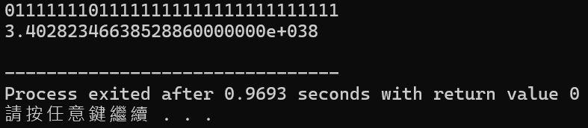

* 1. Find The Minimum Float and Its Bit Patterns

According to the rules of IEEE 754, we can see that to produce the smallest positive floating-point number, it can be divided into three parts. The first part (sign) must be positive. The second part (exponent) needs to produce the smallest exponent, which requires all bits to be 0. However, to qualify as a normalized number, the last bit must be set to 1 (00000001). The third part (mantissa) must be minimized, which requires all bits to be 0. Therefore, we can determine that the bit pattern for the smallest floating-point number is **00000000100000000000000000000000**. Next, by using a program to convert this into floating-point format, we can obtain its value as **1.17549435082228750000000e-038**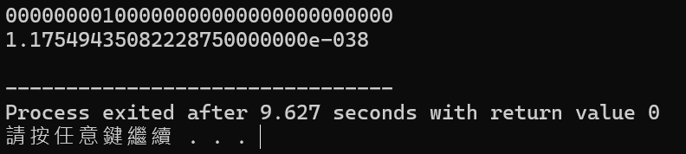

* 1. Find The Minimum Float and Its Bit Patterns