CHAPTER 4
METHODOLOGY, RESULTS AND DISCUSSION
TABLE OF CONTENTS
4.1 Requirements Analysis 5
4.1.1 Performance Requirements 5
4.1.2 Safety Requirements 8
4.1.3 Security Requirements 11
References 15
4.2 Design of Software, Systems, Product, and/or Processes 17
4.2.1 Systems Development Life Cycle (SDLC) Processes 17
Selected model and rationale 17
4.2.2 Test Plan 21
4.2.3 Security Plan 24
4.2.4 Context Diagram 26
4.2.5 Data Flow Diagram 27
4.2.6 System Flowchart 28
4.2.7 Entity Relationship Diagram (ERD) 30
4.2.8 Database Normalization 35
Unnormalized example (UNF) 35
First Normal Form (1NF) 36
Second Normal Form (2NF) 36
Third Normal Form (3NF) and functional dependencies 37
Anomaly reduction in the implemented schema 39
4.2.9 Use Case Diagram 40
Draw.io recreation specification 41
4.2.10 Maintenance Plan 41
4.2.11 Gantt Chart 43
4.2.12 PERT Chart 45
References 46
4.3 Description of the Prototype 48
System architecture 48
Hardware used and hardware requirements 48
Software requirements and development environment 49
Application modules 50
System interfaces 50
Actual deployment environment 51
4.4 Implementation Plan (Infrastructure/Deployment) 52
Project Title 52
Project Description 52
Objectives 52
Duration 53
Implementation plan table 53
4.5 Implementation Results 56
Basis and limitation of the results 56
Working Objective 1: Authenticated management of customers, credit, payments, and balances 56
Working Objective 2: Product catalog and itemized credit and cash purchases 57
Working Objective 3: QR-based customer self-service access 58
Working Objective 4: Gmail SMTP messaging and repayment reminders 59
Working Objective 5: Suki Points and debt-cycle processing 59
Working Objective 6: Store-level analytics and advisory product suggestions 60
Evidence checklist and pending results 61

4.1 Requirements Analysis
This section identifies performance, safety, and security requirements relevant to the current TindahanLedger implementation. The requirements are grounded in the inspected Laravel routes, controllers, request validation, services, models, migrations, tests, and project documentation. A code feature or automated test is evidence of implementation or behavior under test; it is not, by itself, evidence of production deployment, user acceptance, or compliance with a standard.
The project does not contain approved response-time service levels. Accordingly, performance values not fixed by code or an approved project specification are explicitly labeled [PROPOSED TARGET — FOR APPROVAL]. They are planning values only and are not statements of achieved performance. In particular, documented local recommendation measurements are reported separately from proposed acceptance targets.

4.1.1 Performance Requirements
Table 4.1 lists proposed performance requirements for the implemented workflows. Proposed response limits refer to server-side elapsed time from request receipt to response completion, at the 95th percentile (p95), under a workload and environment that must be agreed and documented before acceptance testing. They exclude client rendering and uncontrolled internet latency. For workflows that send SMTP mail synchronously, the mail transport attempt is identified separately because external-provider latency can affect the complete request.
Table 4.1. Proposed performance requirements for TindahanLedger
Requirement ID | System Feature or Module | Performance Requirement and Timing Relationship | Design Rationale
PERF-01 | Owner and Super Admin authentication | [PROPOSED TARGET — FOR APPROVAL] Complete a valid login request and return the authenticated redirect within 2 seconds at p95, excluding the user's network transit time. Login throttling and active-account checks must remain enforced and must not be bypassed to meet the target. | Authentication gates all protected owner/admin operations; a measurable response limit supports routine use while retaining credential checks and throttle behavior. The target must be tested on the approved runtime and hardware.
PERF-02 | Customer management | [PROPOSED TARGET — FOR APPROVAL] Complete customer list, detail, create, or update requests within 2 seconds at p95 for an agreed store/customer dataset size. | Customer information is used repeatedly in ledger operations. An explicit dataset size is needed because listing and retrieval time depends on database volume and pagination.
PERF-03 | Credit transaction recording | [PROPOSED TARGET — FOR APPROVAL] Validate and persist a valid credit, enforce the credit-limit rule, and complete the database transaction within 2 seconds at p95 for an approved workload. Measure the complete request-to-response time separately because a configured synchronous receipt attempt occurs after the financial transaction. The credit and its structured purchase items, when present, must remain in the same database transaction. | The LedgerService validates balances under a customer lock and persists credit-related records transactionally. Performance must not be achieved by skipping financial checks or returning success before persistence completes. The owner-visible response includes the mail attempt, so both transaction and full-request durations must be recorded.
PERF-04 | Payment recording | [PROPOSED TARGET — FOR APPROVAL] Validate, allocate a valid payment to outstanding entries, update the balance and any completed debt-cycle record, and complete the database transaction within 2 seconds at p95 for an approved workload. Measure the complete request-to-response time separately because a configured synchronous receipt attempt occurs after the financial transaction. | Payment allocation and the updated balance must be consistent. The timing test must include the actual ledger size and database engine rather than measuring only a simple page response.
PERF-05 | Running balance and financial summary | [PROPOSED TARGET — FOR APPROVAL] Return the customer financial summary and paginated ledger view within 1 second at p95 for an agreed number of ledger entries. | Owners and customers need timely balance information. The actual history size and database engine must be stated when validating the target.
PERF-06 | Product catalog | [PROPOSED TARGET — FOR APPROVAL] Return a product listing or product-search response within 1 second at p95 for an agreed catalog size and query. | Product selection supports credit and cash purchase recording. The target should be checked for both catalog browsing and the transaction picker, not inferred from a single static page.
PERF-07 | Cash purchase recording | [PROPOSED TARGET — FOR APPROVAL] Validate and persist a cash purchase containing up to the implemented maximum of 50 distinct products, then return its result within 2 seconds at p95, excluding client rendering and network transit. | The request path calculates line totals from validated quantities/prices and verifies the reviewed total. The 50-item maximum is present in LedgerService::MAX_PURCHASE_ITEMS; the elapsed-time limit is not an approved project specification.
PERF-08 | Customer self-service QR portal | [PROPOSED TARGET — FOR APPROVAL] Resolve a valid QR credential and return the read-only portal page within 2 seconds at p95 for an agreed customer-history size. The portal's 15-minute inactivity setting must continue to apply. | Timely read-only access is useful to customers, but the limit must be evaluated without weakening token validation, revocation checks, store-status checks, or session expiration.
PERF-09 | Gmail SMTP notifications | The Gmail mailer is configured with a 15-second transport timeout (app/Services/MailDeliveryService.php). This is a code-configured ceiling for an SMTP attempt, not a measured delivery guarantee. [NEEDS VERIFICATION] Record end-to-end attempt duration, application response impact, failure/retry behavior, and actual delivery only after authorized credentials and a controlled test are available. | Receipt and reminder mail can depend on an external SMTP service. The transport attempt must be distinguished from financial persistence; a successful SMTP handoff does not establish arrival in a recipient's inbox.
PERF-10 | Suki Points earning, cycle completion, and redemption | [PROPOSED TARGET — FOR APPROVAL] Complete the database transaction for point earning, debt-cycle completion, or a valid redemption within 2 seconds at p95 (the same proposed transaction target as PERF-03/PERF-04). Record full request-to-response time separately where synchronous mail is also sent. Each balance, payment allocation, point change, and cycle record must remain atomic. | Loyalty calculations affect financial and points records. The timing criterion should be measured on the full transaction and cannot justify separating related writes into inconsistent states.
PERF-11 | Product recommendations during transaction entry | [PROPOSED TARGET — FOR APPROVAL] Complete a recommendation request for a basket of up to 50 product IDs within 250 milliseconds at p95, using the documented benchmark workload of 300 active products and a 12,000-rule active set as the initial comparison fixture. Revalidate the target on the approved target environment before acceptance. | The picker requests suggestions while an owner edits a basket. Existing README measurements report a 52.4 ms HTTP p95 for 50 basket products in one in-process MariaDB 10.4.32 development benchmark, with 5 queries; this is a local observation, not an accepted target or production guarantee.
Discussion. ISO/IEC 25010:2023 provides a product-quality model that can be used to specify and evaluate software quality throughout a product's lifecycle, including the definition of measures and acceptance criteria (International Organization for Standardization [ISO], 2023). Information-systems research also identifies system quality and information quality as related dimensions in evaluating information-systems success (DeLone & McLean, 2003). In keeping with these quality-oriented approaches, Table 4.1 expresses response limits with a measurement point, percentile, and workload requirement wherever a limit is proposed. The numerical limits in PERF-01 through PERF-08, PERF-10, and PERF-11 are not documented acceptance requirements; they are proposals that require review and approval before they can be used as pass/fail criteria. Nielsen's response-time guidance distinguishes immediate feedback, interruption to the user's flow, and delays that require progress feedback; it is relevant to the design of the interactive picker and transaction screens, but does not establish that this application's proposed values have been achieved (Nielsen, 1993).
The source code and README document concrete timing-related design details, but those details have different evidentiary status. The SMTP transport timeout is configured at 15 seconds, while the recommendation response figures are local measurements under a described synthetic workload. Neither establishes production performance. The README's local recommendation benchmark measured service and in-process HTTP timing without a web server or network; its results therefore must not be generalized to mobile connectivity, production infrastructure, or all store sizes. For financial workflows, a performance test must observe the complete transaction, including validation, database persistence, balance updates, and any synchronous mail attempt, while preserving the transaction and authorization safeguards.
Evidence and verification notes. Relevant code includes routes/web.php; app/Http/Controllers/Auth/AuthenticatedSessionController.php; app/Http/Controllers/CustomerController.php; app/Http/Controllers/CreditController.php; app/Http/Controllers/PaymentController.php; app/Http/Controllers/CashPurchaseController.php; app/Http/Controllers/Portal/CustomerPortalController.php; app/Services/LedgerService.php; app/Services/CashPurchaseService.php; app/Services/ProductRecommendationService.php; app/Services/MailDeliveryService.php; and config/customer_portal.php. Performance-oriented tests and descriptions are in tests/Feature/ and README.md. The project has not supplied an approved workload, target hardware, concurrency level, production benchmark, or acceptance record. Those items remain [NEEDS VERIFICATION] before the proposed values can be adopted.

4.1.2 Safety Requirements
In this application, safety requirements concern foreseeable financial-record errors, customer-impacting mistakes, and loss or destruction of records. The safeguards below are limited to those found in the inspected code and migrations. An operational backup or recovery process is not inferred from the presence of a database, transaction, log, or migration.
Table 4.2. Safety requirements for TindahanLedger
Requirement ID | Potential Hazard or Loss Scenario | System Safeguard and Required Action | Prevented Action or Constraint
SAFE-01 | An incorrect outstanding balance is displayed or used to make a credit decision. | LedgerService calculates money in integer cents through Money, applies payment allocations and balance changes in a database transaction, and locks the customer row during financial updates. The application must report validation or persistence failure rather than confirm an uncommitted transaction. | A credit whose projected outstanding balance exceeds the customer's credit limit is rejected; a payment exceeding the applicable outstanding amount is rejected.
SAFE-02 | Repeated submission or a retry records the same payment more than once. | Payment requests require a UUID idempotency key. A unique database constraint and LedgerService replay handling return the prior payment batch for a repeated key instead of applying the same submission again. | Duplicate application of a payment submission with the same idempotency key is prevented by the database/service path. The key must not be treated as proof that two different keys represent the same real-world cash receipt.
SAFE-03 | An erroneous amount, unsupported product, or stale total creates an incorrect credit or sale. | Server-side Form Requests validate positive, two-decimal monetary amounts; transaction services perform financial checks, verify catalog/store ownership, calculate line totals, and compare the submitted expected cash-sale total with the server total. Credit records and any structured purchase details are written together. | Zero/negative amounts, credit-limit overrun, invalid item data, duplicate product rows, inactive/out-of-store products, and a mismatched cash-sale total are rejected. Product descriptions do not silently change the amount of a credit.
SAFE-04 | Deleting a customer or transaction removes history needed to explain balances or disputes. | Foreign keys use restrictive deletion for financial history and dependent records, including credit/payment relationships, Suki Point history, debt-cycle records, and purchase history. The user must resolve dependent records through an authorized, documented retention process rather than bypassing constraints. | A customer, credit, payment, product, or rule set with protected dependent history cannot be deleted through the constrained relationships. A backup/restore process is not evidenced and must not be assumed.
SAFE-05 | Suki Points are over-redeemed, redeemed against no debt, or deducted more than once. | The redemption request validates a positive whole-number point amount. LedgerService::redeemSukiPoints locks the customer and points records, checks available points and debt, records the redemption/payment allocation and point transaction atomically, and recognizes a repeat idempotency key. | Redemption above the available point balance or outstanding debt, redemption against a zero balance, and repeat deduction under the same idempotency key are rejected/prevented.
SAFE-06 | An unauthorized person changes or views customer financial records. | Owner routes require authentication, changed-password status, and the store-owner role; customer and ledger policies check store ownership. Super Admin routes use a separate role. The system must retain these controls on all financial read/write routes and deny cross-store requests. | Guest, wrong-role, and cross-store customer actions are denied. A suspended store is read-only for the protected transaction routes; a customer cannot write through the read-only QR portal.
SAFE-07 | Hardware, host, or database failure causes loss of financial records. | Financial writes use database transactions and relational constraints to avoid partial application of the covered transaction. Operators must establish, document, and test backups, recovery steps, and access controls before using production financial records. | No claim is made that database transactions alone prevent loss caused by disk failure, deletion, ransomware, or unavailable infrastructure. Until an approved recovery process exists, production readiness for this hazard remains [NEEDS VERIFICATION].
SAFE-08 | A late-fee policy change alters the terms of an already recorded credit, or a duplicate penalty is applied. | The credit stores the accepted policy snapshot; a penalty is a separate linked ledger entry with a unique link to the original credit. Changes to a store policy do not rewrite historical snapshots. | A second penalty for the same credit is prevented by the unique relationship. Existing credits without the relevant snapshot are not to be silently reinterpreted as covered by a later policy.
SAFE-09 | A customer or owner revisits an old payment confirmation and is shown a historical remaining/previous balance calculated from transactions recorded later. | The inspected fallback in PaymentController::confirmation derives prior/remaining balances from the customer's current balance when the original session receipt is absent. [NEEDS VERIFICATION / CORRECTIVE ACTION] Before treating a revisited confirmation as a historical receipt, persist an immutable batch receipt snapshot or display only values that remain derivable from that batch. Verify with a test that records later credits/payments before reopening the earlier confirmation. | Do not present a balance affected by later transactions as the balance immediately after an older payment. This safeguard is not established by the current fallback.
Discussion. Financial records require safeguards against both invalid inputs and inconsistent state changes. TindahanLedger places core checks in server-side request validation and transaction services rather than relying on browser calculations. For example, credit recording checks the projected balance while the customer is locked, payment recording rejects an amount greater than the outstanding amount, and cash-purchase recording recomputes item totals on the server. These controls reduce the risk that a stale interface value or a repeated browser submission changes a financial record without the corresponding business checks.
Database transactions and foreign-key constraints support consistency for the database operations they cover, but they do not replace operational recovery. Restrictive deletion prevents several classes of accidental history removal through normal relational operations. It does not show that the application has tested backups, recovery objectives, retention schedules, or disaster procedures. Before live use, the project owner should identify an approved backup and recovery process and retain evidence of a successful restore test. ISO/IEC 25010:2023 is a suitable quality-model reference when defining reliability and acceptance criteria, but no certification or independent safety assessment is claimed for TindahanLedger (ISO, 2023).
Evidence and verification notes. The financial safeguards are implemented principally in app/Services/LedgerService.php, app/Services/CashPurchaseService.php, app/Support/Money.php, app/Http/Controllers/PaymentController.php, app/Http/Requests/StoreCreditRequest.php, app/Http/Requests/StorePaymentRequest.php, and app/Http/Requests/RedeemSukiPointsRequest.php. The historical payment-confirmation limitation is also described in SPRINT-1-AUDIT-HANDOFF.md. Schema constraints appear in migrations for ledger entries, payments, customer/history deletion, purchase items, Suki Points, debt-cycle completions, and penalty support. Relevant regression tests include tests/Feature/RecordCreditTest.php, RecordPaymentTest.php, TransactionReceiptTest.php, CashPurchaseTest.php, SukiPointRedemptionTest.php, LatePenaltyTest.php, and TenantIsolationTest.php. Tests use the SQLite in-memory test configuration; production database-engine behavior and recovery operations remain [NEEDS VERIFICATION].

4.1.3 Security Requirements
The following requirements describe the controls visible in the inspected source and the protections that must remain in force. Reference to a security standard identifies a comparison framework only; the inspection did not establish formal certification, a complete security audit, or legal compliance.
Table 4.3. Security requirements for TindahanLedger
Requirement ID | Security or Privacy Domain | Authentication and Protection Requirement | Policy or Standard Alignment
SEC-01 | Owner and administrator authentication | Require an authenticated active account for protected routes. Enforce role checks for Store Owner and Super Admin routes. The login flow normalizes usernames, limits repeated failed attempts (five attempts per throttle window in the inspected controller), regenerates the session after authentication, and requires an administrator-issued temporary password to be changed before ordinary use. Password reset and multi-factor authentication were not established as implemented features. | Compare authentication design with NIST SP 800-63B-4 (NIST, 2025) and the authentication requirements in OWASP ASVS 5.0.0. This comparison is not a conformance claim.
SEC-02 | Password storage and handling | Store passwords through Laravel's hashed model cast and exclude password and remember-token fields from model serialization. Do not log, expose, or return passwords. Continue to require server-side password-change validation for temporary credentials. The selected production hashing configuration and password-strength policy require deployment/configuration verification. | NIST SP 800-63B-4; OWASP ASVS 5.0.0. Verify the actual production configuration before asserting alignment.
SEC-03 | Session protection and request forgery | Regenerate the session on successful owner login and QR portal access; invalidate it and regenerate the CSRF token on logout. The application uses Laravel's web routes, which apply the framework's web middleware protections. Private portal responses set no-store, private, and no-referrer headers. Effective cookie flags, HTTPS enforcement, and production session-store protection depend on deployment configuration and require verification. | OWASP ASVS 5.0.0 session-management and request-protection controls; NIST SP 800-63B-4 for authentication-session considerations.
SEC-04 | Store/tenant isolation and authorization | Derive the owner's store from the authenticated user rather than trusting a client-supplied store identifier. Scope customer/product/transaction access to that store, authorize customer and ledger access through policies, and enforce role restrictions. Composite foreign keys in migrations enforce selected customer/store and transaction ownership relationships. | OWASP ASVS 5.0.0 access-control requirements. Cross-store denial is also covered by TenantIsolationTest.php; this does not replace a full authorization review.
SEC-05 | Customer QR portal credential | Treat a QR code as a bearer credential: possession grants access but does not verify the holder's identity. Generate a random token, store its SHA-256 lookup hash and encrypted printable token, revoke replaced codes, remove the encrypted token on revocation, and check credential/store status and a configured 15-minute idle timeout on portal access. Place the QR token in the URL fragment; private headers are applied to portal pages. The token must not be described as password or identity-based authentication. | OWASP ASVS 5.0.0 access-control/session requirements; privacy risk review under the applicable data-protection policy. QR issuance/revocation and portal behavior have feature tests.
SEC-06 | Customer financial-data confidentiality | Limit owner access to customers in the owner's store and expose only the customer's read-only ledger through an active portal session. Prevent caching and referrer leakage on private portal routes. Require HTTPS, suitable storage/access controls, a privacy notice, and a retention/disposal policy in the deployed service; these operational requirements are not verified by repository code alone. | Republic Act No. 10173 (Data Privacy Act of 2012) and National Privacy Commission guidance may be relevant to personal-data processing in the Philippines; applicability and compliance require legal/organizational review. OWASP ASVS 5.0.0 is a technical comparison baseline.
SEC-07 | Input validation and data integrity | Validate untrusted request fields server-side using Laravel validation/Form Requests and apply business-rule checks in transaction services. Preserve store/customer ownership constraints and require positive monetary values, valid UUID idempotency keys, and bounded purchase-item lists on the inspected financial paths. Review all endpoints, background commands, and imports to ensure the same controls apply. | OWASP ASVS 5.0.0 input-validation and data-protection requirements.
SEC-08 | SQL injection and output encoding | Use bound Eloquent/query-builder operations for the inspected financial and portal data paths; do not concatenate untrusted input into raw SQL. Continue to use context-appropriate output escaping in Blade. A repository-wide query/output-encoding assessment and security test report were not produced for this documentation task. | OWASP ASVS 5.0.0 injection-prevention and output-encoding requirements. No claim of complete injection immunity is made.
SEC-09 | Gmail SMTP credentials and notification data | Store the owner's SMTP App Password using Laravel's encrypted cast and hide it from model serialization. The Gmail mailer uses port 587 with required TLS and a configured 15-second timeout; failure logs are designed to mask recipient/sensitive values. Validate customer recipient addresses and send credit/payment receipts only after the financial service returns. Protect production APP_KEY, SMTP settings, logs, and transport configuration. Real Gmail delivery and production secret management were not verified. | OWASP ASVS 5.0.0 secrets/communications requirements; NIST guidance for credential handling where applicable. Mail transport configuration is not proof of inbox delivery or end-to-end confidentiality.
SEC-10 | Administrative and financial changes | Separate Super Admin and Store Owner roles, restrict management routes by middleware, and use the audit logger for recorded administrative actions. Confirm that sensitive financial adjustments, policy waivers, credential issuance/revocation, and administrative changes are authorized and logged with appropriate actor/context without storing secrets. Audit coverage and retention require verification. | OWASP ASVS 5.0.0 access-control and logging requirements; applicable organizational privacy and record-retention policies.
Discussion. TindahanLedger implements several layers of access control. The inspected routes place owner-facing functions behind authentication, password-change, and store-owner middleware, while Super Admin functions use a separate role. The User model hashes passwords through Laravel's hashed cast and hides password-related values from serialization. Store-specific policies and queries, together with relational constraints, reduce the risk of a user retrieving another store's customer records. Feature tests cover login, role access, customer portal access, and cross-store denial.
Customer portal access uses a different trust model from owner authentication. The QR token is a bearer secret; the code itself documents that it proves possession, not the identity of the person scanning it. The implementation mitigates some exposure by hashing the lookup token, keeping a separately encrypted token for owner reprinting, placing it in the URL fragment, applying private response headers, checking revocation and store status, and ending idle sessions. These measures do not make a shared or copied QR code identity proof. Store owners must therefore issue, display, and revoke codes with that limitation in mind.
The email settings model encrypts the saved SMTP App Password, and the Gmail transport configuration requires TLS. Nevertheless, protection at rest and in transit depends on the production key, hosting, database, network, and secret-management configuration. The repository and tests do not establish that production HTTPS is enabled, that backups are encrypted, that the application has undergone a complete security verification, or that a real Gmail message reached an inbox. OWASP ASVS 5.0.0 offers a structured basis for planning technical verification, while NIST SP 800-63B-4 provides current digital-authentication guidance (National Institute of Standards and Technology [NIST], 2025; OWASP Foundation, n.d.). Neither is claimed as a certification or completed audit.
Because the system processes customer names, contact details, email addresses, balances, and transaction histories, the project should determine the applicable privacy obligations before deployment. Republic Act No. 10173 and National Privacy Commission guidance are potential Philippine references; the relevant controller/processor roles, legal basis, privacy notice, retention, data-subject handling, and security obligations require review by the responsible organization. This chapter does not assert legal compliance.
Evidence and verification notes. Relevant source includes routes/web.php; app/Http/Controllers/Auth/AuthenticatedSessionController.php; app/Models/User.php; app/Http/Middleware/EnsureAccountIsActive.php; EnsurePasswordIsChanged.php; EnsureUserHasRole.php; app/Policies/CustomerPolicy.php; app/Services/CustomerAccessService.php; app/Http/Controllers/Portal/PortalAccessController.php; app/Http/Middleware/EnsureCustomerPortalSession.php; app/Http/Middleware/SetPrivatePageHeaders.php; app/Models/CustomerAccessCredential.php; app/Models/StoreEmailSetting.php; app/Services/MailDeliveryService.php; bootstrap/app.php; config/session.php; and migrations for credentials, stores, transactions, and email settings. Supporting tests include OwnerAuthenticationTest.php, RoleAccessTest.php, TenantIsolationTest.php, CustomerAccessCodeTest.php, CustomerPortalTest.php, EmailSettingsTest.php, and ReusableEmailTest.php. [NEEDS VERIFICATION] Production TLS/cookie/key settings, storage encryption, retention/backup controls, complete SQL/output-encoding review, privacy documentation, and independent security-test evidence.

References
DeLone, W. H., & McLean, E. R. (2003). The DeLone and McLean model of information systems success: A ten-year update. Journal of Management Information Systems, 19(4), 9–30. https://doi.org/10.1080/07421222.2003.11045748
International Organization for Standardization. (2023). ISO/IEC 25010:2023 systems and software engineering—Systems and software quality requirements and evaluation (SQuaRE)—Product quality model. https://www.iso.org/standard/78176.html
National Institute of Standards and Technology. (2025). Digital identity guidelines: Authentication and authenticator management (NIST Special Publication 800-63B-4). https://csrc.nist.gov/pubs/sp/800/63/b/4/final
Nielsen, J. (1993). Response times: The three important limits. In Usability engineering (Chapter 5). Morgan Kaufmann. https://www.nngroup.com/articles/response-times-3-important-limits/
OWASP Foundation. (n.d.). Application Security Verification Standard (ASVS), version 5.0.0. https://asvs.owasp.org/
Republic of the Philippines. (2012). Republic Act No. 10173: Data Privacy Act of 2012. National Privacy Commission. https://privacy.gov.ph/data-privacy-act/

4.2 Design of Software, Systems, Product, and/or Processes
This section describes the development process and design of TindahanLedger using the checked-in Laravel application, migration history, tests, README, audit handoff, and Git ticket/branch evidence. The repository contains a working implementation for store-owner and Super Admin workflows, financial records, products and purchases, customer QR access, Suki Points, email infrastructure, late penalties, and product recommendations. Those implementation facts do not establish that the system was deployed to a production environment, accepted by end users, or evaluated on live store data.

4.2.1 Systems Development Life Cycle (SDLC) Processes

Selected model and rationale
The development evidence most closely supports an iterative and incremental SDLC model. In this model, a system is developed through a sequence of usable increments. Each increment involves selecting and clarifying a bounded set of requirements, designing the affected elements, implementing changes, testing the result, and using the accumulated feedback or discovered constraints to shape subsequent work. Iterative and incremental development is a recognized software-development approach with a documented history (Larman & Basili, 2003).
TindahanLedger's repository shows work organized around ticket identifiers and feature-sized commits. The branch list contains ticket-named branches, including branches for DUMS-35 through DUMS-41 and earlier DUMS tasks. The commit history shows incremental additions such as structured credit purchase items (DUMS-36), cash purchase recording (DUMS-37), external dataset validation (DUMS-38), association-rule training (DUMS-39), product suggestions (DUMS-40), and purchase analytics/evaluation (DUMS-41). Later commits further refined the recommendation snapshot and activation behavior. The test suite contains separate feature and unit tests aligned with these capabilities. Together, this evidence is consistent with ticket-oriented, iterative delivery and subsequent refinement.
The evidence does not establish that the project formally adopted Scrum, used fixed-length sprints, held prescribed Scrum ceremonies, or followed a specific Agile framework. The README and Sprint 1 handoff refer to Jira ticket identifiers, and Git branches support feature-branch work; however, a Jira board export, sprint records, pull-request review history, and team meeting records were not available for inspection. Accordingly, the model is described as iterative and incremental, with ticket-based and Agile-influenced practices, rather than as formal Scrum. The Agile Manifesto is relevant as a conceptual comparison because it values working software, collaboration, and responsiveness to change; the available repository evidence does not establish conformance to the Manifesto or its specific methods (Beck et al., 2001).
Figure 4.1. Iterative and incremental development cycle applied to TindahanLedger
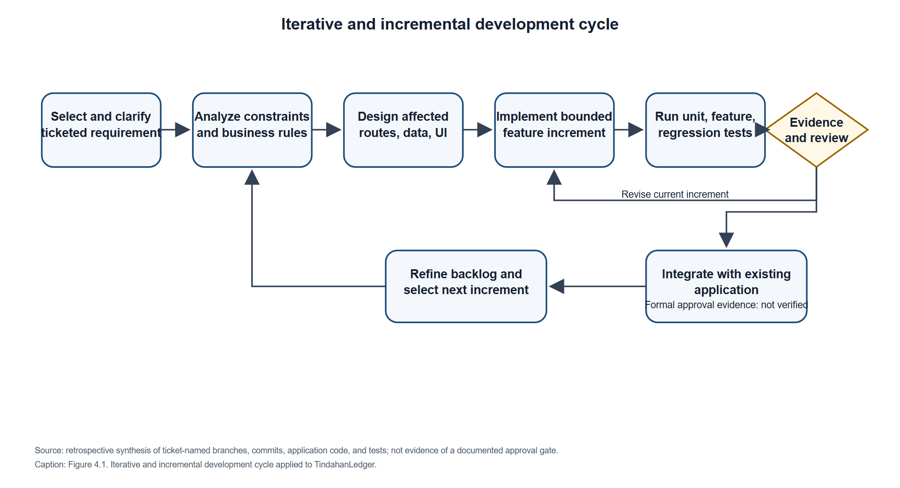
The model represents a retrospective synthesis of observable development artifacts; it is not a claim that every ticket passed through a documented approval gate. In particular, evidence of formal requirement acceptance or release approval was not located.
Table 4.4. SDLC phases and TindahanLedger evidence
Phase | Purpose in the selected model | Actual TindahanLedger activities evidenced | Supporting project evidence | Evidence limitation
Requirements selection and analysis | Select a bounded problem, record expected behavior, and identify business constraints for an increment. | Ticket-keyed work is visible in commit subjects and branch names. Feature scope is reflected in implementation and documentation for customer/ledger workflows, purchases, QR access, email, loyalty, and recommendations. | Ticket identifiers in README.md and SPRINT-1-AUDIT-HANDOFF.md; Git commit subjects such as DUMS-36 through DUMS-41; feature-specific Form Requests and tests. | The Jira board, issue descriptions/status history, approved acceptance criteria, and stakeholder sign-off are [NEEDS VERIFICATION].
Analysis and design | Translate requirements into routes, role boundaries, validation, services, data relationships, and user flows. | Laravel routes and middleware separate Store Owner, Super Admin, and customer portal access. Migration files progressively introduce stores, financial records, products/purchases, points, credentials, reminders, penalties, and recommendation rule sets. | routes/web.php; bootstrap/app.php; app/Http/Requests/; app/Policies/; app/Services/; database/migrations/; relevant models and tests. | No dated, approved design specification or review minutes were found. Some design decisions are documented in source comments/README, not in a separate signed design record.
Incremental implementation | Add a working capability without treating the whole system as a single one-time release. | Ticket-oriented feature work includes itemized credit purchase support, cash purchases, basket validation, a single-item association-rule engine, transaction-entry suggestions, and purchase analytics. The branch list contains feature-/ticket-named branches; their names support branch-based work but do not alone prove review or merge procedures. | Git branch names and history; Laravel controllers/services; migrations; Blade views; composer.json and package.json. | Exact branch-to-merge mapping, pull-request approval, release tags, and deployment history are [NEEDS VERIFICATION].
Verification and regression testing | Check the increment's expected behavior and guard existing financial workflows against regressions. | Separate Pest feature and unit tests cover authentication, role access, tenant isolation, credit/payment behavior, cash purchases, QR portal behavior, mail settings, Suki Point redemption, and recommendation logic. | tests/Feature/; tests/Unit/; phpunit.xml; project README and Sprint 1 audit handoff. | Tests run here use SQLite :memory: as configured in phpunit.xml. Production MySQL/MariaDB concurrency and browser/device behavior are not established by that suite.
Review and refinement | Use test findings, observed constraints, and additional requirements to revise or extend the system. | Later ticketed commits refine recommendation snapshots/activation and add analytics/evaluation. Documentation explicitly limits customer-specific recommendations and external dataset import; README warns that the available external basket file is unsuitable and not approved for customer-facing use. | Later DUMS-39 and DUMS-41 commits; README.md sections on DUMS-38 through DUMS-41; recommendation and analytics services/tests. | Formal retrospective records, backlog prioritization history, user feedback, and approval of the next increment are [NEEDS VERIFICATION].
Release and operation | Package, deploy, monitor, and maintain an accepted increment. | README documents how to configure a production scheduler and how to perform restricted local QR testing. Scheduler commands are defined in source. | README.md; routes/console.php; app/Console/Commands/; application configuration. | A production host, actual release, public deployment, operational ownership, backup procedure, and production monitoring are not evidenced. Local instructions are not proof of deployment.
Discussion. Iterative and incremental development is a better fit for the available project evidence than a strictly sequential model because the codebase contains separately identifiable feature increments, ticket-named branches and commits, associated automated tests, and later changes that refine earlier capabilities. Larman and Basili (2003) describe iterative and incremental development as an approach with a long history in software development; it provides an appropriate conceptual basis for discussing increments and successive refinement. The Agile Manifesto (Beck et al., 2001) offers related values, but the available records are insufficient to call the project Scrum or to claim that all Agile principles or ceremonies were followed.
For TindahanLedger, the phases are best interpreted as recurring work practices rather than a single completed linear sequence. A credit/payment requirement, for example, is represented in request validation, transaction services, schema constraints, and focused tests. Later capabilities such as cash sales and recommendation analytics add new increments while relying on existing customer, store, product, and purchase structures. The model also accommodates refinement when implementation evidence reveals a limitation. Such a limitation is visible in the README's warning that external data are not suitable for live recommendations and in the later recommendation snapshot/activation refinements. However, source history cannot establish who reviewed each change, whether a store owner approved it, or whether the change was deployed.
The test suite was executed during the documentation task and reported 858 tests passed with 3,348 assertions. This is a completed automated test result, not a result predicted by the model. phpunit.xml configures SQLite :memory: for tests; therefore, the result must not be interpreted as a production acceptance test, a MySQL/MariaDB concurrency result, or evidence of user acceptance. Further detailed test activities and their status are given in Table 4.5.

4.2.2 Test Plan
Table 4.5 identifies planned assessment procedures and the criteria that should be used when they are performed. “Expected outcome” is a pass criterion for future execution and is not, by itself, a claim that a test passed. A completed result is identified explicitly where repository or current execution evidence exists.
Table 4.5. TindahanLedger test plan
Test Phase or Module | Testing Method | Actual Plan and Test Procedure | Assessment Criteria and Expected Outcome
Authentication and authorization | Automated feature tests for valid/invalid login, throttling, active/inactive accounts, temporary-password change, role restrictions, logout, and protected routes; manual browser check on the approved release. | Implemented tests exist in OwnerAuthenticationTest.php, ChangePasswordTest.php, and RoleAccessTest.php. Run the focused tests after authentication changes. Verify that successful login rotates the session; logout invalidates it and regenerates the CSRF token. Browser/device validation is planned / [NEEDS VERIFICATION]. | Valid users are authenticated and directed according to role; inactive or invalid accounts cannot access protected functions; throttling is enforced; temporary passwords are changed before normal access; logout ends the session. No protected route is accessible to a guest or wrong role.
Customer and store isolation | Automated cross-store access tests against customer, ledger, transaction summaries, and store-scoped records; review route policies and database constraints. | Implemented tests exist in TenantIsolationTest.php, CustomerPolicyTest.php, and ProductPolicyTest.php. Run them after modifying store-scoped queries, policies, or route middleware. Supplement with a target-database check of composite foreign keys. | An owner can access only records belonging to the owner's store; attempts to access another store's customer/financial record do not disclose the record; cross-store relations cannot be persisted where composite constraints apply. Target MySQL/MariaDB constraint test is planned / [NEEDS VERIFICATION].
Credit transaction recording | Feature tests for valid credit, invalid/zero amount, limit boundary, limit overrun, invalid products, duplicate submission key, transaction rollback, and structured purchase items. | Implemented tests exist in RecordCreditTest.php, StructuredCreditItemsTest.php, and related workflow tests. Run focused tests for service/request/migration changes; verify a credit and its structured purchase items are committed together. | Valid credit within the limit persists once and updates the customer balance; over-limit and invalid submissions are rejected with no partial records; the same idempotency key does not create a duplicate. Concurrency on the intended production database remains [NEEDS VERIFICATION].
Payment recording and balance accuracy | Feature tests for partial/full payment, overpayment, FIFO allocation, repeated idempotency key, batch grouping, and customer balance/running history; hand-calculate representative balances and compare with service output. | Implemented tests exist in RecordPaymentTest.php, CustomerLedgerTest.php, LedgerWorkflowTest.php, and TransactionReceiptTest.php. The handoff identifies a remaining historical-confirmation limitation: when the original session receipt is absent, an old confirmation may derive previous/remaining balances from current customer activity. Add/execute a regression test after later transactions are recorded. | Payment cannot exceed the applicable outstanding amount; allocation order and running balances match business rules; repeat submission does not apply twice. Historical confirmation must not present current balance as a batch-time balance. The latter behavior is not established as safely implemented and requires corrective verification.
Product catalog | Feature tests for create/update, normalization, active/inactive status, store scoping, price validation, and catalog access. | Implemented tests exist in ProductCatalogTest.php and ProductPolicyTest.php. Run focused tests when catalog validation, status, or pricing logic changes. | Only valid products in the owner's store can be added/updated; inactive or foreign-store products cannot be used in a transaction; invalid prices/names are rejected.
Cash purchase recording | Feature tests for item/quantity validation, server-side line total, expected-total mismatch, walk-in/known customer, duplicate products, inactive/out-of-store products, idempotency, and separation from debt/points. | Implemented tests exist in CashPurchaseTest.php. Run after changes to price calculation, item schemas, or purchase persistence. | A valid purchase persists consistent item snapshots and calculated total exactly once; a stale or invalid expected total is rejected; cash purchase creates no credit/payment and does not change debt balance or Suki Points.
Customer self-service QR portal | Feature tests for credential issue/reissue/revoke, malformed/unknown/revoked token, store suspension, session rotation/idle timeout, read-only access, privacy headers, and rate limit; manual scan on approved mobile browsers. | Implemented tests exist in CustomerAccessCodeTest.php and CustomerPortalTest.php. README provides local-network/hotspot scan instructions, but an actual device test is not evidenced. Conduct manual scanning only on a trusted network and record device/browser and result. | Only an active credential opens the corresponding customer's read-only portal; revoked credentials stop working; session is regenerated and ends at configured inactivity; suspended store is unavailable; private responses are not cached and do not send referrer data. Real-device verification is planned / [NEEDS VERIFICATION].
Email notifications and reminders | Unit/feature tests with mocked SMTP transport; verify scheduled command configuration and retry/log behavior; controlled Gmail delivery to an authorized mailbox. | Automated transport/settings tests exist in ReusableEmailTest.php, EmailSettingsTest.php, and PaymentReminderServiceTest.php. README and the audit handoff state that no real Gmail credentials/message/inbox delivery were verified. A real send is a separate manual test requiring owner-provided credentials stored only in local secret configuration. | Invalid recipients are rejected; secrets are not exposed in serialization/logs; failures are recorded/reported; reminders follow schedule and duplicate-prevention rules. SMTP mock acceptance is not inbox delivery. Actual Gmail delivery remains [NEEDS VERIFICATION].
Suki Points earning, cycle completion, and redemption | Feature tests for accrual/remainders, cycle thresholds, rewards, redemption limits, no-debt case, repeated key, and atomic points/payment updates. | Implemented tests exist in SukiPointEarningTest.php, SukiCycleRewardTest.php, and SukiPointRedemptionTest.php. Run focused tests after any change to payment, cycle, or loyalty rules. | Points match configured earning and reward rules; redemption cannot exceed points or eligible outstanding debt; points deduction and ledger allocation are atomic; replay of the same key does not deduct twice.
Recommendation engine and transaction-entry suggestions | Unit/feature tests for basket counts, support/confidence/lift, thresholds, store isolation, model lifecycle, ranking, no active model, and read-only endpoint; offline held-out evaluation on eligible data. | Implemented tests exist in AssociationRuleTrainingTest.php, ProductRecommendationServiceTest.php, ProductRecommendationEndpointTest.php, RecommendationEvaluationTest.php, and related unit tests. README documents a local MariaDB performance benchmark and synthetic offline evaluation; it explicitly says external baskets are not approved for customer-facing recommendations and the 301-basket evaluation is exploratory. | Rules and suggestions use the correct store's active rule set, only active products, and the documented metrics/ranking. No customer data is exposed and the suggestion endpoint does not change a transaction. Effectiveness on representative sari-sari data is [NEEDS VERIFICATION].
Regression suite and target-database verification | Run focused Pest tests for changed modules, then full test suite; separately run approved MySQL/MariaDB integrity/concurrency tests. | Completed during documentation work: full php artisan test --compact reported 858 passed and 3,348 assertions. phpunit.xml uses SQLite :memory:. Not completed by that run: MySQL/MariaDB concurrency/integration verification, production browser/device tests, or deployment acceptance. | The recorded suite result is reproducible only with its recorded environment. Target-database and release tests must be reported separately with database/version, dataset, duration, and outcomes.
Discussion. The testing strategy combines focused feature tests at HTTP/service boundaries with unit tests for calculations and supporting services. The repository's test organization is suitable for testing business rules such as credit limits, overpayment rejection, idempotent submissions, customer/store isolation, and Suki Point redemption without substituting a user-interface value for server validation. ISO/IEC 25010:2023 can guide the definition of quality characteristics and measurable acceptance criteria, while OWASP ASVS 5.0.0 provides a structured source for security verification activities (ISO, 2023; OWASP Foundation, n.d.).
The current full-suite result is explicitly limited to the configured SQLite in-memory test environment. It does not show production database locking semantics, deployment configuration, network behavior, visual responsiveness, customer understanding of QR access, or Gmail delivery. The README's local recommendation timings and synthetic evaluation results should be treated as development evidence only, with dataset and setup limitations retained. Future execution records should identify the tested commit, test command, runtime/database version, test data, failures, and corrective retest where applicable.

4.2.3 Security Plan
The plan below combines actual application controls with assessment activities that remain to be executed or verified. “Implemented” refers only to the inspected code and migrations; it is not a statement of certification or complete security assurance.
Table 4.6. TindahanLedger security plan
Security Layer | Actual Security Plan and Implementation | What to Assess During Security Testing
Owner/admin authentication | Implemented: authenticated web routes; active-account middleware; distinct Store Owner and Super Admin role checks; login rate limiting; session ID regeneration on login; logout invalidation and CSRF-token regeneration; forced change of administrator-issued temporary password. User uses Laravel's hashed password cast. | Attempt guest, inactive-account, wrong-password, throttled, wrong-role, and temporary-password access. Verify session rotation and termination. Inspect the deployed password-hashing configuration, password policy, TLS, and cookie settings; production configuration is [NEEDS VERIFICATION].
Authorization and store isolation | Implemented: owner routes are scoped by the signed-in user's store; role middleware and policies protect operations; customer/ledger access checks ownership; migrations contain store/customer consistency constraints; tenant-isolation tests exist. | Test direct object references, altered IDs, query parameters, and all read/write routes across two stores. Verify DB composite constraints on the target engine and ensure new endpoints do not trust a submitted store ID.
Financial transaction integrity | Implemented: server-side Form Request validation; services enforce business rules; database transactions and row locks are used for credit/payment/redemption workflows; UUID idempotency keys protect selected replayable submissions; foreign keys restrict deletion of financial history. | Test invalid/negative/over-limit amounts, duplicate/replayed submissions, partial failure/rollback, concurrent operations, payment/customer/entry consistency, and auditability. MySQL/MariaDB concurrency tests and production record integrity remain [NEEDS VERIFICATION].
Customer QR portal | Implemented: random bearer tokens; hash-based lookup; encrypted printable token; revocation/reissue; per-request active credential/store checks; rate-limited token submission; session regeneration and idle expiry; read-only customer ledger; private/no-store/no-referrer response headers. QR possession authenticates possession of the code, not the holder's identity. | Test malformed, guessed, copied, revoked, replaced, expired-session, and suspended-store cases; ensure the token is absent from initial request path/referrer/logs and portal has no state-changing routes. Review issuance, reprinting, physical display, and revocation procedures.
Input validation, query/data handling, and browser request protections | Implemented in reviewed routes: Laravel Form Requests/request validation and Eloquent/query-builder access are used on inspected flows; web routes use Laravel's web middleware group; Blade templates are used. This review is not an exhaustive injection/output-encoding assessment. | Run a full endpoint inventory and test boundary inputs, authorization-before-disclosure, CSRF enforcement in a non-test runtime, output encoding, and any raw SQL. Confirm parameter binding on every untrusted query and verify error responses do not disclose customer data.
Customer financial-information privacy | Implemented: owner access is store scoped; customer portal returns a read-only ledger; private portal pages set cache/referrer protections; customer and purchase histories are modeled with relational constraints. Not established: production HTTPS, database/back-up encryption, privacy notice, retention schedule, lawful basis, or privacy-impact/legal review. | Check deployed TLS and headers, cache behavior, cookie configuration, log redaction, least-privilege DB/storage access, data retention and deletion process, and disclosure boundaries. Determine applicable obligations under Republic Act No. 10173 and National Privacy Commission guidance; do not claim compliance without organizational/legal review.
Email credentials and notification handling | Implemented: SMTP App Password is encrypted at rest using Laravel's encrypted cast and hidden from model serialization; Gmail transport uses port 587 and requires TLS; mail failure logging masks recipient/sensitive values; email test route is authenticated and rate limited. Email delivery is synchronous in the inspected receipt workflow. Real Gmail delivery was not verified. | Inspect secret exposure in source, environment/config/cache, logs, model/API serialization, and exception output. Verify TLS negotiation and authorized recipient behavior in a controlled environment; do not include secret credentials in test evidence. Confirm failure/retry behavior and that SMTP failure does not falsely report successful delivery.
Administrative audit and operational security | Implemented in part: an AdminAuditLogger and audit-log model/migration exist for selected administrative actions. [NEEDS VERIFICATION]: completeness of sensitive-action coverage, retention, access to logs, deployment monitoring, backup encryption, incident response, and patch cadence. | Attempt unauthorized administrative actions; verify actor/action/subject evidence without passwords or SMTP secrets; assess log access, integrity, retention, alerting, dependency updates, and incident escalation. Compare controls with OWASP ASVS 5.0.0 and NIST SP 800-53 Rev. 5, Update 1 without asserting conformance (NIST, 2020; OWASP Foundation, n.d.).
Discussion. Security is addressed through multiple application layers rather than a single login check. The route configuration distinguishes owner and Super Admin functions, while customer policies and store-derived queries constrain records by tenant. Financial services add validation and transactional checks. QR portal access is intentionally a bearer-token mechanism: anyone possessing a valid QR code can access that customer's read-only ledger until the credential is revoked or the session expires. This limitation must remain explicit in user-facing procedures and any privacy assessment.
The source demonstrates specific safeguards, but several important controls are operational or deployment-dependent. In particular, repository inspection cannot establish whether the deployed system enforces HTTPS, uses hardened cookie flags, protects application keys and database backups, or has an incident-response process. Testing must therefore assess the actual deployment as well as code. OWASP ASVS 5.0.0 and NIST SP 800-53 Rev. 5, Update 1 can be used to organize technical and organizational control checks, but no formal assessment or compliance claim is made (NIST, 2020; OWASP Foundation, n.d.).

4.2.4 Context Diagram
Figure 4.2 treats TindahanLedger as one system boundary and shows only verified external actors and services. The relational database, application scheduler, Laravel framework, and browser are internal implementation components or runtime mechanisms, not external entities in this context diagram. The source confirms three human roles—Store Owner, Super Admin, and Customer using an issued QR bearer credential—and the configured Gmail SMTP transport. No other external service integration was found.
Figure 4.2. Context diagram of the TindahanLedger system
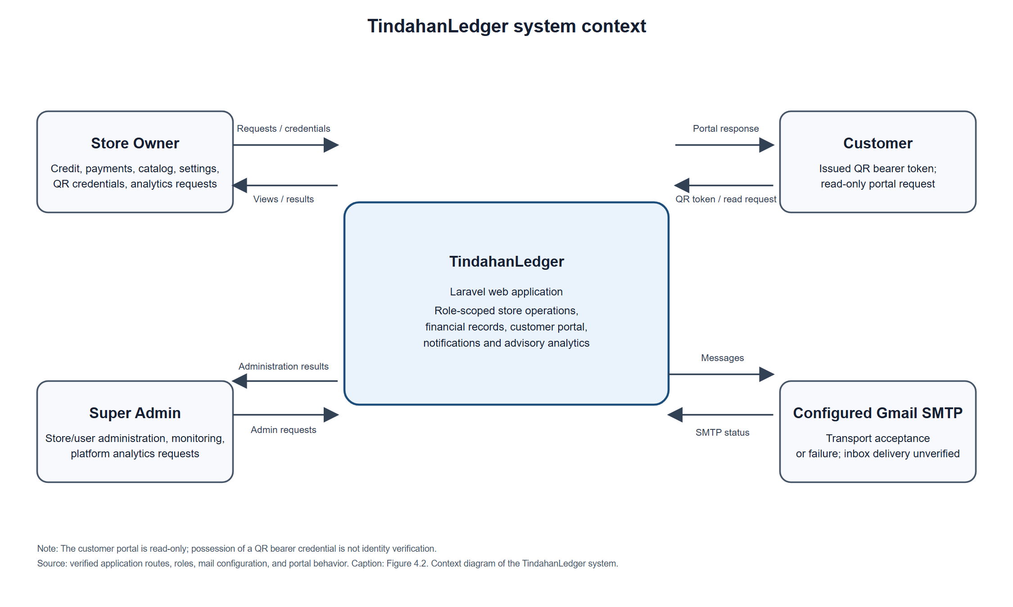
The diagram distinguishes the customer-facing portal from the authenticated owner and administrator workflows. A customer submits a bearer token from an issued QR code and receives only the corresponding read-only ledger view; the code proves possession of the credential, not the identity of the person holding it. Gmail SMTP is the only external service represented because the application contains a configured Gmail transport. Actual Gmail inbox delivery has not been verified, so the return flow denotes transport acceptance or failure rather than confirmed receipt.

4.2.5 Data Flow Diagram
Figure 4.3 decomposes the system boundary into Level 1 processes and logical data stores. Data-store labels name the actual application tables or groups of related tables defined by migrations. Process flows summarize the route/controller/service behavior; they do not imply that the application uses separate deployed services. The external entities match Figure 4.2.
Figure 4.3. Level 1 data flow diagram for TindahanLedger
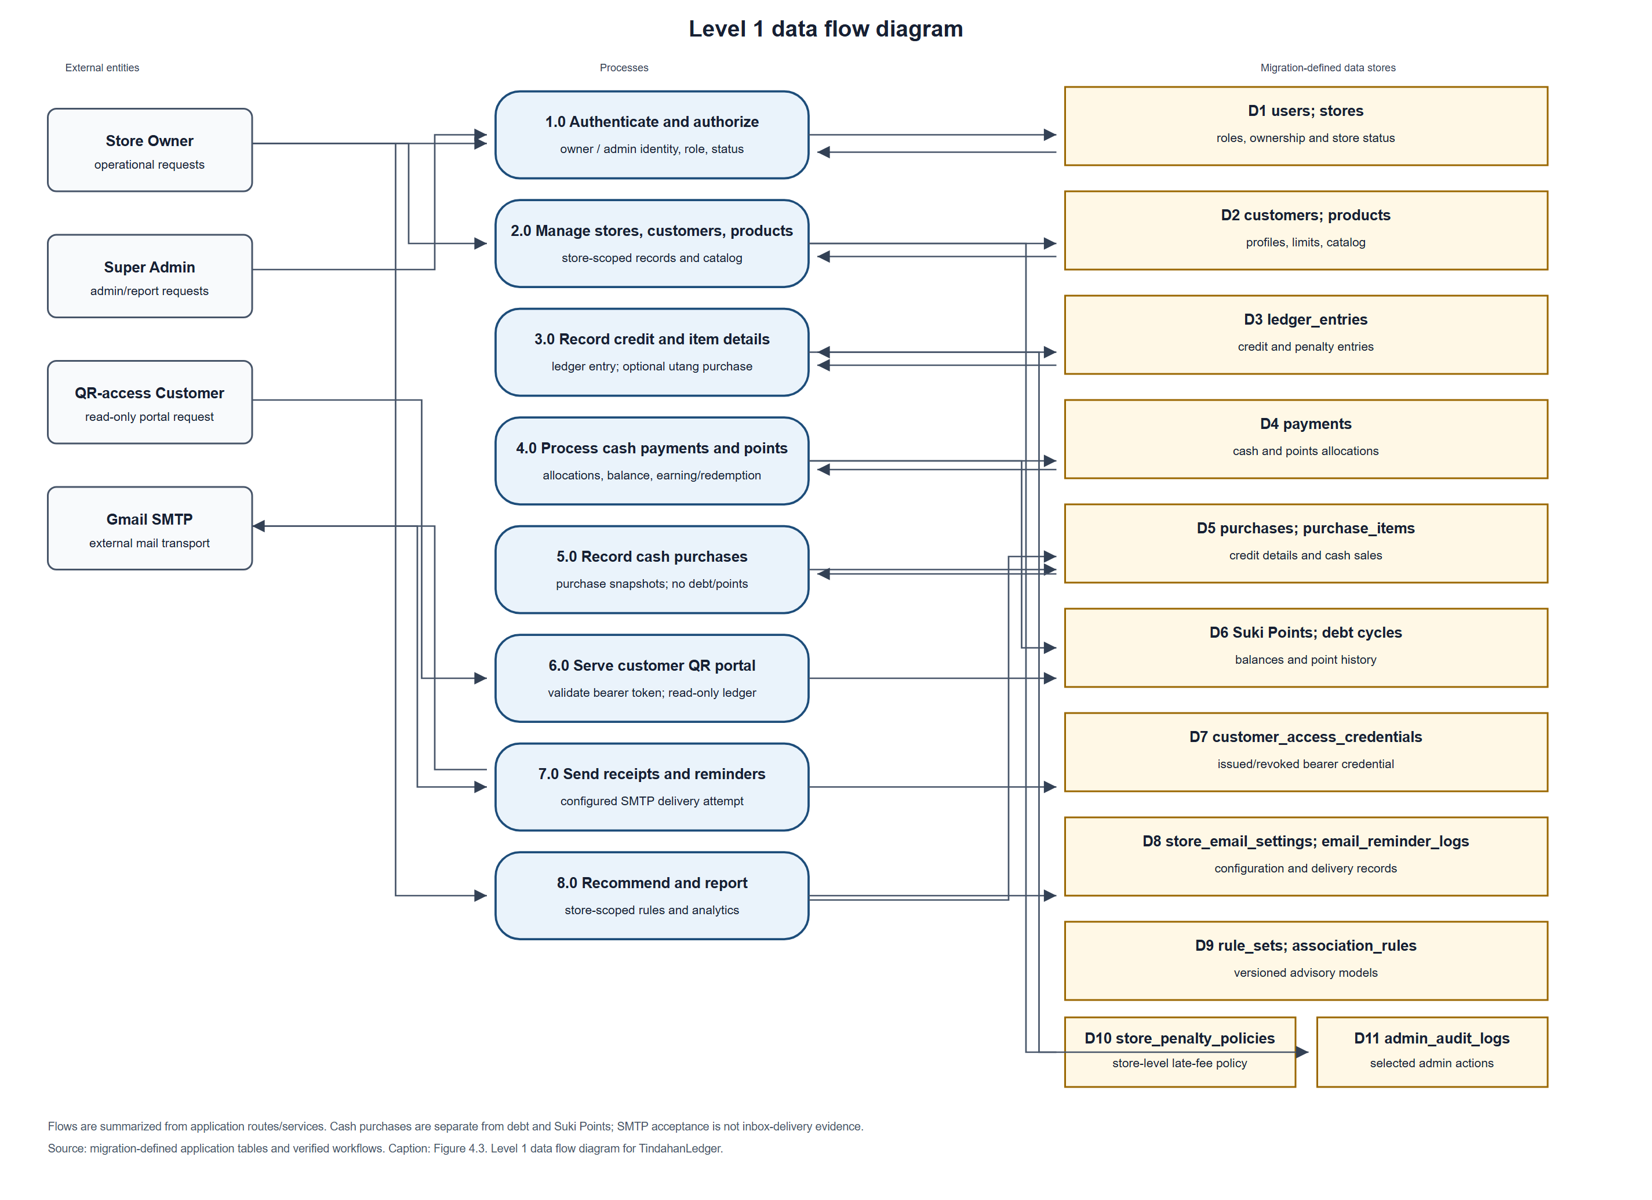
The processes preserve the application's business distinctions. A credit creates a ledger entry and may create a linked utang purchase with item snapshots; a cash purchase creates purchase records only and does not create debt or points. A cash repayment creates one or more payment allocations against outstanding ledger entries, updates the customer's balance summary, and supplies eligible cash allocations to Suki Points processing. A points redemption is recorded as a non-cash payment allocation and a points-history transaction. The recommendation endpoint reads store-scoped purchases, products, and active rules to return advisory suggestions; the application also has a rule-training command that writes versioned rule data. External basket validation is not a customer-facing data source. The data-flow diagram groups tables for legibility, while the ERD below specifies their separate entities and key constraints.

4.2.6 System Flowchart
Figure 4.4 follows an owner through authentication and the main operational workflows. It also shows the separate QR customer path because customer access does not begin with owner login. The diagram reflects server-side validation and transactional persistence found in the controllers and services; it is a high-level workflow, not a screen-by-screen user-interface specification.
Figure 4.4. Main TindahanLedger application workflow
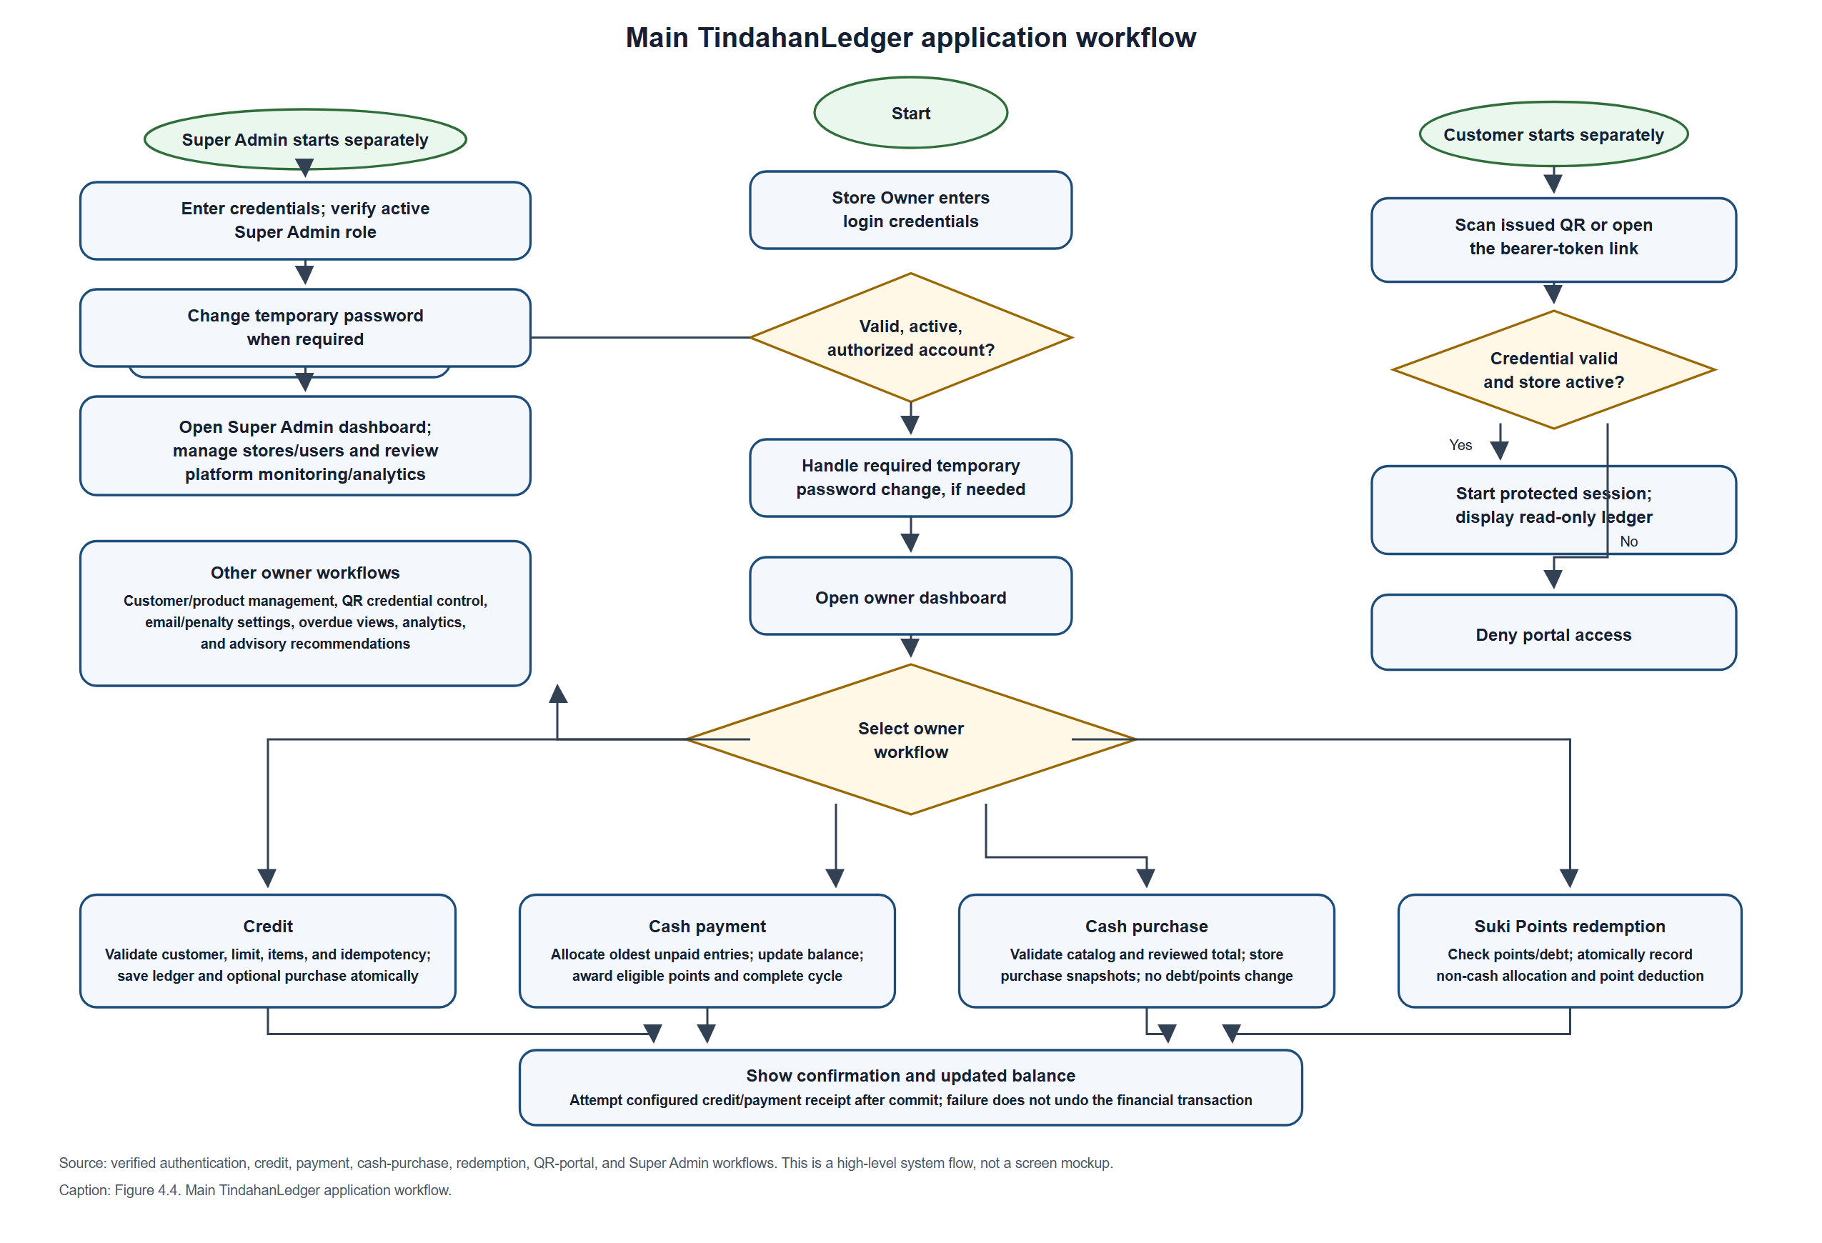
The main flow shows that the owner dashboard is reached only after account and role checks, with a forced password-change step where required. Each credit, payment, cash purchase, and redemption request resolves its idempotency key before creating new financial records, preventing a repeated submission from duplicating the transaction. Credit and payment decisions are validated on the server and written transactionally. Payment allocation is oldest-first; cash allocations can earn Suki Points, and a cleared debt cycle may create a completion record. Cash purchases are deliberately separate from debt recording. Points redemption is also a separate owner action that reduces debt as a non-cash allocation while deducting points in the same transaction. The QR flow starts from the owner's credential-management workflow and permits only read access after the bearer credential and store status are validated. Credit/payment receipt attempts occur only for newly created transactions and after commit; SMTP failure does not undo a committed ledger transaction.

4.2.7 Entity Relationship Diagram (ERD)
Figures 4.5(a) and 4.5(b) form a two-part ERD of the TindahanLedger domain tables represented in the migrations. The diagrams use actual table and column names and show primary keys, foreign keys, important unique constraints, and relationship cardinalities. Attribute lists are focused on identifiers and business-significant fields to keep the figure readable; timestamps, framework-managed columns, and secondary indexes are omitted. Laravel infrastructure tables such as sessions, cache, jobs, job_batches, failed_jobs, and password_reset_tokens are not shown because they are not domain entities. The diagrams describe the migration-defined schema, not a verified production database instance.
Figure 4.5(a). Core store, customer, ledger, catalog, and purchase entities
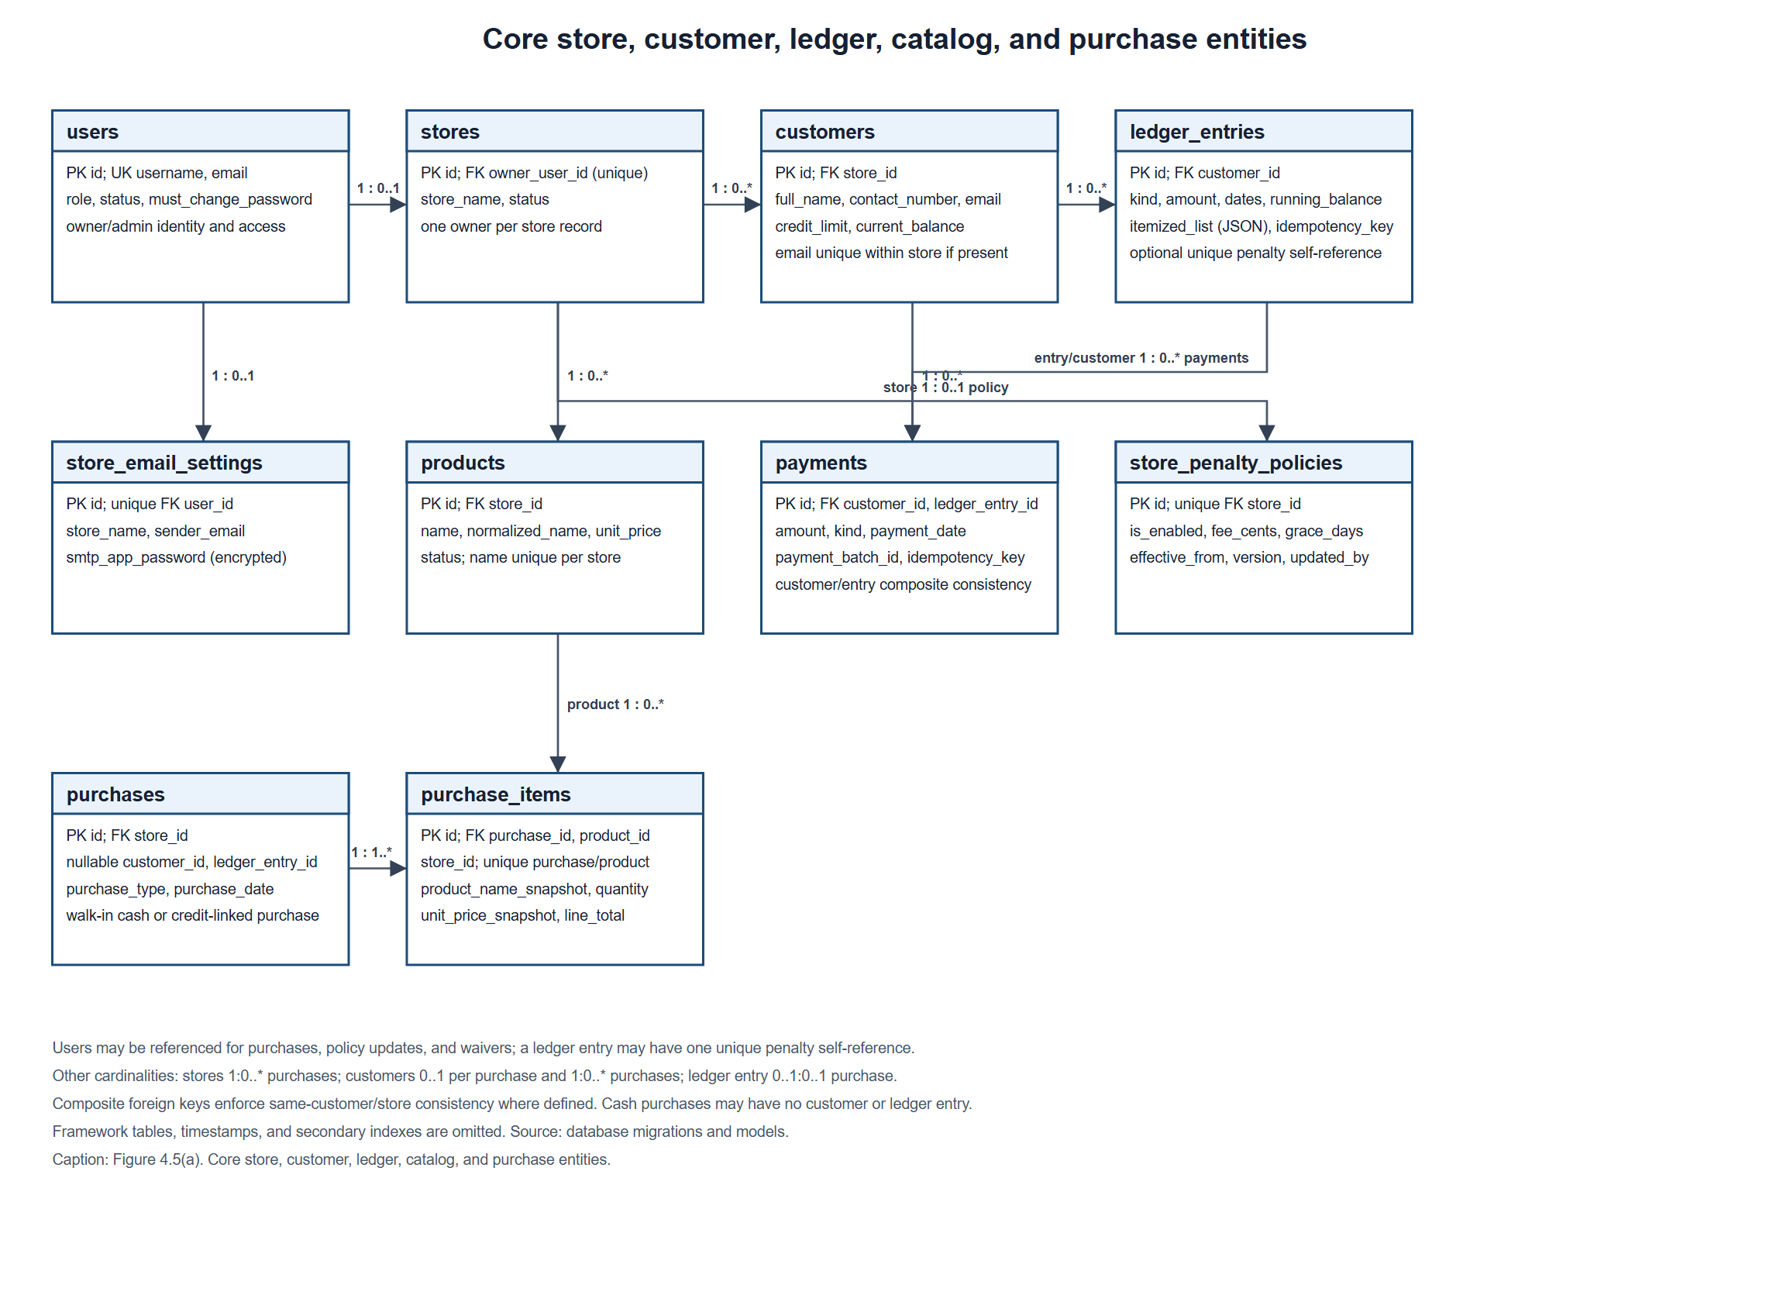
Figure 4.5(a) traces the store's primary commercial records. It separates account ownership, customer profiles, ledger entries, payment allocations, product catalog records, and purchase headers from purchase-item details. The optional links on purchases distinguish a utang purchase from a walk-in cash purchase. Store and customer consistency is enforced with composite foreign keys, while payments must point to a ledger entry for the same customer.
Figure 4.5(b). Loyalty, portal, notification, audit, and recommendation entities
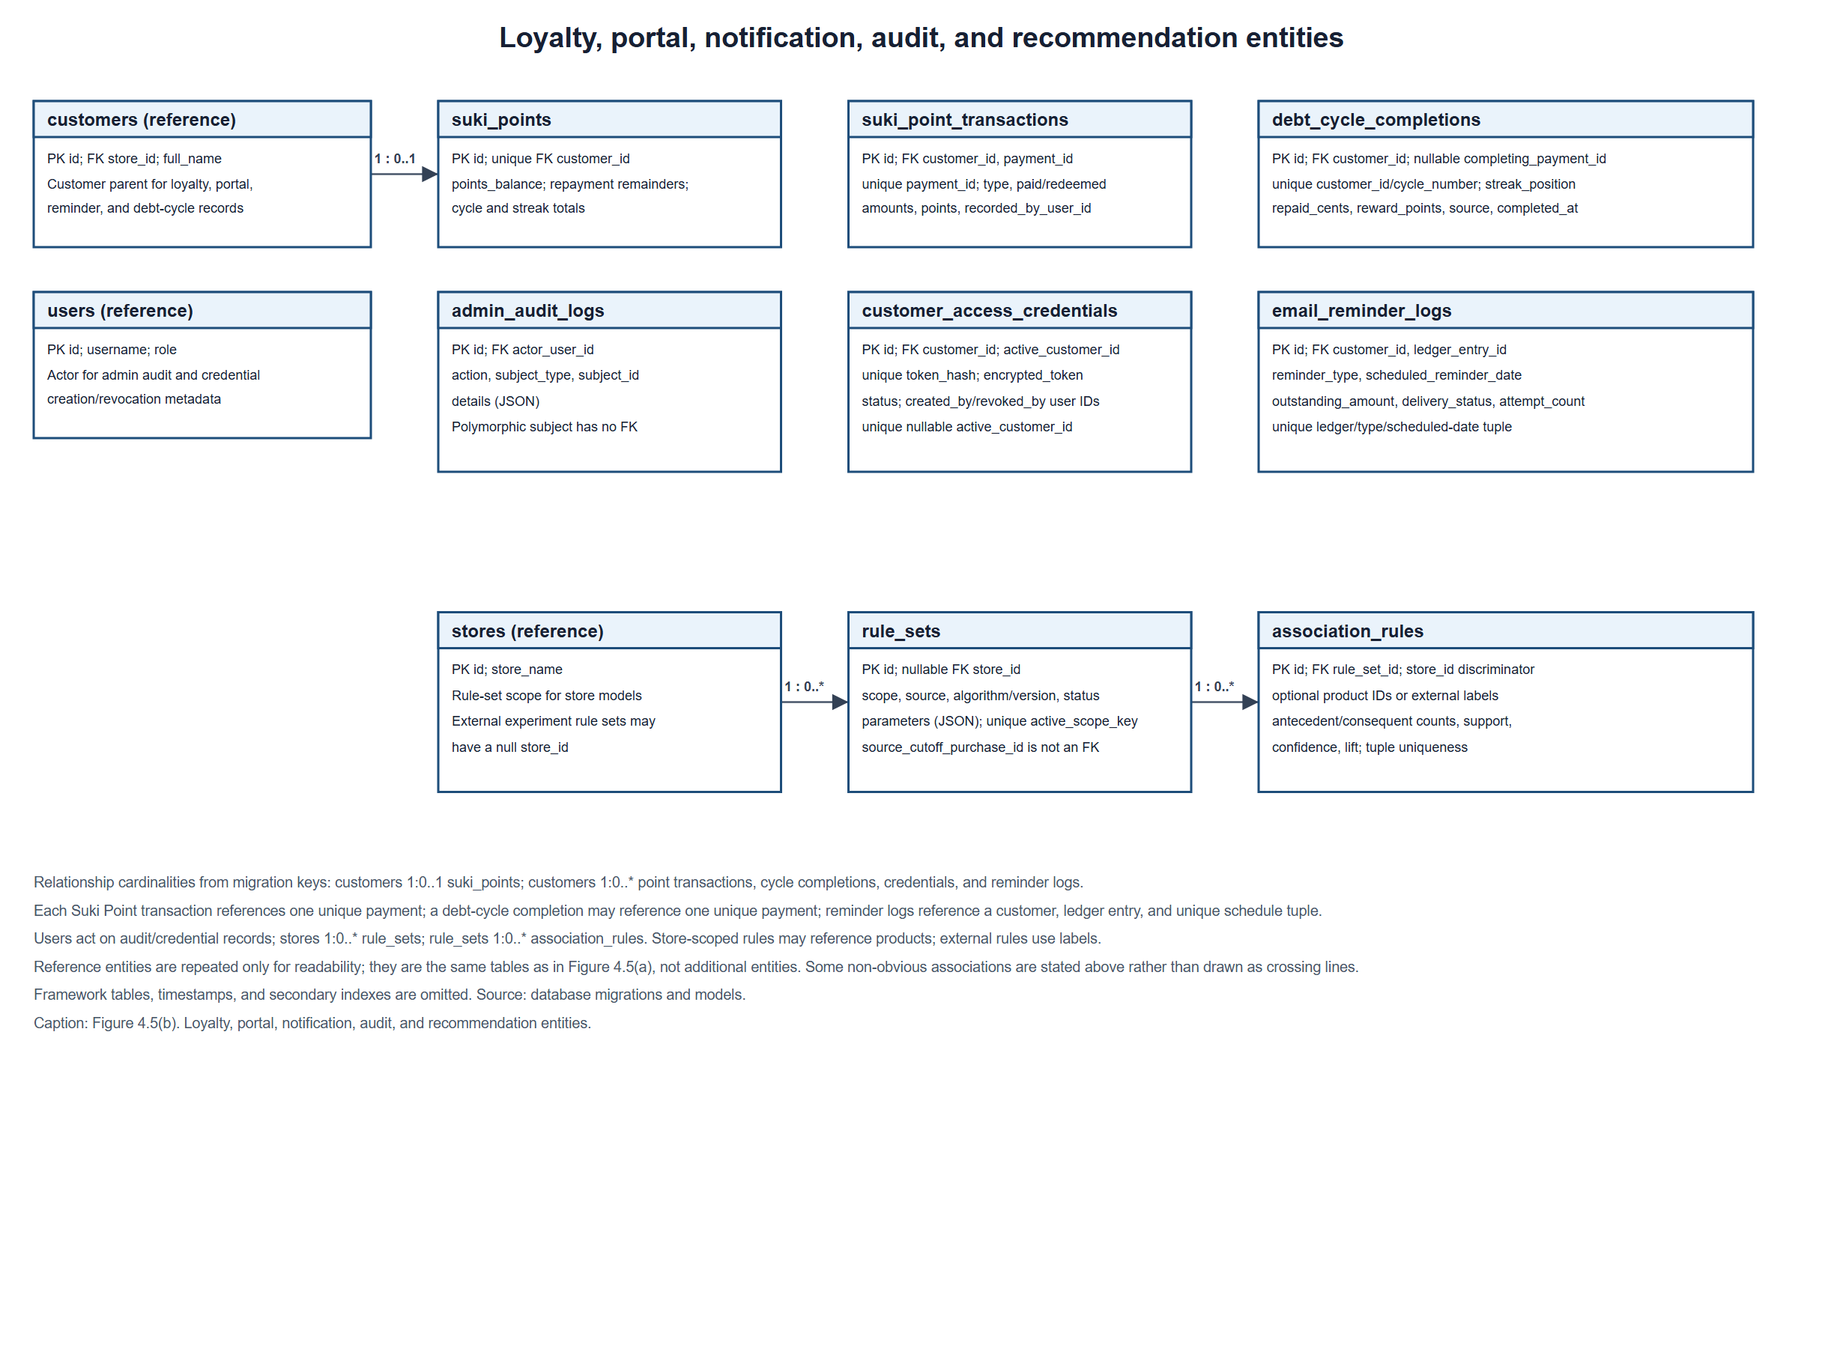
Figure 4.5(b) adds the supporting records for loyalty, portal credentials, reminder delivery, administrative audit, and recommendation models. A customer has at most one suki_points balance row; each Suki Points transaction is linked to one unique payment; and completed debt cycles are unique by customer and cycle number. QR token hashes are unique, while active_customer_id is a separate unique foreign key for the active-credential constraint. Reminder records have a composite uniqueness rule on ledger entry, reminder type, and scheduled date. A store rule set can contain many association rules; product links are present only for store-scoped rules, while external-experiment rows use labels.
The diagrams show each application entity once per part and mark roles of the actual foreign keys. A store owner is linked to at most one store because stores.owner_user_id is unique. payments references both a customer and a ledger entry, and the migration adds a composite constraint requiring the referenced entry to belong to that same customer. purchases may be a credit-linked utang purchase or a cash purchase; the cash form permits a null customer for a walk-in and has no ledger entry. Composite foreign keys on purchases and purchase_items enforce store consistency for customer, ledger, and product links. On MySQL/MariaDB, check constraints further distinguish cash and utang link requirements; where SQLite cannot install those checks on altered tables, services enforce the rule.
Some relationship endpoints require careful interpretation. The customer on a purchase and the ledger entry on a purchase are optional for cash purchases; the ledger-entry link is unique, so at most one purchase describes a credit entry. Other material unique constraints include (store_id, normalized_name) for products, (store_id, email) for a populated customer email, (purchase_id, product_id) for purchase items, and (rule_set_id, antecedent, consequent) or the corresponding label tuple for association rules. A nullable active_customer_id on an access credential is a unique foreign key used to enforce at most one active credential per customer; the service sets it to the same customer as customer_id. The admin_audit_logs.subject_type/subject_id pair is polymorphic and has no subject foreign key. rule_sets.source_cutoff_purchase_id is stored as an identifier but is not declared as a foreign key in the migration. Both are therefore not drawn as referential relationships. External-experiment rules use labels and a null store; they are not linked to catalog products and are never activated as store models.
The application ERD intentionally excludes Laravel infrastructure tables such as cache, sessions, jobs, failed jobs, password-reset tokens, and migration tracking because they are framework/runtime persistence rather than TindahanLedger business entities. The key constraints and optionality shown should be checked against the exact target database engine before describing a deployed schema; the repository establishes migration definitions, not proof that every migration has been applied to a production database.
Table 4.7. TindahanLedger domain data dictionary
Entity (database table) | Primary key | Selected attributes and data types | Relationships and constraints
users | id (bigint) | username (string), email (string), role (string), status (string), must_change_password (boolean) | Owns at most one store; configures email settings; referenced by administrative, credential, policy, purchase, and ledger audit fields.
stores | id (bigint) | owner_user_id (bigint), store_name (string), status (string) | owner_user_id is unique; store has many customers, products, and purchases.
customers | id (bigint) | store_id (bigint), full_name (string), contact_number (string), email (nullable string), residential_landmark (string), credit_limit and current_balance (decimal) | Belongs to a store; email is unique within a store when populated; has ledger, payment, purchase, loyalty, credential, reminder, and debt-cycle records.
ledger_entries | id (bigint) | customer_id (bigint), kind (string), amount and running_balance (decimal), itemized_list and penalty_policy_snapshot (JSON), transaction/deadline dates, idempotency_key (UUID) | Belongs to a customer; can receive payment allocations; a penalty may reference one original entry through a unique self-reference.
payments | id (bigint) | customer_id and ledger_entry_id (bigint), amount (decimal), kind (string), payment_date (date), payment_batch_id and idempotency_key (UUID) | Belongs to a customer and ledger entry; a composite constraint enforces that the entry belongs to that customer; idempotency key is unique.
products | id (bigint) | store_id (bigint), name and normalized_name (string), unit_price (decimal), status (string) | Belongs to a store; normalized name is unique within the store; may appear in purchase items and store-scoped association rules.
purchases | id (bigint) | store_id, nullable customer_id, nullable ledger_entry_id (bigint), purchase_type (string), purchase_date (date), recorded_by_user_id (bigint), idempotency_key (UUID) | Belongs to a store; optional customer and ledger links distinguish walk-in cash purchases from credit-linked purchases; ledger link is unique.
purchase_items | id (bigint) | purchase_id, store_id, product_id (bigint), product_name_snapshot (string), quantity (decimal), unit_price_snapshot and line_total (decimal) | Belongs to a purchase and product; (purchase_id, product_id) is unique; composite keys enforce store consistency.
store_email_settings | id (bigint) | user_id (bigint), store_name, sender_email (string), smtp_app_password (text) | user_id is unique; SMTP credential storage is protected by application encryption.
store_penalty_policies | id (bigint) | store_id (bigint), is_enabled (boolean), fee_cents (integer), grace_days and version (integer), effective_from (date), updated_by_user_id (bigint) | One policy per store; update actor references a user.
suki_points | id (bigint) | customer_id (bigint), points_balance (integer), repayment remainder and cycle totals (integer/bigint) | One balance row per customer through a unique customer reference.
suki_point_transactions | id (bigint) | customer_id, payment_id (bigint), transaction_type (string), paid/redeemed amounts (bigint cents), awarded/redeemed points (integer) | Belongs to a customer and payment; payment_id is unique; records earning or redemption history.
debt_cycle_completions | id (bigint) | customer_id, nullable completing_payment_id (bigint), cycle_number and streak_position (integer), repaid_cents (bigint), reward_points (integer), source (string) | Belongs to a customer; unique by customer/cycle number; completing payment is unique when present.
customer_access_credentials | id (bigint) | customer_id, nullable active_customer_id (bigint), token_hash (string), encrypted_token (text), status (string), creator/revoker user IDs (bigint) | Token hash is unique; unique nullable active_customer_id enforces at most one active credential per customer.
email_reminder_logs | id (bigint) | customer_id, ledger_entry_id (bigint), reminder_type (string), scheduled_reminder_date (date), outstanding_amount (decimal), delivery_status (string), attempt_count (integer) | Belongs to a customer and ledger entry; unique for ledger entry, reminder type, and scheduled date.
admin_audit_logs | id (bigint) | actor_user_id (bigint), action and subject_type (string), subject_id (bigint), details (JSON) | Actor references a user; subject_type/subject_id is polymorphic and has no subject foreign key.
rule_sets | id (bigint) | nullable store_id (bigint), scope_type, scope_key, source_type, algorithm, algorithm_version, status (string), parameters (JSON) | A store can have rule sets; active_scope_key is unique; external experiments may have no store; source_cutoff_purchase_id is not a foreign key.
association_rules | id (bigint) | rule_set_id, store_id, nullable product IDs (bigint), antecedent/consequent labels (string), counts (integer), support/confidence/lift (decimal) | Belongs to a rule set; store/product composite references apply to store-scoped rules; label combinations are unique within a rule set.
This concise dictionary lists the domain entities and business-significant attributes represented in the migration-based ERD. Framework-managed timestamp columns, secondary indexes, and infrastructure tables are omitted; it is not a replacement for the complete migration files or a target-database export.

4.2.8 Database Normalization
Normalization organizes attributes into relations to reduce repeating groups and avoid insertion, update, and deletion anomalies. The analysis below uses customer credit, payments, catalog products, and purchase items from the migration-defined schema. Codd's relational model provides a foundational basis for organizing records around relations and keys (Codd, 1970). This section evaluates the implemented design rather than assuming that a schema is in third normal form merely because it uses separate tables.

Unnormalized example (UNF)
Consider a hypothetical flat transaction record containing customer_id, customer name/contact/email, credit_entry_id, credit date and amount, product_1, quantity_1, product_2, quantity_2, payment_1, payment_date_1, payment_2, payment_date_2, and a balance. This is an instructional UNF example, not an actual TindahanLedger table. The numbered product and payment columns are repeating groups: a transaction with more items or installments requires more columns or duplicated rows. Repeating customer/product details with every transaction also makes single facts appear in several places.
Such a flat structure creates an update anomaly when a customer's contact or a product's catalog details must be changed in multiple transaction rows. It creates an insertion anomaly when a store needs to add a customer or product before that person has a credit transaction. It creates a deletion anomaly when deleting the customer's only credit row also removes the only stored copy of that customer's details. Repeated payment columns also make partial payments and an arbitrary number of installments difficult to represent consistently.

First Normal Form (1NF)
The first normalization step removes repeating groups and stores one value for each attribute in each row. In the actual structured purchase path, a purchase header is stored separately from its product rows in purchases and purchase_items; one item row records one product, quantity, and historical price/name snapshot. Payments are separate allocation rows linked to a ledger entry, so a credit can have multiple payment allocations rather than fixed payment_1 and payment_2 columns. Customers and products are stored as distinct records.
The entire application schema cannot be asserted to satisfy strict 1NF without qualification. ledger_entries.itemized_list is a JSON column designed to store a list of free-text item descriptions; rule-set parameters/source details and audit details are also JSON documents. JSON is a single database column, but a value that semantically contains a list or structured multi-valued attributes is not atomic under a strict relational interpretation. The structured purchase_items path avoids this issue for catalog-linked items; the retained JSON/free-text path should be described as a document-valued exception, not evidence that every relation is strictly 1NF.

Second Normal Form (2NF)
For relations with a composite candidate key, 2NF requires each non-key attribute to depend on the whole candidate key and not only part of it. Most application tables use a single-column primary key, which removes partial dependency relative to that surrogate key. However, the schema also defines meaningful composite unique keys. purchase_items is unique on (purchase_id, product_id), while store_id is determined by the purchase alone (and is also constrained against the product's store). Thus, store_id is repeated relative to that composite key. It is intentionally retained to support composite foreign keys that prevent cross-store purchase/product combinations. The association-rule table likewise stores store_id alongside a rule_set_id that determines the store for store-scoped models, so the store discriminator is partly redundant by design.
These are identifiable departures from a strict 2NF decomposition for the composite-key views of those relations. They are integrity-oriented denormalizations and should not be concealed by labeling all tables fully normalized. Their safety depends on the composite foreign keys on the target engine and, where those constraints are unavailable, on the corresponding service validation.

Third Normal Form (3NF) and functional dependencies
3NF removes non-key attributes that depend transitively on a candidate key through another non-key attribute. The core entity tables separate customer profile, store ownership, product catalog, ledger entries, payment allocations, purchase headers, and item details. This separation limits repeated customer and catalog facts. The following dependencies illustrate both the normalized structure and the remaining redundant attributes.
Table 4.8. Functional dependencies and normalization implications in TindahanLedger
Relation and determinant | Functional dependency supported by keys or business rules | Normalization implication
customers | customer_id → store_id, full_name, contact_number, email, residential_landmark, credit_limit, current_balance. For a non-null email, (store_id, email) → customer_id is enforced by a unique index. | Customer profile facts are kept in one customer record rather than repeated in each credit or payment. Email uniqueness is tenant-scoped; nullable email means the alternate dependency applies only when populated.
ledger_entries | ledger_entry_id → customer_id, kind, amount, transaction_date, repayment_deadline, running_balance, note, penalty fields. A non-null penalty_for_entry_id is unique. | Each ledger row describes one credit or penalty for a customer. The unique self-reference permits at most one penalty entry per underlying entry.
payments | payment_id → ledger_entry_id, customer_id, amount, kind, payment_date, payment_batch_id, note. A non-null idempotency_key is unique. Also, ledger_entry_id → customer_id in ledger_entries. | The payment's customer_id is functionally derivable from its ledger entry, so it is a transitive/repeated value for a given allocation. The composite (ledger_entry_id, customer_id) foreign key intentionally stores and checks both to prevent mismatched-customer allocations.
purchases and purchase_items | purchase_id → store_id, customer_id, ledger_entry_id, purchase_type, purchase_date. (purchase_id, product_id) → quantity, product_name_snapshot, unit_price_snapshot, line_total, store_id is unique at item level. | Header/detail separation removes repeating product groups. store_id in purchase_items is also determined by purchase_id; it is retained for composite same-store foreign keys. Snapshot name and price represent values at the historical sale, not current products values.
suki_point_transactions | payment_id → customer_id, transaction_type, paid_amount_cents, points_awarded, points_redeemed, redeemed_amount_cents, remainder values; payment_id is unique. | Customer identity can be derived through the payment, so storing both identifiers duplicates a dependency. The migrations separately reference both rows; service logic associates the right customer and payment, but no composite customer/payment FK was found for this relation.
products | product_id → store_id, name, normalized_name, unit_price, description, status; (store_id, normalized_name) → product_id is unique. | Product facts are maintained in the catalog once. Purchase item snapshots remain intentionally independent so later catalog edits do not rewrite historical records.
The customers.current_balance, ledger_entries.running_balance, and suki_points.points_balance fields are stored summaries alongside transaction/history records. The services update relevant summaries as part of financial transactions, while ledger/payment records support financial reporting. These values therefore require reconciliation invariants; their storage is a deliberate performance/usability choice rather than proof of a fully non-redundant schema. Similarly, purchase_items.line_total is stored with the quantity and unit-price snapshot to preserve the recorded line value. The financial value owed remains the linked ledger entry amount for an utang purchase; purchase item totals are descriptive purchase data.
Accordingly, the source supports a qualified conclusion: TindahanLedger uses normalized entity separation and key constraints for major business records, but the complete schema cannot presently be certified as wholly 1NF, 2NF, or 3NF. The retained JSON lists, store discriminators on composite-key relations, repeated customer identifiers for integrity constraints, and cached balance/point summaries are material exceptions or design trade-offs. A formal normal-form claim would require a table-by-table candidate-key and dependency analysis, examination of actual JSON value domains, and verification of constraints against the deployed engine.

Anomaly reduction in the implemented schema
The schema reduces common anomalies in several ways. Customer contact and credit-limit facts reside in customers; product catalog facts reside in products; credit/payment history is represented in separate ledger_entries and payments; and product rows for a purchase reside in purchase_items. The unique store/product-name constraint and idempotency keys help prevent duplicate catalog names or replayed financial operations. Composite foreign keys enforce that payments, utang purchase details, and store-scoped recommendation rules do not mix records across customers or stores where those constraints are declared.
An insertion can create a store, customer, or catalog product without requiring an associated credit transaction. Cash purchase records can have no customer, which supports a walk-in sale without inventing a customer row. Restrictive foreign keys preserve customers, ledger entries, payments, purchases, and products referenced by financial or purchase history; where the application supports a product status change, deactivation is preferable to erasing a product needed to interpret past transactions. These restrictions mitigate history-loss deletion anomalies but do not replace an approved retention or privacy-erasure procedure.
Some update anomalies remain possible if stored summaries diverge from their transaction histories. The services lock records and use database transactions for credit, payment, cash-purchase, and Suki Points operations, but the schema includes duplicate or derived state that should be reconciled and tested on the intended production database. In particular, a passing test suite on SQLite does not prove MySQL/MariaDB constraint, lock, or concurrent-update behavior. The final research report should therefore present this analysis as a source-based normalization review, not as a claim of formal database certification.

4.2.9 Use Case Diagram
Figure 4.6 summarizes implemented functions by verified actor. Mermaid does not provide a dedicated standard UML use-case diagram syntax; the flowchart below uses actor-labeled nodes, an explicit system boundary, and oval-shaped nodes for use cases. The associations can be recreated in diagrams.net using UML actor symbols and use-case ovals. No include/extend relationships are asserted.
Figure 4.6. TindahanLedger use-case diagram
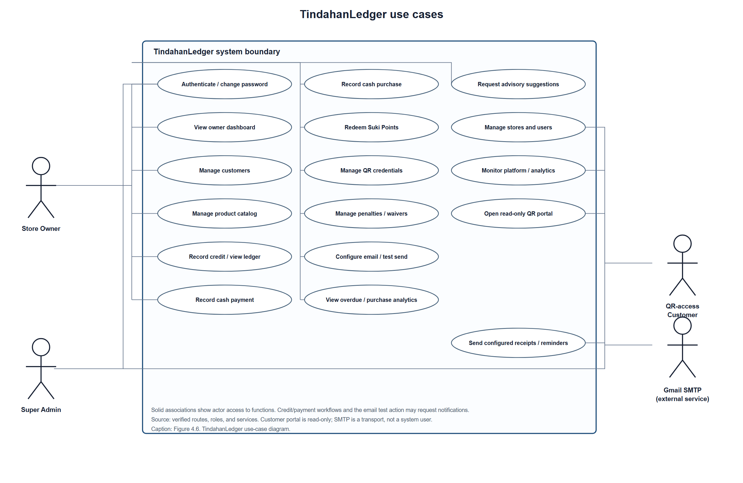
The Store Owner is associated with customer/catalog management, ledger and sales operations, Suki Points, QR credential administration, store settings, and store-level reporting and recommendations. The Super Admin manages stores and user accounts and views platform transaction/analytics functions. A Customer uses the issued bearer credential to access the read-only portal and has no owner/admin permissions or password-based account in the inspected implementation. Gmail SMTP participates only as the external delivery transport for configured receipts, reminders, and test messages; it is not an application user. A credit/payment or email-test workflow may request a notification, but no use-case association implies guaranteed delivery.

Draw.io recreation specification
For a standards-style UML version of Figure 4.6, place a rectangle labeled TindahanLedger as the system boundary. Put four actors outside the boundary: Store Owner on the left, Super Admin below-left, QR-access Customer on the right, and Gmail SMTP below-right as an external service. Place the 17 use cases in the boundary as ovals using the labels in Figure 4.6. Draw solid, undirected associations from each actor to the corresponding ovals shown in the Mermaid diagram. Draw dashed dependency arrows from “Record credit and view ledger,” “Record cash payment,” and “Configure email and send test message” toward “Send configured receipts and reminders,” labeled “may request notification.” Do not add a customer registration/password use case, customer write access, or customer-specific recommendation use case.

4.2.10 Maintenance Plan
Only the repayment-reminder and late-penalty schedules below are configured in the inspected source. Other activities are recommended operating procedures, not existing schedules. Frequency and responsibility must be approved and documented before deployment.
Table 4.9. TindahanLedger maintenance plan
Maintenance Category | Scheduled Plan and Operational Procedure | What to Assess and Monitor
Corrective maintenance and application errors | Proposed: review application errors after releases and investigate production incidents as they occur. Use the existing Laravel logging configuration; preserve sanitized error context and avoid recording credentials, QR tokens, or full customer financial details. Frequency, on-call role, and response targets are [NEEDS VERIFICATION]. | Error/exception rate, failed transactions, failed mail attempts, scheduler command failures, repeated validation failures, sensitive-data leakage in logs, and time to resolution.
Database backup and recovery | Required operational plan; implementation not evidenced: choose a database backup method, schedule, encryption/access control, off-site retention, retention duration, and restore procedure before production records are entered. Perform and document restore tests at an approved interval. | Backup completion/failure, recoverable point-in-time, restore-test outcome, integrity of customers/ledger/payments/purchases/points after restore, access to backup media, and approved recovery-point/recovery-time objectives. All intervals/objectives are [NEEDS VERIFICATION].
Scheduler and background operations | Implemented schedules: reminders:send-due runs daily at 08:00 and penalties:apply-due runs daily at 00:30 in the configured application timezone; both use withoutOverlapping and onOneServer. Deployment procedure documented: configure system cron to invoke php artisan schedule:run each minute and confirm using php artisan schedule:list. | Confirm cron/scheduler availability and timezone, command exit status, processed/sent/skipped/failed counts, duplicate reminder prevention, penalty eligibility, overlap/single-server lock behavior, and cache availability. A production cron installation has not been evidenced.
SMTP and notification operations | Implemented functionality: owner-configured Gmail SMTP settings, receipts, and scheduled reminders; email settings are encrypted in storage. Proposed procedure: validate configuration after authorized credential rotation, use the controlled test-email feature, and verify delivery in the recipient mailbox. No actual delivery record was provided. | TLS connection outcome, SMTP acceptance versus inbox delivery, invalid recipient handling, sanitized failure logs, reminder retries/duplicate behavior, and credential re-entry after key rotation. Do not retain App Passwords in issue trackers or reports.
Security maintenance and access review | Proposed: review user/store status and privileged access at an institution-approved interval and after role/ownership changes; update supported PHP/Laravel/dependencies through reviewed changes; apply security fixes with regression tests. No approved interval or assigned security maintainer was found. | Active accounts, role/store assignment, temporary-password completion, dependency advisories, patch status, secrets exposure, session and authorization regressions, audit-log coverage, and security-test findings.
Schema and financial-integrity maintenance | Proposed: review each migration and rollback impact before applying it to a maintained environment; back up data before high-risk schema changes; run focused financial and migration tests, then the full suite in CI/release verification. | Applied migration version, foreign-key/unique constraints, balance and payment reconciliation, idempotency behavior, rollback safety, target-engine compatibility, and data anomalies. Production MySQL/MariaDB migration state is [NEEDS VERIFICATION].
QR credentials and customer privacy | Implemented: credentials can be issued/replaced/revoked; revoked credentials are invalidated and their encrypted token is cleared. Proposed procedure: revoke exposed/returned credentials promptly, reissue through the authorized owner workflow, and follow the approved privacy incident process if financial data may have been disclosed. | Active credential count/status, last-used metadata, revoked-token denial, customer/store status, idle-session expiry, QR distribution practices, private response headers, and incident handling. Formal incident/privacy procedures are [NEEDS VERIFICATION].
Recommendation model and data quality | Implemented: store-scoped versioned models, validation/activation lifecycle, read-only analytics and evaluation commands; external data validation exists, but external basket import is explicitly not implemented. Proposed procedure: review model status and evaluation evidence before activation; train only on authorized, suitable store data and retain model/run metadata. | Eligible basket count, rule validation, model failures, active/superseded version integrity, data suitability/licensing, evaluation split/coverage/hit metrics, and whether evidence is representative. Do not promote synthetic or unlicensed external data as validated sari-sari demand.
Perfective maintenance and user feedback | Proposed: prioritize approved usability and capability changes as separate increments; preserve current regression tests and update documentation as behavior changes. No formal user-feedback log or approval cadence was found. | Change requests, accepted/rejected rationale, usability evidence, regressions, performance against approved targets, accessibility findings, and alignment with stakeholder-approved requirements.
Discussion. The maintenance plan separates implemented scheduled work from operational procedures that have not yet been evidenced. In source, reminder and late-penalty commands have explicit times, timezone handling, and overlap/single-server controls. The README further explains that a server-level scheduler must invoke Laravel's scheduler; therefore, scheduled command definitions alone do not prove that the commands execute in a deployed environment. Email delivery likewise has configured handling and automated transport tests, but no real Gmail delivery was verified in the project records.
Backups, recovery, security patching, access review, and incident response are necessary proposed operating responsibilities because TindahanLedger stores customer and financial records. They are listed as plans requiring approval, not as current capabilities. Maintenance assessment should retain verifiable evidence such as scheduler output, restore-test records, migration status, test reports, sanitized error summaries, and documented model-evaluation artifacts. The quality-management rationale may be aligned with ISO/IEC 25010:2023, while security and privacy activities can be organized using OWASP ASVS and NIST SP 800-53; those frameworks do not substitute for an approved local operating procedure or a formal compliance assessment.

4.2.11 Gantt Chart
A Gantt chart requires verified activity start/end dates and durations. Git commits and ticket-named branches provide dated implementation milestones, but not the complete time spent on analysis, design, implementation, testing, review, or deployment. The following dated commit timeline is included only as repository evidence; its timestamps are not task creation dates, durations, or dependencies.
Figure 4.7. Dated GitHub branch-head commit milestones identified for TindahanLedger
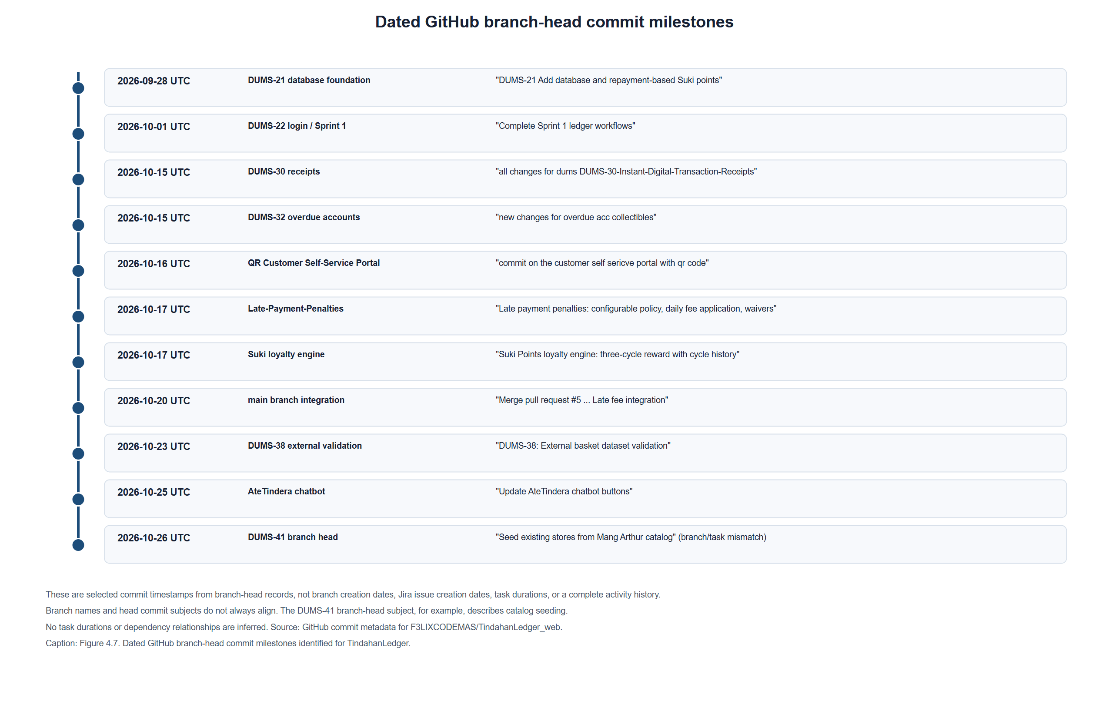
Source: GitHub branch-head commit records for F3LIXCODEMAS/TindahanLedger_web; timestamps are based on the commit metadata and displayed as UTC dates. Branch names and commit subjects are not consistently aligned, and branch creation timestamps are unavailable through the inspected branch listing.
Figure 4.8. Gantt chart pending verified project schedule
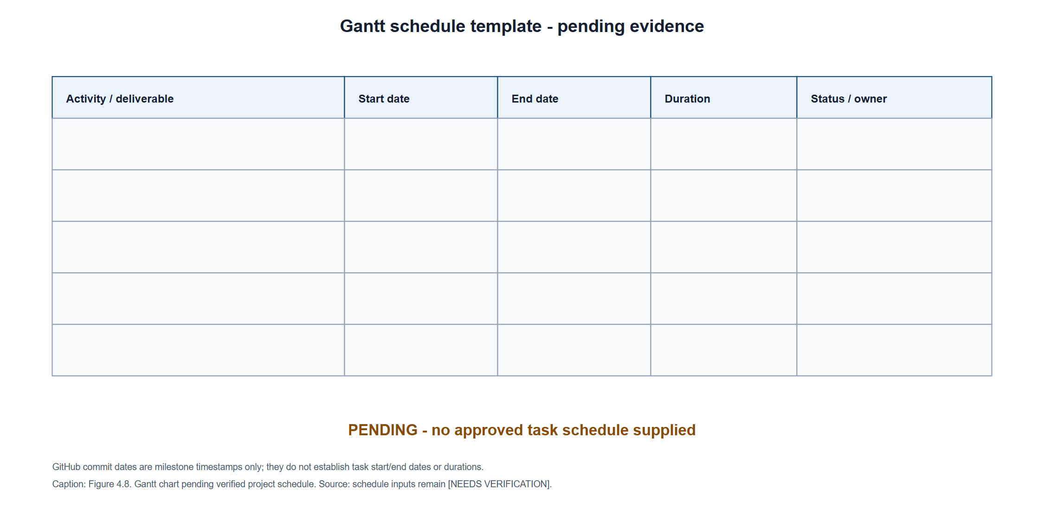
[PENDING: An approved schedule with activity start/end dates or durations, status, and owners is required. Do not interpret Figure 4.7 as a Gantt chart.]

4.2.12 PERT Chart
A PERT chart requires task durations and predecessor relationships to calculate Early Start (ES), Early Finish (EF), Late Start (LS), and Late Finish (LF). These estimates and dependency records were not available in the inspected repository. [NEEDS VERIFICATION] Obtain approved task-duration estimates, activity dependencies, and the scheduling time unit. Until these are supplied, a calculated network and critical path would be invented; no numeric ES/EF/LS/LF values are reported here.
Figure 4.9. PERT network and critical-path calculations pending verified inputs
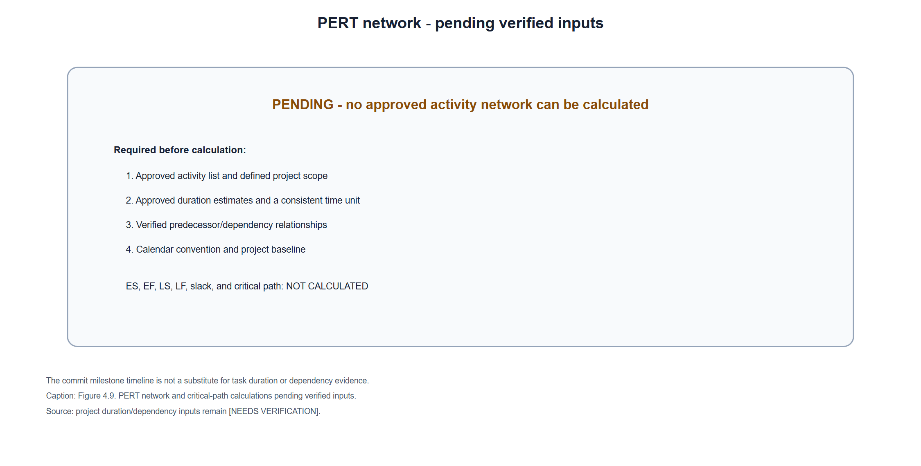
[PENDING: Activity durations, predecessor relationships, and the approved scheduling time unit are unavailable; ES, EF, LS, LF, slack, and critical path are not calculated.]
Table 4.10. PERT input evidence required before calculation
Required input | Evidence needed | Status
Activity and scope | Approved task list corresponding to project deliverables | [NEEDS VERIFICATION]
Duration | Approved optimistic, most-likely, and pessimistic estimates if the selected PERT method uses three-point estimates; or another adviser-approved duration method | [NEEDS VERIFICATION]
Predecessors | Jira dependency links or approved activity dependency list | [NEEDS VERIFICATION]
Calendar convention | Working days or calendar days, project start baseline, and holidays/non-working time | [NEEDS VERIFICATION]
ES, EF, LS, LF, slack, and critical path | Calculated from verified activity/duration/dependency inputs | Not calculated; inputs are unavailable

References
Beck, K., Beedle, M., van Bennekum, A., Cockburn, A., Cunningham, W., Fowler, M., Grenning, J., Highsmith, J., Hunt, A., Jeffries, R., Kern, J., Marick, B., Martin, R. C., Mellor, S., Schwaber, K., Sutherland, J., & Thomas, D. (2001). Manifesto for Agile Software Development. https://agilemanifesto.org/
International Organization for Standardization. (2023). ISO/IEC 25010:2023 systems and software engineering—Systems and software quality requirements and evaluation (SQuaRE)—Product quality model. https://www.iso.org/standard/78176.html
Larman, C., & Basili, V. R. (2003). Iterative and incremental developments: A brief history. Computer, 36(6), 47–56. https://doi.org/10.1109/MC.2003.1204375
National Institute of Standards and Technology. (2020). Security and privacy controls for information systems and organizations (NIST Special Publication 800-53, Revision 5, Update 1). https://csrc.nist.gov/pubs/sp/800/53/r5/upd1/final
OWASP Foundation. (n.d.). Application Security Verification Standard (ASVS), version 5.0.0. https://asvs.owasp.org/
Codd, E. F. (1970). A relational model of data for large shared data banks. Communications of the ACM, 13(6), 377-387. https://doi.org/10.1145/362384.362685

4.3 Description of the Prototype
TindahanLedger is implemented as a browser-based Laravel application for sari-sari store operations. The checked-in prototype includes role-specific owner and Super Admin interfaces, a separate read-only customer portal accessed through an issued QR credential, relational transaction records, and integrations for configured email delivery. The repository and tests establish that these features have implementation evidence; they do not establish that the prototype has been released to a public production server or accepted by store users.

System architecture
The application follows a server-side Laravel web architecture. A browser submits requests to routes in routes/web.php; middleware and policies apply authentication, role, password-change, store-status, and record-access controls. Controllers coordinate requests and responses, Form Requests validate user input, and services implement business rules. Eloquent models and migration-defined tables persist application data. Blade templates render the owner, administrator, and customer-facing pages, with JavaScript and compiled CSS supporting interactive and responsive interfaces.
The principal financial operations are implemented as database transactions in services such as LedgerService and CashPurchaseService. Credit and payment records are kept separate from cash-purchase records. Payment allocation, Suki Points, and associated balance updates are coordinated by the applicable services. The recommendation and analytics functions read store-scoped purchase and product data. Email delivery and scheduled reminder/penalty commands are application operations; they are not separate deployed microservices in the inspected source.

Hardware used and hardware requirements
No specialized point-of-sale terminal, dedicated scanner, or other proprietary hardware is required by the inspected application. The repository documents local QR access testing using a developer computer and a phone connected to the same Wi-Fi network or hotspot. This documents a supported local testing arrangement, not proof that a device test was completed.
The prototype can be accessed using ordinary browser-capable computing devices and network connectivity. A phone camera or QR-scanning capability is needed only when a customer opens the portal by scanning the issued QR code; the URL can otherwise be opened as an ordinary web link. The exact developer computer model, processor, memory, storage, customer device models, and any production-server hardware are [NEEDS VERIFICATION]. No public deployment host or deployment hardware inventory was found.

Software requirements and development environment
The project manifests and local development notes identify the following software components:
Table 4.11. TindahanLedger software requirements and development environment
Component | Evidence-based description
Server-side runtime and framework | PHP ^8.2 and Laravel ^12.0 are declared in composer.json. The installed package report identifies Laravel Framework 12.69.2. The local PHP CLI used for this documentation run reported PHP 8.2.12.
Dependency and asset tools | Composer manages PHP packages. package.json declares Vite 7 and Tailwind CSS 4 toolchain packages; the inspected local environment reports Vite 7.3.6, Tailwind CSS 4.3.3, and Node.js 24.21.0.
Database | Laravel migrations and Eloquent define the relational schema. The audit handoff records that the active local database driver resolved to MySQL and that the listed migrations had run at the time of that audit. The README documents development measurements on MariaDB 10.4.32 under XAMPP on Windows. The final target database engine/version and production schema state are [NEEDS VERIFICATION].
Automated-test database | phpunit.xml configures the test suite to use SQLite :memory:, an array cache/session, synchronous queue, and array mailer. This test arrangement is distinct from the local MariaDB development measurements and any future production database.
Email transport | .env.example contains placeholder settings for Gmail SMTP using port 587 and TLS. Real credentials are not included. Gmail inbox delivery is not verified.
Browser and network | The application is accessed through a web browser. The README documents local Wi-Fi/hotspot QR testing instructions. The supported browser/device matrix and public network configuration are [NEEDS VERIFICATION].
The documented local development arrangement is Windows with XAMPP/MariaDB for selected development checks, plus PHP, Composer, Node.js, and npm-based asset tooling. The repository does not establish a single, fully specified developer workstation image or a production environment. Hardware specifications and an approved browser/version matrix are [NEEDS VERIFICATION].

Application modules
The implemented prototype contains the following modules, based on the routes, controllers, services, views, migrations, tests, and project documentation:
Table 4.12. Implemented TindahanLedger application modules
Module | Prototype functionality
Authentication and role-specific access | Store Owner and Super Admin sign-in, role-restricted routes, account status checks, and required temporary-password change handling.
Store and customer management | Store and user administration; owner management of store customers and customer records.
Credit ledger and payments | Recording customer credit, viewing ledger history and balances, and recording cash payments allocated to outstanding entries.
Product catalog and purchase records | Store-scoped product management; structured item rows for credit-linked purchases; separate cash purchases with item and price snapshots.
Customer QR self-service portal | Owner-issued, replaceable, and revocable bearer credentials; customer read-only ledger and balance access. QR images are generated locally as SVG.
Suki Points and late-payment controls | Points accrual and redemption, debt-cycle records, store penalty settings, due-penalty processing, and supported waiver workflow.
Email settings and reminders | Owner-configured Gmail settings, test-message interface, credit/payment receipts, and scheduled repayment reminders. The underlying SMTP infrastructure is implemented, but real delivery is unverified.
Analytics and recommendations | Owner purchase analytics, transaction-entry suggestions based on store-scoped single-item association rules, and optional offline evaluation. Suggestions are advisory and do not modify a transaction automatically.
Super Admin monitoring | Store and user administration, transaction monitoring, and platform analytics.

System interfaces
The Store Owner interface includes the dashboard and pages for customers, products, credit entries, payments, cash purchases, QR credentials, settings, overdue accounts, purchase analytics, and recommendation suggestions. The Super Admin interface provides administrative store/user management and platform monitoring. The QR-access customer interface is separate from owner and administrator authentication and presents read-only ledger information. Gmail SMTP is an external delivery interface for configured messages; its actual production connection and inbox delivery have not been demonstrated.
The repository includes Blade source views for these screens but no prototype screenshots were found in the inspected public or storage image locations. Consequently, this description is based on source and automated test evidence rather than a verified visual walkthrough.

Actual deployment environment
No production host, public domain, deployment pipeline run, live database instance, production monitoring configuration, or deployment acceptance record was found. The README explains how a developer may run the application locally and how to configure Laravel's scheduler; instructions are not proof those steps were completed on a production server. The prototype's actual production deployment status is therefore [NEEDS VERIFICATION]. The intended hosting provider, server operating system, database version, TLS/domain configuration, backup target, operational owner, and production rollout date require deployment evidence.

4.4 Implementation Plan (Infrastructure/Deployment)

Project Title
TindahanLedger: Digital Utang Tracking System with Gmail SMTP Notifications and Suki Points for Sari-Sari Stores

Project Description
TindahanLedger is a Laravel web application intended to support store owners in recording and reviewing customer credit, payment allocations, balances, products, and purchases. The prototype also provides QR-based read-only customer access, Suki Points, configured Gmail SMTP messaging, store-level purchase analytics, and advisory product suggestions. This section distinguishes the implemented software from the infrastructure and operational arrangements that must still be verified before an actual deployment.

Objectives
The repository does not contain an approved research proposal listing the final general and specific objectives. The following are working objective groupings derived from the supplied project title and implemented scope; their wording and order must be checked against the institution-approved proposal before submission:
- Provide store owners with authenticated, store-scoped customer and financial record management for credit, payments, and outstanding balances.
- Support product catalog management and the recording of itemized credit and cash purchases.
- Provide customers with QR-based, read-only access to their ledger and balance.
- Support configured email notifications and scheduled repayment reminders through Gmail SMTP.
- Implement Suki Points earning, debt-cycle tracking, and points redemption within the supported ledger workflow.
- Provide store-level purchase analytics and advisory product suggestions from recorded purchase data.

Duration
The total project duration, approved start and end dates, deployment window, and module-level activity estimates are [NEEDS VERIFICATION]. No complete approved schedule was found. Git timestamps or ticket identifiers alone are not treated as an approved duration baseline.

Implementation plan table
The table below is a deployment and operational plan, not a claim that the listed deployment activities have already occurred. No dedicated hardware specification is evidenced. “Ordinary computing device” refers to browser access; production server resources must be sized and approved for the selected hosting environment.

Table 4.13. TindahanLedger infrastructure and deployment implementation plan
Module | Specific Objectives | Hardware Requirements | Software Requirements | Duration | Person Involved | Estimated Budget | Risk Assessment and Mitigation Strategies | Evaluation and Monitoring
Application hosting and access control | Prepare the Laravel application for authorized Store Owner and Super Admin access and select a hosting arrangement. | Browser-capable ordinary computer for administration; server/hosting capacity and redundancy [NEEDS VERIFICATION]. No dedicated POS hardware is evidenced. | PHP 8.2-compatible runtime, Laravel 12 application, Composer-installed dependencies, web server, HTTPS/TLS, environment-specific secrets, and asset build. Hosting provider and versions [NEEDS VERIFICATION]. | [NEEDS VERIFICATION] | Store Owner and Super Admin as operational roles; deployment implementer and approver [NEEDS VERIFICATION]. | [NEEDS VERIFICATION] | Misconfiguration, exposed credentials, or unauthorized role access. Use protected secret configuration, HTTPS, least-privilege accounts, reviewed environment settings, and authentication/role regression checks before release. | Record deployment version and configuration review; test owner/admin access, denied-role cases, TLS, and sanitized logs. Assign monitoring ownership and service targets [NEEDS VERIFICATION].
Relational database and migration rollout | Install the migration-defined schema and preserve store, customer, ledger, payment, product, purchase, and loyalty relationships. | Persistent database storage, backup storage, and server resources [NEEDS VERIFICATION]. | MySQL/MariaDB-compatible database and supported version [NEEDS VERIFICATION]; Laravel migrations. SQLite :memory: is the configured automated-test database, not evidence of production readiness. | [NEEDS VERIFICATION] | Database/deployment administrator and reviewer [NEEDS VERIFICATION]. | [NEEDS VERIFICATION] | Migration incompatibility, data loss, lock/concurrency differences, or failed restore. Review migrations, back up before rollout, validate constraints on the target engine, and conduct a documented restore test before accepting production records. | Check migration status, foreign keys/unique constraints, balance reconciliation, backup completion, and restore-test evidence. Recovery objectives and monitoring intervals [NEEDS VERIFICATION].
Customer and credit/payment ledger | Configure and verify customer management, credit limits, credit entries, payment allocation, and balance summaries. | Ordinary browser-capable owner device and network; server hardware [NEEDS VERIFICATION]. | Laravel web application, relational database, browser; automated tests currently use SQLite in memory. | [NEEDS VERIFICATION] | Store Owner as operational user; implementer and financial-rule approver [NEEDS VERIFICATION]. | [NEEDS VERIFICATION] | Duplicate submissions, incorrect balances, or cross-store record access. Retain idempotency and transaction safeguards; verify ledger/payment invariants, tenant isolation, and database concurrency on the approved target engine. | Execute focused financial and tenant-isolation tests; reconcile representative ledger totals; retain test output and approval records. Test datasets and acceptance limits [NEEDS VERIFICATION].
Product catalog, credit items, and cash purchases | Maintain store-scoped product records and record purchase items without conflating cash sales with debt. | Ordinary browser-capable owner device and network; server hardware [NEEDS VERIFICATION]. | Laravel, database, Blade/JavaScript interface, and compiled Vite assets. | [NEEDS VERIFICATION] | Store Owner as operational user; implementer and acceptance reviewer [NEEDS VERIFICATION]. | [NEEDS VERIFICATION] | Invalid or stale price/quantity data and duplicate sales. Validate catalog items and totals server-side, persist price/name snapshots, use idempotency keys, and test that cash purchases do not alter debt or points. | Review product/purchase records and expected-total checks; run product catalog, structured-credit-item, and cash-purchase regression tests. Release acceptance criteria [NEEDS VERIFICATION].
Customer QR self-service portal | Enable an owner to issue/revoke QR credentials and a customer to view only their corresponding read-only ledger. | Ordinary browser-capable device; phone camera/QR reader when opening by scan; internet or trusted local network. Exact device requirements [NEEDS VERIFICATION]. | Laravel portal routes and customer session, locally generated SVG QR, browser supporting the portal interface, configured APP_URL. Public domain/TLS [NEEDS VERIFICATION]. | [NEEDS VERIFICATION] | Store Owner for credential administration; Customer for portal use; deployment implementer [NEEDS VERIFICATION]. | [NEEDS VERIFICATION] | Credential disclosure could expose financial information. Use the existing credential issue/revoke lifecycle, private response headers, session controls, and read-only authorization; test on a trusted network before any public access. | Record credential lifecycle and access-control test results; conduct an approved real-device/browser scan and verify revocation. Device matrix and privacy acceptance [NEEDS VERIFICATION].
Gmail SMTP, receipts, and repayment reminders | Configure mail delivery and the scheduler for supported receipts and due reminders. | No dedicated mail hardware; application host must have network access to the configured SMTP service. Host/network policy [NEEDS VERIFICATION]. | Gmail SMTP using a Google App Password and TLS on the documented port; Laravel mail configuration; scheduler and cron or equivalent. Real credentials must remain outside source control. | [NEEDS VERIFICATION] | Store Owner configures store email; mail/deployment administrator [NEEDS VERIFICATION]. | [NEEDS VERIFICATION] | Invalid credentials, rejected/duplicate messages, or false assumptions that SMTP acceptance means inbox delivery. Use the test-message flow, inspect sanitized failure status, validate reminder deduplication/retry behavior, and verify recipient inbox delivery manually. | Record test transport outcome separately from inbox receipt; monitor scheduled-command outcomes and reminder history. Mail provider, inbox verification, and schedule operations [NEEDS VERIFICATION].
Suki Points and late-payment processing | Verify point accrual/redemption and the configured due-penalty workflow with transaction records. | Ordinary browser-capable owner device; server and persistent database requirements [NEEDS VERIFICATION]. | Laravel services, relational database, scheduler for due penalties, and supported browser. | [NEEDS VERIFICATION] | Store Owner as operational user; implementation and business-rule approver [NEEDS VERIFICATION]. | [NEEDS VERIFICATION] | Incorrect points or penalty totals can affect customer balances. Preserve atomic transaction processing, test earning/remainder/redemption and penalty rules, and require authorized policy approval before live activation. | Reconcile point history, payment allocations, penalty eligibility, and balance changes; retain focused test results and policy approvals. Operational thresholds [NEEDS VERIFICATION].
Analytics and product recommendations | Deploy read-only purchase analytics and advisory suggestions using store-scoped records. | Ordinary browser-capable owner device and network; server capacity [NEEDS VERIFICATION]. | Laravel analytics/recommendation services, relational purchase/product data, and Vite-built browser assets. No approved external basket dataset is required or established for live use. | [NEEDS VERIFICATION] | Store Owner as user; data/model reviewer and implementer [NEEDS VERIFICATION]. | [NEEDS VERIFICATION] | Sparse, synthetic, or nonrepresentative purchases may produce misleading suggestions. Label suggestions as advisory, monitor eligible basket counts and model status, and evaluate against an approved representative dataset before making effectiveness claims. | Review eligibility counts, rule checks, and offline evaluation with dataset provenance and sample size. Real-store quality evaluation and acceptance thresholds [NEEDS VERIFICATION].
Backup, monitoring, and operational handover | Establish ongoing ownership, recovery, log monitoring, security updates, and release procedures. | Backup and monitoring infrastructure [NEEDS VERIFICATION]. | Approved backup tool/storage, log/alerting service, scheduler, and dependency-update process [NEEDS VERIFICATION]. | [NEEDS VERIFICATION] | Operational maintainer, incident contact, and data custodian [NEEDS VERIFICATION]. | [NEEDS VERIFICATION] | Unnoticed failures or unrecoverable data loss. Define access control, retention, recovery objectives, incident escalation, and restore testing before production operation. | Review backup/restore records, scheduler and application errors, dependency advisories, access reviews, and incident records at an approved cadence [NEEDS VERIFICATION].

4.5 Implementation Results

Basis and limitation of the results
The approved proposal's exact specific-objective wording was not present in the inspected repository. To organize the available evidence without inventing formal research objectives, the subsections below use the six working objective groupings listed in Section 4.4, derived from the supplied project scope and implemented modules. The research team must replace or map these headings to the approved objective wording before submission. Results below describe source-level implementation, automated tests, and explicitly documented local measurements; they do not establish production deployment, user acceptance, or effectiveness in actual sari-sari store operations.
During preparation of this section, php artisan test --compact completed with 858 tests passed and 3,348 assertions in 60.55 seconds. The test configuration in phpunit.xml uses SQLite :memory:, array cache/session, synchronous queue, and array mailer. This is evidence of the current automated test run in that configured test environment only. It is not a MySQL/MariaDB concurrency assessment, live Gmail test, browser/device evaluation, or user acceptance result.

Working Objective 1: Authenticated management of customers, credit, payments, and balances
The prototype implements separate Store Owner and Super Admin access. Owner workflows include customer records, credit entry, payment entry, customer ledger history, and balance views. LedgerService records credit and customer payments within database transactions; the payment workflow allocates amounts oldest-first, while request/service logic prevents a credit from exceeding the configured customer credit limit and rejects an overpayment. Idempotency keys are used to prevent repeated submissions from creating duplicate financial records.
Evidence includes routes/web.php, app/Services/LedgerService.php, the authentication and customer/ledger controllers, OwnerAuthenticationTest.php, RoleAccessTest.php, TenantIsolationTest.php, CustomerLedgerTest.php, RecordCreditTest.php, RecordPaymentTest.php, and related financial workflow tests. All tests included in the full test run reported above passed in the configured SQLite environment.
These features provide the core recordkeeping and balance workflows described by the working objective. The observed result is implementation and automated coverage of normal and selected invalid paths, not proof that users entered real transactions accurately or that balances were accepted by store owners. The audit handoff identifies database-engine concurrency and certain historical payment-confirmation behavior as requiring further review; MySQL/MariaDB concurrency and a real operational reconciliation remain [NEEDS VERIFICATION]. No user acceptance or productivity measurement was located.

Working Objective 2: Product catalog and itemized credit and cash purchases
The prototype includes store-scoped product management and structured purchase items. Credit purchases may create a ledger entry and linked utang purchase with item snapshots. Cash purchases are recorded separately and may be associated with a customer or remain a walk-in transaction; they do not create debt or award points. CashPurchaseService validates active-store/catalog constraints, calculates totals on the server, compares them with the reviewed expected total, writes purchase/item records transactionally, and returns an existing purchase for a repeated idempotency key.
Evidence includes ProductController.php, CashPurchaseController.php, CreditController.php, app/Services/CashPurchaseService.php, app/Services/LedgerService.php, the products, purchases, and purchase_items migrations, and ProductCatalogTest.php, StructuredCreditItemsTest.php, and CashPurchaseTest.php. The automated suite's successful result supports the tested application paths in SQLite; it does not demonstrate retail use or target-engine performance.
The implementation addresses the working objective by separating catalog, purchase header, and item detail records and by maintaining a distinction between credit and cash sales. The README and migration-backed source provide evidence of these records and safeguards. Actual inventory operations, receipt printing, physical POS integration, live sales volume, and stock deduction were not established and must not be inferred. No cashier hardware or deployment budget has been verified.

Working Objective 3: QR-based customer self-service access
The application provides an owner-managed customer access credential and a separate read-only portal. CustomerAccessService generates a random bearer token, stores its hash and protected token representation, generates QR content locally as SVG, and supports credential replacement and revocation. The customer portal resolves an active token and displays the corresponding customer's ledger information without owner write functions. A QR token is a bearer credential: possession grants access but does not independently verify the holder's identity.
Evidence includes CustomerAccessService.php, the portal and QR controllers, routes/web.php, the customer-access credential migration, CustomerAccessCodeTest.php, and CustomerPortalTest.php. The README documents how a developer could test a phone on the same local Wi-Fi network or hotspot. That instruction is not evidence that an actual phone scan was completed. Automated tests passed as part of the full suite, but browser rendering, accessibility, device compatibility, session behavior in a real browser, and real-device scanning remain [NEEDS VERIFICATION].
The implementation addresses the working objective by exposing a distinct read-only path for a customer who has an issued credential. No respondent feedback, customer identity verification, or evidence of portal use by real customers was found. A controlled device test and privacy review should be recorded before claiming practical customer usability.

Working Objective 4: Gmail SMTP messaging and repayment reminders
The prototype includes owner email settings, a test-message flow, reusable email views, delivery handling, credit/payment receipts, and scheduled repayment reminders. The source and project documentation describe Gmail SMTP configuration using TLS and an App Password. Scheduled commands are defined in routes/console.php, and the README explains that a server-level scheduler must be configured for recurring execution.
Evidence includes StoreEmailSettingsController.php, MailDeliveryService.php, email templates, PaymentReminderService.php, SendDueReminders.php, routes/console.php, and tests such as EmailSettingsTest.php, ReusableEmailTest.php, PaymentReminderServiceTest.php, and TransactionReceiptTest.php. The audit handoff records successful automated tests using mocked or configured test transport, but explicitly states that no real Gmail credentials were entered and no real message or inbox delivery was verified.
The implemented interfaces and automated tests demonstrate a messaging pathway and reminder logic; they do not show that customers received messages. SMTP transport acceptance is distinct from inbox delivery. Actual Gmail configuration, message delivery, spam handling, production scheduler installation, and reminder operation in a deployed environment remain [NEEDS VERIFICATION]. No notification delivery rate or response-time result is claimed.

Working Objective 5: Suki Points and debt-cycle processing
The system implements Suki Points balances and transaction history, eligible point earning from cash repayment allocations, carry-forward of payment remainders, debt-cycle completion records, and points redemption as a non-cash payment allocation. The redemption and financial updates are coordinated transactionally. A cash purchase, by contrast, does not alter outstanding debt or award points. The system also contains configurable late-payment policies and penalty processing; these are related financial controls but are distinct from points accrual.
Evidence includes LedgerService.php, SukiPointService.php, SukiPointRedemptionController.php, LatePenaltyService.php, the Suki Points/debt-cycle/penalty migrations, and SukiPointEarningTest.php, SukiCycleRewardTest.php, SukiPointRedemptionTest.php, and late-penalty tests. The full automated suite reported passing tests in SQLite :memory:.
The implementation addresses the working objective by recording point changes and linking supported redemptions to financial allocations rather than treating points as cash outside the ledger. Test coverage supports the coded rules under the test configuration; no real-store redemption, respondent assessment, incentive effectiveness, or customer-retention effect was measured. Business-rule approval, reconciliation against live records, and target-database concurrency remain [NEEDS VERIFICATION].

Working Objective 6: Store-level analytics and advisory product suggestions
The prototype includes purchase analytics and store-scoped recommendations derived from recorded purchase baskets. The implemented recommendation service reads active store rule sets and produces single-product-to-single-product suggestions; the transaction-entry interface can display up to three advisory suggestions. A suggestion does not add an item or submit a transaction automatically. The analytics page and offline evaluation are read-only and do not train or activate a live model.
Evidence includes ProductRecommendationService.php, PurchaseAnalyticsController.php, PurchasePatternAnalyticsService.php, recommendation training/evaluation services and commands, ProductRecommendationServiceTest.php, ProductRecommendationEndpointTest.php, PurchaseAnalyticsTest.php, and RecommendationEvaluationTest.php. The README documents internal measurements on development MariaDB 10.4.32 under XAMPP on Windows. Those measurements used synthetic data on one development machine and ran through the service and application kernel without a web server or network; they are not production benchmarks:
Table 4.14. Local synthetic recommendation benchmark measurements
Basket products | Query count | Service median / p95 | In-process HTTP median / p95
1 | 5 | 4.9 / 6.2 ms | 9.4 / 15.6 ms
5 | 5 | 9.1 / 10.7 ms | 14.4 / 17.3 ms
20 | 5 | 12.7 / 14.4 ms | 20.9 / 26.1 ms
50 | 5 | 33.5 / 40.3 ms | 46.0 / 52.4 ms
The project README also records an exploratory synthetic offline evaluation using 75 held-out baskets: the popularity baseline achieved a 9.3% hit rate@3, while the association-rule suggestions achieved 5.3%. The report itself labels this evaluation exploratory because of its small sample and synthetic data. It does not measure customer behavior, sales uplift, profit, or performance on representative Philippine sari-sari store records. The external basket file's source and license were not established, so it is not evidence of real-market recommendation quality. No claim that recommendations are effective or beneficial to store owners is supported.

Evidence checklist and pending results
The following items are needed before finalizing implementation results as a complete research evaluation:
- The approved general and specific objectives, so each working objective above can be replaced with the proposal's exact wording.
- Dated deployment records identifying the actual host, domain, server/runtime, production database, migration state, scheduler setup, and release version.
- Screenshots or a recorded, approved walkthrough of the owner, Super Admin, and customer portal interfaces; no screenshots were located in the inspected image folders.
- A documented browser/device matrix and observed QR portal test on a real phone or other intended customer device.
- A real Gmail test performed with owner-controlled credentials kept out of source control, with SMTP acceptance and inbox arrival recorded separately.
- Target-engine migration, financial-integrity, and concurrency test results for the approved MySQL/MariaDB version.
- Approved functional acceptance criteria and test execution records tied to the final release.
- Respondent/user evaluation protocol, consented participant counts, instruments, raw evidence, and analysis, if user acceptance or usability claims are required.
- A valid, licensed, representative store dataset and a predefined recommendation-evaluation protocol, if real-world recommendation quality is to be claimed.
- Approved hardware/software inventory, hosting and backup plan, project duration, responsible personnel, and budget for Section 4.4.
Until these materials are collected, deployment outcomes, user acceptance, real-world effectiveness, production reliability, and customer response are [PENDING IMPLEMENTATION EVIDENCE].

