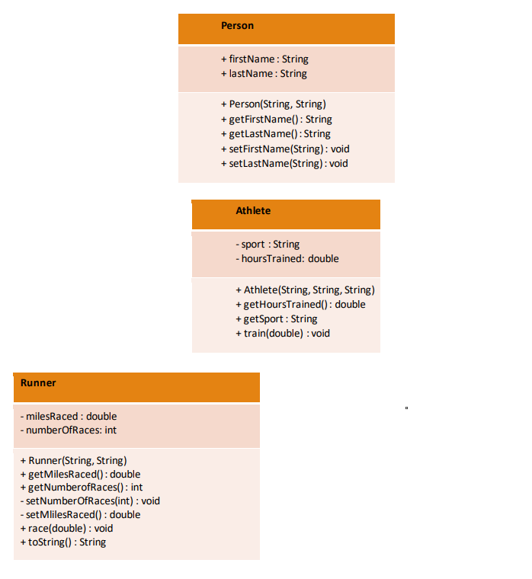

Bicyclist

- milesRacedOnroad : double

- numberOfRacesOnroad : int

+ Bicyclist(String, String)

+ getMilesRacedOnroad() : double

+ getNumberOfRacesOnroad() : int

- setNumberOfRacesOnroad(int) : void

- setMilesRacedOnroad() : double

- raceOnroad(double) : void

- toString() : String

**Description of new subclass:**  Bicyclist is a sublass of athlete. Bicycle racers tend to travel at different speeds whether onroad or offroad. It’s useless to include those metrics together so I’m renaming them to be more specific. Variables will track road miles and number of road races participated in. Functions exist to get and set those values and also a toString function which will make the code more readable.

Dan Doughty

CS255

U1Lab2(Athlete)