UTR = UnTranslatedRegions
uORF= upstream Open reading frames
In bacteria, uORFs are called leader peptides
uAUG = upstream AUG
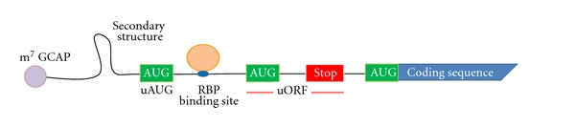
cis-Regulatory Elements (CREs) are regions of non-coding DNA which regulate the transcription of nearby genes.
The out-of-frame upstream AUGs are the first 2 green.

5'-cap structure: 5′ cap is a specially altered nucleotide on the 5′ end of mRNA → important (for stability) to make mature mRNA. This only occurs in the nucleus, mitochondrial and chloroplast mRNA are not capped.
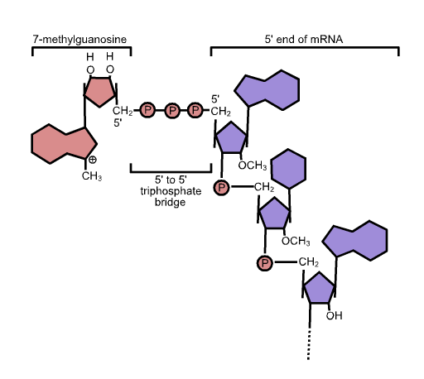
5'-cap function:
-helps the export of the mRNA from the nucleus to the citoplasm.
-Prevention of degradation by exonucleases.(Why is this important?)
-Promotion of translation
-Promotion of 5′ proximal intron excision (=περικοπή)

Length[edit]
The 5′ UTR begins at the transcription start site and ends one nucleotide (nt) before the initiation codon (usually AUG) of the coding region. In prokaryotes, the length of the 5′ UTR tends to be 3-10 nucleotides long while in eukaryotes it tends to be anywhere from 100 to several thousands nucleotides long.[2] For example, the ste11 transcript in Schizosaccharomyces pombe has a 2273 nucleotide 5′ UTR[3] while the lac operon in Escherichia coli only has 7 nucleotides in its 5′ UTR.[4] The differing sizes are likely due to the complexity of the eukaryotic regulation which the 5′ UTR holds, as well as the larger preinitiation complex which must form to begin translation.

Elements[edit]

The binding of an IRP (Iron Regulatory Protein) to and IRE (Iron Response Element), which are hairpin loops, regulation translation.
The elements of a eukaryotic and prokaryotic 5′ UTR differ greatly. The prokaryotic 5′ UTR contains a ribosome binding site (RBS), also known as the Shine Dalgarno sequence (AGGAGGU) which is usually 3-10 base pairs upstream from the initiation codon.[4] Meanwhile the eukaryotic 5′ UTR contains the Kozak consensus sequence (ACCAUGG), which contains the initiation codon.[4] The eukaryotic 5′ UTR also contains cis-acting regulatory elements called upstream open reading frames (uORFs) and upstream AUGs and termination codons (uAUGs), which have a great impact on the regulation of translation (see below).

Secondary structure[edit]
As the 5′ UTR has a high GC content, secondary structures often occur within it. Hairpin loops are one such secondary structure that can be located within the 5′ UTR. These secondary structures also impact the regulation of translation.[5]

60S : Large Ribosomal SubUnit
40S: small Ribosomal subunit
footprints: Ribosome RNA fragments
IRES: internal ribosome entry site (IRES)
Transgene: is a gene transferred from one organism to another one.
Elongation factors are a set of proteins that are used in protein synthesis in the cell. In the ribosome, they facilitate translational elongation, from the formation of the first peptide bond to the formation of the last one.
Allosteric effectors:
Allosteric effectors can be bad or good. There are two types of allosteric effectors: positive allosteric effectors and negative allosteric effectors. The positive ones activate something, whereas the negative ones deactivate something.
A negative allosteric regulator can be both good or bad. An example of a good one would be like feedback inhibition. If a certain pathway in the body is making too much of something, then the product of the pathway will come back and inhibit one of the earlier enzymes thereby saving energyfig. An example of a bad one would be if some kind of drug were administered in the body where it inhibits something it's not supposed to.

A positive allosteric effector could also be good or bad.
An example of a good one would be if an enzyme is being activated to make something that's deficient(=ελλειπής) in the cell. An example of a bad one would be when the allosteric effector is working when it's not supposed to.
In general, when the allosteric effect is a result of some natural physiological response, then it's usually a good thing whether it's an activator or an inhibitor.

Translation Initiation Rate
Initiation The first step in translation is known as initiation. Here, the large (60S) and small (40S) ribosomal units are assembled into a fully functional 80S ribosome. This is positioned at the start codon (AUG) of the mRNA strand to be translated

~Alexey~
Yes, you would need to see whether it’s possible to build a regressor that takes sequences and outputs translation initiation rates (not exactly number of ribosomes, but can be though of a the number of ribosomes binding per unit of time).

If Segal finds elements that affect translation, then it’s plausible that these elements influence translation by modulating the translation initiation rates. So presence of same/similar elements in the 5’ UTR sequence could be predictive of the translation initiation rate.
The goal of building a regressor is two-fold really. First, it would be great if we can simply predict initiation rates for new sequences, because then we can use this predictor to design new sequences with high initiation rates. On the other hand, a regressor can be used to really understand what elements of the 5’UTR sequence influence translation initiation rates, so also to find motifs or other features of the sequences that are predictive of the initiation rate.

Attached is a text file with yeast gene names and the inferred initiation rates for ±3000 genes that were obtained in our work on the ribosome movement model.
You can obtain similar dataset with initiation rates from the papers of Shah (http://www.cell.com/cell/abstract/S0092-8674(13)00655-7) and Siwiak (http://www.ploscompbiol.org/article/info%3Adoi%2F10.1371%2Fjournal.pcbi.1000865) - they should have some supplementary tables with those values as far as I remember.

Since you’re interested on how the sequences upstream of the CDSes (such as the 5’ UTR) influence the initiation rate, then you probably will want to look at the yeast genome and it’s annotation (with CDSs and UTRs). These can be obtained from the Saccharomyces Genome Database (SGD, http://browse.yeastgenome.org/fgb2/gbrowse/scgenome/) as the GFF and fasta files.
As an example I attached two GFF files from the publications of Nagalakshmi and Yassour, which attempted to identify 5’ and 3’ UTRs of S.cerevisiae genes. Note that these sequences are not available for all genes and are probably not strictly defined (can vary depending on conditions and mRNAs with several difference UTR sequences can probably be simultaneously present in the cell). This means that you could decide not to use the UTR annotations and just look at some bases upstream of the CDS. I don’t know whether this is a good/better solution, that’s something to find out perhaps.

To answer your other question about different elements. Yes, I think that would be the approach. But it’s a question what those elements (does the published literature give an idea about this?) are or how they can be discovered if they are unknown?

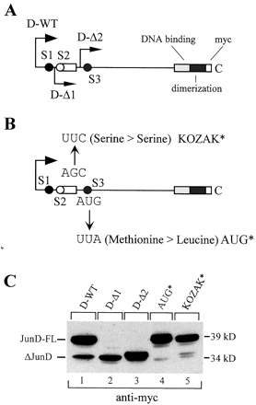

Figure 3
The truncated JunD isoform (ΔJunD) is generated by translational regulation. A, schematic of wild-type (D-WT) and truncated (D-Δ1 and D-Δ2) JunD expression constructs. The three AUG start sites are shown as circles; the primary AUG is filledblack (S1), the μORF AUG is open (S2), and the secondary AUG is filled gray (S3). All constructs were tagged with an Myc epitope-encoding sequence at the C terminus. The D-Δ1 and D-Δ2 constructs lack the primary AUG but retain the secondary AUG. D-Δ2 also lacks the μORF sequence. B, JunD expression constructs with the secondary AUG start site mutated (AUG*), which changes the methionine to a leucine residue, or the Kozak sequence disrupted by mutation (KOZAK*), which results in a silent expression mutation of serine to serine.C, expression vectors were transfected into HeLa cells, and Western blots of whole cell extracts were probed with an anti-Myc antibody. The wild-type expression vector produced both JunD-FL and ΔJunD isoforms (lane 1). Truncation of the primary AUG resulted in expression of only ΔJunD (lanes 2 and3). Mutation of the secondary AUG or the Kozak sequence abolished expression of ΔJunD (lanes 4 and5).

+ In order to decrease ribosome densities, we may have fast initiation of short genes, instead of slow codons at the start of transcripts.

_______________________
http://www.tbi.univie.ac.at/RNA/RNAfold.html
−d, −−dangles=INT

How to treat "dangling end" energies for bases adjacent to helices in free ends and multi−loops

(default=‘2’)

With −d1 only unpaired bases can participate in at most one dangling end, this is the default for mfe folding but unsupported for the partition function folding.

With −d2 this check is ignored, dangling energies will be added for the bases adjacent to a helix on both sides in any case; this is the default for partition function folding (−p). The option −d0 ignores dangling ends altogether (mostly for debugging). With −d3 mfe folding will allow coaxial stacking of adjacent helices in multi−loops. At the moment the implementation will not allow coaxial stacking of the two interior pairs in a loop of degree 3 and works only for mfe folding.

Note that by default (as well as with −d1 and −d3) pf and mfe folding treat dangling ends differently. Use −d2 in addition to −p to ensure that both algorithms use the same energy model.

Dangling ends are nucleotides that stack on the ends of helices. In secondary structures, they occur in multibranch and exterior loops. They occur as either 5' dangling ends (an unpaired nucleotide 5' to the helix end) or 3' dangling ends (an unpaired nucleotide 3' to the helix end).

If you want to explore your data it is best to compute both, since the relation between the Spearman (S) and Pearson (P) correlations will give some information. Briefly, S is computed on ranks and so depicts monotonic relationships while P is on true values and depicts linear relationships.

As an example, if you set:

x=(1:100);
y=exp(x); % then,
corr(x,y,'type','Spearman'); % will equal 1, and
corr(x,y,'type','Pearson'); % will be about equal to 0.25

This is because y increases monotonically with x so the Spearman correlation is perfect, but not linearly, so the Pearson correlation is imperfect.

corr(x,log(y),'type','Pearson'); % will equal 1
Doing both is interesting because if you have S > P, that means that you have a correlation that is monotonic but not linear. Since it is good to have linearity in statistics (it is easier) you can try to apply a transformation on y (such a log).

I hope this helps to make the differences between the types of correlations easier to understand.

Pearson's correlation coefficient is a measure of how well your data would be fitted by a linear regression. If you only provide it with two points, then there is a line passing exactly through both points, hence your data perfectly fits a line, hence the correlation coefficient is exactly 1.

Theoretical and Empirical Evidence for Decelerated Elongation of Highly Expressed Genes

The expression level of a gene (i.e., its cellular mRNA concentration) is another potential predictor of the requirement for translational accuracy, because the fitness cost of mistranslation increases with the number of translational errors, which is proportional to the amount of protein synthesis and hence mRNA concentration [8]. Nevertheless, the selective pressure for fast elongation to lessen ribosome sequestration also intensifies as the expression level of a gene rises, because a given increase in elongation speed reduces ribosome sequestration more when occurring to a highly expressed gene than to a lowly expressed gene. To predict the outcome of these competing demands, we built a mathematical model that estimates the fitness impact of translational speed and accuracy (see Materials and Methods).

The first part of our model considers the benefit of reducing ribosome sequestration by accelerated elongation. The model assumes equilibrium in cellular protein concentration for each gene, which is achieved by a balance of protein synthesis, degradation, and dilution due to cell division. We parameterized the model with the best estimates from the literature (see Materials and Methods) and calculated the fitness advantage (sv) due to a predefined change (Δν) in elongation speed from a baseline for gene g. This model showed that, given Δν, the absolute value of sv is greater when Δν occurs to a highly expressed gene than to a lowly expressed gene (Figure 2A). Furthermore, given the expression level, the fitness advantage does not increase linearly with Δν, but shows a diminishing return, evident from the increasing distances between the contour lines when Δν increases (Figure 2A). This phenomenon is expected, because as Δν in gene g increases, ribosomes spend a larger fraction of time on genes other than g, effectively reducing the benefit of the increased elongation speed in g.

