Name: Date: Score:
Basic Router Configuration with Static Routing
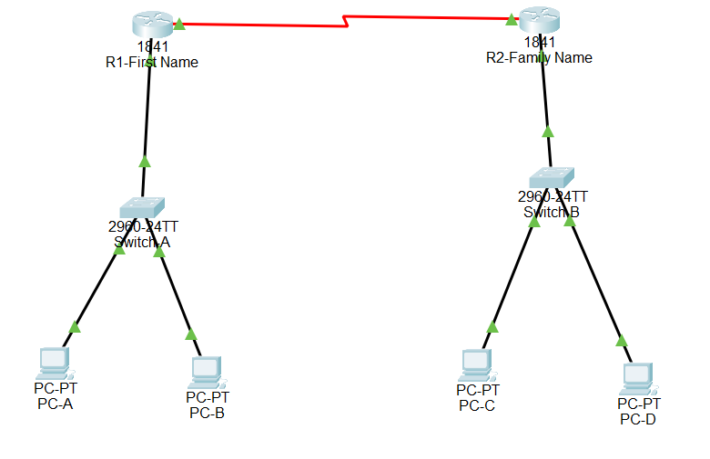
Direction: Read and perform all the given task below using any Packet Tracer version. Save it with the ff. filename format familyname-BasicRouter.pkt (ex. Rizal-BasicRouter.pkt)

1. Simulate a network of any industry or organization with the following descriptions;
Device (Hostname) | Interface | IP Address | Subnet Mask | Gateway
R1-FirstName | Serial 0/1/0 | Supply your own IP Address | 255.255.255.0
R1-FirstName | Fa 0/1 | Supply your own IP Address | 255.255.255.0
Switch-A | Fa 0/1 | Supply your own IP Address | 255.255.255.0
PC-A | Fa 0/2 | Supply your own IP Address | 255.255.255.0
PC-B | Fa 0/3 | Supply your own IP Address | 255.255.255.0
R2-FamilyName | Serial 0/1/0 | Supply your own IP Address | 255.255.255.0
R2-FamilyName | Fa 0/1 | Supply your own IP Address | 255.255.255.0
Switch-B | Fa 0/1 | Supply your own IP Address | 255.255.255.0
PC-C | Fa 0/2 | Supply your own IP Address | 255.255.255.0
PC-D | Fa 0/3 | Supply your own IP Address | 255.255.255.0

I. General Description;
- Utilize at least 2 switches either CISCO 2950 or 2960 and two Routers model 1841
- Follow the topology presented above.
- Utilize Straight through cable in connecting PCs and Switches , while Serial Cable in connecting Router to Router
II. Perform Basic Switch Configuration in all Switches
  - Configure the switch name as shown in the table above
  - Assign your family name as the password for Line Console, Line VTY and Enable Secret.
  - Configure used ports with a speed of 100 Mbps and set duplex mode to auto.
  - Configure basic switch port security
  - Port Security to be applied - Shutdown
  - Port Security Maximum – 1
  - Disable unused port by issuing the Shutdown command
III Perform Basic Router Configuration in all Routes
- Configure the router’s name as shown in the table above
- Assign your family name as the password for Line Console, Line VTY and Enable Secret.
- Configure No IP Domain-lookup
- Configure Your Own Banner ( Note : No obscene words to be used)
- Assign IP address for the ff. Router’s interfaces Fa0/1 (Local Network) and Serial Interface (WAN) , based on the table above
- Configure description in each interface.

- Configure clock rate as shown below
- Configure Static Routing
IV. End Devices (Computer)
- Rename the computer based on the table above.
- Assign IP address to each computer based on the table above.
- Connect the computers to their assigned ports.
- This rubrics will be used to grade your performance;
Criteria | Excellent | Very Good | Good | Needs Improvement | Score
Network Topology Setup | Correctly built network following the given topology without errors(10pts) | With Missing one or two connections((8pts) | Topology partly resembles requirement (6pts) | Topology incomplete or missing (4pts)
Basic Switch Configuration | All switches properly configured with hostname, passwords, port security, and shutdown on unused ports (15pts) | One or two minor errors (13pts) | Some incomplete configs but switch operational (10pts) | Little to no configuration(7pts)
Basic Router Configuration | All routers properly configured with hostname, passwords, no IP domain-lookup, interfaces’ IPs, descriptions, banner, and clock rate (20pts) | One or two minor errors (15pts) | Some incomplete configs but router operational (10pts) | Little to no configuration (5pts)
Static Routing | Static routes configured accurately and full end-to-end connectivity achieved (20pts) | One wrong or missing static route (15pts) | Partial connectivity due to static route errors (10pts) | No static routes configured (5pts)
End Device Configuration | All PCs correctly named, IP configured, connected, and verified (10pts) | One minor error (e.g. IP, hostname) (8pts) | Two to three device config issues (6pts) | Majority unconfigured (4pts)
Network Functionality | All devices can communicate to each other. (15pts) | 1 or 2 devices fail to communicate(13pts) | 3 or more devices fail to communicate(10pts) | Majority of the network fails to communicate. (5pts)
Time Management | Completed within the allotted time. (10pts) | Finished 1–5 minutes late. (8pts) | Finished 6–10 minutes late. (6pts) | Did not finish.  (4pts)
Total Score: ______ / 100

