TinyML-MLOps: An Open-Source, Reproducible Framework for Training, Compressing, and Deploying Convolutional Neural Networks on ARM Cortex-M7 Microcontrollers with Hardware-in-the-Loop Validation
Jheyson Fabian Villavisan Buitrago (ORCID: 0000-0002-2777-1257)
Escuela Tecnológica Instituto Técnico Central, Bogotá, Colombia

Abstract
TinyML-MLOps is an open-source framework that integrates the complete workflow required to train, compress, convert, deploy, and validate convolutional neural networks (CNNs) on ARM Cortex-M7 microcontrollers, using the Arduino Portenta H7 as a reference target. The framework couples Python-based transfer-learning pipelines (MobileNetV2, MobileNetV3, ResNet18, SqueezeNet, and the FOMO object-detection architecture) with structured model compression (magnitude-based pruning and full-INT8 quantization), automatic generation of C/C++ inference headers, automated firmware compilation and flashing via arduino-cli, and a hardware-in-the-loop (HIL) evaluation protocol that streams test images to the microcontroller over USB serial and compares on-device predictions against ground-truth labels. Unlike closed or vendor-locked TinyML toolchains, every stage is open source, scriptable, and reproducible, with versioned artifacts and TensorBoard logging. On a binary image-classification benchmark, the framework reduces model size by 3.5x (from 2,221 KB to 631 KB) via INT8 quantization while keeping accuracy loss below 0.3 percentage points, demonstrating its suitability for rapid, reproducible Edge AI research across scientific domains.
Keywords: TinyML; Edge AI; MLOps; Model compression; INT8 quantization; ARM Cortex-M7; Arduino Portenta H7; Hardware-in-the-loop testing

Code metadata
Nr. | Code metadata description | Please fill in this column
C1 | Current code version | v1.0
C2 | Permanent link to code/repository used for this code version | https://github.com/F4bian1012/Investigacion
C3 | Permanent link to Reproducible Capsule | To be archived on Zenodo upon acceptance (DOI pending)
C4 | Legal Code License | MIT License
C5 | Code versioning system used | git
C6 | Software code languages, tools and services used | Python 3.10+, TensorFlow/Keras >= 2.15, TensorFlow Model Optimization, OpenCV, scikit-learn, pandas, C/C++ (Arduino mbed), arduino-cli
C7 | Compilation requirements, operating environments & dependencies | Python 3.10+ with packages listed in requirements.txt; Arduino IDE or arduino-cli with the arduino:mbed_portenta core; Arduino Portenta H7 with Vision Shield for HIL evaluation
C8 | If available, link to developer documentation/manual | README.md in the repository
C9 | Support email for questions | fvillavisan@gmail.com

1. Motivation and significance
Deploying deep convolutional neural networks on microcontroller-class hardware -- the so-called “far edge” -- has become a central goal of the TinyML movement, which targets devices with a few hundred kilobytes to a few megabytes of RAM and no operating system [1,2]. While dedicated runtimes such as TensorFlow Lite for Microcontrollers [2] and benchmark suites such as MLPerf Tiny [4] have matured, the practical path from a researcher's labeled image dataset to a working, validated embedded vision system remains fragmented and largely manual.
Two categories of tools currently dominate this space. Commercial MLOps platforms such as Edge Impulse [5] offer an end-to-end experience, but rely on a proprietary cloud backend, limit transparency over the optimization pipeline, and constrain reproducibility for academic publication. Vendor toolchains (e.g., ST's X-CUBE-AI) are tightly coupled to a single hardware family and rarely expose the training and compression stages as scriptable, version-controlled artifacts. On the other side, official TensorFlow Lite Micro examples [2] and academic reference implementations such as MCUNet [3] demonstrate individual techniques (quantization, architecture search) but stop short of providing a coherent, reusable pipeline that a non-specialist can apply to a new dataset and a new board.
This gap is particularly limiting for researchers outside computer science -- in agriculture, environmental monitoring, industrial inspection, biology, or assistive technology -- who have image data and a deployment question, but not the embedded-systems expertise to bridge Python model training and C++ firmware. TinyML-MLOps directly addresses this gap. It provides a single, open-source, command-line-driven codebase that takes a raw image dataset through data preparation, transfer-learning training across four CNN backbones plus a FOMO object detector, magnitude-based pruning, full-INT8 quantization, automatic C-array header generation, automated compilation and flashing to an Arduino Portenta H7 via arduino-cli, and -- critically -- a hardware-in-the-loop (HIL) evaluation stage that streams real test images to the running firmware and compares on-device predictions with ground truth.
The significance of this contribution to SoftwareX's mission is threefold. First, it packages domain-independent functionality -- any labeled image dataset can be processed -- so its impact is not confined to a single research field, in line with SoftwareX's emphasis on cross-disciplinary software [author guidelines]. Second, it enforces academic reproducibility through version-controlled models, deterministic data hierarchies (raw/processed/augmented), and TensorBoard logging, giving software developers citable, peer-reviewed credit for infrastructure that is usually reported only as a footnote in application papers. Third, by closing the loop with HIL evaluation, it produces compression benchmarks (accuracy vs. memory footprint) measured on physical silicon rather than only on a desktop TFLite interpreter -- a methodological step that is frequently skipped in TinyML literature.

2. Software description

2.1. Software architecture
TinyML-MLOps separates the data-science environment from the embedded-engineering firmware while connecting both through versioned artifacts (Fig. 1). The data pipeline normalizes raw images (JPEG/PNG/BMP) to single-channel grayscale and resizes them to model-specific resolutions (e.g., 96x96, 160x120, 320x320), storing the result in a structured data/processed/{width}x{height} hierarchy. Training scripts in src/ consume these processed datasets and produce Keras checkpoints. An optimization stage applies polynomial-decay or layer-wise magnitude pruning and full-INT8 post-training quantization, producing a quantized .tflite model calibrated against 100 representative samples. A conversion stage (tflite_to_c.py) embeds the quantized model as a 16-byte-aligned C array inside an Arduino sketch, which compile_upload_arduino.py compiles and flashes to the Portenta H7 using arduino-cli. Finally, send_multiple_images_serial.py streams the processed test set to the board over a custom serial protocol, collects on-device predictions, and generates accuracy, precision, recall, F1-score and a confusion matrix comparing edge inference with the original labels.

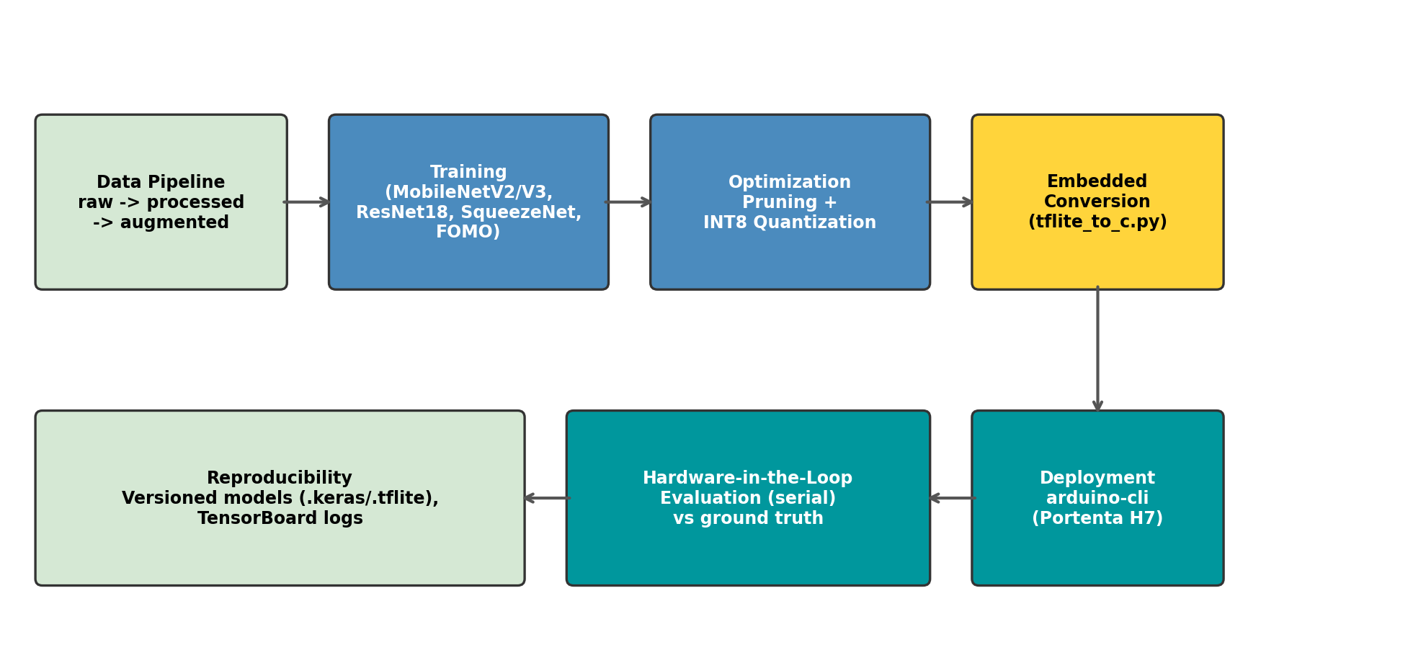
Fig. 1. End-to-end TinyML-MLOps pipeline: data preparation, transfer-learning training, compression, embedded conversion, on-device deployment, and hardware-in-the-loop evaluation.

2.2. Software functionalities
Data engineering. process_images.py converts heterogeneous raw images to compressed single-channel grayscale (JPEG quality 70, PNG compression level 9); reshape_images.py recursively resizes images to any target resolution required by a model architecture.
Model training. train_mobilenet.py performs transfer learning from ImageNet weights for MobileNet, MobileNetV2, MobileNetV3Large and MobileNetV3Small, adapted to grayscale inputs and a user-defined number of classes, with configurable batch size, learning rate, epochs and validation split. train_resnet18.py and train_squeezenet.py provide equivalent pipelines for ResNet18 and SqueezeNet. train_fomo.py trains a Faster-Objects-More-Objects (FOMO) detector on a MobileNetV2 backbone, replacing bounding-box regression with a cell-level presence heatmap on an H/8 or H/16 grid trained with focal loss, making object detection feasible within microcontroller memory budgets.
Model optimization and evaluation. prune_model.py applies global or layer-specific magnitude-based pruning to Conv2D and Dense layers and reports initial/final sparsity. quantize_int8_basic.py converts FP32 Keras models to full-INT8 TFLite models with INT8 input/output tensors required by MCU runtimes. test_model.py and test_tflite_model.py evaluate Keras and TFLite models respectively, automatically producing classification reports and Seaborn confusion-matrix plots, the latter simulating on-MCU input scaling and output dequantization.
Embedded conversion and deployment. tflite_to_c.py converts a .tflite binary into a 16-byte-aligned C/C++ header compatible with TensorFlow Lite for Microcontrollers. compile_upload_arduino.py automates arduino-cli core installation, board detection and compilation/upload, including fixes for Windows path handling. send_multiple_images_serial.py implements the HIL evaluation protocol described in Section 2.1.

2.3. Sample code snippets
The complete pipeline is driven from the command line. A typical session trains a MobileNetV2 classifier, quantizes it to INT8, converts it to a C header, and deploys it to the Portenta H7:
# 1. Data preparation
python src/process_images.py
python src/reshape_images.py --width 160 --height 120
# 2. Transfer-learning training
python src/train_mobilenet.py --base_model MobileNetV2 \
--width 160 --height 120 --batch_size 32 --epochs 20 \
--learning_rate 0.0001
# 3. INT8 quantization
python src/quantize_int8_basic.py \
--model_path models/checkpoints/best_model.keras
# 4. Embedded conversion
python src/tflite_to_c.py models/tflite/model_int8.tflite \
deployment/arduino_project_test/model.h --var_name model_tflite
# 5. Compile and flash to Arduino Portenta H7
python src/compile_upload_arduino.py \
--path_proyecto deployment/arduino_project_test
# 6. Hardware-in-the-loop evaluation
python src/send_multiple_images_serial.py \
--folder data/processed/160x120 --width 160 --height 120
Development note. The Python pipeline scripts in src/ were developed with the assistance of the AI-based coding tool Antigravity, used for code drafting, debugging and refactoring under the author's direction; all generated code was reviewed, tested and validated by the author, who takes full responsibility for its correctness.

3. Illustrative example
To demonstrate the framework, a binary image-classification dataset of 7,525 grayscale images (Class1: 4,387; Class2: 3,138) was processed at two resolutions and used to train MobileNetV2 with the transfer-learning pipeline described above. Table 1 summarizes the accuracy and model footprint obtained at each stage of the pipeline -- the FP32 Keras checkpoint and the corresponding full-INT8 TFLite model produced by quantize_int8_basic.py and evaluated with test_model.py / test_tflite_model.py over the full labeled set.

Configuration | Format | Accuracy | Model size
MobileNetV2, 160x120, 10 epochs | FP32 (.keras) | 92.3% | 2,221 KB
MobileNetV2, 160x120, 10 epochs | INT8 (.tflite) | 92.0% | 631 KB
MobileNetV2, 160x120, 10 epochs | INT8 (Arduino HIL, n=10) | 100.0% | 631 KB
MobileNetV2, 320x320, 10 epochs | FP32 (.keras) | TBD | TBD
MobileNetV2, 320x320, 10 epochs | INT8 (.tflite) | TBD | TBD
MobileNetV2, 320x240, 40 epochs | INT8 (.tflite) | TBD | TBD
Table 1. Accuracy and footprint of MobileNetV2 before and after full-INT8 quantization, at two input resolutions and training schedules. All accuracies were computed over the full 7,525-image labeled set.
INT8 quantization reduces the on-disk/on-flash model size by 3.5x (from 2,221 KB to 631 KB) -- placing the model comfortably within the SRAM/flash budget of the Cortex-M7 -- while the accuracy loss remains below 0.3 percentage points (160x120: -0.3 pp). The quantized model was further deployed on the Arduino Portenta H7 and evaluated over a hardware-in-the-loop (HIL) test set of 10 images transmitted via serial, reaching 100% accuracy and confirming that the on-device predictions match the offline TFLite inference (Fig. 4). Fig. 2 and Fig. 3 show the confusion matrices generated automatically by test_model.py and test_tflite_model.py for the 160x120 configuration, illustrating that the misclassification pattern is essentially preserved after quantization.
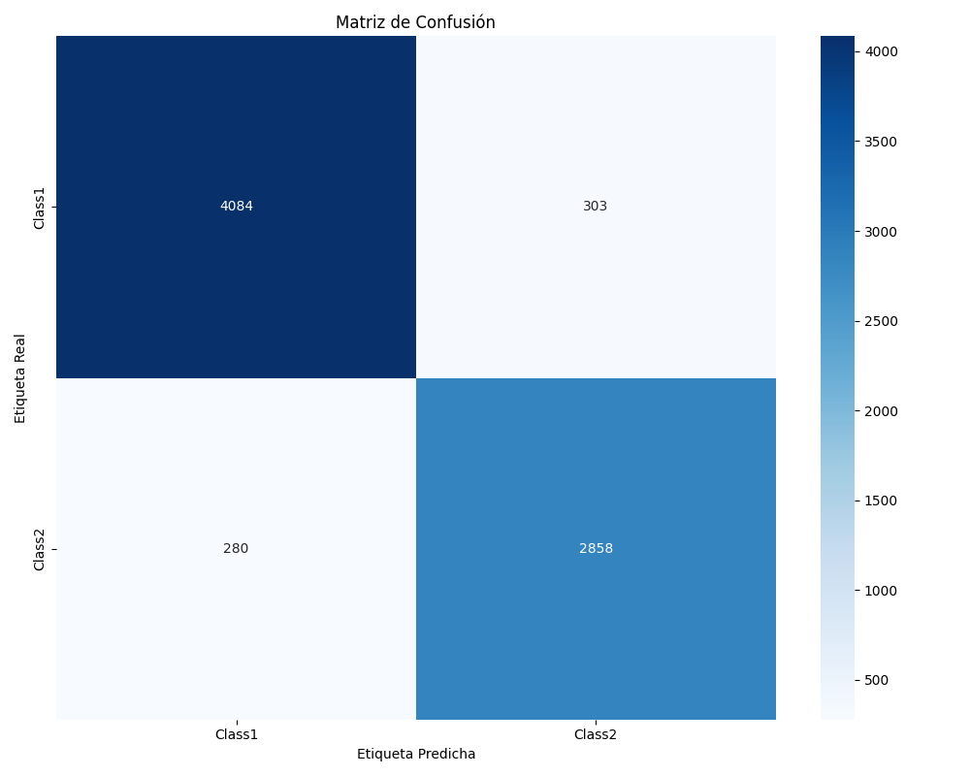
Fig. 2. Confusion matrix for the FP32 MobileNetV2 model (160x120, 10 epochs), generated by test_model.py.
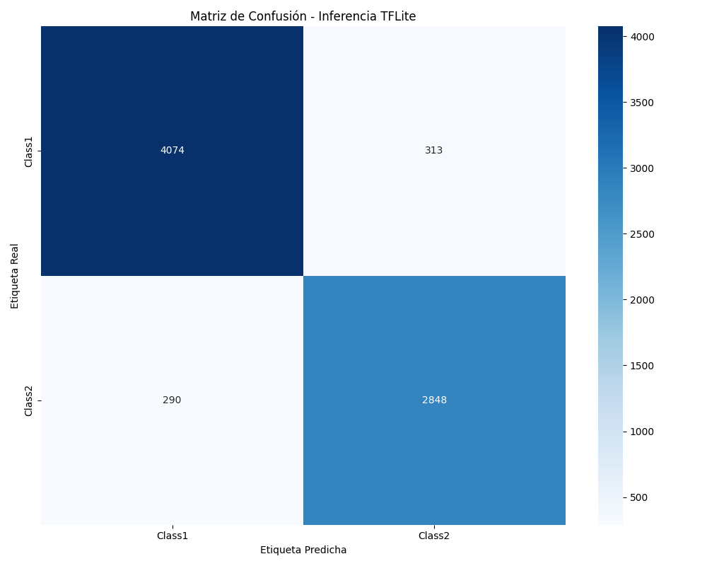
Fig. 3. Confusion matrix for the full-INT8 quantized MobileNetV2 model (160x120, 10 epochs), generated by test_tflite_model.py.
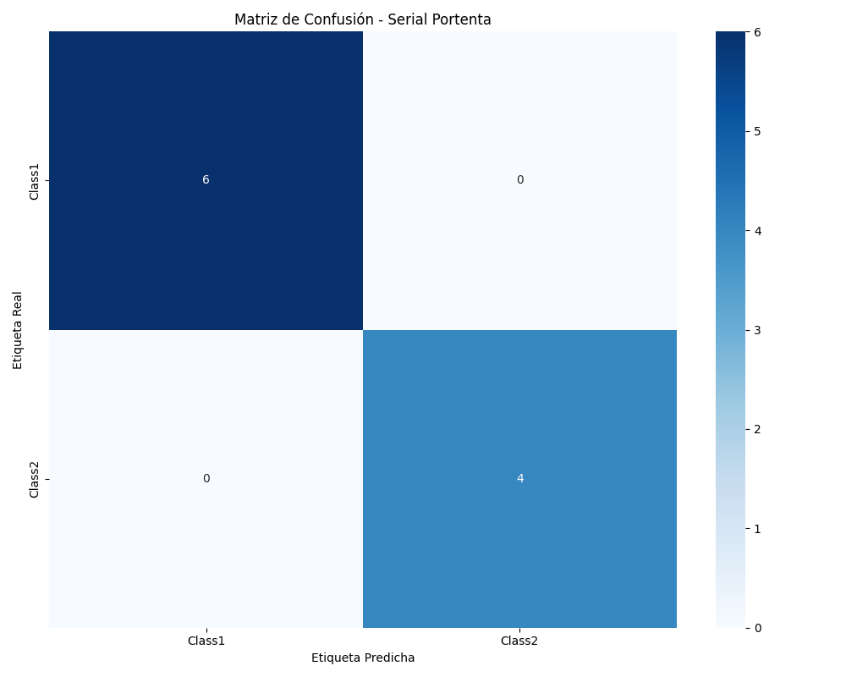
Fig. 4. Confusion matrix for the full-INT8 model running on the Arduino Portenta H7 (160x120, n=10), generated by send_multiple_images_serial.py via the serial hardware-in-the-loop protocol.
Because the dataset, resolution, and number of classes are fully parameterized, the same sequence of commands can be re-run on any new binary- or multi-class image dataset placed in data/raw/, making this example representative of the framework's general applicability rather than specific to the dataset used here.

4. Impact
TinyML-MLOps lowers the technical barrier for domain researchers who need to deploy CNN-based perception on battery-powered, memory-constrained hardware but lack embedded-systems expertise. Because every stage is exposed as a parameterized command-line script operating on a standard data/raw -> data/processed -> models/checkpoints -> models/tflite -> deployment/ artifact chain, the framework can be applied unchanged to new datasets in fields such as precision agriculture (crop or pest classification), environmental monitoring (camera-trap species recognition), industrial quality control (defect detection), or assistive devices -- areas in which Cortex-M7 boards such as the Portenta H7 are already used.
The empirical compression results in Section 3 contribute a reproducible data point to the broader TinyML benchmarking effort represented by MLPerf Tiny [4]: a measured, hardware-validated trade-off curve between accuracy and footprint for full-INT8 quantization of MobileNetV2 at multiple resolutions, obtained with an openly available script rather than a closed benchmarking harness.
Methodologically, the hardware-in-the-loop evaluation stage addresses a frequently overlooked validation gap: many TinyML studies report accuracy only from a desktop TFLite interpreter simulation, without confirming that the quantized model behaves identically once compiled, flashed, and executed on the target MCU with its real serial I/O, memory layout and numerical behavior. By making this HIL comparison a one-command operation, TinyML-MLOps encourages researchers to report hardware-validated, rather than purely simulated, performance figures.
Finally, in line with SoftwareX's mission, releasing this framework as a citable, archived, MIT-licensed repository gives explicit academic credit to the engineering effort underlying applied TinyML research, supports the academic career path of the developer, and allows other groups to validate, reuse, and extend the pipeline -- including adding new backbones, compression techniques (e.g., quantization-aware training, weight clustering), or target boards (e.g., ESP32-S3, STM32) -- without starting from scratch.

5. Conclusions
TinyML-MLOps consolidates the otherwise fragmented workflow of training, compressing, converting, deploying and validating CNNs on ARM Cortex-M7 microcontrollers into a single, open-source, reproducible, command-line pipeline, targeting the Arduino Portenta H7. On a binary classification benchmark it achieves a 3.5x reduction in model size through full-INT8 quantization with less than 0.3 percentage points of accuracy loss, validated end-to-end with a hardware-in-the-loop evaluation against the physical board. Future work includes extending hardware support to additional Cortex-M targets, integrating quantization-aware training and weight clustering, releasing a small public benchmark dataset alongside the code, and archiving tagged releases on Zenodo to provide a permanent, citable DOI.

Declaration of competing interest
The author declares that he has no known competing financial interests or personal relationships that could have appeared to influence the work reported in this paper.

Acknowledgements
The author thanks the Escuela Tecnológica Instituto Técnico Central for institutional support.

Declaration of Generative AI and AI-assisted technologies in the writing process
During the preparation of this work the author used Claude (Anthropic) in order to draft and structure the manuscript text in English following the SoftwareX Original Software Publication format. The author also used the AI-assisted coding tool Antigravity during development of the software described in this paper, for code drafting, debugging and refactoring of the scripts in src/. After using these tools, the author reviewed and edited all content and code as needed and takes full responsibility for the content of this publication.

References
[1] P. Warden, D. Situnayake, TinyML: Machine Learning with TensorFlow Lite on Arduino and Ultra-Low-Power Microcontrollers, O'Reilly Media, 2019.
[2] R. David, J. Duke, A. Jain, V.J. Reddi, et al., TensorFlow Lite Micro: Embedded Machine Learning for TinyML Systems, Proceedings of Machine Learning and Systems (MLSys) 3 (2021) 800-811.
[3] J. Lin, W.-M. Chen, Y. Lin, J. Cohn, C. Gan, S. Han, MCUNet: Tiny Deep Learning on IoT Devices, Advances in Neural Information Processing Systems (NeurIPS) 33 (2020) 11711-11722.
[4] C. Banbury, V.J. Reddi, P. Torelli, et al., MLPerf Tiny Benchmark, arXiv:2106.07597, 2021.
[5] S. Hymel, C. Banbury, D. Situnayake, et al., Edge Impulse: An MLOps Platform for Tiny Machine Learning, arXiv:2212.03332, 2022.
[6] M. Sandler, A. Howard, M. Zhu, A. Zhmoginov, L.-C. Chen, MobileNetV2: Inverted Residuals and Linear Bottlenecks, in: Proceedings of the IEEE Conference on Computer Vision and Pattern Recognition (CVPR), 2018, pp. 4510-4520.
[7] S. Han, J. Pool, J. Tran, W. Dally, Learning Both Weights and Connections for Efficient Neural Networks, Advances in Neural Information Processing Systems (NIPS) 28 (2015) 1135-1143.
[8] B. Jacob, S. Kligys, B. Chen, et al., Quantization and Training of Neural Networks for Efficient Integer-Arithmetic-Only Inference, in: Proceedings of the IEEE Conference on Computer Vision and Pattern Recognition (CVPR), 2018, pp. 2704-2713.

