|  |  |  |  |
| --- | --- | --- | --- |
| NO | Tgl Kejadian | Lokasi | Peristiwa |
| 1 | 20/1/2016 | Gatot Subroto, menabrak separator busway | http://poskotanews.com/2016/01/21/pengemudi-gojek-tewas-kecelakaan/ |
| 2 | 19/9/2015 | Gambir, Menabrak trotoar | http://megapolitan.kompas.com/read/2015/09/19/16272391/Kecelakaan.Tunggal.Pengemudi.GrabBike.Tewas.di.Gambir |
| 3 | 25/8/2016 | Surabaya, kecelakaan tunggal | <https://plus.google.com/117895810096910931526/posts/Bq1da1mfDHD> |
|  |  |  |  |
|  |  |  |  |
|  |  |  |  |
|  |  |  |  |

<http://sains.kompas.com/read/2016/03/17/162000830/Gawat.Angka.Kecelakaan.di.Indonesia.Makin.Mengkhawatirkan>.

|  |  |  |
| --- | --- | --- |
| 2014 | 77.439 | 26.623  meninggal |
| 2015 | 84.099 |  |
| 2016 | 71.616 |  |
|  |  |  |

Adu banteng : 20.000 leih

Depan belakang : 16.767

**Hilang fokus : 14.255**

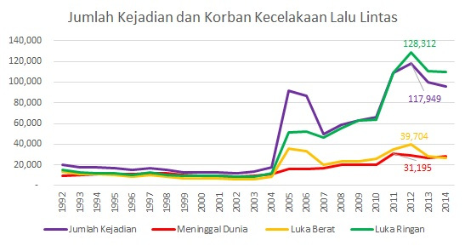

<http://otomotif.liputan6.com/read/2631169/inilah-penyebab-utama-kecelakaan-sepeda-motor-di-indonesia>