SOFTWARE DEVELOPMENT  
BUSINESS REQUIREMENTS

PAISA

The first online investment and financial planning platform.

FinalTouch

HazratShahAli Plaza

Mirpur-10Dhaka-1216

[finaltouch](http://www.finaltouch.com.bd/).com.bd

Version 1.0.0

00/00/0000

**PREPARED BY**

|  |  |
| --- | --- |
|  | |
| *Name and Title (Printed)* | |
|  |  |
| *Signature* | *Date* |

**RECOMMENDED BY**

|  |  |
| --- | --- |
|  | |
| *Name and Title (Printed)* | |
|  |  |
| *Signature* | *Date* |

**APPROVED BY**

|  |  |
| --- | --- |
|  | |
| *Project Sponsor Name and Title (Printed)* | |
|  |  |
| *Project Sponsor Signature* | *Date* |

# INTRODUCTION

Provide an overview of the entire Software Development Business Requirements including the purpose, scope, definitions, acronyms, abbreviations, references, etc.

## Summary

The name of the project is Paisa. Paisa is a one-stop solution for all kinds of investments and transactions. Paisa will launch a **paperless money** project in Bangladesh.

The purpose of the Business Requirement Document (BRD) is to describe the various requirements for the PAISA project software and all the researchers.

Paisa will emerge as a cryptocurrency technology in the future.

## Project overview

Welcome to PAISA ---— the first 100% free online investment and financial planning platform in Bangladesh.

Paisa main responsibilities include digitization of banks, implementation of e-currency schemes in the country, foreign currency exchange, and offering paperless money in commercial banks.

Here all the investors of the country will have the opportunity to invest on one platform and to invest in all the shares of the stock market.

## Project scope

All types of the functionality of the software and the necessary things of the software are highlighted.

1. The software should be divided into three separate parts. Each of them will have its own functionality. And each will be interconnected with the other.

|  |  |  |
| --- | --- | --- |
| 1 | 2 | 3 |
| investment | **money transaction** | **currency exchange** |
| Paisa.com.bd | Paisa.com | Paxchange.com |

1. Since the software is divided into three separate parts and each of them will be interconnected within itself. Customer will choose the service as per his requirement.
   1. **Investment:** In the functions of investment-
      1. login type:

|  |  |
| --- | --- |
| * + - 1. Investor Mood | * + - 1. guest mood |

* + 1. Investor Mood – Registration
       1. kyc verification ***
       2. Email ***
       3. Phone Number***
       4. Fingerprint
       5. retina scan security
    2. guest mood- Registration
       1. Email ***
       2. Phone Number***

Here the customer will get the opportunity to make his investment. And all types of monitoring will be seen, all the complex functionalities will exist here. And the customer will see all the overview on his dashboard.

* 1. **money transaction:** While the customer continues to earn money through "Invest" in his own account. And when this withdrawal is required, he will use the Paisa Money Transfer service. I will also give them the opportunity to transact from Bikash. But the main objective here is that a customer can do all kinds of transactions with us so that he does not have to take any external service.
  2. **currency exchange:** This will be added in the future.

# GENERAL DESCRIPTION

## 2.0 Features

1. **Investment app scheme**

|  |  |  |
| --- | --- | --- |
| * 1. FDR | * 1. DPS | * 1. Active income |
| * 1. Pactiv income | * 1. Asset and property purchase | * 1. Gadget and gear purchase |
| * 1. Travel scheme | * 1. Health services | * 1. Wardrobe and accessories |
| * 1. Lifestyle management | * 1. Money exchange | * 1. Request |

|  |  |
| --- | --- |
| Goal Calculators | Set a goal |
| Trade Smart | Tax Harvesting |
| Save taxes | **Current balance** |

1. **money transaction: Mobile financial service companies such as " bKash, Nagad " will provide money transaction services**
   1. cash in
   2. cash out
   3. send money
   4. bill pays
2. **currency exchange:** This will be added in the future.

## Product Context

At the beginning there will be Bata 1.00

|  |  |  |
| --- | --- | --- |
| * 1. FDR | * 1. DPS | * 1. Request |

# REQUIREMENTS

## External Interface Requirements

**D DPS S**

|  |  |  |  |  |  |  |  |
| --- | --- | --- | --- | --- | --- | --- | --- |
| 9 | 9 | 9 | 9 | 9 | 0 | 0 | 0 |

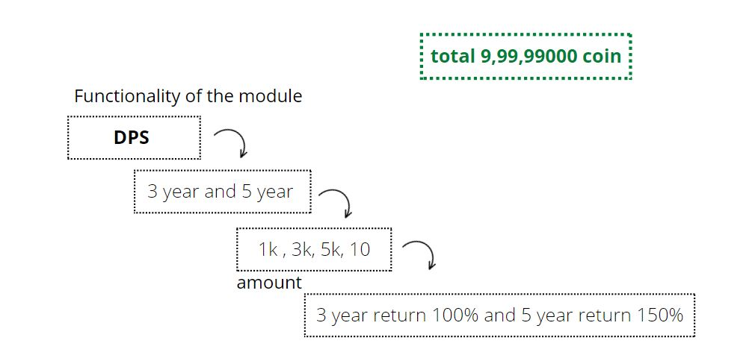We will have a virtual coin total of [ volume (1) {999999000} ]. Now the value of 1 coin is 1 rupee. And investors will invest now that money will equal the total coins will decrease. such as,

When the user invests here, the amount invested will be deducted from the total coins.

Again the user will deposit money in the next month then it will be subtracted from my total coins.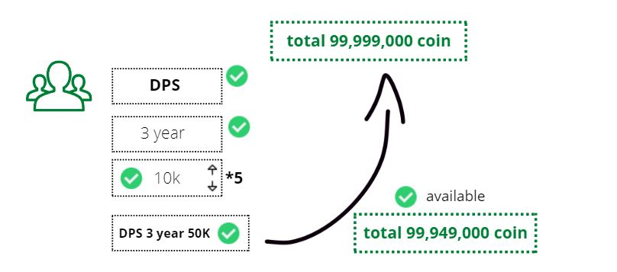

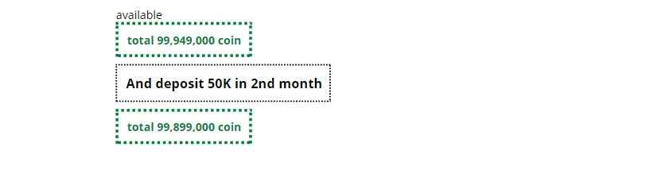

All users can see total coins increase or decrease on their dashboard.

And DPS will get 100% return for 120 months, and after that, the current balance will continue to accrue. The user can withdraw money anytime.

**D FDR S**

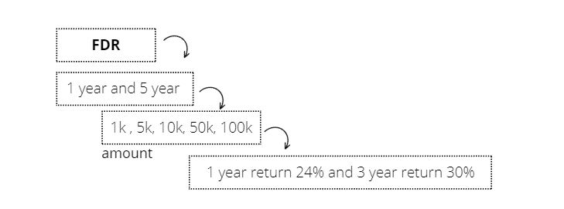

### User Interfaces

### Hardware Interfaces

### Software Interfaces

1. Analysis Models

List any attached / referenced documentation such as data flow diagrams, class diagrams, state-transition diagrams, entity-relationship diagrams, etc.

1. Issues List

Detail any unresolved issues.

| ISSUES LIST | | |
| --- | --- | --- |
| ISSUE ID | ISSUE DESCRIPTION | STATUS |
|  |  |  |
|  |  |  |
|  |  |  |
|  |  |  |
|  |  |  |
|  |  |  |
|  |  |  |

|  |
| --- |
| **DISCLAIMER**  Any articles, templates, or information provided by Smartsheet on the website are for reference only. While we strive to keep the information up to date and correct, we make no representations or warranties of any kind, express or implied, about the completeness, accuracy, reliability, suitability, or availability with respect to the website or the information, articles, templates, or related graphics contained on the website. Any reliance you place on such information is therefore strictly at your own risk. |