學號:F74031166

姓名:戴子祐

UML class

|  |
| --- |
| Game |
| +*w=QWdget  +*pointL=QLCDNumber  +*endit= QLabel  +*gameover=QLabel  +*pushButton= QPushButton  +*pushButton2=QPushButton  +*title=QLabel  +*score=QLabel  +*movep=QTimer  -point= int  -tag= int  -key= int  -nowpoint= int  -result=bool  -table[4][4] = int  -testtable[4][4] = int  -before[16] = int  -after[16]=int  -br=int  -bc=int  -randomr=int  -randomc=int  -str[15]=QString  -*num[16]= QLabel |
| <<constructor>>+Game(QWidget *window=0)  +random()  +move()  +check():bool  +show(r,c: int):Integer  +getnowpoint():Integer  +getpoint():Integer  +getP(d, r, bc, ac:int)  +reset()  +moveslot()  +end()  +*keyPressEvent*(*event: QKeyEvent) |

遊戲畫面:

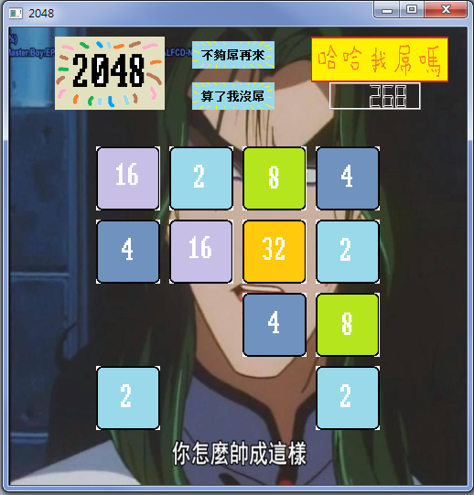

簡單說明:

這是一個簡單的2048

規則和2048相同(本來想加的但時間有限)

最上面兩個小圖形分別為重新開始及離開鍵

而右上角為分數欄

另外我有做像一般2048所具備之動畫效果

Win:

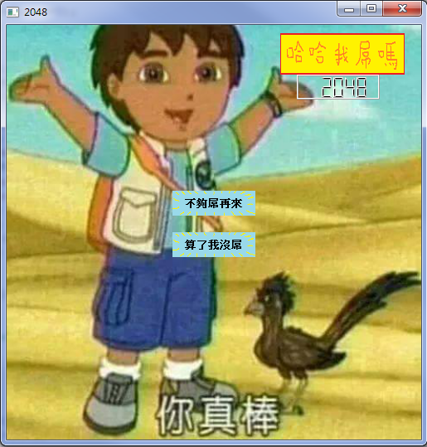

Gameover:

