Project 3 report

F74036239 謝佩軒 資訊107甲

1.UML

|  |
| --- |
| Mainwindow |
| +b[10][10] : Blank *  +isclicked : bool  +record_R : int  +record_C : int  +Result_star : int  +timer : QTimer *  -ui : Ui::MainWindow *  -resWindow : result *  -T : QThread * |
| <<constructor>>+MainWindow(QWidget *parent=0) : MainWindow  +gameStart() : void  +gameover(QString S): void  +setClickPicture(Blank *b) : void  +newPicture() : void  +fillzero() : void  +judgeTime() : void  +conti_judge() : bool  +judge(int row1,int col1,int row2,int col2) : bool  + judge2Special(int row1,int col1,int row2 , int col2) : bool  +judgeStar(int row,int col) : bool  +judgeBomb(int row,int col) : bool  +judgeFour(int row,int col) :bool  +judgeThree(int row,int col) : bool  +button_clicked(int R, int C) : void  +zeroDisappear() : void  +lefttime() : void  +gameExit() : void  <<destructor>>+~MainWindow() : MainWindow |

|  |
| --- |
| Move_success |
| +scoreSum : int |
| <<constructor>>+move_success() : move_success  + generate(Blank *b[10][10],Blank *clicked,int mode)=0 : virtual void  +eliminate(Blank *b[10][10], Blank *clicked ,int mode=1)=0 : virtual void  +whichType(Blank *b[10][10], Blank *clicked )=0 : virtual void  <<destructor>>+~move_success() : vritual move_success |

|  |
| --- |
| Star |
| +scoreSum : int |
| <<constructor>>+star() : star  + generate(Blank *b[10][10],Blank *clicked,int mode) : virtual void  +eliminate(Blank *b[10][10], Blank *clicked ,int mode=1) : virtual void  +whichType(Blank *b[10][10], Blank *clicked ) : virtual void  <<destructor>>+~star() : vritual star |

|  |
| --- |
| Bomb |
| +scoreSum : int |
| <<constructor>>+bomb() : bomb  + generate(Blank *b[10][10],Blank *clicked,int mode) : virtual void  +eliminate(Blank *b[10][10], Blank *clicked ,int mode=1) : virtual void  +whichType(Blank *b[10][10], Blank *clicked ) : virtual void  <<destructor>>+~bomb() : vritual bomb |

|  |
| --- |
| Four |
| +scoreSum : int |
| <<constructor>>+four () : four  + generate(Blank *b[10][10],Blank *clicked,int mode) : virtual void  +eliminate(Blank *b[10][10], Blank *clicked ,int mode=1) : virtual void  +whichType(Blank *b[10][10], Blank *clicked ) : virtual void  <<destructor>>+~four() : vritual four |

|  |
| --- |
| Three |
| +scoreSum : int |
| <<constructor>>+three() : three  + generate(Blank *b[10][10],Blank *clicked,int mode) : virtual void  +eliminate(Blank *b[10][10], Blank *clicked ,int mode=1) : virtual void  +whichType(Blank *b[10][10], Blank *clicked ) : virtual void  <<destructor>>+~three() : vritual three |

|  |
| --- |
| Blank |
| +row : cons tint  +column : cons tint  +number : int  +shift : int  +button : QPushbutton  +time : QTimer |
| <<constructor>>+Blank(int R , int C , QWidget *parent) : Blank  +setNumber() : void  +setButtonPicture() : void  +operator –(Blank *b) : void  +operator |(Blank *b) : void  +click() : void  +moveRight() : void  +moveLeft() : void  +moveUp() : void  +moveDown() : void  <<desturctor>>+~Blank() : Blank |

|  |
| --- |
| Result |
| -ui : Ui::result *  -mainWindow : QWidget * |
| <<constructor>>+ result(QWidget *parent =0) : result  +setStar(int sc,int R) : void  +setScore(const QString &sc) : void  +setWord(QString S) : void  +pushbutton_2_clicked() : void  <<destructor>>+~result() : result |

繼承:

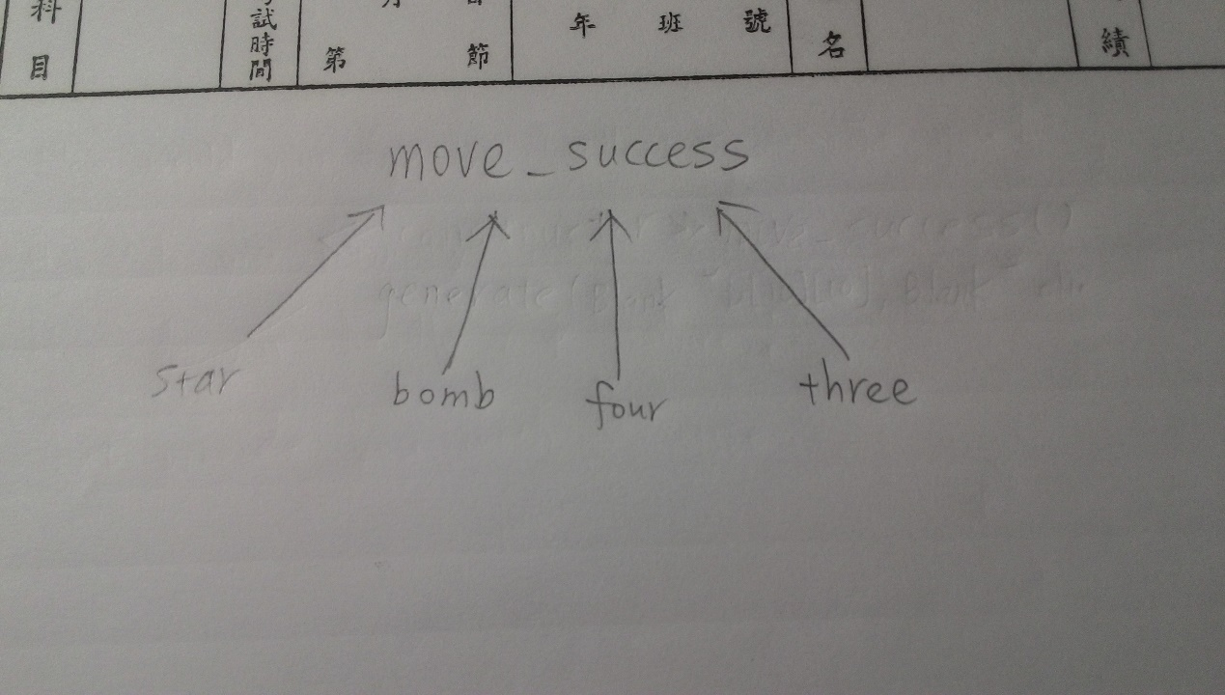

2.截圖

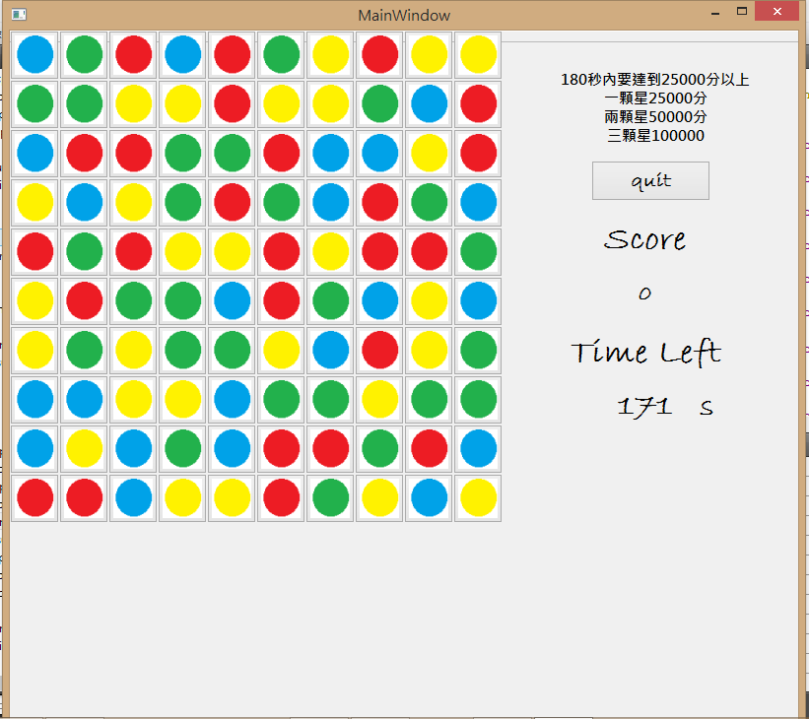

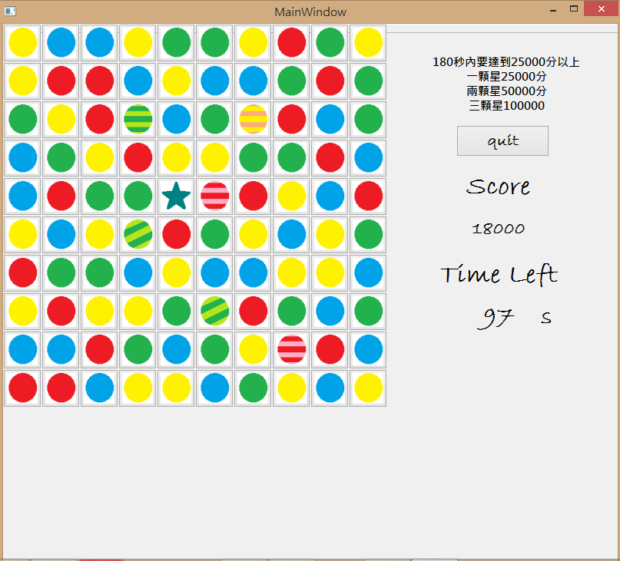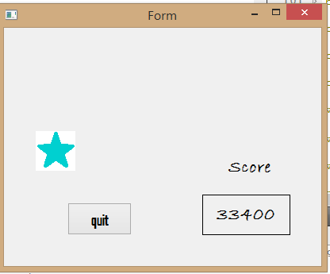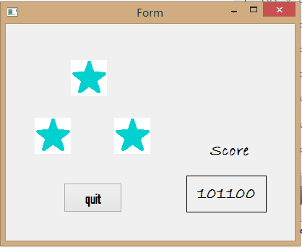

3. 有 error

星星不能跟其他特殊糖果結合