F74036360 梁嘉容

一開始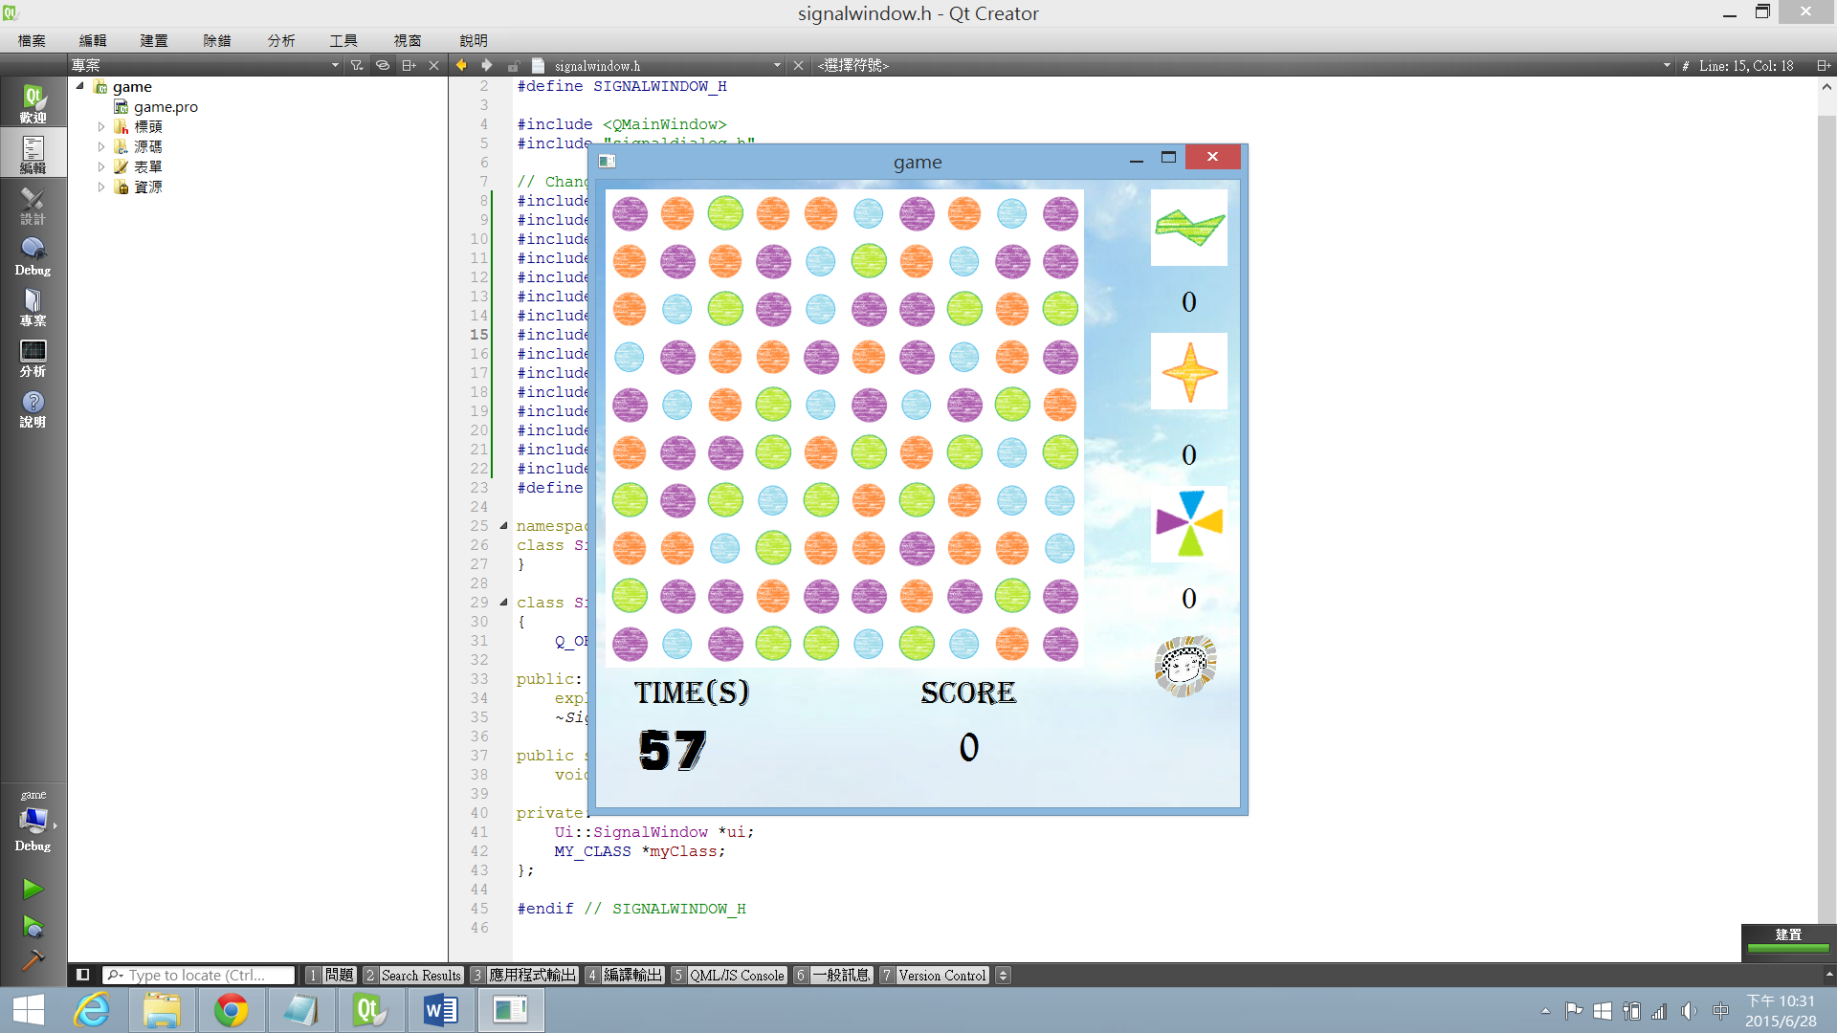

紀錄各種石頭樹木及目前等級和時間

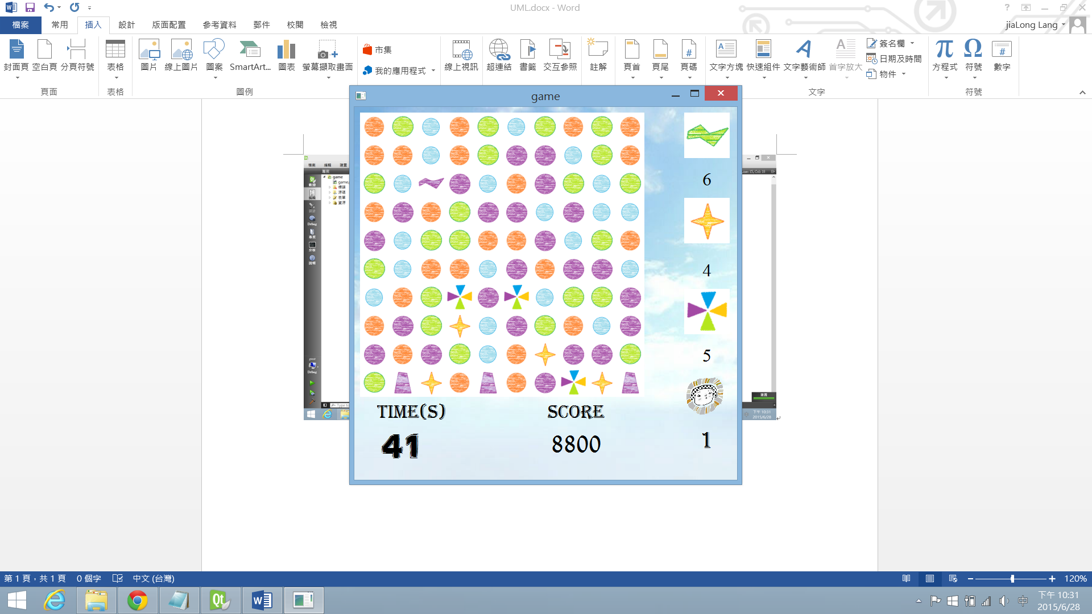

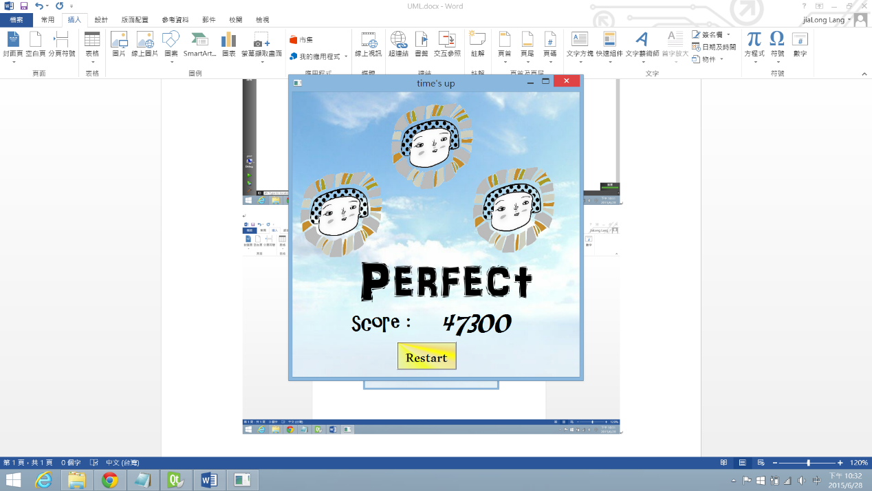結束後顯示等級與分數，並問玩家是否想要再玩一次

UML

|  |
| --- |
| Block |
| * i:int * j:int * *time:QTimer * Shift: int   + getrand:int  + row : int  + col :int  + button *: QPushButton |
| + click():void  + toleft():void  + toright():void  + toup():void  + todown():void  + Click(row:int ,col:int) :void  + aftermove():void  + tomove():void  + Rand():void  +setpic():void  + operator -(block *b) :void  + operator |(block *b) :void |

|  |
| --- |
| Destroy |
|  |
| *+ getsomething*(block *blk[10][10],block *clicked,int more): virtual void  *+ toclear*(block *blk[10][10],block *clicked,int moreclear): virtual void  *+ ifmore*(block *blk[10][10],block *clicked): virtual int |

|  |
| --- |
| For3 |
|  |
| *+ getsomething*(block *blk[10][10],block *clicked,int more): virtual void  *+ toclear*(block *blk[10][10],block *clicked,int moreclear): virtual void  *+ ifmore*(block *blk[10][10],block *clicked): virtual int |

|  |
| --- |
| For4 |
| + center: int |
| *+ getsomething*(block *blk[10][10],block *clicked,int more): virtual void  *+ toclear*(block *blk[10][10],block *clicked,int moreclear): virtual void  *+ ifmore*(block *blk[10][10],block *clicked): virtual int |

|  |
| --- |
| For5 |
|  |
| *+ getsomething*(block *blk[10][10],block *clicked,int more): virtual void  *+ toclear*(block *blk[10][10],block *clicked,int moreclear): virtual void  *+ ifmore*(block *blk[10][10],block *clicked): virtual int |

|  |
| --- |
| Forhori |
| + center: int |
| *+ getsomething*(block *blk[10][10],block *clicked,int more): virtual void  *+ toclear*(block *blk[10][10],block *clicked,int moreclear): virtual void  *+ ifmore*(block *blk[10][10],block *clicked): virtual int |

|  |
| --- |
| Forvertical |
|  |
| *+ getsomething*(block *blk[10][10],block *clicked,int more): virtual void  *+ toclear*(block *blk[10][10],block *clicked,int moreclear): virtual void  *+ ifmore*(block *blk[10][10],block *clicked): virtual int |

|  |
| --- |
| Fornine |
|  |
| *+ getsomething*(block *blk[10][10],block *clicked,int more): virtual void  *+ toclear*(block *blk[10][10],block *clicked,int moreclear): virtual void  *+ ifmore*(block *blk[10][10],block *clicked): virtual int |

|  |
| --- |
| Forlort |
|  |
| *+ getsomething*(block *blk[10][10],block *clicked,int more): virtual void  *+ toclear*(block *blk[10][10],block *clicked,int moreclear): virtual void  *+ ifmore*(block *blk[10][10],block *clicked): virtual int |

全都繼承Dsetroy.h

|  |
| --- |
| Game |
| + board[12][12]: int  + ori[10][10]:int  + score:int   * *ttt: QTimer * Count:int * str: QString * str1: QString * stone5: int * stone4: int * stoneL: int * forstone4: QString * forstone5: QString * forstoneL: QString |
| + renewpic():void  - blkclick(int row,int col) :void  - forzero():void  - counttime():void  - i:int  -j: int  - rblk1:int  - cblk1:int  - ifclicked:bool  - start():void  - setclickpic(block *b):void  - judge(int r1,int c1,int r2,int c2): bool  - For5(int row,int col) : bool  - For3(int row,int col) : bool  - For4(int row,int col) : bool  - Forstar(int r1,int c1,int r2,int c2);  - ForLT(int row,int col) : bool  - fall():void  - check(): bool  - tofill():void  - randverse2():void |

|  |
| --- |
| Win |
|  |
| + check( score:int):void |