Student id : F4036386

Name:林昌翰

Combine more than 3 same color stone will combine.

In limit step have more than 1000 score will pass.

More 1000 score more star the most star is three.

Press restart button will restart.

Use file open and file to memory the best score in the pest without cleaning when the program restart;

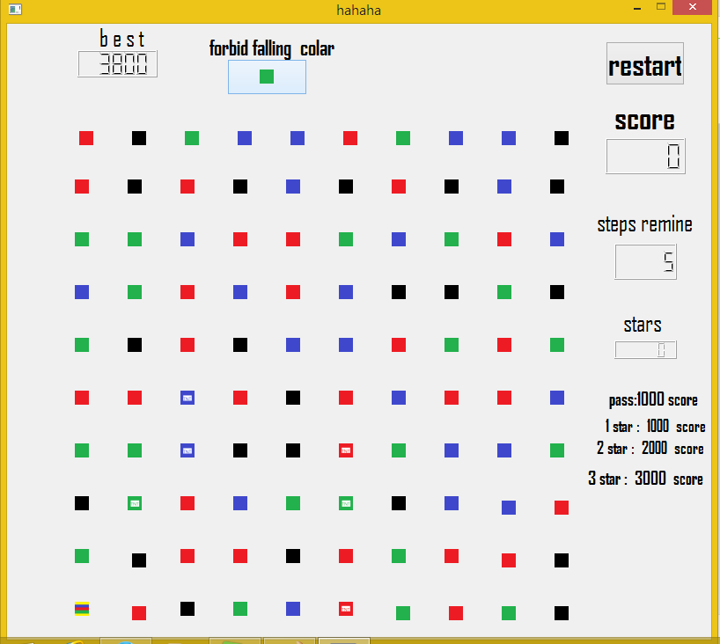

Gameing

public:

explicit gameing(QWidget \*parent = 0);

void makelab(int row,int col,int cola,int type);

void newlab(int row,int col);

void scorechange();

void stepchange();

void connectall(int row,int col);

bool isfill();

void falling();

bool checkcomb();

void sleep(unsigned int);

bool isgameover();

void gameover();

void checkbest();

~gameing();

signals:

void quit(int star,int score);

private slots:

void restart();

void check(int ,int);

void solve(int ,int ,int);

private:

Ui::gameing \*ui;

stone\* lab[10][10];

int colar[10][10];

int tcolar[10][10];

Score score;

int step;

int temrow,temcol;

int chitest;

int go;

QLabel \*gameoverlab;

Int best;

Score

public:

Score();

int getscore();

int getstar();

void operator+(int);

void zero();

int setscore(int a);

private:

int scor;

int star;

Rowstone

public:

rowstone(QWidget \*parent,int colar,int col ,int row);

void solve();

signals:

void click(int,int);

void slo(int,int,int);

public slots:

void check(bool);

Tntstone

public:

tntstone(QWidget \*parent,int colar,int col ,int row);

void solve();

signals:

void click(int,int);

void slo(int,int,int);

public slots:

void check(bool);

Colarclean

stone

public:

colarcleanstone(QWidget \*parent,int colar,int col ,int row);

void solve();

signals:

void click(int,int);

void slo(int,int,int);

public slots:

void check(bool);

Columnstone

Public:

columnstone(QWidget \*parent,int colar,int col ,int row);

void solve();

signals:

void click(int,int);

void slo(int,int,int);

public slots:

void check(bool);

Normalstone

public:

normalstone(QWidget \*parent,int colar,int col ,int row);

void solve();

signals:

void click(int,int);

void slo(int,int,int);

public slots:

void check(bool);

Stone

public:

stone(); ~stone()

void move(int tergetrow,int tergetcol);

void movelab(int tergetrow,int tergetcol,int movetimes);

virtual void solve()=0;

signals:

void click(int,int);

void slo(int,int,int);

public slots:

void check(bool);

protected:

int colaror;

QPushButton\* button;

int rowlo;

int collo;

int type;

QObject