1. UML class diagram

|  |
| --- |
| BlueDrum |
| - pressSound:QMediaPlayer* |
| <constructor>+BlueDrum()  +keyPressEvent(event: QKeyEvent *)  +move() |

|  |
| --- |
| RedDrum |
| - pressSound:QMediaPlayer* |
| <constructor>+RedDrum()  +keyPressEvent(event:QKeyEvent*)  +move() |

|  |
| --- |
| Button |
| - text:QGraphicsTextItem* |
| <constructor>+Button(name:QString, parent:QGraphicsItem*)  +mousePressEvent(event: QGraphicsSceneMouseEvent*)  + hoverEnterEvent(event: QGraphicsSceneHoverEvent*)  + hoverLeaveEvent(event: QGraphicsSceneHoverEvent*); |

|  |
| --- |
| MyRect |
|  |
| <constructor>+MyRect()  +spawn() |

|  |
| --- |
| MyTimer |
| +mytime:Integer |
| <constructor>+MyTimer()  +decrease() |

|  |
| --- |
| Game |
| + scene: QGraphicsScene *  +player: MyRect *  + score: Score *  + target: Target *  + mytimer: MyTimer *  +music: QMediaPlayer*  - timer: QTimer *  - countdown_timer: QTimer * |
| <constructor>+Game()  +displayMainMenu()  +gameover()  + displayGameOverWindow()  + stopSpawn()  + stopCountdown()  +start()  +restartGame()  - drawPanel(x:Integer, y:Integer, width:Integer, height:Integer, color:Qcolor, opacity:Double) |

|  |
| --- |
| Score |
| +score:Integer |
| <constructor>+Score(parent:QGraphicsItem*)  +increase()  +getScore():Integer |

|  |
| --- |
| Target |
|  |
| <constructor>+Target() |

1. Screen shot

(1)start

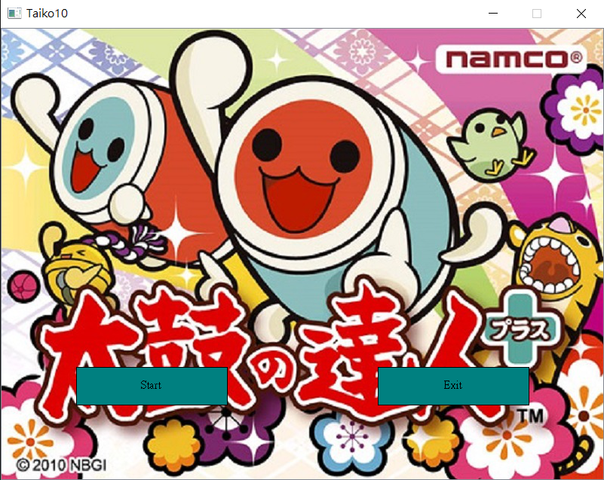

(2)play

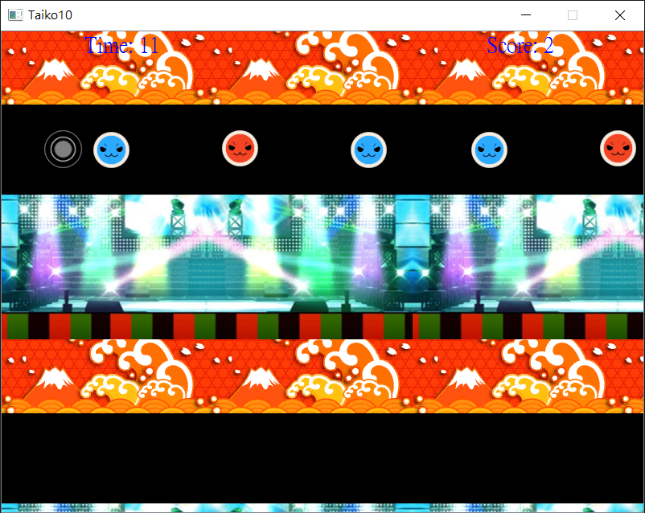

(3)gameover

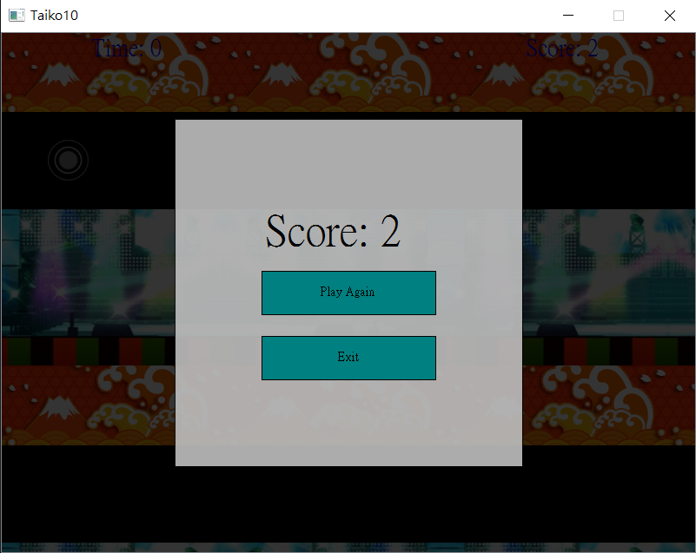

1. How to play

(1)Press J to eliminate red drum.(2)Press K to eliminate blue drum.(3)You can eliminate the drum by pressing J and K only when the drum near the target.

1. Bonus

Music:background and eliminate drums

1. Program architecture

link

Taiko

compile

main.o

target.o

score.o

mytimer.o

game.o

button.o

red_drum.o

blue_drum.o

myrect.o

myrect.cpp

Preprocess(#include)

red_drum.h

game.h

game.cpp

mytimer.cpp

score.cpp

target.cpp

main.cpp

button.cpp

red_drum.cpp

blue_drum.cpp

target.h

score.h

mytimer.h

button.h

blue_drum.h

myrect.h