UML:

|  |
| --- |
| MainWindow |
| - ui: Ui::MainWindow*  - scene: QGraphicsScene*  - world: b2World*  - itemList: QList<GameItem*>  - timer: QTimer*  - music: QMediaPlayer*  - init_x: float  - init_y: float  - land: Land*  - bird[ ]: Bird*  - pig[ ]: Wood*  - isPressed: bool  - isFired: bool  - skillUsed: bool  - done: bool  - alldone: bool  - birdnum: int  - dx: float  - dy: float  - score: int  - isReady: bool  - die0: bool  - die1: bool  - die2: bool  - die3: bool  - die4: bool  - v0: b2Vec2  - v1: b2Vec2  - v2: b2Vec2  - v3: b2Vec2  - v4: b2Vec2 |
| <<constructor>>+ MainWindow(parent: QWidget*)  <<destructor>>+ ~MainWindow()  + showEvent(QShowEvent*): void  + eventFilter(QObject*, event: QEvent*): bool  + closeEvent(QCloseEvent*): void  <<signals>>+ quitGame(): void  <<slots>>- startGame(): void  <<slots>>- clear(): void  <<slots>>- setBird(): void  <<slots>>- setWood(): void  <<slots>>- setPig(): void  <<slots>>- tick(): void  <<slots>>- setReady(): void  <<slots>>- newBird(): void  <<slots>>- isAllDone(): void  <<slots>>- QUITSLOT(): void |

|  |
| --- |
| Gameitem |
| # g_body: b2Body*  # g_pixmap: QGraphicsPixmapItem  #g_size: QSizeF  #g_world: b2World  #g_worldsize: static QSizeF  #g_windowsize: static QSizeF |
| <<constructor>>+ GameItem(world: b2World*)  <<destructor>>+ ~GameItem()  + setGloabalSize(worldsize: QSizeF, windowsize: QSizeF): static void  <<slots>>+ paint(): void |

|  |
| --- |
| Land |
|  |
| <<constructor>>+ Land(x: float, y: float, w: float, h: float, pixmap: QPixmap*, world: b2World, scene: QGraphicsScene*) |

|  |
| --- |
| Wood |
|  |
| <<constructor>>+ Wood(x: float, y: float, w: float, h: float, timer: QTimer*, pixmap: QPixmap*, world: b2World, scene: QGraphicsScene*) |

|  |
| --- |
| Bird |
|  |
| <<constructor>>+ Bird(x: float, y: float, radius: float, timer: QTimer*, pixmap: QPixmap*, world: b2World, scene: QGraphicsScene*)  + setDynamic(): void  + setVelocity(x: float, y: float): void  + getVelocity(): b2Vec2  + setPos(x: float, y: float): void  + getPos(): b2Vec2  + rotate(rad: int): void |

|  |
| --- |
| Pig |
|  |
| <<constructor>>+ Pig(x: float, y: float, radius: float, timer: QTimer*, pixmap: QPixmap*, world: b2World, scene: QGraphicsScene*)  + getVelocity(): b2Vec2  + changePic(pixmap: QPixmap): void |

關係圖：

QMainWindow

QGraphicsScene

QMouseEvent

QDesktopWidget

QList

MainWindow

QList

include

include

Box2D

QGraphicsPixmapItem

Land

Wood

Bird

Pig

繼承

GameItem

遊戲截圖：

1.遊戲開始畫面

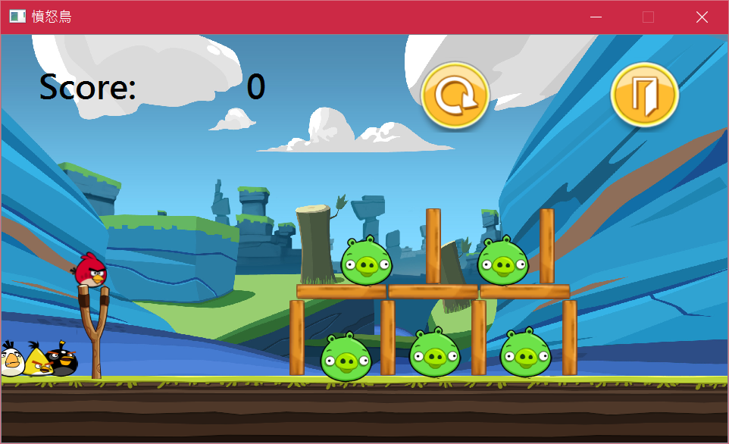

2.遊戲勝利(全部擊中)

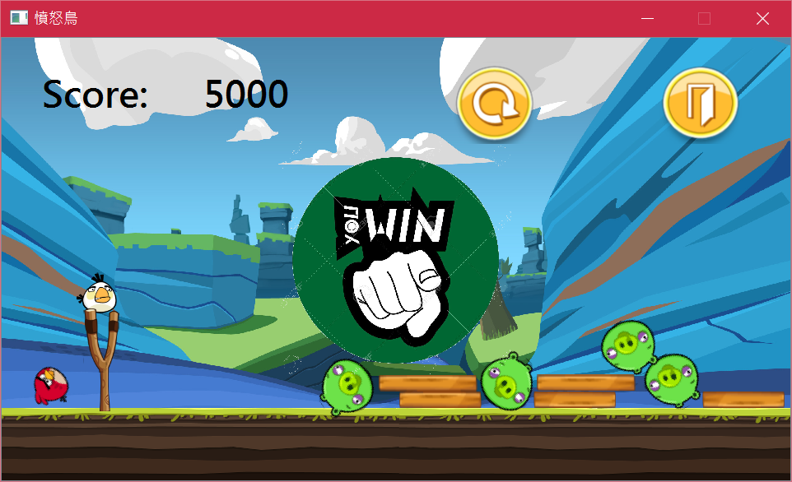

3.遊戲失敗(沒有全部擊中)

