program architecture:

main.cpp用來呼叫 mainwindow

mainwindow以ui形式寫成，藉由click進入game.cpp中，將要放到game.cpp(也就是遊戲的主視窗)中的好幾個物件分好幾個class宣告，在移到game constructor 中呼叫

執行後按下start就能到主視窗了，這是藉由J、K鍵感應移動的物品，自指定範圍內便能得分。

Screen shot:

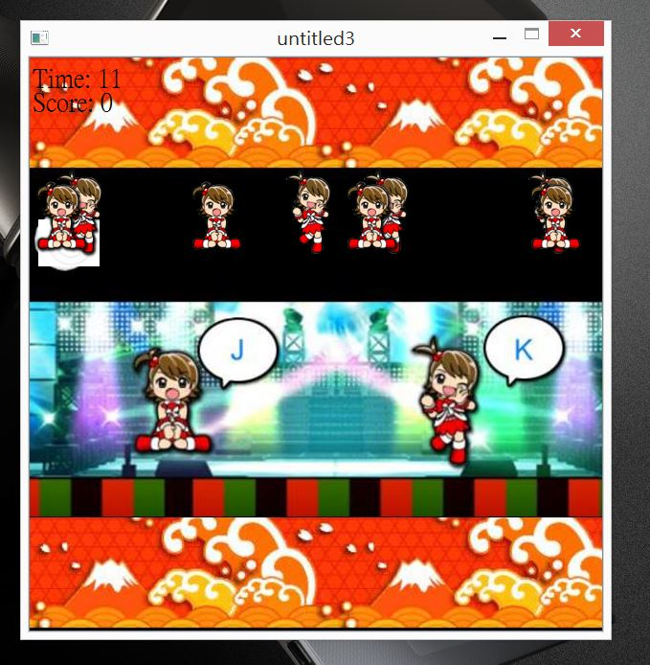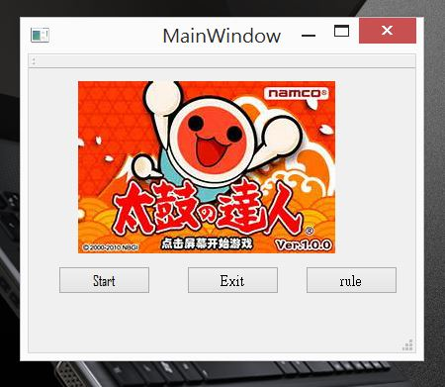

UML class diagram

|  |
| --- |
| **Enemy** |
| +Enemy |
| +move()  +spawn() |

|  |
| --- |
| **Enemy2** |
| + Enemy2 |
| +move2()  +spawn2() |

|  |
| --- |
| **Game** |
| +Game ,+scene, +time  +score, +player,+player2 |
| +keyPressEvent(QKeyEvent *event);  +keyPressEventt(QKeyEvent *eventt); |

|  |
| --- |
| **Score** |
| -score, |
| +increase()  +getscore() |

|  |
| --- |
| **Time** |
| -time |
| +timer_timeout(), +getTime();  + dialog(); |
|  |

|  |
| --- |
| **Myrect** |
| +enemy  +enemy2 |
| +spawn()  +spawn2() |