|  |
| --- |
| MainWindow |
| scene:QGraphicsScene*  world:b2world*  item:QList<game_item *>  timer:QTimer*  scoreboard:QLebel*  bbird[4]:bird*  ppig[2]:pig*  left_button_count,right_button_count,num,score:int  start_1,start_2,step_1,step_2,pig_1,pig_2,end_1,end_2:float  skill_status,ready_shoot,mouse_move,kill_1,kill_2:bool |
| MainWindow(QWidget *parent = 0); :explist  *showEvent*(QShowEvent *); :void  *eventFilter*(QObject *,QEvent *event); :bool  *closeEvent*(QCloseEvent *); :void  quit_game(); :void  tick(); :void  QUITSLOT(); :void  restart_game(); :void  exit_game(); :void |

|  |
| --- |
| game_item |
| g_body:b2Body*  g_pixmap:QGraphicsPixmapItem  g_size:QSizeF  g_world:b2World*  g_worldsize,g_windowsize:QSizeF |
| game_item(b2World*world);~game_item()  set_global_size(QSizeF worldsize, QSizeF windowsize); :void |

|  |
| --- |
| pig |
| pig(float x, float y, float radius, QTimer *timer, QPixmap pixmap, b2World *world, QGraphicsScene *scene); :void  get_linear_velocity(); :b2Vec2 |

|  |
| --- |
| wood |
| wood(float x, float y, float w, float h, QTimer *timer, QPixmap pixmap, b2World *world, QGraphicsScene *scene); |

|  |
| --- |
| shooter |
| shooter(float x, float y, float w, float h, QPixmap pixmap, b2World *world, QGraphicsScene *scene); |

|  |
| --- |
| bird |
| bird_1,bird_2,bird_3,bird_4 |
| bird(float x, float y, float radius, QTimer *timer, QPixmap pixmap, b2World *world, QGraphicsScene *scene);  set_linear_velocity(b2Vec2 velocity); :void  set_transform(b2Vec2 loc, float angle); :void  get_linear_velocity(); :b2Vec2  get_position(); :b2Vec2  *skill*() = 0; :virtual void |

遊戲截圖

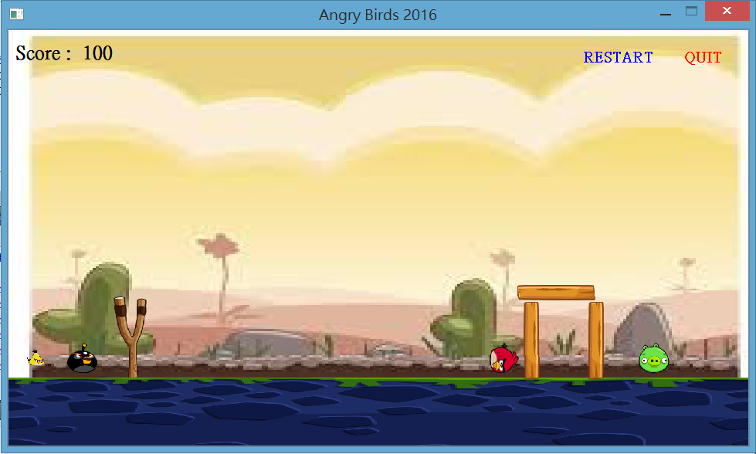

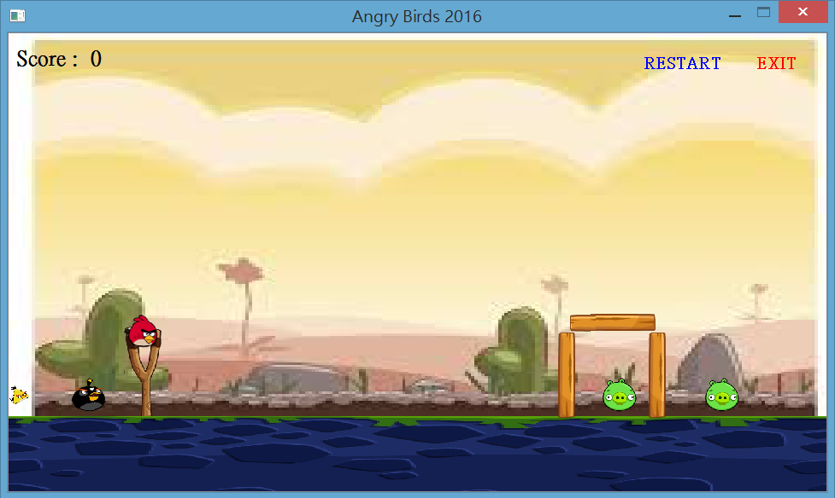

遊戲方法:

點擊左鍵並按住拖曳以移動鳥身蓄力，鬆開即可彈出，在點擊右鍵可施方小鳥技能。擊殺豬可得100分，遊戲結束尚有小鳥存活可得500分