**Computer Organization 2019**

**HOMEWORK 6**

系級: 資訊110 學號: F74066307 姓名: 陳品修

**問題(Question)**

Q1. How do you know the number of block from input file?

A1:將讀入的address拆成tag index data三部分，用index來判斷

Q2. How do you know how many set in this cache?

A2:Direct mapped就是block的數量，4-way就除以4，full就只有一個set

Q3. How do you know the bits of the width of the Tag ?

A3: 32 – blockoffset – index width

Q4. Briefly describe your data structure of your cache.

A4:二維array cache[index][content]

content的部分為->[valid bit][tag][data]

Q5. Briefly describe your algorithm of LRU.

利用double linked list串起已用過的tag，每次都去檢查list，如果重複用到tag，就把他搬到list最左邊(head→next)，而list的末尾就是目前的LRU atg

Q6. Briefly describe your algorithm of your policy.

就是FIFO

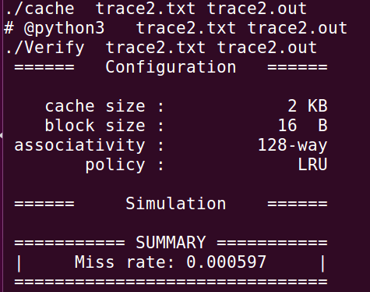Q7. Run trace2.txt, trace3.txt and then makefile to get the miss rate and put it in your report.

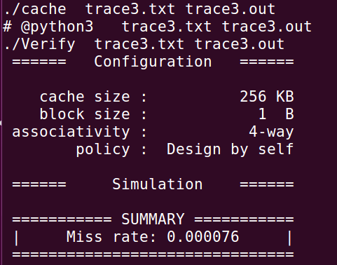

**心得**

(請寫下完成本次作業的心得、學到哪些東西、困難點的部分。)

(Please write your learned lesson and conclusion, and difficult point.)

c++太久沒寫有點生疏，還有c++ 的string的用法也不熟悉，linked list也是最後才注意到兩個忘記連起來的部分，不過跟verilog比起來真是天堂