實驗數據

單層LSTM

1. 增加Dropout

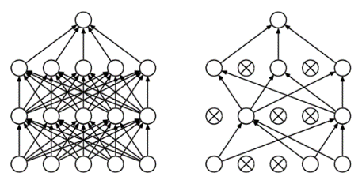

|  |  |  |  |  |  |
| --- | --- | --- | --- | --- | --- |
| **Dropout** | **0.0** | **0.2** | **0.4** | **0.6** | **0.8** |
| RMSE | 7.567 | 9.339 | 9.498 | 16.754 | 17.680 |
| Explained variance | 0.935 | 0.899 | 0.893 | 0.698 | 0.682 |
| R2 score | 0.903 | 0.852 | 0.847 | 0.523 | 0.469 |
| exp |  |  |  |  |  |

二 、使用不同的optimizer(dropout=0.4)

* Adam
* RMSprop
* SGD

(補充: Adam 就是在 RMSprop 的基礎上加了 bias-correction 和 momentum，隨著梯度變的稀疏，Adam 比 RMSprop 效果會好)

|  |  |  |  |
| --- | --- | --- | --- |
| Optimizer | Adam | RMSprop | SGD |
| RSME | 9.614 | 9.958 | 28.831 |
| Explained variance | 0.892 | 0.919 | 0.315 |
| R2 score | 0.843 | 0.831 | -0.369 |
| exp |  |  |  |