Monolith

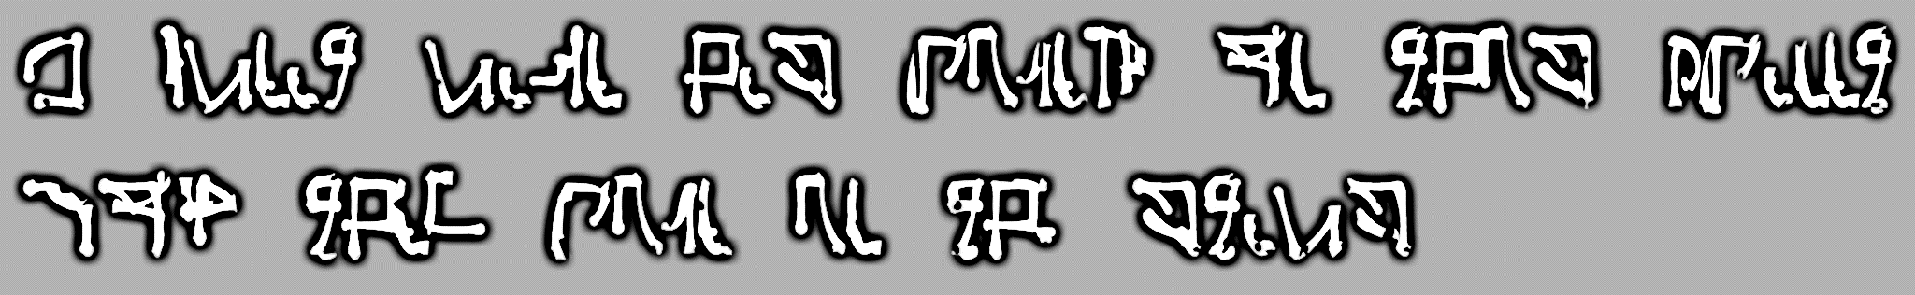

A great race has lived on this planet Now they live in the stars

Stereolith



