Zero-Click Attack Sandbox

Design and Implementation of a Defensive File Arrival Monitoring System for Windows

Course Project Paper
Prepared from project code, logs, and screenshots supplied by the student
Project Idea | Zero-click attack sandbox with monitoring, scoring, scanning, and quarantine
Environment | Windows VM / PowerShell / Microsoft Defender / Sysmon
Main Script | ZeroClick-Guard.ps1
Output Artifacts | Console alerts, JSONL log, and quarantine folder

Instructor: Dr. Jehad Hamamreh

Prepared by: Ahmad Hamad, Wassem Ahmad, Assad Dwikat , Waleed Fuqha

Abstract
This project presents a defensive sandbox concept for zero-click style threats on a Windows system. The implemented prototype, named ZeroClick Guard, continuously watches high-risk folders such as Downloads and Temp, evaluates newly created or modified files, and assigns a suspicion score based on extension type, file path, signature status, and Mark-of-the-Web metadata. The system then invokes Microsoft Defender for a targeted scan, collects recent Sysmon context, and automatically moves highly suspicious files to a quarantine folder. In addition to real-time console alerts, the project stores structured JSONL logs for later forensic analysis. The final result is a lightweight local containment mechanism that demonstrates how defensive monitoring can reduce the risk of malicious files that arrive without direct user intent, which is a common concern in modern zero-click and near-zero-click attack scenarios.
Keywords: zero-click attacks, sandboxing, PowerShell, Microsoft Defender, Sysmon, file monitoring, quarantine, Windows security

1. Introduction
A zero-click attack is a threat that can be triggered without the victim intentionally opening a malicious file or pressing a suspicious link. In practice, many attacks exploit messaging clients, browsers, mail applications, auto-preview behavior, or background processing of downloaded content. Because of this, defenders need protective controls that react as soon as suspicious files appear on disk rather than waiting for a manual scan later.
The goal of this project is not to build a complete antivirus engine. Instead, the aim is to create a practical defensive layer that observes risky arrival points on a Windows machine, evaluates each file using simple but meaningful indicators, and isolates dangerous files before they can be executed or abused by another process. This makes the project suitable as a sandbox-style defensive prototype for academic work in cryptography and security.

2. Project Objectives
The main objective was to design a local monitoring tool that can detect suspicious file arrivals in real time and respond automatically. The system should be simple to deploy, easy to understand, and based on built-in Windows security capabilities whenever possible.
More specifically, the project aimed to monitor selected user-facing folders, compute a risk score for each observed file, launch Microsoft Defender custom scans, inspect digital signature information, extract Mark-of-the-Web metadata, correlate activity with recent Sysmon events, quarantine files whose scores exceed a defined threshold, and store all actions in a structured log for auditing and later analysis.

3. System Architecture
The architecture of ZeroClick Guard follows an event-driven design. A PowerShell script initializes FileSystemWatcher objects for several high-risk locations, including the current user Downloads folder, the temporary folder, the Local AppData Temp folder, and the public downloads directory. Whenever a file is created, changed, or renamed, the script triggers an analysis workflow.
Inside the analysis stage, the system waits briefly to avoid racing with incomplete file writes, checks whether the same path was processed moments ago, gathers file metadata and SHA-256 hash values, reads Zone.Identifier alternate data streams when present, checks Authenticode signature status, and computes a score. After this, Microsoft Defender and Sysmon are queried to add more security context. Finally, if the total score reaches the configured quarantine threshold, the file is moved into an isolated folder and the event is recorded in JSONL format.

4. Implementation Details
The implementation is written in PowerShell and designed to run with administrative privileges. The script first creates the log and quarantine directories under C:\ZeroClickGuard, then registers watcher events and enters a persistent loop. Each event uses the same analysis function so that the behavior remains consistent across create, modify, and rename operations.
The scoring logic is intentionally transparent. High-risk extensions such as EXE, DLL, JS, BAT, CMD, ISO, ZIP, MSI, JAR, and LNK increase the score. Suspicious storage locations such as AppData Temp or public download areas add more risk. A Mark-of-the-Web value from an external zone contributes additional points, while valid signatures reduce the score. Unsigned files and signature mismatches raise suspicion, and recognized operating system binaries receive a lower score to reduce false alarms. The final score is clipped between 0 and 100 so that the decision remains easy to interpret.

5. Main Functional Components
The project can be understood through six main components. The first component is path monitoring, which detects file activity in real time. The second component is file profiling, which extracts size, hash, extension, timestamps, and origin metadata. The third component is trust evaluation, which checks signatures and OS-binary status. The fourth component is security correlation, which uses Defender and Sysmon data to attach context from the host. The fifth component is response, which performs quarantine when the threshold is reached. The sixth component is logging, which stores machine-readable event records for later investigation.
This modular structure is useful academically because each component can be explained, tested, and improved independently. For example, the scoring policy can be tuned without changing the watcher layer, and the quarantine decision can be replaced later with a more advanced policy engine or machine learning classifier if required.

6. Experimental Output and Observations
The supplied screenshots show the script running successfully inside a Windows virtual machine. The console confirms that ZeroClick Guard starts correctly, creates the JSONL log path, and begins watching all configured directories. During execution, the monitor reports several observed files together with their scores and quarantine status. Most ordinary PDF or temporary files receive modest scores and remain unquarantined, which indicates that the scoring model distinguishes between normal documents and obviously risky content.
Additional screenshots confirm that the project creates the required folder structure at C:\ZeroClickGuard, including separate Logs and Quarantine directories. The log folder contains an events.jsonl file, while the quarantine folder stores isolated samples that were moved after scoring or testing. This behavior demonstrates that the prototype completed its core end-to-end workflow: detect, analyze, classify, and isolate.

7. Security Value of the Project
Even though this prototype does not replace enterprise endpoint protection, it provides real defensive value. It reduces attacker dwell time by responding immediately when suspicious files land on disk. It also improves visibility because every event is written in structured form, which helps in incident response, debugging, and future expansion. For a teaching environment, the project is especially valuable because it connects several security concepts in one implementation: file system monitoring, integrity checks, reputation signals, host telemetry, and quarantine response.
From a cryptography course perspective, the project is still relevant because strong security depends not only on cryptographic algorithms but also on secure system behavior. A file that bypasses user interaction can still threaten encrypted systems if the endpoint is weak. Therefore, this sandbox demonstrates how defensive controls can complement cryptographic protections in a larger secure architecture.

8. Limitations
The current design is rule-based and therefore depends on handcrafted scoring decisions. A sophisticated attacker may use signed malware, low-risk extensions, or staged payload delivery to stay below the quarantine threshold. In addition, Microsoft Defender and Sysmon availability may vary across systems, and event correlation is intentionally limited to a recent time window rather than a full historical graph.
Another limitation is that the prototype focuses on files that arrive on disk. Pure memory-only exploitation or remote code execution that leaves no monitored artifact would not be fully captured by this design. For that reason, the project should be viewed as a practical host-based containment layer rather than a universal zero-click solution.

9. Possible Future Improvements
Several extensions can make the system stronger. The scoring engine can be enhanced with file entropy checks, YARA rules, MIME verification, archive unpacking, macro detection, or connections to external reputation services. The quarantine module can also be upgraded to support restoration workflows, digital evidence export, and secure hashing reports for forensic handling.
A future version may add a small dashboard that visualizes current alerts, top risky paths, and recent detections from the JSONL log. It would also be useful to integrate email or SIEM forwarding so that security administrators are notified immediately when suspicious files are quarantined. Finally, the project can be expanded into a more realistic sandbox by executing suspicious samples inside an isolated environment rather than only moving them aside.

10. Conclusion
ZeroClick Guard is a clear example of how a lightweight script can provide meaningful defensive monitoring on Windows. By combining file-system events, metadata inspection, signature validation, Defender scans, Sysmon context, and automated quarantine, the project creates a complete response loop around suspicious file arrivals.
The project successfully demonstrates the main idea behind a zero-click attack sandbox: do not wait for manual interaction, but inspect risky content the moment it appears and contain it before it can cause harm. As a student project, it is practical, understandable, and extensible, which makes it a strong foundation for later research or a more advanced defensive security system.

11. Summary of Key Detection Features
Feature | Role in Detection | Expected Effect on Score
High-risk extension | Flags executable or script-like content such as EXE, DLL, JS, BAT, and MSI | Increase
Suspicious path | Raises concern for files appearing in Temp, Public Downloads, or similar paths | Increase
Mark-of-the-Web | Shows likely internet origin through Zone.Identifier metadata | Increase
Valid Authenticode signature | Indicates better trustworthiness for signed files | Decrease
Unsigned or mismatched signature | Shows weak or suspicious trust state | Increase
OS binary status | Reduces false positives for trusted Windows components | Decrease
Defender custom scan | Adds built-in malware scanning to the workflow | Context / validation
Recent Sysmon events | Provides process and network context around the file event | Context enrichment

12. Project Screenshots
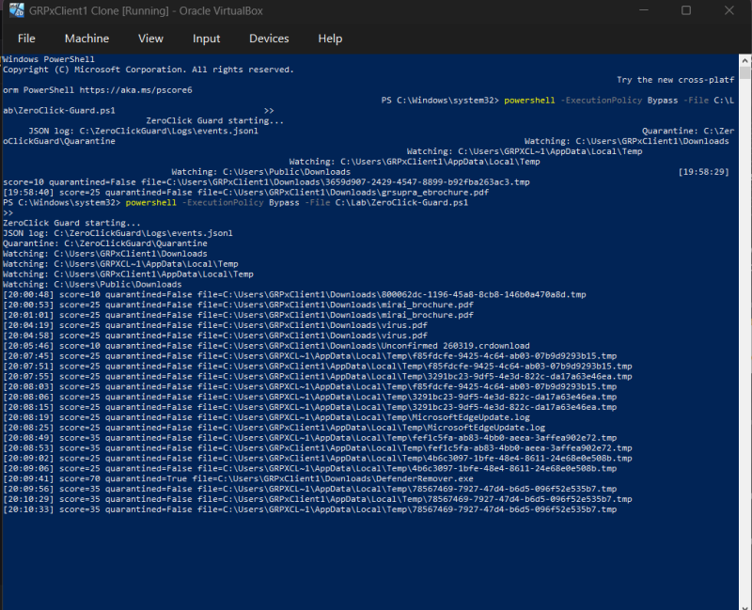
Figure 1. Running ZeroClick Guard in PowerShell and observing scored files.
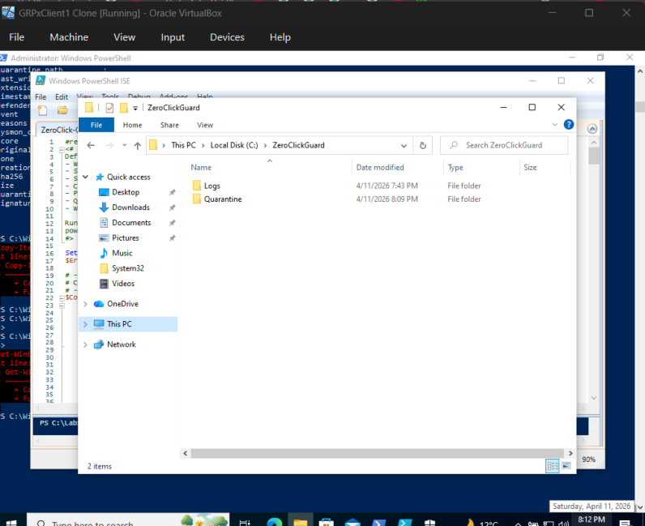
Figure 2. Main ZeroClickGuard directory showing Logs and Quarantine folders.
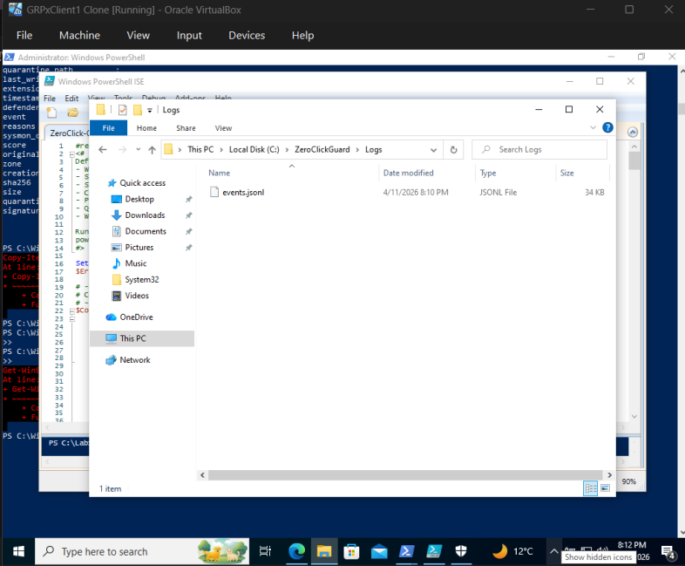
Figure 3. JSONL log file generated by the system.
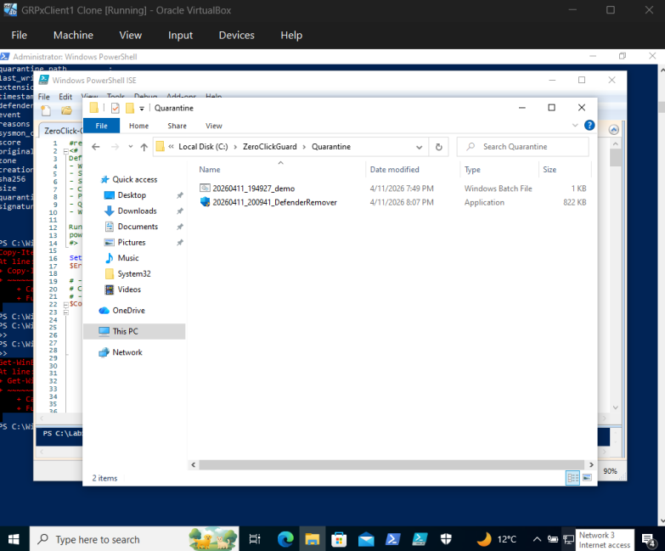
Figure 4. Quarantine folder containing isolated files.

13. References
- Marczak, B., Scott-Railton, J., McKune, S., Razzak, B., & Deibert, R. (2018). Hide and Seek: Tracking NSO Group’s Pegasus Spyware. Citizen Lab, University of Toronto.

- Kerner, S. M. (2021). What is a zero-click attack? Network World.

- ENISA. (2021). ENISA Threat Landscape 2021.

- NIST. (2018). Guide to Malware Incident Prevention and Handling for Desktops and Laptops (SP 800-83).

- Apple. (2021). BlastDoor: A sandbox for iMessage security.

- Kaspersky. (2020). Mobile malware evolution and zero-click threats.

- Google Project Zero. (2021). A deep dive into an NSO zero-click iMessage exploit.

