QUESTION-1: Average Speed
#include<stdio.h>
int main()
{
int hours;
float dis;

printf("Enter the value of hours\n");
scanf("%d", &hours);

printf("Enter the value of dis\n");
scanf("%f", &dis);
float average_speed = (float) dis/hours;
printf("Average speed %f km/hr", average_speed);
return 0;
}
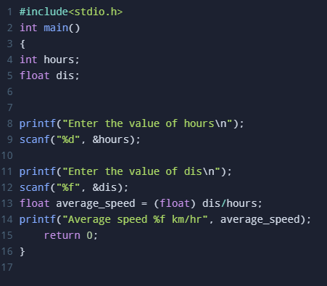
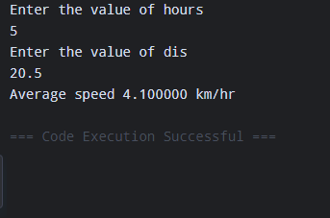

QUESTION-2: Swapping Two values

#include<stdio.h>

int main()

{

int num1;

int num2;

int x;

printf("Enter the value of num1");

scanf("%d", &num1);

printf("Enter the value of num2");

scanf("%d", &num2);

x = num1;

num1 = num2;

num2 = x;

printf("num1 %d", num1);

printf("num2 %d", num2);

return 0;

}

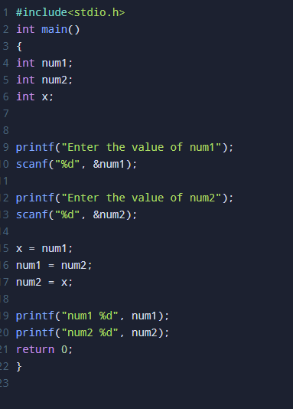
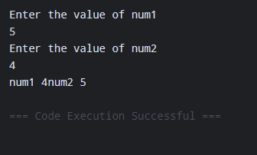

QUESTION-3: Salary After Tax
#include<stdio.h>
int main()
{
float tax_rate;
int salary;
float tax_payable;
float remaining_salary;

printf("Enter the value of tax_rate in %%");
scanf("%f", &tax_rate);
printf("Enter the value of salary");
scanf("%d", &salary);

tax_payable = salary * (tax_rate/100.0);
remaining_salary = salary - tax_payable;

printf("Tax Amount:\t\t %f\n", tax_payable);
printf("Net Income:\t\t %f\n", remaining_salary);
return 0;
}
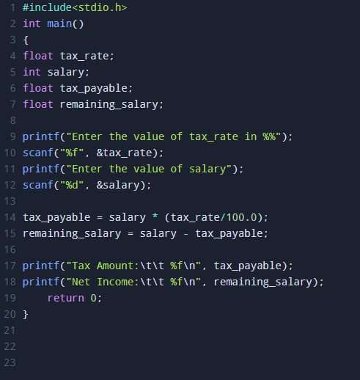
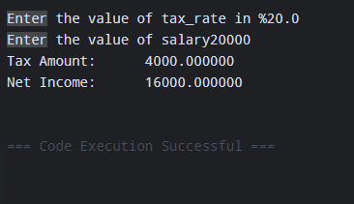

QUESTION-4: Convert Pennies into Coins
#include <stdio.h>
int main()
{
int total_pennies = 368;
int quarter;
int dime;
int nickel;
int pennies;

quarter = total_pennies / 25;
total_pennies = total_pennies % 25;
dime = total_pennies / 10;
total_pennies = total_pennies % 10;
nickel = total_pennies / 5;
total_pennies = total_pennies % 5;
pennies = total_pennies;

printf("Quarters = %d\n", quarter);
printf("Dimes\t = %d\n", dime);
printf("Nickels\t = %d\n", nickel);
printf("pennies\t = %d\n", pennies);
return 0;
}
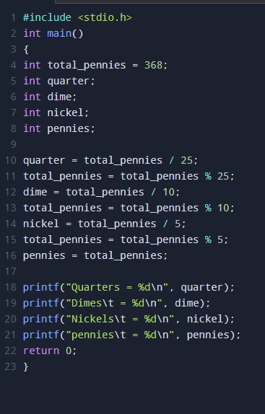
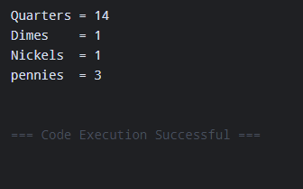
QUESTION-5: Roots Of a Quadratic Equation
#include <stdio.h>
#include <math.h>
int main()
{
int a;
int b;
int c;
float descriminant;
float x1;
float x2;

printf("Enter the value of a\n");
scanf("%d", &a);
printf("Enter the value of b\n");
scanf("%d", &b);
printf("Enter the value of c\n");
scanf("%d", &c);

descriminant = pow(b,2)-(4*a*c);
x1 = (-b + sqrt(descriminant)) / (2*a);
x2 = (-b - sqrt(descriminant)) / (2*a);

printf("Root 1 = %f\n", x1);
printf("Root 2 = %f\n", x2);
return 0;
}
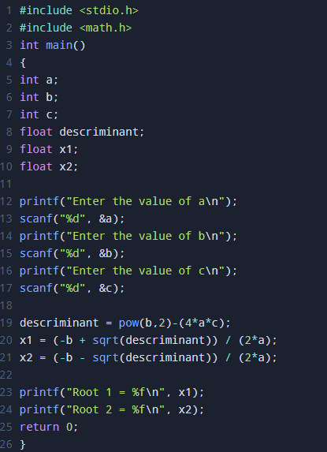
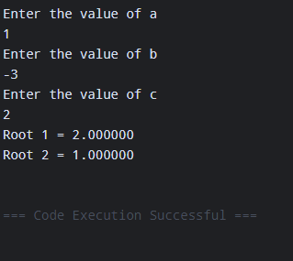
QUESTION-6: Typecasting Before and After Division
#include <stdio.h>
int main()
{
int a;
int b;
float result1;
float result2;
float result3;

printf("Enter the value of a\n");
scanf("%d", &a);
printf("Enter the value of b\n");
scanf("%d", &b);

result1 = a/b;
result2 = (float) a/b;
result3 = (float) (a/b);

printf("a/b = %f\n", result1);
printf("(float) a/b = %f\n", result2);
printf("(float) (a/b) = %f\n", result3);
return 0;
}
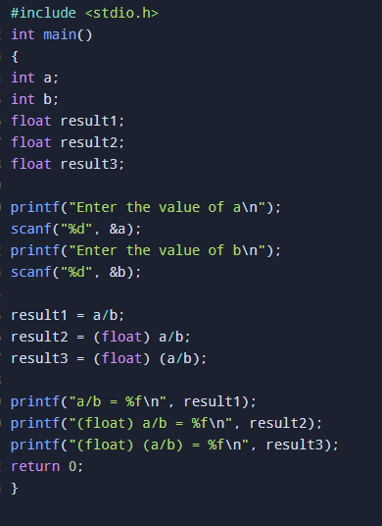
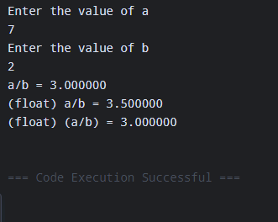

QUESTION-7: Average Marks Using Typecasting
#include <stdio.h>
int main()
{
int marks_s1;
int marks_s2;
int marks_s3;
int total_marks;
float average;

printf("Enter the value of marks_s1\n");
scanf("%d", &marks_s1);
printf("Enter the value of marks_s2\n");
scanf("%d", &marks_s2);
printf("Enter the value of marks_s3\n");
scanf("%d", &marks_s3);

total_marks = marks_s1 + marks_s2 + marks_s3;
average = (float) total_marks / 3;

printf("Total = %d\n", total_marks);
printf("Average = %f\n", average);
return 0;
}
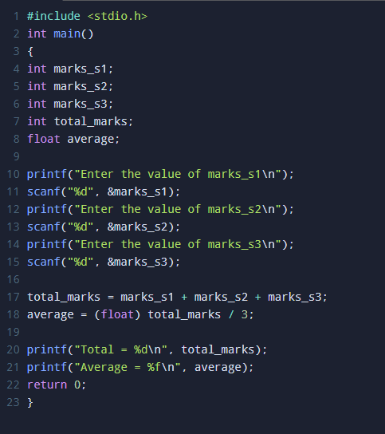

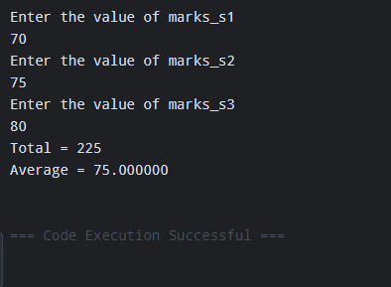
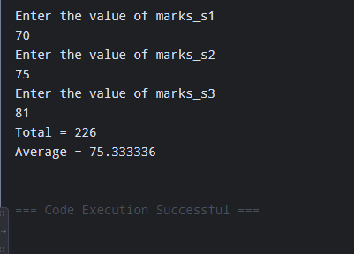

QUESTION-8: Converting a Float To an Integer
#include <stdio.h>
int main()
{
float float_value;
int converted_int;
float difference;

printf("Enter the value of float between -1000 to 1000\n");
scanf("%f", &float_value);

converted_int =(int) float_value;
difference = float_value - converted_int;

printf("Original value = %f\n", float_value);
printf("Converted Integer = %d\n", converted_int);
printf("Difference = %f\n", difference);
return 0;
}

