## Rabia

Lab 12

Fa17bece2001

## Exercise

### Exercise 1

Design the given below circuit

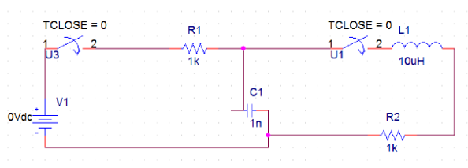

Figure 12-16

**Circuit:**

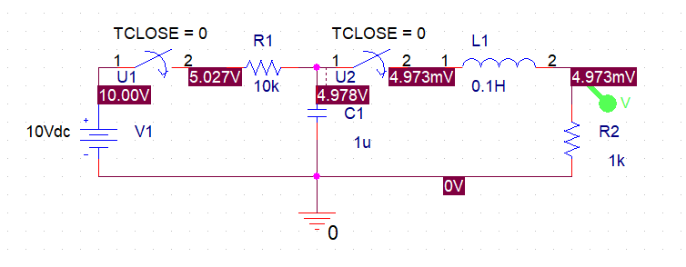

**Output-Wave:**

