## 

## Rabia

Fa17bece2001

Lab13

## Exercise 1

Using PSPICE design a full wave rectifier

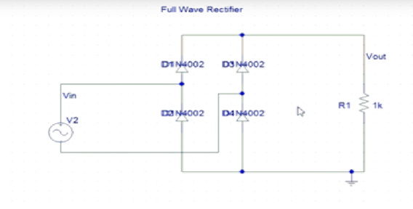

Figure 13-9 Full Wave Rectifier

**Circuit:**

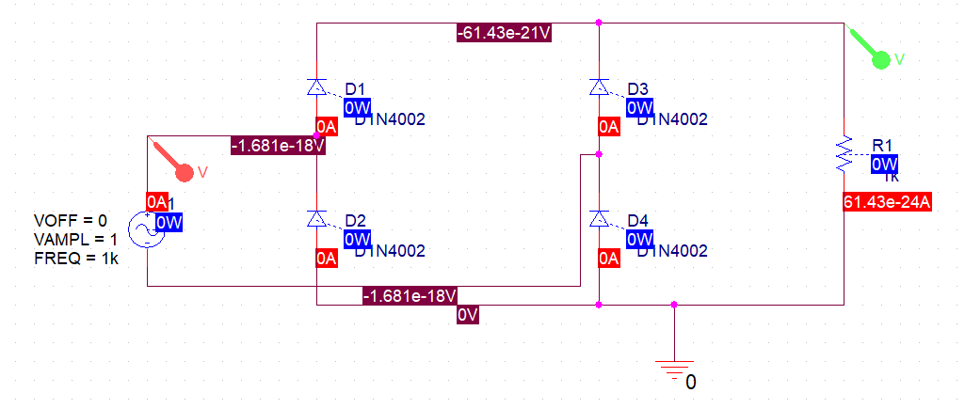

**Output-Wave:**

