## Rabia

Fa17bece2001

Lab 14

## Exercises

1. From Pakistani Rupee to Indian Rupee

**Diagram:**

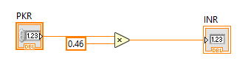

**Output:**

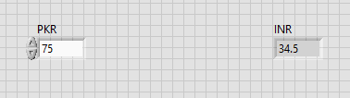

1. From Pakistani Rupee to US DOLLAR

**Diagram:**

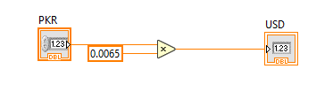

**Output:**

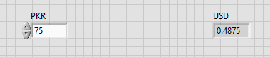

1. From Pakistani Rupee to Chinese Yuan

**Diagram:**

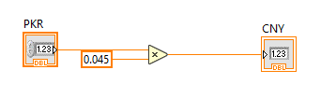

**Output:**

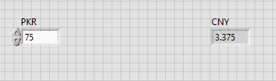

1. From Pakistani Rupee to Saudi riyal

**Diagram:**

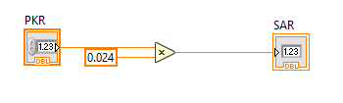

**Output:**

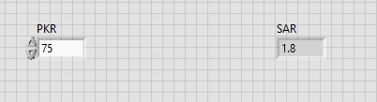

1. From Pakistani Rupee to Iraqi Dinar

**Diagram:**

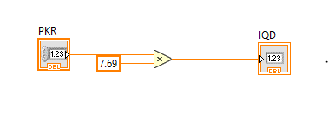

**Output:**

