import numpy as np  
import pandas as pd  
import scipy  
import sklearn  
from sklearn import preprocessing  
from sklearn import neighbors  
from sklearn.model_selection import train_test_split  
from sklearn import metrics  
import matplotlib.pyplot as plt

grade = pd.read_csv("rp1.csv")  
grade.columns = ['SAT_Score', 'HS_GPA', 'FU_GPA']

grade.head()

SAT_Score HS_GPA FU_GPA  
0 1270 3.4 3.18  
1 1220 4.0 3.33  
2 1160 3.8 3.25  
3 950 3.8 2.42  
4 1070 4.0 2.63

grade.shape

(1000, 3)

X = grade.drop('FU_GPA', axis=1).values  
y = grade['FU_GPA'].values  
  
X1 = grade.drop(['HS_GPA', 'FU_GPA'], axis=1).values  
X2 = grade.drop(['SAT_Score', 'FU_GPA'], axis=1).values

X_train, X_test, y_train, y_test = train_test_split(X,y,test_size = 0.1, shuffle=False)  
X_train1, X_test1, y_train1, y_test1 = train_test_split(X1,y,test_size = 0.1, shuffle=False)  
X_train2, X_test2, y_train2, y_test2 = train_test_split(X2,y,test_size = 0.1, shuffle=False)

from sklearn.neural_network import MLPRegressor  
reg = MLPRegressor(hidden_layer_sizes=(100,50,25), activation="logistic", alpha=0.0001, batch_size = 'auto',   
 learning_rate = 'constant', learning_rate_init = 0.001, random_state=1, max_iter=2000).fit(X_train, y_train)  
reg1 = MLPRegressor(hidden_layer_sizes=(100,50,25), activation="logistic", alpha=0.0001, batch_size = 'auto',   
 learning_rate = 'constant', learning_rate_init = 0.001, random_state=1, max_iter=2000).fit(X_train1, y_train1)  
reg2 = MLPRegressor(hidden_layer_sizes=(100,50,25), activation="logistic", alpha=0.0001, batch_size = 'auto',   
 learning_rate = 'constant', learning_rate_init = 0.001, random_state=1, max_iter=2000).fit(X_train2, y_train1)

y_test_predict = reg.predict(X_test)  
y_test_predict1 = reg1.predict(X_test1)  
y_test_predict2 = reg2.predict(X_test2)

plt.scatter(X_test1, y_test_predict1, color='red')  
plt.show()  
plt.scatter(X_test2, y_test_predict2, color='blue')  
plt.show

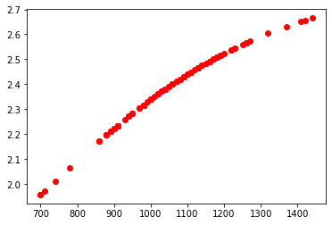

<function matplotlib.pyplot.show(close=None, block=None)>

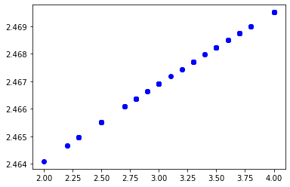

from sklearn.metrics import mean_absolute_error  
from sklearn.metrics import mean_squared_error  
from sklearn.metrics import mean_squared_log_error  
from sklearn.metrics import median_absolute_error  
from sklearn.metrics import r2_score

mean_absolute_error(y_test, y_test_predict)

0.5389190112475692

mean_squared_error(y_test, y_test_predict)

0.44887982976566604

mean_squared_log_error(y_test, y_test_predict)

0.04389112458491746

median_absolute_error(y_test, y_test_predict)

0.4780938242509949

r2_score(y_test, y_test_predict)

0.0020125396663569495

from sklearn.model_selection import GridSearchCV  
from sklearn.model_selection import ShuffleSplit  
cv=ShuffleSplit(n_splits=10, test_size=0.1, random_state=1)  
params = {'hidden_layer_sizes':[100,50,25], 'activation':['logistic'], 'max_iter':[2000], 'random_state':[1],   
 'learning_rate':['constant']}  
model = GridSearchCV(MLPRegressor(), params, cv=cv)  
model.fit(X_test, y_test_predict)  
model.best_params_

{'activation': 'logistic',  
 'hidden_layer_sizes': 25,  
 'learning_rate': 'constant',  
 'max_iter': 2000,  
 'random_state': 1}